Linking Ecosystem Services, Urban Form and Green Space Configuration Using Multivariate Landscape Metric Analysis
  - Darren R. Grafius, Ron Corstanje, and Jim A. Harris

Supplementary Materials

Table S1: Eigenvectors from Principal Component Analysis (PCA) showing strength of influence of each landscape metric for first six principal components. These show the extent to which each component was influenced by the different factors that were used in the PCA, and in turn how they contribute as combined components to the cluster analysis.
 | Prin1 | Prin2 | Prin3 | Prin4 | Prin5 | Prin6
AREA | 0.35970 | 0.28526 | -0.03864 | -0.11529 | -0.12040 | 0.08635
PERIM | 0.35982 | 0.28168 | -0.04397 | -0.08157 | -0.16156 | 0.15431
GYRATE | 0.37533 | -0.02446 | 0.07479 | 0.15521 | 0.40161 | -0.57905
PARA | -0.20810 | 0.45815 | -0.01144 | 0.39357 | 0.33746 | 0.27478
SHAPE | 0.37908 | -0.06718 | 0.04598 | 0.38096 | 0.18740 | -0.26791
FRAC | 0.20977 | -0.36276 | -0.00033 | 0.70200 | -0.30973 | 0.36856
CONTIG | 0.22487 | -0.47424 | 0.03189 | -0.26740 | -0.27711 | -0.05194
CORE | 0.35382 | 0.28093 | -0.03458 | -0.12708 | -0.09327 | 0.04130
NCORE | 0.35920 | 0.26449 | -0.04075 | -0.06975 | -0.16159 | 0.19378
CAI | 0.24966 | -0.31850 | 0.18738 | -0.26506 | 0.64180 | 0.55477
ENN | -0.04635 | 0.13210 | 0.97455 | 0.01902 | -0.17227 | -0.02459

Table S2: Correlation coefficients for paired results of landscape metrics used in multivariate analysis. Colour coded to show strong positive and negative correlations. Some metrics were included in analysis despite high correlation values due to the importance of capturing the aspects of landscape configuration that they measure.
 | AREA | PERIM | GYRATE | PARA | SHAPE | FRAC | CONTIG | CORE | NCORE | CAI | ENN
AREA | -
PERIM | 0.9778 | -
GYRATE | 0.7169 | 0.6918 | -
PARA | -0.1166 | -0.1210 | -0.3961 | -
SHAPE | 0.6744 | 0.7002 | 0.9121 | -0.4313 | -
FRAC | 0.1369 | 0.1521 | 0.4459 | -0.5781 | 0.6212 | -
CONTIG | 0.1307 | 0.1353 | 0.4399 | -0.9815 | 0.4919 | 0.6739 | -
CORE | 0.9937 | 0.9483 | 0.7205 | -0.1132 | 0.6522 | 0.1289 | 0.1272 | -
NCORE | 0.9518 | 0.9910 | 0.6825 | -0.1388 | 0.7158 | 0.1687 | 0.1547 | 0.9134 | -
CAI | 0.2466 | 0.2347 | 0.6350 | -0.6174 | 0.5910 | 0.4333 | 0.6823 | 0.2501 | 0.2510 | -
ENN | -0.0195 | -0.0219 | -0.0725 | 0.1818 | -0.0945 | -0.1517 | -0.1781 | -0.0182 | -0.0250 | -0.0717 | -

a)
Eigenvalue
b)
c) 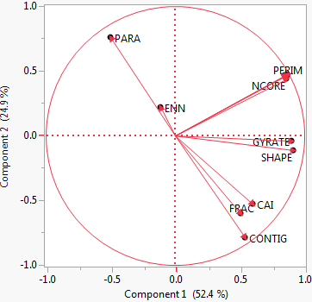
Figure S1: Scree plot (a), Eigenvalue/principal component cumulative percentage table (b), and PCA loadings graph for principal components 1 and 2 (c) from the Principal Component Analysis. The first six principal components were used in analysis based on cumulative percentages of explained variability and the scree plot's inflection point.

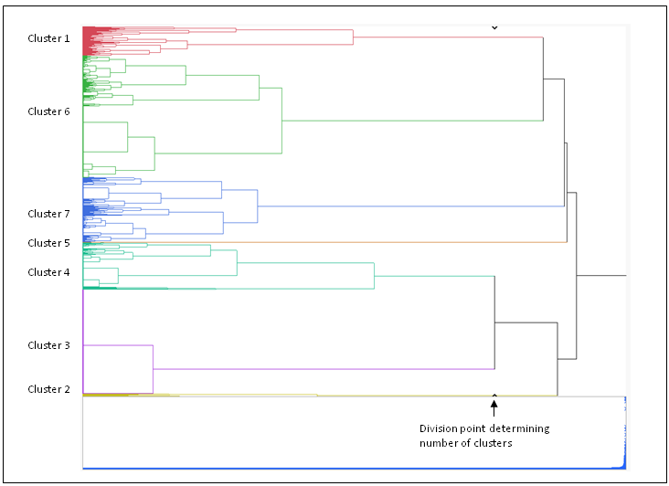
Figure S2: Dendrogram from Ward's Hierarchical Cluster Analysis. Seven clusters were used for analysis based on cluster division points. Each colour in the dendrogram represents one of the clusters resulting from the analysis (corresponding to colours used in main text Figure 3), which were then mapped as each data point was associated with a patch on the landscape. The black arrows denote the division point used to determine the number of clusters.

