Bobiec et al. Landscape Ecology – Supplementary material

Captions of supplementary figures
Fig. 1. Processes and factors influencing oak stands establishment in mesic deciduous/mixed forest communities; round shapes – developmental stages; rectangles – processes; diamonds – turning point moments; solid lines and text in grey area pertain to processes leading to oak stand development; dashed lines – pathways seldom resulting in oak regeneration.
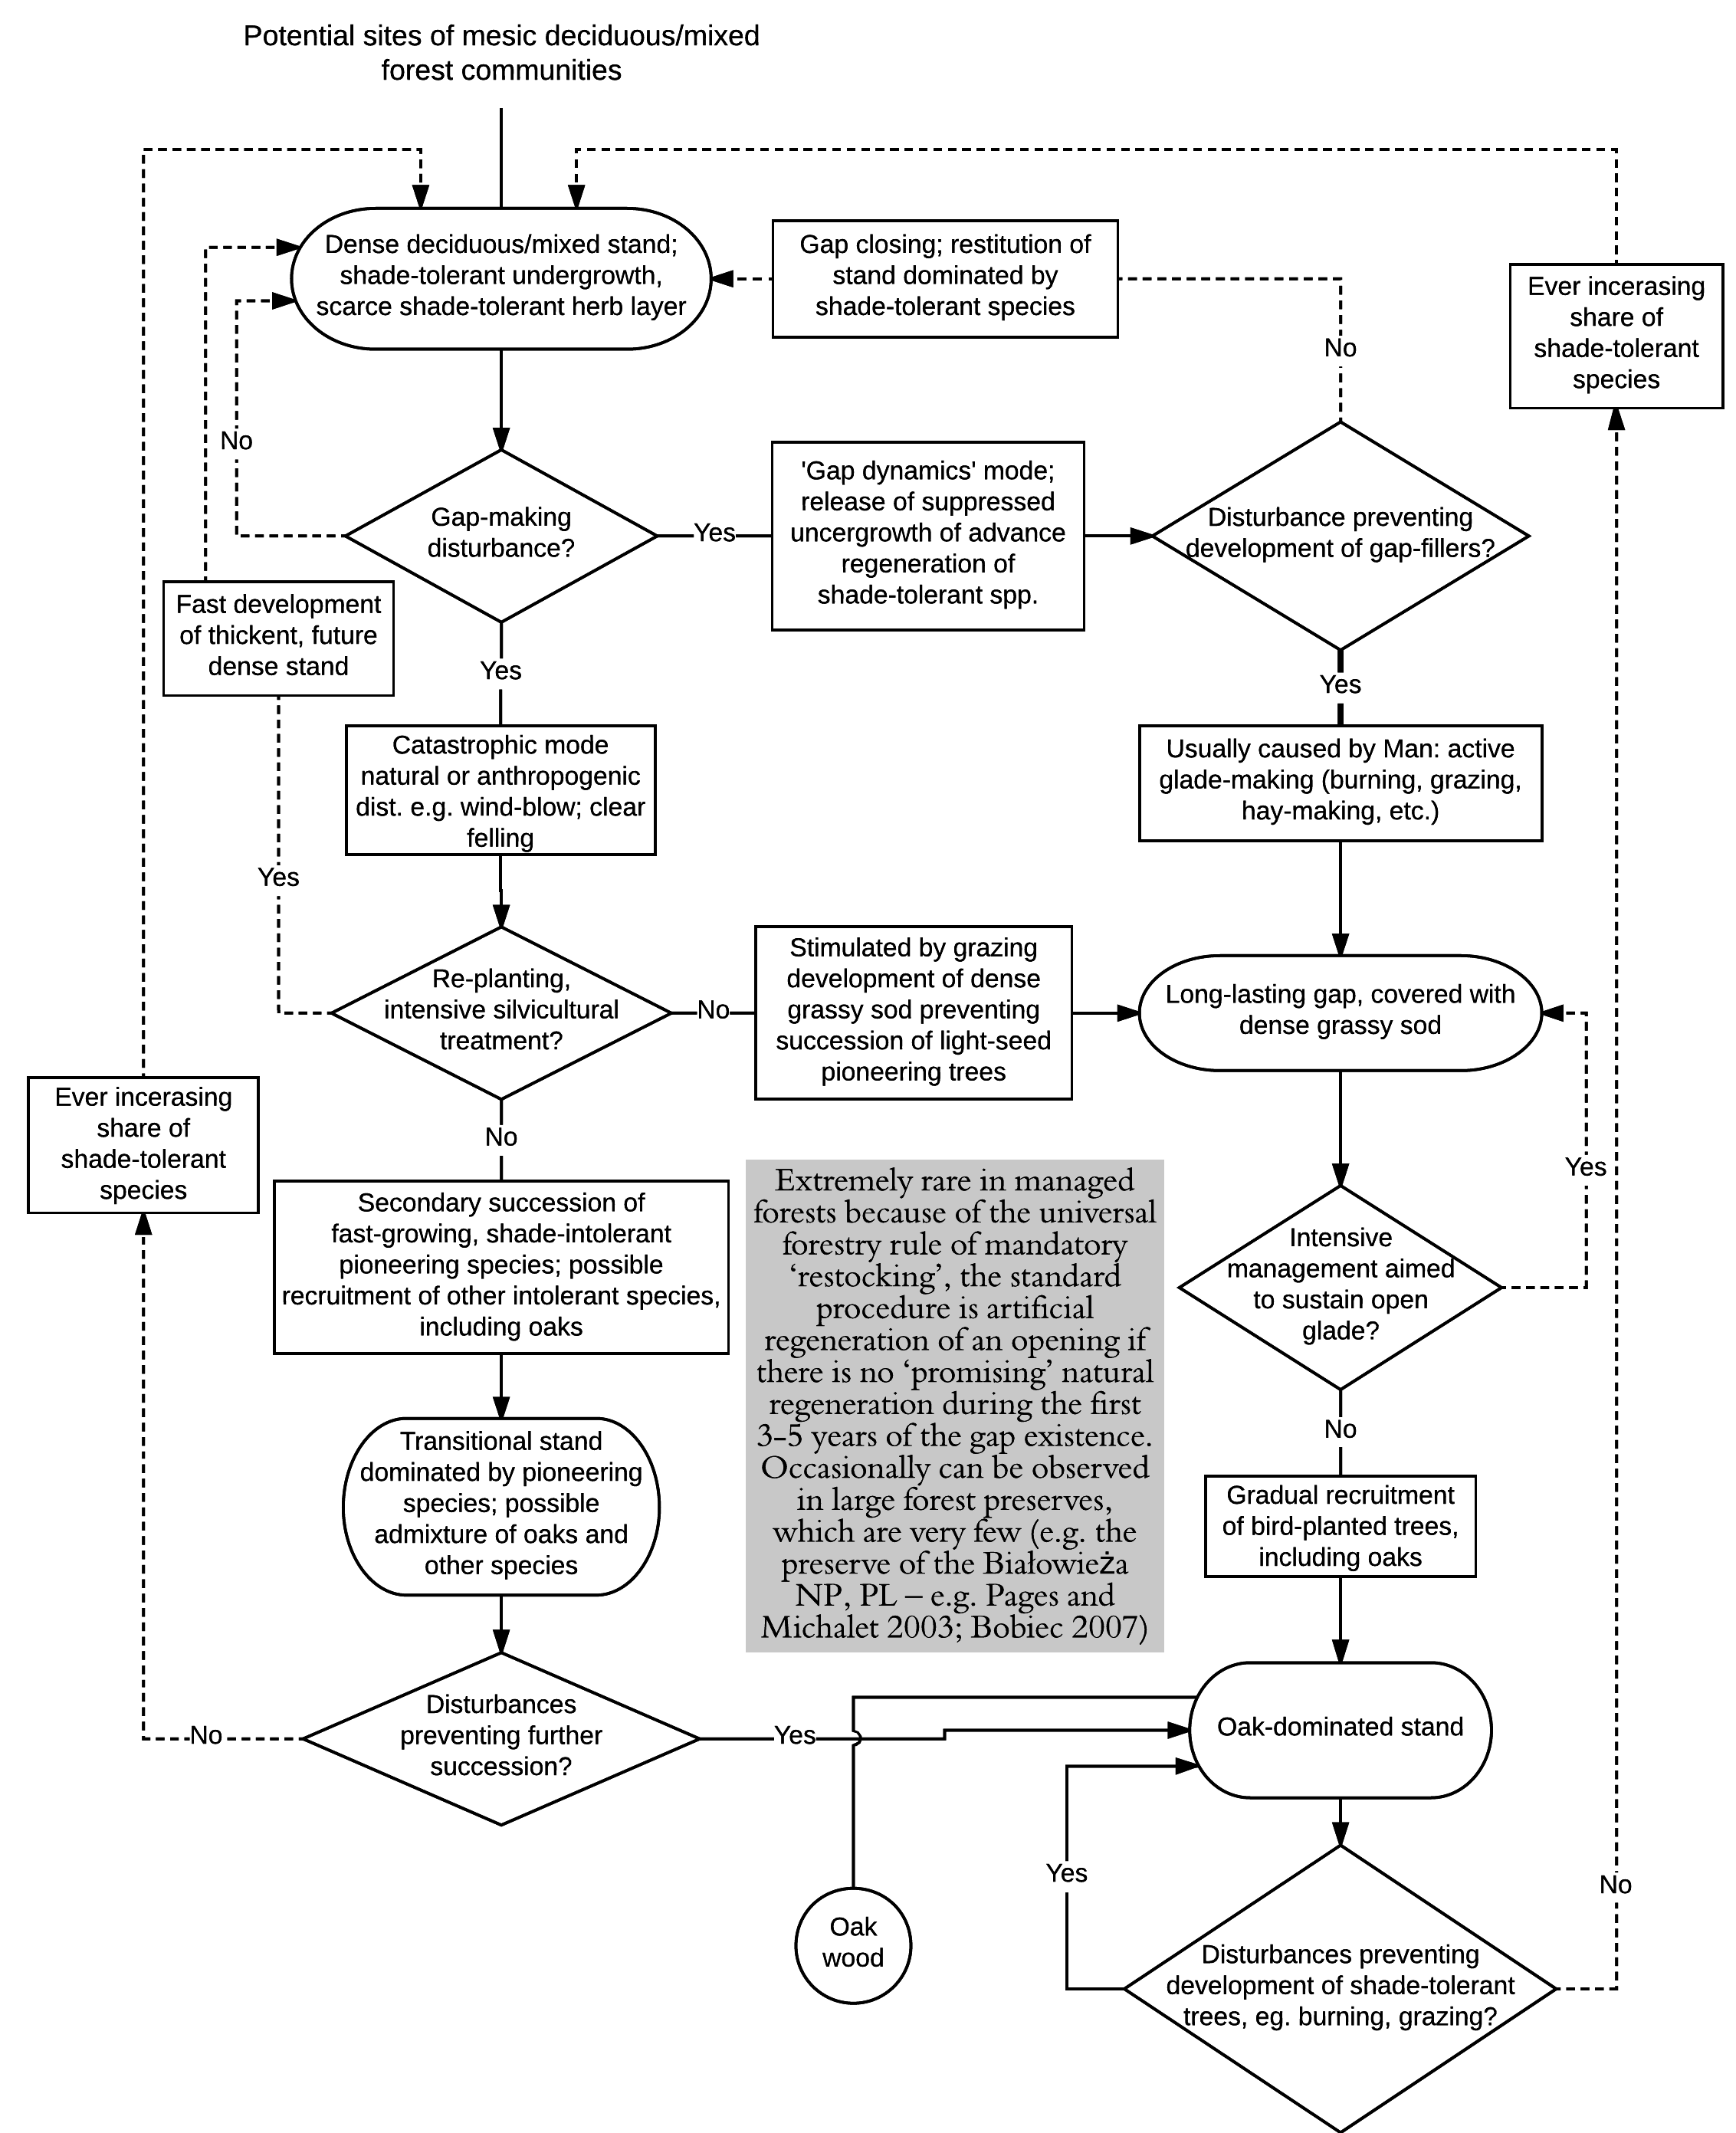
Fig. 2. Processes and factors influencing oak stands establishment extra-zonal habitats; see Fig. 1 for symbolization.
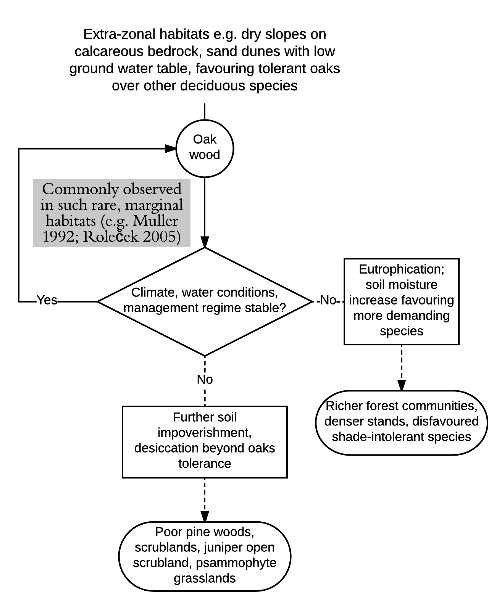
Fig. 3. Processes and factors influencing oak stands establishment in ecotonal zones between mesic deciduous/mix forests and agricultural land; see Fig. 1 for symbolization.
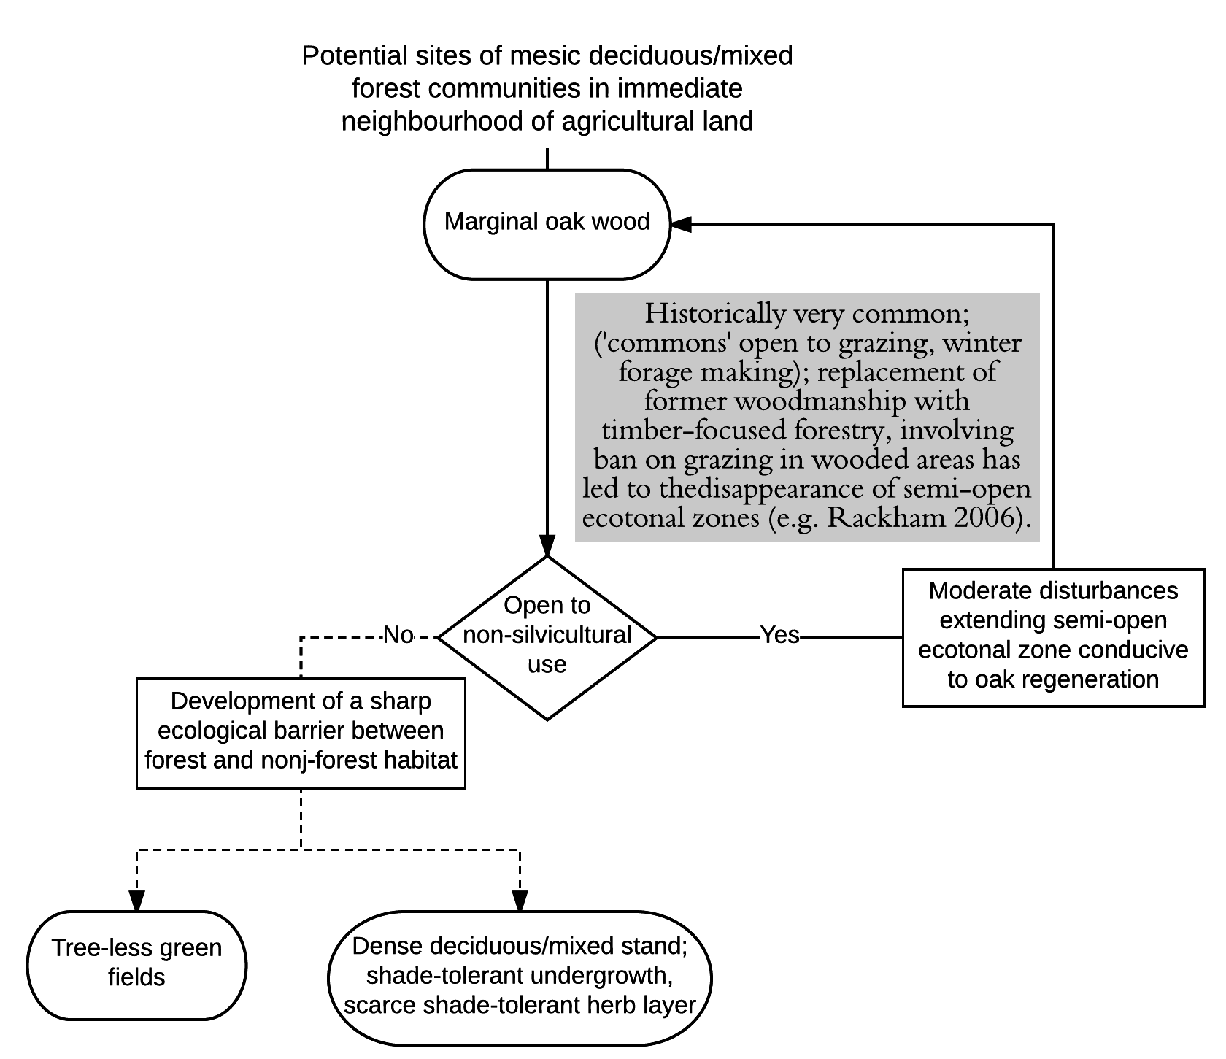
Fig. 4. Processes and factors influencing oak stands establishment in non-forest anthropogenic habitats; see Fig. 1 for symbolization.
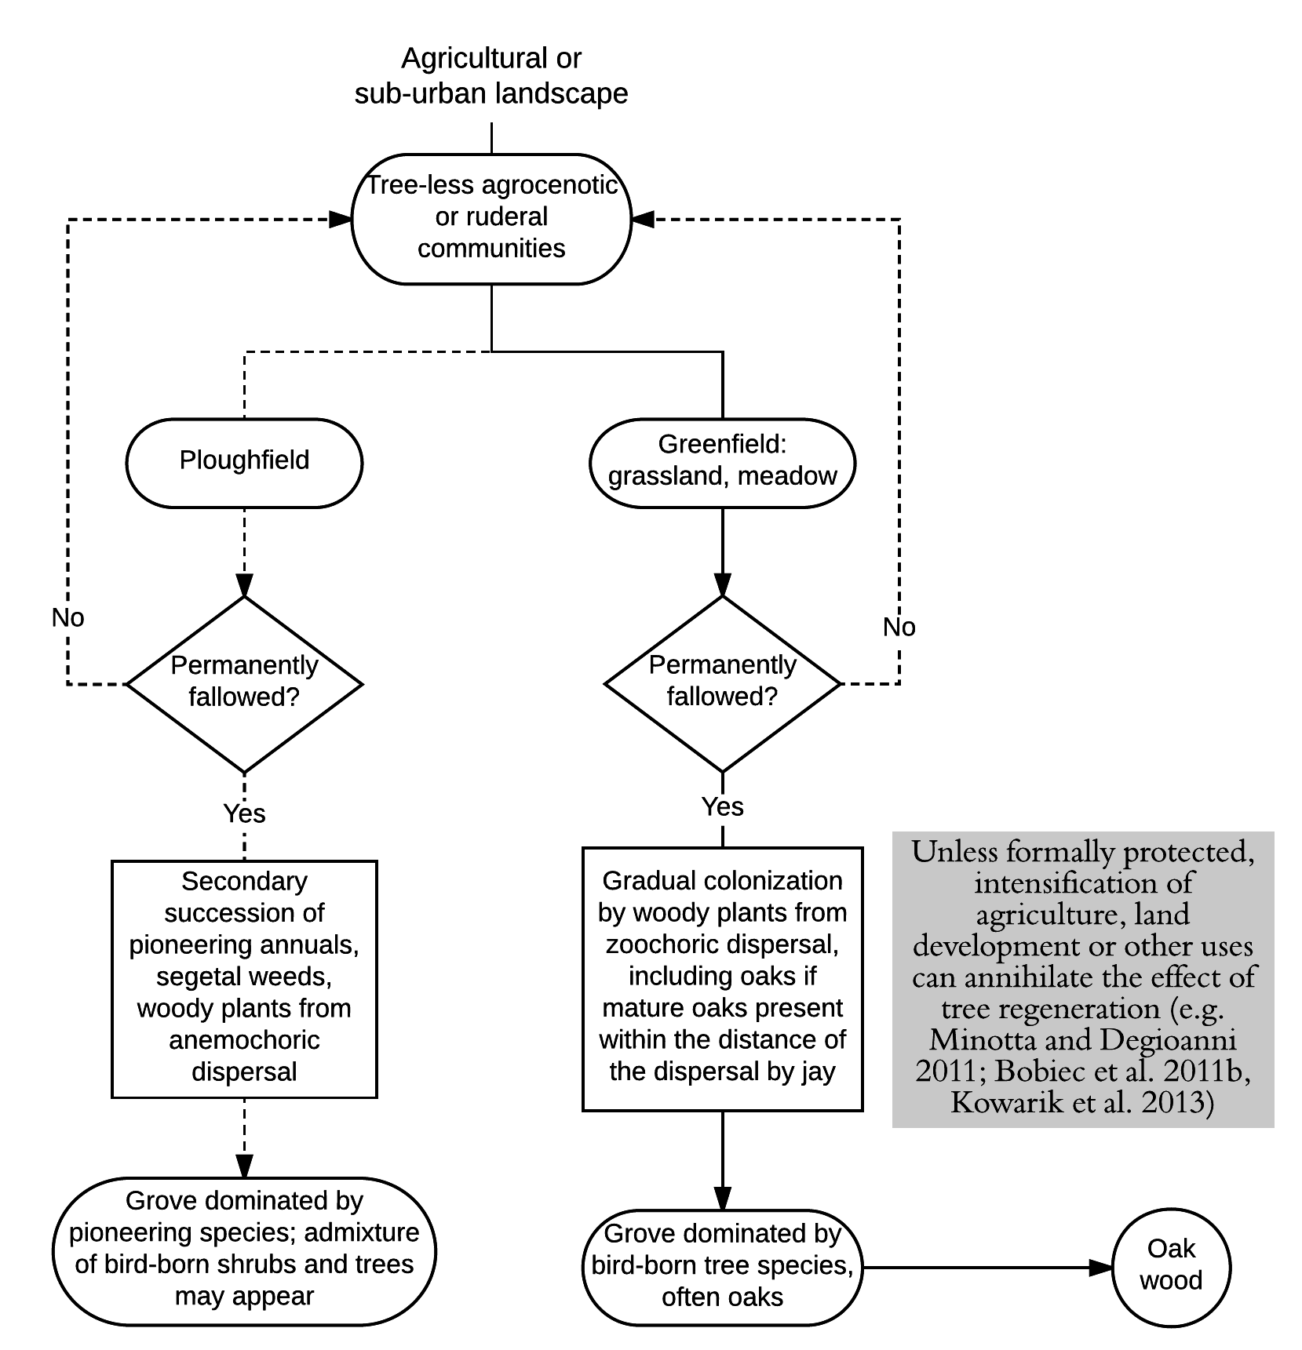
Fig. 5. Processes and factors influencing oak regeneration in wood-pasture systems; see Fig. 1 for symbolization.
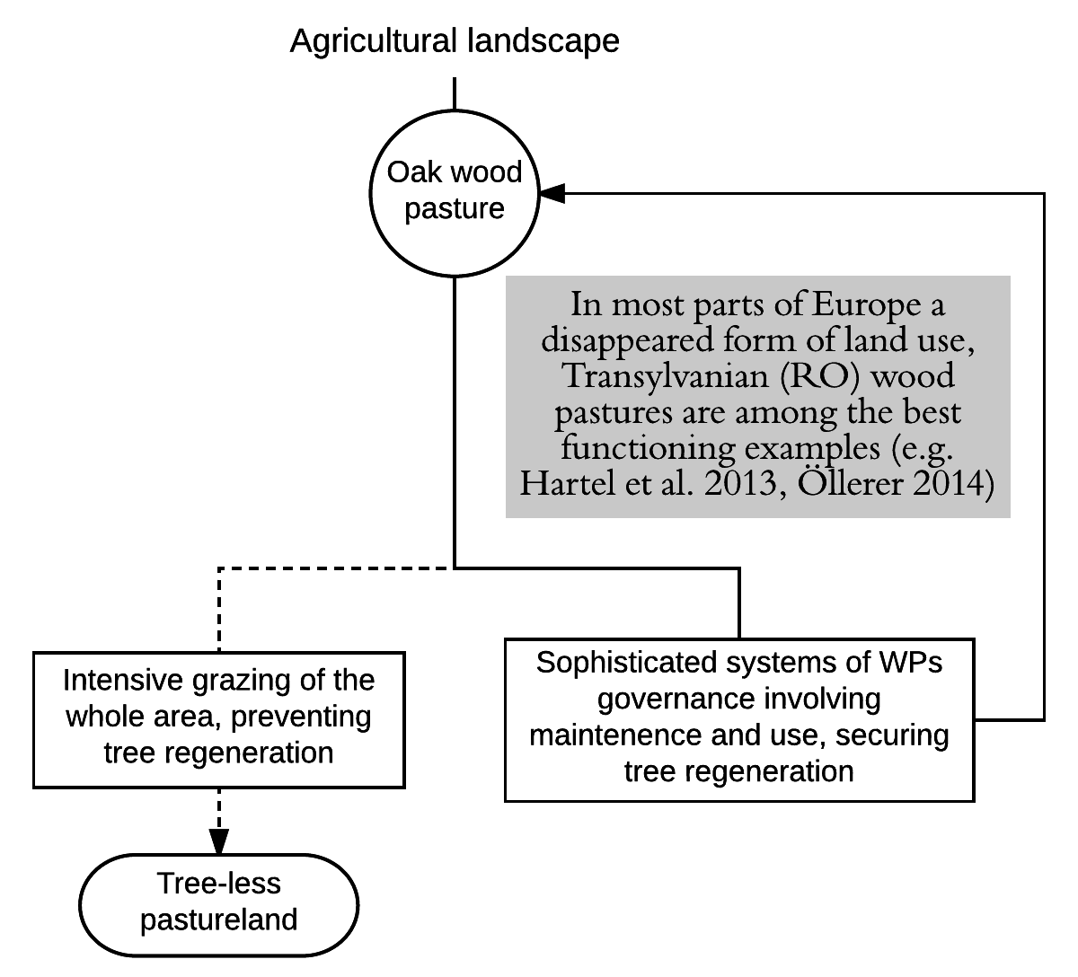
Fig. 6. Processes and factors influencing oak wood development from undergrowth in pine forests; see Fig. 1 for symbolization.