Appendix 1

Since the methodology we used for classifying habitats in the later periods (1990 and 2015 used the Land Cover Maps), was quite different from the previous time points, we performed validation to assess the accuracy and consistency of the time series across all periods. We used a number of spatial datasets, including Natural England’s Priority Habitats Inventory (PHI) (Natural England 2015), recent aerial photography (© ESRI World Imagery), OS 1:25,000 Colour Raster (Ordnance Survey 2017), as well as survey data from the 2000s. The PHI is a spatial dataset that describes the geographic extent and location of Natural Environment and Rural Communities Act (2006) Section 41 habitats of principal importance in England (Natural England 2015). Firstly, site locations were intersected with the PHI layer, to identify the priority habitat present, if any. Over 70% of sites had consistent habitat allocations across both the LCM2015 and PHI, as determined by matching the datasets using Table A1. For sites which didn’t match, we manually checked through individual sites using a mixture of aerial photography (© ESRI World Imagery) and the OS 1:25,000 Colour Raster. The OS 1:25,000 Colour Raster was particularly useful for checking ponds and rivers which were not detected by the LCM2015, whilst the aerial photography highlighted small areas of woodland often found on the edges of fields and were thus classified incorrectly as improved grassland or arable in the LCM2015. The remaining 250 sites which were not consistent across the two datasets, were assigned improved grassland by the LCM2015, however the LCM2015 is known to have some difficulty differentiating between improved grassland, calcareous grassland and neutral grassland (Rowland et al. 2017a). Where aerial photos could not be used to distinguish the habitat of these 250 sites, we used Natural England’s Designated Sites database (Natural England 2017) to reveal the broad habitat for these individual sites. Only 112 sites were not consistent across the LCM2015 and PHI, nor could they be identified using the OS maps, aerial photography or SSSI data. For these 112 sites we used the PHI habitat where the coverage was greater than 50%, whilst those with less than 50% remained as improved grassland.

We also utilised re-survey data for three habitat types; calcareous grassland, heathland and woodland, which were re-surveyed in 2009, 2010 and 2008, respectively, see Newton et al. (2012), Diaz et al., (2013), Keith et al. (2011, 2009) for further details. Over 90% of the 84 woodland re-survey sites matched the classification designated by the LCM2015. For the few sites where this was not the case, these were adjusted to reflect the woodland re-survey habitat, because these were physically visited in 2008, which is thus more reliable than the LCM. Over 76% of the 131 heathland sites were consistent with the classification assigned by the LCM2015. Similarly, for those which didn’t match the re-survey data, these were changed to reflect the heathland re-survey habitat. Note that not all heathland sites re-surveyed in 2010 remained as heathland (Diaz et al. 2013). Unless otherwise stated, for example “recent restoration/clearance of scrub” etc, the re-survey habitat was also presumed for 1990. For the calcareous grassland re-survey, only 30% of 83 sites were consistent with the LCM2015, however this was later explained by the fact that although sites were identified as calcareous grassland in 2009, many of the sites had reduced dramatically in size, to such a point where the main habitat was in actual fact the habitat classified by the LCM2015. This was checked using recent aerial photography (© ESRI World Imagery) and consequently these sites remained assigned to the habitat first identified using the LCM2015. Additionally, many of the calcareous grassland sites which were resurveyed in 2009, had seen an increase in more competitive species typical of mesotrophic grasslands due to eutrophication and management changes (Newton et al. 2012) and would therefore be classified as improved grassland in the LCM2015. Where sites were not consistent between the two datasets, but clearly only one main habitat existed, these sites were adjusted to reflect the calcareous grassland resurvey designation.

Table A1. Broad habitat type matching with the Land Cover Map 2015 and Natural England’s Priority Habitats Inventory.

Land Cover Map Habitat | Priority Habitats
Freshwater | Validated by OS maps
Arable and horticulture | NA
Fen, marsh and swamp | Lowland fens, Reedbeds, Coastal saltmarsh
Acid grassland | Lowland dry acid grassland
Calcareous grassland | Lowland calcareous grassland
Improved grassland | NA, Good quality semi-improved grassland
Neutral grassland | Lowland meadows
Dwarf Shrub Heath | Lowland heathland
Inland rock | NA
Saltwater | Mudflats, coastal saltmarsh, NA
Littoral sediment | Coastal vegetated shingle, Coastal sand dunes, Maritime cliff and slope
Saltmarsh | Coastal saltmarsh, Reedbeds, Mudflats
Supra-littoral rock | Maritime cliff and slope
Supra-littoral sediment | Maritime cliff and slope
Urban | NA
Suburban | NA
Broadleaved, mixed and yew woodland | Deciduous woodland
Coniferous woodland | NA, Deciduous woodland (when mixed)

Appendix 2

The size variation for sites which remained and those that were lost in Dorset between 1930 and 2015 in each semi-natural habitat type can be seen in Fig A2. To determine if stand size influenced whether a site was likely to remain or not in Dorset between 1930 and 2015, we performed a Mann-Whitney U test for each of the six habitat types. We found significant differences in the area of sites which were lost versus those which remained for broadleaved woodland, calcareous grassland, fen, marsh and swamp and heathland (Table A2). The difference however was variable between habitat types. In broadleaved woodland and calcareous grassland sites, sites which were lost tended to be larger than those which remained, whereas for fen, marsh and swamp and heathland it was the smaller sites which were lost.
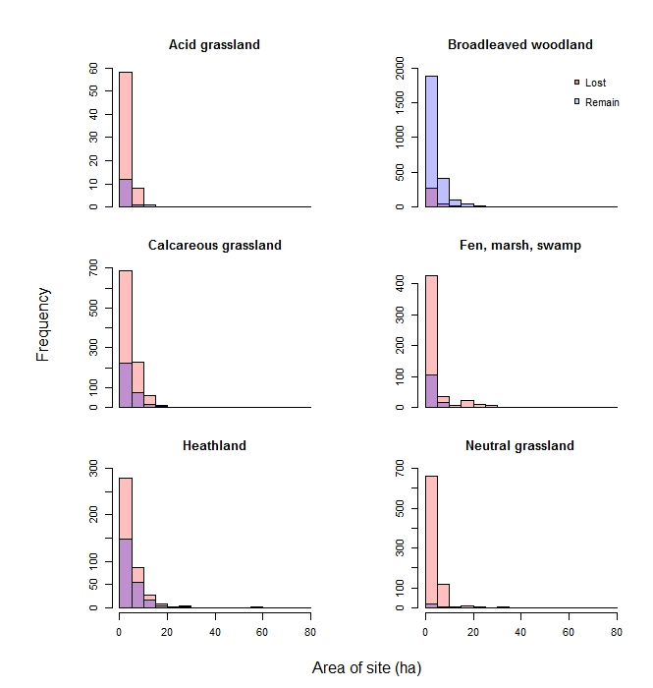
Fig A2. Histograms of site size for remaining and lost sites for each semi-natural habitat type (acid grassland, broadleaved woodland, calcareous grassland, fen, marsh and swamp, heathland, neutral grassland) in Dorset between 1930 and 2015.

Table A2. Mean ± S.E. area for sites which have remained and were lost in Dorset between 1930 and 2015, with Mann-Whitney U test results for acid grassland, broadleaved woodland, calcareous grassland, fen, marsh and swamp, heathland and neutral grassland.

 | Remain | Lost | W | p
Acid grassland | 8.64 ± 4.14 | 2.48 ± 0.24 | 108 | 0.434
Broadleaved woodland | 3.65 ± 0.10 | 4.83 ± 0.40 | 120149 | 0.027
Calcareous grassland | 4.53 ± 0.31 | 5.53 ± 0.25 | 45696 | 0.017
Fen, marsh, swamp | 2.99 ± 0.41 | 2.02 ± 0.16 | 6013 | 0.020
Heathland | 7.26 ± 0.74 | 5.41 ± 0.39 | 10222 | 0.010
Neutral grassland | 2.45 ± 0.72 | 2.96 ± 0.11 | 2363 | 0.260

