Appendices

Appendix 1.
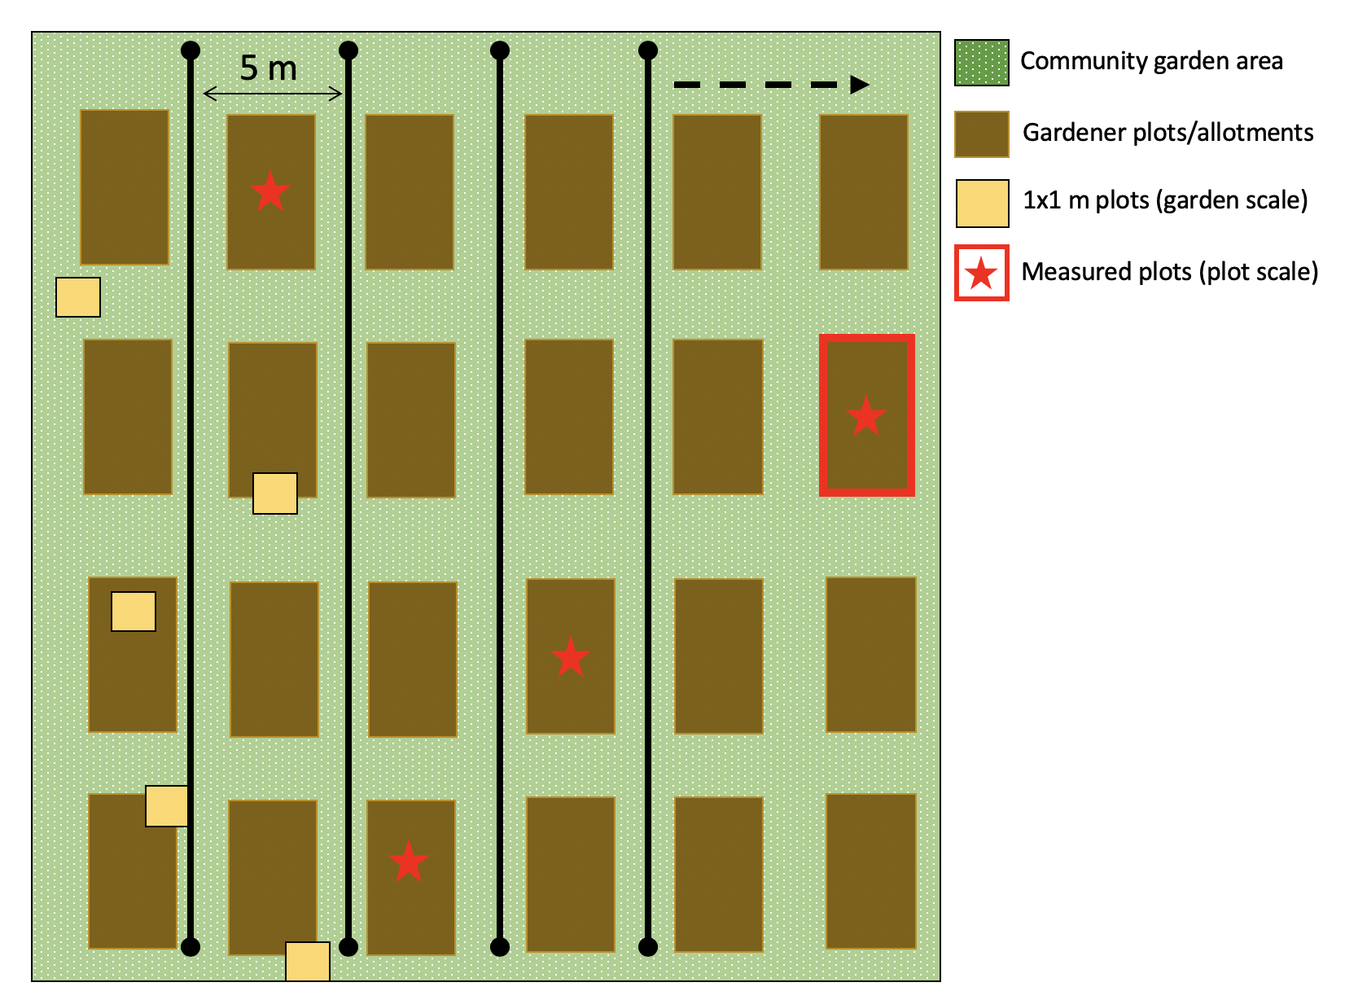
Appendix Figure 1. Visualization of field sampling design. We placed transects every 5 m across the width of the garden, along which we randomly placed 1 x 1 m quadrats to sample plant species richness, vegetation ground cover, and vegetation height. Gardens had varied numbers of transects due to differences in garden size and we proportionally increased the number of 1 × 1 m quadrats relative to garden size. All gardens had a minimum of eight 1 × 1 m quadrats, and we added one 1 × 1 m quadrat for every additional 500 m² (resulting a minimum of eight quadrats, up to 19 quadrats in the largest garden). We divided the number of quadrats by the number of transects in order to determine how many quadrats to sample along each transect (minimum of two, up to five quadrats per transect). Within each 1 x 1 m quadrat, we recorded the species identity of all plants present, took the height of the tallest non-woody vegetation (cm), and estimated the percent of herbaceous vegetation ground cover including crop plants, weed plants and grass (i.e., versus bare soil, mulch, rock). At the plot scale, we similarly sampled the species identity of plants present, took the height of the tallest non-woody vegetation, estimated the percent of herbaceous vegetation cover in the entire plot, and measured the size of each gardener’s plot (m²).
Appendix 2. Summarized information on the UAV specifications, the flight parameters for the data collection, and aerial imagery processing parameters.
UAV specifications | UAV model | DJI Mavic Pro
UAV specifications | Satellite Positioning Systems | GPS + GLONASS
UAV specifications | Sensor | 1/2.3” (CMOS)
UAV specifications | Bands | 3 (RGB)
UAV specifications | Pixel | 12.35 M
UAV specifications | Lens | FOV 78.8° 26 mm, f/2.2
UAV specifications | Shutter speed | 8s -1/8000 s
UAV specifications | Image Size | 4000 x 3000
UAV specifications | Camera Settings | Manual depending on ambient light
Flight parameters | Planning Software | DJI Ground Station Pro V2.x
Flight parameters | Mission Type | Photo Map
Flight parameters | Maximum speed | 7 M/S
Flight parameters | Maximum altitude | 120 M
Flight parameters | Flight altitude | 70 M
Flight parameters | Shooting angle | Parallel to main path
Flight parameters | Capture Mode | Capture at equal distance interval
Flight parameters | Shutter Interval | 1 Sec
Flight parameters | Resolution | 2.5 CM/PX
Flight parameters | Front Overlap Ratio | 85%
Flight parameters | Side Overlap Ratio | 75%
Flight parameters | Course Angle | 0°
Processing parameters | Image processing Software | Agisoft Photoscan Pro 1.4.4
Processing parameters | Pointcloud processing Software | lidR (based on LAStools)
Processing parameters | Coordinate system | EPSG 4326, WGS 84
Processing parameters | Image coordinates accuracy | 0.1 PX
Processing parameters | Tie point accuracy | 1 PX
Processing parameters | Rotation angles | Yaw, Pitch, Roll
Processing parameters | Focal length | 8.8 mm
Processing parameters | Photo alignment accuracy | High
Processing parameters | Key point limit | 40,000
Processing parameters | Tie point limit | 4,000
Processing parameters | Adaptive camera model fitting | Yes
Processing parameters | Alignment optimization fitting | f, k1, k2, k3, k4, b1, b2, p1, p2, p3, p4
Processing parameters | Dense point cloud processing quality | High
Processing parameters | Depth filtering | Mild
Processing parameters | Calculate point colors | Yes
Processing parameters | DEM projection | Geographic
Processing parameters | DEM source data | Dense cloud
Processing parameters | Interpolation | Enabled
Processing parameters | DEM resolution | 17 CM/PX
Processing parameters | Orthomosaic projection | Geographic
Processing parameters | Orthomosaic surface data | DEM
Processing parameters | Blending mode | Mosaic
Processing parameters | Orthomosaic resolution | 4.5 CM/PX
Processing parameters | CHM processing functions (lidR) | readLAS
Processing parameters | CHM processing functions (lidR) | lasground (method = 'pmf', ws = seq(3,12,3), th = seq(0.1, 0.4, length.out = length(ws))
Processing parameters | CHM processing functions (lidR) | lasnormalize (method = 'delaunay)
Processing parameters | CHM processing functions (lidR) | grid_canopy (res = 0.2, subcircle = 0.2)
Processing parameters | CHM resolution | 2.5 CM/PX

Appendix 3

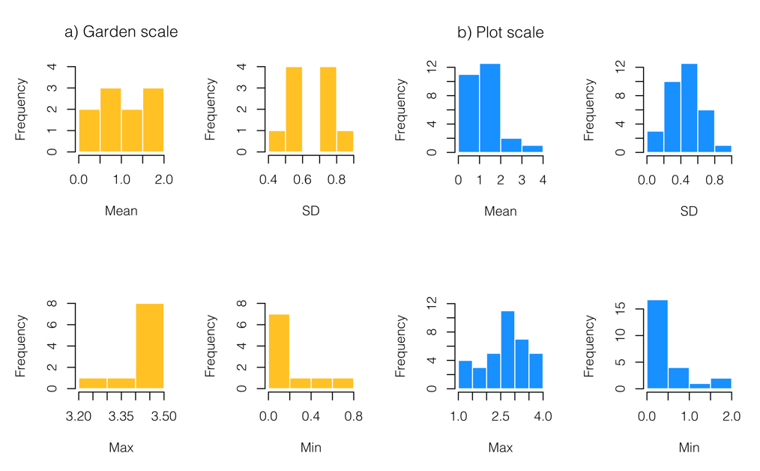
Appendix 3. Summary of CHM data (in meters) derived from UAV imagery. Histograms of the distribution of CHM summary statistics (mean, standard deviation (SD), maximum (max), and minimum (min)) across (a) garden sites and (b) garden plots.

