Supplementary Information for:

Variation in parasitoid attraction to herbivore-infested plants and alternative host plant cover mediate tritrophic interactions at the landscape scale

Yavanna Aartsma^{1,2,3}, Yueyi Hao², Marcel Dicke², Wopke van der Werf³, Erik H. Poelman², Felix J.J.A. Bianchi¹

¹Farming Systems Ecology, Wageningen University, P.O. Box 430, 6700 AK Wageningen, The Netherlands
²Laboratory of Entomology, Wageningen University, P.O. Box 16, 6700 AA, Wageningen, The Netherlands
³Centre for Crop Systems Analysis, Wageningen University, P.O. Box 430, 6700 AK Wageningen, The Netherlands
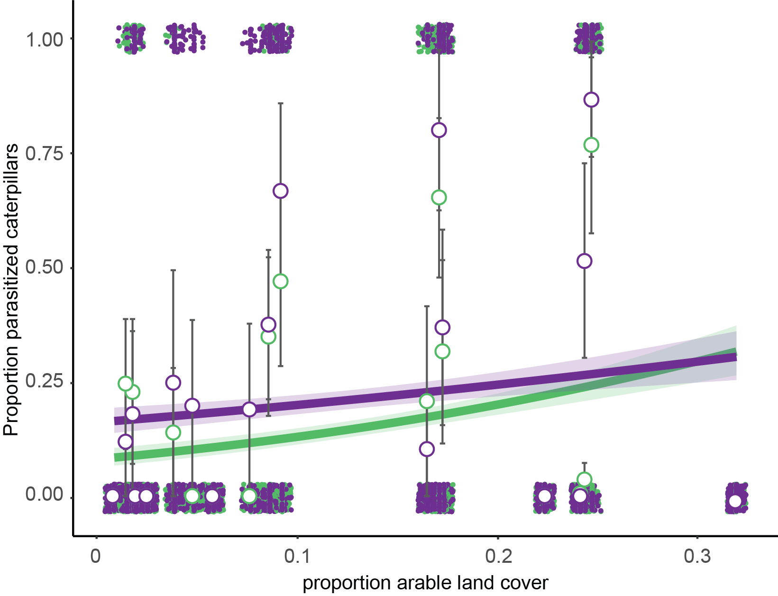
Figure S1: Parasitism rates on different white cabbage accessions Badger Shipper (BS; green) and Christmas Drumhead (CD; purple) and in landscapes varying in area of arable land in a 1000 m radius circle surrounding the patches, the most important variable selected in the structural land use model. Open circle markers show averages across five temporal replicates and error bars reflect SEM. Binary responses of individual larvae are presented as a jitter plots at 0 (no parasitism) and 1 (parasitism).

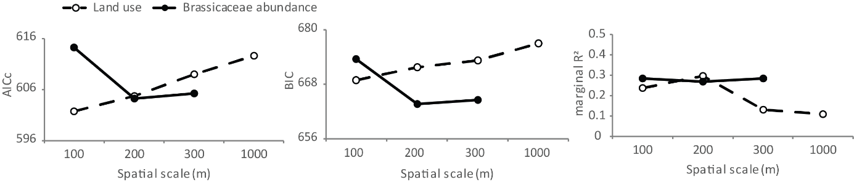
Figure S2: Corrected Akaike information criterion (AICc) values, Bayesian information criterion (BIC) values and marginal R² for most parsimoneous models predicting parasitism rates of Pieris brassicae caterpillars using cabbage accession and general landscape variables (area of arable land, forest, seminatural land and length of hedgerows; open circles and dashed line) or including double square root transformed Brassicaceae cover and landscape variables (closed circles and line), at different spatial scales (100 m, 200 m, 300 m and 1000 m). Models <2 ΔAICc or ΔBIC of the most parsimoneous model have considerable support from the data, models >4 ΔAICc or ΔBIC have less support from the data.

