Electronic Supplementary Material

Landscape Ecology

Political borders impact associations between habitat suitability predictions and resource availability

Matthias Tschumi^{1*}, Patrick Scherler^{1,2}, Julien Fattebert^{1,3}, Beat Naef-Daenzer¹, Martin U. Grüebler¹

Affiliation of authors:
¹Swiss Ornithological Institute, Seerose 1, CH-6204 Sempach, Switzerland
²Institute of Evolutionary Biology and Environmental Studies, University of Zurich, Winterthurerstrasse 190, CH-8057 Zurich, Switzerland
³School of Life Sciences, University of KwaZulu-Natal, Durban 4000, South Africa

*Corresponding author:
Matthias Tschumi
Swiss Ornithological Institute
Seerose 1
CH-6204 Sempach, Switzerland
Phone: +41 41 462 99 24
E-mail: matthias.tschumi@vogelwarte.ch
ORCID: 0000-0002-7991-7780
Table S1. Descriptive statistics of land-cover types recorded in the 1 ha study plots. Shown are arithmetic means (Mean), standard errors (SE), minima (Min) and maxima (Max) of the percentage land cover of the individual land-cover types.

Land-cover type | Mean | SE | Min | Max
Recently sown | 1.7 | 0.4 | 0 | 72
Oilseed rape | 1.1 | 0.2 | 0 | 45
Maize | 4.1 | 0.5 | 0 | 75
Winter cereals | 7.4 | 0.7 | 0 | 90
Spring cereals | 1.5 | 0.3 | 0 | 60
Potatoes | 0.7 | 0.2 | 0 | 70
Sugar beet | 0.9 | 0.3 | 0 | 70
Vegetables | 1.4 | 0.3 | 0 | 70
Ley | 4.5 | 0.6 | 0 | 97
Permanent grassland | 70.4 | 1.2 | 2 | 100

Table S2. Grouping of trees into size classes used for investigating cavity and tree number patterns across tree size classes.

Class name | dbh range [cm]
05 | 0 ≤ dbh < 10
15 | 10 ≤ dbh < 20
25 | 20 ≤ dbh < 30
35 | 30 ≤ dbh < 40
45 | 40 ≤ dbh < 50
55 | 50 ≤ dbh < 60
65 | 60 ≤ dbh < 70
75 | 70 ≤ dbh < 80
85 | 80 ≤ dbh < 90
95 | 90 ≤ dbh < 100
105 | 100 ≤ dbh < 110
115 | 110 ≤ dbh < 120

Table S3. Model summary of the probability of tree cavity occurrence in plots in south-western Germany and Switzerland (country) and in relation to standardized diameter above breast height (bhd) of the trees. Shown are parameter estimates and 95% CrI. Effects with CrI not overlapping zero are printed in bold
 | Estimate | 95% CrI
Probability of cavity occurrence
country | 0.852 | 0.415 to 1.302
bhd | 2.011 | 1.510 to 2.541
bhd^2 | -0.428 | -0.595 to -0.263
country x bhd | 0.200 | -0.364 to 0.746
country x bhd^2 | -0.215 | -0.419 to -0.006

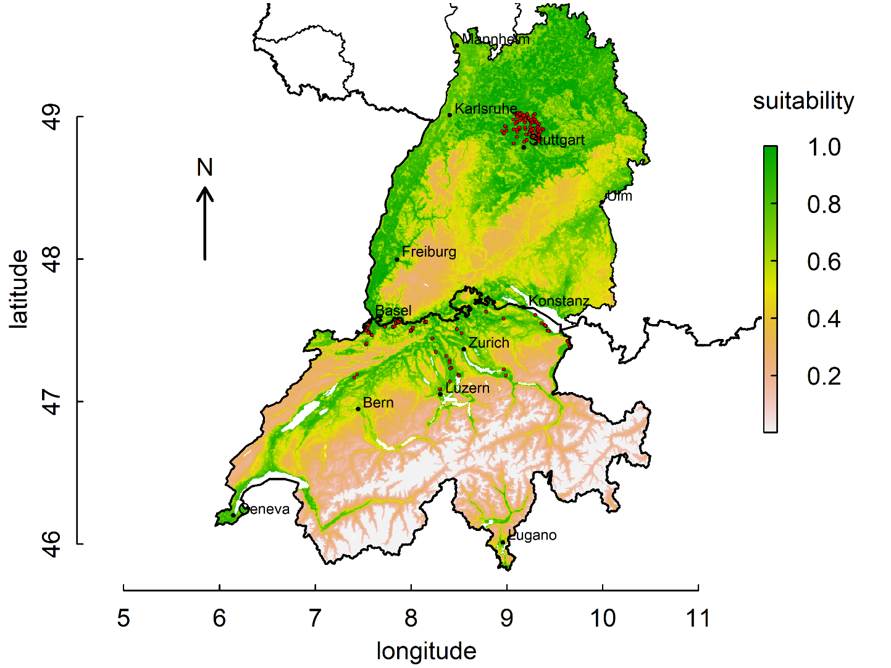
Fig. S1 Map depicting Baden-Württemberg (Germany) in the north and Switzerland in the south separated by the Swiss-German border (thick black line), overlaid by the multi-level habitat suitability model values of Fattebert et al. (2018) and the study plots (red filled circles).
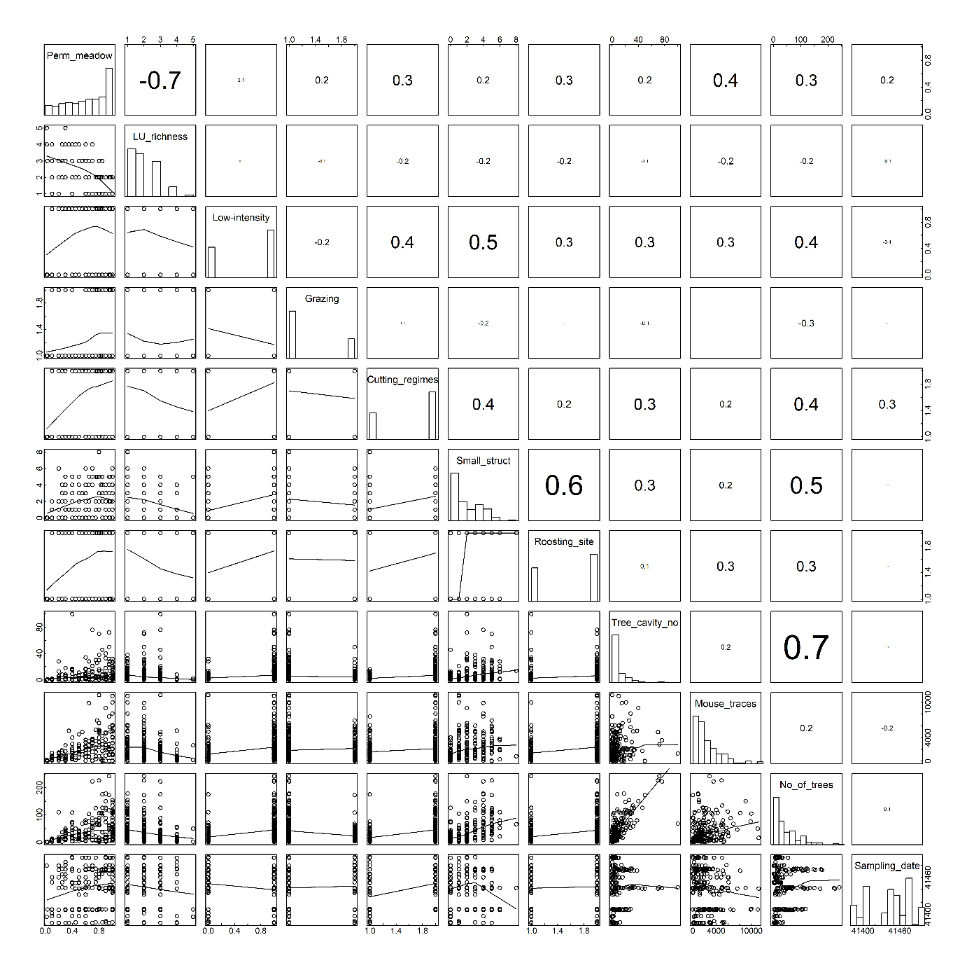
Fig. S2 Pairplot of all investigate habitat parameters and covariates. The upper panel shows pair-wise correlations with font size corresponding to correlation coefficients, the diagonal panel shows histograms and the lower panel scatterplots with a LOESS smoother (Zuur et al., 2009)

References
Zuur, A.F., Ieno, E.N., Walker, N.J., Saveliev, A.A., Smith, G.M., 2009. Mixed Effects Models and Extensions in Ecology with R, Statistics for Biology and Health. Springer Science+Business Media LLC, New York. doi:10.1007/978-0-387-87458-6_1

