Figure S1. The biplot of δ¹⁵N (‰) and δ¹³C (‰) stable isotopes for the different sources used in a mixing model to assess the origin of the sedimentary C_{org} content in seagrass sediments. As the isotopic signals from mangrove leaves and terrestrial plants were overlapping, these two sources were combined when analyzing the contribution of C_{org} sources in the mixing model.

²¹⁰Pb analysis for sediment dating
Total ²¹⁰Pb was determined in the <125 m sediment fraction through the analysis of its granddaughter ²¹⁰Po by alpha spectrometry after complete sample digestion in a HNO₃:HF mixture (9:3 ml) using an analytical microwave. A known amount of ²⁰⁹Po was added as a tracer (Sanchez-Cabeza et al., 1998). The specific activities of excess ²¹⁰Pb, i.e. fractions used to obtain age models and accumulation rates, were determined as the difference between total ²¹⁰Pb and ²²⁶Ra (supported ²¹⁰Pb). Specific activities of ²²⁶Ra were determined for selected samples within each core by gamma spectrometry through the measurement of ²²⁶Ra decay product emission lines of ²¹⁴Pb at 295 and 352 keV and using calibrated geometries in a HPGe detector (CANBERRA, Mod. SAGe Well).

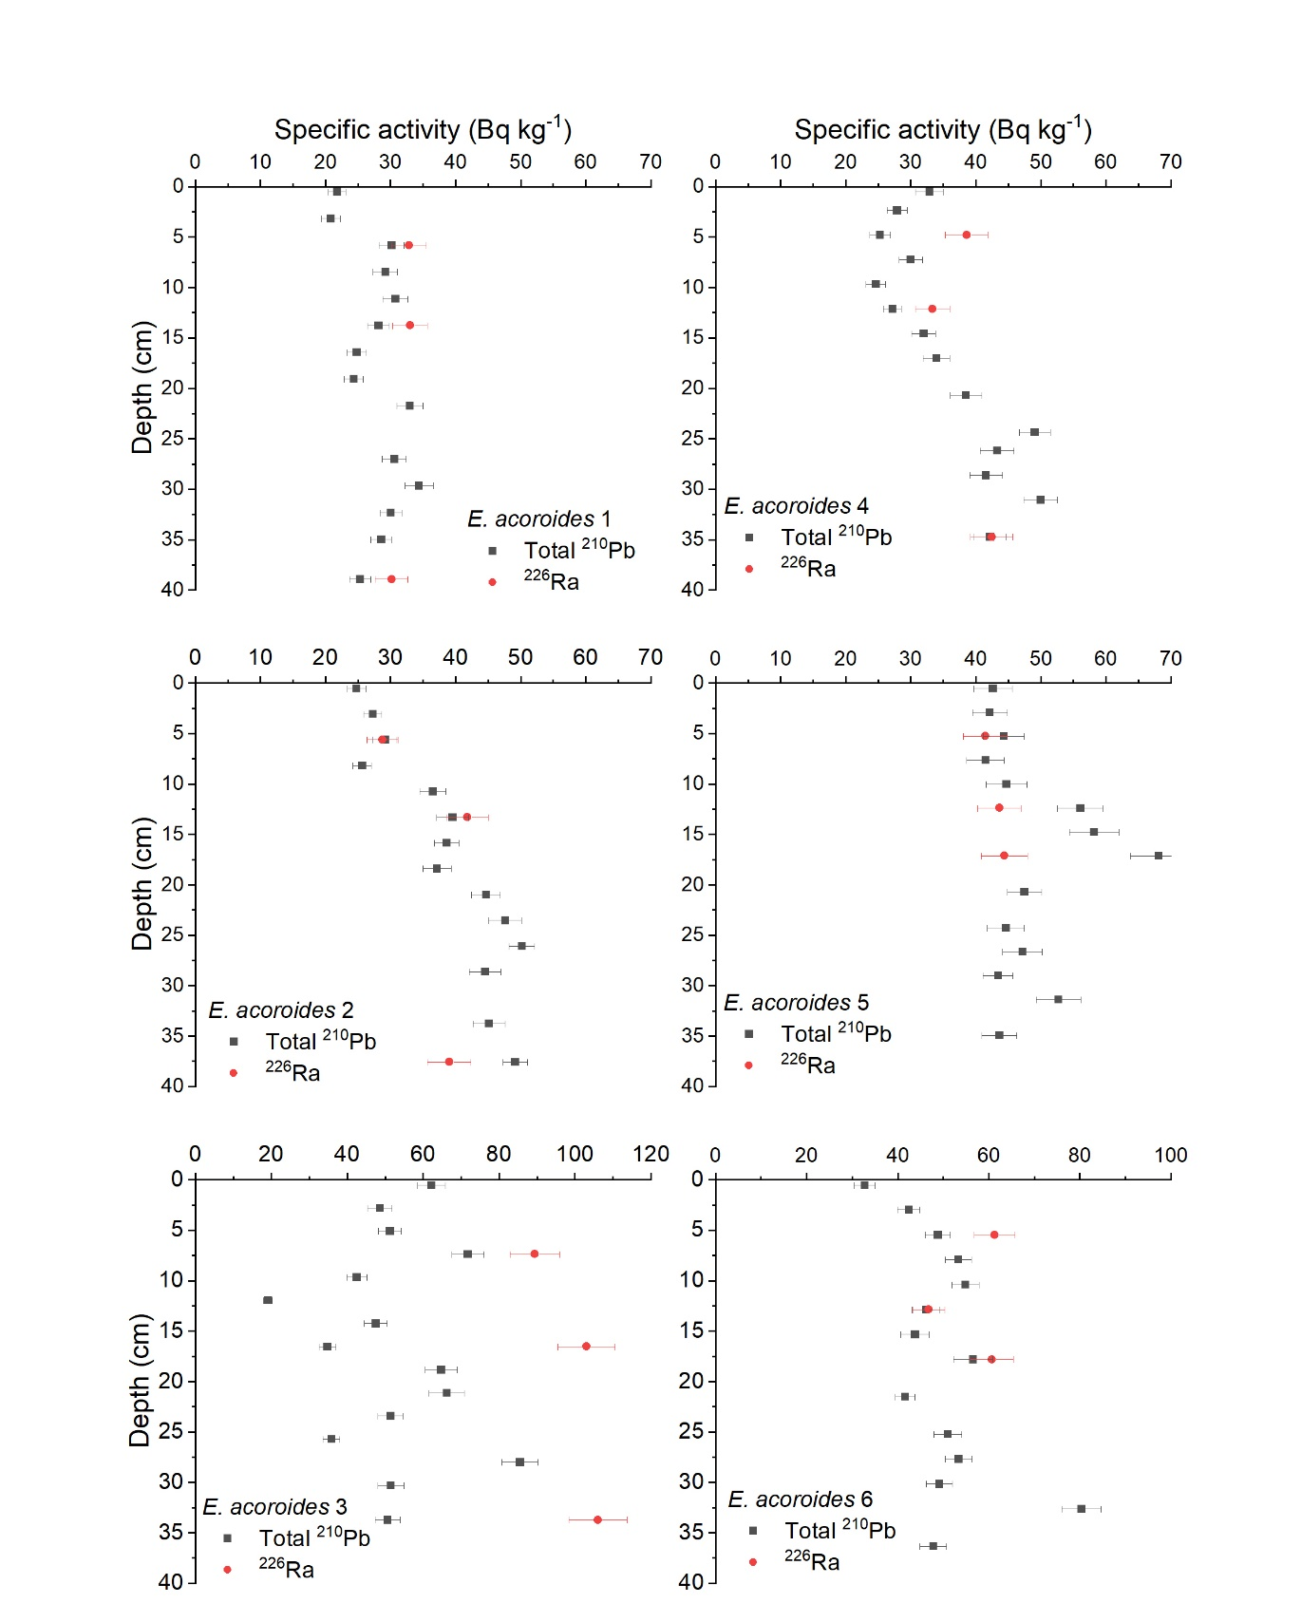

Figure S2. Total ²¹⁰Pb and ²²⁶Ra specific activities with depth in Enhalus acoroides long sediment cores collected in Tsimipaika Bay, Madagascar. Error bars are 1 sigma measurement error. All samples were sieved to the <125 m sediment fraction before alpha- and gamma spectrometry was conducted.

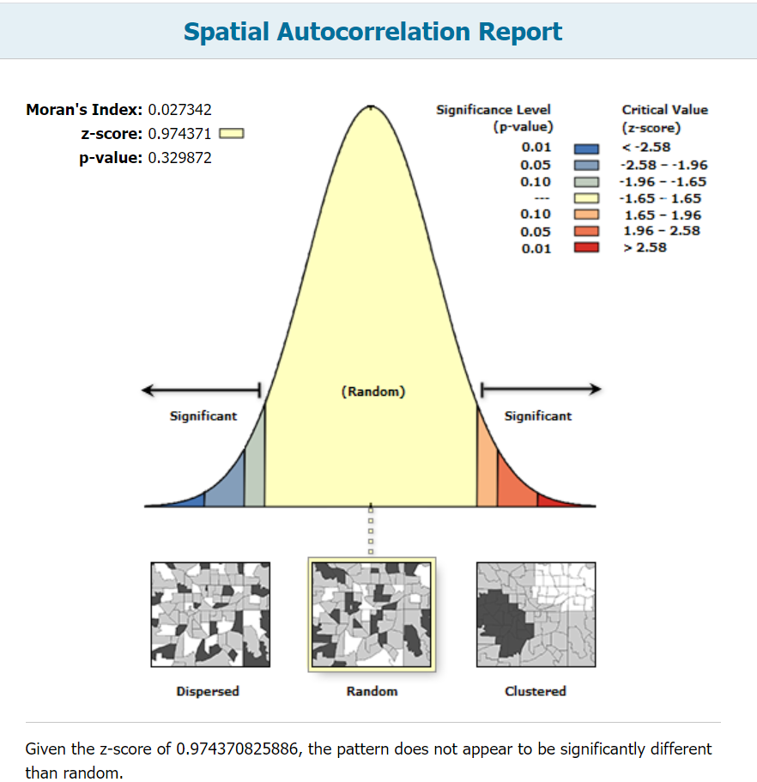
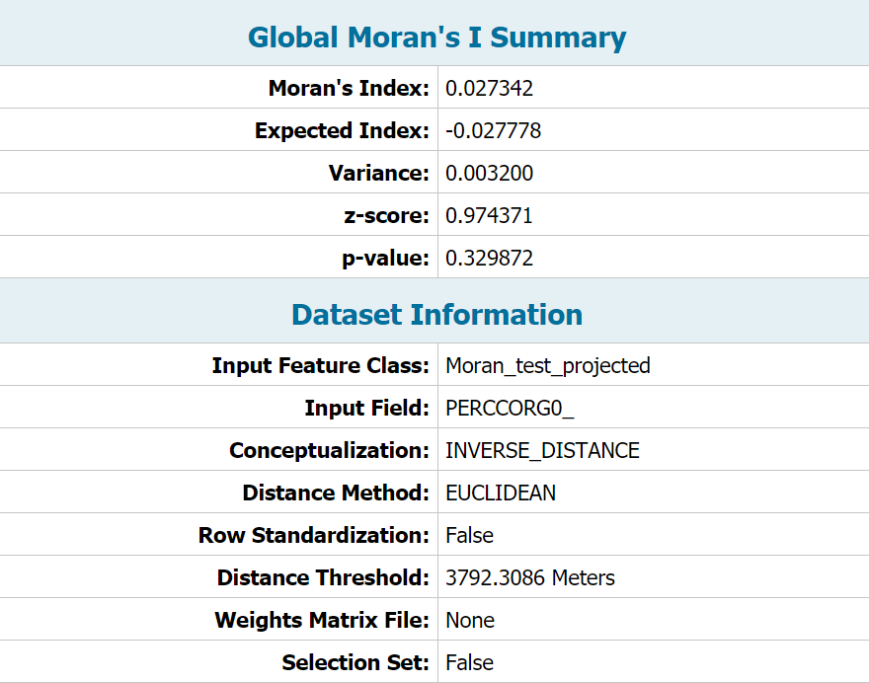
Figure S3. Spatial autocorrelation test (Morans I) of the % C_{org} (0-25 cm) data from the 36 sites (polygons where the short cores were sampled) using ArcGIS (v10.7).

References:
Sanchez-Cabeza JA, Masqué P, Ani-Ragolta I (1998) ²¹⁰Pb and ²¹⁰Po analysis in sediments and soils by microwave acid digestion. J Radioanal Nucl Chem 227:19–22

