Supplementary Material for

A new European land systems representation accounting for landscape characteristics

Yue Dou ^{1*}, Francesca Cosentino ², Ziga Malek ¹, Luigi Maiorano ², Wilfried Thuiller ³, Peter H. Verburg ^{1, 4}

1, Environmental Geography Group, Institute for Environmental Studies (IVM), Vrije Universiteit Amsterdam, De Boelelaan 1087, 1081 HV Amsterdam, the Netherlands
2, Department of Biology and Biotechnologies “Charles Darwin”, University of Rome “La Sapienza”, Rome, Italy
3, Laboratoire d’Ecologie Alpine, LECA, Université Grenoble Alpes, CNRS, Université Savoie Mont Blanc, Grenoble, France
4, Swiss Federal Institute for Forest, Snow and Landscape Research (WSL), Birmensdorf, Switzerland

Corresponding author:
Yue Dou: yue.dou@vu.nl, +31 61 31 90 255

Detailed methods description-land use intensity 4
Human settlement system 4
Forest system 4
Grassland system 4
Cropland system 5
Annual cropland 5
Permanent cropland 5
Mosaic systems 6
Forest fragmentation 6
Selection of species 6
Group A: species vulnerable to forest management 6
Group B: species vulnerable to agricultural land-use intensity 7
Group C: generalist species 7
Maxent parameter setting 7
Table S1 Maxent parameter setting 7
Detailed land system description 8
Settlement systems 8
Forest systems 8
Grassland systems 8
Cropland systems 9
Mosaic systems 9
Snow, water, and wetland 10
Shrubs and bare 10
Forest fragmentation and maxent results 10
Table S2 Forest fragmentation and intensity 10
Figure S1 Model predictive ability (AUC score) of selected bird species using Maxent models calibrated with different environmental variables 11
Figure S2 Variable contribution from land cover/use maps to species distribution in Maxent models calibrated with climate variables and land cover/use maps 12
Table S3 Overview of land systems 12
Table S4 Statistics for land systems 15
Figure S3 Overview of land system classification 18
Table S5 Details of indicators used for classification 19
Table S6 Selection of bioclimatic variables 23
Figure S4 Workflow of human settlement system 23
Figure S5 Workflow of forest system 24
Figure S6 workflow of grassland system 25
Figure S7 workflow of cropland system (annual crops, EU-region) 25
Figure S8 workflow of cropland system (permanent crops) 26
Figure S9 workflow of agricultural mosaics 26
Figure S10 Sensitivity analysis of cropland percentage when aggregated to 1km pixel 27
Figure S11 Sensitivity analysis of forest percentage when aggregated to 1km pixel 28

Detailed methods description-land use intensity
We used a range of metrics to measure land use intensity (A complete list please see Table-S1). Detailed intensity classification of each system is discussed below.

Human settlement system
The influence of human settlements reaches far out of its boundary through flows of people, energy, matter, as well as climate and biodiversity(Y. Chen, Li, Liu, Zhang, & Huang, 2019; Seto, Reenberg, et al., 2012; van Vliet, 2019). Urbanization in Europe undergoes multiple dimensional changes in land cover, land use, and socio-ecological activities (Shaw, Vliet, & Verburg, 2020), and most recent changes are small incremental increases (van Vliet et al., 2019). In comparison to current practices that use “built-up” land or a binary classification of urban and rural area (Seto, Güneralp, & Hutyra, 2012), we classified three intensity levels for settlement systems: urban core (high intensity), peri-urban (medium intensity), and rural areas (low intensity). We used the intensity of imperviousness (i.e., each cell has a value from 0-100%), namely artificial impermeable cover of soil, as a proxy of urbanization degree, based on similar mapping attempts(Demuzere, Bechtel, Middel, & Mills, 2019; Linard, Gilbert, Snow, Noor, & Tatem, 2012; van Asselen & Verburg, 2012). In addition, we considered the adjacency to urban core areas when distinguishing peri-urban and rural settlement (Linard et al., 2012; Stürck et al., 2018). If more than one urban core was detected within the 9×9 cell neighborhood of a non-urban core pixel, we classified it as peri-urban. The remaining built-up cells were classified as rural settlements (Figure S2). Urban areas have high imperviousness density (at least more than 25% imperviousness), representing the dense buildings and road networks in a city, while peri-urban is less dense and adjacent to urban cores and rural areas are far from urban cores.

Forest system
Forest management and forest types are sparsely included yet important to accurately assess biodiversity (Chaudhary et al., 2016; Erb et al., 2018). We used wood production of Europe (1km) (Verkerk et al., 2015) and the primary forest probability (1km) (Sabatini et al., 2018) to characterize the intensity of forest land use in the EU region. We used the threshold of 0.5 to distinguish high and low likelihood of being primary forest. In addition, the top 25% percentile of wood production were identified as high and the bottom 25% percentile as low wood production systems. Forest pixels with high likelihood of being primary forest and with low and medium wood production were classified as low-intensity forests (Figure S3). Other pixels with low likelihood of primary forests were classified as medium-intensity and high-intensity based on the wood production. For the non-EU region, we extracted the forest classes for this region from a global dataset (Schulze, Malek, & Verburg, 2019). The three classes (e.g., primary, naturally regrown, and planted) were resembled as low-intensity, medium-intensity, and high-intensity of our forest classification.

Grassland system
Three indicators were used to map the intensity of grazing grassland: livestock unit density, nitrogen input, and mowing frequency. We selected three animals (i.e., cattle, goat, and sheep) from the global dataset(Gilbert et al., 2018) and converted to LSU density (Eurostat, 2013), which is the number of animals converted to equivalent to one adult dairy cow producing 3000 kg of milk annually(lsu/km²). The distribution of other animals, such as pigs, buffalo, and poultry, was not put into consideration because these animals are either not grazed or the likelihood for them being grazed is low in Europe (Eitelberg, Van Vliet, & Verburg, 2017). The LSU density was reclassified into: (1) 0-50 lsu/km², (2) 50-100 lsu/km², and (3) >100 lsu/km² to match previous studies(Estel et al., 2018; Overmars et al., 2014; Temme & Verburg, 2011). The nitrogen was calculated using CAPRI dataset, which was estimated with mineral fertilizer input and the manure input deposited by grazing animals. The nitrogen input was then classified into three classes: (1) 0-50 kgN/ha, (2) 50-100 kgN/ha, and (3) >100 kgN/ha. Previous nitrogen estimation from grassland in Europe has only two classes because of lacking enough samples of the high nitrogen input for grassland(Overmars et al., 2014). However, we have found enough distribution in the third class therefore we kept three classes. The indicator of mowing frequency represents the average number of annual mowing events in the period of 2000-2012(Estel et al., 2018). We interpolated the data to cover all grazing grassland pixels, which are three classes: (1) annually one mowing event, (2) annually two mowing events, and (3) annually three or more mowing events. When combining the three indicators, LSU was used as the primary indicator and complemented by nitrogen and then the mowing frequency (Figure S4). For the non-EU region, we only used LSU as the indicator due to data availability.

Cropland system

Annual cropland
Agricultural intensity in general is defined as the ratio of inputs and outputs within an agricultural system(Ruiz-Martinez, Marraccini, Debolini, & Bonari, 2015). A conceptual framework for measuring land-use intensity was suggested, as moving beyond the simplified ratio measurement, to integrate the input (e.g., labour, land, capital) into production systems with the outputs (e.g., products, services) (Krausmann et al., 2013). Here we focused on agricultural input, and chose nitrogen input and field size as a proxy for machinery usage to quantify the agricultural intensity.
The nitrogen input was based on CAPRI nitrogen database, from which we derived inorganic fertilizer input and manure input that was intentionally put into cropland. The amount of nitrogen input in each farm soil unit was aggregated and divided by the total amount of cropland to estimate the nitrogen input intensity. The nitrogen intensity was then classified into three classes that match the previous classes(Overmars et al., 2014): (1) <50 kgN/ha, (2) 50-150 kgN/ha, and (3)>150 kgN/ha. For the field size, we used the field size map created by(Tieskens et al., 2017). It was interpolated to the 1-km grid based on the Land Use/Cover Area Frame Survey (LUCAS) 2012 raw database(Eurostat, 2012). The field size was then reclassified into small (bottom 25%, <3.75ha), medium(3.75-11.25), and large (top 25%, >11.25 ha) fields. We used the nitrogen as primary intensity factor and the field size as secondary indicator (Figure S5). If a cropland pixel has high nitrogen input it is classified as high-intensity cropland unless it’s field size is in the small class. On the other hand, if a pixel has low nitrogen input it is a low-intensity cropland unless the field size is in the large class.
For the non-EU region, we used two global datasets. One is the global nitrogen application rate dataset from EarthStat (Mueller et al., 2012; West et al., 2014). The other one is the global field size map(Lesiv et al., 2019). We weighted the crop nitrogen application on the proportion of major crop harvested areas in countries from the Balkan region found on FAOSTAT (http://www.fao.org/faostat/en/#data/QC), then classified them into the same nitrogen levels as the EU region: (1) <50 kgN/ha, (2) 50-150 kgN/ha, and (3)>150 kgN/ha. The field size map was extracted and reclassified into small, medium, and large field size as well. For Switzerland, we assumed cropland above 800m as medium-intensity and below as high-intensity.

Permanent cropland
In addition to the intensity of annual crops, we want to single out permanent crops because they have different management styles and effects on biodiversity. We selected the classes of vineyards, olive groves, fruit trees and berry plantation, and annual crops associated with permanent crops from CLC and aggregated to 1km. We used 25% as the cutoff value for permanent crops, as they were found to occur in landscapes with annual crops or other land cover (similar to the cropland extent used by(Malek & Verburg, 2017). For biodiversity purposes, the understory between stripes of grapes and olive trees are important environment information for both habitat and management styles, therefore the second land cover type identified in LUCAS (Eurostat, 2018) is selected as the indicator. We first subtracted the point observations of the permanent crops from LUCAS dataset, and classified the second land cover type of these points into (1) vegetated surfaces (e.g., tree/shrub, crops) and (2) bare land. We created a likelihood map using the Inverse Distance Weighting in ArcMap. Combining the understory likelihood with the permanent crop extent, we classified intensive and extensive permanent crops (Figure S6).

Mosaic systems
We aggregated the remaining pixels without dominant land cover types into mosaic systems. Two sub-mosaic systems were classified: agricultural mosaics and forest/shrubs mosaics. Because of the relatively high threshold (70%) used for grassland and croplands, the rest croplands and grasslands without any tree cover were aggregated to agricultural mosaic systems. This system was further classified into three agricultural intensities: low, medium, and high. Two indicators of livestock density unit (LSU) and nitrogen application rate were used. The LSU were derived from the global livestock database(Gilbert et al., 2018) and reclassified into three classes same as the ones used in the grassland system. The nitrogen application rate was calculated based on both inorganic fertilizer input, manure input in the cropland, deposited by grazing animals. It was regrouped into the three classes (<50 kgN/ha, 50-150 kgN/ha, and >150 kgN/ha). LSU was used as the primary indicator and nitrogen was the secondary indicator. If an agricultural mosaic was in the low LSU class and low to medium nitrogen input, it fell in the low-intensity agricultural mosaic subdivision. But if this pixel was with a high nitrogen input, it would be classified as medium-intensity agricultural mosaic (Figure S7).
The forest/shrub mosaics include mixed land cover types with some portion of forest/shrubs. Forest and shrubs were combined as one in the mosaic systems, for their similarity serving as habitat in a mosaic land system. Small groups were assembled into the next group that are most resembling their land cover composition. In total, four mosaic systems with forest/shrubs were defined: forest/shrub and cropland, forest/shrub and grassland, forest/shrub and bare land, forest/shrub and mixed agricultural land.

Forest fragmentation
The mosaics systems in our land systems classifications already contain certain landscape ecology information, for which land cover diversity and fragmentation is represented as sub-pixel information. Besides this, we used fragmentation of forest pixels as a spatial-context and structure-focused landscape characteristic, and conducted a Maxent species distribution modeling analysis.
We created a 3×3 km fishnet and counted the number of forest pixels in every fishnet grid. If there were more than five (including five) pixels as forest (i.e., all intensity levels), we classified these forest pixels as non-fragment. To reduce the sensitivity on forest edges caused by the shape of fishnet, we moved the left top corner of the fishnet over one pixel diagonally three times, and conducted the fragmentation count for all three fishnets. The final fragmentation classification was the result of the three fishnets combined. If one forest pixel was classified as non-fragmented in any fishnet then it was non-fragmented. To test the sensitivity we also changed the thresholds from five to four.

Selection of species

Group A: species sensitive to forest management
Columba oenas, Migratory, breeding period: April-October (416 total obs.; 300 cleaned obs.)
Dendrocopos major, Resident, breeding period: April-June (3637 total observations; 2727 cleaned obs.)

Lophophanes cristatus, Resident, breeding period: March-June (314 total obs; 271 cleaned obs.)

Group B: species sensitive to agricultural land use intensity
Alauda arvensis, Resident, breeding period: April-July (1231 total obs.; 805 cleaned obs.)
Motacilla flava, Migratory, breeding period: April-August (2081 total obs.; 693 cleaned obs.)
Tyto alba, Resident, breeding period: February-November (407 total obs., 365 cleaned obs.)

Group C: generalist species
Corvus corax, Resident, breeding period: February-June (1656 total obs,; 769 cleaned obs.)
Hirundo rustica, Migratory, breeding period: May-August (4445 total obs.; 3446 cleaned obs.)
Phoenicurus phoenicurus, Migratory, breeding period: April-July (2067 total obs.; 1389 cleaned obs.)
Reference for breeding period, distribution and ecology: S. M. Billerman, B. K. Keeney, P. G. Rodewald, and T. S. Schulenberg (Editors) (2020). Birds of the World. Cornell Laboratory of Ornithology, Ithaca, NY, USA. https://birdsoftheworld.org/bow/home

Maxent parameter setting
Maxent is a commonly used species distribution model which is based on the concept of maximum entropy where a species is found at locations with the least variability given environmental constraints. Maxent is also included in the ensemble of SDMs. We used Maxent to demonstrate the effect of including forest fragmentation as additional attribute of the land system map. The predictive ability of the models is measured by AUC (area under receiver operating characteristic curve) and the variable contribution is the relative contribution of the environmental variables to the predicting model. In the main text, we only reported the ensemble of SDMs on the comparison of all land cover/system maps without forest fragmentation attribute. The settings of the Maxent are in the following table (S1).

Table S1 Maxent parameter setting
Parameter | Settings
Replicated run type | Cross validate (in comparison to bootstramp and subsample)
Maximum iterations | 500
Adjust sample radius | 0, 5, 10
Probability format | Cloglog
Responsive curve | Numeric to climate variables and categorical to land classes

Detailed land system description

Settlement systems
High-intensity settlements, conceptualized as urban centers, have the average imperviousness degree around 42%. The medium and low intensity settlement classes, which can be understood as peri-urban and rural areas, have the average imperviousness degree of 12% and 10% respectively, with the rest covered by cropland (37 and 36% respectively) and grassland (23 and 24% respectively).
Settlements systems in Europe cover 7.1% of the total continent, far above the global average of only 2% of the total land surface(van Asselen & Verburg, 2012). Western Europe has the highest coverage (about 13%) of settlement systems among the four regions (Fig.2) where the medium-intensity class is the largest among the three (5.9%). Southern Europe shares the same characteristics as Western Europe, with medium-intensity (3.4%) also being the dominant among three intensity classes(i.e., low-intensity 2.5% and high-intensity 1.7%). In Eastern Europe, low-intensity settlement has the largest area (2.6%) among the three intensity classes where the high-intensity settlement accounts for less than 1%. However, in Northern Europe, three intensity classes of the settlement system together cover 1.8%. The spatial patterns of intensities of settlements between and within each region are also distinguishable. For instance, Western Europe has the largest area and the highest density of metropolitan areas(in Fig.2). Linear regions with large medium-intensity settlement classes can be found along coastlines and mountain valleys in Southern Europe, such as from Lisbon to Porto in Portugal and in the Po Valley of Italy(in Fig.3).

Forest systems
Forest systems are characterized by the high forest cover of over 70% and the rest as some grassland and cropland. The high-intensity forest has the average annual wood production of 36.5 m³/km², and this number is 15.2 m³/km² and 4.6 m³/km² for medium and low-intensity forest.
Forest systems are the largest land system in Europe with a total of 1.6 million km² area covering 32.3%, making Europe more forested than the global average of 21% (van Asselen & Verburg, 2012). In Northern Europe, forest systems cover almost half of the area, with a relatively even distribution among low, medium, and high intensity (Fig.2 and Fig.3). In the southern and eastern regions of Europe, forest systems share similar coverage (31.8% and 31.2% respectively). However, in Southern Europe (Fig.3C), most forests are used with a low-intensity (20.7%) while in the east most forests are under medium and high intensity (16.5% and 11.7%). Compared to the other three regions, Western Europe has the lowest forest cover (a total of 19%) and most of the forests are with high (10.6%) and medium (7.3%) intensity levels.
Nonetheless, forests of low-intensity level are the smallest within the three intensity levels, accounting for 30.3% of the total forest cover and 9.8% of the total European land surface. The low-intensity forests are mostly located in the mountain areas of Europe, including the Alps, Pyrenees, the Carpathian Mountains(Fig.3), and in the Scandinavian Mountains. However, large areas of forests in Western Europe are used with high-intensity, particularly in Germany, France, and southern Sweden.

Grassland systems
The three intensity levels (i.e., low, medium, and high-intensity) of grassland are different in three aspects: livestock unit density (LSU), nitrogen input, and mowing frequency. The low-intensity grassland has an average LSU value of 19 and nitrogen input of 124 kg/ha. The average LSU value of the medium-intensity grassland is 65 and 125 for the high-intensity grassland. The average nitrogen input, which shares the similar trend with the LSU, is 50% higher in the medium-intensity and more than 200% higher in the high-intensity grassland compared to the low-intensity grassland.
Grassland systems cover about 6.2% of the total European land surface, most of which are in Western Europe (i.e., an area of 0.2 million km² and 67% of total grassland coverage in Europe). In Southern and Eastern Europe, the grassland coverage is about ⅓ of the western region. In terms of intensity, most grassland in Western Europe is classified as medium and high-intensity, which account for 73,146 and 80,814 km² respectively. Most high-intensity grassland areas are concentrated in Ireland, the Netherlands(Fig.3), northern Germany, and middle France. Others are scattered in Southern Europe and Eastern Europe, and little grassland in the Northern region.

Cropland systems
The annual cropland classes are characterized by a high average of 84% cropland cover and some forest, grassland, with low imperviousness degree. The low and medium intensity levels of annual cropland classes have an average nitrogen input of 87kg/ha and 157kg/ha respectively. The average nitrogen input of the high-intensity level is as high as 338 kg/ha, almost four times the nitrogen value of low-intensity annual cropland.
In total, cropland systems cover 24.8% of Europe, which is significantly higher than the global coverage of 8% (van Asselen & Verburg, 2012)and the agricultural landscape estimation of Europe (van der Zanden, Levers, Verburg, & Kuemmerle, 2016) but lower than the 34.5% estimated by another European study(Levers et al., 2018). Cropland systems are the largest systems covering about a third of the area in all three regions of western, southern, and eastern except the northern region. In Western Europe, only 1.1% is low-intensity cropland, while medium and high-intensity cropland cover 10.3% and 11.4%. Most croplands in Eastern Europe are medium-intensity (22.8%), the rest are are low (7.5%) and high-intensity (3.7%). Croplands in Southern Europe are mostly medium and low intensity (. d).
In addition, there is some extensive and very few intensive permanent crops in the western region, covering about 1.1%. Eastern Europe shares the same distribution of extensive and intensive permanent crops. Majority extensive permanent crops are found in Southern Europe with an area of 75,968 km². In addition, majority of intensive permanent crops are also found in southern Spain and along the coastlines of Italy.

Mosaic systems
There is no dominant land cover for this system but mixed land cover types that constitute a functional landscape. Mosaic systems hence are characterized by a mixed low to medium coverage of cropland (6%-50%), grassland (10%-48%), and forest (6%-44%), without substantial imperviousness degree (0.0%-0.8%).
Mosaic systems cover 14.5% of Europe. This is lower than the global average of 28% (van Asselen & Verburg, 2012) but similar to the study of EU 23 16.0% (Levers et al., 2018). There are two subsystems as mosaics with forest/shrub (11.0%) and agriculture mosaics (3.4%). The largest coverage of mosaic systems, 20.0%, is in the western region of Europe, of which about 12.9% is forest/shrub mosaics. The rest 7.1% is agricultural moscais and the majority are medium and high-intensity (Fig.3). The smallest coverage (5.4%) of mosaic systems is in Northern Europe, where most of the mosaics are forest/shrub mosaics with cropland (3.5%) and bare land (Fig.3) (1.3%). Similarly, the two largest mosaic classes in Eastern Europe are forest/shrub with cropland (8.9%) and grassland (4.2%) respectively. In addition, there are 3.4% low-intensity and 0.6% medium-intensity agricultural mosaics (e and f). In Southern Europe, there is only 1.3% low-intensity agricultural mosaics and the rest are mostly forest/shrub mosaics with cropland (6.6%), grassland (3.3%), mixed agricultural land (1.3%), and bare land (0.4%). This is because the popular agroforestry landscape in Spain and Portugal, where forestry, grazing animals, and crop cultivation are found simultaneously in the same landscape (Fig.3C).

Snow, water, and wetland
Snow, water, and wetland contains some portion of forest, grassland, and cropland, and low imperviousness degree. Other land system studies have not included this system. This system covers about 10.0% of Europe, of which 3.1% is water body, 6.8% is wetland, and 0.1% is snow. Northern Europe has the largest proportion of snow, water, and wetland among the four regions, with a total 27% coverage. Southern Europe has the smallest proportion of snow, water, and wetlands, which covers only 1.9% of the area. The west and east of Europe have 7.2% and 4.4% of the coverage, of which mostly are wetland.

Shrubs and bare
Shrubs cover about 4.5% of our study region, mostly in Northern and Southern Europe. Despite the small coverage, bare and rocks are quite important for certain species and cover about 0.7% of Europe, the majority of which are in Northern and Southern Europe.

Forest fragmentation and Maxent results
Overall the fragmented forest pixels account for 5% of the total forest pixels, when the fragmentation threshold was set at five (Table S2). The proportion of fragmented forest pixels is relatively same across three intensity levels.

Table S2 Forest fragmentation and intensity
 | Threshold of forest in the 3×3km fishnet
 | 5 |  | 4
 | Fragmented | Non-fragmented | Fragmented | Non-fragmented
Low-intensity forest | 28020 | 458591 | 18707 | 467904
Medium-intensity forest | 32000 | 608114 | 20278 | 619836
High-intensity forest | 20354 | 474237 | 11515 | 483076
Total forest | 80374 | 1540942 | 50500 | 1570816

Overall, the models with both climate variables and land cover/system maps have the highest AUC in all modeled species (Figure S1). Models with the second highest fit are calibrated with climate variables only and no land cover/system maps. Models with lowest AUC appear to be using land cover/system maps only and no climate variables. Although climate variables are visibly dominant in these models, the inclusion of land cover/system maps consistently increases AUC despite the size of the increase. For certain species, such as Dendrocopos major and Motacilla flava, adding land system map to climate variables allows the AUC to increase by 5%. Consistently, the land system map, as compared to the other two land cover maps, leads to higher AUC. Within the models using the combination of climate variables and land cover/system maps, land system classification almost always produces the highest AUC. For models without climate variables, the AUC when using the land system classification remains the highest. The gap in AUC can be as large as 20%, with AUC increasing from 0.703 to 0.837 (e.g., Columba oenas).
The variable contribution of different land cover/system maps (Fig. S2) also shows a clear pattern. The land system map always has the largest contribution to the spatial distribution of modeled species among the three land cover/system maps. The difference of contribution between land system map and land cover maps range from 1.3% to 22.6%. Despite the dominant explanatory role of climate variables, land system map sometimes can account for more than 50% among all variables contributing to the spatial distribution such as Dendrocopos major, Motacilla flava, Phoenicurus phoenicurus (Fig. S2). While for species vulnerable to forest management (indicated as group 1 in Fig. S2) and for generalist species (indicated as group 3 in Fig. S2), the land system map always demonstrates noticeably higher contribution than the other two land cover maps. This is, however, not always the case for the species that are vulnerable to agricultural land-use intensity (indicated as group 2 in Fig. S2), particularly for Tyto alba.
The inclusion of fragmentation only provided limited improvement in AUC, particularly when combined with climate variables. The AUC improvement by including the forest fragmentation to the land systems map only increased AUC ranging from 0.007 to 0.016 in models calibrated with land system map solely. The variable contributions from land system map without forest fragmentation and with forest fragmentation are also quite similar. The biggest increase from having forest fragmentation is in Phoenicurus phenicurus, of which the land system contribution increased from 48.3% to 56.6%. However, the increase of variable contributions in the rest species is minimal. Because the limited improvement in both AUC and variable contribution, we did not include forest fragmentation in the final land systems map.

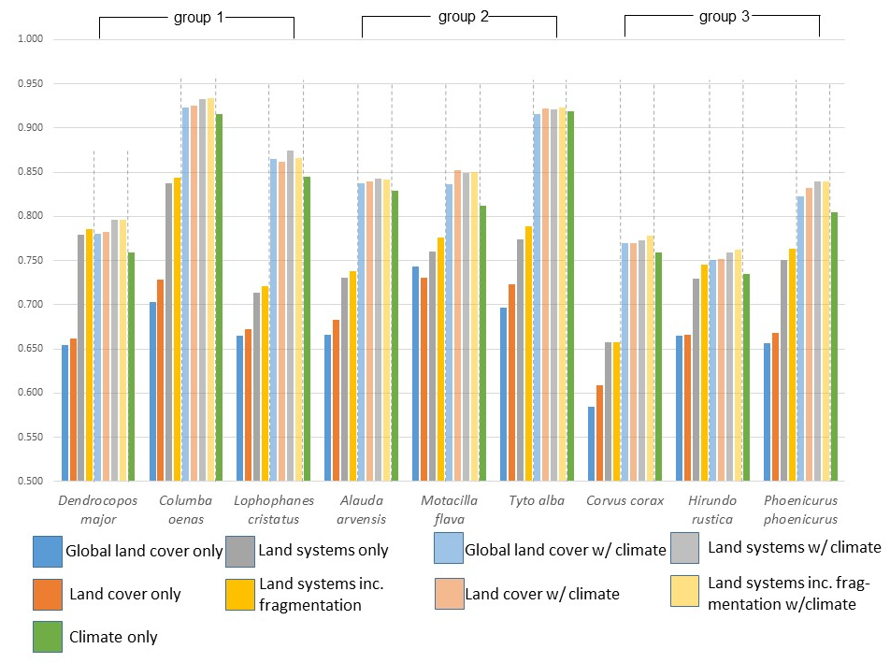

Figure S1 Model predictive ability (AUC score) of selected bird species using Maxent models calibrated with different environmental variables

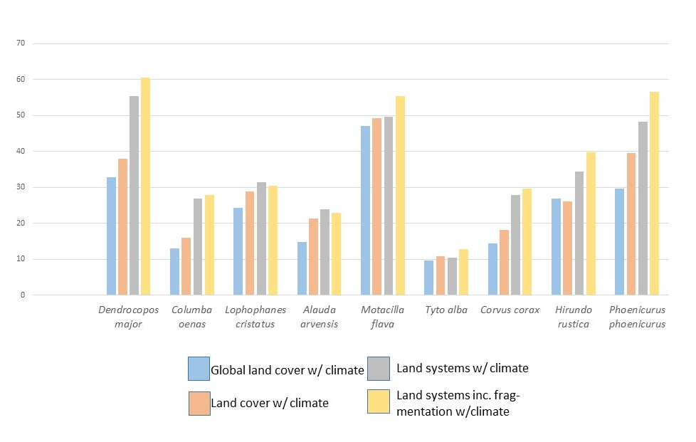

Figure S2 Variable contribution from land cover/system maps to species distribution in Maxent models calibrated with climate variables and land cover/system maps

Table S3 Overview of land systems

Land system | Subdivisions | Land cover composition | Description of systems | Indicators used | Expert-based rules
1. settlement systems | 1.1 low-intensity settlement | imperviousness degree more than 5% | low-medium density, far away from urban cores | imperviousness degree; adjacency to urban core | imperviousness degree>5%, within the 9*9 window there is one or no high-intensity settlement
1. settlement systems | 1.2 medium-intensity settlement | imperviousness degree more than 5% | medium density or adjacent to urban core | imperviousness degree; adjacency to urban core | imperviousness degree>5%, within the 9*9 window there is more than one high-intensity settlement
1. settlement systems | 1.3 high-intensity settlement | imperviousness degree more than 5% | high density imperviousness | imperviousness degree; adjacency to urban core | imperviousness degree>25%, within the 9*9 window there is at least one high-intensity settlement
2. forest systems | 2.1 low-intensity forest | forest covers more than 70%. | high probability as primary forest and low/medium wood production | probability of being primary forest; wood production | Probability of being primary forest is larger than 0.5, and the wood production is lower than the top quantile
2. forest systems | 2.2 medium-intensity forest | forest covers more than 70%. | low probability as primary forest and medium wood production | probability of being primary forest; wood production | Probability of being primary forest is smaller than 0.5, or the wood production is larger than the top quantile
2. forest systems | 2.3 high-intensity forest | forest covers more than 70%. | low probability as primary forest and high wood production | probability of being primary forest; wood production | Probability of being primary forest is smaller than 0.5 and the wood production is larger than the top quantile
3. cropland systems | 3.1 low-intensity arable land | cropland covers more than 70%. | low inorganic fertilizer input, small field size | nitrogen application rate; field size | nitrogen application rate smaller than 50kgN/ha and are small or medium size fields
3. cropland systems | 3.2 medium-intensity arable land | cropland covers more than 70%. | medium inorganic fertilizer input, medium field size | nitrogen application rate; field size | nitrogen application rate is between 50-150 kgN/ha, low application but large field size, or high application rate but small fieldsize
3. cropland systems | 3.3 high-intensity arable land | cropland covers more than 70%. | high inorganic fertilizer input, large field size | nitrogen application rate; field size | nitrogen application rate higher than 150 kgN/ha and medium to large fields
3. cropland systems | 3.4 low-intensity permanent crops | permanent crop covers more than 25% | vineyards, olive graves, fruit gardens, with understory vegetation, this class also has mixed annual and permanent crops | understory vegetation | with understories
3. cropland systems | 3.5 high-intensity permanent crops | permanent crop covers more than 25% | vineyards, olive graves, fruit gardens, without understory | understory vegetation | without understories
4. grassland systems | 4.1 low-intensity grassland | grassland cover more than 70% | low density of livestock, low inorganic fertilizer input, and low mowing frequency | lsu density, nitrogen application rate, and mowing frequency | host less than 50 lsu and nitrogen application rater is lower than 50kgN/ha or mowing frequency is less than 3
4. grassland systems | 4.2 medium-intensity grassland | grassland cover more than 70% | medium density of livestock, medium use of inorganic fertilizer, and medium mowing frequency | lsu density, nitrogen application rate, and mowing frequency | host less than 50 lsu but nitrogen application rater is more than 150 kgN/ha; between 50-100 lsu but nitrogen rate is lower than 50 or mowing frequency smaller than3
4. grassland systems | 4.3 high-intensity grassland | grassland cover more than 70% | high density of livestock, high inorganic fertilizer input, and/or high mowing frequency | lsu density, nitrogen application rate, and mowing frequency | more than 100 lsu; 50-100lsu but with nitrogen application rate bigger than 150 kgN/ha or mowing frequency is equal or more than 3
5. shrub |  | shrub land covers more than 70% | areas dominated by shrub land cover or similar | N/A | N/A
6. rocks and bare soil |  | rocks and bare soil cover more than 70% | areas dominated by rocks, bare soil, or similar | N/A | N/A
7. mosaic systems | 7.1 forest/shrub and cropland mosaics | cropland mixed with forest or shrubs. forest and shrub cover between 30-70%; cropland cover between 30-70%. other land covers are smaller than 30%. | areas with small parcels of forest/shrubs and cropland | N/A | N/A
7. mosaic systems | 7.2 forest/shrub and grassland mosaic | grassland mixed with forest or shrubs. forest and shrub cover between 30-70%; grassland cover between 30-70%. other land covers are smaller than 30%. | areas with small parcels of forest/shrubs and grassland | N/A | N/A
7. mosaic systems | 7.3 forest/shrubs and bare mosaics | bare land and rocks mixed with forest or shrubs. forest and shrub cover between 30-70%; bare land and rocks between 30-70%. other land covers are smaller than 30%. | areas with small parcels of forest/shrubs and bare land | N/A | N/A
7. mosaic systems | 7.4 forest/shrubs and mixed agriculture mosaics | no dominant land covers, all land covers are smaller than 30%. | areas with small parcels of forest/shrubs and mixed areas of cropland and grassland | N/A | N/A
7. mosaic systems | 7.5.1 low-intensity agricultural mosaic (cropland and grassland) | mixed cropland and grassland. both cover between 30-70%. other land covers are smaller than 30%. | low density of inorganic fertilizer input, small field size, and low livestock density | nitrogen application rate; lsu density | lsu smaller than 50 lsu and nitrogen application rater lower than 150 kgN
7. mosaic systems | 7.5.2 medium-intensity agricultural mosaic (cropland and grassland) | mixed cropland and grassland. both cover between 30-70%. other land covers are smaller than 30%. | medium use of inorganic fertilizer, medium field size, and medium livestock density | nitrogen application rate; lsu density | lsu between 50-100; lsu smaller than 50lsu but with higher than 150kgN/ha nitrogen application rate; lsu larger than 100 lsu but with smaller than 50 kgN nitrogen application rate
7. mosaic systems | 7.5.3 high-intensity agricultural mosaic (cropland and grassland) | mixed cropland and grassland. both cover between 30-70%. other land covers are smaller than 30%. | high inorganic fertilizer input, large field size, and/or large livestock density | nitrogen application rate; lsu density | lsu bigger than 100 lsu and nitrogen application rater higher than 50 kgN
8. snow, water, wetland systems | 8.1 glaciers | glacier covers more than 50% | areas dominated by glaciers, wetland, or water body | N/A | N/A
8. snow, water, wetland systems | 8.2 water body | water body covers more than 50% | areas dominated by glaciers, wetland, or water body | N/A | N/A
8. snow, water, wetland systems | 8.3 wetland | wetland covers more than 50% | areas dominated by glaciers, wetland, or water body | N/A | N/A

Table S4 Statistics for land systems
land system | Legend | Area[km²] | Area share [%]
low-intensity settlement |  | 112,759 | 2.30
medium-intensity settlement |  | 152,898 | 3.12
high-intensity settlement |  | 82,689 | 1.69
 |  | 348,346 | 7.11
low-intensity forest |  | 480,091 | 9.80
medium-intensity forest |  | 612,953 | 12.51
high-intensity forest |  | 490,380 | 10.01
 |  | 1,583,424 | 32.3
low-intensity grassland |  | 137,714 | 2.81
medium-intensity grassland |  | 83,231 | 1.70
high-intensity grassland |  | 82,074 | 1.68
 |  | 303,019 | 6.2
low-intensity cropland |  | 178,877 | 3.65
medium-intensity cropland |  | 635,498 | 12.97
high-intensity cropland |  | 243,992 | 4.98
extensive perm-crop |  | 109,545 | 2.24
intensive perm-crop |  | 45,805 | 0.94
 |  | 1,213,717 | 24.8
forest/shrub and cropland mosaic |  | 299,919 | 6.12
forest/shrub and grassland mosaics |  | 187,974 | 3.84
forest/shrub and bare mosaics |  | 24,211 | 0.49
forest/shrub and mixed agriculture mosaics |  | 28,637 | 0.58
low-intensity agricultural mosaic |  | 82,650 | 1.69
medium-intensity agricultural mosaic |  | 64,991 | 1.33
high-intensity agricultural mosaic |  | 20,820 | 0.43
 |  | 709,202 | 14.5
water body |  | 152,665 | 3.12
wetland |  | 330563 | 6.75
glacier |  | 6730 | 0.14
 |  | 489,958 | 10
shrub |  | 218,455 | 4.46
bare and rocks |  | 32,475 | 0.66
 |  | 250,930 | 5.12

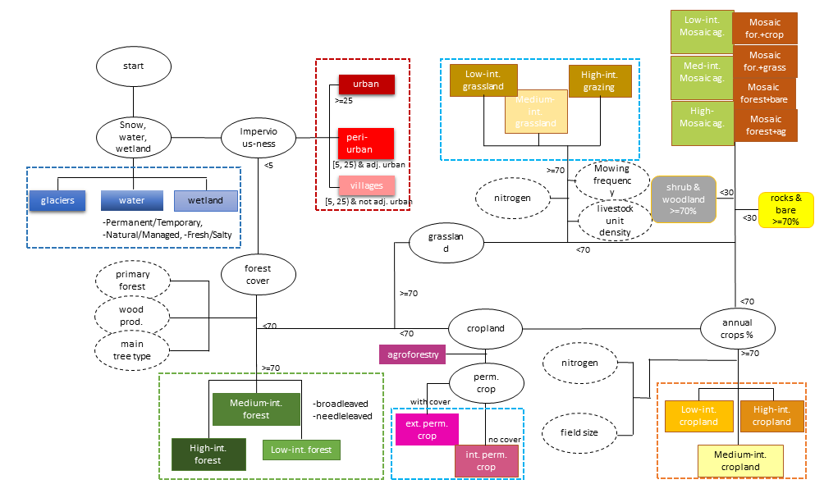

Figure S3 Overview of land system classification

Table S5 Details of indicators used for classification
 | Possible land cover types from Corine | Indicator | Data source | Spatial resolution of raw data | Temporal coverage of raw data | Unit of raw data and reclass | Reference
Settlement system | Continuous urban fabric, discontinuous urban fabric, industrial and commercial units, road and rail network and associated land, port areas, airports | Imperviousness degree | HRL-imperviousness | 20m | 2015 | % imperviousness:  class 1: >25%, dense built-up; class 2: 5-25% medium dense built-up | https://land.copernicus.eu/pan-european/high-resolution-layers
Settlement system |  | Distance to urban core | Derived from HRL-imperviousness |  |  | Number of dense built-up class in a 9*9 neighborhood cell:  class 1: >1, peri-urban; class2: <=1, villages
Forest system | Broad-leaved forests, coniferous forests, mixed forests | Wood production | Wood production dataset of Europe | 1km² | annual map from 2000 to 2010 (we used the average) | m3ha⁻¹ yr⁻¹:  class 1: <0.9 low production  class 2: >=0.9 high production | (Verkerk et al. 2015)
Forest system | Broad-leaved forests, coniferous forests, mixed forests | Probability of primary forest | Map of primary forest probability | 1km² |  | - probability:  class 1: >0.5 high prob.  Class 2: <=0.5 low prob | (Sabatini et al. 2018)
Forest system | Broad-leaved forests, coniferous forests, mixed forests | Forest types | HRL-forest type product | 100m | 2015 | Broadleaved, coniferous, or mixed | https://land.copernicus.eu/pan-european/high-resolution-layers
Cropland system | Non-irrigated arable land, permanently irrigated land, rice field, complex cultivation patterns, land principally occupied by agriculture, with significant areas of natural vegetation | Field size | LUCAS 2018 |  |  | PARCEL_AREA_HA, class 1=0.05ha; class 2=0.3ha; class 3=0.75ha; class4=5.5ha; class5=15ha | (van der Zanden et al. 2016, Tieskens et al. 2017)
Cropland system |  | Nitrogen input | jrc |  | 2012 | 1km grid shapefile
--Permanent crops | Vineyard,  Fruit trees and berry plantation,  Olive grove,  Annual crops associated with permanent crops (perm. crops>50%) | Understory | CORINE 2018,  LUCAS2018 | Survey points, 2km apart | 2018 | Class 1: bare soil  Class 2: vegetated surface
Grassland | Pasture, complex cultivation patterns, land principally occupied by agriculture, with significant areas of natural vegetation | Mowing frequency | Map of grassland management intensity | 3km | 2000-2012 | Average number of annual mowing events | (Estel et al. 2018)
Grassland |  | Livestock density | Global livestock dataset | 0.0833 decimal degrees | 2010 | Number of animals at each pixel (converted):  Class 1: 0-50 lsu/ km²  Class 2: 50-100 lsu/ km²  Class 3: >100 lsu/ km² | (Gilbert et al. 2018)
Shrubs, rocks, and mosaic systems | Shrubs, rocks, and other mixed land cover | N/A | CORINE 2018 | 100m | 2018 | Agro-forestry areas, moors and heathland, sclerophyllous vegetation, beaches, dunes, and sand plains, bare rocks, sparsely vegetated areas, burnt area, mineral extractions sites, dump sites, sport and leisure facilities
Snow, water, and wetland systems | Glaciers and perpetual snow,  inland marshes,  peatbogs, salt marshes,  salines,  interdal flats,  water courses,  water bodies,  coastal lagoons, estuaries, sea and ocean | N/A | GLIM dataset | shapefile |  |  | (Global Land Ice Measurements from Space (GLIMS) & National Snow and Ice Data Center, 2012)

Table S6 Selection of bioclimatic variables

No. | Variables
2 | Mean Diurnal Range
4 | Temperature Seasonality
8 | Mean Temperature of Wettest Quarter
10 | Mean Temperature of Warmest Quarter
15 | Precipitation Seasonality
19 | Precipitation of Coldest Quarter

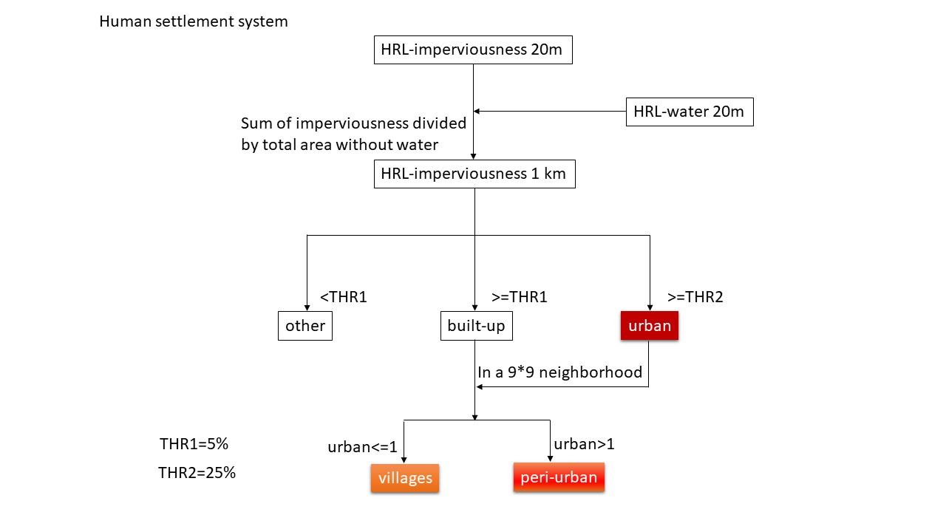

Figure S4 Workflow of human settlement system

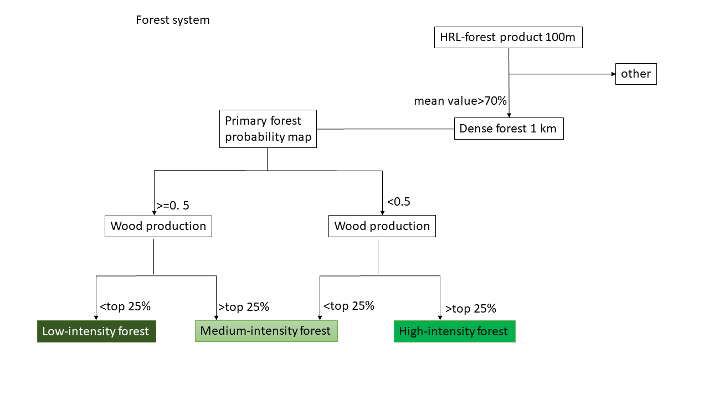

Figure S5 Workflow of forest system

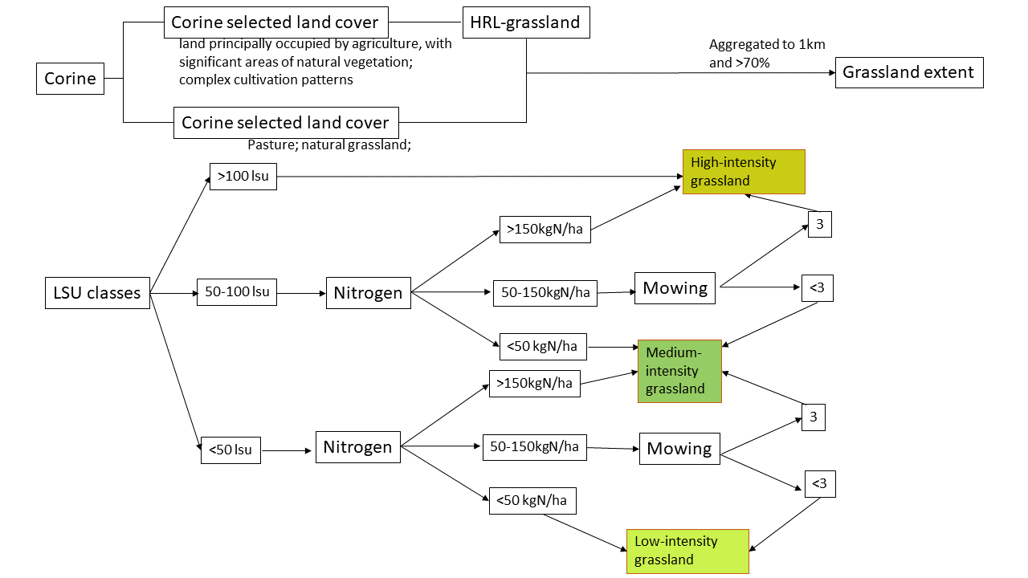

Figure S6 workflow of grassland system
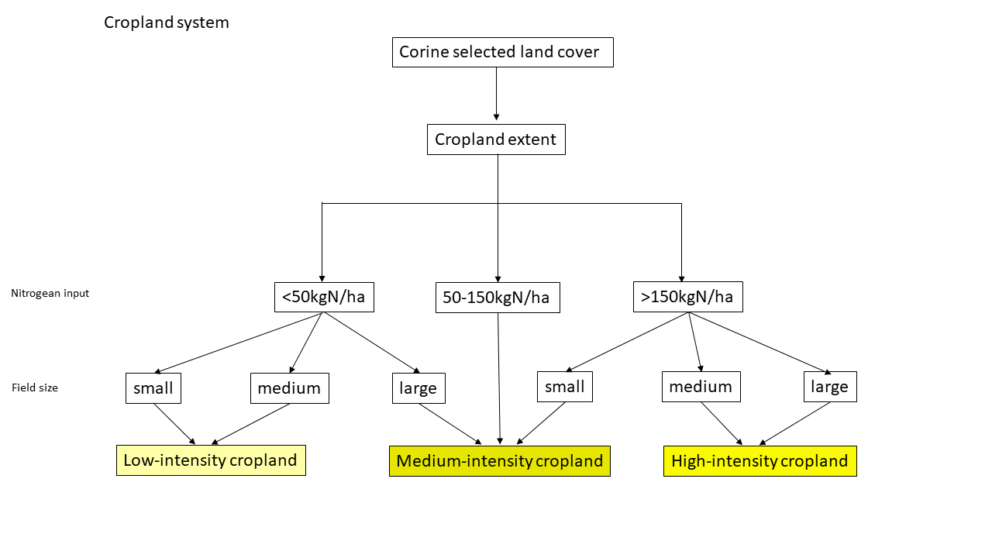

Figure S7 workflow of cropland system (annual crops, EU-region)
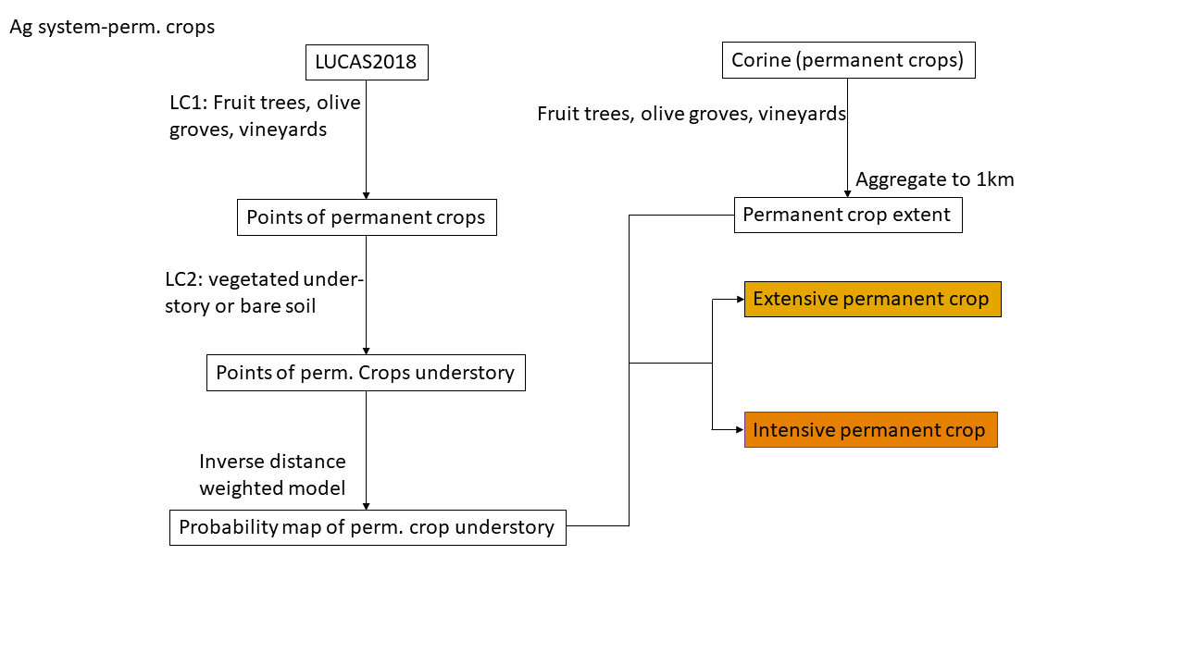

Figure S8 workflow of cropland system (permanent crops)
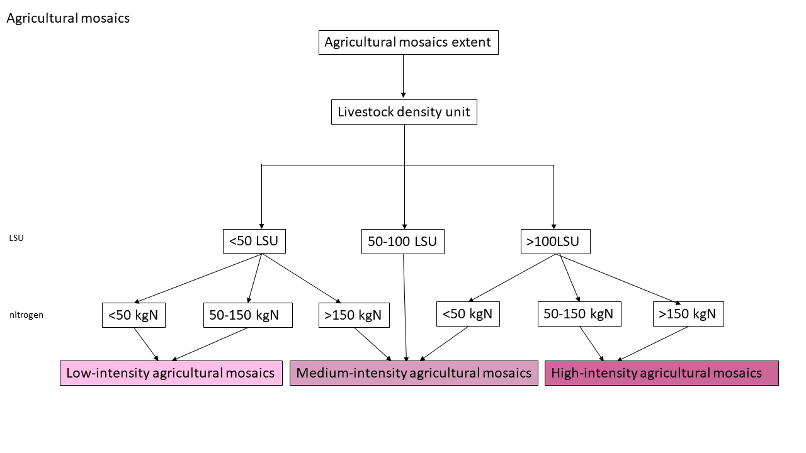

Figure S9 workflow of agricultural mosaics

Figure S10 Sensitivity analysis of cropland percentage when aggregated to 1km pixel

Figure S11 Sensitivity analysis of forest percentage when aggregated to 1km pixel

