SUPPLEMENTAL MATERIAL

Title: Multi-scale waterfowl habitat conservation planning in Wisconsin, USA.

Matthew D. Palumbo^{1,2}, Jacob N. Straub¹, Mohammed A. Al-Saffar³, Gregory J. Soulliere³, Jason Fleener⁴, Mitchell T. Bergeson⁵, John M. Coluccy⁶, Andrew Cruz⁵, Taylor Finger⁴, Drew N. Fowler⁷, Brian J. Glenzinski⁸, Rusty K. Griffin⁵, Scott E. Hygnstrom¹, Greg Kidd⁹, Nicholas A. Miller¹⁰, Kent Van Horn⁴, and Kurt Waterstradt¹¹

¹University of Wisconsin-Stevens Point, College of Natural Resources, 800 Reserve Street, Stevens Point, WI 54481, USA.
²Present address: New York State Department of Environmental Conservation, 625 Broadway, Albany, NY 12233-4754, USA
³ U.S. Fish and Wildlife Service, Upper Mississippi / Great Lakes Joint Venture, 2651 Coolidge Road, East Lansing, MI 48823, USA.
⁴Wisconsin Department of Natural Resources, 101 S. Webster St., Madison, WI, 53707, USA.
⁵ U.S. Fish and Wildlife Service, Ecological Services, National Wetlands Inventory, 505 Science Drive, Suite A, Madison, WI 53711, USA.
⁶ Ducks Unlimited, Inc., 7322 Newman Boulevard, Building 1, Dexter, Michigan, 48310, USA.
⁷ Wisconsin Department of Natural Resources, 2801 Progress Road, Madison, Wisconsin, 53716, USA.
⁸ Ducks Unlimited, Inc., 505 Science Drive, Suite A, Madison, WI 53711, USA.
⁹U.S. Department of Agriculture, Natural Resources Conservation Service, 8030 Excelsior Drive, Madison WI 53717, USA.
¹⁰ The Nature Conservancy in Wisconsin, 633 West Main Street, Madison, WI 53703, USA.
¹¹U.S. Fish and Wildlife Service, Wisconsin Private Lands Office, W10040 Cascade Mountain Rd, Portage, WI 53901, USA.

Supplemental Table 1. Breeding season landscape suitability criteria of focal species used for habitat conservation planning in Wisconsin, USA. All National Wetland Inventory system, sub-system, class, subclass and water regime acronyms follow the Federal Geographic Data Committee’s Classification of Wetlands and deepwater habitats classification system (Federal Geographic Data Committee, 2013). Land cover classifications were derived from the WISCLAND 2.0 Land Cover User Guide, September 2016.

Supplemental Table 2. Autumn season landscape suitability criteria of focal species used for habitat conservation planning in Wisconsin, USA. All National Wetland Inventory system, sub-system, class, subclass and water regime acronyms follow the Federal Geographic Data Committee’s Classification of Wetlands and deepwater habitats classification system (Federal Geographic Data Committee, 2013). Land cover classifications were derived from the WISCLAND 2.0 Land Cover User Guide, September 2016.

Supplemental Table 3. Spring season landscape suitability criteria of focal species used for habitat conservation planning in Wisconsin, USA. All National Wetland Inventory system, sub-system, class, subclass and water regime acronyms follow the Federal Geographic Data Committee’s Classification of Wetlands and deepwater habitats classification system (Federal Geographic Data Committee, 2013).

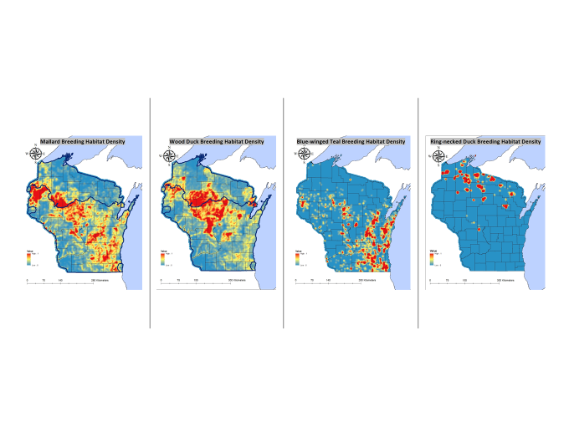
Supplemental Fig. 1. Density and distribution of breeding habitat of mallard, wood duck, blue-winged teal, and ring-necked duck in Wisconsin, USA. Red indicates highest density and distribution of habitat in Wisconsin, blue indicates lowest.

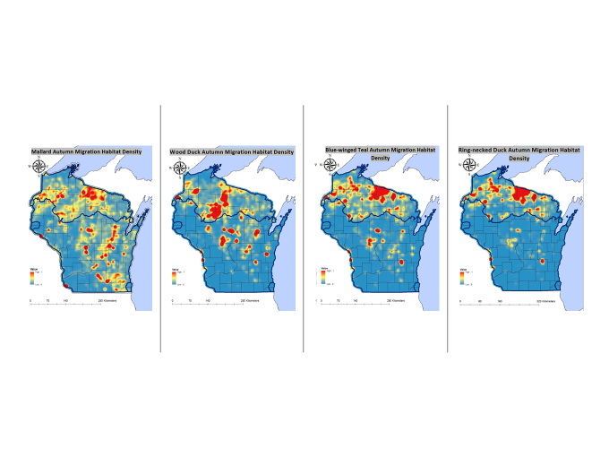
Supplemental Fig. 2. Density and distribution of autumn habitat of mallard, wood duck, blue-winged teal, and ring-necked duck in Wisconsin, USA. Red indicates highest density and distribution of habitat in Wisconsin, blue indicates lowest.

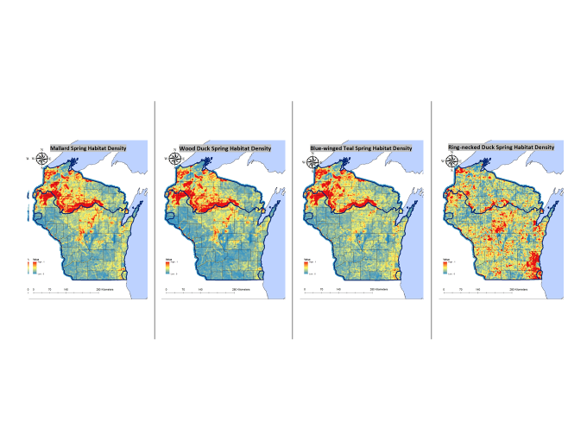
Supplemental Fig. 3. Density and distribution of spring habitat of mallard, wood, duck, blue-winged teal, and ring-necked duck in Wisconsin, USA. Red indicates highest density and distribution of habitat in Wisconsin, blue indicates lowest.

Supplemental Fig. 4. Hydrologic Unit Code 12 watersheds in Wisconsin ranked independently [Priority 3 (greatest) through 0 (least)] within each Ecological Landscape (black boundaries) for Conservation Capital.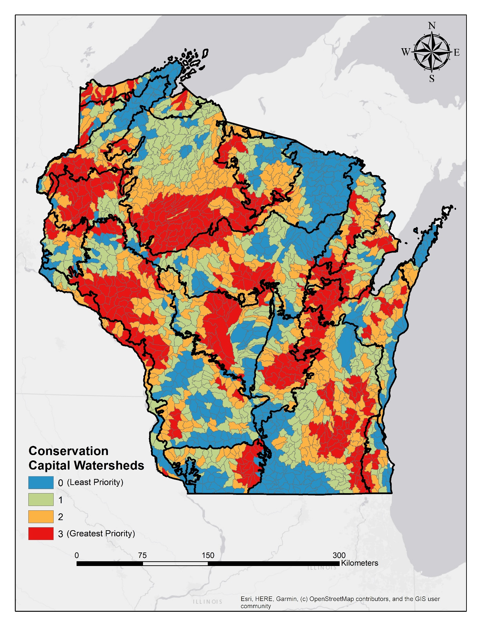
Supplemental Fig 5. Hydrologic Unit Code 12 watersheds in Wisconsin ranked independently [Priority 3 (greatest) through 0 (least)] within each Ecological Landscape (black boundaries) for Conservation Opportunities.
