Supplemantery Material for:
Landscape configuration of an Amazonian island-like ecosystem drives population structure and genetic diversity of a habitat-specialist bird
Camila D. Ritter^{1*}, Camila C. Ribas², Juliana Menger², Sergio H. Borges³ Christine D. Bacon^{4,5}, Jean P. Metzger⁶, John Bates⁷, Cintia Cornelius³

Author affiliations

¹ Department of Eukaryotic Microbiology, University of Duisburg-Essen, Universitätsstrasse 5 D-45141 Essen, Germany
² Coordenação de Biodiversidade e Coleções Zoológicas, Instituto Nacional de Pesquisas da Amazônia, Av. André Araújo 2936, Manaus, AM 69060-001, Brazil
³ Universidade Federal do Amazonas, Av. Rodrigo Otávio Jordão Ramos 3000, Bloco E, Setor Sul, Manaus, AM 69077-000, Brazil
⁴ Department of Biological and Environmental Sciences, University of Gothenburg, Box 463, 405 30 Göteborg, Sweden.
⁵ Gothenburg Global Biodiversity Centre, Box 461, SE-405 30 Göteborg, Sweden.
⁶ Departamento de Ecologia, Instituto de Biociências, Universidade de São Paulo, Rua do Matão, 321, travessa 14, São Paulo, SP 05508-900, Brazil
⁷ Life Sciences Section, Negaunee Integrative Research Center, The Field Museum of Natural History, 1400 S. Lake Shore Drive, Chicago, IL 60605, USA

*Corresponding author
Camila D. Ritter, kmicaduarte@gmail.com. Phone: +55 48991434597. Postal address: University of Duisburg-Essen, Universitätsstrasse 5 - D-45141 Essen, Germany. ORCID: 0000-0002-3371-7425.
Contents
Table S1 3
Table S2 4
Table S3 6
Table S4 7
Table S5 8
Table S6 9
Table S7 10
Figure S1. 12
Figure S2. 13
Figure S3 14

Table S1 – Number of samples used in this study per sampling site. The geographical coordinates are also provided.
Landscape | Site | N | Latitude | Longitude
Aracá | AR1 | 10 | 0.5556 | -63.4983
Aracá | AR2 | 12 | 0.5453 | -63.4539
Aracá | AR3 | 14 | 0.6103 | -63.4303
Aracá | AR4 | 10 | 0.4689 | -63.4756
Aracá | AR5 | 12 | 0.4067 | -63.4092
Aracá | AR7 | 14 | 0.3267 | -63.2622
Uatumã | UT1 | 10 | -2.2817 | -59.0617
Uatumã | UT10 | 9 | -2.2858 | -58.865
Uatumã | UT12 | 9 | -2.2728 | -58.6719
Uatumã | UT2 | 12 | -2.2867 | -58.9561
Uatumã | UT3 | 13 | -2.2822 | -59.03
Uatumã | UT5 | 5 | -2.1817 | -59.0217
Viruá | V1 | 12 | 1.4093 | -60.9912
Viruá | V3 | 8 | 1.4317 | -60.8684
Viruá | V4 | 10 | 1.5962 | -61.0456
Viruá | V5 | 18 | 1.6621 | -60.9325

Table S2 - Number of alleles (N_{A}), allelic richness (A_{R}), observed (H_{o}) and expected (H_{e}) heterozygosity, and Wright’s fixation index (F_{IS}) of 15 microsatellite loci within E. ruficeps populations.
 | Aracá |  |  |  |  | Uatumã |  |  |  |  | Viruá
 | N_{A} | A_{R} | H_{o} | H_{e} | F_{IS} | N_{A} | A_{R} | H_{o} | H_{e} | F_{IS} | N_{A} | A_{R} | H_{o} | H_{e} | F_{IS}
Eru1 | 8 | 7.757 | 0.4583 | 0.4629 | 0.0099 | 10 | 9.885 | 0.2069 | 0.4778 | 0.567 | 7 | 7.000 | 0.4792 | 0.4834 | 0.0087
Eru2 | 8 | 7.452 | 0.2917 | 0.2974 | 0.0194 | 8 | 7.829 | 0.3276 | 0.3265 | -0.0032 | 6 | 6.000 | 0.5208 | 0.4858 | -0.0721
Eru3 | 34 | 31.911 | 0.6111 | 0.8793 | 0.305 | 20 | 19.826 | 0.5172 | 0.8491 | 0.3908 | 22 | 22.000 | 0.4167 | 0.8925 | 0.5332
Eru4 | 22 | 20.648 | 0.7083 | 0.7041 | 0.5029 | 19 | 18.712 | 0.8103 | 0.7122 | 0.276 | 13 | 13.000 | 0.6875 | 0.6485 | 0.4648
Eru5 | 36 | 33.911 | 0.4583 | 0.922 | 0.7905 | 37 | 36.198 | 0.6724 | 0.9288 | 0.7177 | 35 | 35.000 | 0.5 | 0.9342 | 0.847
Eru6 | 8 | 7.867 | 0.1389 | 0.6629 | 0.2691 | 6 | 10.801 | 0.1552 | 0.5496 | 0.1309 | 7 | 7.000 | 0.1042 | 0.6809 | 0.4331
Eru9 | 8 | 7.659 | 0.2361 | 0.3231 | 0.0467 | 7 | 6.970 | 0.3966 | 0.4563 | 0.0696 | 4 | 4.000 | 0.2083 | 0.3675 | 0.4079
Eru10 | 59 | 53.637 | 0.9028 | 0.947 | 0.6417 | 58 | 51.629 | 0.8793 | 0.9451 | 0.6103 | 32 | 32.000 | 0.5417 | 0.9149 | 0.6008
Eru11 | 11 | 10.441 | 0.25 | 0.6978 | 0.0793 | 8 | 7.971 | 0.2414 | 0.6193 | -0.0792 | 14 | 14.000 | 0.2917 | 0.7307 | 0.0874
Eru12 | 5 | 4.671 | 0.2361 | 0.2565 | 0.1118 | 3 | 2.999 | 0.1897 | 0.1757 | 0.0275 | 6 | 6.000 | 0.3958 | 0.4337 | -0.1238
Eru13 | 8 | 7.660 | 0.4444 | 0.5004 | 0.0514 | 9 | 8.941 | 0.5517 | 0.5673 | 0.233 | 7 | 7.000 | 0.5833 | 0.5191 | 0.1604
Eru14 | 21 | 19.878 | 0.7361 | 0.776 | 0.2092 | 15 | 14.827 | 0.569 | 0.7418 | 0.2787 | 13 | 13.000 | 0.5833 | 0.6948 | 0.1899
Eru15 | 37 | 34.431 | 0.7083 | 0.8957 | -0.0007 | 31 | 30.399 | 0.6379 | 0.8845 | 0.0945 | 33 | 33.000 | 0.7292 | 0.9 | 0.0535
Eru16 | 44 | 40.413 | 0.9167 | 0.916 | -0.2261 | 39 | 38.254 | 0.8448 | 0.933 | 0.0653 | 32 | 32.000 | 0.875 | 0.9244 | -0.0258
Eru17 | 4 | 3.989 | 0.4583 | 0.3738 | -0.006 | 6 | 5.971 | 0.4483 | 0.4796 | -0.1378 | 5 | 6.000 | 0.3958 | 0.3859 | -0.0602

Table S3 – Resistance values by landscape category attributed by each expert Amazon Ornithologist and the average used in the resistance models. We had asked each expert to attributed a value of resistance of the different land covers and we used the average value for each category of land cover.
Land Cover | Expert1 | Expert2 | Expert3 | Expert4 | Average
Campina (open white-sand vegetation) | 0.01 | 0.01 | 0.1 | 0.01 | 0.04
Campinarana (forests white-sand vegetation) | 0.60 | 0.1 | 0.3 | 0.1 | 0.16667
Igapó (black-water flooded forest) | 0.60 | 0.15 | 0.4 | 0.25 | 0.26667
Várzea (white-water flooded forest) | 0.99 | ?? | 0.4 | 0.8 | 0.6
Terra firme forest | 0.99 | 0.8 | 0.7 | 0.99 | 0.83
Deforested área (anthropogenic) | 0.30 | 0.8 | 0.5 | 0.75 | 0.68333
Big black-water river (e.g. Negro River) | 0.6 | 0.5 | 0.6 | 0.5 | 0.53333
Big white-water river (e.g. Amazon River) | 0.99 | ?? | 0.7 | 0.99 | 0.845
Medium black-water river (e.g. AracáRiver) | 0.10 | 0.25 | 0.8 | 0.25 | 0.43333
Medium white-water river (e.g. Branco River) | 0.60 | ?? | 0.8 | 0.8 | 0.8

Table S4 - The genetic diversity measurements for each individual landscape. Nucleotide (Pi) and haplotype (H_{D}) diversity from mitochondrial data, and allelic richness (A_{R}) and genetic diversity (Theta) from microsatellite data.
 | ND2 |  | Microsat
Landscape | P_{i} | H_{D} | A_{R} | Theta
Aracá | 0.003 +/- 0.0006 | 0.84 +/- 0.07 | 19.49 +/- 15.65 | 1.61 +/-0.06
Uatumã | 0.001 +/- 0.0004 | 0.78 +/- 0.1 | 18.08 +/- 14.48 | 1.56 +/- 0.05
Viruá | 0.001 +/- 0.0003 | 0.76 +/- 0.04 | 15.8 +/- 11.67 | 1.69 +/- 0.04

Table S5 – FST between the sites inside and among each landscape from the microsatellite data above the diagonal line, and the MD2 mitochondrial sequences data reported below the diagonal. AR represents sites in Aracá, UT in Uatumã and V in Viruá. Values in bold are significant (p < 0.05).
Table S6 – Estimated parameters (values estimated with standardize error, t-value and respective p-value) of the best fit models selected in model selection. The genetic diversity variables for mitochondrial data are nucleotide (Pi) and haplotype (H_{D}) diversity and for the microsatellite data are Theta and A_{R}. For Pi and Theta just landscape was selected to explain diversity. HD the best model was the constant null model. For N_{G} the best model was just with the proximity index.
Variable | Parameters | Estimate | Std. Error | t value | Pr(>|t|)
Pi | Intercept | 0.0032333 | 0.0001941 | 16.654 | 3.77E-10
Pi | Uatumã | -0.0018567 | 0.0002746 | -6.762 | 1.34E-05
Pi | Viruá | -0.0019808 | 0.000307 | -6.453 | 2.16E-05
H_{D} | Intercept | 0.7945 | 0.02029 | 39.16 | <2e-16
Theta | Intercept | 1.60514 | 0.02082 | 77.103 | <2e-16
Theta | Uatumã | -0.04426 | 0.02944 | -1.503 | 0.1567
Theta | Viruá | 0.08194 | 0.03292 | 2.489 | 0.0271
A_{R} | Intercept | 2.06E-16 | 0.217 | 0 | 1
A_{R} | Proximity index | 0.544 | 0.224 | 2.423 | 0.0295

Table S7 – Mantel results for the sites inside each landscape for test of isolation by distance and isolation by resistance. The response variables are the F_{ST}.
Isolation | Landscape | Micros |  | ND2
 |  | R | p | R | P
Distance | Aracá | 0.26 | 0.3 | -0.41 | 0.93
Distance | Viruá | 0.04 | 0.42 | -0.2 | 0.83
Distance | Uatumã | 0.002 | 0.57 | 0.13 | 0.24
Resistance | Aracá | 0.21 | 0.31 | 0.005 | 0.5
Resistance | Viruá | -0.14 | 0.7 | -0.56 | 0.92
Resistance | Uatumã | 0.11 | 0.4 | 0.33 | 0.19

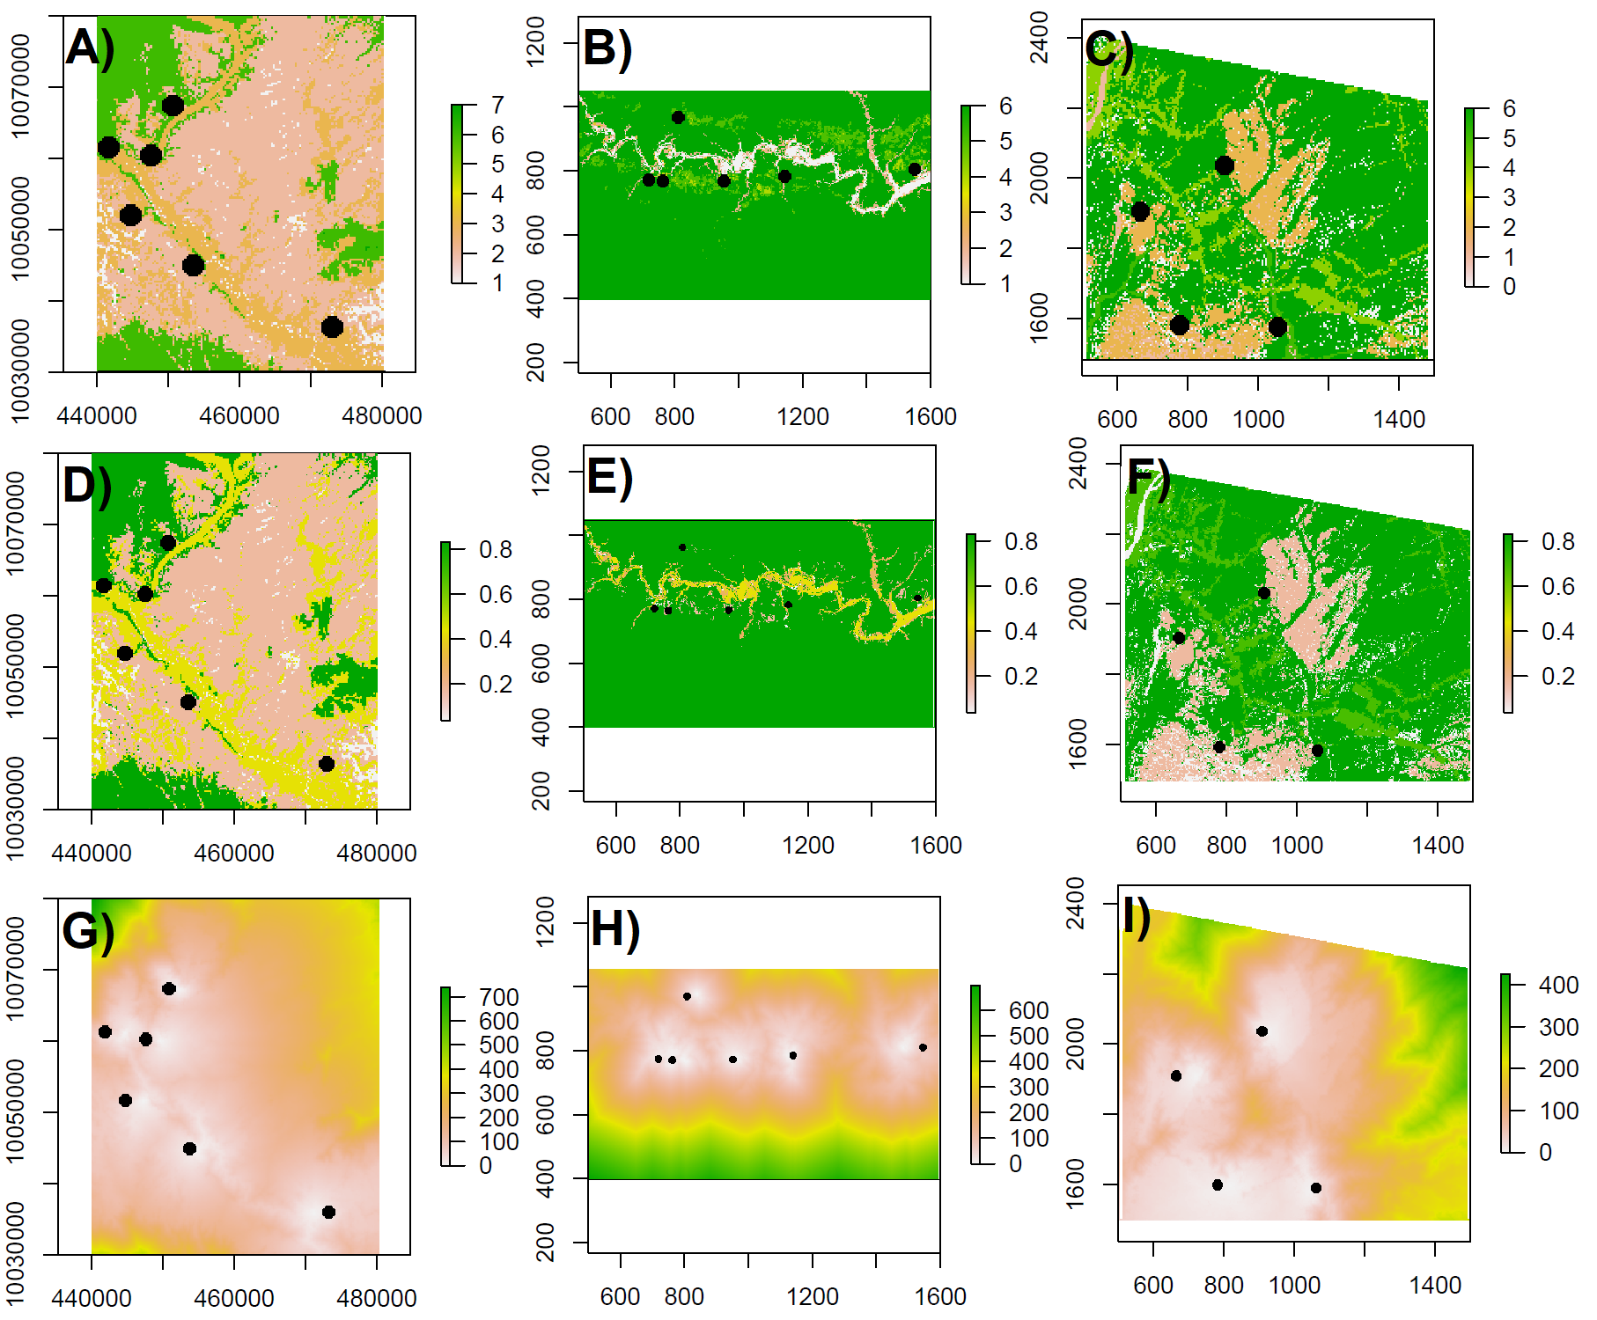
Figure S1. Raster layers by landscape used to create the resistance matrix. Classified raster for vegetation category from A) Aracá, B) Uatumã and, C) Viruá. The classified raster by resistance matrix from D) Aracá, E) Uatumã and, F) Viruá. The conductance transitional layer created to measure the resistance between the pairwise points from G) Aracá, H) Uatumã and, I) Viruá.

Figure S2. Spatial correlation between migration rates and geographic distances in A) all sites, and B) among landscape. Gray points represent the contemporary migration rate calculate from microsatellite data using the BayesAss software. Black points and line represent the historical migration rate calculated from ND2 sequences, both estimated by Migrate-N software.

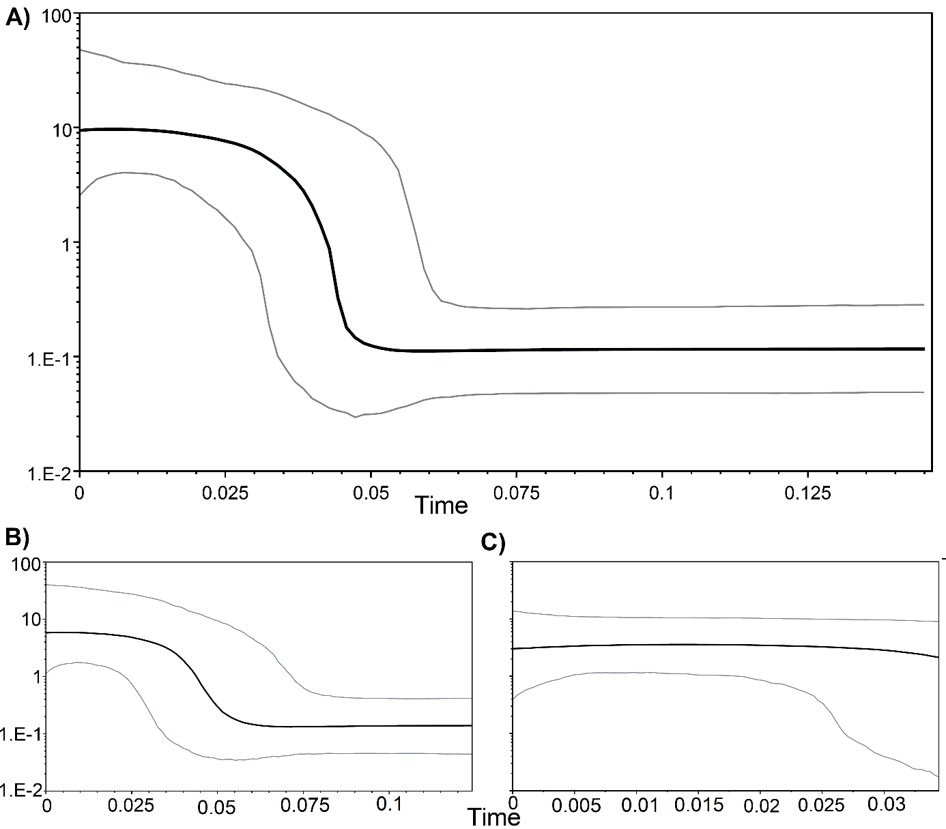
Figure S3. Bayesian skyline plot based on 978 bp of 178 mitochondrial ND2 sequences showing the demographic history of sampled Elaenia ruficeps populations in the study region (A). (B) Is the population demography from Aracá, and (C) from Viruá + Uatumã, following the populations identified with BAPS. (B) and (C) had the same y-axis values. The horizontal axis shows time in thousands of years before the present and the vertical axis shows effective population size. The black line represents the median value, while the gray lines indicate the 95% Bayesian read confidence intervals.

