Supporting Materials
for

Using landscape metrics to characterize towns along
an urban-rural gradient

Submitted to Landscape Ecology June 2021

Table S1. Recent studies using continuous metrics of urban-rural gradients
Study |  | Objective/Purpose |  | Study Area |  | Unit of Analysis |  | Metric Used
Banaszak-Cibicka & Żmihorski, 2012 |  | Examine variability of bee species richness and community composition |  | Poznań, Poland |  | 500-m buffer around study site |  | PC1 – based on built areas, tree cover, green space, distance to city center
Carrino-Kyker et al., 2011 |  | Examine effects of urbanization on vernal pool microbial communities |  | Cuyahoga River Basin, Ohio, USA |  | sub-watershed |  | % Urban land cover
Eakin et al., 2018 |  | Describe bird and mammal use of vernal pools |  | Maine, USA |  | 1000-m buffer around study site |  | % Impervious surface
Evans et al., 2015  Evans et al., 2018 |  | Examine avian survival and community composition |  | Washington, DC, USA |  | 500-m/1000-m buffer around study site |  | % Impervious surface
Feist et al., 2018 |  | Assess threats of urbanization to coho salmon |  | Pugent Sound Washington, USA |  | stream sub-basins |  | Factor Score – based on population density, traffic intensity, 10 land covers
Fortel et al., 2014 |  | Assess bee community abundance, species richness, and composition |  | Lyon, France |  | 2-km buffer around study site |  | % Impervious surface
Jantz et al., 2012 |  | Assess urbanization impact on seasonal activity patterns of coyote |  | Alabama, USA |  | Individual coyote home range |  | % Urban land cover
Larondelle & Haase, 2013 |  | Assess ecosystem service provisioning |  | Berlin, Germany; Salzburg, Austria; Helsinki, Finland; Stockholm, Sweden |  | 100-m² pixels |  | Distance from city center
Riem et al., 2012 |  | Quantify mammalian species diversity |  | Ohio, USA |  | 6 study sites of varying sizes |  | Expert opinion ranking based on tree cover, lawns, pavement, and buildings
Saito & Koike, 2013 |  | Evaluate effects of urbanization on wild mammal assemblages |  | Tokyo metro area, Japan |  | varying buffers around study site |  | PC1 – based on forest, urban and agricultural land covers
Tomasevic & Marzluff, 2017 |  | Examine impact of human facilitation on cavity-nesting bird communities |  | Washington, USA |  | 1-km² pixels |  | % Forest cover
Wadduwage et al., 2017 |  | Assess loss, degradation, and fragmentation of agricultural land |  | Adelaide, Australia |  | 1-km² pixels |  | Distance from city center
Note: PC1 refers to the first principle component resulting from a principle component analysis and Factor Score refers to the result of a factor analysis; both principle component and factor analyses are performed on multiple input variables whereby the resulting principle components and factor scores are continuous agglomeration variables.
Table S2. Studies developing or implementing categorical urban-rural gradient typologies
Study | Objective/Purpose |  | Study Area |  | Unit of Analysis |  | Metric(s) Used |  | Typology Classes
Ahrné et al., 2009 | Examine importance of landscape structure and quality on bumble bees |  | Stockholm, Sweden |  | 300-m buffers |  | Impervious surface |  | Urban  Intermediate  Peri-urban
Bates et al., 2011* | Assess changes in pollinator assemblages |  | West Midlands region, United Kingdom |  | 900-km² pixels |  | Reclassification of Owen et al. (2006) typology |  | Urban  Suburban  Rural
Boarnet et al., 2011 | Test whether growth management legislation has led to changes in development patterns |  | Florida, USA |  | Counties |  | USDA ERS rural-urban continuum codes |  | Urban  Suburban  Exurban
Brown et al., 2005 | Summarize changes in developed & agricultural land use patterns |  | USA |  | Counties |  | Housing density |  | Urban  Exurban  Rural
Isserman, 2005 | Distinguish among areas between urban and rural to improve public policy |  | USA |  | Counties |  | Population density and US Census urban/rural area designations |  | Urban  Mixed urban  Mixed rural  Rural
Lee & Carroll, 2015 | Understand role of pine forests in avian diversity conservation |  | Georgia, USA |  | Pine patches |  | Urban development and agriculture land covers |  | Moderate urban  Low urban  Moderate (mixed)  Moderate agriculture  Low agriculture  Low (mixed)  Wildland
McDonnell & Hahs, 2008 | Compare urban-rural gradient between two cities |  | Melbourne, Australia; Aukland, New Zealand |  | 1-km² pixels |  | Index based on population density and percent impervious surface |  | Dense urban  Suburban  Exurban  Rural
Mondal et al., 2013 | Examine trends and project future changes in private forests |  | Eastern USA |  | Census blocks converted to grid cells |  | Housing density |  | Urban/suburban  Exurban  Rural
Nagy & Lockaby, 2011 | Examine effects of urbanization on ecosystem structure and function |  | Piedmont region of Georgia, USA |  | Watersheds |  | Dominant land cover |  | Urban  Developing  Pasture/cropland  Managed forest  Unmanaged forest
Owen et al., 2006* | Facilitate stratified survey and sampling in urban regions |  | West Midlands region, United Kingdom |  | 900-km² pixels |  | 27 metrics based on land covers, roads, and slope |  | Urban  Urban/transport  Light urban/water  Dense suburban  Suburban  Light suburban  Villages/farms  Woodland
Rao et al., 2013 | Quantify effects of urbanization on soil and vegetation carbon and nitrogen |  | Boston, Massachusetts metro area, USA |  | 1-km² pixels |  | Population density, impervious surface, and land use/cover |  | High-urban forest  High-urban residential  High-urban other dev.  Low-urban forest  Low-urban residential  Low-urban other dev.  Non-urban forest  Non-urban residential  Non-urban other dev.
Richert, 2004 | Explore the rise of ‘low-density suburbs’ across the state over time |  | Maine, USA |  | Municipalities |  | Housing density |  | Urban/suburban  Emerging suburb  Rural
Salvati, 2014 | Establish a procedure for measuring soil sealing at the local scale |  | Greece |  | Municipalities |  | Distance to city center |  | Urban  Suburban  Rural
Samuelson and Leadbeater, 2017* | Describe classification protocol for pollinator ecology research |  | Southeast England, United Kingdom |  | Buffers around study sites |  | Impervious surface, pollinator habitat, agriculture, and other land covers |  | 2-4 classes depending on buffer size
Samuelson et al., 2018* | Examine bumble bee colony reproductive success |  | Southeast England, United Kingdom |  | 500-m buffers |  | Application of Samuelson and Leadbeater (2017) |  | City  Village  Agricultural
Santana & Armstrong, 2017 | Examine diets of coyotes in areas of differing levels of development |  | Alabama, USA |  | Opportunistic sampling locations |  | Population density, road density, and land covers |  | Urban  Exurban  Rural
Stein et al., 2005 | Assess trends & identify private forest lands with projected increases in housing density |  | U.S. watersheds where 50% of forest is private |  | Census blocks summarized to watersheds |  | Housing density |  | Urban  Exurban  Rural
Theobald, 2005 | Improve understanding of exurban growth over time |  | USA |  | Census blocks |  | Housing density |  | Urban  Suburban  Exurban  Rural
Zhao et al., 2012 | Investigate the impacts of development on carbon uptake by vegetation |  | Eastern USA |  | Census blocks |  | Housing density |  | Urban  Suburban  Exurban  Rural
Note: Typologies indicated by a * were generated using a cluster algorithm; the remaining were generated using a fixed set of rules.

Table S3. Pearson Correlation Matrix of Landscape Metrics
 | Developed | Core Developed | Islet Developed | Forest | Core Forest | Islet Forest | Agriculture
Developed | 1
Core Developed | 0.93144 | 1
Islet Developed | 0.13810 | -0.06463 | 1
Forest | -0.87935 | -0.75571 | -0.31190 | 1
Core Forest | -0.82056 | -0.66497 | -0.44435 | 0.97707 | 1
Islet Forest | 0.69171 | 0.48659 | 0.39567 | -0.81980 | -0.83032 | 1
Agriculture | -0.17877 | -0.17806 | 0.13125 | -0.23377 | -0.23861 | 0.14279 | 1

Table S4. One-way ANOVA Test Results
Metric | F | Significance
Proportion impervious surface | 3290 | <0.000
Proportion core impervious surface | 1366 | <0.000
Proportion islet impervious surface | 350.4 | <0.000
Proportion forest/wetlands | 3038 | <0.000
Proportion core forest/wetlands | 2516 | <0.000
Proportion islet forest/wetlands | 944.3 | <0.000
Proportion agriculture | 853.9 | <0.000

Table S5. Tukey’s HSD Test Results. The mean difference, upper and lower bounds, and adjusted P value are reported. Shaded cells indicate comparisons that are significantly different (p ≤ 0.05).

Table S5.1. Proportion impervious surface (i.e., developed lands)
 | difference | lower | upper | p adj
exurban-agricultural | 0.011 | -0.012 | 0.035 | 0.666
rural-agricultural | -0.034 | -0.057 | -0.011 | 0.001
suburban-agricultural | 0.221 | 0.196 | 0.245 | 0.000
urban-agricultural | 0.605 | 0.578 | 0.632 | 0.000
rural-exurban | -0.045 | -0.054 | -0.036 | 0.000
suburban-exurban | 0.209 | 0.197 | 0.222 | 0.000
urban-exurban | 0.594 | 0.577 | 0.611 | 0.000
suburban-rural | 0.255 | 0.243 | 0.266 | 0.000
urban-rural | 0.639 | 0.622 | 0.656 | 0.000
urban-suburban | 0.384 | 0.365 | 0.403 | 0.000

Table S5.2. Proportion of core impervious surface (i.e., developed lands)
 | difference | lower | upper | p adj
exurban-agricultural | 0.003 | -0.019 | 0.025 | 0.995
rural-agricultural | -0.006 | -0.028 | 0.015 | 0.931
suburban-agricultural | 0.077 | 0.054 | 0.100 | 0.000
urban-agricultural | 0.409 | 0.383 | 0.434 | 0.000
rural-exurban | -0.009 | -0.018 | -0.001 | 0.018
suburban-exurban | 0.074 | 0.062 | 0.085 | 0.000
urban-exurban | 0.406 | 0.389 | 0.422 | 0.000
suburban-rural | 0.083 | 0.072 | 0.094 | 0.000
urban-rural | 0.415 | 0.399 | 0.431 | 0.000
urban-suburban | 0.332 | 0.314 | 0.350 | 0.000

Table S5.3. Proportion of islet impervious surface (i.e., developed lands)
 | difference | lower | upper | p adj
exurban-agricultural | 0.002 | -0.001 | 0.005 | 0.194
rural-agricultural | -0.008 | -0.010 | -0.005 | 0.000
suburban-agricultural | 0.009 | 0.006 | 0.012 | 0.000
urban-agricultural | -0.007 | -0.010 | -0.004 | 0.000
rural-exurban | -0.010 | -0.011 | -0.009 | 0.000
suburban-exurban | 0.007 | 0.006 | 0.008 | 0.000
urban-exurban | -0.009 | -0.011 | -0.007 | 0.000
suburban-rural | 0.017 | 0.016 | 0.018 | 0.000
urban-rural | 0.000 | -0.002 | 0.002 | 0.968
urban-suburban | -0.016 | -0.019 | -0.014 | 0.000

Table S5.4. Proportion forest/wetland (i.e., natural lands)
 | difference | lower | upper | p adj
exurban-agricultural | 0.306 | 0.277 | 0.335 | 0.000
rural-agricultural | 0.448 | 0.419 | 0.477 | 0.000
suburban-agricultural | 0.063 | 0.033 | 0.094 | 0.000
urban-agricultural | -0.241 | -0.275 | -0.207 | 0.000
rural-exurban | 0.142 | 0.131 | 0.153 | 0.000
suburban-exurban | -0.243 | -0.258 | -0.227 | 0.000
urban-exurban | -0.547 | -0.568 | -0.525 | 0.000
suburban-rural | -0.385 | -0.399 | -0.370 | 0.000
urban-rural | -0.689 | -0.710 | -0.668 | 0.000
urban-suburban | -0.304 | -0.328 | -0.281 | 0.000

Table S5.5. Proportion core forest/wetland (i.e., natural lands)
 | difference | lower | upper | p adj
exurban-agricultural | 0.269 | 0.236 | 0.302 | 0.000
rural-agricultural | 0.459 | 0.427 | 0.492 | 0.000
suburban-agricultural | 0.013 | -0.021 | 0.048 | 0.830
urban-agricultural | -0.194 | -0.233 | -0.155 | 0.000
rural-exurban | 0.190 | 0.177 | 0.203 | 0.000
suburban-exurban | -0.256 | -0.273 | -0.238 | 0.000
urban-exurban | -0.463 | -0.488 | -0.439 | 0.000
suburban-rural | -0.446 | -0.463 | -0.429 | 0.000
urban-rural | -0.653 | -0.677 | -0.629 | 0.000
urban-suburban | -0.207 | -0.234 | -0.181 | 0.000

Table S5.6. Proportion islet forest/wetland (i.e., natural lands)
 | difference | lower | upper | p adj
exurban-agricultural | -0.005 | -0.006 | -0.004 | 0.000
rural-agricultural | -0.007 | -0.008 | -0.006 | 0.000
suburban-agricultural | 0.002 | 0.001 | 0.002 | 0.000
urban-agricultural | 0.002 | 0.001 | 0.003 | 0.000
rural-exurban | -0.002 | -0.002 | -0.002 | 0.000
suburban-exurban | 0.006 | 0.006 | 0.007 | 0.000
urban-exurban | 0.007 | 0.006 | 0.008 | 0.000
suburban-rural | 0.008 | 0.008 | 0.009 | 0.000
urban-rural | 0.009 | 0.008 | 0.009 | 0.000
urban-suburban | 0.000 | 0.000 | 0.001 | 0.342

Table S5.7. Proportion agriculture (i.e., agricultural lands)
 | difference | lower | upper | p adj
exurban-agricultural | -0.345 | -0.366 | -0.324 | 0.000
rural-agricultural | -0.417 | -0.437 | -0.396 | 0.000
suburban-agricultural | -0.402 | -0.424 | -0.380 | 0.000
urban-agricultural | -0.440 | -0.465 | -0.415 | 0.000
rural-exurban | -0.071 | -0.079 | -0.063 | 0.000
suburban-exurban | -0.057 | -0.068 | -0.046 | 0.000
urban-exurban | -0.095 | -0.111 | -0.079 | 0.000
suburban-rural | 0.014 | 0.004 | 0.025 | 0.002
urban-rural | -0.024 | -0.039 | -0.008 | 0.000
urban-suburban | -0.038 | -0.055 | -0.021 | 0.000

Table S6. Percent of each land cover composition and pattern metric by exemplar town
Metric | Rural  Abbot, ME | Exurban  Livermore Falls, ME | Agricultural  St. Albans, VT | Suburban  Londonderry, NH | Urban  Worcester, MA
Developed areas | 1.0 | 5.8 | 8.7 | 26.0 | 65.1
Core developed areas | <0.1 | 1.2 | 1.5 | 7.0 | 39.0
Islet developed areas | 0.6 | 1.7 | 1.5 | 2.0 | 0.5
Forested lands | 86.7 | 73.3 | 36.8 | 51.6 | 17.9
Core forested lands | 74.3 | 56.5 | 27.4 | 30.5 | 8.8
Islet forested lands | 0.1 | 0.2 | 0.7 | 1.2 | 0.9
Agricultural lands | 3.5 | 11.3 | 47.4 | 5.3 | 0.2

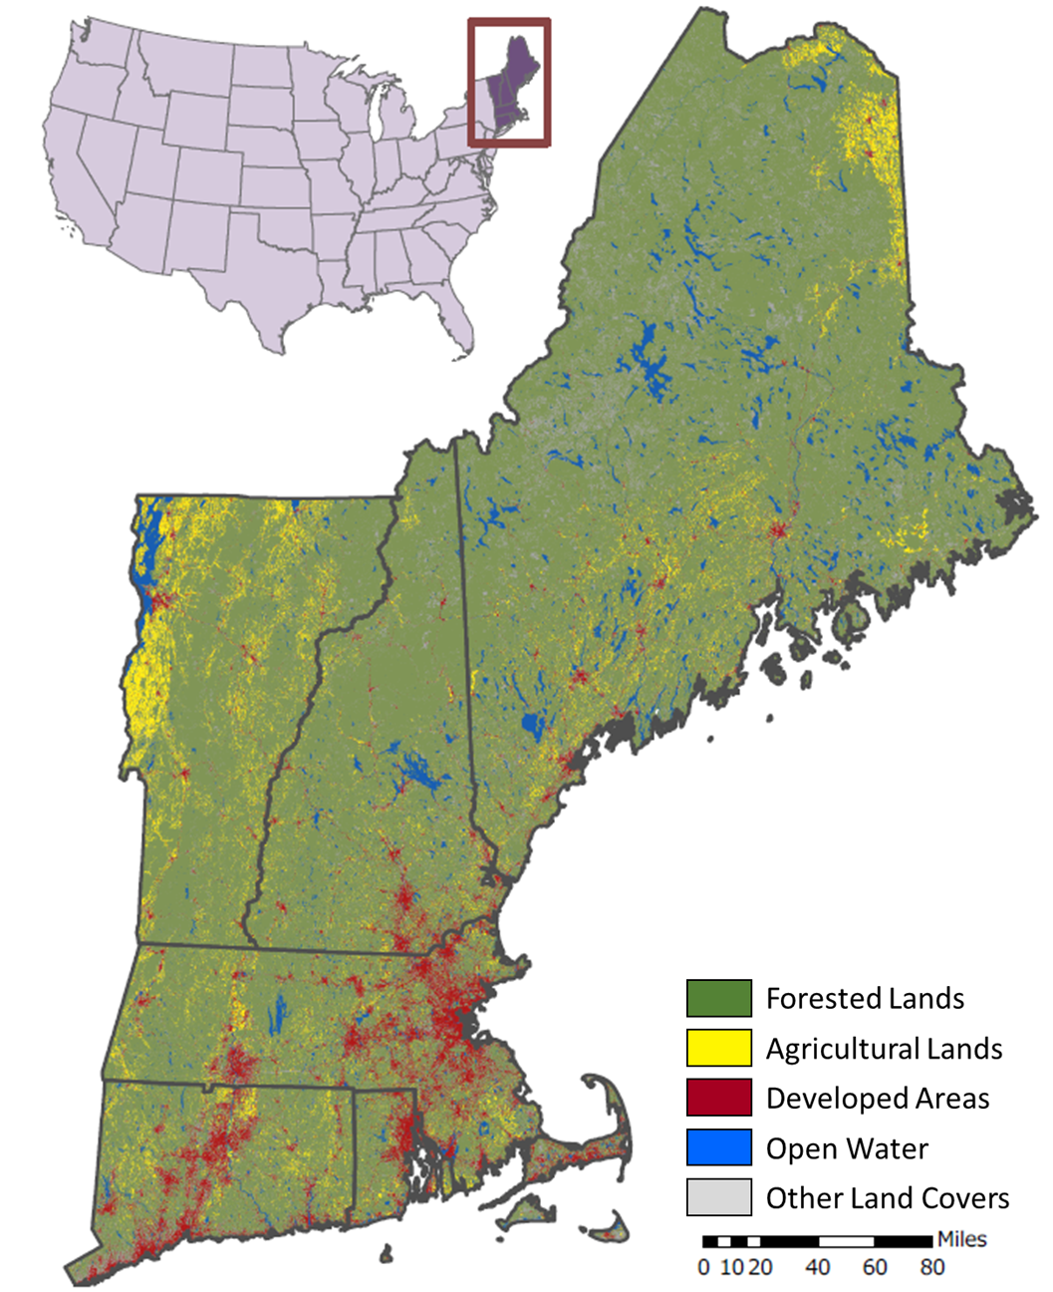
Figure S1. Aggregated 2011 National Land Cover Database land cover map of New England (USA).
(a) | (b) | (c)
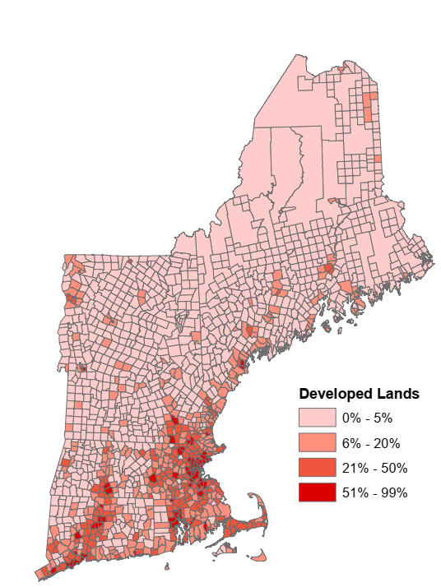 | 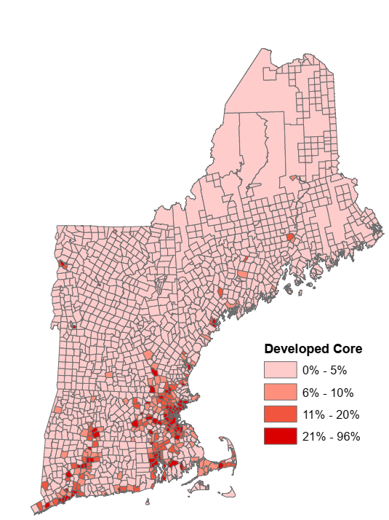 | 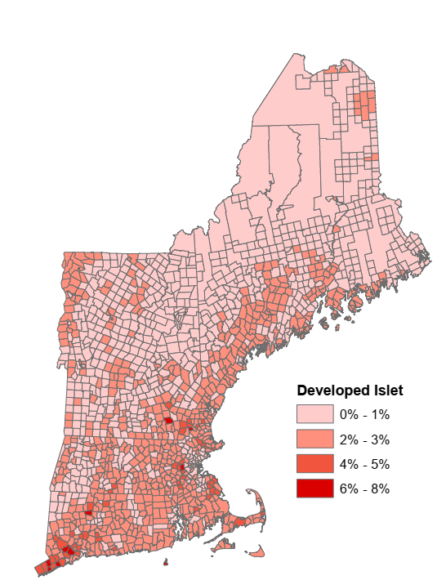
(d) | (e) | (f) | (g)
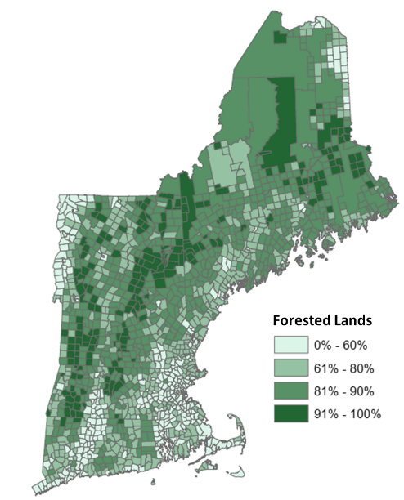 | 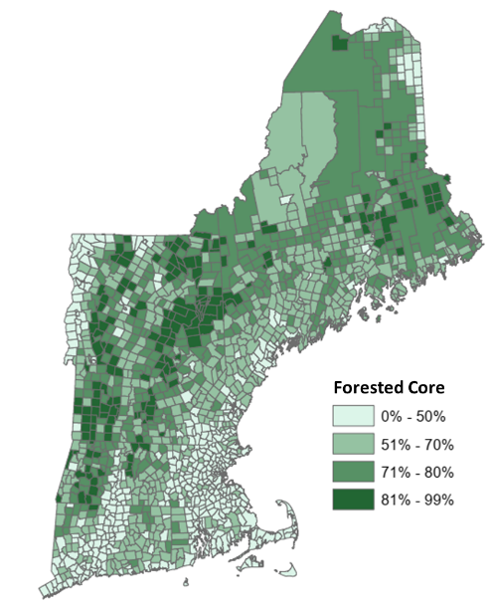 | 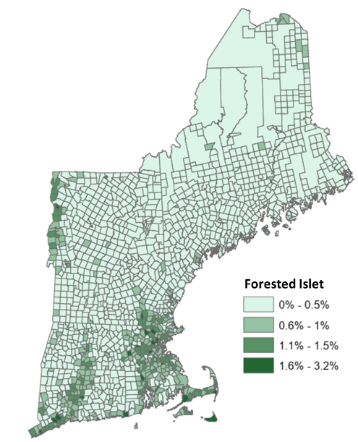 | 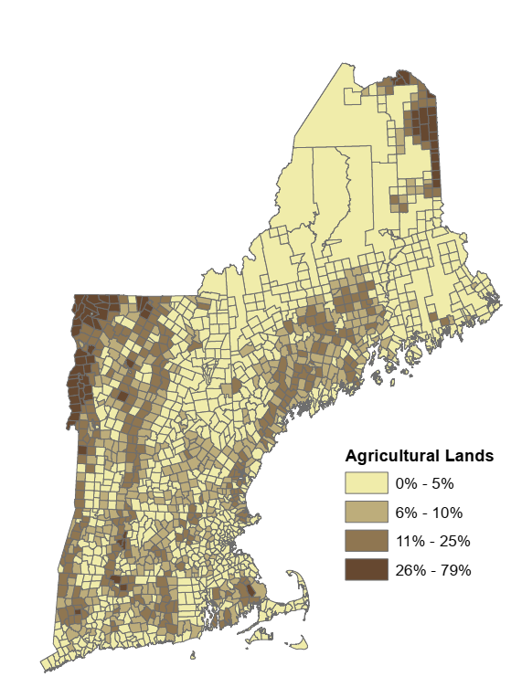
Figure S2. Land cover composition and pattern metrics distributed across the study area. Land cover aggregates are defined in the Methods section of the main text. All metrics are calculated as the percent of town land area. Thresholds differentiating classes were manually determined, but informed by geometric intervals.

(a) | 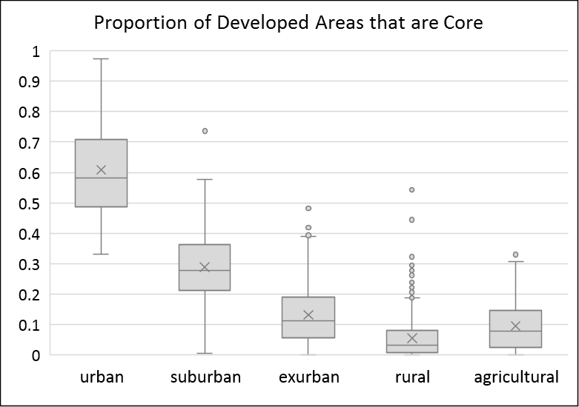 | (b) | 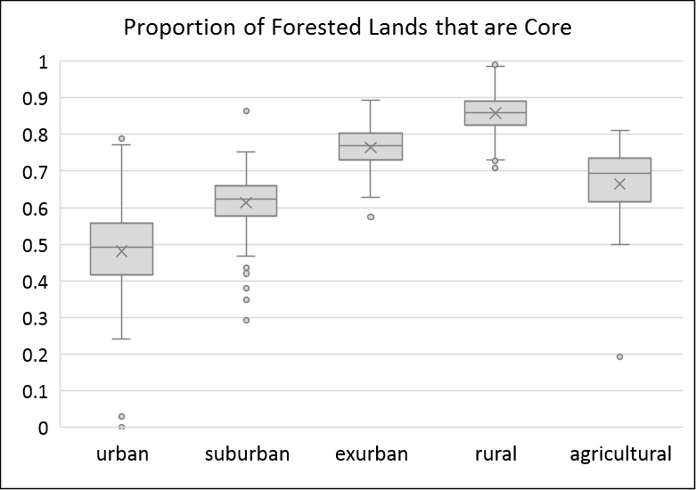
(c) | 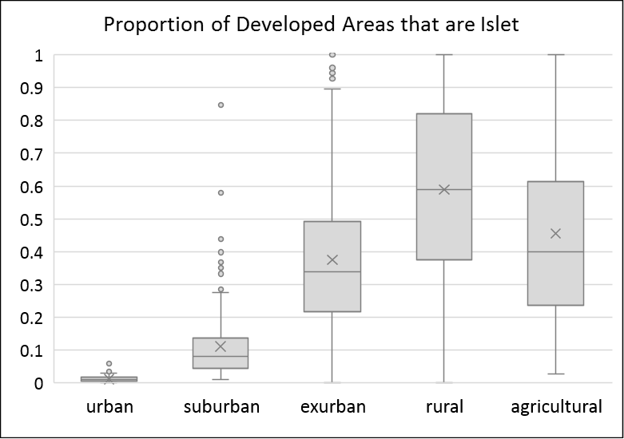 | (d) | 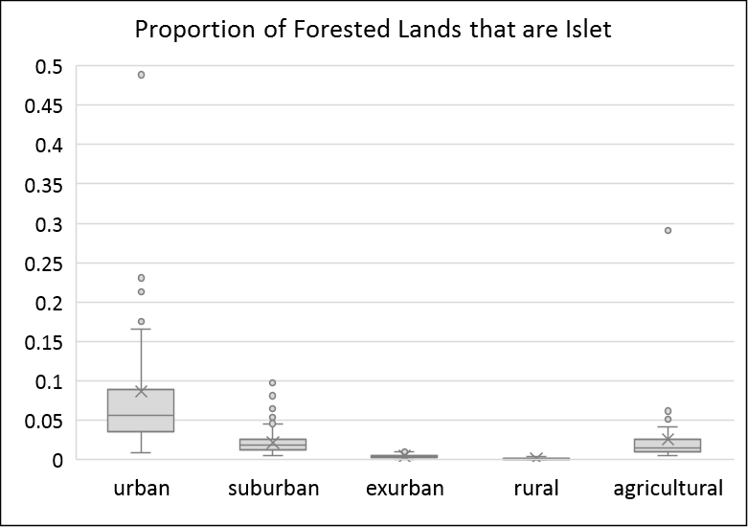
Figure S3. Additional land cover pattern metrics as a proportion of the land cover (rather than total town land area) by town type. Metrics not directly used in the cluster analysis, but further explain the cluster-based urban-rural gradient typology. Boxes show middle quartiles, lines show outer quartiles, X’s indicate medians, and dots show outliers.

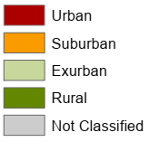
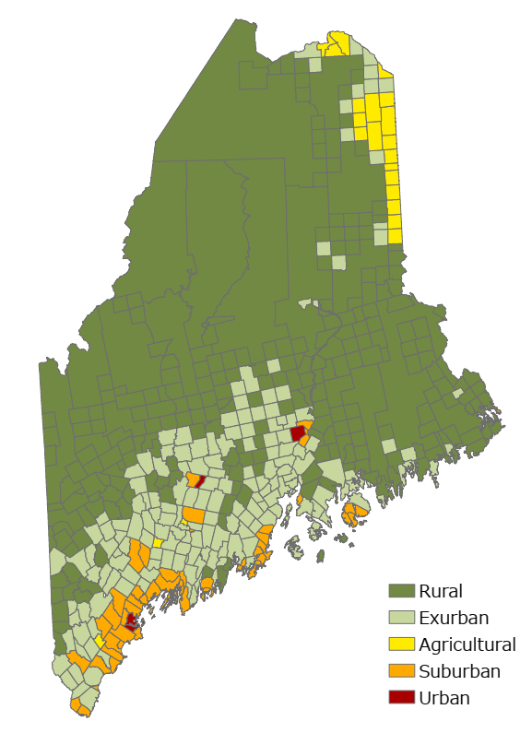
Figure S4. Application of cluster-based urban-rural gradient typology for the state of Maine (USA) illustrating how the cluster process re-scales across different sets of input data. Compared to the distribution of town types across Maine in the New England regional analysis, the results here show fewer rural towns and more towns of all other types.
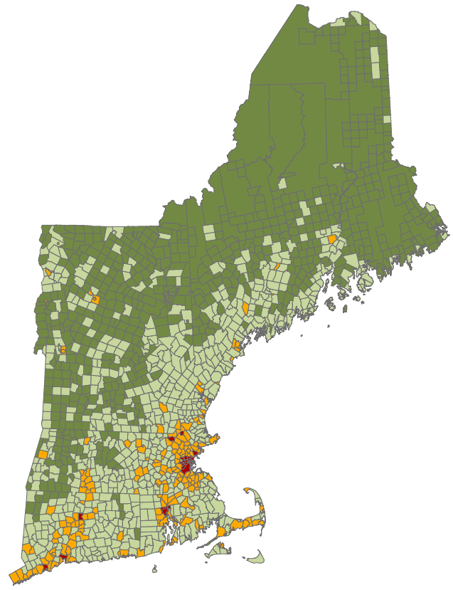
Figure S5. Alternative rule-based urban-rural gradient typology using housing density following Theobald’s (2005) 20-acre minimum lot size threshold for rural towns. Compared to the recommended 40-acre threshold shown in the main text, here there are fewer exurban and more rural towns.
References for Supporting Information

Ahrné, K., Bengtsson, J., & Elmqvist. (2009). Bumble bees (Bombus spp) along a gradient of increasing urbanization. PLoS ONE, 4(5): e5574. https://doi.org/10.1371/journal.pone.0005574
Banaszak-Cibicka, W., & Żmihorski, M. (2012). Wild bees along and urban gradient: winners and losers. Journal of Insect Conservation, 16(3), 331-343. https://doi.org/10.1007/s10841-011-9419-2
Bates, A.J., Sadler, J.P., Fairbrass, A.J., Falk, S.J., Hale, J.D., & Matthews, T.J. (2011). Changing bee and hoverfly assemblages along an urban-rural gradient. PLoS ONE, 6(8): e23459. https://doi.org/10.1371/journal.pone.0023459
Boarnet, M. G., McLaughlin, R. B., Carruthers, J. I. (2011). Does state growth management change the pattern of urban growth? Evidence from Florida. Regional Science and Urban Economics, 41(3), 236-252. https://doi.org/10.1016/j.regsciurbeco.2010.12.004
Brown, D. G., Johnson, K. M., Loveland, T. R., & Theobald, D. M. (2005). Rural land‐use trends in the conterminous United States, 1950–2000. Ecological Applications, 15(6), 1851-1863. https://doi.org/10.1890/03-5220
Carrino-Kyker, S. R., Swanson, A. K., & Burke, D. J. (2011). Changes in eukaryotic microbial communities of vernal pools along an urban–rural land use gradient. Aquatic Microbial Ecology, 62(1), 13-24. https://doi.org/10.3354/ame01432
Eakin, C. J., Hunter, M. L., & Calhoun, A. J. (2018). Bird and mammal use of vernal pools along an urban development gradient. Urban Ecosystems, 21(6), 1029-1041. https://doi.org/10.1007/s11252-018-0782-6
Evans, B. S., Ryder, T. B., Reitsma, R., Hurlbert, A. H., & Marra, P. P. (2015). Characterizing avian survival along a rural‐to‐urban land use gradient. Ecology, 96(6), 1631-1640. https://doi.org/10.1890/14-0171.1
Evans, B. S., Reitsma, R., Hurlbert, A. H., & Marra, P. P. (2018). Environmental filtering of avian communities along a rural‐to‐urban gradient in Greater Washington, DC, USA. Ecosphere, 9(11), e02402. https://doi.org/10.1002/ecs2.2402
Feist, B. E., Buhle, E. R., Baldwin, D. H., Spromberg, J. A., Damm, S. E., Davis, J. W., & Scholz, N. L. (2017). Roads to ruin: conservation threats to a sentinel species across an urban gradient. Ecological Applications, 27(8), 2382-2396. https://doi.org/10.1002/eap.1615
Fortel, L., Henry, M., Guilbaud, L., Guirao, A.L., Kuhlmann, M., Mouret, H., Rollin, O., & Vaissière, B.E. (2014). Decreasing abundance, increasing diversity and changing structure of the wild bee community (Hymenoptera: Anthophila) along an ubanization gradient. PLoS ONE, 9(8): e104679. https://doi.org/10.1371/journal.pone.0104679
Isserman, A. M. (2005). In the national interest: Defining rural and urban correctly in research and public policy. International Regional Science Review, 28(4), 465-499. https://doi.org/10.1177/0160017605279000
Jantz, H. E., Armstrong, J. B., Arjo, W., & Moore, M. J. (2012). Activity patterns of the coyote (Canis latrans) along an urban-rural gradient. In Proceedings of the Vertebrate Pest Conference (Vol. 25, No. 25). https://doi.org/10.5070/V425110351
Larondelle, N., & Haase, D. (2013). Urban ecosystem services assessment along a rural–urban gradient: A cross-analysis of European cities. Ecological Indicators, 29, 179-190. https://doi.org/10.1016/j.ecolind.2012.12.022
Lee, M. B., & Carroll, J. P. (2015). Avian diversity in pine forests along an urban–rural/agriculture-wildland gradient. Urban Ecosystems, 18(3), 685-700. https://doi.org/10.1007/s11252-014-0421-9
McDonnell, M. J., & Hahs, A. K. (2008). The use of gradient analysis studies in advancing our understanding of the ecology of urbanizing landscapes: current status and future directions. Landscape Ecology, 23(10), 1143-1155. https://doi.org/10.1007/s10980-008-9253-4
Mondal, P., Butler, B. J., Kittredge, D. B., & Moser, W. K. (2013). How are America's private forests changing? An integrated assessment of forest management, housing pressure, and urban development in alternate emissions scenarios. Land Use Policy, 32, 230-238. https://doi.org/10.1016/j.landusepol.2012.10.014
Nagy, R. C., & Lockaby, B. G. (2011). Urbanization in the Southeastern United States: Socioeconomic forces and ecological responses along an urban-rural gradient. Urban Ecosystems, 14(1), 71-86. https://doi.org/10.1007/s11252-010-0143-6
Owen, S., MacKenzie, A., Bunce, R., Stewart, H., Donovan, R., Stark, G., & Hewitt, C. (2006). Urban land classification and its uncertainties using principal component and cluster analyses: A case study for the UK West Midlands. Landscape and Urban Planning, 78(4), 311-321. https://doi.org/10.1016/j.landurbplan.2005.11.002
Rao, P, Hutyra, L.R., Raciti, S.M, & Finzi, A.C. (2013). Field and remotely sensed measures of soil and vegetation carbon and nitrogen across an urbanization gradient in the Boston metropolitan area. Urban Ecosystems, 16(3):593-616. https://doi.org/10.1007/s11252-013-0291-6
Richert, E. (2004). Land use in Maine: From production to consumption. In Barringer, R. (Ed.), Changing Maine: 1960 -2010 (pp 211-235). Gardiner, ME: Tillbury House Publishers.
Riem, J. G., Blair, R. B., Pennington, D. N., & Solomon, N. G. (2012). Estimating mammalian species diversity across an urban gradient. The American Midland Naturalist, 168(2), 315-333. https://doi.org/10.1674/0003-0031-168.2.315
Saito, M., & Koike, F. (2013). Distribution of wild mammal assemblages along an urban–rural–forest landscape gradient in warm-temperate East Asia. PloS ONE, 8(5), e65464. https://doi.org/10.1371/journal.pone.0065464
Salvati, L. (2014). The spatial pattern of soil sealing along the urban-rural gradient in a Mediterranean region. Journal of Environmental Planning and Management, 57(6), 848-861. https://doi.org/10.1080/09640568.2013.770730
Samuelson, A. E., & Leadbeater, E. (2018). A land classification protocol for pollinator ecology research: An urbanization case study. Ecology and Evolution, 8(11), 5598-5610. https://doi.org/10.1002/ece3.4087
Samuelson, A. E., Gill, R. J., Brown, M. J., & Leadbeater, E. (2018). Lower bumblebee colony reproductive success in agricultural compared with urban environments. Proceedings of the Royal Society B: Biological Sciences, 285(1881), 20180807. https://doi.org/10.1098/rspb.2018.0807
Santana, E.M., & Armstrong, J.B. (2017). Food habits and anthropogenic supplementation in coyote diets along an urban-rural gradient. Human-Wildlife Interactions 11(2), 156-166. https://doi.org/10.26077/vhdx-1033
Stein, S. M., McRoberts, R. E., Alig, R. J., Nelson, M. D., Theobald, D. M., Eley, M., . . . Carr, M. (2005). Forests on the Edge: Housing Development on America's Private Forests. (PNW-GTR-636). Portland, OR: Pacific Northwest Research Station.
Theobald, D. M. (2005). Landscape patterns of exurban growth in the USA from 1980 to 2020. Ecology and Society, 10(1). http://www.ecologyandsociety.org/vol10/iss1/art32/
Tomasevic, J. A., & Marzluff, J. M. (2017). Cavity nesting birds along an urban-wildland gradient: is human facilitation structuring the bird community? Urban Ecosystems, 20(2), 435-448. https://doi.org/10.1007/s11252-016-0605-6
Wadduwage, S., Millington, A., Crossman, N. D., & Sandhu, H. (2017). Agricultural land fragmentation at urban fringes: an application of urban-to-rural gradient analysis in Adelaide. Land, 6(2), 28. https://doi.org/10.3390/land6020028
Zhao, T., Brown, D. G., Fang, H., Theobald, D. M., Liu, T., & Zhang, T. (2012). Vegetation productivity consequences of human settlement growth in the eastern United States. Landscape Ecology, 27(8), 1149-1165.

