Insectivorous songbirds as early indicators of future defoliation by spruce budworm
Marion Germain, Louis De Grandpré, Mélanie Desrochers, Patrick M. A. James, Udayalakshmi Vepakomma, Jean-François Poulin, Daniel Kneeshaw, Marc-André Villard

Landscape Ecology

Appendix S2: Results for the 5, 10 and 30km
Tennessee warbler
At 5, 10 and 30 km, lagged cumulative spruce budworm defoliation improved the “habitat-only” model of Tennessee warbler presence (i.e. ΔAIC >10; Figure S1). As for 2km, cumulative defoliation had the greatest influence at t+1 (i.e., one year after bird counts) at each spatial scale (Table S1a, Table S2a, Table S3a). Hence, the probability of presence of Tennessee warbler increased with spruce budworm abundance a year before defoliation was visible.
Cape May warbler
At each spatial scale, lagged cumulative spruce budworm defoliation improved the “habitat-only” model of Cape May warbler presence (i.e. ΔAIC >10; Figure S2): cumulative defoliation at t+1 and t had the greatest influence on Cape May warbler presence (Table S1b, Table S2b, Table S3b).
Bay-breasted warbler
As with Tennessee warbler and Cape May warbler, lagged defoliation improved the habitat model for bay-breasted warbler (Figure S3) at each spatial scale. As for 2km the best model suggested an earlier response to increasing spruce budworm defoliation. Models with cumulative defoliation 4 years after bird counts performed equally well (Table S1c, Table S2c, Table S3c). In other words, bay-breasted warbler showed a numerical response to increasing spruce budworm populations 4 years before defoliation was observed at 5, 10 and 30km.
Figure S1: Change in AIC of habitat-only model following the addition of individual cumulative defoliation time lags for Tennessee warbler at (a) 5 km, (b) 10 km and (c) 30 km.

Figure S2: Change in AIC of habitat-only model following the addition of individual cumulative defoliation time lags for Cape May warbler at (a) 5 km, (b) 10 km and (c) 30 km.

Figure S3: Change in AIC of habitat-only model following the addition of individual cumulative defoliation time lags for bay-breasted warbler at (a) 5 km, (b) 10 km and (c) 30 km.

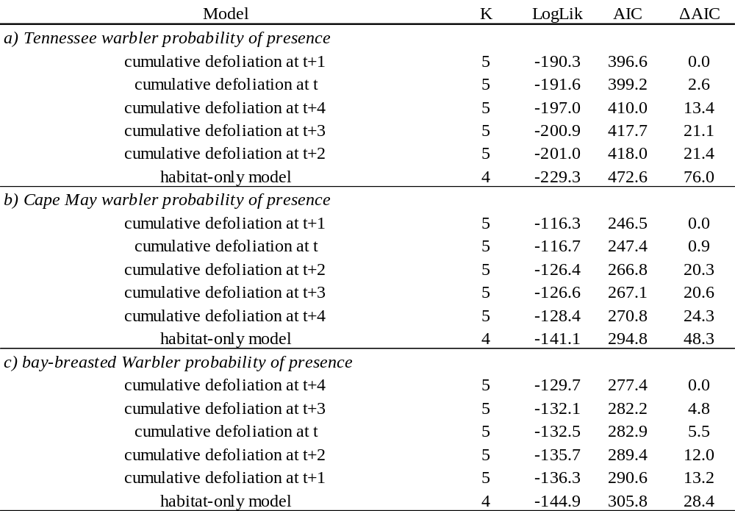
Table S1: Model comparison based on AIC values for the probability of presence of a) Tennessee warbler, b) Cape May warbler and c) bay-breasted warbler at a spatial scale of 5km. K number of parameters in the model: LogLik: log-likelihood, ΔAIC: difference in AIC to the best model (i.e. model with the lowest AIC value).
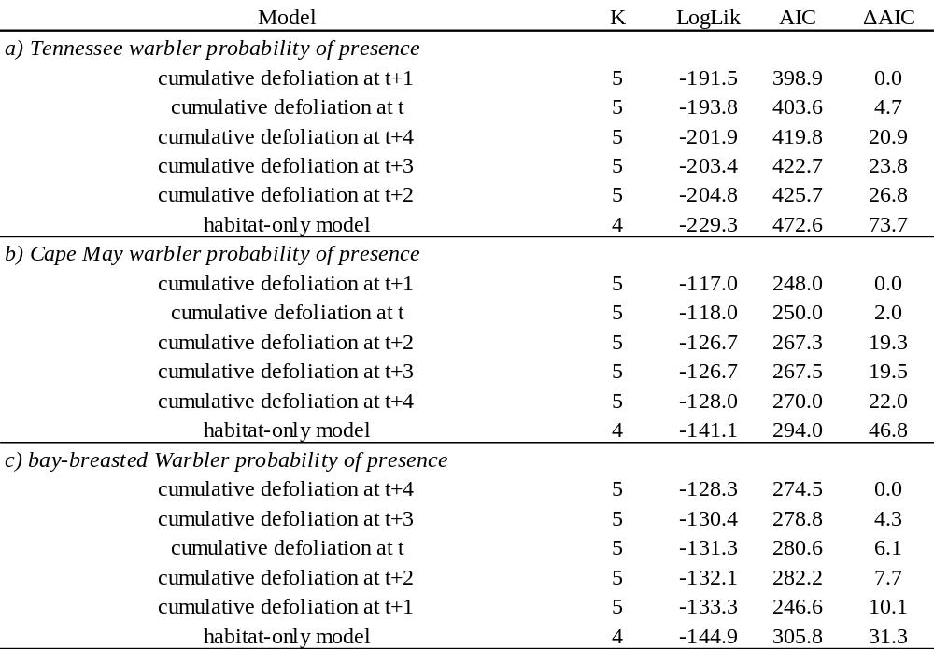
Table S2: Model comparison based on AIC values for the probability of presence of a) Tennessee warbler, b) Cape May warbler and c) bay-breasted warbler at a spatial scale of 10 km. K number of parameters in the model: LogLik: log-likelihood, ΔAIC: difference in AIC to the best model (i.e. model with the lowest AIC value).
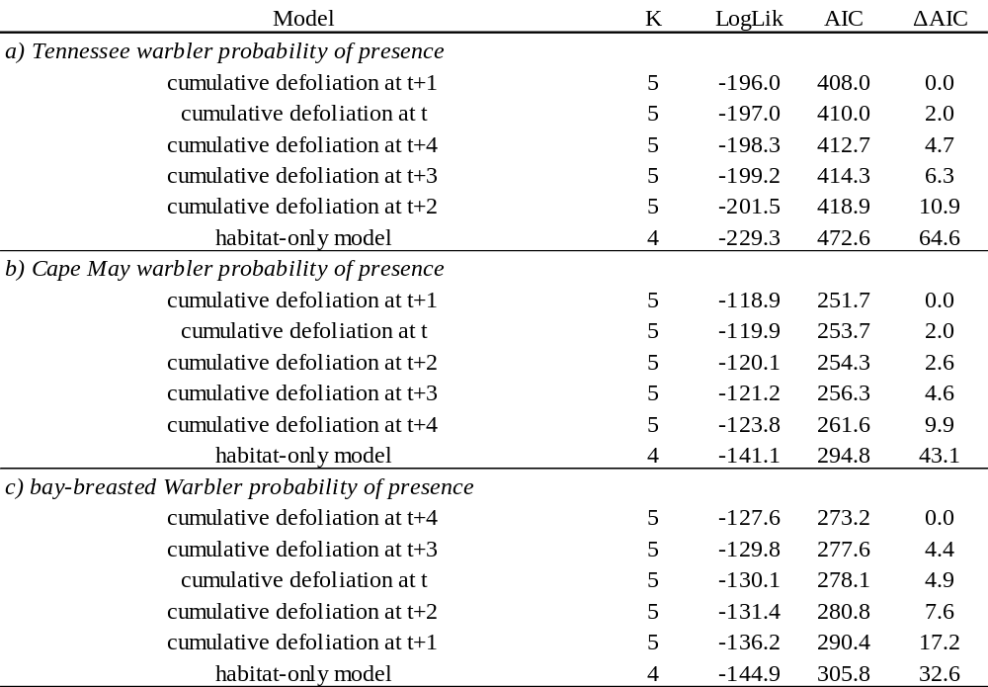
Table S3: Model comparison based on AIC values for the probability of presence of a) Tennessee warbler, b) Cape May warbler and c) bay-breasted warbler at a spatial scale of 30 km. K number of parameters in the model: LogLik: log-likelihood, ΔAIC: difference in AIC to the best model (i.e. model with the lowest AIC value).

