Insectivorous songbirds as early indicators of future defoliation by spruce budworm
Marion Germain, Louis De Grandpré, Mélanie Desrochers, Patrick M. A. James, Udayalakshmi Vepakomma, Jean-François Poulin, Daniel Kneeshaw, Marc-André Villard

Landscape Ecology

Appendix S3 – Habitat effects
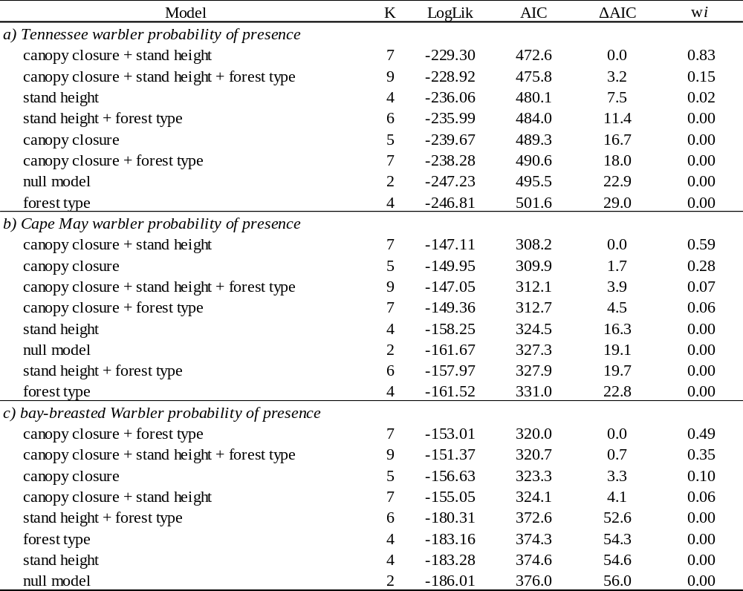
Table S1. Best habitat models based on AIC (i.e. models with ΔAIC compared to the best model < 2), as well as null model and starting models for (a) Tennessee warbler, (b) Cape May warbler and (c) bay-breasted warbler probability of presence. K: number of parameters in the model, LogLik: log-likelihood, ΔAIC: difference in AIC to the best model, wi: Akaike weight.

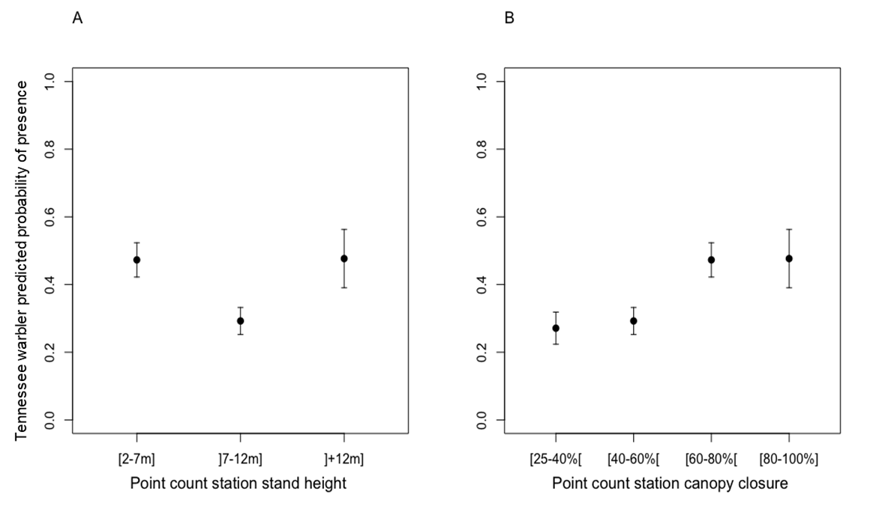
Figure S1. Tennessee warbler probability of presence according to point count station (A) stand height and (B) canopy closure. The figure shows means values (± 1 s.e.) adjusted for other parameters in the model (i.e. residuals from the model without (A) point count stand height and (B) point count canopy closure).
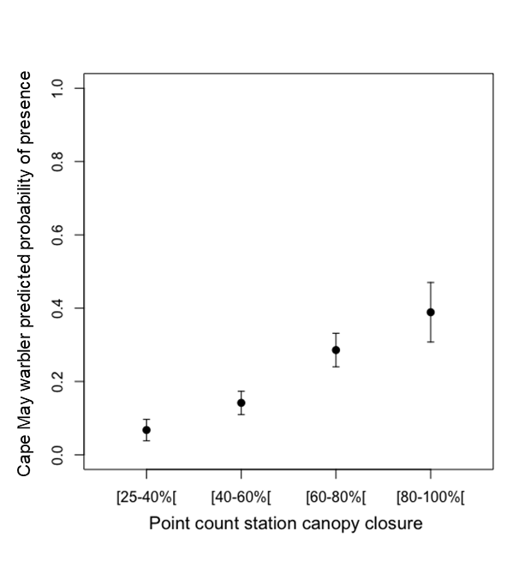
Figure S2. Cape May warbler probability of presence according to point count canopy closure. The figure shows means values (± 1 s.e.).

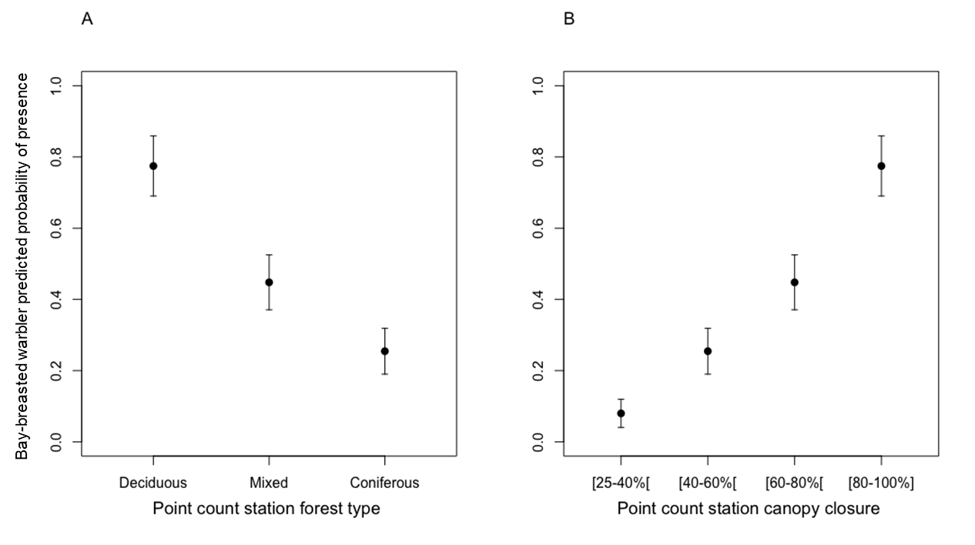
Figure S3. Bay-breasted warbler probability of presence according to point count station (A) forest type and (B) canopy closure. The figure shows means values (± 1 s.e.) adjusted for other parameters in the model (i.e. residuals from the model without (A) point count forest type and (B) point count canopy closure).
.

