Supplementary Materials for manuscript:
“The importance of spatial configuration of neighbouring land cover for explanation of surface temperature of individual patches in urban landscapes”
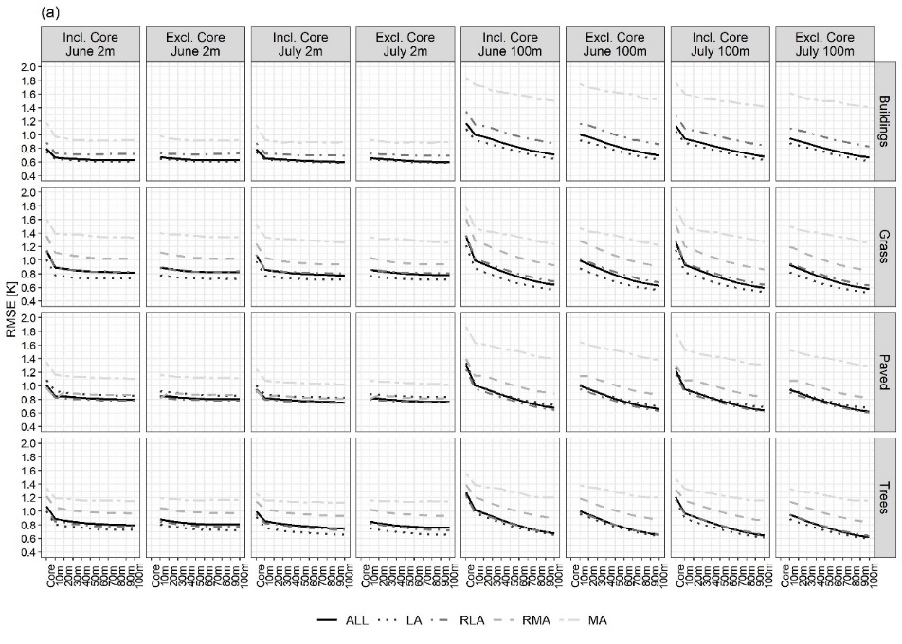
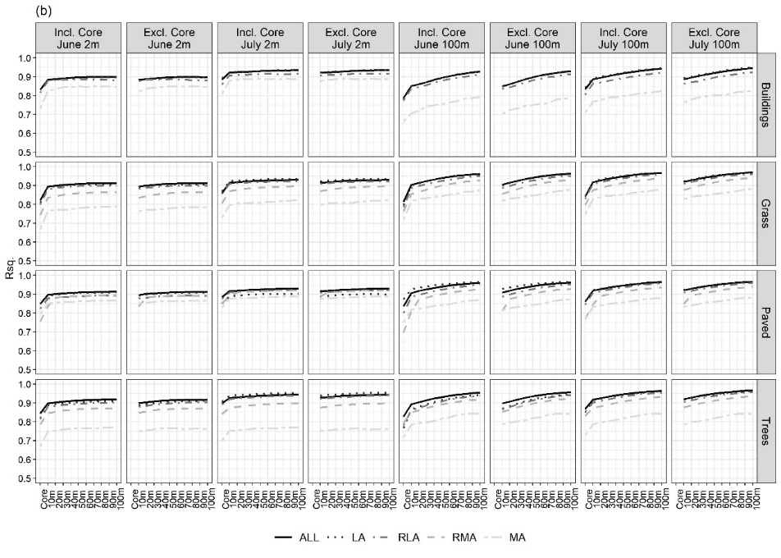
Figure S1 Mean square error (a) and R² (b) obtained from RF models relating LST at two dates (6th June and 8th July 2013) and spatial resolutions (2m and 100m) to spatial configuration descriptors for all patches of a given LC type (ALL) and separately for LC patches contained within Tier 1 clusters (LA – least aggregated, RLA – relatively less aggregated, RMA – relatively more aggregated, MA – most aggregated). ‘Core’ refers to models constructed with spatial configuration descriptors for core patches only, whilst 10m, etc., indicate models with addition of patches intersecting with consecutive zones around the core patches. Metrics for models that included or excluded the spatial configuration descriptors for core patches are shown.

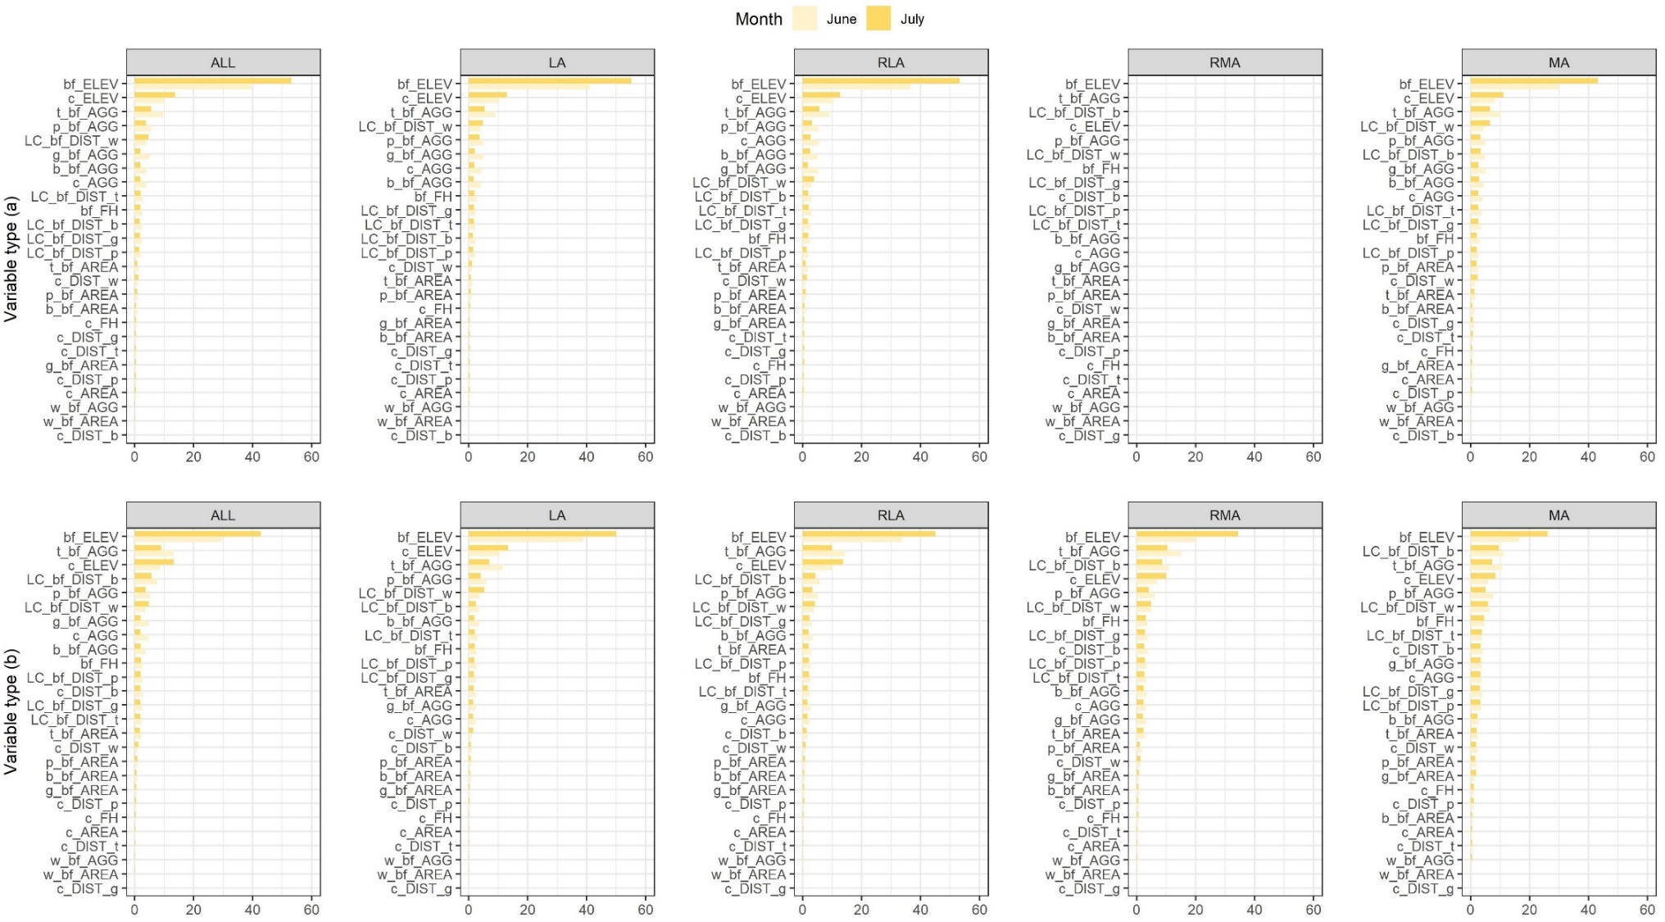
Figure S2a Percentage of total variance of LST in (a) buildings and (b) grass explained by RF models attributed to the main LST predictor groups (Table 1, main text) in June and July at 2m spatial resolution. Predictors are sorted by the decreasing mean percentage of total variance explained for the two dates.
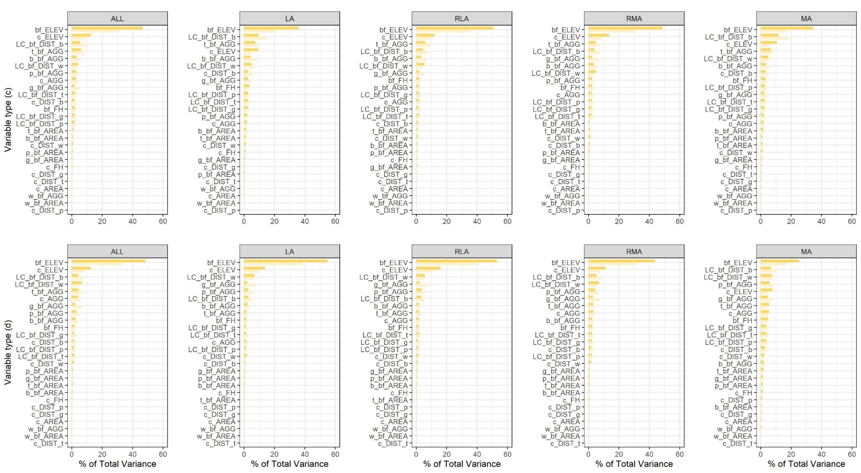
Figure S2b Percentage of total variance of LST in (c) paved and (d) trees explained by RF models attributed to the main LST predictor groups (Table 1, main text) in June and July at 2m spatial resolution. Predictors are sorted by the decreasing mean percentage of total variance explained for the two dates.

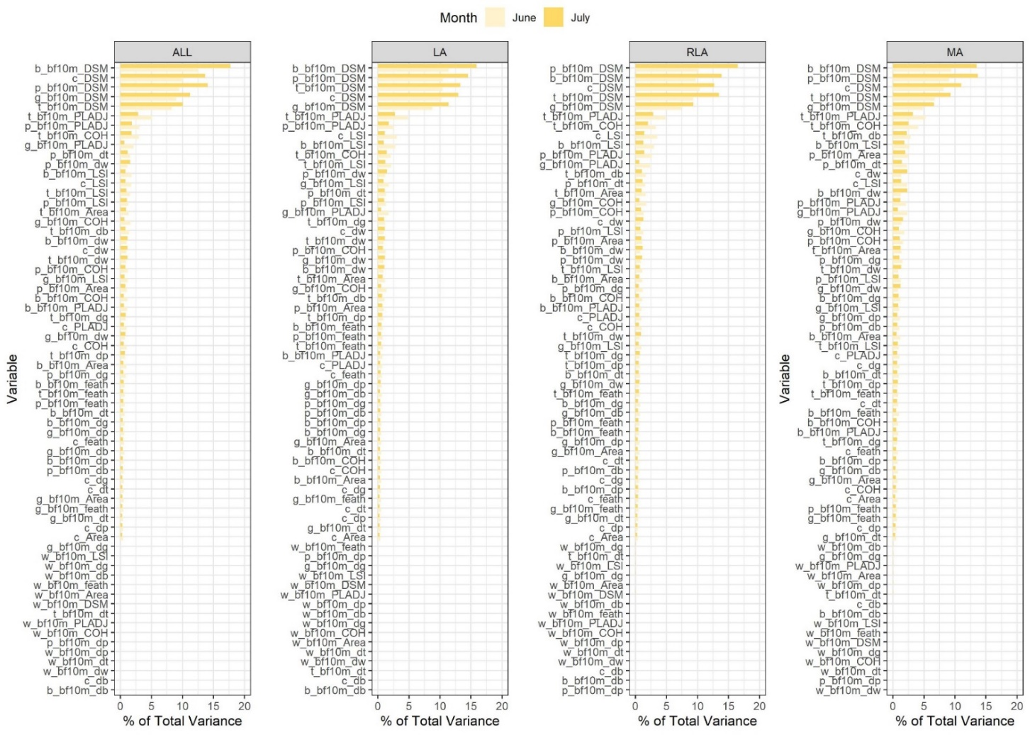
Figure S3 Importance of spatial configuration descriptors of LST of three subtypes of buildings in June and July ordered by decreasing variable importance in June expressed as the amount of variance in LST explained by the RF models. ‘bf10m’ indicates properties of LC types in the 10m buffer zone around the core (‘c’) patches, ‘b’ – buildings, ‘g’ – grass, ‘p’ – paved, ‘t’ – trees, ‘db, dg, dp, dt, dw’ - distance to buildings, grass, paved, trees, water, DSM – elevation, COH – cohesion index, LSI – landscape shape index, PLADJ – percentage of like adjacencies index.
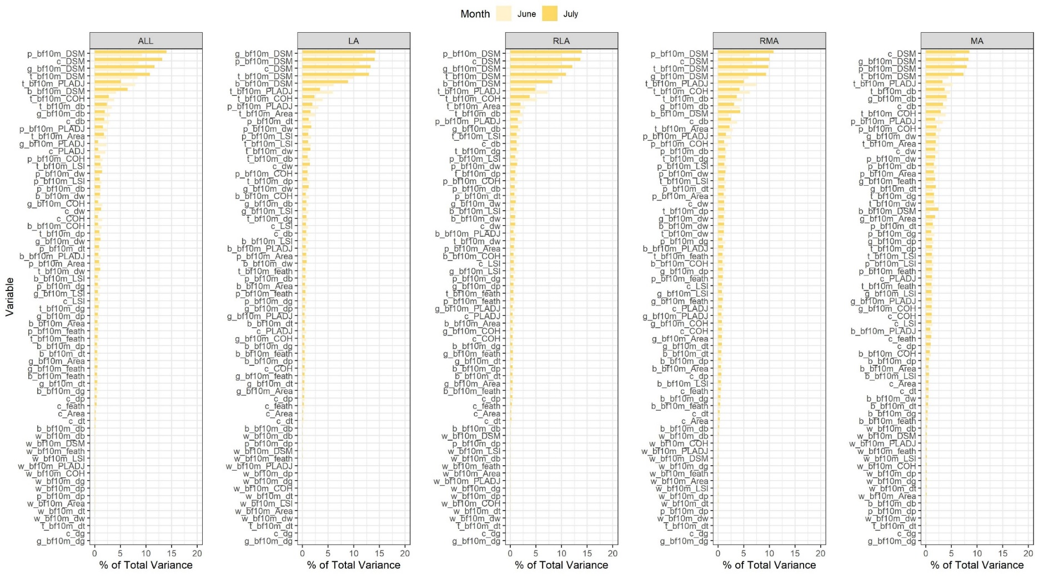
Figure S4 Importance of spatial configuration descriptors of LST of three subtypes of grass in June and July ordered by decreasing variable importance in June expressed as the amount of variance in LST explained by the RF models. ‘bf10m’ indicates properties of LC types in the 10m buffer zone around the core (‘c’) patches, ‘b’ – buildings, ‘g’ – grass, ‘p’ – paved, ‘t’ – trees, ‘db, dg, dp, dt, dw’ - distance to buildings, grass, paved, trees, water, DSM – elevation, COH – cohesion index, LSI – landscape shape index, PLADJ – percentage of like adjacencies index.
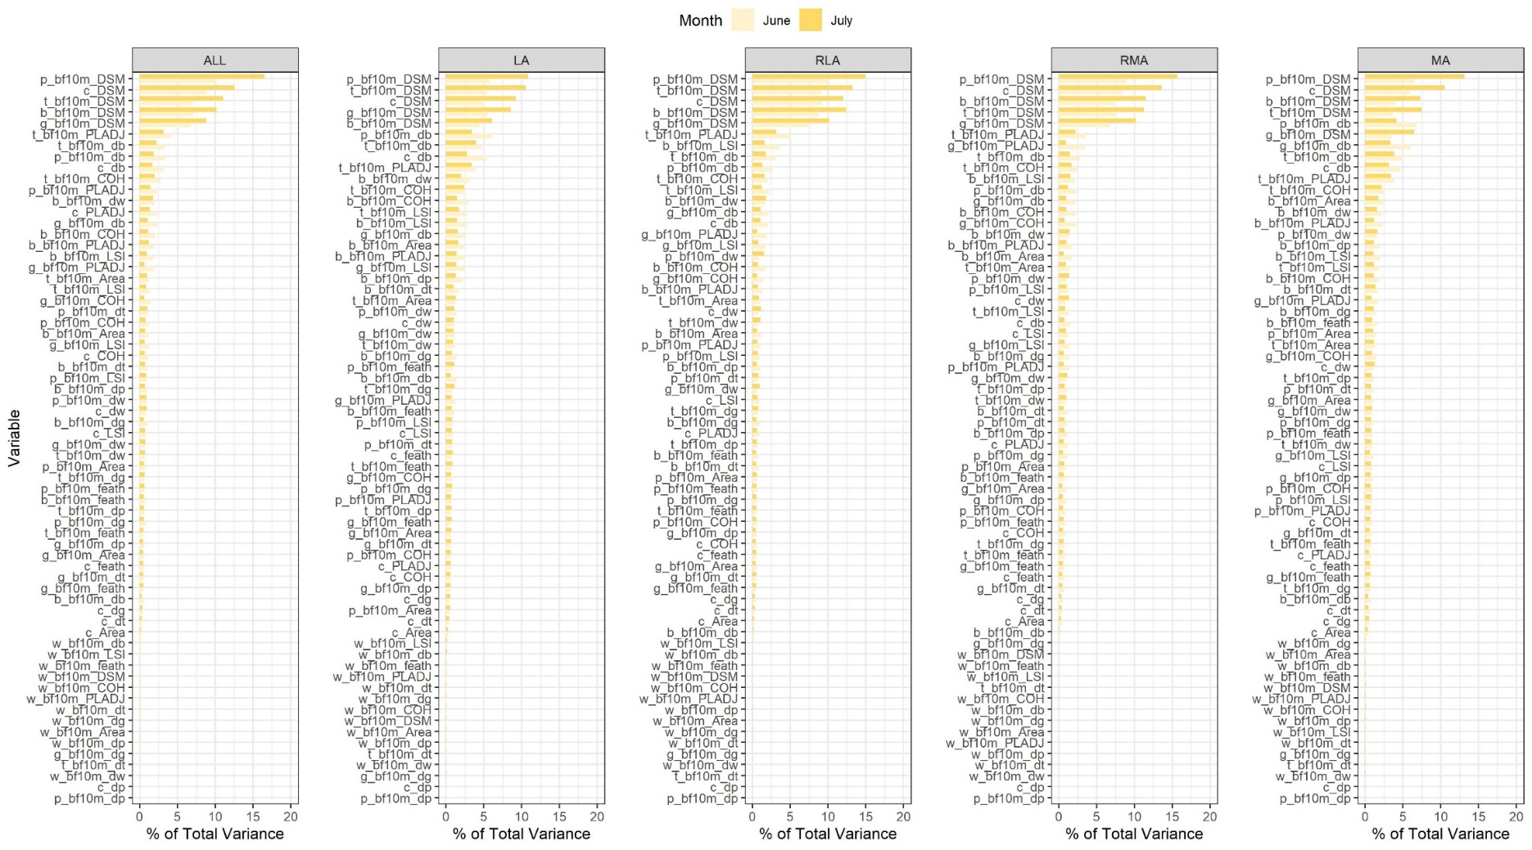
Figure S5 Importance of spatial configuration descriptors of LST of three subtypes of paved in June and July ordered by decreasing variable importance in June expressed as the amount of variance in LST explained by the RF models. ‘bf10m’ indicates properties of LC types in the 10m buffer zone around the core (‘c’) patches, ‘b’ – buildings, ‘g’ – grass, ‘p’ – paved, ‘t’ – trees, ‘db, dg, dp, dt, dw’ - distance to buildings, grass, paved, trees, water, DSM – elevation, COH – cohesion index, LSI – landscape shape index, PLADJ – percentage of like adjacencies index.
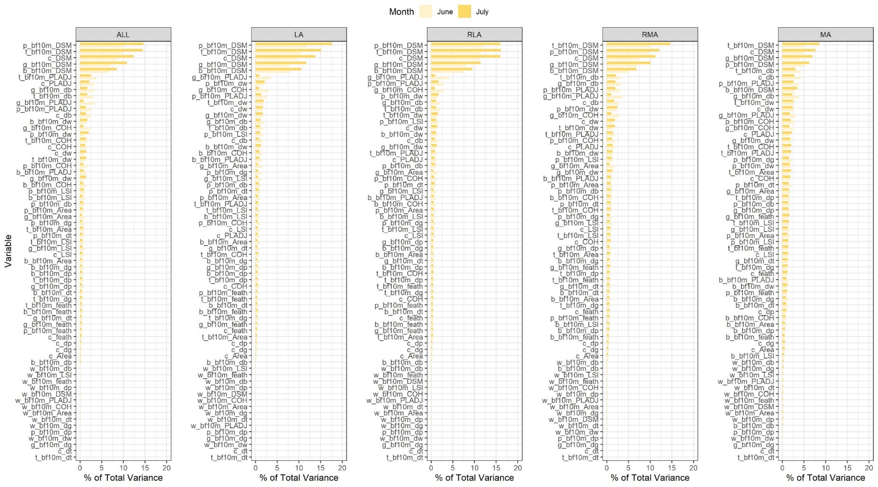
Figure S6 Importance of spatial configuration descriptors of LST of three subtypes of trees in June and July ordered by decreasing variable importance in June expressed as the amount of variance in LST explained by the RF models. ‘bf10m’ indicates properties of LC types in the 10m buffer zone around the core (‘c’) patches, ‘b’ – buildings, ‘g’ – grass, ‘p’ – paved, ‘t’ – trees, ‘db, dg, dp, dt, dw’ - distance to buildings, grass, paved, trees, water, DSM – elevation, COH – cohesion index, LSI – landscape shape index, PLADJ – percentage of like adjacencies index.
Table S1 Means and standard deviations (in brackets) of selected most important descriptors of spatial configuration of urban form attributed to the coldest and hottest LC patches of different subtypes. (c) – core patch, (bf) – patches intersecting with the 10m buffer zone around (c). All means for C and H patches at a given date are statistically different at p<0.001.
Overall aggregation level of core LC |  |  | Least aggregated (LA) |  |  |  | Relatively less aggregated (RLA) |  |  |  | Relatively more aggregated (RMA) |  |  |  | Most aggregated (MA)
DT | Descriptor | Core LC | June |  | July |  | June |  | July |  | June |  | July |  | June |  | July
DT | Descriptor | Core LC | C | H | C | H | C | H | C | H | C | H | C | H | C | H | C | H
Elevation | Elevation (c) | Buildings | 89 (22) | 102 (51) | 88 (19) | 140 (20) | 88 (21) | 92 (51) | 88 (18) | 136 (21) | n/a | n/a | n/a | n/a | 88 (21) | 101 (47) | 87 (18) | 133 (16)
Elevation | [m] | Grass | 85 (19) | 107 (49) | 84 (20) | 134 (23) | 83 (20) | 101 (49) | 82 (20) | 130 (27) | 81 (22) | 94 (51) | 81 (21) | 122 (39) | 81 (25) | 101 (49) | 82 (26) | 125 (38)
Elevation |  | Paved | 81 (18) | 80 (51) | 82 (18) | 96 (53) | 87 (21) | 106 (51) | 87 (19) | 134 (29) | 94 (53) | 108 (48) | 88 (24) | 135 (23) | 89 (25) | 103 (48) | 86 (21) | 131 (21)
Elevation |  | Trees | 87 (21) | 135 (18) | 88 (17) | 137 (17) | 88 (21) | 136 (18) | 87 (17) | 138 (18) | 85 (19) | 132 (23) | 85 (17) | 136 (18) | 85 (20) | 120 (30) | 85 (18) | 132 (24)
Aggregation | PLADJ of trees (bf) [%] | Buildings | 74 (7) | 65 (7) | 73 (7) | 66 (6) | 76 (7) | 65 (8) | 75 (7) | 66 (8) | n/a | n/a | n/a | n/a | 76 (9) | 63 (10) | 76 (8) | 65 (10)
Aggregation | PLADJ of trees (bf) [%] | Grass | 77 (9) | 65 (7) | 76 (9) | 67 (7) | 81 (7) | 66 (8) | 80 (7) | 67 (7) | 83 (7) | 68 (10) | 82 (8) | 69 (9) | 82 (8) | 69 (12) | 81 (9) | 70 (10)
Aggregation | PLADJ of trees (bf) [%] | Paved | 83 (7) | 68 (8) | 82 (7) | 68 (7) | 79 (7) | 66 (7) | 77 (8) | 66 (7) | 78 (12) | 65 (8) | 74 (10) | 66 (8) | 83 (9) | 65 (12) | 82 (11) | 66 (12)
Aggregation | COH of trees (bf) [%] | Buildings | 92 (5) | 86 (7) | 92 (5) | 87 (6) | 92 (5) | 84 (9) | 91 (5) | 85 (8) | n/a | n/a | n/a | n/a | 90 (7) | 79 (11) | 90 (6) | 81 (11)
Aggregation | COH of trees (bf) [%] | Grass | 93 (5) | 86 (7) | 93 (5) | 87 (7) | 95 (4) | 86 (7) | 94 (4) | 87 (7) | 95 (4) | 86 (9) | 94 (5) | 87 (8) | 93 (5) | 85 (12) | 93 (7) | 87 (9)
Aggregation | COH of trees (bf) [%] | Paved | 94 (5) | 88 (7) | 95 (5) | 88 (7) | 93 (5) | 87 (6) | 92 (5) | 87 (6) | 91 (11) | 84 (8) | 90 (7) | 85 (7) | 93 (7) | 82 (12) | 93 (8) | 82 (12)
Aggregation | PLADJ of grass (bf) [%] | Trees | 72 (16) | 53 (12) | 64 (17) | 57 (13) | 71 (15) | 54 (10) | 65 (16) | 57 (11) | 77 (13) | 58 (12) | 72 (14) | 60 (13) | 79 (11) | 61 (15) | 76 (12) | 66 (16)
Aggregation | COH of grass (bf) [%] | Trees | 85 (13) | 70 (13) | 78 (16) | 73 (12) | 85 (12) | 71 (10) | 79 (14) | 73 (11) | 89 (10) | 74 (11) | 86 (12) | 76 (12) | 91 (8) | 77 (14) | 89 (9) | 81 (13)
Aggregation | PLADJ of paved (bf) | Buildings | 72 (5) | 76 (5) | 72 (5) | 76 (4) | 74 (6) | 80 (5) | 75 (7) | 79 (5) | n/a | n/a | n/a | n/a | 81 (7) | 86 (5) | 81 (6) | 86 (4)
Aggregation | [%] | Grass | 72 (8) | 78 (6) | 72 (8) | 77 (5) | 74 (9) | 78 (6) | 74 (9) | 77 (6) | 73 (12) | 78 (8) | 73 (12) | 78 (7) | 67 (15) | 81 (9) | 68 (15) | 80 (8)
Aggregation |  | Trees | 74 (9) | 80 (6) | 74 (7) | 78 (6) | 72 (8) | 78 (5) | 72 (7) | 77 (5) | 70 (12) | 79 (6) | 71 (11) | 78 (6) | 69 (15) | 82 (8) | 70 (15) | 79 (9)
Aggregation | LSI (c) [-] | Buildings | 4.9 (1) | 6.0 (0.8) | 5.1 (1) | 5.9 (0.7) | 4 (0.9) | 5.2 (1) | 4.1 (1) | 5.0 (0.9) | n/a | n/a | n/a | n/a | 2.6 (0.6) | 3.2 (0.9) | 2.6 (0.6) | 3.2 (0.9)
Aggregation | LSI of buildings (bf) [-] | Buildings | 5.0 (1) | 6.0 (0.8) | 5.1 (1) | 5.9 (0.7) | 4 (0.9) | 5.3 (1) | 4.2 (1) | 5.1 (0.9) | n/a | n/a | n/a | n/a | 2.5 (0.6) | 3.3 (0.9) | 2.5 (0.6) | 3.2 (0.9)
Aggregation | LSI of buildings (bf) [-] | Paved | 4.1 (1) | 5.5 (1.1) | 4.5 (1) | 5.5 (1) | 4.4 (1.1) | 5.7 (0.9) | 4.7 (1.1) | 5.7 (0.9) | 3.7 (1.2) | 5.1 (1.3) | 4.1 (1.4) | 5.2 (1.1) | 3.0 (1) | 3.4 (1.2) | 2.8 (1.2) | 3.5 (1.1)
Distance | Distance to water (c) [m] | Buildings | 257 (209) | 483 (315) | 252 (193) | 569 (363) | 274 (227) | 457 (268) | 276 (208) | 565 (331) | n/a | n/a | n/a | n/a | 279 (198) | 455 (305) | 276 (170) | 527 (316)
Distance | Distance to water (c) [m] | Grass | 269 (202) | 517 (316) | 268 (197) | 587 (336) | 237 (195) | 482 (319) | 239 (197) | 555 (360) | 182 (190) | 428 (326) | 183 (193) | 510 (369) | 137 (176) | 398 (334) | 154 (199) | 468 (370)
Distance | Distance to water (c) [m] | Paved | 118 (150) | 410 (264) | 135 (164) | 443 (289) | 235 (212) | 506 (323) | 245 (206) | 571 (353) | 326 (319) | 498 (321) | 278 (210) | 567 (350) | 176 (173) | 443 (288) | 188 (168) | 516 (305)
Distance | Distance to water (c) [m] | Trees | 233 (199) | 572 (315) | 247 (190) | 571 (329) | 232 (212) | 573 (351) | 238 (200) | 582 (371) | 182 (203) | 537 (353) | 183 (183) | 555 (369) | 159 (184) | 513 (400) | 163 (180) | 559 (426)
Distance | Distance to buildings (c) [m] | Grass | 19 (36) | 8 (8) | 18 (35) | 8 (8) | 34 (42) | 10 (12) | 33 (42) | 9 (11) | 70 (62) | 18 (38) | 69 (65) | 15 (20) | 98 (71) | 42 (74) | 97 (76) | 32 (42)
Distance | Distance to buildings (c) [m] | Paved | 94 (73) | 8 (23) | 81 (74) | 8 (22) | 35 (50) | 4 (8) | 27 (46) | 5 (10) | 34 (32) | 5 (10) | 33 (77) | 5 (12) | 99 (77) | 10 (21) | 98 (94) | 10 (19)
Distance | Distance to buildings (c) [m] | Trees | 47 (75) | 8 (16) | 40 (84) | 8 (15) | 37 (56) | 7 (12) | 29 (53) | 7 (11) | 65 (66) | 11 (18) | 55 (64) | 11 (15) | 88 (63) | 25 (37) | 81 (61) | 29 (35)
Distance | Distance of trees (bf) | Grass | 19 (31) | 7 (7) | 18 (30) | 7 (7) | 34 (39) | 9 (10) | 33 (40) | 9 (9) | 67 (58) | 16 (31) | 67 (61) | 14 (15) | 90 (65) | 33 (61) | 90 (69) | 27 (37)
Distance | to buildings [m] | Paved | 90 (69) | 9 (17) | 79 (69) | 8 (13) | 35 (47) | 6 (4) | 27 (42) | 6 (5) | 34 (32) | 6 (9) | 29 (59) | 7 (9) | 91 (69) | 11 (16) | 89 (76) | 12 (18)
Distance |  | Trees | 47 (75) | 8 (16) | 40 (84) | 8 (15) | 37 (56) | 7 (11) | 30 (52) | 8 (11) | 65 (64) | 12 (18) | 55 (62) | 12 (14) | 86 (60) | 28 (35) | 80 (58) | 30 (32)
Distance | Distance of grass (bf) | Grass | 19 (36) | 8 (7) | 18 (35) | 8 (7) | 34 (41) | 10 (11) | 33 (42) | 9 (10) | 70 (61) | 18 (37) | 69 (65) | 16 (19) | 97 (69) | 44 (73) | 96 (72) | 33 (41)
Distance | to buildings [m] | Paved | 91 (69) | 10 (20) | 78 (70) | 10 (20) | 37 (49) | 7 (8) | 28 (45) | 7 (9) | 36 (31) | 7 (8) | 36 (77) | 8 (10) | 100 (76) | 14 (23) | 102 (97) | 15 (23)
Distance |  | Trees | 47 (68) | 9 (15) | 40 (79) | 9 (14) | 38 (54) | 8 (11) | 30 (51) | 8 (10) | 65 (63) | 12 (17) | 55 (62) | 12 (14) | 85 (59) | 28 (41) | 79 (58) | 29 (33)

Table S2 Full list of variables considered in this study.
Variable | Description
c_Area | Mean area of core patches
c_COH | Mean cohesion index of core patches
c_db | Mean distance to buildings of core patches
c_dg | Mean distance to grass of core patches
c_dp | Mean distance to paved of core patches
c_DSM | Mean distance to trees of core patches
c_dt | Mean distance to water of core patches
c_dw | Mean surface elevation of core patches
c_feath | Mean height of core patches
c_LSI | Mean landscape shape index of core patches
c_PLADJ | Mean percentage of like adjacencies of core patches intersecting with the 10m buffer zone
b_bf10m_COH | Mean cohesion index of buildings intersecting with the 10m buffer zone
b_bf10m_db | Mean distance to buildings of buildings intersecting with the 10m buffer zone
b_bf10m_dg | Mean distance to grass of buildings intersecting with the 10m buffer zone
b_bf10m_dp | Mean distance to paved of buildings intersecting with the 10m buffer zone
b_bf10m_dt | Mean distance to trees of buildings intersecting with the 10m buffer zone
b_bf10m_dw | Mean distance to water of buildings intersecting with the 10m buffer zone
b_bf10m_DSM | Mean surface elevation of buildings intersecting with the 10m buffer zone
b_bf10m_feath | Mean height of buildings intersecting with the 10m buffer zone
b_bf10m_Area | Mean area of buildings intersecting with the 10m buffer zone
b_bf10m_LSI | Mean landscape shape index of buildings intersecting with the 10m buffer zone
b_bf10m_PLADJ | Mean percentage of like adjacencies of buildings intersecting with the 10m buffer zone
g_bf10m_COH | Mean cohesion index of grass intersecting with the 10m buffer zone
g_bf10m_db | Mean distance to buildings of grass intersecting with the 10m buffer zone
g_bf10m_dg | Mean distance to grass of grass intersecting with the 10m buffer zone
g_bf10m_dp | Mean distance to paved of grass intersecting with the 10m buffer zone
g_bf10m_dt | Mean distance to trees of grass intersecting with the 10m buffer zone
g_bf10m_dw | Mean distance to water of grass intersecting with the 10m buffer zone
g_bf10m_DSM | Mean surface elevation of grass intersecting with the 10m buffer zone
g_bf10m_feath | Mean height of grass intersecting with the 10m buffer zone
g_bf10m_Area | Mean area of grass intersecting with the 10m buffer zone
g_bf10m_LSI | Mean landscape shape index of grass intersecting with the 10m buffer zone
g_bf10m_PLADJ | Mean percentage of like adjacencies of grass intersecting with the 10m buffer zone
p_bf10m_COH | Mean cohesion index of paved intersecting with the 10m buffer zone
p_bf10m_db | Mean distance to buildings of paved intersecting with the 10m buffer zone
p_bf10m_dg | Mean distance to grass of paved intersecting with the 10m buffer zone
p_bf10m_dp | Mean distance to paved of paved intersecting with the 10m buffer zone
p_bf10m_dt | Mean distance to trees of paved intersecting with the 10m buffer zone
p_bf10m_dw | Mean distance to water of paved intersecting with the 10m buffer zone
p_bf10m_DSM | Mean surface elevation of paved intersecting with the 10m buffer zone
p_bf10m_feath | Mean height of paved intersecting with the 10m buffer zone
p_bf10m_Area | Mean area of paved intersecting with the 10m buffer zone
p_bf10m_LSI | Mean landscape shape index of paved intersecting with the 10m buffer zone
p_bf10m_PLADJ | Mean percentage of like adjacencies of paved intersecting with the 10m buffer zone
t_bf10m_COH | Mean cohesion index of trees intersecting with the 10m buffer zone
t_bf10m_db | Mean distance to buildings of trees intersecting with the 10m buffer zone
t_bf10m_dg | Mean distance to grass of trees intersecting with the 10m buffer zone
t_bf10m_dp | Mean distance to paved of trees intersecting with the 10m buffer zone
t_bf10m_dt | Mean distance to trees of trees intersecting with the 10m buffer zone
t_bf10m_dw | Mean distance to water of trees intersecting with the 10m buffer zone
t_bf10m_DSM | Mean surface elevation of trees intersecting with the 10m buffer zone
t_bf10m_feath | Mean height of trees intersecting with the 10m buffer zone
t_bf10m_Area | Mean area of trees intersecting with the 10m buffer zone
t_bf10m_LSI | Mean landscape shape index of trees intersecting with the 10m buffer zone
t_bf10m_PLADJ | Mean percentage of like adjacencies of trees intersecting with the 10m buffer zone
w_bf10m_COH | Mean cohesion index of water intersecting with the 10m buffer zone
w_bf10m_db | Mean distance to buildings of water intersecting with the 10m buffer zone
w_bf10m_dg | Mean distance to grass of water intersecting with the 10m buffer zone
w_bf10m_dp | Mean distance to paved of water intersecting with the 10m buffer zone
w_bf10m_dt | Mean distance to trees of water intersecting with the 10m buffer zone
w_bf10m_dw | Mean distance to water of water intersecting with the 10m buffer zone
w_bf10m_DSM | Mean surface elevation of water intersecting with the 10m buffer zone
w_bf10m_feath | Mean height of water intersecting with the 10m buffer zone
w_bf10m_Area | Mean area of water intersecting with the 10m buffer zone
w_bf10m_LSI | Mean landscape shape index of water intersecting with the 10m buffer zone
w_bf10m_PLADJ | Mean percentage of like adjacencies of water intersecting with the 10m buffer zone

Table S3 Ordinary kriging results for LST in the three towns at 2m and 100m resolution observed on 6th June and 8th July 2013. Major range is indicative of spatial auto-correlation distance of LST values.
Dataset | BD | LT JUN 100m | MK | BD | LT JUL 100m | MK | BD | LT JUN 2m | MK | BD | LT JUL 2m | MK
Function | Exp | Exp | Exp | Exp | Exp | Exp | Exp | Exp | Exp | Exp | Exp | Exp
Major range [m] | 1100 | 1000 | 1100 | 900 | 1050 | 1100 | 300 | 520 | 400 | 250 | 450 | 350
Nugget | 0 | 0 | 0 | 0 | 0 | 0 | 0.1 | 0 | 0.08 | 0.5 | 0 | 0.11
Partial sill | 4.7 | 4.34 | 6.6 | 2.7 | 3.6 | 4.85 | 3.25 | 3.2 | 3.7 | 1.5 | 2.54 | 2.3
Lag | 100 | 100 | 100 | 100 | 100 | 100 | 10 | 10 | 10 | 10 | 10 | 10
No of Lags | 30 | 30 | 30 | 30 | 30 | 30 | 100 | 100 | 100 | 100 | 100 | 100
RMSE | 0.07 | 0.07 | 0.08 | 0.06 | 0.06 | 0.07 | 0.34 | 0.23 | 0.42 | 0.52 | 0.19 | 0.41

Table S5 Properties of Tier 1 clusters. LC – Land Cover, T1CL – Tier one cluster number. Thermal properties based on LST means in June and July at 2m and 100m resolution sorted according to decreasing aggregation level: MA – most aggregated, RMA – relatively more aggregated, RLA – relatively less aggregated, LA – least aggregated.
LC class | Tier 1 Cluster (LC type) | Aggreg-  ation level | Description – spatial properties including use | Thermal properties  (LC subtype)
Buildings | T1CL1 | MA | Typically in industrial, commercial and other non-residential use. Largest size, most aggregated, located farthest away from grass or trees. Located primarily in city centres and on industrial estates. | Warmest
Buildings | T1CL2 | RLA | Intermediary in size and other descriptors, representative of terraced housing, flats or smaller non-residential use. Due to height and proximity to vegetation more similar to CL3 than CL1. Typically located closer to city centres than buildings in CL3. | Medium-cold
Buildings | T1CL3 | LA | Smallest, most fragmented and lowest buildings typically in residential use (detached and semi-detached housing associated with gardens). Located in close proximity to vegetation, typically farthest away from city centres. | Coldest
Paved | T1CL1 | MA | Most aggregated, typical of squares, paved areas in commercial or industrial estates or wider roads with low amounts of scattered greenspaces or housing. Located distinctly farthest away from buildings, but not from grass or trees. | Warmest
Paved | T1CL3 | RMA | Wider roads as well as crossroads in areas where roads are relatively narrow | Warmest
Paved | T1CL4 | RLA | Mostly residential or narrower parts of main roads, less aggregated than CL3 | Medium-cold
Paved | T1CL2 | LA | Distinctly least aggregated and located in close proximity to grass or trees. Typically narrow patches of footpaths, rarely roads, scattered in residential areas or crossing larger greenspaces. | Coldest
Grass | T1CL4 | MA | Very large stretches of grass typical of parks and recreation areas, and occasionally larger strips of grass at roadsides. Located farthest away from buildings. | Coldest
Grass | T1CL2 | RMA | Wider strips of grass located next to roads or in parkland in between rows of trees, relatively far from buildings | Medium-cold
Grass | T1CL3 | RLA | Patches of grass that were larger than in CL 1 and located either next to residential housing or on industrial estates. Also includes elongated, narrow strips of grass next to roads. | Medium-warm
Grass | T1CL1 | LA | Small patches of grass located in residential areas and typically immediately adjacent to trees, paved areas and buildings | Warmest
Trees | T1CL2 | MA | Largest, highly aggregated stretches of urban forest located away from buildings and paved areas | Coldest
Trees | T1CL4 | RMA | Well-aggregated patches of trees that could be scattered across large patches of grass or form elongated but relatively wide tree patches at roadsides; also patches of trees located in larger gardens in-between wider-spaced housing | Medium-cold
Trees | T1CL1 | RLA | Relatively small but bigger and more aggregated patches typical of terraced housing | Medium-warm
Trees | T1CL3 | LA | Very small and fragmented patches typically located near detached or semi-detached housing | Warmest
Water | T1CL3 | MA | Large and most aggregated water bodies such as lakes | Coldest
Water | T1CL1 | RMA | Wider rivers, canals or ponds, high aggregation metrics values | Coldest
Water | T1CL2 | RLA | Narrow stream and ditches | Medium-warm
Water | T1CL4 | LA | Narrow stream and ditches, very close proximity to trees | Warmest

(a)  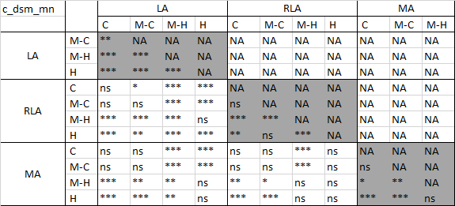 | (b)  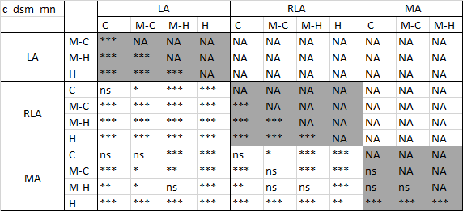
(c)  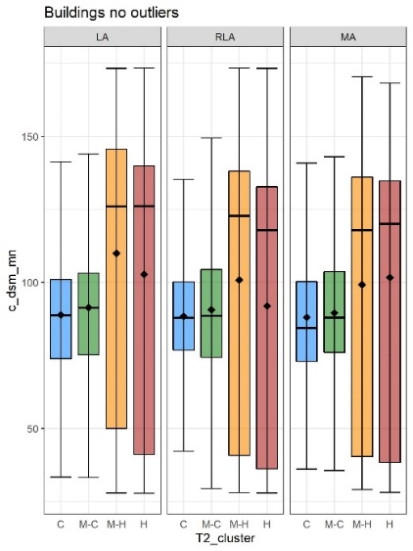 | (d)  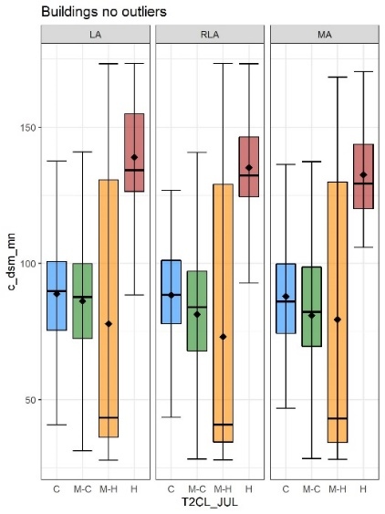
Figure S7 Results of the ANOVA (a, b) and boxplots (c, d) for elevation (dsm) of the core patches of buildings in June (a, c) and July (b, d). Boxplots represent elevation values associated with the coldest (C), medium-cold (M-C), medium-hot (M-H) and the hottest (H) Tier 2 clusters within each Tier 1 cluster: LA – Least aggregated, RLA – Relatively less aggregated, MA – Most aggregated.
(a)  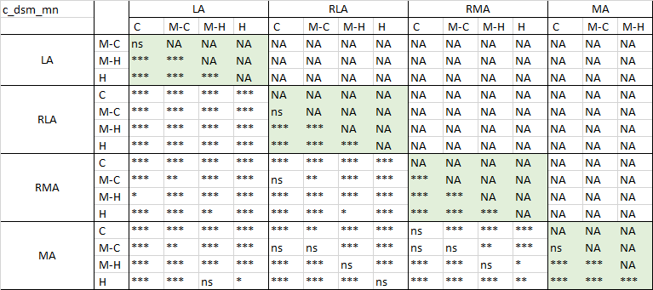 | (b)  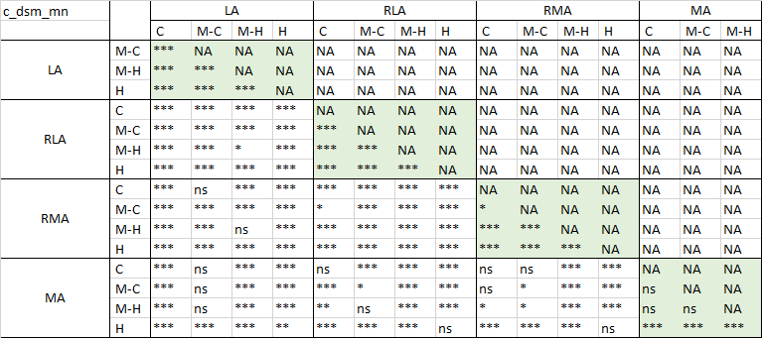
(c)  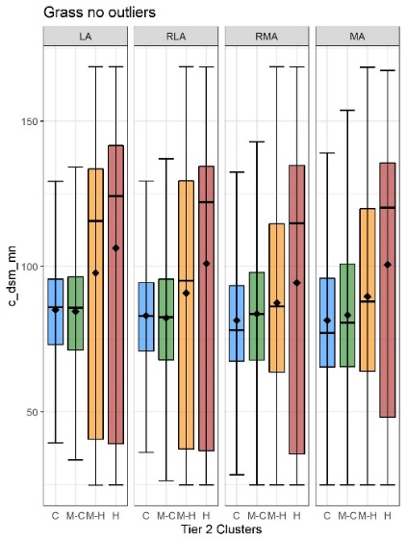 | (d)  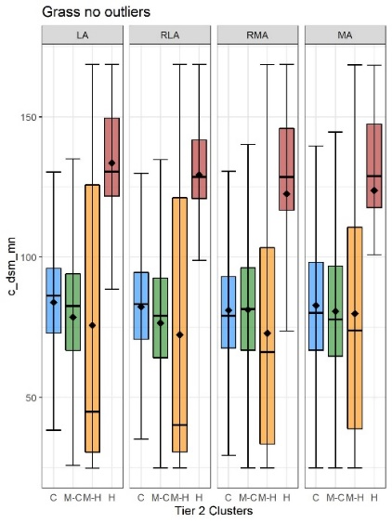
Figure S8 Results of the ANOVA (a, b) and boxplots (c, d) for elevation (dsm) of the core patches of grass in June (a, c) and July (b, d). Boxplots represent elevation values associated with the coldest (C), medium-cold (M-C), medium-hot (M-H) and the hottest (H) Tier 2 clusters within each Tier 1 cluster: LA – Least aggregated, RLA – Relatively less aggregated, RMA – Relatively more aggregated, MA – Most aggregated.
(a)  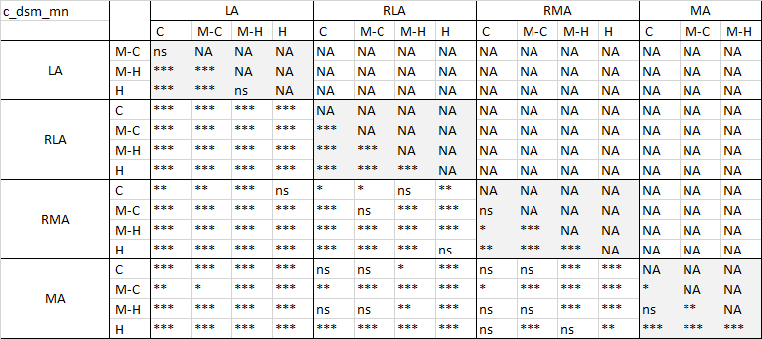 | (b)  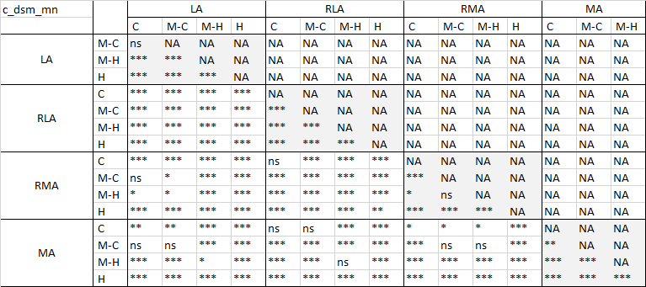
(c)  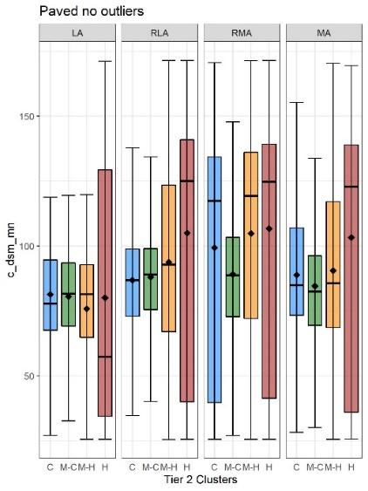 | (d)  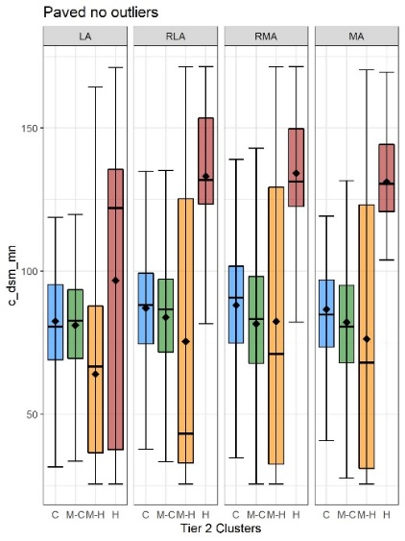
Figure S9 Results of the ANOVA (a, b) and boxplots (c, d) for elevation (dsm) of the core patches of paved in June (a, c) and July (b, d). Boxplots represent elevation values associated with the coldest (C), medium-cold (M-C), medium-hot (M-H) and the hottest (H) Tier 2 clusters within each Tier 1 cluster: LA – Least aggregated, RLA – Relatively less aggregated, RMA – Relatively more aggregated, MA – Most aggregated.
(a)  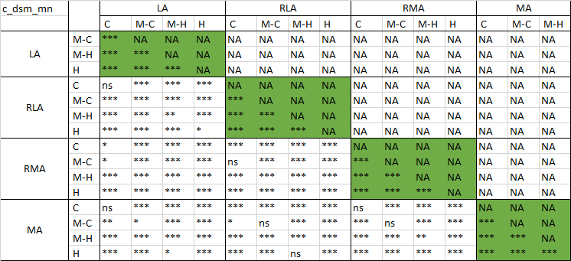 | (b)  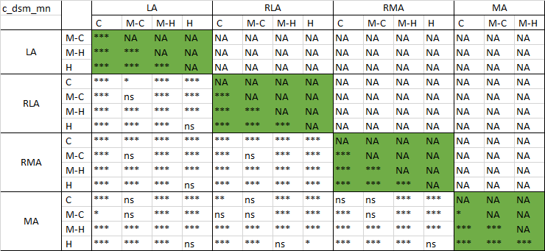
(c)  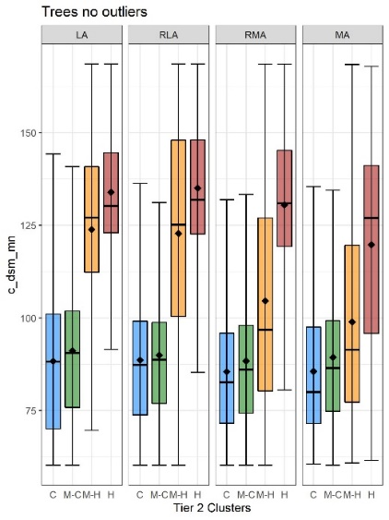 | (d)  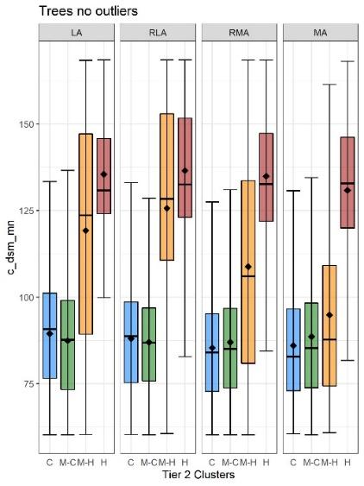
Figure S10 Results of the ANOVA (a, b) and boxplots (c, d) for elevation (dsm) of the core patches of trees in June (a, c) and July (b, d). Boxplots represent elevation values associated with the coldest (C), medium-cold (M-C), medium-hot (M-H) and the hottest (H) Tier 2 clusters within each Tier 1 cluster: LA – Least aggregated, RLA – Relatively less aggregated, RMA – Relatively more aggregated, MA – Most aggregated.
(a)  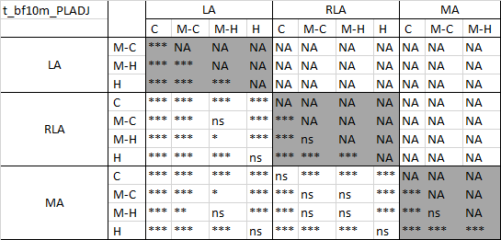 | (b)  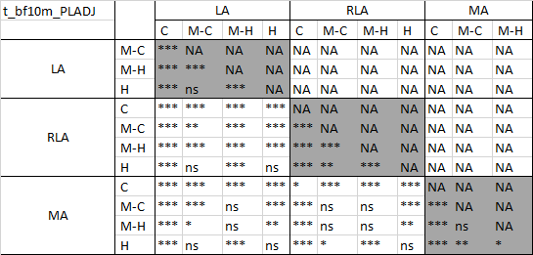
(c)  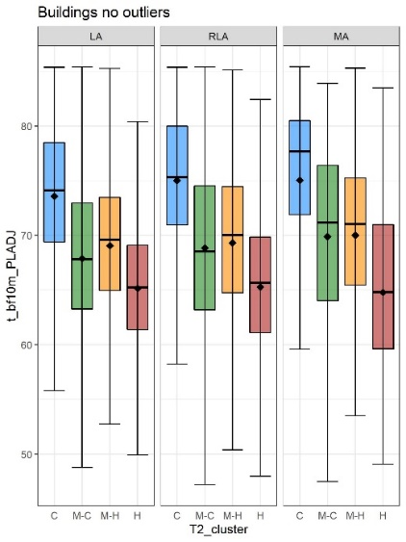 | (d)  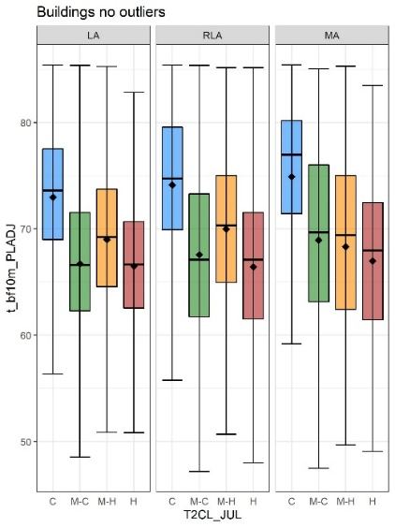
Figure S11 Results of the ANOVA (a, b) and boxplots (c, d) for PLADJ of trees located in the neighbourhood to core building patches in June (a, c) and July (b, d). Boxplots represent elevation values associated with the coldest (C), medium-cold (M-C), medium-hot (M-H) and the hottest (H) Tier 2 clusters within each Tier 1 cluster: LA – Least aggregated, RLA – Relatively less aggregated, MA – Most aggregated.

(a)  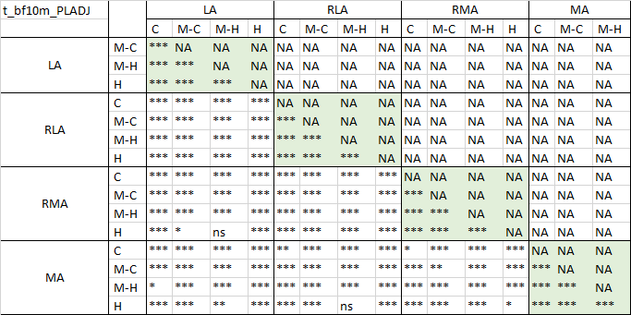 | (b)  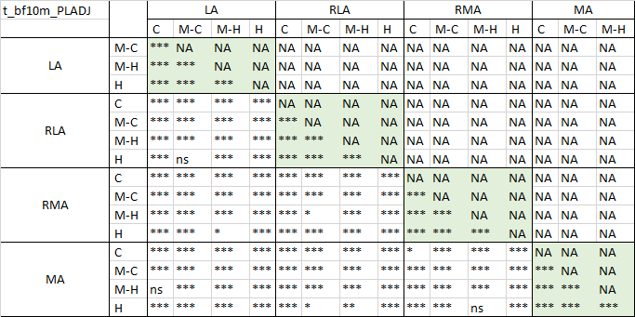
(c)  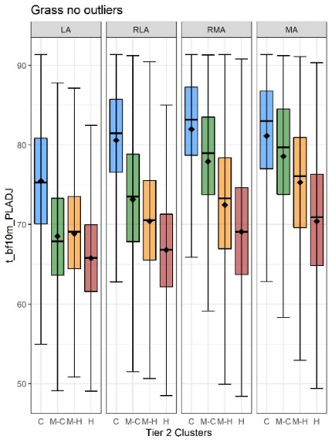 | (d)  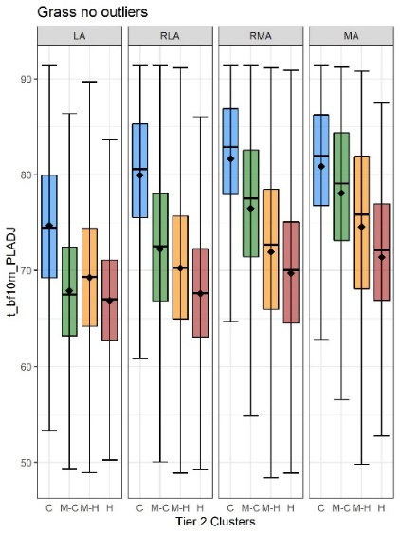
Figure S12 Results of the ANOVA (a, b) and boxplots (c, d) for PLADJ of trees located in the neighbourhood to core grass patches in June (a, c) and July (b, d). Boxplots represent elevation values associated with the coldest (C), medium-cold (M-C), medium-hot (M-H) and the hottest (H) Tier 2 clusters within each Tier 1 cluster: LA – Least aggregated, RLA – Relatively less aggregated, RMA – Relatively more aggregated, MA – Most aggregated.
(a)  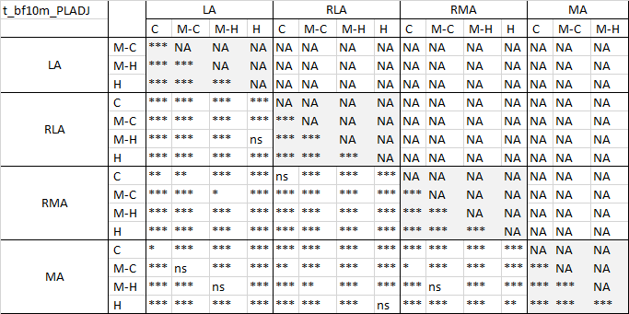 | (b)  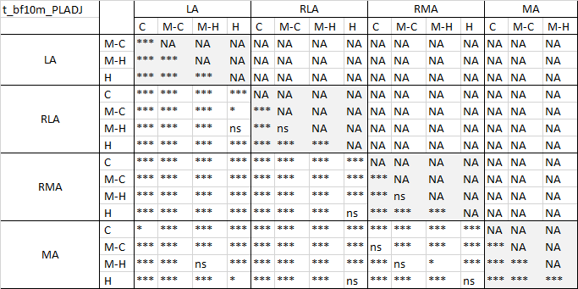
(c)  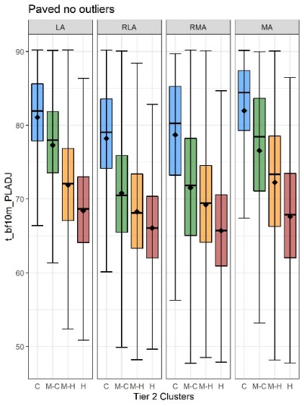 | (d)  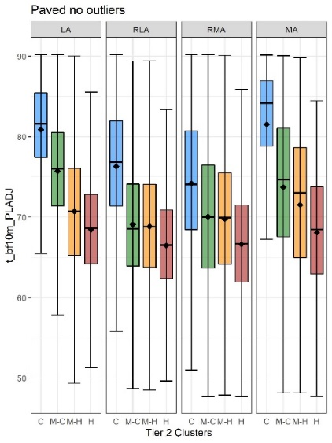
Figure S13 Results of the ANOVA (a, b) and boxplots (c, d) for PLADJ of trees located in the neighbourhood to core paved patches in June (a, c) and July (b, d). Boxplots represent elevation values associated with the coldest (C), medium-cold (M-C), medium-hot (M-H) and the hottest (H) Tier 2 clusters within each Tier 1 cluster: LA – Least aggregated, RLA – Relatively less aggregated, RMA – Relatively more aggregated, MA – Most aggregated.
(a)  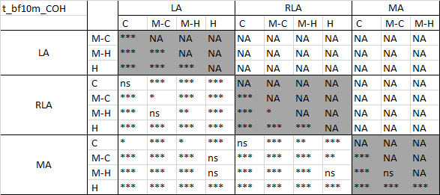 | (b)  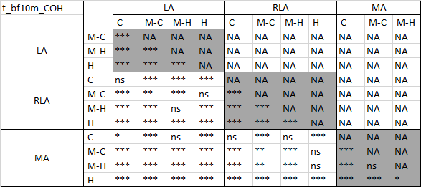
(c)  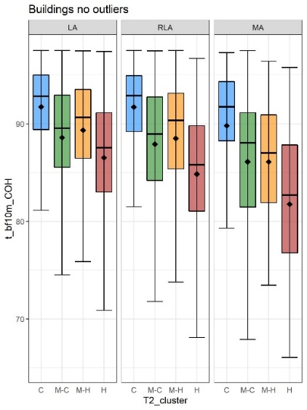 | (d)  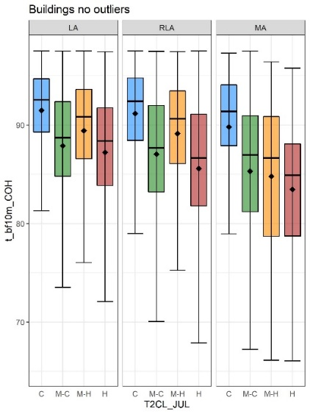
Figure S14 Results of the ANOVA (a, b) and boxplots (c, d) for COHESION of trees located in the neighbourhood to core building patches in June (a, c) and July (b, d). Boxplots represent elevation values associated with the coldest (C), medium-cold (M-C), medium-hot (M-H) and the hottest (H) Tier 2 clusters within each Tier 1 cluster: LA – Least aggregated, RLA – Relatively less aggregated, MA – Most aggregated.

(a)  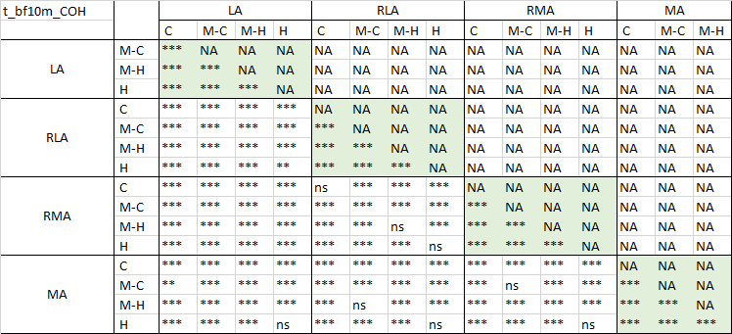 | (b)  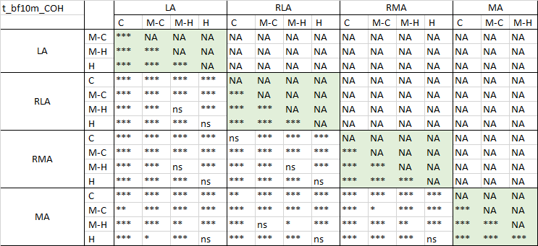
(c)  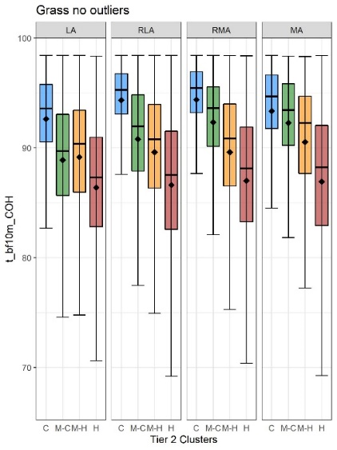 | (d)  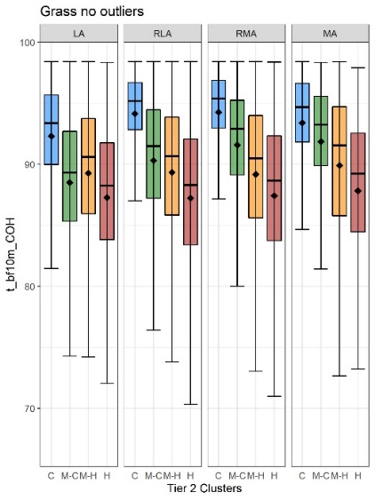
Figure S15 Results of the ANOVA (a, b) and boxplots (c, d) for COHESION of trees located in the neighbourhood to core grass patches in June (a, c) and July (b, d). Boxplots represent elevation values associated with the coldest (C), medium-cold (M-C), medium-hot (M-H) and the hottest (H) Tier 2 clusters within each Tier 1 cluster: LA – Least aggregated, RLA – Relatively less aggregated, RMA – Relatively more aggregated, MA – Most aggregated.
(a)  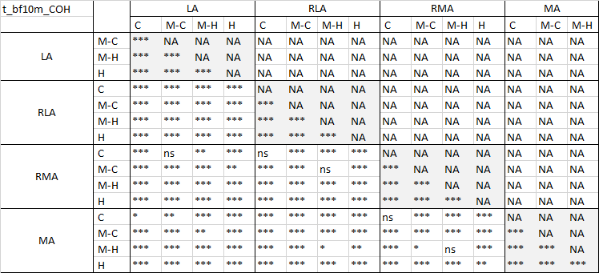 | (b)  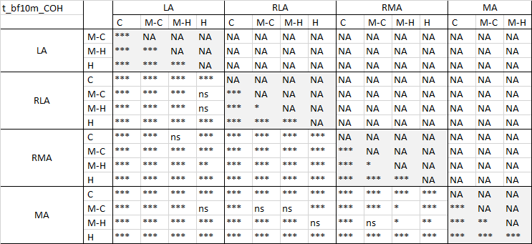
(c)  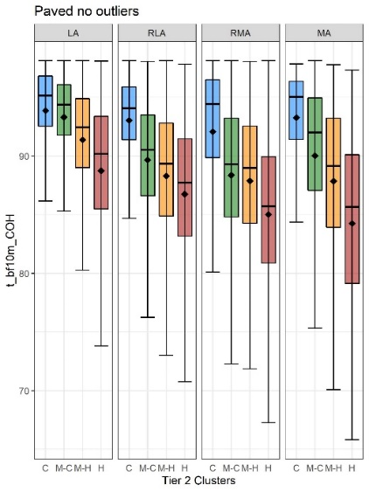 | (d)  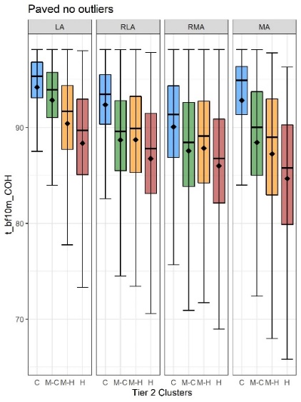
Figure S16 Results of the ANOVA (a, b) and boxplots (c, d) for COHESION of trees located in the neighbourhood to core paved patches in June (a, c) and July (b, d). Boxplots represent elevation values associated with the coldest (C), medium-cold (M-C), medium-hot (M-H) and the hottest (H) Tier 2 clusters within each Tier 1 cluster: LA – Least aggregated, RLA – Relatively less aggregated, RMA – Relatively more aggregated, MA – Most aggregated.
(a)  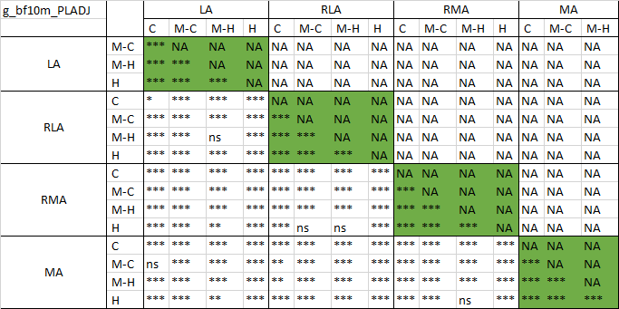 | (b)  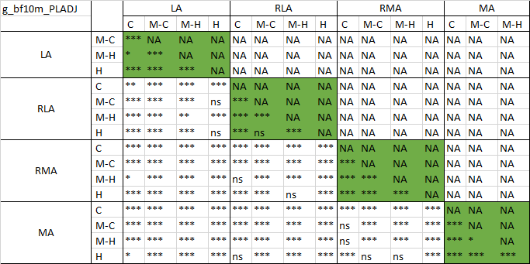
(c)  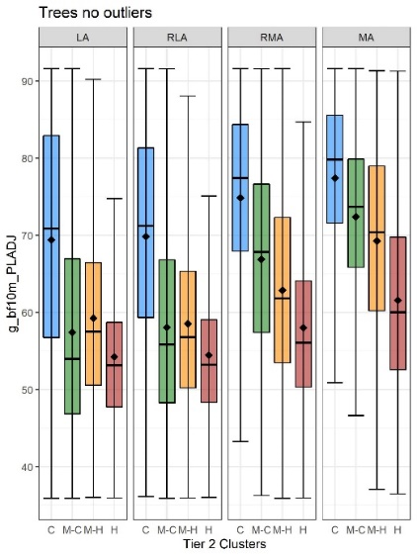 | (d)  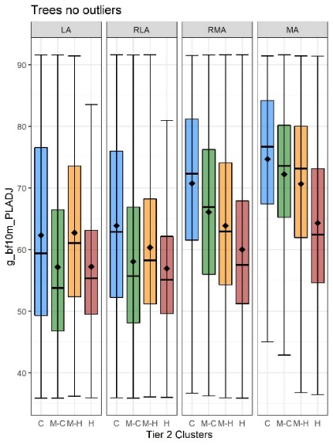
Figure S17 Results of the ANOVA (a, b) and boxplots (c, d) for PLADJ of grass located in the neighbourhood to core tree patches in June (a, c) and July (b, d). Boxplots represent elevation values associated with the coldest (C), medium-cold (M-C), medium-hot (M-H) and the hottest (H) Tier 2 clusters within each Tier 1 cluster: LA – Least aggregated, RLA – Relatively less aggregated, RMA – Relatively more aggregated, MA – Most aggregated.
(a)  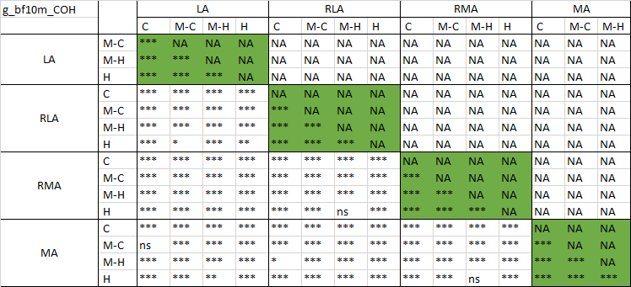 | (b)  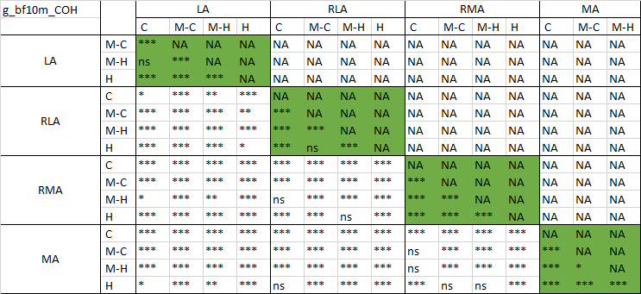
(c)  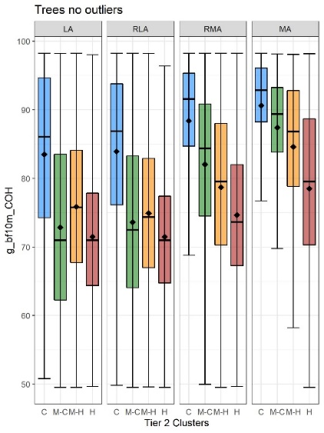 | (d)  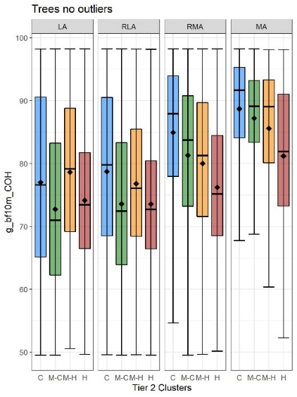
Figure S18 Results of the ANOVA (a, b) and boxplots (c, d) for COHESION of grass located in the neighbourhood to core tree patches in June (a, c) and July (b, d). Boxplots represent elevation values associated with the coldest (C), medium-cold (M-C), medium-hot (M-H) and the hottest (H) Tier 2 clusters within each Tier 1 cluster: LA – Least aggregated, RLA – Relatively less aggregated, RMA – Relatively more aggregated, MA – Most aggregated.
(a)  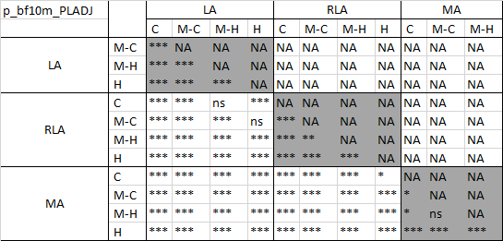 | (b)  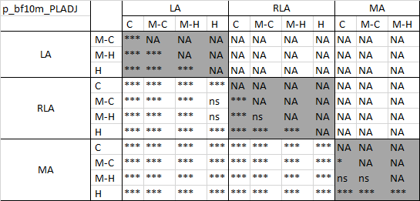
(c)  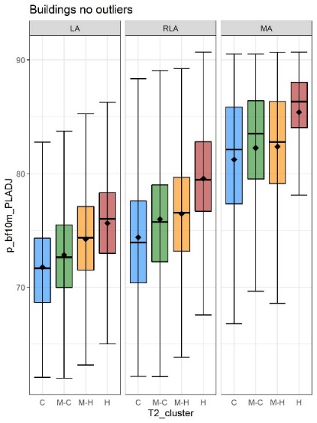 | (d)  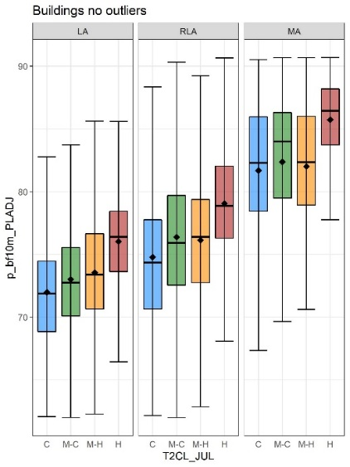
Figure S19 Results of the ANOVA (a, b) and boxplots (c, d) for PLADJ of paved located in the neighbourhood to core building patches in June (a, c) and July (b, d). Boxplots represent elevation values associated with the coldest (C), medium-cold (M-C), medium-hot (M-H) and the hottest (H) Tier 2 clusters within each Tier 1 cluster: LA – Least aggregated, RLA – Relatively less aggregated, MA – Most aggregated.
(a)  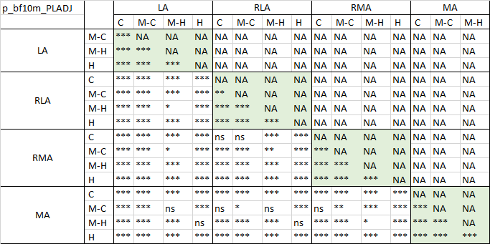 | (b)  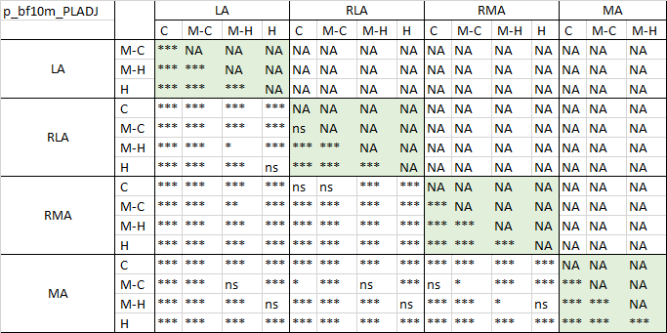
(c)  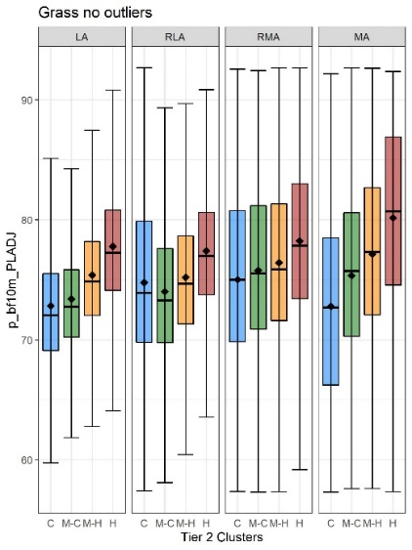 | (d)  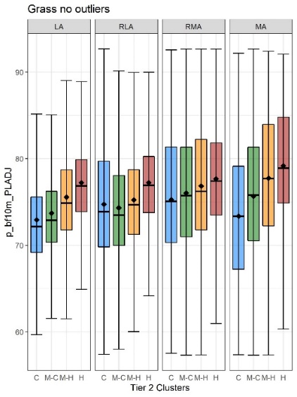
Figure S20 Results of the ANOVA (a, b) and boxplots (c, d) for PLADJ of paved located in the neighbourhood to core grass patches in June (a, c) and July (b, d). Boxplots represent elevation values associated with the coldest (C), medium-cold (M-C), medium-hot (M-H) and the hottest (H) Tier 2 clusters within each Tier 1 cluster: LA – Least aggregated, RLA – Relatively less aggregated, RMA – Relatively more aggregated, MA – Most aggregated.
(a)  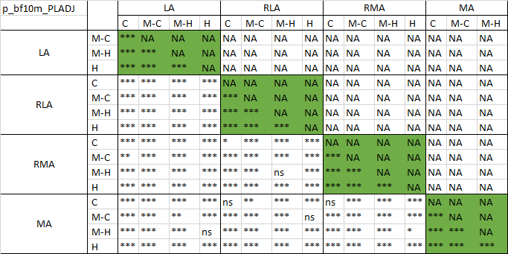 | (b)  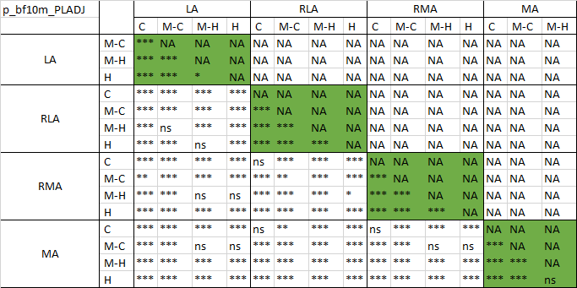
(c)  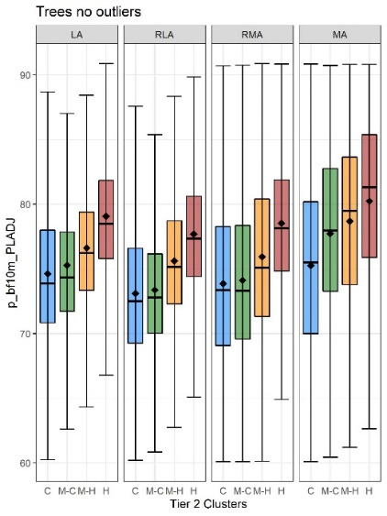 | (d)  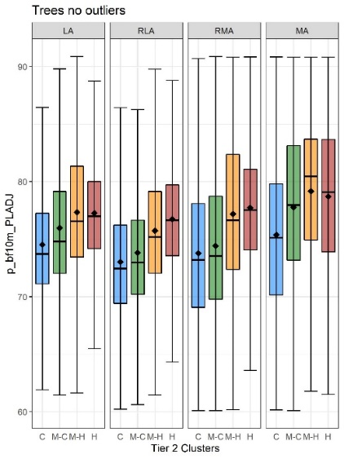
Figure S21 Results of the ANOVA (a, b) and boxplots (c, d) for PLADJ of paved located in the neighbourhood to core tree patches in June (a, c) and July (b, d). Boxplots represent elevation values associated with the coldest (C), medium-cold (M-C), medium-hot (M-H) and the hottest (H) Tier 2 clusters within each Tier 1 cluster: LA – Least aggregated, RLA – Relatively less aggregated, RMA – Relatively more aggregated, MA – Most aggregated.
(a)  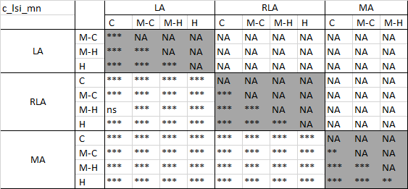 | (b)  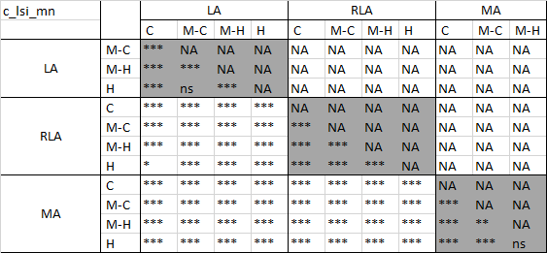
(c)  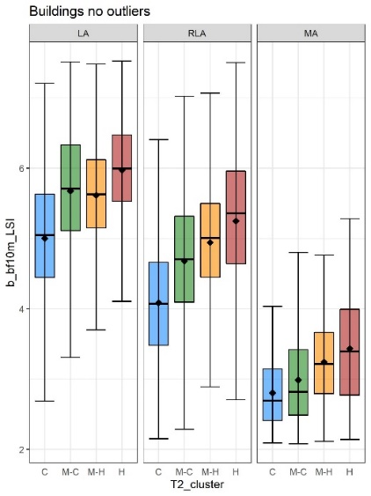 | (d)  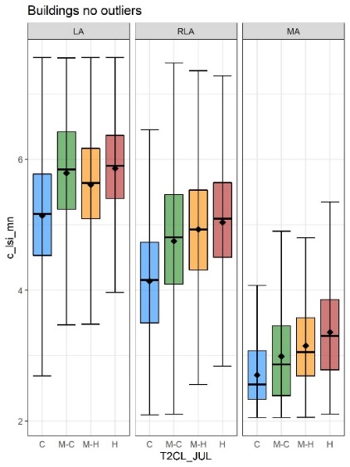
Figure S22 Results of the ANOVA (a, b) and boxplots (c, d) for LSI of core building patches in June (a, c) and July (b, d). Boxplots represent elevation values associated with the coldest (C), medium-cold (M-C), medium-hot (M-H) and the hottest (H) Tier 2 clusters within each Tier 1 cluster: LA – Least aggregated, RLA – Relatively less aggregated, MA – Most aggregated.
(a)  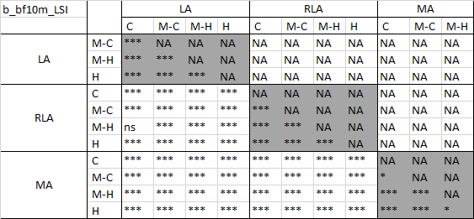 | (b)  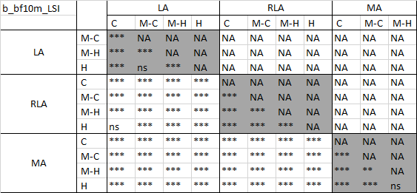
(c) | (d)  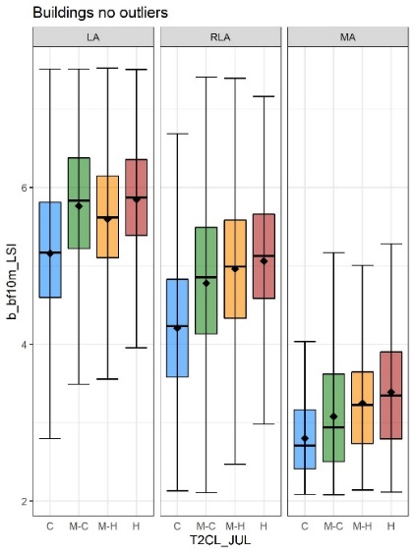
Figure S23 Results of the ANOVA (a, b) and boxplots (c, d) for LSI of buildings located in neighbourhood of core building patches in June (a, c) and July (b, d). Boxplots represent elevation values associated with the coldest (C), medium-cold (M-C), medium-hot (M-H) and the hottest (H) Tier 2 clusters within each Tier 1 cluster: LA – Least aggregated, RLA – Relatively less aggregated, MA – Most aggregated.
(a)  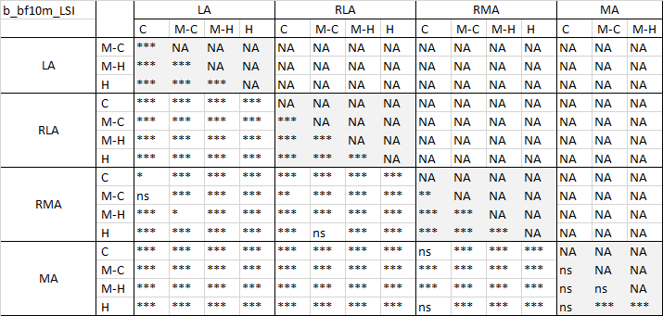 | (b)  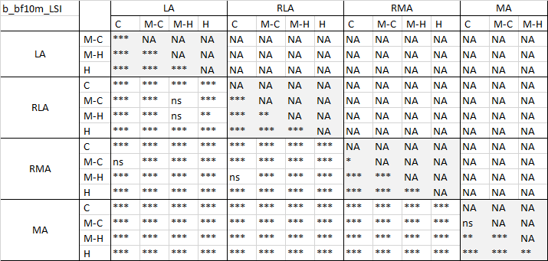
(c)  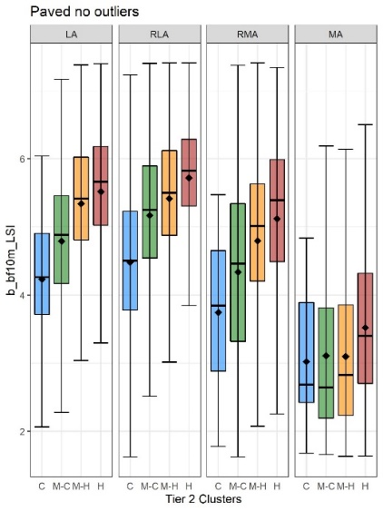 | (d)  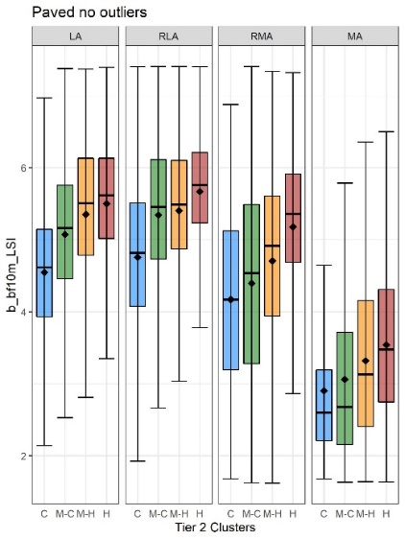
Figure S24 Results of the ANOVA (a, b) and boxplots (c, d) for LSI of buildings located in the neighbourhood to core paved patches in June (a, c) and July (b, d). Boxplots represent elevation values associated with the coldest (C), medium-cold (M-C), medium-hot (M-H) and the hottest (H) Tier 2 clusters within each Tier 1 cluster: LA – Least aggregated, RLA – Relatively less aggregated, RMA – Relatively more aggregated, MA – Most aggregated.
(a)  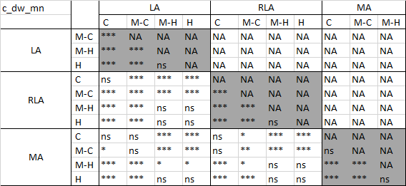 | (b)  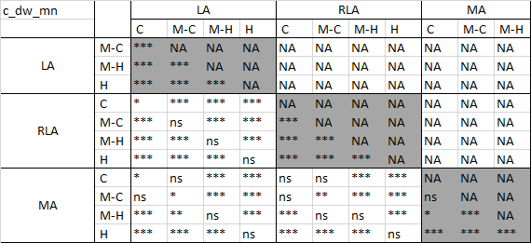
(c)  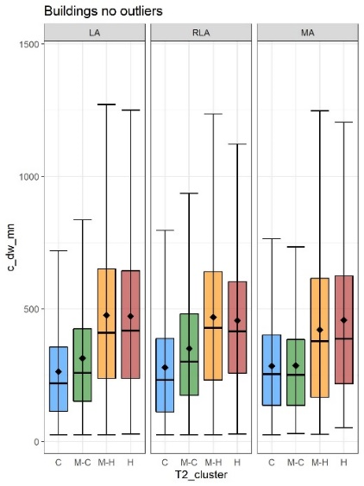 | (d)  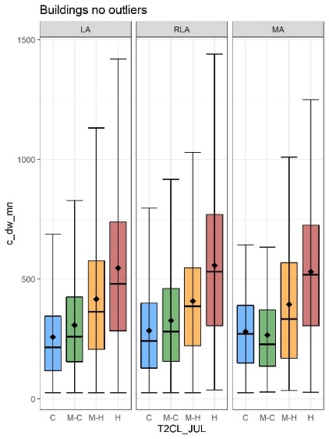
Figure S25 Results of the ANOVA (a, b) and boxplots (c, d) for distance to water of core building patches in June (a, c) and July (b, d). Boxplots represent elevation values associated with the coldest (C), medium-cold (M-C), medium-hot (M-H) and the hottest (H) Tier 2 clusters within each Tier 1 cluster: LA – Least aggregated, RLA – Relatively less aggregated, MA – Most aggregated.
(a)  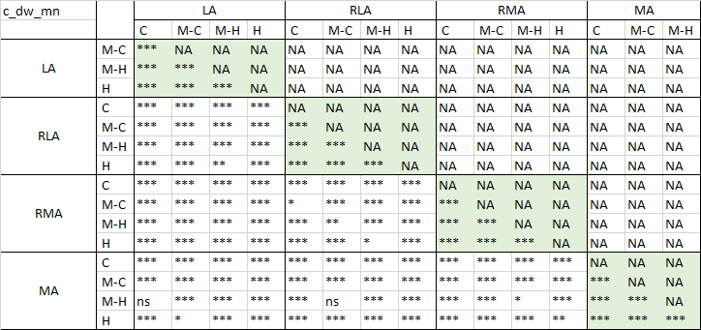 | (b)  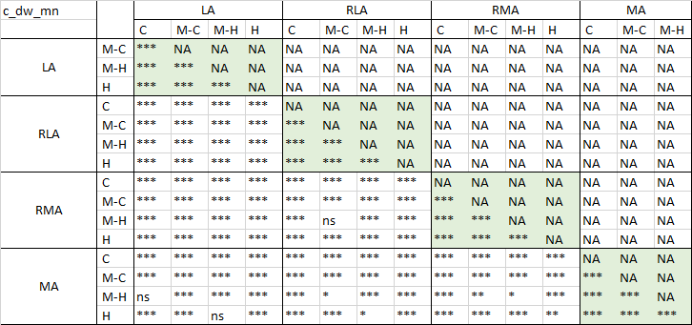
(c)  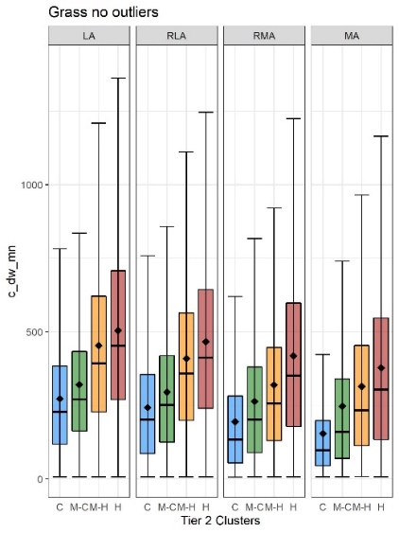 | (d)  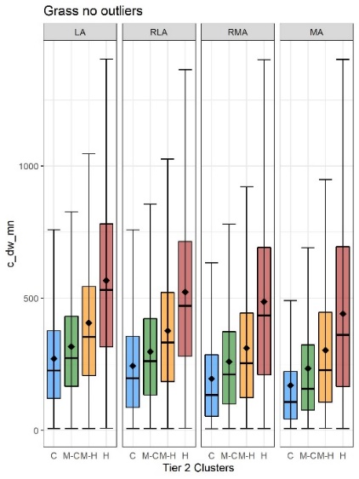
Figure S26 Results of the ANOVA (a, b) and boxplots (c, d) for distance to water of core grass patches in June (a, c) and July (b, d). Boxplots represent elevation values associated with the coldest (C), medium-cold (M-C), medium-hot (M-H) and the hottest (H) Tier 2 clusters within each Tier 1 cluster: LA – Least aggregated, RLA – Relatively less aggregated, RMA – Relatively more aggregated, MA – Most aggregated.
(a)  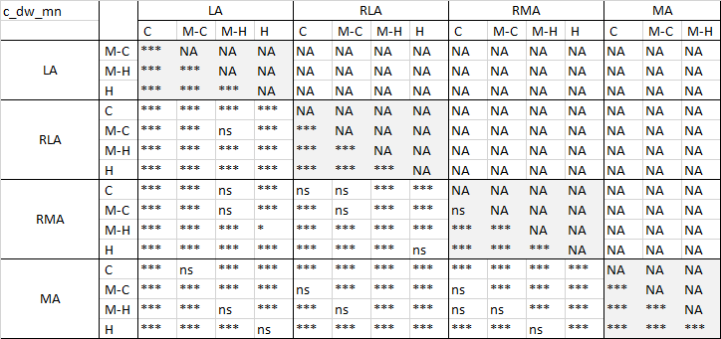 | (b)  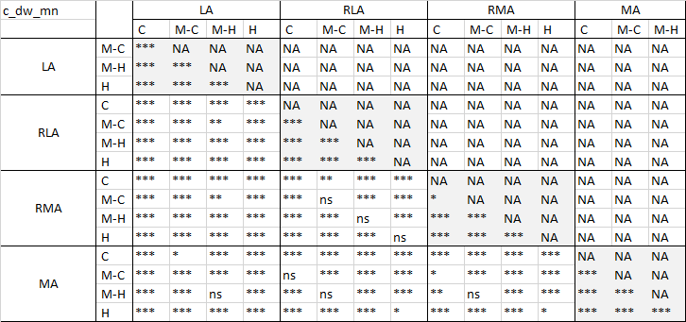
(c)  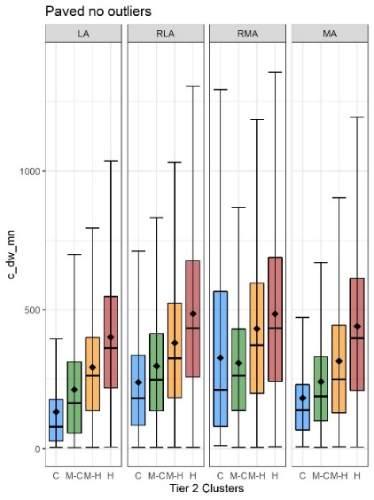 | (d)  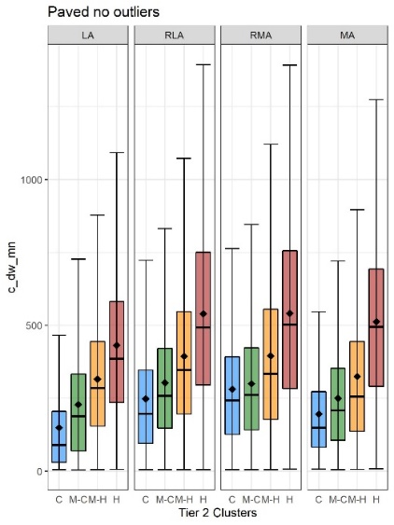
Figure S27 Results of the ANOVA (a, b) and boxplots (c, d) for distance to water of core paved patches in June (a, c) and July (b, d). Boxplots represent elevation values associated with the coldest (C), medium-cold (M-C), medium-hot (M-H) and the hottest (H) Tier 2 clusters within each Tier 1 cluster: LA – Least aggregated, RLA – Relatively less aggregated, RMA – Relatively more aggregated, MA – Most aggregated.
(a)  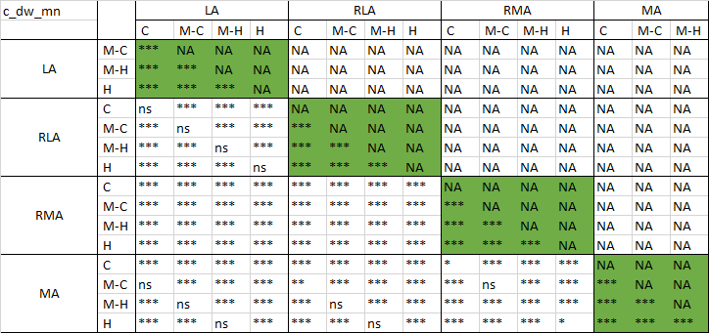 | (b)  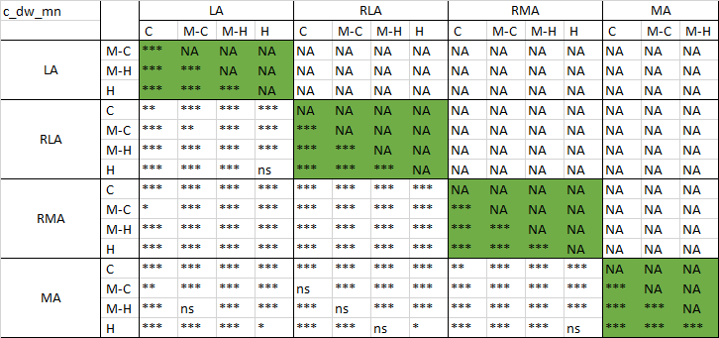
(c)  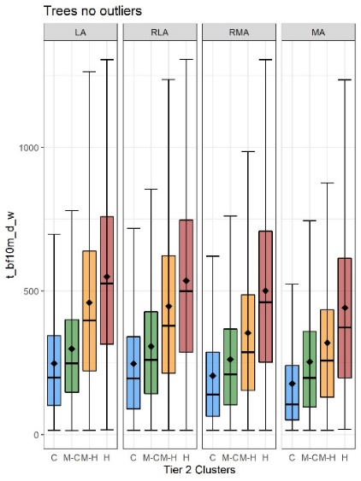 | (d)  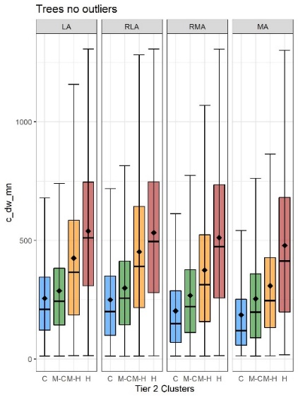
Figure S28 Results of the ANOVA (a, b) and boxplots (c, d) for distance to water of core tree patches in June (a, c) and July (b, d). Boxplots represent elevation values associated with the coldest (C), medium-cold (M-C), medium-hot (M-H) and the hottest (H) Tier 2 clusters within each Tier 1 cluster: LA – Least aggregated, RLA – Relatively less aggregated, RMA – Relatively more aggregated, MA – Most aggregated.
(a)  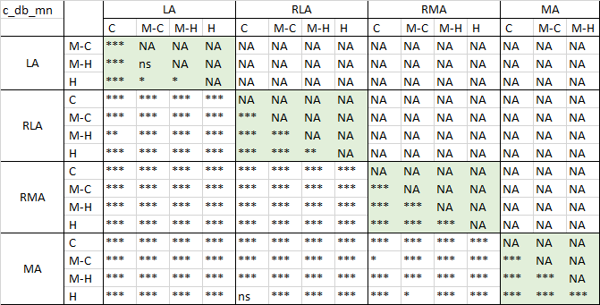 | (b)  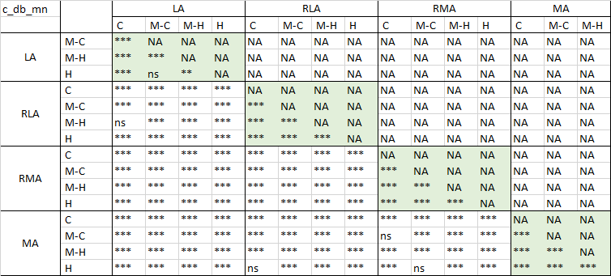
(c)  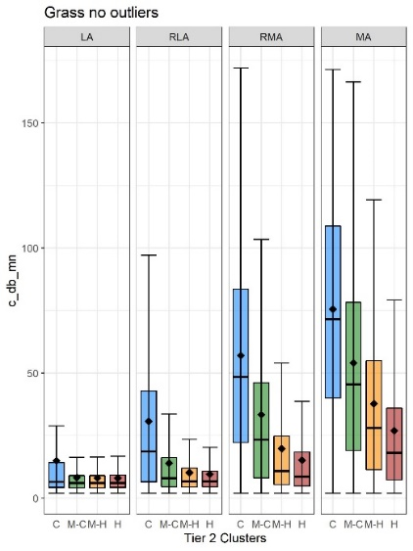 | (d)  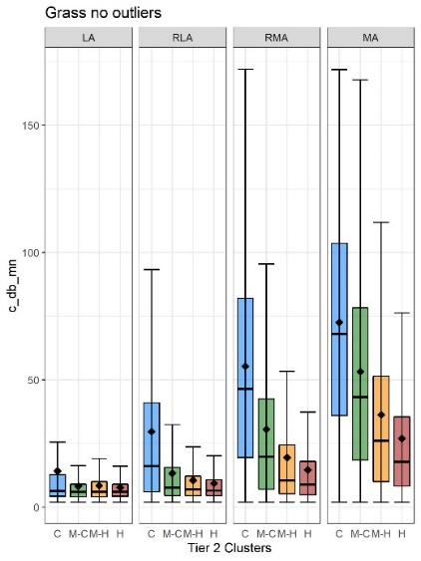
Figure S29 Results of the ANOVA (a, b) and boxplots (c, d) for distance to buildings of core grass patches in June (a, c) and July (b, d). Boxplots represent elevation values associated with the coldest (C), medium-cold (M-C), medium-hot (M-H) and the hottest (H) Tier 2 clusters within each Tier 1 cluster: LA – Least aggregated, RLA – Relatively less aggregated, RMA – Relatively more aggregated, MA – Most aggregated.
(a)  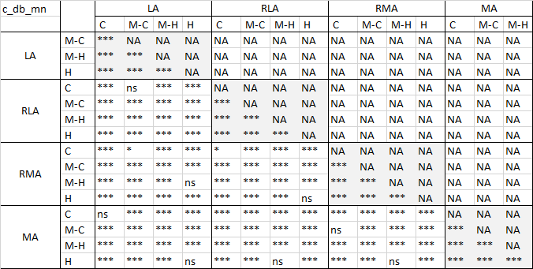 | (b)  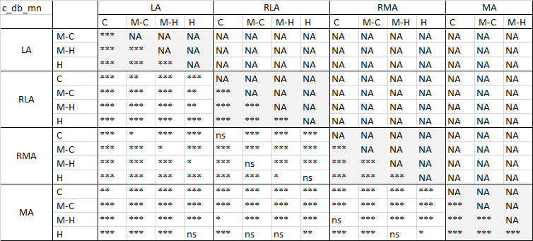
(c)  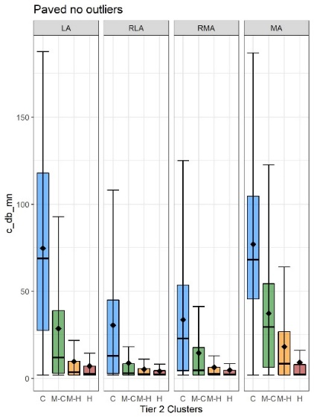 | (d)  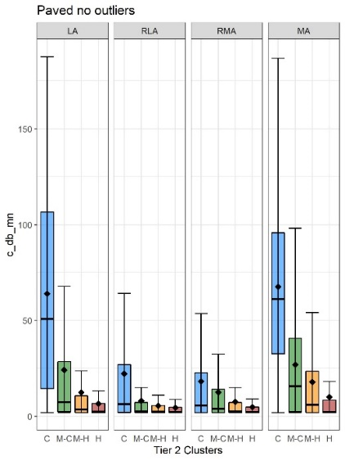
Figure S30 Results of the ANOVA (a, b) and boxplots (c, d) for distance to buildings r of core paved patches in June (a, c) and July (b, d). Boxplots represent elevation values associated with the coldest (C), medium-cold (M-C), medium-hot (M-H) and the hottest (H) Tier 2 clusters within each Tier 1 cluster: LA – Least aggregated, RLA – Relatively less aggregated, RMA – Relatively more aggregated, MA – Most aggregated.

(a)  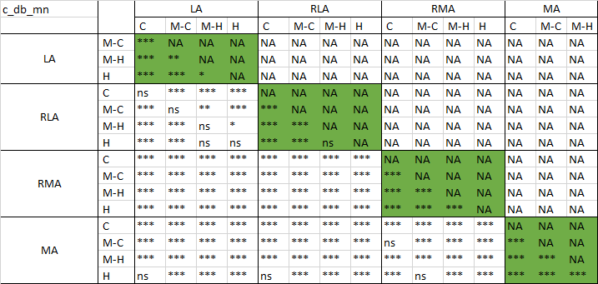 | (b)  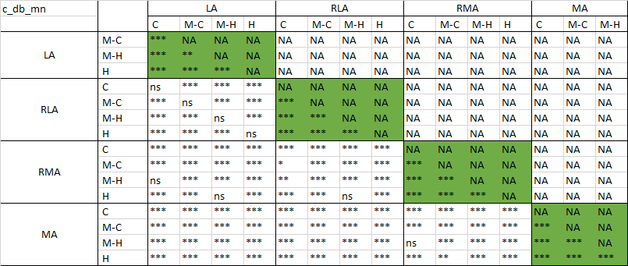
(c)  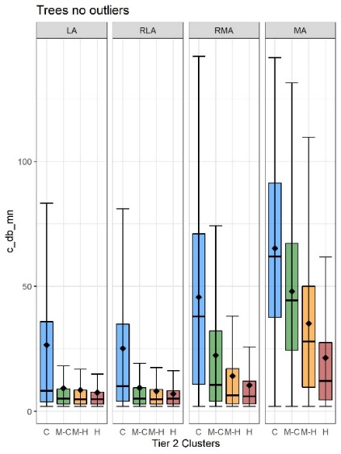 | (d)  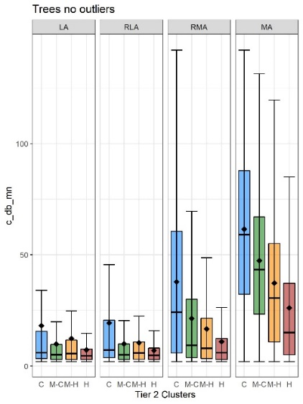
Figure S31 Results of the ANOVA (a, b) and boxplots (c, d) for distance to buildings of core tree patches in June (a, c) and July (b, d). Boxplots represent elevation values associated with the coldest (C), medium-cold (M-C), medium-hot (M-H) and the hottest (H) Tier 2 clusters within each Tier 1 cluster: LA – Least aggregated, RLA – Relatively less aggregated, RMA – Relatively more aggregated, MA – Most aggregated.
(a)  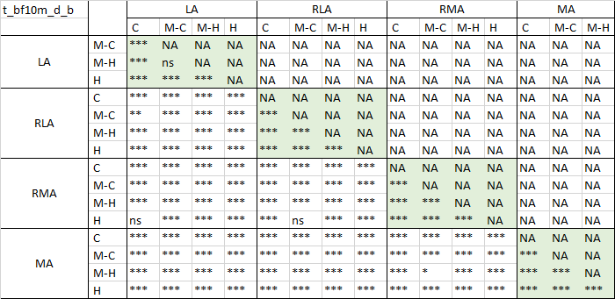 | (b)  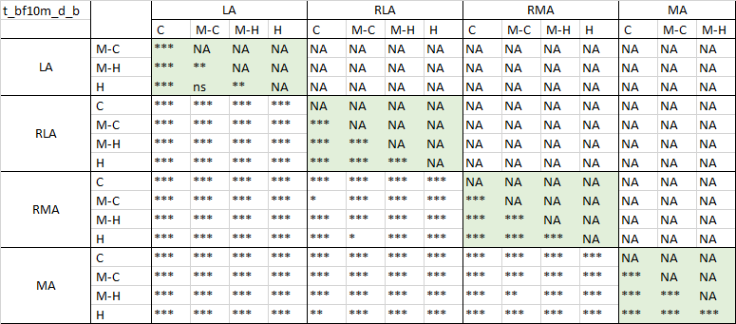
(c)  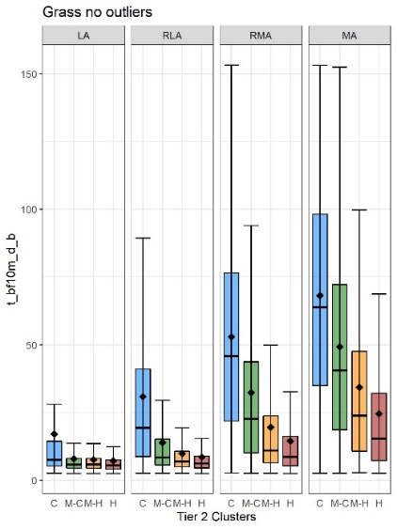 | (d)  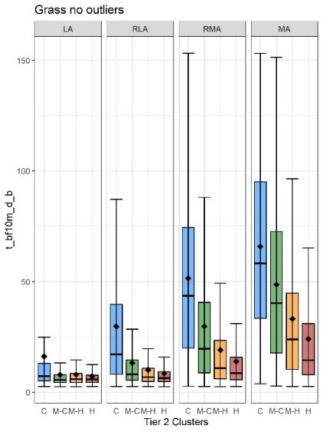
Figure S32 Results of the ANOVA (a, b) and boxplots (c, d) for distance to buildings of tree patches located in the neighbourhood of core grass patches in June (a, c) and July (b, d). Boxplots represent elevation values associated with the coldest (C), medium-cold (M-C), medium-hot (M-H) and the hottest (H) Tier 2 clusters within each Tier 1 cluster: LA – Least aggregated, RLA – Relatively less aggregated, RMA – Relatively more aggregated, MA – Most aggregated.
(a)  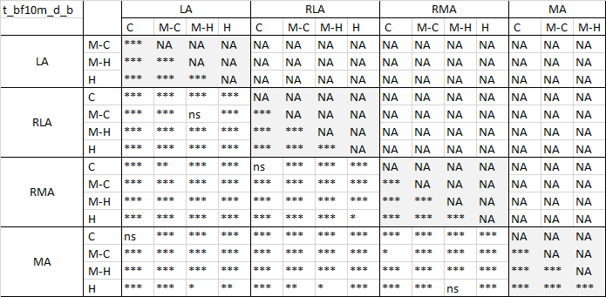 | (b)  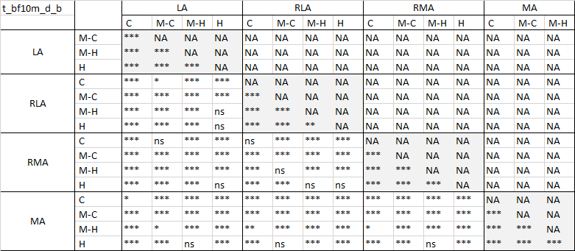
(c)  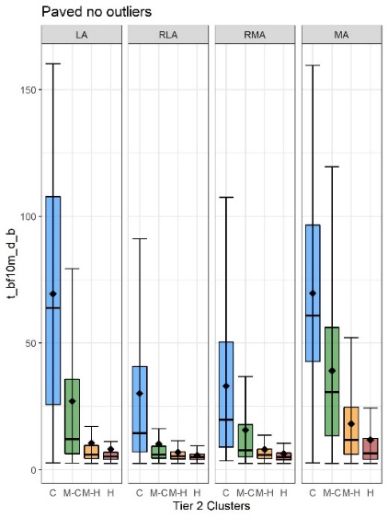 | (d)  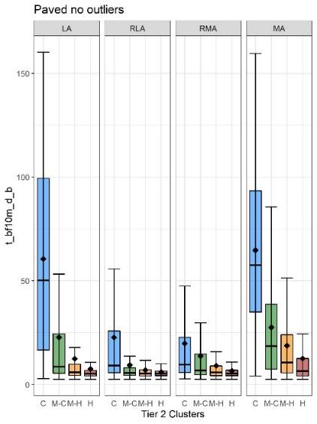
Figure S33 Results of the ANOVA (a, b) and boxplots (c, d) for distance to buildings of tree patches located in the neighbourhood of core paved patches in June (a, c) and July (b, d). Boxplots represent elevation values associated with the coldest (C), medium-cold (M-C), medium-hot (M-H) and the hottest (H) Tier 2 clusters within each Tier 1 cluster: LA – Least aggregated, RLA – Relatively less aggregated, RMA – Relatively more aggregated, MA – Most aggregated.
(a)  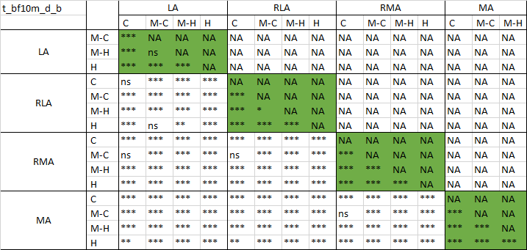 | (b)  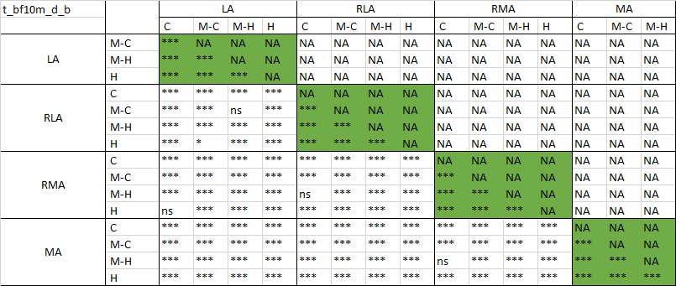
(c)  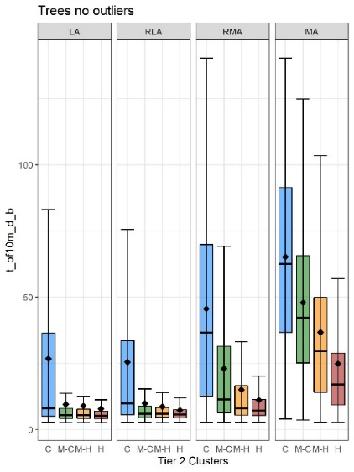 | (d)  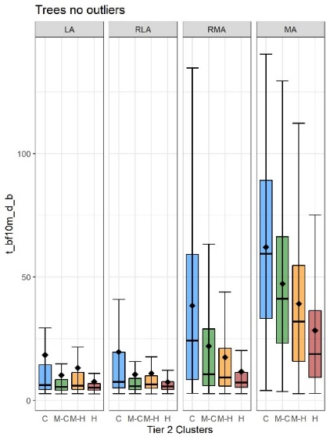
Figure S34 Results of the ANOVA (a, b) and boxplots (c, d) for distance to buildings of tree patches located in the neighbourhood of core tree patches in June (a, c) and July (b, d). Boxplots represent elevation values associated with the coldest (C), medium-cold (M-C), medium-hot (M-H) and the hottest (H) Tier 2 clusters within each Tier 1 cluster: LA – Least aggregated, RLA – Relatively less aggregated, RMA – Relatively more aggregated, MA – Most aggregated.
(a)  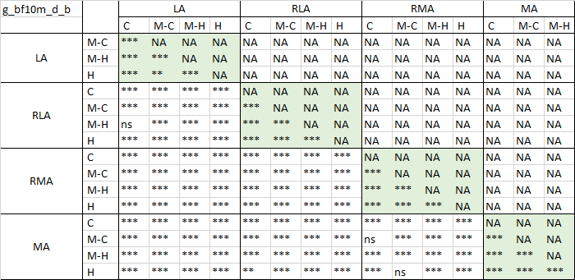 | (b)  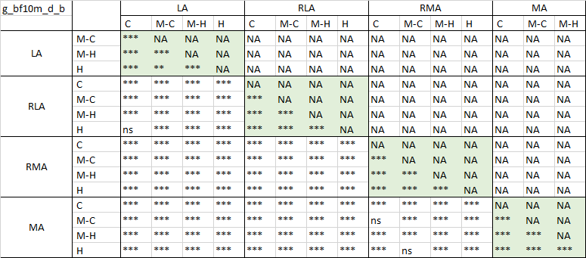
(c)  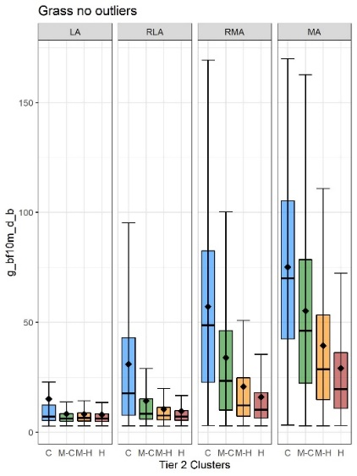 | (d)  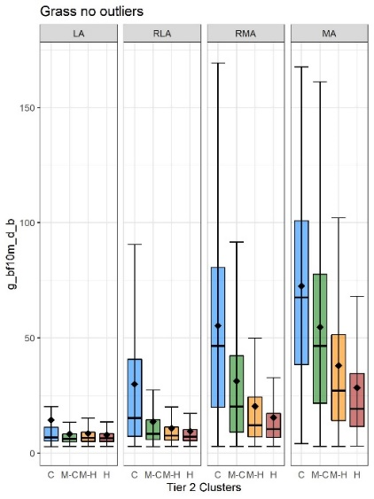
Figure S35 Results of the ANOVA (a, b) and boxplots (c, d) for distance to buildings of grass patches located in the neighbourhood of core grass patches in June (a, c) and July (b, d). Boxplots represent elevation values associated with the coldest (C), medium-cold (M-C), medium-hot (M-H) and the hottest (H) Tier 2 clusters within each Tier 1 cluster: LA – Least aggregated, RLA – Relatively less aggregated, RMA – Relatively more aggregated, MA – Most aggregated.
(a)  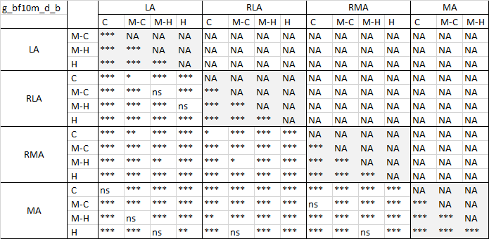 | (b)  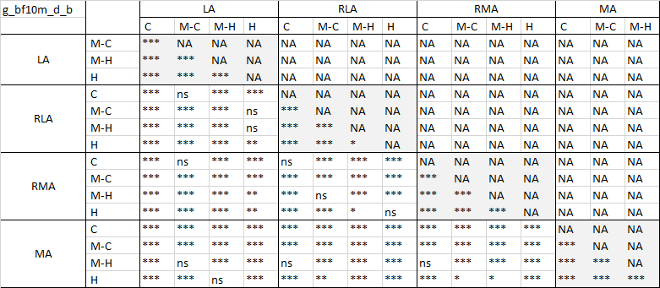
(c)  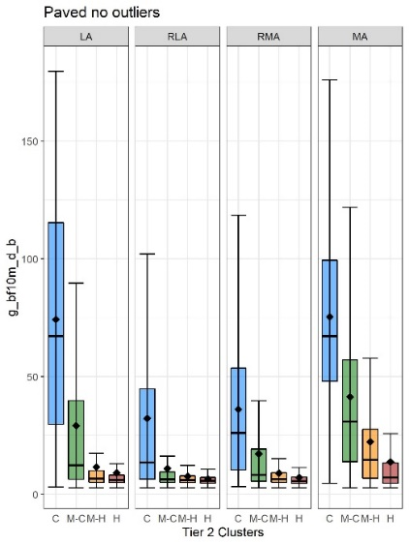 | (d)  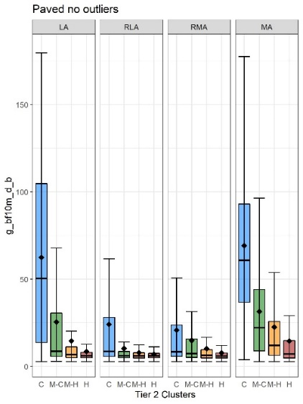
Figure S36 Results of the ANOVA (a, b) and boxplots (c, d) for distance to buildings of grass patches located in the neighbourhood of core paved patches in June (a, c) and July (b, d). Boxplots represent elevation values associated with the coldest (C), medium-cold (M-C), medium-hot (M-H) and the hottest (H) Tier 2 clusters within each Tier 1 cluster: LA – Least aggregated, RLA – Relatively less aggregated, RMA – Relatively more aggregated, MA – Most aggregated.
(a)  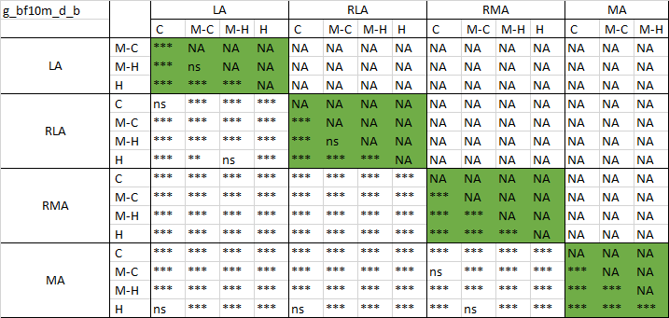 | (b)  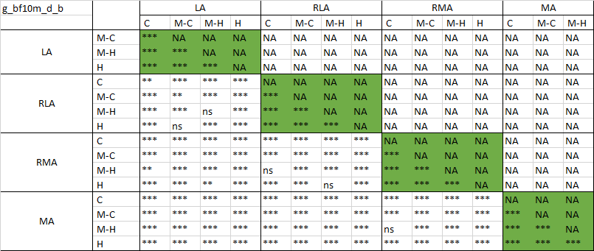
(c)  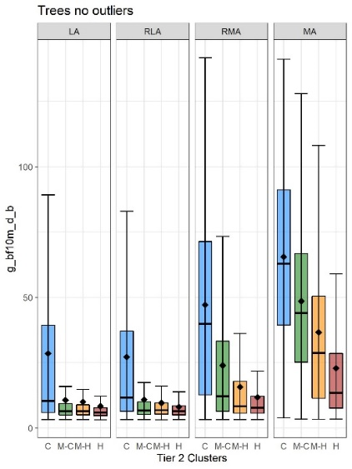 | (d)  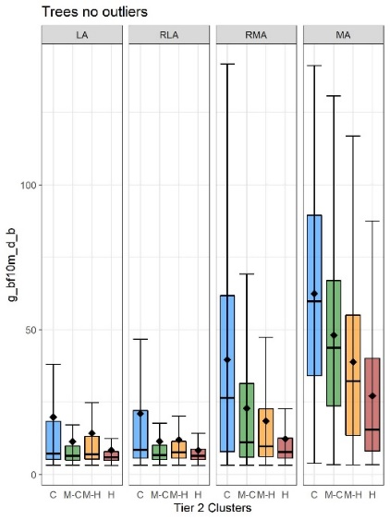
Figure S37 Results of the ANOVA (a, b) and boxplots (c, d) for distance to buildings of grass patches located in the neighbourhood of core tree patches in June (a, c) and July (b, d). Boxplots represent elevation values associated with the coldest (C), medium-cold (M-C), medium-hot (M-H) and the hottest (H) Tier 2 clusters within each Tier 1 cluster: LA – Least aggregated, RLA – Relatively less aggregated, RMA – Relatively more aggregated, MA – Most aggregated.

