Characterising the relationship between suitable habitat and gene flow for Myotis bechsteinii and Eptesicus serotinus in Britain

Wright, P.G.R.^{1,2}, Bellamy, C.³, Hamilton, P.B.⁴, Schofield, H.¹, Finch, D.² & Mathews, F.^{2*}
¹ Vincent Wildlife Trust, Ledbury, HR8 1EP, United Kingdom
² University of Sussex, Brighton, BN1 9RH, UK
³ Centre for Ecosystems, Forest Research, Roslin, UK
⁴ University of Exeter, Exeter, EX4 4PS, UK

ORCID
P. Wright – 0000-0002-1026-6596
C. Bellamy - 0000-0002-3830-0995
D. Finch - 0000-0003-1545-4286
F. Mathews - 0000-0002-2580-2769

*Corresponding author: f.mathews@sussex.ac.uk

Supplementary material
Supplementary 1: Environmental predictors used at each level. A description of each predictor (units), the statistic measured within the focal scale window and original data sources provided by Bellamy et al. (2020).
Level | Predictor (units) | Statistic | Data Source
Population range | Annual precipitation (mm) | Mean | WorldClim Version2, 1970-2000 (Fick & Hijmans, 2017)
Population range | Maximum temperature of warmest month (⁰C) | Mean | WorldClim Version2, 1970-2000 (Fick & Hijmans, 2017)
Population range | Minimum temperature of coldest month (⁰C) | Mean | WorldClim Version2, 1970-2000 (Fick & Hijmans, 2017)
Population range | Cover of woodland (%) | Mean | Land Cover Map 2007 (1km percentage aggregate class, GB) v1.2 (Morton et al., 2011)
Population range | Cover of urban (%) | Mean
Home range | Cover of ancient woodland (%) | Mean | Ancient Woodland inventories (Natural England, 2018; Natural Resources Wales, 2011; Scottish Natural Heritage, 2010)
Home range | Cover of coniferous woodland (%) | Mean
Home range | Cover of broadleaved woodland (%) | Mean
Home range | Cover of woodland (%) | Mean
Home range | Cover of heathland (%) | Mean | Landcover map 2007 (Morton et al., 2011)
Home range | Cover of arable or improved grassland (%) | Mean | Landcover map 2007 (Morton et al., 2011)
Home range | Size of largest woodland (ha) | Mean | National Forest Inventory (Forestry Commission, 2007)
Home range | Density of hedgerows (m/m2) | Mean | Woody Linear Features (Scholefield et al., 2016)
Home range | Proportion of broadleaf likely to be managed for biodiversity/conservation | Mean | National Forest Inventory woodlands (Forestry Commission, 2007) overlapping with terrestrial protected sites (UNEP-WCMC and IUCN, 2017) or land owned/managed by the Royal Society for the Protection of Birds, Woodland Trust, National Trust or Wildlife Trusts.
Local foraging habitat | Cover of ancient woodland (%) | Mean | Ancient Woodland inventories (Natural England, 2018; Natural Resources Wales, 2011; Scottish Natural Heritage, 2010)
Local foraging habitat | Cover of woodland (%) | Mean | National Forest Inventory (Forestry Commission, 2007)
Local foraging habitat | Cover of deciduous woodland (%) | Mean | National Forest Inventory (Forestry Commission, 2007)
Local foraging habitat | Cover of coniferous woodland (%) | Mean | National Forest Inventory (Forestry Commission, 2007)
Local foraging habitat | Cover of heathland (%) | Mean | Landcover map 2007(Morton et al., 2011)
Local foraging habitat | Cover of arable/improved grassland (%) | Max | Landcover map 2007(Morton et al., 2011)
Local foraging habitat | Size of largest woodland (ha) | Mean | National Forest Inventory (Forestry Commission, 2007)
Local foraging habitat | Woodland patch shape compactness (0-1)** | N/A | National Forest Inventory (Forestry Commission, 2007)
Local foraging habitat | Euclidean distance to woodland edge (negative values for interior; m)* | N/A | National Forest Inventory (Forestry Commission, 2007)
Local foraging habitat | Euclidean distance to hedgerow (m) * | N/A | Woody Linear Features (Scholefield et al., 2016)
Local foraging habitat | Euclidean distance to primary roads, motorways & railways (m) * | N/A | OS Open Roads (Ordnance Survey, 2017)
Local foraging habitat | Euclidean distance to buildings (m) * | N/A | OS Open Buildings (Ordnance Survey, 2017)
Local foraging habitat | Topographic Wetness Index | Mean | OS Terrain 50 (Ordnance Survey, 2017)

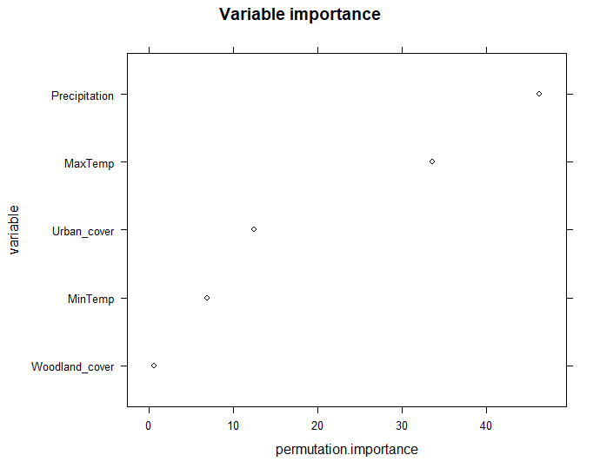
Supplementary 2: Permutation importance of the environmental variables for the population range model on Myotis bechsteinii
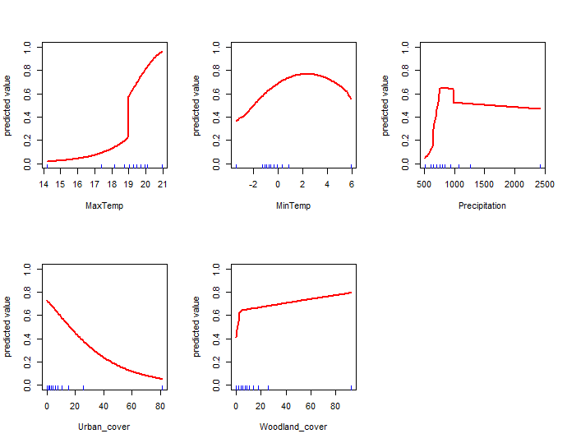
Supplementary 3: Response curves of the environmental variables for the population range model on Myotis bechsteinii

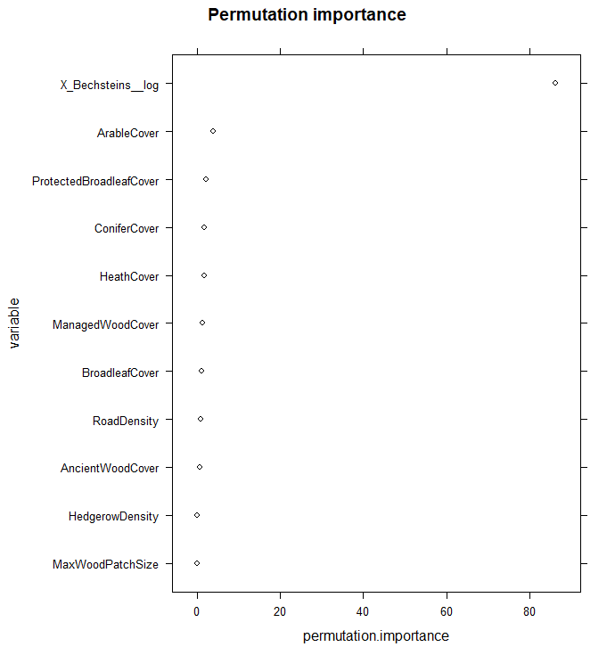
Supplementary 4: Permutation importance of the environmental variables for the home range model on Myotis bechsteinii
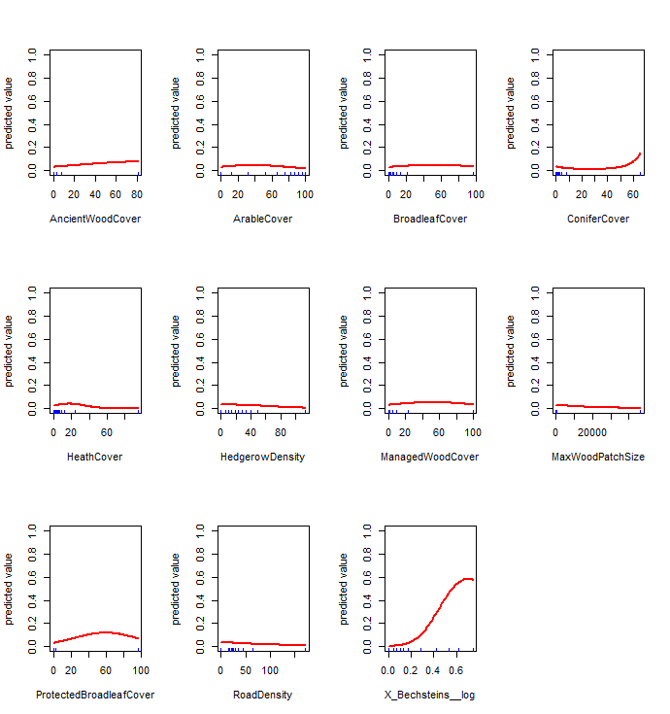
Supplementary 5: Response curves of the environmental variables for the home range model on Myotis bechsteinii

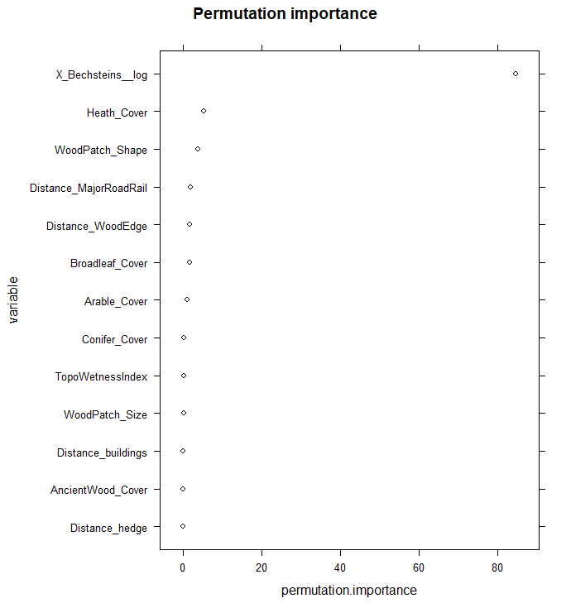
Supplementary 6: Permutation importance of the environmental variables for the local model on Myotis bechsteinii

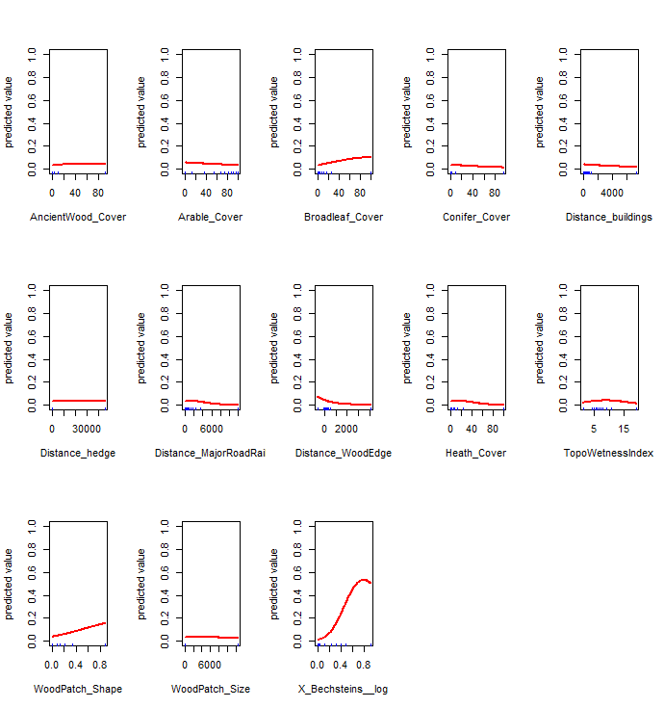

Supplementary 7: Response curves of the environmental variables for the local model on Myotis bechsteinii

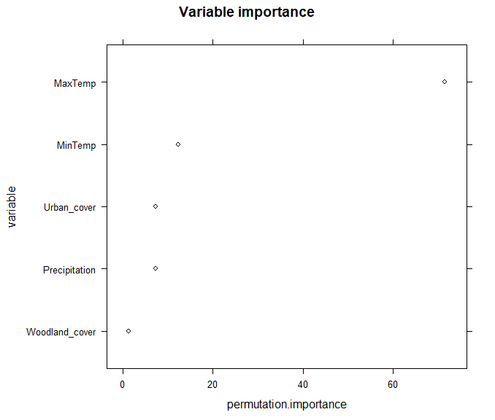
Supplementary 8: Permutation importance of the environmental variables for the population range model on Eptesicus serotinus

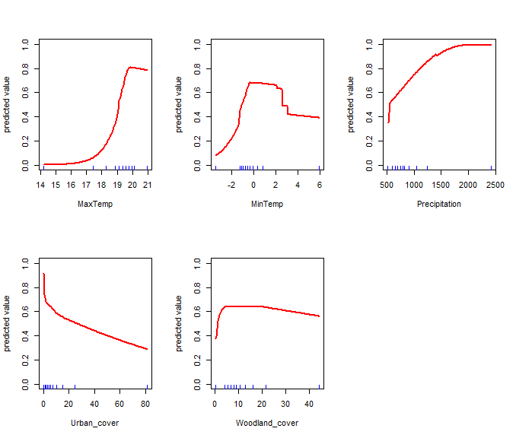
Supplementary 9: Response curves of the environmental variables for the population range model on Eptesicus serotinus

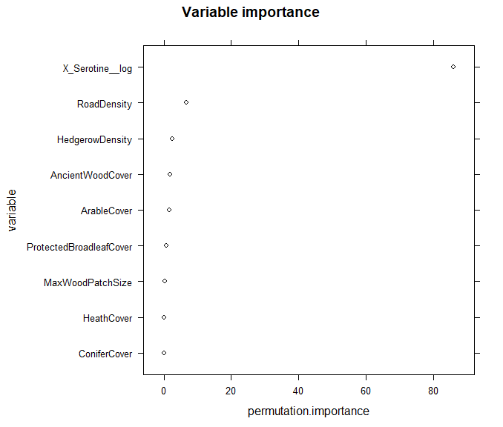
Supplementary 10: Permutation importance of the environmental variables for the home range model on Eptesicus serotinus

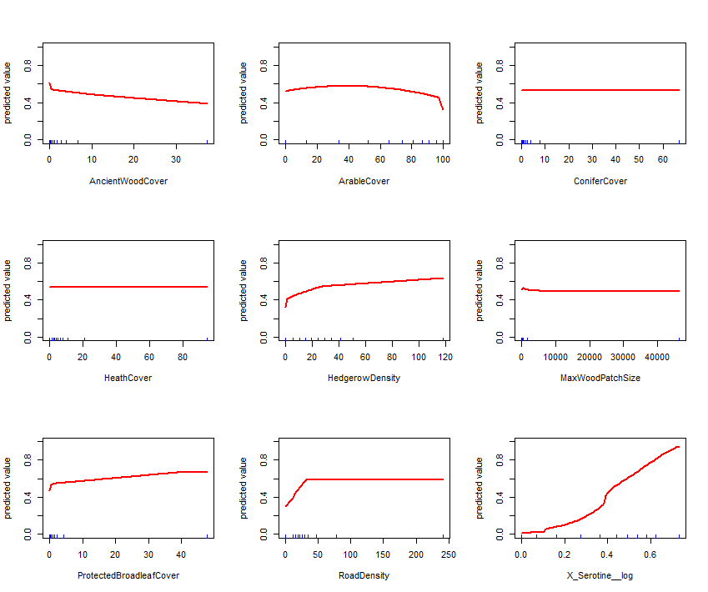
Supplementary 11: Response curves of the environmental variables for the home range model on Eptesicus serotinus

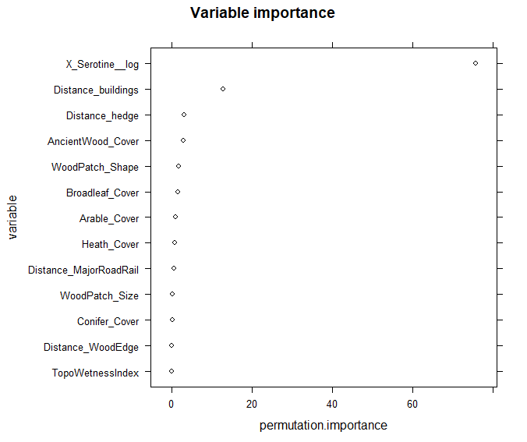
Supplementary 12: Permutation importance of the environmental variables for the local model on Eptesicus serotinus

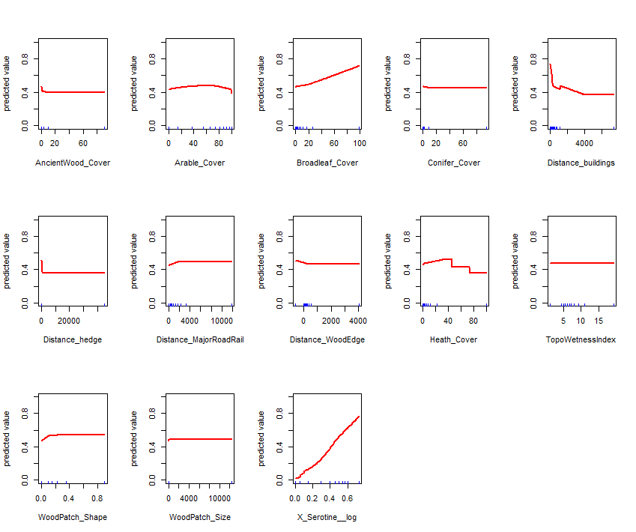
Supplementary 13: Response curves of the environmental variables for the local model on Eptesicus serotinus

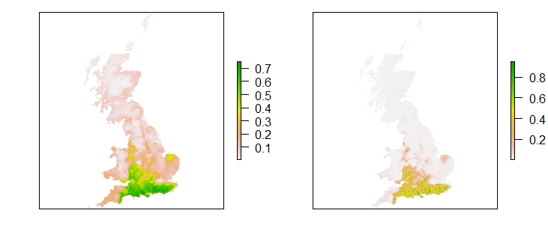
Supplementary 14: Population range and home range model predictions for M. bechsteinii

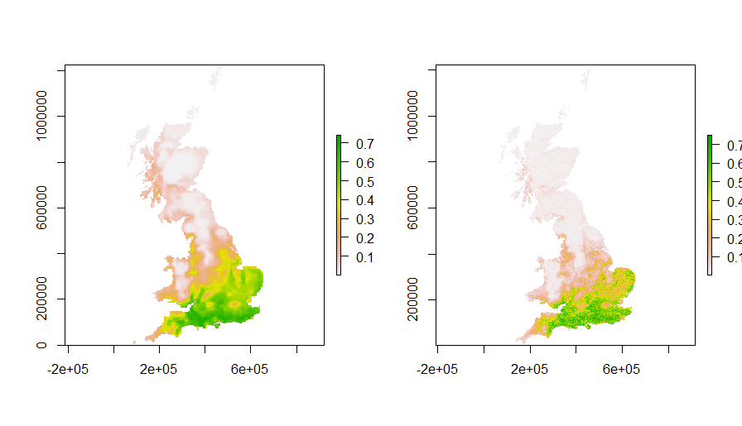
Supplementary 15: Population range and home range model predictions for E. serotinus

