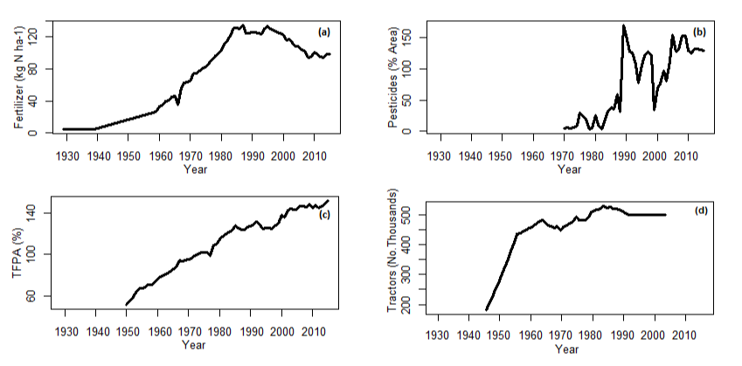
Appendix 3
Figure S1 Trends in UK farming metrics over the last 85 years. These UK wide estimates are used as a proxy for agricultural intensification in Dorset which has experienced similar trends to the whole of the UK (Robinson et al., 2002) (a) Total amount of fertilizer applied in Britain: (b) Area sprayed with insecticide in the county of Sussex UK (c) Total factor productivity of UK agriculture (TFPA) (d) Numbers of tractors in use in the UK (e) Total income from farming in England (TIFF). Total fertiliser data from (Robinson and Sutherland, 2002) via personal communication with the author. Pesticide, TFPA & TIFF data from DEFRA statistics. Agricultural machinery (Tractor numbers) taken from FAOSTAT data. Robinson, R.A., Sutherland, W.J., (2002). Post-war changes in arable farming and biodiversity in Great Britain. J. Appl. Ecol. 39, 157–176. https://doi.org/10.1046/j.1365-2664.2002.00695.x
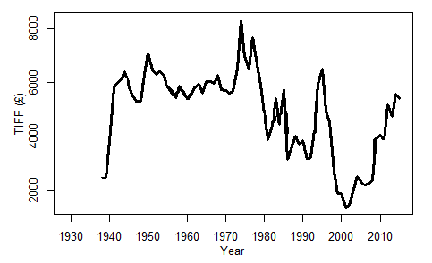
Figure S1 (continued) Trends in UK farming metrics over the last 85 years. These UK wide estimates are used as a proxy for agricultural intensification in Dorset which has experienced similar trends to the whole of the UK (Robinson et al., 2002) (a) Total amount of fertilizer applied in Britain: (b) Area sprayed with insecticide in the county of Sussex UK (c) Total factor productivity of UK agriculture (TFPA) (d) Numbers of tractors in use in the UK (e) Total income from farming in England (TIFF). Total fertiliser data from (Robinson and Sutherland, 2002) via personal communication with the author. Pesticide, TFPA & TIFF data from DEFRA statistics. Agricultural machinery (Tractor numbers) taken from FAOSTAT data. Robinson, R.A., Sutherland, W.J., (2002). Post-war changes in arable farming and biodiversity in Great Britain. J. Appl. Ecol. 39, 157–176. https://doi.org/10.1046/j.1365-2664.2002.00695.x
(e)

