Appendix 6
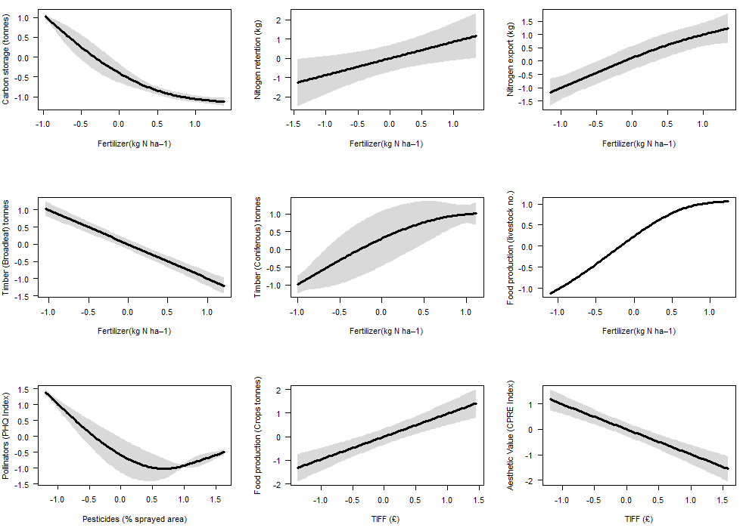
Figure S1 Full GAM analyses (data from 1930 to 2015) of timeseries ecosystem service responses to agricultural pressures (n= 75). The grey polygon represents 95% confidence intervals. See Table 1 in the main manuscript for additional details on significance values and Appendix 3 for the agricultural pressure time series.
