Butterfly biodiversity in the city is driven by the interaction of the urban landscape and species traits: a call for contextualised management
Clàudia PLA-NARBONA, Constantí STEFANESCU, Joan PINO, Francisco J. CABRERO-SAÑUDO, Enrique GARCÍA-BARROS, Miguel L. MUNGUIRA, Yolanda MELERO
Corresponding autor: Yolanda Melero. CREAF, Cerdanyola del Vallés 08193, Spain. E-mail: y.melero@creaf.uab.cat, Phone: +34 935814677

Appendix 1: Complete explanation of the species cluster selection process.
A combination of Hill & Smith principal component analysis (Hill and Smith 1976) and a subsequent hierarchical clustering with dissimilarity matrix, made with gower distances (Reusova 2018), was used to group butterfly species (N = 152; Supplementary Table 4) into functional clusters, based on 7 species traits (Supplementary Table A1). There are two hierarchical clustering methods known; divisive and agglomerative method, both were tested. Clustering was done with R 3.5.5 software (R Core Team 2019) using R packages ‘CLUSTER’ (Kaufman and Rousseeuw 2005), ‘FPC’ (Henning 2015) and ‘DENDEXTEND’ (Galili 2015).
The optimal number of clusters to be chosen is the minimum number of clusters that maximises (i) the reduction of the sum of squares within clusters (i.e. reduced variation within each cluster), which is evaluated by means of elbow plots, (ii) the distance between the points of a cluster and the neighbouring clusters, by means of silhouette plots, and (iii) the balanced number of species per cluster (Reusova 2018). We obtained the optimal number of clusters inspecting both elbow and silhouette plots, for both divisive and agglomerative methods, which show the sum of squares (the lower the better) and the distance between the species from a cluster to the others (the higher the better), respectively (Supplementary Fig. A1 and Fig. A2).
According to Reusova (2018), we first looked to the shrinking sum of squares within clusters, followed by the balanced number of species per cluster and the average silhouette width. Therefore, considering the sum of squares within clusters the highest reduction of those was from zero to four clusters (Supplementary Fig. A1 and Table A2), thus, the optimal number of clusters for the 152 species was four (assuming that the optimal number of clusters was also the minimum number of clusters with balanced number of species per cluster). Taking into account the number of species per cluster and the average silhouette width within the four clusters (Supplementary Fig. A2, and Table A2) the best hierarchical clustering method for the selected number of clusters appears to be divisive method.

Supplementary Table A1 Butterfly species traits description and categories

Species trait | Description of trait | Reference
Species specialisation index (SSI) | Adult habitat specialisation measured using the Species Specialisation Index, i.e. quantified as the coefficient of the variations in the average density in the available habitat; higher the value greater the specialization. | Julliard et al 2006
Larval specialisation (LS) | Larval trophic specialisation, from L1 (extreme specialists) to L3 (extreme generalists). | Stefanescu et al 2011; Fernández-Chacón 2014
Voltinism | Number of generations per year categorised as ‘Univoltine’ (1 generation/year) or ‘Multivoltine’ (>1 generations/year). | Stefanescu et al 2011; Fernández-Chacón 2014
Overwintering stage | Categorised as ‘Egg’ , ‘Larva’ , ‘Pupa’ , ‘Adult’, ‘Any’ or ‘None’. ‘Any’ is a category for those species that depending on the year can overwinter in any stage. ‘None’ is a category for migratory species (i.e. not overwintering in the region). | García-Barros et al Moreno 2013
Species temperature index (STI) | Medium temperature the species live in. | Schweiger et al 2014
Mobility | Dispersion capacity, from ‘D1’ (few dispersion capacity) to ‘D4’ (high dispersion capacity). | Kuussaari et al 2014
Habitat openness | Habitat openness index (TAO) for Catalonia; from -1 (totally forest species) to +1 (cropland species). | Suggitt et al 2012

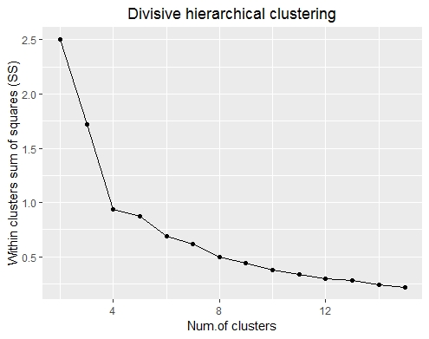
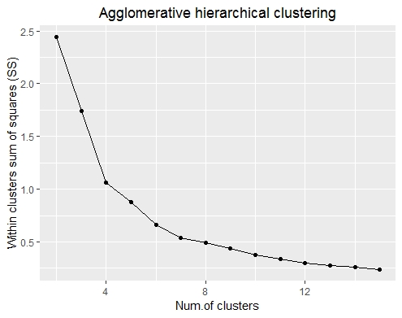

(a)
(b)

Supplementary Fig. A1 Elbow graphics showing the shrinking sum of squares within the rising number of clusters; for (a) the divisive hierarchical clustering method (for four clusters: 0.94), and (b) the agglomerative hierarchical clustering method (for four clusters: 1.06).
(a)

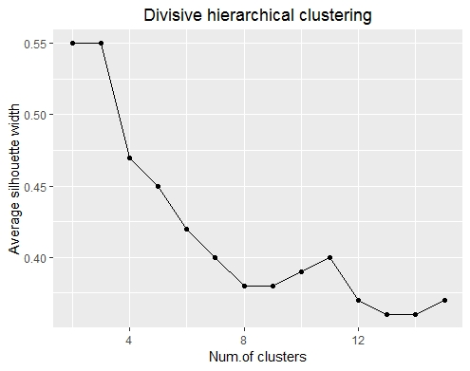
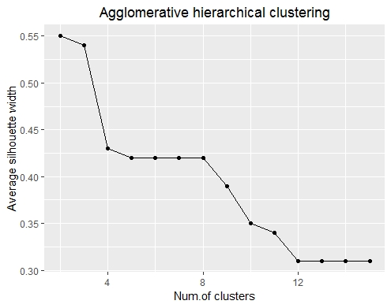

(a)
(b)

(b)

Supplementary Fig. A2 Silhouette graphic showing the change in average silhouette width as the number of clusters increases; for (a) the divisive hierarchical clustering (for four clusters: 0.47), and (b) the agglomerative hierarchical clustering (for four clusters: 0.43).

Supplementary Table A2 Summary table for clusters’ selection, for the divisive hierarchical clustering (Div.; in white) and the agglomerative hierarchical clustering (Aggl.; in grey) methods. In bold the clustering method and numbers chosen for the clústers.
 | Div. | Aggl. | Div. | Aggl. | Div. | Aggl. | Div. | Aggl. | Div. | Aggl.
Clusters’ number | 2 |  | 3 |  | 4 |  | 5 |  | 6
SS within clusters (Elbow) | 2.50 | 2.44 | 1.72 | 1.74 | 0.94 | 1.06 | 0.87 | 0.88 | 0.69 | 0.66
Average width (Silhouette) | 0.55 | 0.55 | 0.55 | 0.54 | 0.47 | 0.43 | 0.45 | 0.42 | 0.42 | 0.42
Cluster 1 size | 32 | 35 | 13 | 16 | 13 | 16 | 3 | 9 | 3 | 9
Cluster 2 size | 129 | 117 | 120 | 117 | 58 | 46 | 58 | 46 | 58 | 46
Cluster 3 size |  |  | 19 | 19 | 62 | 71 | 62 | 71 | 46 | 57
Cluster 4 size |  |  |  |  | 19 | 19 | 10 | 7 | 10 | 7
Cluster 5 size |  |  |  |  |  |  | 19 | 19 | 16 | 14
Cluster 6 size |  |  |  |  |  |  |  |  | 19 | 19

The first two axes of the multivariate ordination explained 32% of the total variance in species traits. Mobility is the one that contributed the most to species separation, thus had the highest correlation values for both axes. Overwintering stage also showed high correlation values for both axes. Furthermore, SSI and voltinism had high correlation ratios only for axis 1. However, habitat openness, LS and STI showed low contribution to the species separation, due to its small correlation values for both axes; therefore, these traits did not define the clusters in a representative way (Supplementary Fig. A3, Fig. A4 and Table A2).

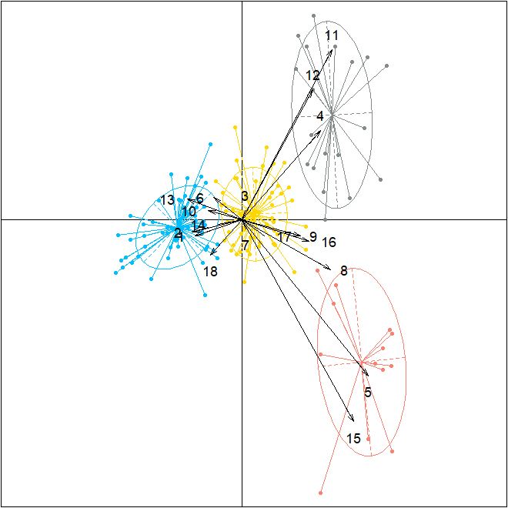
Supplementary Fig. A3 Multivariate analysis based on ordination (Hill & Smith Principal Component Analysis) of species trait relationships and the species clusters. The divisive hierarchical clustering to group the Catalan butterfly species considered (N = 152) into functional clusters (k = 4) was done, based on seven species traits represented as numbers: 1 Species specialisation index; 2 Mobility D1, 3 Mobility D2, 4 Mobility D3 and 5 Mobility D4; 6 Larval specialisation LS1, 7 Larval specialisation LS2 and 8 Larval specialisation LS3; 9 Multivoltine and 10 Univoline; 11 Overwintering stage adult, 12 Overwintering stage any, 13 Overwintering stage egg, 14 Overwintering stage larva, 15 no overwintering (none) and 16 Overwintering stage Pupa; 17 Species Temperature Index; and 18 Habitat openness (Table A1). In blue cluster C1, in yellow cluster C2, in salmon cluster C3 and in grey cluster C4. The correlation ratios for each species trait are shown in Supplementary Table A3.

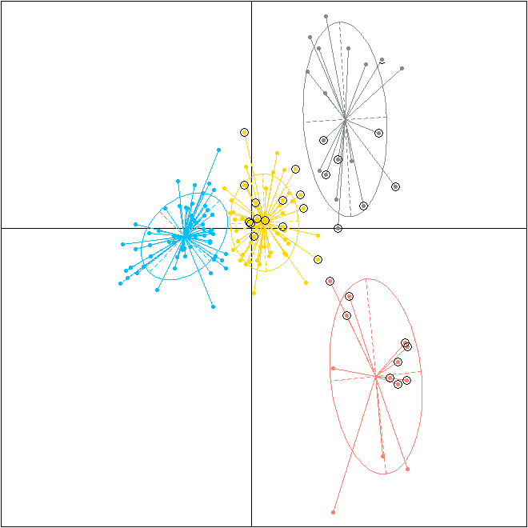
Supplementary Fig. A4 Multivariate analysis based on ordination (Hill & Smith Principal Component Analysis) made from the Catalan butterfly species considered (N= 152) with the divisive hierarchical clustering method. with the divisive hierarchical clustering method. In blue cluster C1, in yellow cluster C2, in salmon cluster C3 and in grey cluster C4. Species occurred in Barcelona are indicated with a black circle.

Supplementary Table A3 Correlation ratio for each trait category in the multivariate analysis is shown for axis 1 and 2. Traits with relevant weight (i.e. higher than the average correlation ratio for that axis; average correlation ratio for axis 1 = 0.38 and for axis 2 = 0.27) in each axis are marked in bold.

Species trait | Axis 1 | Axis 2
Species specialisation index (SSI) | 0.475 | 0.054
Larval specialisation (LS) | 0.277 | 0.118
Voltinism | 0.421 | 0.031
Overwintering stage | 0.491 | 0.612
Species temperature index (STI) | 0.109 | 0.056
Mobility | 0.691 | 0.656
Habitat openness (TAO) | 0.210 | 0.268

References
Galili T (2015) Dendextend: an R package for visualizing, adjusting and comparing trees of hierarchical clustering. Bioinformatics, Volume 31, Issue 22, 15 November 2015, Pages 3718–3720. https://doi.org/10.1093/bioinformatics/btv428
García-Barros E, Munguira ML, Stefanescu C and Vives Moreno A (Ed.) (2013)
Lepidoptera Papilionoidea. Fauna Ibérica. Museo Nacional de Ciencias Naturales. CSIC, Madrid.
Henning C (2015) fpc: Flexible Procedures for Clustering. R package version 2.1-10. Retrieved from https://cran.r-project.org/web/packages/fpc/index.html
Hill MO and Smith AJE (1976) Principal Component Analysis of Taxonomic Data With
Multi-State Discrete Characters. Taxon, 25(2–3), 249–255.
https://doi.org/10.2307/1219449
Julliard R, Clavel J, Devictor V, Jiguet F and Couvet D (2006) Spatial segregation of specialists and generalists in bird communities. Ecology Letters, 9(11), 1237–1244. https://doi.org/10.1111/j.1461-0248.2006.00977.x
Kaufman L and Rousseeuw P (2005) Finding Groups in Data: An Introduction to Cluster Analysis. John Wiley & Sons. ISBN: 978-0-471-73578-6
Kuussaari M, Saarinen M, Korpela EL, Pöyry J and Hyvönen T (2014) Higher mobility of butterflies than moths connected to habitat suitability and body size in a release experiment. Ecology and Evolution, 4(19), 3800–3811. https://doi.org/10.1002/ece3.1187
R Core Team (2020) R: A language and environment for statistical computing. R
Foundation for Statistical Computing, Vienna, Austria. URL: https://www.R-project.org/.
Reusova A (2018) Hierarchical Clustering on Categorical Data in R. Towards Data Science. https://medium.com/@anastasia.reusova/hierarchical-clustering-on-categorical-data-in-r-a27e578f2995.
Schweiger O, Harpke A, Wiemers M and Settele J (2014) Climber: Climatic niche characteristics of the butterflies in Europe. ZooKeys, 367, 65–84. https://doi.org/10.3897/zookeys.367.6185
Stefanescu C, Carnicer J and Peñuelas J (2011) Determinants of species richness in generalist and specialist Mediterranean butterflies: The negative synergistic forces of climate and habitat change. Ecography, 34(3), 353–363. https://doi.org/10.1111/j.1600-0587.2010.06264.x
Suggitt AJ, Stefanescu C, Páramo F, Oliver T, Anderson BJ, Hill JK, … Thomas CD (2012) Habitat associations of species show consistent but weak responses to climate. Biology Letters, 8(4), 590–593. https://doi.org/10.1098/rsbl.2012.0112

