Appendix 1
Full model description of the generalized linear model (GLM) with beta distribution and the results of the optimal model.
GLM with beta distribution:
$$Y_{ijk}\sim beta\left(μ_{ijk},ϕ\right)$$
$$logit\left(μ_{ijk}\right)=α_{0}+β_{0}×{Distance}_{ij}+{β_{l}×Pond_Combination}_{k}+{β_{m}×{Distance}_{ij}×Pond_Combination}_{k}+ε_{ijk}$$
where $ε_{ijk}\sim N(0,σ^{2})$
$$i=1,2, …,26$$
$$j=i+1, j<26$$
The term Y_{ijk} means the observation of community dissimilarities between pond i and pond j in in the pond scenario between ponds k. The pond combination contains three categories, i.e. “both fishless”, “one fishless and one with fish”, “both with fish”. The expectation of Y_{ijk} depends on π_{ijk}, while ϕ is the shape parameter. The term µ_{ijk} is modelled in terms of Euclidean distance between ponds (${Distance}_{ij}$) and the fish pond between ponds$({Pond_Combination}_{k}$). The term α₀ is the intercept, while β₀ is the parameter of the distance between ponds. The term β_{l} means the regression parameters for ${Pond_Combination}_{k}$, while the term β_{m} means the regression parameters for the interaction between ${Distance}_{ij}$ and ${Pond_Combination}_{k}$. The term ε_{ijk} is the unexplainable variable assumed normally distributed with expectation 0 and variance σ².

The optimal model does not include the interaction between ${Distance}_{ij}$ and ${Pond_Combination}_{k}$. Here we show the results when the pond combination “both fishless” is set as the reference level. SE means standard error.
 | Estimate | SE | Z-value | p-value
Intercept | 0.94 | 0.08 | 12.54 | <0.001
Distance | 0.24 | 0.05 | 4.66 | <0.001
Fishless + Fish | 0.48 | 0.10 | 4.81 | <0.001
Fish + Fish | 0.57 | 0.16 | 3.55 | <0.001

Appendix 2
Matrix of dytiscid species and ponds. Thirty species occurred in at least one of the ponds during two out of the three sampling years. The dark grey squares mean the species occurred in a pond at least 2 out of 3 sampling years; the light grey squares represent the species occurred in a pond only 1 out of 3 sampling years; the empty squares mean that a species did not occur in a pond during the sampling years. The fish symbols represent ponds with fish.
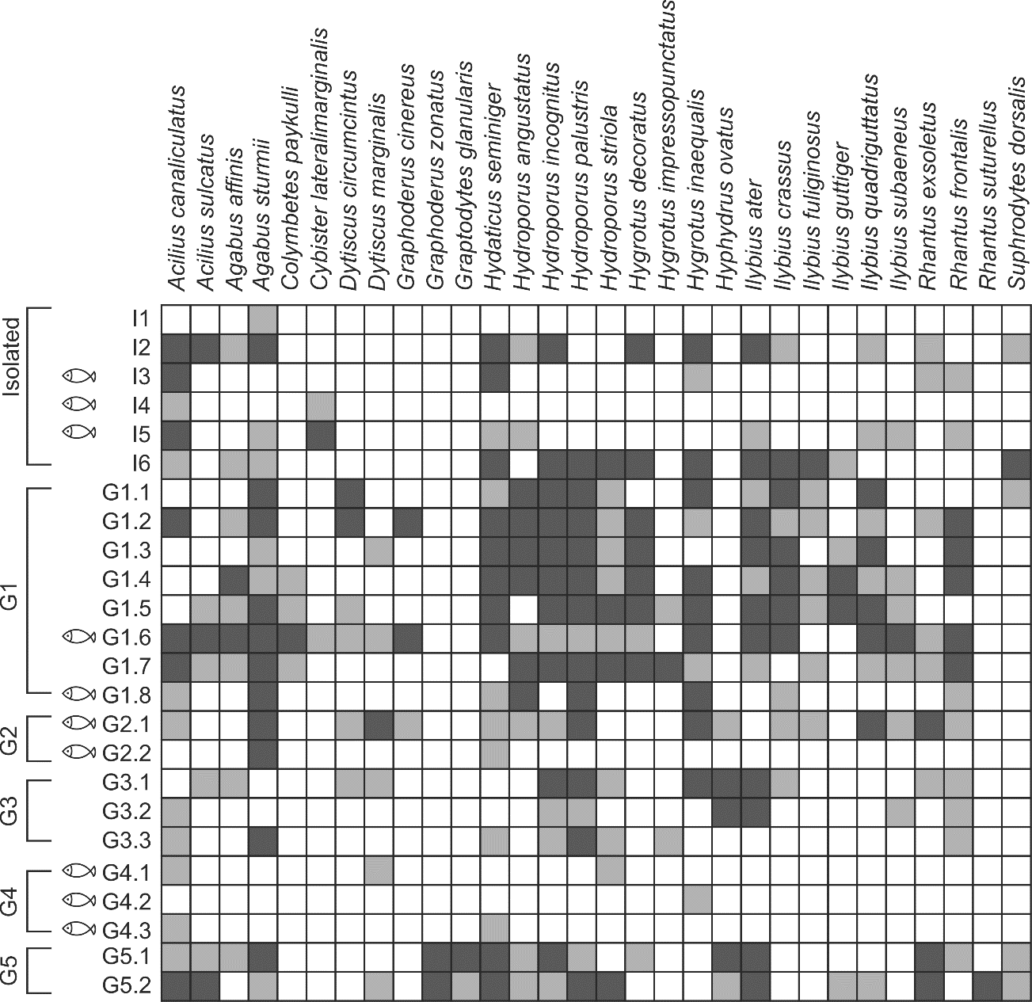

Appendix 3
Matrix of dytiscid species and ponds. The other 30 species were recorded in only one of the sampling years. The light grey squares represent the species occurred in a pond 1 out of 3 sampling years. The fish symbols represent ponds with fish.
