Appendix S4 – Classification mismatch of red and roe deer GPS relocations between TCD/CLC layers: validation through visual comparison with orthophotos
Out of all GPS relocations that were classified differently by CLC and TCD, we sampled 100 relocations for each population of both species (5 red deer and 5 roe deer populations), obtaining 1000 mismatching relocations in total. We then performed a validation using orthophotos (Google maps) as ground truth. According to the orthophotos, for red deer 274 GPS relocations were forest habitat while 201 were open habitat. For 25 GPS relocations we could not identify the habitat type through visual interpretation of the orthophotos (e.g. because of shadows, unclear vegetation patterns, blurry contours). For roe deer 328 GPS relocations were forest habitat while 140 were open habitat. For 32 GPS relocations we could not determine the habitat type through visual interpretation of the orthophotos.
For red deer 386 [0.77] GPS relocations were correctly classified by TCD, while only 89 [0.18] GPS relocations were correctly classified by CLC (Fig. S4.1, right hand side bar ‘all’). However, these proportions changed according to the study area: in N-Italy (population 3) TCD correctly classified 0.70 of the sampled GPS relocations and CLC the 0.22, whereas in SE-Germany (population 8) TCD correctly classified 0.83 of the relocations and CLC only 0.12 (see figure S4.2).
For roe deer 344 [0.69] GPS relocations were correctly classified by TCD, while 124 [0.24] GPS relocations were correctly classified by CLC (Fig. S4.2, right hand side bar ‘all’). Again, these proportions changed according to the study area: in N-Italy (population 1) TCD correctly classified 0.60 of the sampled GPS relocations and CLC the 0.32, whereas in SW-France (population 8) TCD correctly classified 0.83 of the relocations and CLC only 0.14 (see figure S4.1).
As apparent from the above numbers (and illustrated by Figures S4.1 and S4.2), for those GPS relocations that showed a mismatch between CLC and TCD, the vast majority turned out to be correctly classified by TCD, and not by CLC. This general pattern was consistent across populations, even though some inter-population variability was present.

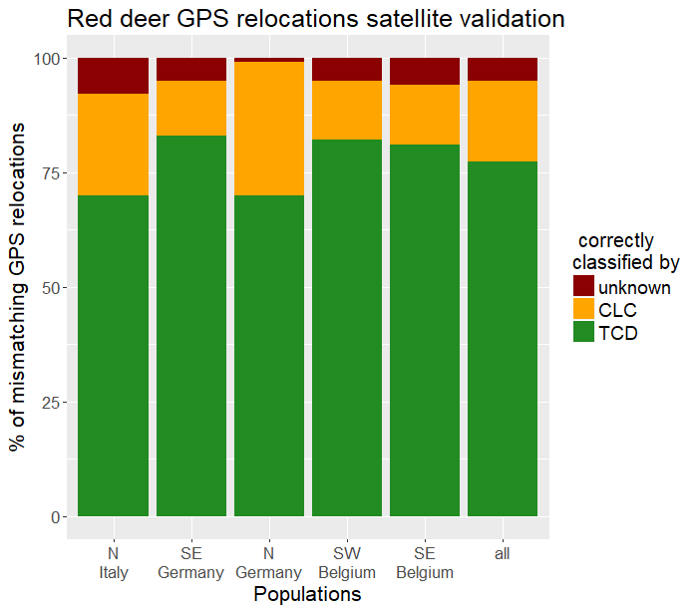
Fig. S4.1 Barplot with the percentage of mismatching GPS relocations correctly classified by TCD (green), correctly classified by CLC (orange), and not classifiable (dark red). Bars show the proportion for each population and the overall average (right hand side bar). These data refer to a sample of 500 red deer mismatching relocations
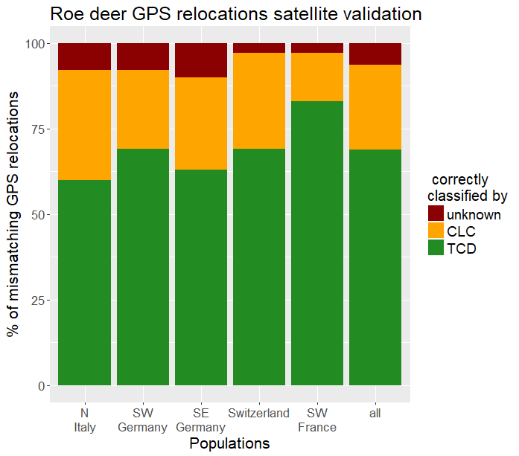
Fig. S4.2 Barplot with the percentage of mismatching GPS relocations correctly classified by TCD (green), correctly classified by CLC (orange), and not classifiable (dark red). Bars show the proportion for each population and the overall average (right hand side bar). These data refer to a sample of 500 roe deer mismatching relocations

