Supplementary material for

An overview of computational tools for preparing, constructing and using resistance surfaces in landscape connectivity research

Supplementary S1 Workflow to create resistance surfaces
Here, we present a workflow to build landscape resistance surfaces. Landscape resistance is species specific and represents the willingness, the physiological cost or the mortality associated with moving through a particular combination of environmental variables across the landscape (Adriaensen et al. 2003; Zeller, McGarigal & Whiteley 2012). Resistance is typically represented as a cell (pixel) value in a grid (raster) within a Geographic Information System (GIS).
Along with this workflow, we provide a decision tree (Supplementary material S2) and tutorial (Supplementary material S5) to perform some basic operations we describe hereafter using R (R Core Team 2020). Note that there are many non-R tools that are suitable for manipulating data and perform resistance and connectivity analyses (Tables 1, 2 and 3), but we here chose R because it is a multi-platform, open source language and environment for statistical computing and graphics (r-project.org). R includes a wide range of packages, supporting advanced geospatial statistics, modeling and visualization. Newly integrated development environments such as RStudio have made R more user-friendly and popular among ecologists (Lai et al. 2019) facilitating map making (Guisan, Thuiller & Zimmermann 2017).

I- Preparing data
Before any analyses, the first step is to select environmental features relevant to the study question and species. Variable selection should be based on the biological requirements of the study species and the type of connectivity modelled (e.g., seasonal migration, natal dispersal, range shift). For example, different environmental variables might affect seasonal home range shift and natal dispersal of a given species, or dispersal for different species (e.g., fish dispersal, Thomas et al. 2015; or roe deer dispersal, Loro et al. 2016). Additionally, special attention must be paid to the temporal scale of the data used. Organisms exploit their environments over time periods that are species-specific and could depend on life-stage, or season. For example, connectivity of species living in ephemeral or fluctuating environment such as ponds might depends on environmental characteristics that fluctuate over time and between-wetland conditions (Watts et al. 2015).
The environmental variables are represented by spatial objects which are numerical or categorical values in a geographic coordinate system. These objects can be of different types (e.g., vector or raster), with different projection system, extent and resolution which must be standardised after variables were selected. More detailed information can be found in the R Series books (e.g., Lovelace, Nowosad & Muenchow 2019).

1- Spatial data
Spatial variables are of two types, discrete objects with clear boundaries such as forest patches and roads, or a continuous phenomenon with no natural boundaries such as elevation or temperature. Discrete objects are usually represented by vector data which describe the geometry (i.e., shape) of the objects, and can also include additional variables called attributes (e.g., types of road). In contrast, continuous spatial data are usually under the form of a raster. While discrete data can be represented with a raster, the opposite is not possible.

a- Vector data
Vector data can be of three types: points, lines and polygons. Points are the simplest object with a set of coordinates pairs and n associated variables (e.g., number of nights of activity for traps). Lines are composed of polylines (i.e., line segments) connecting ordered nodes (i.e., sets of coordinates) with n associated variables (e.g., type of roads). Ordering the points is important to know which points should be connected. Polygons are a set of closed polylines connecting nodes, but the last node coincides with the first one to close the polygon. As points or lines, polygons can be associated with n variables (e.g., type of forest). The most common data format for storing vector data is a “shapefile”, with ending “.shp” (Supplementary material S5).

b- Raster data
A raster can be viewed as a classic data matrix, it divides the variable of interest into a grid of equally sized rectangles (i.e., cells or pixels) that all have one or more values (or missing values). Contrary to vector data, the geometry in raster data is not stored as coordinates, but is set by knowing the spatial extent and the number of rows and columns in which the area is divided.
Raster data can represent continuous features which are, by definition, not spatially discrete. The transition between the cells values on a continuous surface is without abrupt or well-defined breaks between values. For example, values for surface elevations are continuous across the entire study landscape. Raster data can also represent distinct categories or classes (e.g., land cover use) with clear boundaries. It is assumed that the class fills the entire area of the cell. Common data formats for storing raster data include ASCII (.asc), Grid (.grd), Tiff (.tif) or various image formats (Supplementary material S5).

2- Parameters
a- Coordinate reference system
The Coordinate Reference System (CRS) defines how the spatial objects relate to the surface of the Earth. CRSs can be either geographic or projected. Geographic CRSs identify any location on the Earth’s surface using two values, longitude and latitude, while projected CRSs are based on Cartesian coordinates on an implicitly flat surface, with an origin, x and y axes, and a linear unit of measurement (e.g., meters). Geographic CRSs span the entire globe (e.g., latitude-longitude), while projected CRSs are localized to minimize visual distortion in a particular region (e.g., Lambert93, French official CRS).

b- Spatial extent
The spatial extent is defined as the overall area considered in an analysis (Turner 1989). The extent should be large enough to encompass both the range of landscape variability and conservation management units. It is advised to add a buffer around the sampling locations to avoid edge effect, e.g., to avoid connectivity analyses to be artificially limited by the map edges (Koen et al. 2010). Buffering beyond the area of interest reduces the likelihood that important potential linkages will be missed. If the study area is either too large or too small, practitioners will be unable to implement recommendations, or will regard the results as irrelevant for management (Keller et al. 2015). For example, in landscape genetics, the study area extent should be larger than the range at which the genetic variability is structured, with a buffer of at least the dispersal distance of the studied species (Anderson et al. 2010).

c- Spatial resolution
The spatial resolution, also called spatial scale, or grain (Anderson et al. 2010), is the finest resolution of patterns that can be described in the data, i.e., the size of the smallest element in the case of vector data, or the size of pixels for raster data. As the resolution decreases, feature boundaries must be smoothed, simplified, or not shown at all. The global resolution of the resistance surfaces will be limited by the lowest resolution of the input variables. Decreasing the resolution of a raster by aggregating cells into larger cells without loosing to much information is possible, but the opposite is not meaningful, i.e., landscape features should not be described at a spatial resolution that is finer than the features are actually be mapped at. The choice of spatial resolution must rely on available ecological and demographic information on movement and dispersal distances. For example, a spatial resolution of 25 m for raster data might be too coarse for a lizard species, but not for an elephant. A different type of resolution, called thematic resolution, refers to the number of categories that are distinguished in discrete data. For example, we could distinguish beech forests vs. oak forests vs. fir forests in our data, or we could only distinguish deciduous forests (beech and oak) vs. coniferous forests (fir), or we could combine all of these forests types into ‘forests’. Compared to spatial resolution and extent, thematic resolution seems to have greater impact on connectivity analyses, at least when using landscape genetics (Cushman & Landguth 2010).

d- Missing data value
For raster data, the value for cells with missing data must be set carefully, with the same value for all these cells, and a value corresponding to the software used to be considered properly, and not as a factor of the variable represented. For example, -9999 is a common value for storing “NoData” value in the ArcGIS suite and in ASCII files.

3- Standardisation
Measures of resistance can be quantified using either univariate or multivariate surfaces. Whenever more than one landscape feature or variable is considered, it is recommended to combine all layers into a single resistance surface before proceeding with any connectivity analyses (e.g., estimation of least-cost paths or circuit-theoretic resistances; Peterman & Pope 2020). Before overlaying or combining several resistance surfaces, it is necessary to first standardise all layers, so that they have the same spatial projection, extent and resolution. The first step is to standardise the CRS and the extent of all the layers to be certain that all the variables overlay and are available for the whole study landscape.
Then, if vector layers are used as input, they must be converted into raster layers, i.e., we need to transfer the values associated with the vector spatial objects to the raster cells. If both vector and raster layers are used, one of the raster layers can be used as a reference layer, i.e., a layer upon which all the other layer are built with the same parameters, otherwise, one reference raster layer can be created from scratch. Both vector and raster layers can be manipulated and standardised with R and the sp (Pebesma & Bivand 2005), sf (Pebesma 2018), rgeos (Bivand & Rundel 2020), and raster (Hijmans 2014) libraries, respectively. These basic operations are presented in the R tutorial (Supplementary material S5).
When converting a vector layer to a raster layer, there are several ways to assign value to cells that are covered by multiple spatial objects. One should carefully think about the most adequate representation of the variables: discrete (e.g., presence-absence of roads or protected versus non protected area) or continuous (e.g., distance to the closest road or percentage of forest cover). Multiple layers from the same variable may often be generated (e.g., presence absence of roads, distance from roads, different categories of roads) and the most appropriate derived variable may be used in the analysis.
Raster layers with extent and/or resolution different from the reference raster layer must be resampled, i.e., values from the original raster must be transferred to the spatial extent and resolution of the reference layer. There are 2 main resampling methods: (1) the nearest neighbor method is usually used for discrete data as it does not change the value and each pixel in the resampled raster acquires the same value as its nearest neighbor in the original raster, and (2) the bilinear interpolation is used for continuous data as it assigns the output cell value by taking the weighted average of the neighboring cells. Note that after this resampling step, it is important to check again the missing data values.

The output of the preparation step is one or several raster layers with the same parameters (coordinate system, extent, and resolution), that describe the landscape variables of interest for the study.

II- Constructing and optimizing

The biggest challenge for creating resistance surfaces is the assignment of resistance values to different landscape features, as the actual effects of different landscape or environmental variables on movement, survival, and reproduction are generally unknown (Spear et al. 2010). Depending on your objectives, several types of data can be used as input to transform your raster layers into resistance surfaces, i.e., to assign cost to the different variables represented by your raster layers. We can distinguish two main types of data: expert opinion and empirical data (e.g., habitat suitability modelling or georeferenced genotypes).
Expert opinion-based resistance values of different landscape variables are usually assigned on an arbitrary scale meant to reflect low to high movement suitability. This option is useful where there is a particular shortage of empirical data and an urgency to act. Empirical data can be divided into four types: species occurrence, animal movement paths, interpatch movement rates, and genetic patterns (Beier, Majka & Spencer 2008; Zeller, McGarigal & Whiteley 2012). Species occurrences, animal movement data, and experimental movement studies are often used to build resource selection metrics which are in turn, converted into resistance (i.e., resistance = 1 - metric). Genetic data are used to select the resistance surface, among a set of candidate resistance surfaces, that has the greatest fit with it.
While results are highly sensitive to the type of data used to define resistance values (Sawyer, Epps & Brashares 2011), it is beyond the scope of this paper to discuss the relevance of the different methods in detail. Reviews of pros and cons associated with these approaches can be found in (Spear, Cushman & McRae 2015) and Zeller, McGarigal and Whiteley (2012). However, it is important to consider carefully the link between the functional biological underpinnings of input data and the purpose of connectivity modelling. For example, results from home range selection are only directly pertinent to model daily habitat connectivity, while a landscape genetic approach is useful to model dispersal connectivity.

1- Expert opinion
Resistance values are attributed by one or several experts (with extensive field experience with the focal species) based on the likely capacity of the focal species to move through each landscape variable. Movement capacity is usually scored on a range from 1 (unconstrained movements equivalent to low resistance) to 100 (totally inhibited movements or very high resistance). However, when comparing resistance surfaces among different species, the maximum resistance values can be species specific.
Raster layers can be easily modified with the raster library (Hijmans 2014) in R. For categorical raster layers, the different factor values can be replaced by their resistance values through a basic indexation that does not require a specific function. For continuous raster layers, resistance values can be attributed assuming a linear relationship between the original landscape values and the resistance values (e.g., resistance increasing with increasing percentage of anthropized area). However, a linear relationship should not necessarily be assumed, as critical thresholds can exist, and non-linear relationships sometimes are a better fit for the data (Spear et al. 2010). These operations can require more elaborate functions such as the calc or reclassify functions of the raster library (Hijmans 2014).
When several resistance surfaces are used, they can be combined, and a specific weight can be chosen for each variable. Most of the studies assume an additive relationship between the variables, but more complex relationship can be guessed from literature reviews for example. The choice of these weighting parameters and arithmetic operators must be done carefully, and when possible, uncertainty analyses should be done to investigate the sensitivity of the results to the parameters chosen (Rayfield, Fortin & Fall 2010; Spear et al. 2010).
In R, most arithmetic operations can be applied to raster layers as they would be with any numbers with the raster library (Hijmans 2014). However, for large raster layers, computation time can be limiting, and it is therefore advised to use the overlay function for more efficient processing (Hijmans 2014).

2- Species distribution models and resource selection functions
Resistance can be estimated from field measures such as presence-only data, presence-absence data, telemetry and experimental movement studies (Spear et al. 2010). These approaches are first used to estimate habitat suitability from the environmental variables, or to develop a Resource Selection Function (RSF) measuring habitat preferences. A transformation of the indexes or RSF coefficients can then be taken as the resistance values (e.g., an inverse transformation would be resistance = 1 - RSF coefficients). However, species may be more readily willing to move through lower quality habitat when traveling or dispersing, than when establishing in a home range (Beier, Majka & Spencer 2008). As a result, a negative exponential relationship to translate habitat suitability into resistance may be more adequate than a simple negative linear relationship (Keeley, Beier & Gagnon 2016).
The R raster library (Hijmans 2014) can be used to convert a habitat suitability raster to a resistance surface using any transformation chosen. Moreover, the R environment offers numerous libraries to analyse presence-absence, telemetry and experimental movement data such as the library adehabitatLT (Calenge 2006) or amt (Signer, Fieberg & Avgar 2019).

3- Genetics
Using a landscape genetics framework (Manel et al. 2003), genetic data collected at multiple locations are used to estimate gene flow and dispersal between individuals or populations, which are considered as a proxy for functional connectivity. Estimates of gene flow are then evaluated against measures of effective geographic distance under alternative resistance surfaces to find the best estimates of resistance. The classic approach consists in choosing a range of potential resistances associated with each landscape variables, testing each of these potential resistances and their combinations against each other (e.g., 1,953,125 surfaces, Portanier et al. 2018), and selecting the surface that has the greatest fit with genetic data.
The R raster library (Hijmans 2014) is often used to create an unlimited number of resistances surfaces and combine them. Landscape genetic approaches can also be conducted in the R environment with for example, the libraries ade4 (Dray & Dufour 2007), ecodist (Goslee & Urban 2007) or LandGenReport (Gruber & Adamack 2015).
The use of genetic data offers a way to select among several resistance surfaces the one with the best fit, but the choice of the candidate surfaces can still be biased. For example, Portanier et al. (2018) investigated nine landscape variables, covering a very large number of contrasted scenarios (1,953,125 surfaces), but assumed each variable to be categorical (e.g., presence vs. absence of deciduous forest). This has led researchers to implement automated exhaustive search and optimization methods (Wang, Savage & Bradley Shaffer 2009; Graves, Beier & Royle 2013; Peterman et al. 2014) including the most recent and complete one implemented in the R package ResistanceGA (Peterman 2018) or Radish (Peterman & Pope 2020). Using a machine-learning algorithm, these automated approaches enable unbiased optimisation and selection of the best resistance surfaces based on genetic data. However, they require a high computational power due to the high number of resistance surfaces tested.

The output of the creating step is at least one raster layers describing the resistance associated with a particular combination of landscape variables in the study area.

III- Using
Although essential, final resistance surfaces are rarely the final product to answer the research questions. Resistance surface are especially useful to map biological/ecological corridors or linkages, identify pinch-points and bottlenecks (i.e., features through which dispersers have a high likelihood or necessity of passing), predict the impacts of climate change on future connectivity. We briefly provide a few additional steps to conduct most connectivity analyses.

1- Defining the nodes
A crucial step in any connectivity analysis is defining the entities to be connected, as their selection will define and limit the modeled movements (Beier et al. 2011). The areas or points to be connected are often called ‘nodes’. Depending on the species and type of connectivity modeled, nodes can be areas of high naturalness, protected areas, core areas of species habitat, home ranges, pixels with low resistance values, areas with high species occupancy. When there is no a priori reason to locate nodes in a particular place, Koen et al. (2014) recommend (Supplementary material S5) to randomly place nodes (i.e., points) in a certain buffer around the area of interest to avoid constraining the connectivity algorithms to pass through areas which are in reality not connected and would prevent the detection of isolated areas. This method also enables to avoid any edge effect (Koen et al. 2010). As for the assignment of resistance values, it is advised to perform a sensitivity analyse by varying the nodes locations and evaluate the changes in the connectivity estimated.

2- Connectivity models
There are two main categories of connectivity models, each of them takes resistance surfaces as inputs, but they are different in the way movement among nodes is characterised. Least-cost path models assume that movements are directly related to the total cumulative resistance (sum of the resistance values) of a single and optimal path between nodes (Adriaensen et al. 2003). This model assumes that individuals have perfect knowledge of the entire landscape and choose the path that minimizes the cumulative cost of moving among nodes. The least-cost path model hence also assumes that organisms move across the landscape in an optimal way. Circuit theory-based models apply concepts related to flow of charge through an electrical circuit to the movement of individuals through a landscape. They incorporate all possible pathways across landscapes, and their parameters and predictions can be expressed in terms of random walk probabilities (McRae et al. 2008).
In addition to these two main categories, there are several ‘hybrid’ connectivity models that assume a certain amount of (local) knowledge and resulting optimal movements, but also some variability around such optimal movements, in addition to increasingly random movements at larger spatial scales (e.g., Palmer, Coulon & Travis 2011; Ribeiro et al. 2017).
The choice of the connectivity model depends on the study question, landscape characteristics, species, and data availability. Least-cost path models might be well suited to predict the migration path of elks, a long-lived species for which migration paths are passed down through generations and route fidelity is high, and thus with a good knowledge of the optimal path between seasonal home ranges (McClure, Hansen & Inman 2016). Circuit theoretic models in turn, might be particularly useful for modeling the passive wind-dispersed process of a Lepidoptera (Larroque et al. in prep).
Least-cost paths can be computed in R using the gdistance package (van Etten 2017) (Supplementary material S5). There is currently no option to compute resistance distance with R, however, the gdistance package (van Etten 2017) offers a function to calculate the commute-time distance (i.e., the expected length of paths travelled by random walkers during a round trip between two nodes, Göbel & Jagers 1974) which is computationally much faster and highly correlated with the resistance distance (Peterman 2018).

3- Using the connectivity map
Once the best optimized landscape variables combination has been found and connectivity defined, one might need to identify areas with relatively high connectivity (i.e., corridors and core areas) or of primary importance for the global connectivity (i.e., pinch points) to preserve it, or areas with low connectivity to restore it, in order to plan and mitigate future human-wildlife conflicts for example. The most straightforward way to identify corridors or core areas is to take an upper percentage of connectivity values (e.g., 10%, Zeller et al. 2018). This operation can be performed on the connectivity raster with the R raster library (Hijmans 2014) (Supplementary material S5). The identification of pinch points (i.e., movement bottlenecks that should be prioritized) requires more complex operations that can be done using pinchpoint mapper (McRae 2012b) for example. It is also possible to identify the effect of mitigation measure on connectivity by identifying areas that would benefit the most of restoration measures using barrier mapper (McRae 2012a). It is also possible to consider the impact of climate change on connectivity by identifying corridors that support continuity along projected climatic gradients through time using Climate Linkage Mapper (Kavanagh, Nuñez & McRae 2012). We provided here just a few examples of what can be done with a connectivity map, but a very large number of questions can be answered.

References
Adriaensen, F., Chardon, J.P., De Blust, G., Swinnen, E., Villalba, S., Gulinck, H. & Matthysen, E. (2003) The application of 'least-cost' modelling as a functional landscape model. Landscape and Urban Planning, 64, 233-247.
Anderson, C.D., Epperson, B.K., Fortin, M.-J., Holderegger, R., James, P.M.A., Rosenberg, M.S., Scribner, K.T. & Spear, S. (2010) Considering spatial and temporal scale in landscape-genetic studies of gene flow. Molecular Ecology, 19, 3565-3575.
Beier, P., Majka, D.R. & Spencer, W.D. (2008) Forks in the Road: Choices in Procedures for Designing Wildland Linkages. Conservation Biology, 22, 836-851.
Beier, P., Spencer, W., Baldwin, R.F. & McRae, B.H. (2011) Toward Best Practices for Developing Regional Connectivity Maps. Conservation Biology, 25, 879-892.
Bivand, R. & Rundel, C. (2020) rgeos: Interface to Geometry Engine - Open Source (GEOS). R package version 0.5-3.
Calenge, C. (2006) The package “adehabitat” for the R software: A tool for the analysis of space and habitat use by animals. Ecological Modelling, 197, 516-519.
Cushman, S.A. & Landguth, E.L. (2010) Scale dependent inference in landscape genetics. Landscape Ecology, 25, 967-979.
Dray, S. & Dufour, A.B. (2007) The ade4 package: implementing the duality diagram for ecologists. Journal of Statistical Software, 22, 1-20.
Göbel, F. & Jagers, A.A. (1974) Random walks on graphs. Stochastic Processes and their Applications, 2, 311-336.
Goslee, S.C. & Urban, D.L. (2007) The ecodist package for dissimilarity-based analysis of ecological data. Journal of Statistical Software, 22, 1-19.
Graves, T.A., Beier, P. & Royle, J.A. (2013) Current approaches using genetic distances produce poor estimates of landscape resistance to interindividual dispersal. Molecular Ecology, 22, 3888-3903.
Gruber, B. & Adamack, A.T. (2015) landgenreport: a new r function to simplify landscape genetic analysis using resistance surface layers. Molecular Ecology Resources, 15, 1172-1178.
Guisan, A., Thuiller, W. & Zimmermann, N.E. (2017) Habitat Suitability and Distribution Models: With Applications in R. Cambridge University Press, Cambridge.
Hijmans, R.J. (2014) raster: raster: Geographic data analysis and modeling. R package version 2.3-12. http://CRAN.R-project.org/package=raster.
Kavanagh, D.M., Nuñez, T.A. & McRae, B.H. (2012) Climate linkage mapper connectivity analysis software. (ed. T.N. Conservancy). Seattle WA.
Keeley, A.T.H., Beier, P. & Gagnon, J.W. (2016) Estimating landscape resistance from habitat suitability: effects of data source and nonlinearities. Landscape Ecology, 31, 2151-2162.
Keller, D., Holderegger, R., van Strien, M.J. & Bolliger, J. (2015) How to make landscape genetics beneficial for conservation management? Conservation Genetics, 16, 503-512.
Koen, E.L., Bowman, J., Sadowski, C. & Walpole, A.A. (2014) Landscape connectivity for wildlife: development and validation of multispecies linkage maps. Methods in Ecology and Evolution, 5, 626-633.
Koen, E.L., Garroway, C.J., Wilson, P.J. & Bowman, J. (2010) The Effect of Map Boundary on Estimates of Landscape Resistance to Animal Movement. PLoS ONE, 5, e11785.
Lai, J., Lortie, C.J., Muenchen, R.A., Yang, J. & Ma, K. (2019) Evaluating the popularity of R in ecology. Ecosphere, 10, e02567.
Loro, M., Ortega, E., Arce, R.M. & Geneletti, D. (2016) Assessing landscape resistance to roe deer dispersal using fuzzy set theory and multicriteria analysis: a case study in Central Spain. Landscape and Ecological Engineering, 12, 41-60.
Lovelace, R., Nowosad, J. & Muenchow, J. (2019) Geocomputation with R. CRS Press.
Manel, S., Schwartz, M.K., Luikart, G. & Taberlet, P. (2003) Landscape genetics: combining landscape ecology and population genetics. Trends in Ecology & Evolution, 18, 189-197.
McClure, M.L., Hansen, A.J. & Inman, R.M. (2016) Connecting models to movements: testing connectivity model predictions against empirical migration and dispersal data. Landscape Ecology, 31, 1419-1432.
McRae, B.H. (2012a) Barrier Mapper Connectivity Analysis Software. (ed. T.N. Conservancy). Seattle WA.
McRae, B.H. (2012b) Pinchpoint Mapper Connectivity Analysis Software. (ed. T.N. Conservancy). Seattle, WA.
McRae, B.H., Dickson, B.G., Keitt, T.H. & Shah, V.B. (2008) Using circuit theory to model connectivity in ecology, evolution, and conservation. Ecology, 89, 2712-2724.
Palmer, S.C.F., Coulon, A. & Travis, J.M.J. (2011) Introducing a ‘stochastic movement simulator’ for estimating habitat connectivity. Methods in Ecology and Evolution, 2, 258-268.
Pebesma, E. (2018) Simple Features for R: Standardized Support for Spatial Vector Data. The R Journal, 10, 439-446.
Pebesma, E.J. & Bivand, R.S. (2005) Classes and methods for spatial data in R. R News, 5, 9-13.
Peterman, W.E. (2018) ResistanceGA: An R package for the optimization of resistance surfaces using genetic algorithms. Methods in Ecology and Evolution, 9, 1638-1647.
Peterman, W.E., Connette, G.M., Semlitsch, R.D. & Eggert, L.S. (2014) Ecological resistance surfaces predict fine-scale genetic differentiation in a terrestrial woodland salamander. Molecular Ecology, 23, 2402-2413.
Peterman, W.E. & Pope, N.S. (2020) The use and misuse of regression models in landscape genetic analyses. Molecular Ecology.
Portanier, E., Larroque, J., Garel, M., Marchand, P., Maillard, D., Bourgoin, G. & Devillard, S. (2018) Landscape genetics matches with behavioral ecology and brings new insight on the functional connectivity in Mediterranean mouflon. Landscape Ecology, 33, 1069-1085.
R Core Team (2020) R: A Language and Environment for Statistical Computing. R Foundation for Statistical Computing, Vienna, Austria.
Rayfield, B., Fortin, M.-J. & Fall, A. (2010) The sensitivity of least-cost habitat graphs to relative cost surface values. Landscape Ecology, 25, 519-532.
Ribeiro, J.W., Silveira dos Santos, J., Dodonov, P., Martello, F., Brandão Niebuhr, B. & Ribeiro, M.C. (2017) LandScape Corridors (lscorridors): a new software package for modelling ecological corridors based on landscape patterns and species requirements. Methods in Ecology and Evolution, 8, 1425-1432.
Sawyer, S.C., Epps, C.W. & Brashares, J.S. (2011) Placing linkages among fragmented habitats: do least-cost models reflect how animals use landscapes? Journal of Applied Ecology, 48, 668-678.
Signer, J., Fieberg, J. & Avgar, T. (2019) Animal movement tools (amt): R package for managing tracking data and conducting habitat selection analyses. Ecology and Evolution, 9, 880-890.
Spear, S.F., Balkenhol, N., Fortin, M.J., McRae, B.H. & Scribner, K. (2010) Use of resistance surfaces for landscape genetic studies: considerations for parameterization and analysis. Molecular Ecology, 19, 3576-3591.
Spear, S.F., Cushman, S.A. & McRae, B.H. (2015) Resistance surface modeling in landscape genetics. Landscape Genetics: Concepts, Methods, Applications. John Wiley & Sons, Ltd.
Thomas, L., Kennington, W.J., Stat, M., Wilkinson, S.P., Kool, J.T. & Kendrick, G.A. (2015) Isolation by resistance across a complex coral reef seascape. Proceedings. Biological sciences, 282, 20151217-20151217.
Turner, M.G. (1989) Landscape Ecology: The Effect of Pattern on Process. 20, 171-197.
van Etten, J. (2017) R Package gdistance: Distances and Routes on Geographical Grids. 2017, 76, 21.
Wang, I.J., Savage, W.K. & Bradley Shaffer, H. (2009) Landscape genetics and least-cost path analysis reveal unexpected dispersal routes in the California tiger salamander (Ambystoma californiense). Molecular Ecology, 18, 1365-1374.
Watts, A.G., Schlichting, P.E., Billerman, S.M., Jesmer, B.R., Micheletti, S., Fortin, M.-J., Funk, W.C., Hapeman, P., Muths, E. & Murphy, M.A. (2015) How spatio-temporal habitat connectivity affects amphibian genetic structure. Frontiers in Genetics, 6.
Zeller, K.A., Jennings, M.K., Vickers, T.W., Ernest, H.B., Cushman, S.A. & Boyce, W.M. (2018) Are all data types and connectivity models created equal? Validating common connectivity approaches with dispersal data. Diversity and Distributions, 24, 868-879.
Zeller, K.A., McGarigal, K. & Whiteley, A.R. (2012) Estimating landscape resistance to movement: a review. Landscape Ecology, 27, 777-797.

Supplementary S2: Decision tree to direct researchers through the process of preparing, creating, and using resistance surfaces
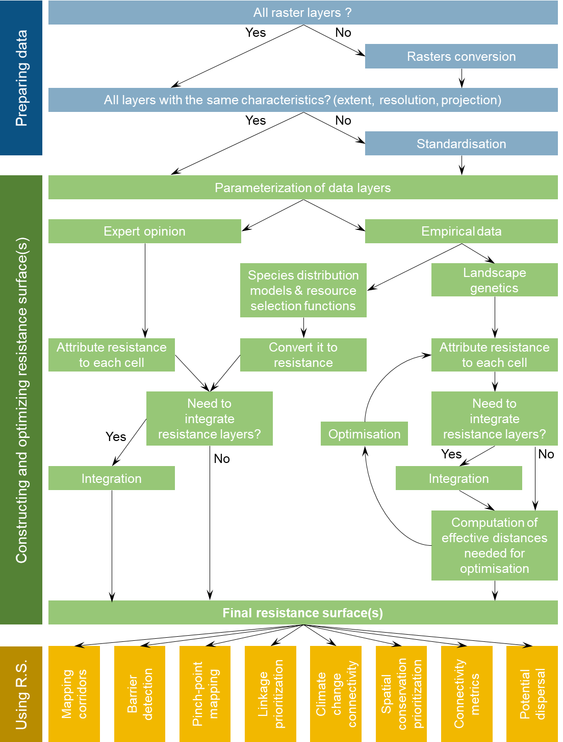
Supplementary S3: Timeline of tool development

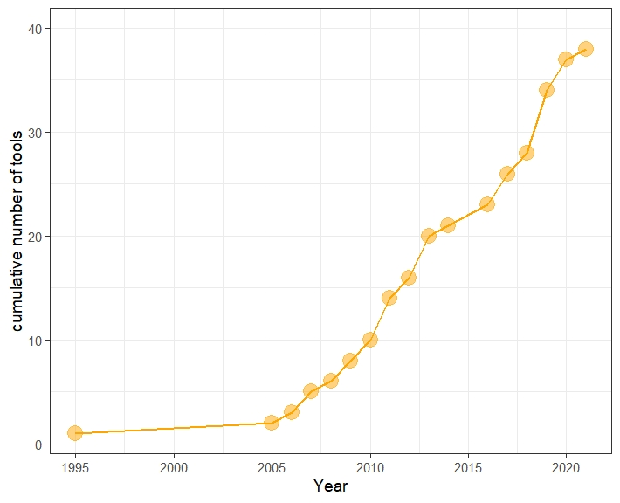
Fig S3: Development of connectivity tools over time, tools from Table 1-3 in the main text.

Supplementary S4: Responses from the online survey
Section 1: Profile of survey participants (n= 148)
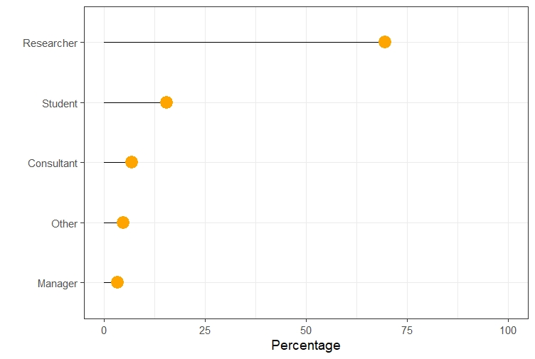
Fig S4.1: Job description

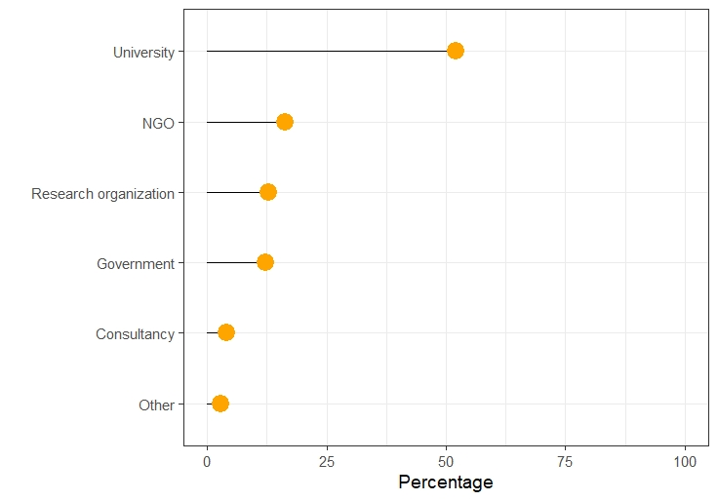
Fig S4.2: Professional affiliation
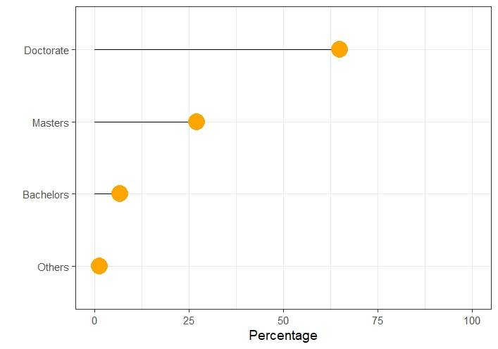
Fig S4.3: Highest academic degree
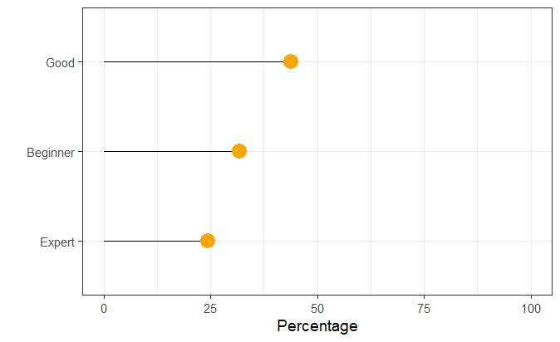
Fig S4.4: Self-rated expertise in connectivity analyses

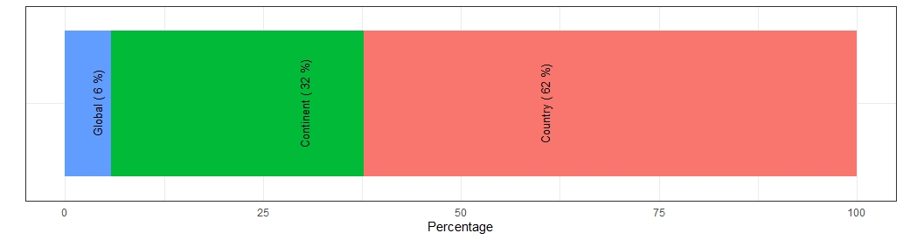
a
b
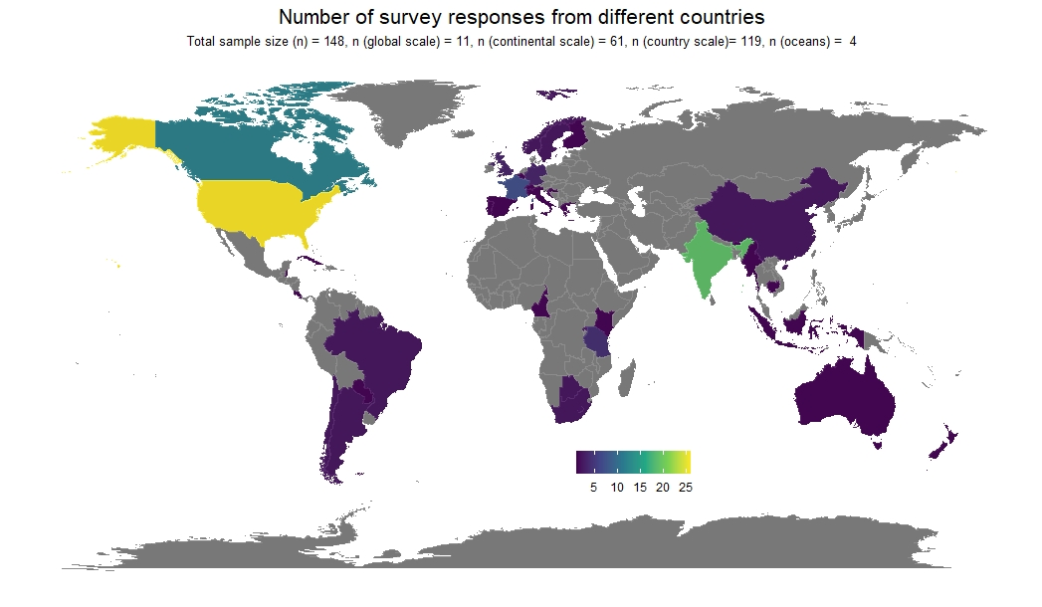
Fig S4.5: Geographic representation of connectivity research by survey participants. (a) Scale of research, (b) countries of research

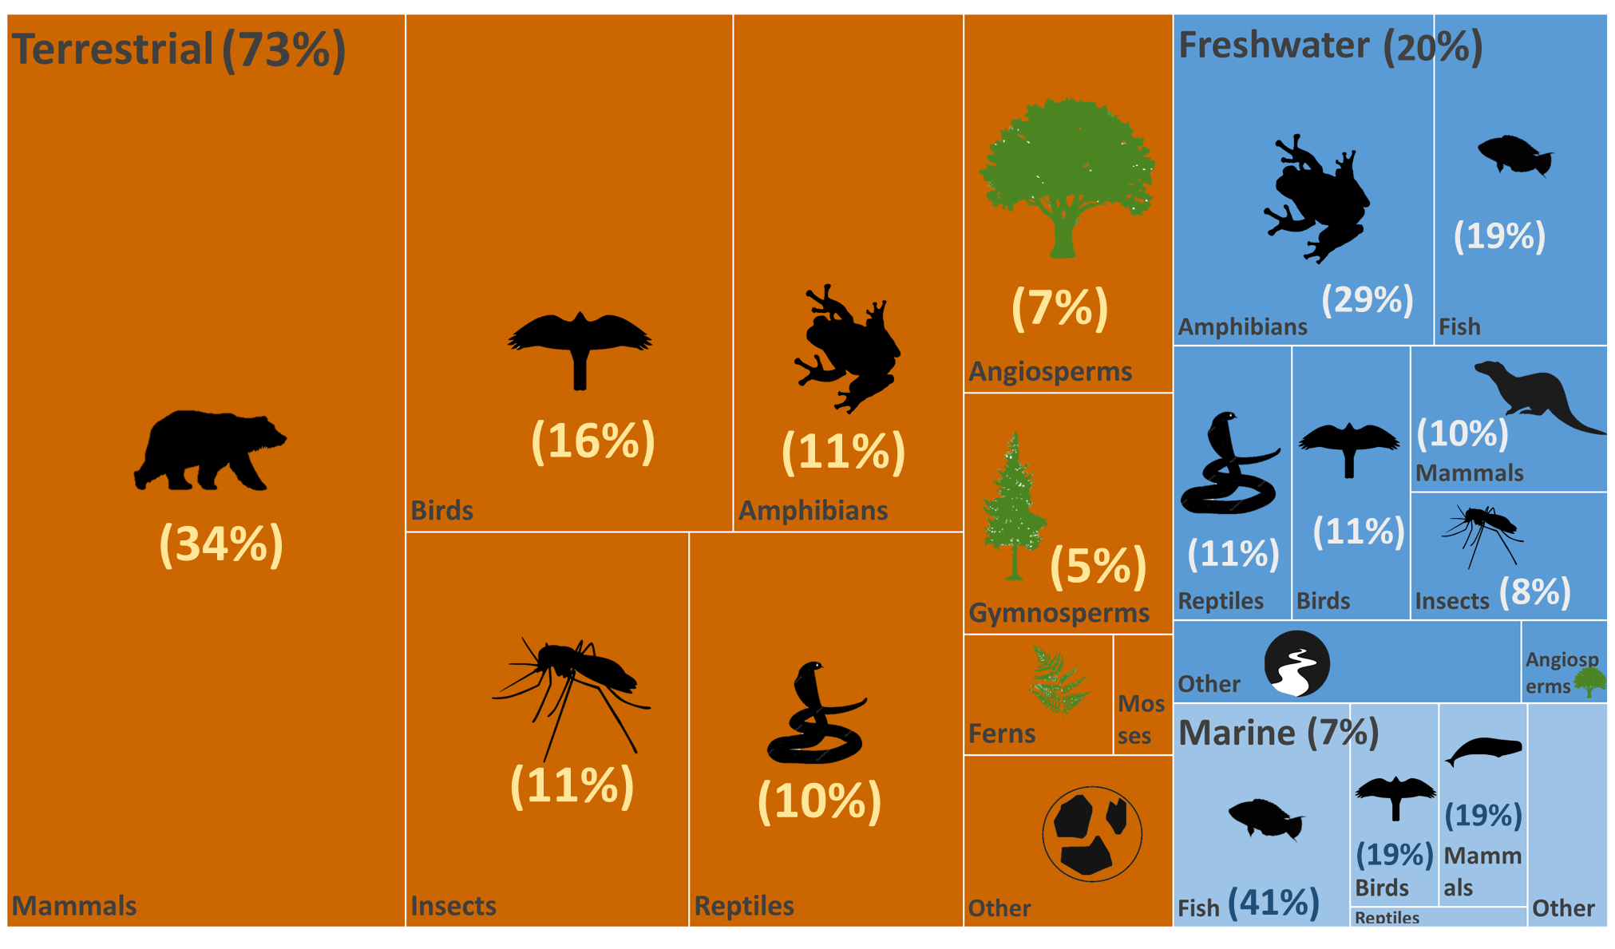
Fig S4.6: Ecosystems and taxa. Numbers after commas are percentage

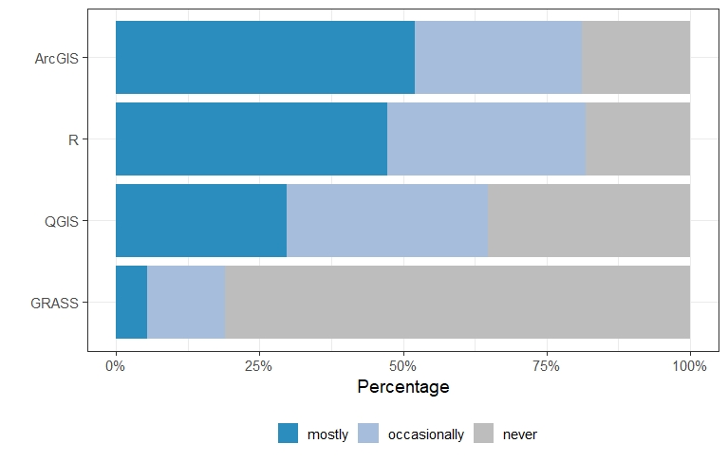
Fig S4.7: Spatial handling software used

Section 2: Familiarity with connectivity tools (n= 134)
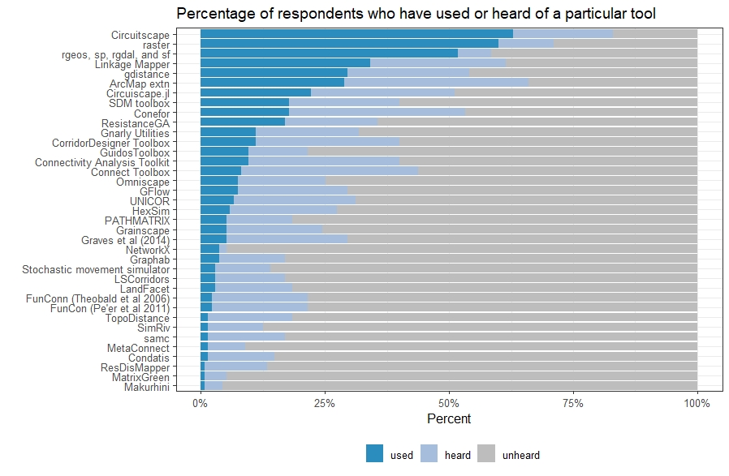
Fig S4.8: Level of familiarity of the survey respondents to the various connectivity tools.

Section 3: Evaluations of the connectivity tools by users (n= 123)

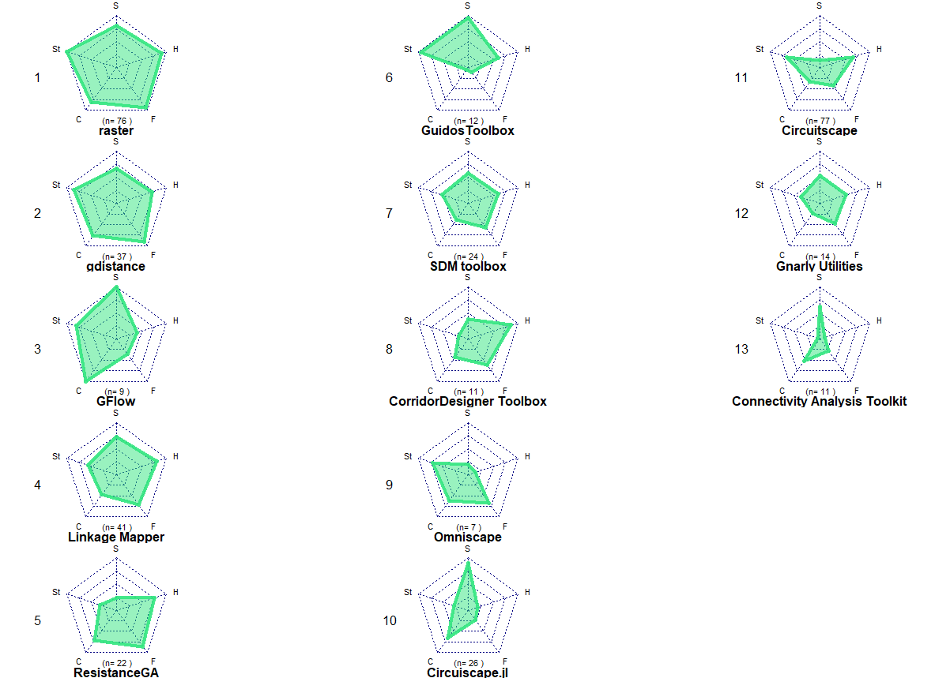
S4.9: Ranking of all tools useful in Step 2: constructing resistance surfaces. n represents the total number of respondents for the tool. The five criteria, i.e., stability (St), customization (C), data format (F), getting help (H), and speed (S) are arranged in a radial axis with lowest ranks in the center and highest ranks towards the periphery. Tools with a larger and uniform web rank high across all criteria, whereas smaller or non-uniform webs indicate a poor ranking overall, or in the criteria represented by that axis respectively.

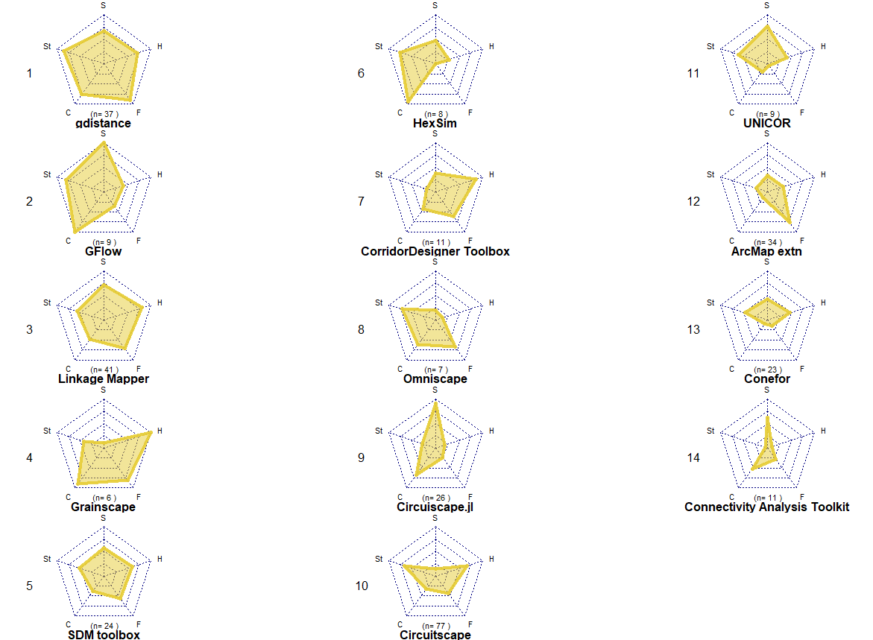
S4.10: Ranking of all tools for using resistance surfaces in Step 3: using resistance surfaces. n represents the total number of respondents for the tool. The five criteria, i.e., stability (St), customization (C), data format (F), getting help (H), and speed (S) are arranged in a radial axis with lowest ranks in the center and highest ranks towards the periphery. Tools with a larger and uniform web rank high across all criteria, whereas smaller or non-uniform webs indicate a poor ranking overall, or in the criteria represented by that axis respectively.

Section 4: Evaluations of the connectivity tools by users (n= 123)

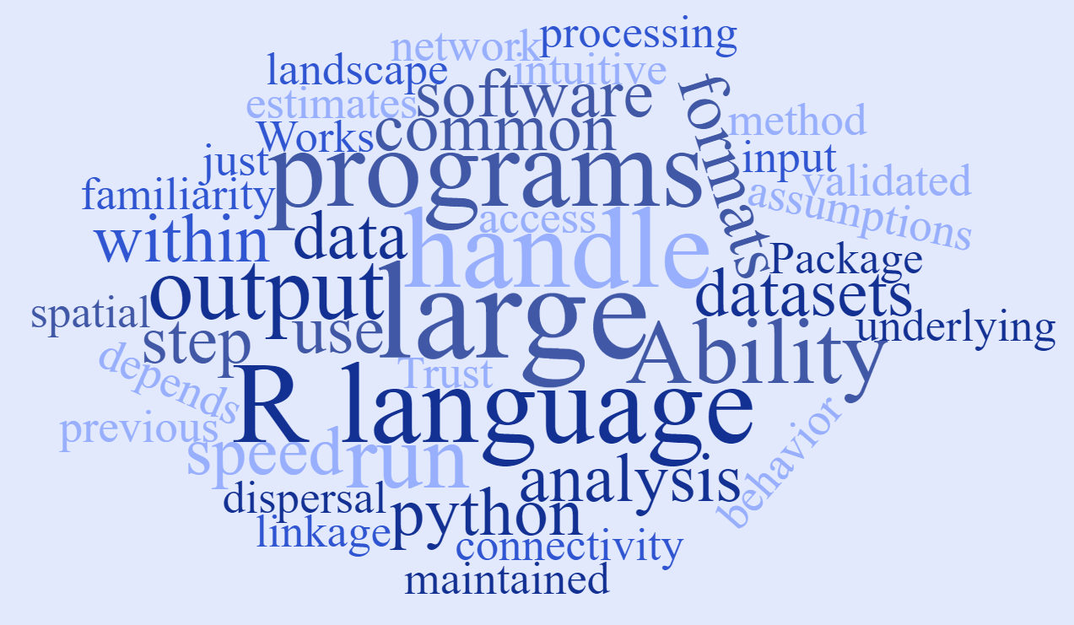
Fig S4.11: Word cloud of additional criteria suggested by survey respondents’ used in deciding the usage of tools.
Detailed comments by respondents:
- Interoperability with other GIS / connectivity tools
- Computation speed
- Ability to get them to run on large landscapes
- processing speed - though much of that is dependent on the machine, the software you use, etc.
- Ability to handle large datasets
- Speed
- Possibility to run in batch
- Ability of the tool to handle large datasets (large spatial extent, small pixel sizes)
- Ability of tool to handle large raster datasets
- Efficiently programmed. Applicable to very large areas.
- Free access
- generic applicability
- intuitive handling
- Liability
- Ability to handle many different data input formats
- using common data formats (e.g. tifs) as an input
- spatially explicit maps
- That the tool uses common formats, or depends on common packages if on R.
- Works on all platforms (Unix/Mac/Windows)
- Previous experience with the tool in research group
- API accessible within programming languages (e.g. R, Python)
- feasibility of analysis (how difficult and time-conusming) it is? Is the effort worth the expected results?
- Trust: Algorithm can be explained to, understood, and trusted by stakeholders and decision-makers
- Actively being maintained to run on newer operating systems at least
- The tool has an active development cycle to refine and improve it
- Power and sensitivity of the tool
- Maintenance of the tools through updates
- Assumptions are clearly stated, especially about animal movements and behavior, dispersal tendencies, behavior states, and so on
- Transparent caveats and assumptions, including when method/approach is not appropriate
- Either R or Python based
- That the creators/maintainers are still working on it.
- Guidance on how to interpret/evaluate output, not just to run the analysis
- underlying biological assumptions
- Workflow ability-works with R
- Package in a programming language (preferably python) with good links to numpy, etc.
- How the tool aligns with previous analysis steps and outputs.
- R language
- Rerun specific step of processing chain
- Integrative with other programs
- must be able to deal with dendritic stream network and dispersal within network
- intuitive
- That the effectiveness of the tools have been extensively checked via simulations.
- theoretical and mathematical coherence of all steps - from habitat quality estimates, to fragmentation estimates, to connectivity
- Outputs can prioritize among linkages on a landscape, not just among cells within a linkage
- Software is grounded in ecology, biology, and life history of species
- Data availability
- Prior familiarity (e.g. with the programming language)
- Trackability
- Familiarity with underlying coding language
- Method's outcomes have been validated
- Outputs of software have been field validated
- quantitative results
- "Modern" and not a clique
- I use these tools to understand the modelling and mapping of connectivity plans but not as the primary tool user
- For application, methods/tools/results should be available to practitioners in a repeatable manner, not just to academics.
- There should be a strong capacity building for conservationists in regard to the use of technology.

Supplementary S5: R tutorial
Please refer to the data and code available at https://doi.org/10.6084/m9.figshare.14371613.v1

