Supplementary Material

Interplay between local and landscape-scale effects on the taxonomic, functional and phylogenetic diversity of aerial insectivorous Neotropical bats

Adrià López-Baucells, Sarah Rowley, Ricardo Rocha, Paulo E. D. Bobrowiec, Jorge M. Palmeirim, Fábio Z. Farneda, Christoph F. J. Meyer

Corresponding authors: Adrià López-Baucells; E-mail: albaucells@mcng.cat
Sarah Rowley: Email: sarahrowley_consultancy@outlook.com

This supplementary material contains:
Figure S1 Pruned phylogenetic tree depicting aerial insectivorous bat species/ sonotype
Figure S2 Ordination biplot of the PCA
Figure S3 Comparison of α-diversity metrics for TD, FD, PD; q = 0 (species richness) and q = 1 (Shannon diversity) between habitat types modelled using MCMC_{GLMM}
Figure S4 TD, FD, PD metrics q = 0 modelled with local and landscape predictor variables
Figure S5 TD, FD ,PD metrics q = 1 modelled with local and landscape predictor variables
Table S1 BDFFP Bat echolocation call sonotypes and bat passes
Table S2 List of functional traits used to calculate functional diversity (FD)
Table S3 Species functional trait data used to calculate FD
Table S4 Vegetation principal components analysis variable loadings, eigenvalues and proportion of variance
Table S5 Model output comparing α-diversity metric q = 2 with habitat types
Table S6 Model output comparing α-diversity metric q = 0 with habitat types
Table S7 Model output comparing α-diversity metric q = 1 with habitat types
Table S8 Model output comparing α-diversity metric q = 0 with local and landscape predictor variables
Table S9 Model output comparing α-diversity metric q = 1 with local and landscape predictor variables
Table S10 Model output comparing α-diversity metric q = 2 with local and landscape predictor variables

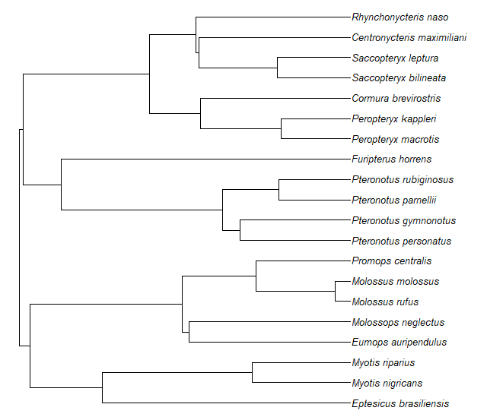
Fig. S1 Pruned phylogenetic tree depicting aerial insectivorous bat species /sonotype (Molossidae II; Molossus rufus, Molossidae III; Eumops auripendulus, Molossops I; Molossops neglectus and Promops I; Promops centralis) within the BDFFP landscape

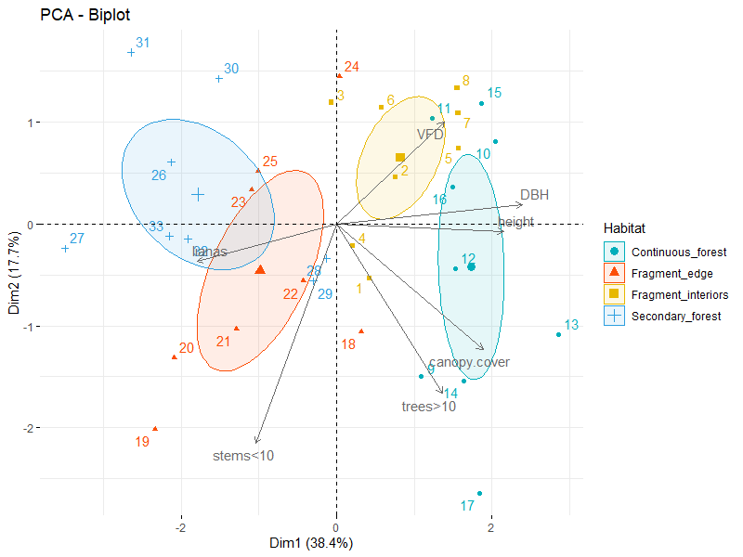
Fig. S2 Principal components analysis biplot examining the covariation between local vegetation structure variables across 33 sites and grouped by habitat type
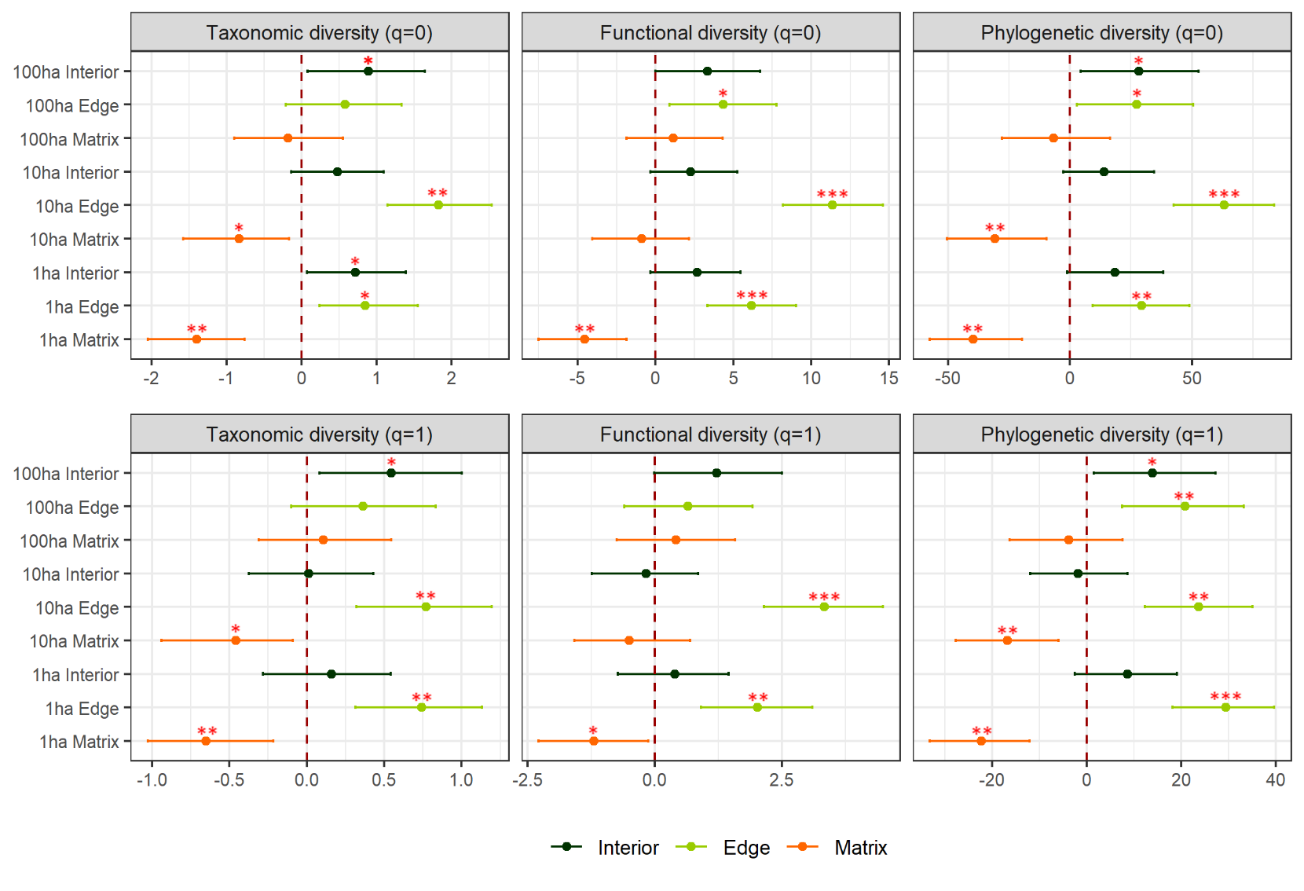
Fig. S3 Comparison of α-diversity metrics q = 0 and q = 1 across the interior-edge-matrix- and size gradients at the Biological Dynamics of Forest Fragments Project (forest fragment interiors, forest fragment edges and adjoining secondary forest/matrix). The predicted differences between each habitat and continuous forest interior, modelled using MCMC_{GLMM} are plotted with their corresponding 95% credible interval. Those which do not touch or overlap the vertical dashed line (0) are considered significant (* p_{MCMC} < 0.05, ** p_{MCMC} < 0.01 *** p_{MCMC} < 0.001)
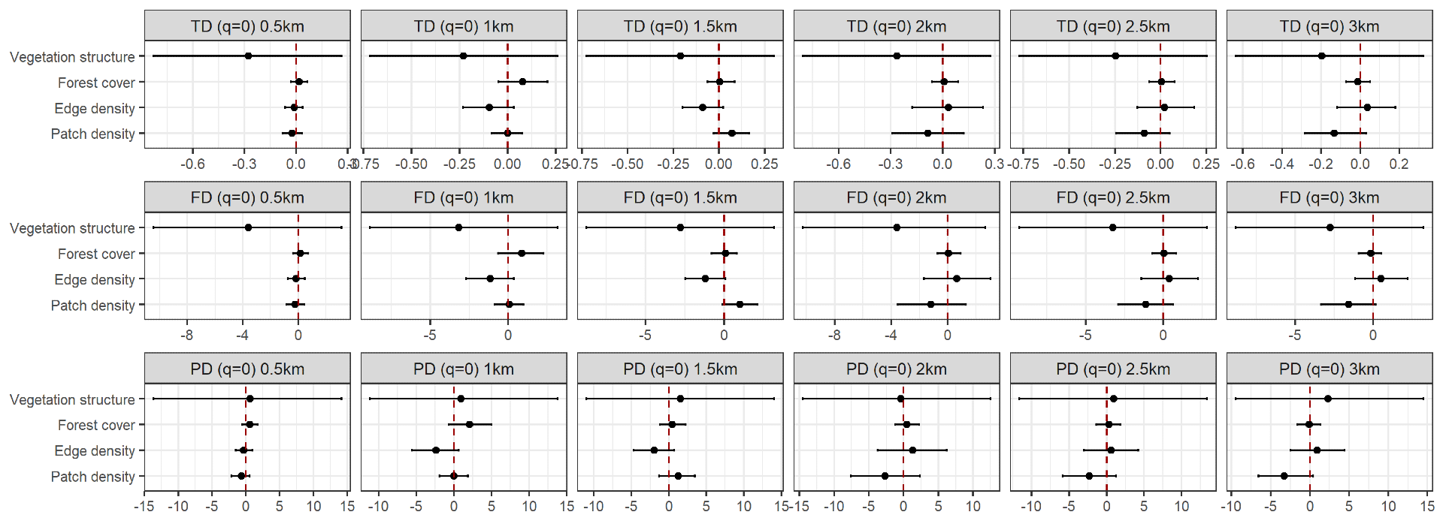
Fig. S4 Taxonomic, functional and phylogenetic diversity metrics q = 0 modelled as a function of local and landscape predictor variables (vegetation structure, forest cover, edge and patch density) based on surveys of aerial insectivorous bats at the Biological Dynamics of Forest Fragments Project, Brazil. Shown are posterior mean estimates ± 95% credible intervals. Credible intervals which do not touch or overlap the zero line are considered significant (* p_{MCMC} < 0.05)
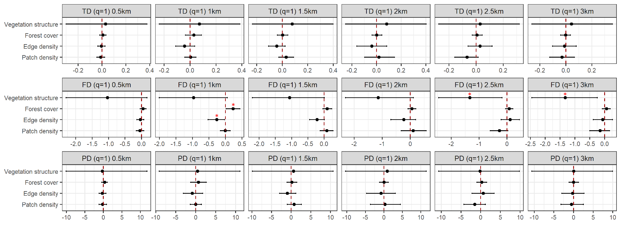
Fig. S5 Taxonomic, functional and phylogenetic diversity metrics q = 1 modelled as a function of local and landscape predictor variables (vegetation structure, forest cover, edge and patch density) based on surveys of aerial insectivorous bats at the Biological Dynamics of Forest Fragments Project, Brazil. Shown are posterior mean estimates ± 95% credible intervals. Credible intervals which do not touch or overlap the zero line are considered significant (* p_{MCMC} < 0.05)
Table S1 Total number of bat passes per species/sonotype detected at the Biological Dynamics of Forest Fragments Project, Central Amazon. Total bat passes recorded: 283,242. Total bat passes analysed: 281,425, following removal of Saccopteryx gymnure (E1) sonotype
Species / Sonotype | Species calls included: | Code | Total number bat passes
Emballonuridae
Centronycteris maximiliani | Centronycteris maximiliani | CM | 77247
Cormura brevirostris | Cormura brevirostris | CB | 6079
Peropteryx kappleri | Peropteryx kappleri | PK | 4262
Peropteryx macrotis | Peropteryx macrotis | PM | 471
Rhynchonycteris naso | Rhynchonycteris naso | RN | 3
Saccopteryx bilineata | Saccopteryx bilineata | SB | 27675
Saccopteryx gymnura | Saccopteryx gymnura | E1 | 1817
Saccopteryx leptura | Saccopteryx leptura | SL | 15862
Furipteridae
Furipterus horrens | Furipterus horrens | FH | 709
Molossidae
Molossidae I | Molossus molossus | M1 | 42
Molossidae II | Molossus sinaloae / currentium / rufus | M2 | 1291
Molossidae III | Cynomops planirostris / paranus, Cynomops greenhalli /abrasus, Eumops auripendulus / glaucinus / dabbenei / hansae / maurus, Nyctinomops laticaudatus, Tadarida brasiliensis | M3 | 1444
Molossops I | Molossops neglectus, Molossops temminckii | MNE | 4
Promops I | Promops centralis, Promops nasutus | P | 555
Mormoopidae
Pteronotus alitonus | Pteronotus alitonus | P6 | 50505
Pteronotus gymnonotus | Pteronotus gymnonotus | PG | 1028
Pteronotus personatus | Pteronotus personatus | PP | 164
Pteronotus rubiginosus | Pteronotus rubiginosus | P5 | 45603
Vespertilionidae
Eptesicus brasiliensis | Eptesicus brasiliensis | EB | 1206
Myotis nigricans | Myotis nigricans | MN | 1251
Myotis riparius | Myotis riparius | MR | 46024
Table S2 List of functional traits used to calculate functional diversity (FD)
Trait variable | Definition | Reference
Call frequency | Frequency with the highest intensity of each echolocation call (or the average of diagnostic call measurements) | López-Baucells et al., 2018
Call structure | Pulse shape, classified into three main categories: quasi constant frequency (QCF), constant frequency (CF), frequency modulated (FM) | López-Baucells et al., 2018
Call alternation | Categorization of call sequence: (1) single 'monotonous' pulse, (2) alternating frequency sequence containing two ‘low-high’ note pulse pairs or (3) a ‘low-medium-high’ triple pulse sequence | Jung, Kalko and Helversen, 2007; Ratcliffe et al., 2011; López-Baucells et al., 2018
Body mass | An average weight for each species based on BDFFP capture data (adults only) | Unpublished data collected at the BDFFP (Rocha, López-Baucells, et al., 2017b; Rocha, Ovaskainen, et al., 2017
Aspect ratio | Square of the wingspan divided by the wing area | Norberg & Rayner 1987
Relative wing loading | Mass of the individual divided by the wing area (WL) divided by body mass raised to one third (RWL = WL/mass1/3) | Norberg & Rayner 1987
Vertical stratification | Forest stratum where each species tends to forage; categorization based on three levels: understory, canopy and above the canopy | Mas et al., 2014

Table S3 Species functional trait data used to calculate FD. Sources listed in Table 1 (E1 excluded from analysis due to no available trait data)
Abbreviations: BM = Body Mass (Kg), AR = Aspect ratio, RWL = Relative Wing loading
Species / Sonotype | Species code | Call frequency | Call structure | Alternation | BM | AR | RWL | Vertical Stratification
Emballonuridae
Centronycteris maximiliani | CM | 40 | QCF | 1 | 0.0058 | 7.9575 | 11.9858432 | 2
Cormura brevirostris | CB | 28 | QCF | 3 | 0.0089 | 8.73 | 21.77496447 | 2
Peropteryx kappleri | PK | 31 | QCF | 1 | 0.0081 | 7.3268 | 15.49136026 | 2
Peropteryx macrotis | PM | 38 | QCF | 1 | 0.0055 | 6.8 | 26.72867774 | 2
Rhynchonycteris naso | RN | 97 | QCF | 1 | 0.0035 | 8.73 | 13.22988609 | 2
Saccopteryx bilineata | SB | 43.5 | QCF | 2 | 0.0093 | 6.3546 | 13.6390583 | 2
Saccopteryx leptura | SL | 51.5 | QCF | 2 | 0.0035 | 5.6774 | 19.2294856 | 2
Furipteridae
Furipterus horrens | FH | 176 | FM | 1 | 0.00365 | 5.4684 | 12.22694 | 2
Molossidae
Molossidae I | M1 | 38.25 | QCF | 3 | 0.012 | 8.7 | 32.6465 | 3
Molossidae II | M2 | 33.5 | QCF | 3 | 0.0325 | 7.412433 | 41.08406 | 3
Molossidae III | M3 | 21 | QCF | 2 | 0.025763 | 8.804175 | 32.21455 | 3
Molossops I | MNE | 50 | QCF | 2 | 0.0059 | 7.59 | 24.43008 | 3
Promops I | P | 32.25 | QCF | 2 | 0.0375 | 11.0626 | 34.47177 | 3
Mormoopidae
Pteronotus alitonus | P6 | 60 | CF | 1 | 0.02 | 6.68 | 11.15172 | 1
Pteronotus gymnonotus | PG | 55 | FM | 1 | 0.013 | 7.26555 | 13.46973 | 1
Pteronotus personatus | PP | 68.5 | FM | 1 | 0.0075 | 6.7 | 14.24725 | 1
Pteronotus rubiginosus | P5 | 55 | CF | 1 | 0.02 | 6.68 | 11.15172 | 1
Vespertilionidae
Eptesicus brasiliensis | EB | 32 | FM | 1 | 0.012 | 6.8648 | 18.24123 | 2
Myotis nigricans | MN | 60 | FM | 1 | 0.0045 | 6.3 | 14.43033 | 2
Myotis riparius | MR | 50 | FM | 1 | 0.0044 | 6.3 | 14.53884 | 2

Table S4 Variable loadings, eigenvalues and proportion of variance explained by the first two axes of a principal components analysis on the local vegetation structure variables
Local vegetation variables | Abbreviation | PC1 | PC2
Number of trees (DBH >10) | trees >10 | 0.48 | -0.58
Number of woody stems (DBH <10 cm) | stems<10 | -0.36 | -0.75
Average DBH of trees ≥10 cm | DBH | 0.84 | 0.07
Canopy cover (%) | canopy.cover | 0.66 | -0.43
Liana density | lianas | -0.63 | -0.13
Canopy height (m) | height | 0.75 | 0.03
Vertical foliage density | VFD | 0.48 | 0.35
Eigenvalue |  | 2.69 | 1.24
% explained |  | 38.39 | 17.67
Cumulative Proportion |  | 38.39 | 56.06

.
Table S5 MCMC_{GLMM} model output comparing α-diversity q = 2 across different habitat types (continuous forest interior, forest fragment interiors, forest fragment edges and adjoining secondary forest/matrix). We report mean posterior estimate, 95% credible intervals, the effective sample size and Bayesian p-values (p_{MCMC}) indicating the significance of variables with a threshold of * p_{MCMC} < 0.05, ** p_{MCMC} < 0.01 *** p_{MCMC} < 0.001
Inverse Simpson (q=2) | Size | Habitat | Estimate | Inferior | Superior | Effective sample | p_{MCMC}
Taxonomic | 100ha | Interior | 0.46 | 0.08 | 0.87 | 4500 | 0.03*
Taxonomic | 100ha | Edge | 0.37 | -0.06 | 0.75 | 4500 | 0.07
Taxonomic | 100ha | Matrix | 0.22 | -0.15 | 0.60 | 4500 | 0.20
Taxonomic | 10ha | Interior | 0.00 | -0.35 | 0.34 | 4164 | 0.98
Taxonomic | 10ha | Edge | 0.59 | 0.19 | 0.94 | 4500 | 0.01**
Taxonomic | 10ha | Matrix | -0.36 | -0.73 | -0.02 | 4500 | 0.05
Taxonomic | 1ha | Interior | 0.07 | -0.29 | 0.42 | 4500 | 0.66
Taxonomic | 1ha | Edge | 0.68 | 0.34 | 1.04 | 4500 | 0.01**
Taxonomic | 1ha | Matrix | -0.51 | -0.84 | -0.16 | 4380 | 0.01*
Functional | 100ha | Interior | 0.77 | -0.15 | 1.84 | 4500 | 0.11
Functional | 100ha | Edge | 0.31 | -0.71 | 1.29 | 4500 | 0.49
Functional | 100ha | Matrix | 0.25 | -0.67 | 1.17 | 3946 | 0.55
Functional | 10ha | Interior | -0.32 | -1.16 | 0.51 | 4500 | 0.39
Functional | 10ha | Edge | 2.01 | 1.09 | 2.90 | 4295 | 0.00**
Functional | 10ha | Matrix | -0.47 | -1.40 | 0.39 | 4500 | 0.27
Functional | 1ha | Interior | 0.17 | -0.65 | 1.03 | 4500 | 0.67
Functional | 1ha | Edge | 1.34 | 0.48 | 2.21 | 4500 | 0.01**
Functional | 1ha | Matrix | -0.80 | -1.68 | 0.04 | 4500 | 0.07
Phylogenetic | 100ha | Interior | 12.10 | 1.41 | 23.86 | 4547 | 0.04*
Phylogenetic | 100ha | Edge | 22.34 | 10.84 | 33.61 | 4500 | 0.00***
Phylogenetic | 100ha | Matrix | -0.55 | -11.32 | 9.05 | 4500 | 0.89
Phylogenetic | 10ha | Interior | -2.31 | -10.87 | 7.22 | 4500 | 0.58
Phylogenetic | 10ha | Edge | 17.44 | 7.04 | 27.02 | 4500 | 0.00**
Phylogenetic | 10ha | Matrix | -11.26 | -21.39 | -1.80 | 4500 | 0.03*
Phylogenetic | 1ha | Interior | 7.83 | -1.45 | 17.26 | 4500 | 0.09
Phylogenetic | 1ha | Edge | 27.31 | 18.20 | 37.17 | 4500 | 0.00***
Phylogenetic | 1ha | Matrix | -17.34 | -26.55 | -8.73 | 4476 | 0.00**
Table S6 MCMC_{GLMM} model output comparing α-diversity metric q = 0 across different habitat types (continuous forest interior, forest fragment interiors, forest fragment edges and adjoining secondary forest/matrix). We report mean posterior estimate, 95% credible intervals, effective sample size and Bayesian p-values (p_{MCMC}) indicating the significance of variables with a threshold of * p_{MCMC} < 0.05, ** p_{MCMC} < 0.01 *** p_{MCMC} < 0.001
Richness (q=0) | Size | Habitat | Estimate | Inferior | Superior | Effective sample | p_{MCMC}
Taxonomic | 100ha | Interior | 0.90 | 0.10 | 1.69 | 4500 | 0.02*
Taxonomic | 100ha | Edge | 0.58 | -0.21 | 1.38 | 4500 | 0.14
Taxonomic | 100ha | Matrix | -0.18 | -0.90 | 0.53 | 4233 | 0.60
Taxonomic | 10ha | Interior | 0.48 | -0.15 | 1.16 | 4500 | 0.13
Taxonomic | 10ha | Edge | 1.81 | 1.10 | 2.52 | 4729 | 0.00**
Taxonomic | 10ha | Matrix | -0.83 | -1.54 | -0.13 | 4073 | 0.02*
Taxonomic | 1ha | Interior | 0.72 | 0.02 | 1.38 | 4500 | 0.04*
Taxonomic | 1ha | Edge | 0.85 | 0.19 | 1.52 | 4620 | 0.02*
Taxonomic | 1ha | Matrix | -1.40 | -2.05 | -0.75 | 4730 | 0.00**
Functional | 100ha | Interior | 3.32 | -0.17 | 6.83 | 4500 | 0.06
Functional | 100ha | Edge | 4.38 | 0.97 | 8.00 | 4500 | 0.01*
Functional | 100ha | Matrix | 1.17 | -2.15 | 4.12 | 4500 | 0.46
Functional | 10ha | Interior | 2.26 | -0.57 | 4.92 | 4500 | 0.10
Functional | 10ha | Edge | 11.36 | 8.19 | 14.40 | 4500 | 0.00***
Functional | 10ha | Matrix | -0.83 | -3.71 | 2.33 | 3965 | 0.58
Functional | 1ha | Interior | 2.66 | -0.16 | 5.55 | 4500 | 0.06
Functional | 1ha | Edge | 6.14 | 3.46 | 9.11 | 4500 | 0.00***
Functional | 1ha | Matrix | -4.57 | -7.42 | -1.88 | 4500 | 0.00**
Phylogenetic | 100ha | Interior | 28.10 | 3.52 | 52.05 | 4500 | 0.03*
Phylogenetic | 100ha | Edge | 26.93 | 2.56 | 50.89 | 3986 | 0.03*
Phylogenetic | 100ha | Matrix | -6.67 | -28.13 | 14.67 | 4500 | 0.53
Phylogenetic | 10ha | Interior | 13.54 | -4.55 | 31.89 | 4500 | 0.14
Phylogenetic | 10ha | Edge | 63.02 | 43.25 | 85.52 | 3840 | 0.00***
Phylogenetic | 10ha | Matrix | -31.35 | -52.04 | -10.81 | 4218 | 0.01**
Phylogenetic | 1ha | Interior | 18.21 | -0.97 | 39.09 | 4500 | 0.07
Phylogenetic | 1ha | Edge | 29.26 | 9.23 | 47.70 | 4500 | 0.00**
Phylogenetic | 1ha | Matrix | -39.75 | -58.41 | -21.29 | 4500 | 0.00**
Table S7 MCMC_{GLMM} model output comparing α-diversity metric q = 1 across different habitat types (continuous forest interior, forest fragment interiors, forest fragment edges and adjoining secondary forest/matrix). We report mean posterior estimate, 95% credible intervals, the effective sample size and Bayesian p-values (p_{MCMC}) indicating the significance of variables with a threshold of * p_{MCMC} < 0.05, ** p_{MCMC} < 0.01 *** p_{MCMC} < 0.001
Shannon entropy index (q=1) | Size | Habitat | Estimate | Inferior | Superior | Effective sample | p_{MCMC}
Taxonomic | 100ha | Interior | 0.54 | 0.06 | 0.99 | 4500 | 0.03*
Taxonomic | 100ha | Edge | 0.36 | -0.09 | 0.85 | 4500 | 0.12
Taxonomic | 100ha | Matrix | 0.10 | -0.34 | 0.54 | 4500 | 0.66
Taxonomic | 10ha | Interior | 0.01 | -0.42 | 0.40 | 4500 | 0.98
Taxonomic | 10ha | Edge | 0.77 | 0.30 | 1.21 | 4500 | 0.00**
Taxonomic | 10ha | Matrix | -0.46 | -0.88 | -0.04 | 4500 | 0.04*
Taxonomic | 1ha | Interior | 0.16 | -0.27 | 0.57 | 4500 | 0.44
Taxonomic | 1ha | Edge | 0.74 | 0.30 | 1.15 | 4500 | 0.00**
Taxonomic | 1ha | Matrix | -0.66 | -1.09 | -0.26 | 4500 | 0.01**
Functional | 100ha | Interior | 1.23 | -0.12 | 2.48 | 4500 | 0.06
Functional | 100ha | Edge | 0.67 | -0.57 | 2.03 | 4290 | 0.30
Functional | 100ha | Matrix | 0.42 | -0.75 | 1.66 | 4500 | 0.48
Functional | 10ha | Interior | -0.16 | -1.26 | 0.88 | 4500 | 0.74
Functional | 10ha | Edge | 3.33 | 2.18 | 4.54 | 4724 | 0.00***
Functional | 10ha | Matrix | -0.50 | -1.63 | 0.68 | 4289 | 0.38
Functional | 1ha | Interior | 0.40 | -0.73 | 1.46 | 4292 | 0.45
Functional | 1ha | Edge | 2.04 | 0.99 | 3.15 | 5231 | 0.00**
Functional | 1ha | Matrix | -1.18 | -2.28 | -0.11 | 4254 | 0.04*
Phylogenetic | 100ha | Interior | 13.83 | 1.92 | 27.05 | 4500 | 0.03*
Phylogenetic | 100ha | Edge | 20.64 | 7.17 | 33.18 | 4500 | 0.00**
Phylogenetic | 100ha | Matrix | -4.11 | -15.14 | 7.58 | 4500 | 0.47
Phylogenetic | 10ha | Interior | -1.93 | -12.35 | 7.90 | 4278 | 0.69
Phylogenetic | 10ha | Edge | 23.57 | 11.41 | 35.00 | 4500 | 0.00**
Phylogenetic | 10ha | Matrix | -16.86 | -28.30 | -5.92 | 4247 | 0.01**
Phylogenetic | 1ha | Interior | 8.43 | -2.56 | 18.73 | 4500 | 0.11
Phylogenetic | 1ha | Edge | 29.35 | 18.61 | 39.90 | 4500 | 0.00***
Phylogenetic | 1ha | Matrix | -22.46 | -32.52 | -12.04 | 4500 | 0.00**

Table S8 MCMC_{GLMM} Model output comparing α-diversity metric q = 0 modelled with local and landscape predictor variables (Vegetation structure, Forest cover, Edge density, Patch density) We report mean posterior estimate, 95% credible intervals, the effective sample size and Bayesian p-values (p_{MCMC}) indicating the significance of variables with a threshold of * p_{MCMC} < 0.05, ** p_{MCMC} < 0.01 *** p_{MCMC} < 0.001
Richness (q=0) | Buffer Size | Habitat | Estimate | Inferior | Superior | Effective sample | p_{MCMC}
Taxonomic | 0.5km | Vegetation structure | -0.28 | -0.84 | 0.26 | 4288 | 0.31
Taxonomic | 0.5km | Forest Cover | 0.02 | -0.03 | 0.07 | 4500 | 0.45
Taxonomic | 0.5km | Edge Density | -0.01 | -0.06 | 0.04 | 4500 | 0.62
Taxonomic | 0.5km | Patch Density | -0.02 | -0.08 | 0.04 | 4500 | 0.43
Taxonomic | 1km | Vegetation structure | -0.23 | -0.74 | 0.25 | 3921 | 0.35
Taxonomic | 1km | Forest Cover | 0.08 | -0.05 | 0.21 | 5401 | 0.20
Taxonomic | 1km | Edge Density | -0.09 | -0.23 | 0.03 | 4500 | 0.14
Taxonomic | 1km | Patch Density | 0.00 | -0.08 | 0.08 | 4309 | 0.95
Taxonomic | 1.5km | Vegetation structure | -0.22 | -0.72 | 0.30 | 5151 | 0.39
Taxonomic | 1.5km | Forest Cover | 0.00 | -0.07 | 0.08 | 4273 | 0.88
Taxonomic | 1.5km | Edge Density | -0.09 | -0.20 | 0.03 | 4201 | 0.12
Taxonomic | 1.5km | Patch Density | 0.07 | -0.03 | 0.17 | 4500 | 0.15
Taxonomic | 2km | Vegetation structure | -0.27 | -0.81 | 0.30 | 4500 | 0.32
Taxonomic | 2km | Forest Cover | 0.01 | -0.07 | 0.08 | 4500 | 0.88
Taxonomic | 2km | Edge Density | 0.03 | -0.17 | 0.23 | 5017 | 0.74
Taxonomic | 2km | Patch Density | -0.08 | -0.30 | 0.11 | 4500 | 0.42
Taxonomic | 2.5km | Vegetation structure | -0.25 | -0.76 | 0.27 | 4234 | 0.33
Taxonomic | 2.5km | Forest Cover | 0.00 | -0.06 | 0.08 | 4194 | 0.91
Taxonomic | 2.5km | Edge Density | 0.02 | -0.14 | 0.17 | 4500 | 0.76
Taxonomic | 2.5km | Patch Density | -0.09 | -0.24 | 0.06 | 4500 | 0.22
Taxonomic | 3km | Vegetation structure | -0.19 | -0.66 | 0.31 | 4500 | 0.43
Taxonomic | 3km | Forest Cover | -0.01 | -0.07 | 0.05 | 4500 | 0.66
Taxonomic | 3km | Edge Density | 0.04 | -0.11 | 0.18 | 3849 | 0.56
Taxonomic | 3km | Patch Density | -0.14 | -0.30 | 0.02 | 3984 | 0.09
Functional | 0.5km | Vegetation structure | -3.70 | -10.65 | 3.21 | 4500 | 0.29
Functional | 0.5km | Forest Cover | 0.17 | -0.38 | 0.67 | 4359 | 0.50
Functional | 0.5km | Edge Density | -0.16 | -0.72 | 0.48 | 4063 | 0.59
Functional | 0.5km | Patch Density | -0.21 | -0.84 | 0.46 | 4500 | 0.52
Functional | 1km | Vegetation structure | -3.16 | -8.92 | 3.14 | 4500 | 0.30
Functional | 1km | Forest Cover | 0.86 | -0.57 | 2.28 | 4930 | 0.20
Functional | 1km | Edge Density | -1.14 | -2.66 | 0.41 | 4500 | 0.13
Functional | 1km | Patch Density | 0.08 | -0.87 | 0.98 | 4057 | 0.84
Functional | 1.5km | Vegetation structure | -2.87 | -8.74 | 3.40 | 4500 | 0.34
Functional | 1.5km | Forest Cover | 0.08 | -0.75 | 0.84 | 4500 | 0.82
Functional | 1.5km | Edge Density | -1.17 | -2.48 | 0.10 | 4500 | 0.07
Functional | 1.5km | Patch Density | 0.97 | -0.17 | 2.06 | 4500 | 0.09
Functional | 2km | Vegetation structure | -3.54 | -10.53 | 2.83 | 4500 | 0.28
Functional | 2km | Forest Cover | 0.06 | -0.78 | 0.86 | 4500 | 0.90
Functional | 2km | Edge Density | 0.58 | -1.86 | 3.00 | 4093 | 0.63
Functional | 2km | Patch Density | -1.13 | -3.63 | 1.23 | 4287 | 0.34
Functional | 2.5km | Vegetation structure | -3.19 | -9.05 | 2.98 | 4500 | 0.30
Functional | 2.5km | Forest Cover | 0.02 | -0.71 | 0.82 | 4500 | 0.97
Functional | 2.5km | Edge Density | 0.39 | -1.55 | 2.07 | 4500 | 0.66
Functional | 2.5km | Patch Density | -1.14 | -2.85 | 0.72 | 4306 | 0.21
Functional | 3km | Vegetation structure | -2.74 | -8.14 | 3.32 | 4212 | 0.34
Functional | 3km | Forest Cover | -0.15 | -0.83 | 0.58 | 4500 | 0.67
Functional | 3km | Edge Density | 0.51 | -1.19 | 2.14 | 4500 | 0.52
Functional | 3km | Patch Density | -1.55 | -3.24 | 0.12 | 4500 | 0.07
Phylogenetic | 0.5km | Vegetation structure | 0.62 | -13.24 | 14.18 | 4500 | 0.93
Phylogenetic | 0.5km | Forest Cover | 0.55 | -0.49 | 1.78 | 4500 | 0.31
Phylogenetic | 0.5km | Edge Density | -0.29 | -1.46 | 1.04 | 4500 | 0.62
Phylogenetic | 0.5km | Patch Density | -0.68 | -2.04 | 0.67 | 4733 | 0.31
Phylogenetic | 1km | Vegetation structure | 0.96 | -12.20 | 13.05 | 3974 | 0.88
Phylogenetic | 1km | Forest Cover | 2.10 | -0.79 | 5.07 | 4500 | 0.13
Phylogenetic | 1km | Edge Density | -2.37 | -5.56 | 0.71 | 4500 | 0.13
Phylogenetic | 1km | Patch Density | -0.05 | -1.89 | 1.84 | 3935 | 0.97
Phylogenetic | 1.5km | Vegetation structure | 1.60 | -11.48 | 13.63 | 3805 | 0.81
Phylogenetic | 1.5km | Forest Cover | 0.44 | -1.42 | 2.10 | 4500 | 0.58
Phylogenetic | 1.5km | Edge Density | -1.93 | -4.50 | 0.78 | 4041 | 0.16
Phylogenetic | 1.5km | Patch Density | 1.20 | -1.17 | 3.54 | 4197 | 0.31
Phylogenetic | 2km | Vegetation structure | -0.19 | -12.92 | 13.56 | 3910 | 0.97
Phylogenetic | 2km | Forest Cover | 0.45 | -1.35 | 2.14 | 4500 | 0.59
Phylogenetic | 2km | Edge Density | 1.20 | -3.66 | 6.29 | 3684 | 0.62
Phylogenetic | 2km | Patch Density | -2.57 | -7.28 | 2.83 | 3770 | 0.31
Phylogenetic | 2.5km | Vegetation structure | 0.93 | -12.06 | 12.86 | 4699 | 0.87
Phylogenetic | 2.5km | Forest Cover | 0.30 | -1.23 | 1.81 | 4311 | 0.69
Phylogenetic | 2.5km | Edge Density | 0.63 | -2.84 | 4.54 | 4500 | 0.76
Phylogenetic | 2.5km | Patch Density | -2.36 | -5.73 | 1.37 | 4500 | 0.18
Phylogenetic | 3km | Vegetation structure | 2.31 | -9.75 | 14.02 | 4500 | 0.69
Phylogenetic | 3km | Forest Cover | -0.12 | -1.54 | 1.33 | 4500 | 0.85
Phylogenetic | 3km | Edge Density | 0.90 | -2.33 | 4.33 | 3896 | 0.58
Phylogenetic | 3km | Patch Density | -3.25 | -6.79 | 0.11 | 4500 | 0.06

Table S9 MCMC_{GLMM} Model output comparing α-diversity metric q = 1 modelled with local and landscape predictor variables (Vegetation structure, Forest cover, Edge density, Patch density) We report mean posterior estimate, 95% credible intervals, the effective sample size and Bayesian p-values (p_{MCMC}) indicating the significance of variables with a threshold of * p_{MCMC} < 0.05, ** p_{MCMC} < 0.01 *** p_{MCMC} < 0.001
Shannon entropy index (q=1) | Buffer Size | Habitat | Estimate | Inferior | Superior | Effective sample | p_{MCMC}
Taxonomic | 0.5km | Vegetation structure | 0.03 | -0.31 | 0.36 | 4822 | 0.89
Taxonomic | 0.5km | Forest Cover | 0.01 | -0.02 | 0.03 | 4500 | 0.51
Taxonomic | 0.5km | Edge Density | 0.00 | -0.03 | 0.02 | 5591 | 0.74
Taxonomic | 0.5km | Patch Density | -0.01 | -0.04 | 0.02 | 4500 | 0.50
Taxonomic | 1km | Vegetation structure | 0.07 | -0.23 | 0.37 | 4500 | 0.65
Taxonomic | 1km | Forest Cover | 0.03 | -0.04 | 0.09 | 4500 | 0.38
Taxonomic | 1km | Edge Density | -0.04 | -0.12 | 0.03 | 4500 | 0.27
Taxonomic | 1km | Patch Density | 0.00 | -0.04 | 0.05 | 4500 | 0.85
Taxonomic | 1.5km | Vegetation structure | 0.08 | -0.24 | 0.38 | 4619 | 0.61
Taxonomic | 1.5km | Forest Cover | 0.00 | -0.04 | 0.04 | 4500 | 0.83
Taxonomic | 1.5km | Edge Density | -0.04 | -0.11 | 0.02 | 4555 | 0.21
Taxonomic | 1.5km | Patch Density | 0.03 | -0.02 | 0.09 | 4500 | 0.27
Taxonomic | 2km | Vegetation structure | 0.09 | -0.23 | 0.43 | 4500 | 0.59
Taxonomic | 2km | Forest Cover | 0.00 | -0.04 | 0.04 | 4500 | 0.99
Taxonomic | 2km | Edge Density | -0.04 | -0.16 | 0.08 | 5235 | 0.52
Taxonomic | 2km | Patch Density | 0.02 | -0.10 | 0.14 | 4500 | 0.75
Taxonomic | 2.5km | Vegetation structure | 0.04 | -0.26 | 0.33 | 4500 | 0.80
Taxonomic | 2.5km | Forest Cover | 0.01 | -0.03 | 0.05 | 4500 | 0.70
Taxonomic | 2.5km | Edge Density | 0.03 | -0.06 | 0.12 | 4500 | 0.47
Taxonomic | 2.5km | Patch Density | -0.07 | -0.16 | 0.02 | 4500 | 0.12
Taxonomic | 3km | Vegetation structure | 0.04 | -0.27 | 0.34 | 4500 | 0.78
Taxonomic | 3km | Forest Cover | 0.00 | -0.04 | 0.04 | 4500 | 0.95
Taxonomic | 3km | Edge Density | -0.01 | -0.10 | 0.08 | 4500 | 0.86
Taxonomic | 3km | Patch Density | -0.03 | -0.12 | 0.07 | 4500 | 0.51
Functional | 0.5km | Vegetation structure | -1.04 | -2.29 | 0.18 | 4500 | 0.09
Functional | 0.5km | Forest Cover | 0.05 | -0.06 | 0.14 | 4500 | 0.33
Functional | 0.5km | Edge Density | -0.04 | -0.15 | 0.07 | 4773 | 0.51
Functional | 0.5km | Patch Density | -0.04 | -0.16 | 0.08 | 4500 | 0.45
Functional | 1km | Vegetation structure | -0.95 | -1.98 | 0.12 | 4500 | 0.07
Functional | 1km | Forest Cover | 0.23 | 0.02 | 0.45 | 3955 | 0.04*
Functional | 1km | Edge Density | -0.26 | -0.51 | -0.01 | 4500 | 0.04*
Functional | 1km | Patch Density | -0.01 | -0.15 | 0.13 | 4796 | 0.90
Functional | 1.5km | Vegetation structure | -1.07 | -2.21 | -0.04 | 4603 | 0.05
Functional | 1.5km | Forest Cover | 0.10 | -0.04 | 0.23 | 4500 | 0.15
Functional | 1.5km | Edge Density | -0.22 | -0.44 | 0.02 | 4694 | 0.06
Functional | 1.5km | Patch Density | 0.09 | -0.10 | 0.29 | 4694 | 0.37
Functional | 2km | Vegetation structure | -1.15 | -2.40 | 0.02 | 4500 | 0.07
Functional | 2km | Forest Cover | 0.06 | -0.07 | 0.21 | 4500 | 0.35
Functional | 2km | Edge Density | -0.23 | -0.65 | 0.21 | 4500 | 0.29
Functional | 2km | Patch Density | 0.11 | -0.34 | 0.57 | 4500 | 0.63
Functional | 2.5km | Vegetation structure | -1.33 | -2.40 | -0.16 | 4639 | 0.03*
Functional | 2.5km | Forest Cover | 0.08 | -0.06 | 0.22 | 4108 | 0.25
Functional | 2.5km | Edge Density | 0.11 | -0.24 | 0.43 | 4500 | 0.49
Functional | 2.5km | Patch Density | -0.27 | -0.61 | 0.05 | 4780 | 0.10
Functional | 3km | Vegetation structure | -1.33 | -2.47 | -0.26 | 4798 | 0.02*
Functional | 3km | Forest Cover | 0.07 | -0.06 | 0.21 | 4500 | 0.32
Functional | 3km | Edge Density | -0.05 | -0.38 | 0.27 | 4500 | 0.74
Functional | 3km | Patch Density | -0.16 | -0.48 | 0.19 | 4500 | 0.32
Phylogenetic | 0.5km | Vegetation structure | -0.40 | -11.71 | 10.10 | 4500 | 0.95
Phylogenetic | 0.5km | Forest Cover | 0.35 | -0.46 | 1.14 | 4500 | 0.37
Phylogenetic | 0.5km | Edge Density | -0.31 | -1.20 | 0.70 | 4500 | 0.50
Phylogenetic | 0.5km | Patch Density | -0.21 | -1.25 | 0.80 | 4500 | 0.67
Phylogenetic | 1km | Vegetation structure | 0.60 | -8.91 | 10.73 | 4500 | 0.90
Phylogenetic | 1km | Forest Cover | 0.69 | -1.37 | 2.65 | 4488 | 0.47
Phylogenetic | 1km | Edge Density | -0.80 | -3.29 | 1.60 | 4450 | 0.51
Phylogenetic | 1km | Patch Density | -0.03 | -1.38 | 1.36 | 4500 | 0.97
Phylogenetic | 1.5km | Vegetation structure | 0.56 | -10.01 | 10.68 | 6017 | 0.91
Phylogenetic | 1.5km | Forest Cover | 0.21 | -1.06 | 1.43 | 4500 | 0.73
Phylogenetic | 1.5km | Edge Density | -1.03 | -3.24 | 0.95 | 4500 | 0.33
Phylogenetic | 1.5km | Patch Density | 0.78 | -1.13 | 2.56 | 4500 | 0.40
Phylogenetic | 2km | Vegetation structure | 0.55 | -9.93 | 12.16 | 4500 | 0.92
Phylogenetic | 2km | Forest Cover | 0.10 | -1.10 | 1.30 | 4500 | 0.88
Phylogenetic | 2km | Edge Density | -0.71 | -4.64 | 3.33 | 4500 | 0.72
Phylogenetic | 2km | Patch Density | 0.31 | -3.83 | 4.30 | 4500 | 0.88
Phylogenetic | 2.5km | Vegetation structure | -0.20 | -10.70 | 10.03 | 4500 | 0.98
Phylogenetic | 2.5km | Forest Cover | 0.28 | -0.92 | 1.49 | 4500 | 0.64
Phylogenetic | 2.5km | Edge Density | 0.57 | -2.26 | 3.50 | 4500 | 0.68
Phylogenetic | 2.5km | Patch Density | -1.46 | -4.27 | 1.32 | 4500 | 0.32
Phylogenetic | 3km | Vegetation structure | 0.15 | -9.92 | 10.72 | 4500 | 0.97
Phylogenetic | 3km | Forest Cover | 0.05 | -1.24 | 1.24 | 4500 | 0.93
Phylogenetic | 3km | Edge Density | -0.24 | -3.02 | 2.67 | 4500 | 0.87
Phylogenetic | 3km | Patch Density | -0.51 | -3.36 | 2.37 | 4500 | 0.70

Table S10 MCMC_{GLMM} Model output comparing α-diversity metric q = 2 modelled with local and landscape predictor variables (Vegetation structure, Forest cover, Edge density, Patch density) We report mean posterior estimate, 95% credible intervals, the effective sample size and Bayesian p-values (p_{MCMC}) indicating the significance of variables with a threshold of * p_{MCMC} < 0.05, ** p_{MCMC} < 0.01 *** p_{MCMC} < 0.001
Inverse Simpson (q=2) | Buffer Size | Habitat | Estimate | Inferior | Superior | Effective sample | p_{MCMC}
Taxonomic | 0.5km | Vegetation structure | 0.06 | -0.26 | 0.37 | 4500 | 0.71
Taxonomic | 0.5km | Forest Cover | 0.01 | -0.02 | 0.03 | 4500 | 0.59
Taxonomic | 0.5km | Edge Density | -0.01 | -0.04 | 0.02 | 4500 | 0.57
Taxonomic | 0.5km | Patch Density | 0.00 | -0.03 | 0.03 | 4308 | 0.87
Taxonomic | 1km | Vegetation structure | 0.11 | -0.19 | 0.38 | 4500 | 0.42
Taxonomic | 1km | Forest Cover | 0.02 | -0.04 | 0.09 | 4093 | 0.53
Taxonomic | 1km | Edge Density | -0.04 | -0.11 | 0.03 | 4229 | 0.27
Taxonomic | 1km | Patch Density | 0.02 | -0.02 | 0.06 | 4500 | 0.45
Taxonomic | 1.5km | Vegetation structure | 0.13 | -0.17 | 0.41 | 4500 | 0.36
Taxonomic | 1.5km | Forest Cover | 0.00 | -0.04 | 0.04 | 4107 | 0.85
Taxonomic | 1.5km | Edge Density | -0.04 | -0.10 | 0.02 | 4114 | 0.21
Taxonomic | 1.5km | Patch Density | 0.04 | -0.01 | 0.09 | 4295 | 0.15
Taxonomic | 2km | Vegetation structure | 0.14 | -0.20 | 0.43 | 4500 | 0.34
Taxonomic | 2km | Forest Cover | 0.00 | -0.04 | 0.03 | 3922 | 0.84
Taxonomic | 2km | Edge Density | -0.02 | -0.14 | 0.09 | 4500 | 0.72
Taxonomic | 2km | Patch Density | 0.01 | -0.11 | 0.12 | 4500 | 0.95
Taxonomic | 2.5km | Vegetation structure | 0.11 | -0.18 | 0.39 | 4500 | 0.43
Taxonomic | 2.5km | Forest Cover | 0.00 | -0.04 | 0.04 | 4500 | 0.94
Taxonomic | 2.5km | Edge Density | 0.03 | -0.05 | 0.12 | 4500 | 0.42
Taxonomic | 2.5km | Patch Density | -0.07 | -0.15 | 0.01 | 4500 | 0.08
Taxonomic | 3km | Vegetation structure | 0.13 | -0.17 | 0.41 | 4500 | 0.37
Taxonomic | 3km | Forest Cover | -0.01 | -0.05 | 0.03 | 4500 | 0.55
Taxonomic | 3km | Edge Density | 0.00 | -0.09 | 0.09 | 4500 | 0.94
Taxonomic | 3km | Patch Density | -0.03 | -0.12 | 0.06 | 4500 | 0.47
Functional | 0.5km | Vegetation structure | -0.48 | -1.24 | 0.39 | 4500 | 0.25
Functional | 0.5km | Forest Cover | 0.04 | -0.03 | 0.10 | 4500 | 0.26
Functional | 0.5km | Edge Density | -0.03 | -0.10 | 0.04 | 4500 | 0.44
Functional | 0.5km | Patch Density | -0.03 | -0.11 | 0.04 | 4500 | 0.45
Functional | 1km | Vegetation structure | -0.40 | -1.12 | 0.28 | 4500 | 0.26
Functional | 1km | Forest Cover | 0.15 | 0.00 | 0.29 | 4500 | 0.04*
Functional | 1km | Edge Density | -0.18 | -0.35 | -0.01 | 4500 | 0.04*
Functional | 1km | Patch Density | 0.00 | -0.10 | 0.10 | 4500 | 0.99
Functional | 1.5km | Vegetation structure | -0.45 | -1.15 | 0.31 | 4500 | 0.23
Functional | 1.5km | Forest Cover | 0.06 | -0.03 | 0.15 | 4500 | 0.21
Functional | 1.5km | Edge Density | -0.14 | -0.29 | 0.00 | 4500 | 0.06
Functional | 1.5km | Patch Density | 0.06 | -0.08 | 0.19 | 4500 | 0.38
Functional | 2km | Vegetation structure | -0.52 | -1.36 | 0.28 | 4500 | 0.18
Functional | 2km | Forest Cover | 0.04 | -0.05 | 0.14 | 4500 | 0.38
Functional | 2km | Edge Density | -0.14 | -0.41 | 0.16 | 4500 | 0.35
Functional | 2km | Patch Density | 0.05 | -0.25 | 0.34 | 4500 | 0.72
Functional | 2.5km | Vegetation structure | -0.65 | -1.39 | 0.02 | 4671 | 0.07
Functional | 2.5km | Forest Cover | 0.06 | -0.03 | 0.15 | 4697 | 0.16
Functional | 2.5km | Edge Density | 0.09 | -0.12 | 0.31 | 4500 | 0.36
Functional | 2.5km | Patch Density | -0.22 | -0.43 | -0.02 | 4500 | 0.03*
Functional | 3km | Vegetation structure | -0.63 | -1.37 | 0.07 | 4226 | 0.08
Functional | 3km | Forest Cover | 0.05 | -0.04 | 0.14 | 4950 | 0.30
Functional | 3km | Edge Density | -0.05 | -0.27 | 0.15 | 4500 | 0.62
Functional | 3km | Patch Density | -0.11 | -0.34 | 0.10 | 4500 | 0.30
Phylogenetic | 0.5km | Vegetation structure | 0.35 | -11.00 | 11.12 | 4149 | 0.95
Phylogenetic | 0.5km | Forest Cover | 0.35 | -0.47 | 1.16 | 4262 | 0.38
Phylogenetic | 0.5km | Edge Density | -0.40 | -1.41 | 0.55 | 4500 | 0.40
Phylogenetic | 0.5km | Patch Density | -0.10 | -1.12 | 0.93 | 4500 | 0.84
Phylogenetic | 1km | Vegetation structure | 1.46 | -8.75 | 11.73 | 4500 | 0.78
Phylogenetic | 1km | Forest Cover | 0.54 | -1.66 | 2.48 | 4500 | 0.59
Phylogenetic | 1km | Edge Density | -0.74 | -3.10 | 1.79 | 4500 | 0.55
Phylogenetic | 1km | Patch Density | 0.09 | -1.32 | 1.48 | 4709 | 0.90
Phylogenetic | 1.5km | Vegetation structure | 1.77 | -8.20 | 12.06 | 4500 | 0.74
Phylogenetic | 1.5km | Forest Cover | 0.00 | -1.24 | 1.29 | 3926 | 1.00
Phylogenetic | 1.5km | Edge Density | -0.86 | -2.98 | 1.15 | 4304 | 0.43
Phylogenetic | 1.5km | Patch Density | 0.81 | -0.92 | 2.87 | 4181 | 0.39
Phylogenetic | 2km | Vegetation structure | 1.73 | -8.96 | 13.50 | 4500 | 0.75
Phylogenetic | 2km | Forest Cover | -0.02 | -1.25 | 1.14 | 4500 | 0.97
Phylogenetic | 2km | Edge Density | 0.04 | -3.70 | 4.32 | 3859 | 0.98
Phylogenetic | 2km | Patch Density | -0.38 | -4.46 | 3.52 | 4500 | 0.85
Phylogenetic | 2.5km | Vegetation structure | 1.43 | -7.97 | 11.87 | 4500 | 0.77
Phylogenetic | 2.5km | Forest Cover | 0.15 | -1.04 | 1.39 | 4500 | 0.80
Phylogenetic | 2.5km | Edge Density | 0.67 | -2.11 | 3.65 | 4500 | 0.64
Phylogenetic | 2.5km | Patch Density | -1.56 | -4.42 | 1.21 | 4201 | 0.26
Phylogenetic | 3km | Vegetation structure | 1.99 | -7.85 | 12.51 | 4500 | 0.68
Phylogenetic | 3km | Forest Cover | -0.19 | -1.40 | 1.10 | 4218 | 0.75
Phylogenetic | 3km | Edge Density | -0.11 | -2.96 | 2.75 | 4500 | 0.95
Phylogenetic | 3km | Patch Density | -0.48 | -3.36 | 2.43 | 4500 | 0.73

