Supplementary Material 4.0:
Mortality and Perception Analysis
Examining how modifying the per-step mortality and perceptual range parameters would affect the Traversal Probability of simulated individuals within stylised TartanGraph systems was outside the scope of the study documented in Anderson et al.
In experimental simulations, both parameters were controlled for across experiments, with a per-step mortality of movement set to 0.01 and a perceptual range of one cell radius assigned to all simulated individuals. In order to confirm how parameter modifications might impact results we have enclosed here a number of graphs showing the effect of 1. Increasing or decreasing mortality risk and 2. Increasing perceptual range on the Traversal Probabilities of simulated individuals in fifteen TartanGraphs. We think that these results not only show the strong impact of these parameters on dispersal rates but also that our novel findings regarding the contrasting effects of connecting versus transecting-edges still hold even when these parameters are altered. Our decision not to include this information in the main paper is based on the opinion that it does not add sufficiently to the novelty of findings already described therein.

Supplementary Material 4.1: Per-step Mortality Graphs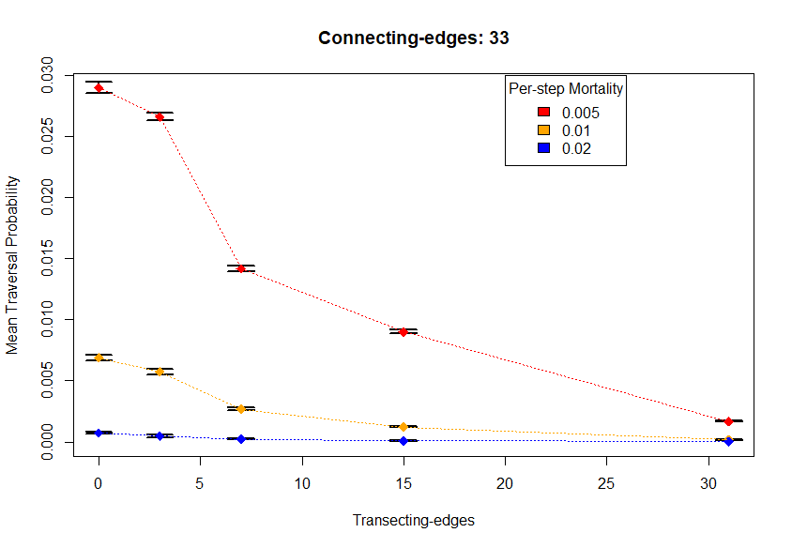
Figure 1: mean Traversal Probability of 15 TartanGraphs at Directional Persistence of 7.5. Each point indicates mean of three TartanGraphs and error bars indicate standard deviation. Traversal Probability correlates negatively with per-step mortality and transecting-edge number. TartanGraphs had varying transecting-edges numbers but uniformly possessed 33 connecting-edges.
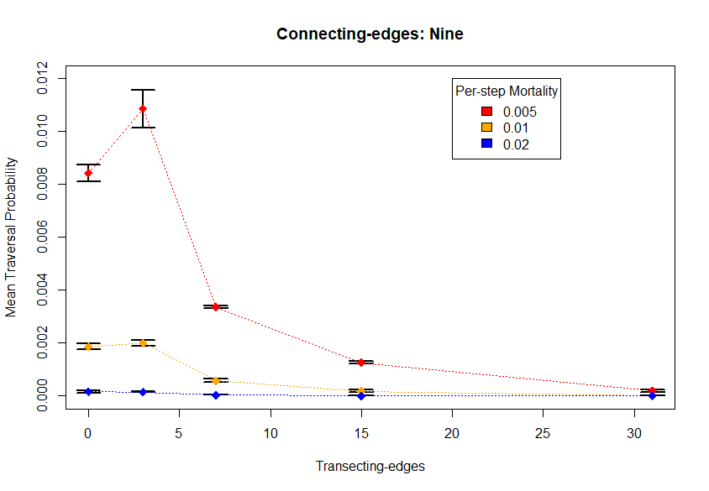
Figure 2: mean Traversal Probability of 15 TartanGraphs at Directional Persistence of 7.5. Each point indicates mean of three TartanGraphs and error bars indicate standard deviation. Traversal Probability correlates negatively with per-step mortality and transecting-edge number. TartanGraphs had varying transecting-edges numbers but uniformly possessed nine connecting-edges.
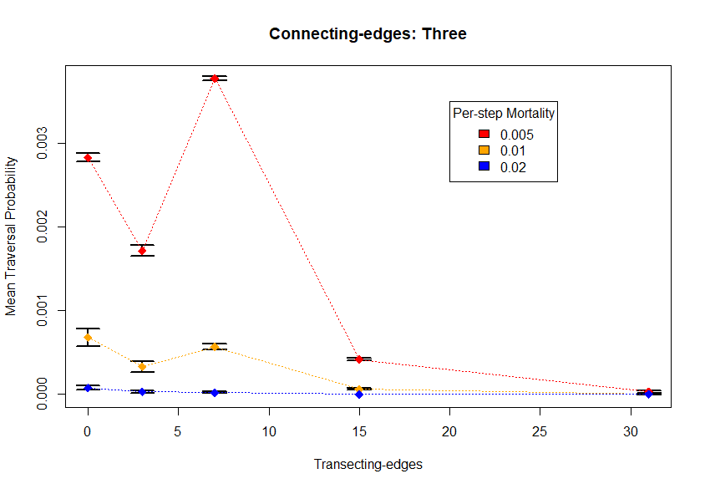
Figure 3: mean Traversal Probability of 15 TartanGraphs at Directional Persistence of 7.5. Each point indicates mean of three TartanGraphs and error bars indicate standard deviation. Traversal Probability correlates negatively with per-step mortality and transecting-edge number. TartanGraphs had varying transecting-edges numbers but uniformly possessed three connecting-edges.
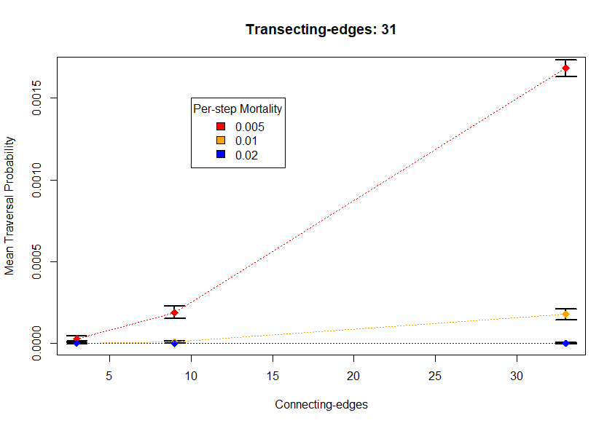
Figure 4: mean Traversal Probability of 15 TartanGraphs at Directional Persistence of 7.5. Each point indicates mean of five TartanGraphs and error bars indicate standard deviation. Traversal Probability correlates negatively with per-step mortality and positively with connecting-edge number. All TartanGraphs had 31 transecting-edges.
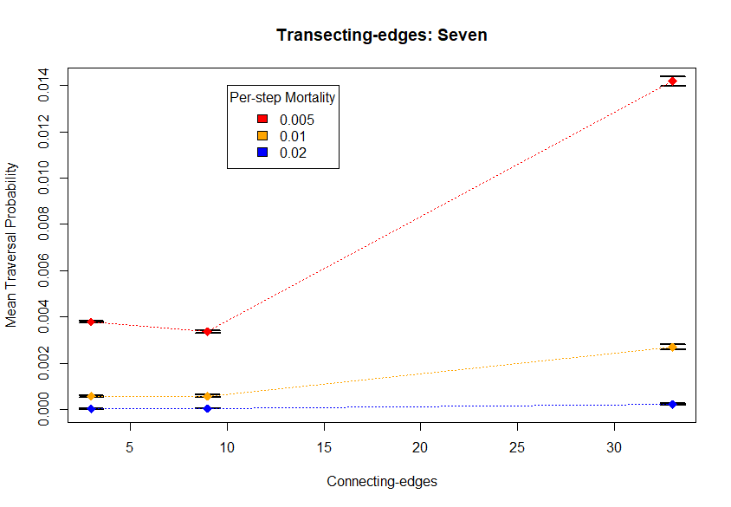
Figure 5: mean Traversal Probability of 15 TartanGraphs at Directional Persistence of 7.5. Each point indicates mean of five TartanGraphs and error bars indicate standard deviation. Traversal Probability correlates negatively with per-step mortality and positively with connecting-edge number. All TartanGraphs had seven transecting-edges.
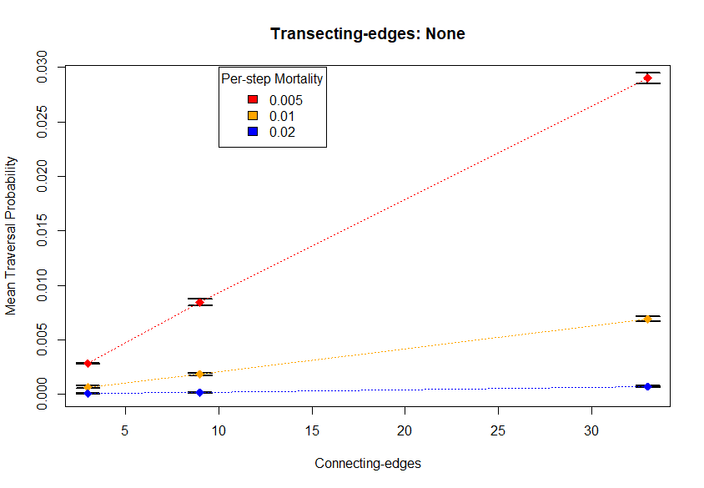
Figure 6: mean Traversal Probability of 15 TartanGraphs at Directional Persistence of 7.5. Each point indicates mean of five TartanGraphs and error bars indicate standard deviation. Traversal Probability correlates negatively with per-step mortality and positively with connecting-edge number. All TartanGraphs had zero transecting-edges.
Supplementary Material 4.2: Perceptual Range Graphs
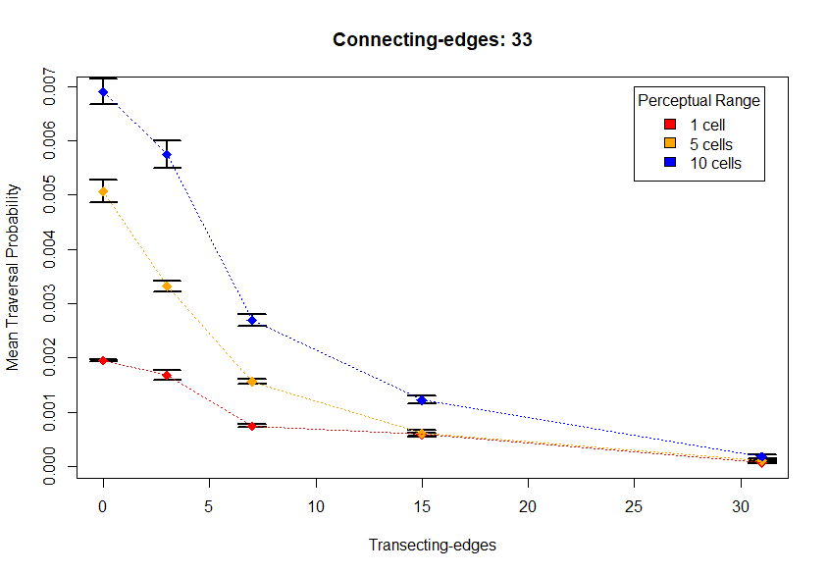
Figure 7: mean Traversal Probability of fifteen TartanGraphs at Directional Persistence of 7.5. Each point indicates mean of three TartanGraphs and error bars indicate standard deviation. Traversal probability correlates positively with perceptual range and negatively with transecting-edge number.
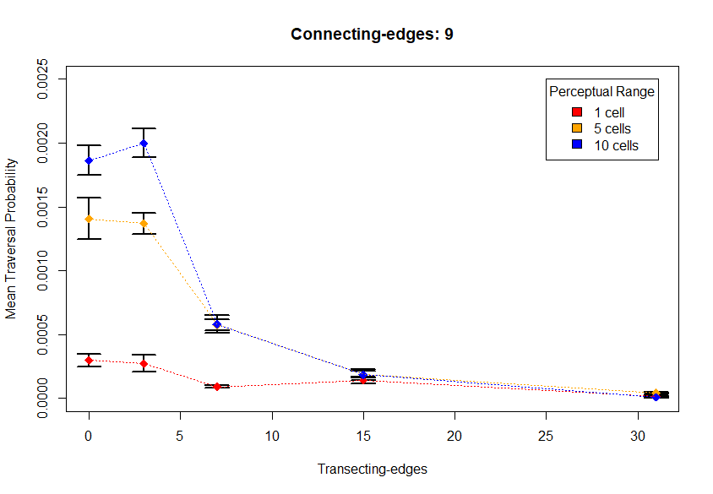
Figure 8: mean Traversal Probability of fifteen TartanGraphs at Directional Persistence of 7.5. Each point indicates mean of three TartanGraphs and error bars indicate standard deviation. Traversal probability correlates positively with perceptual range and negatively with transecting-edge number.

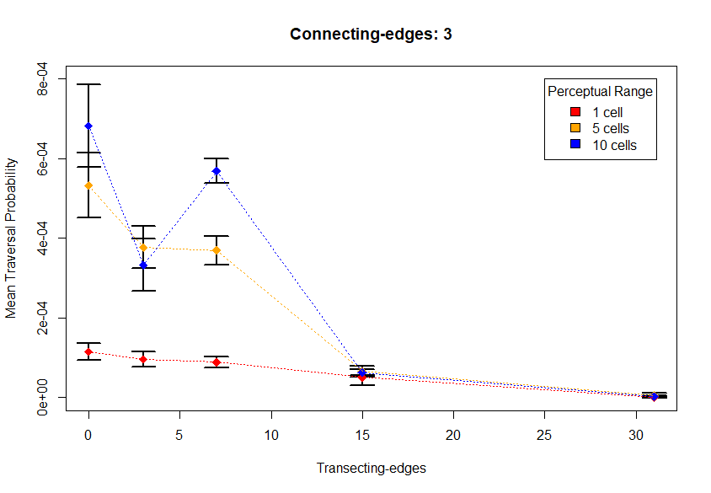
Figure 9: mean Traversal Probability of fifteen TartanGraphs at Directional Persistence of 7.5. Each point indicates mean of three TartanGraphs and error bars indicate standard deviation. Traversal probability correlates positively with perceptual range and negatively with transecting-edge number.

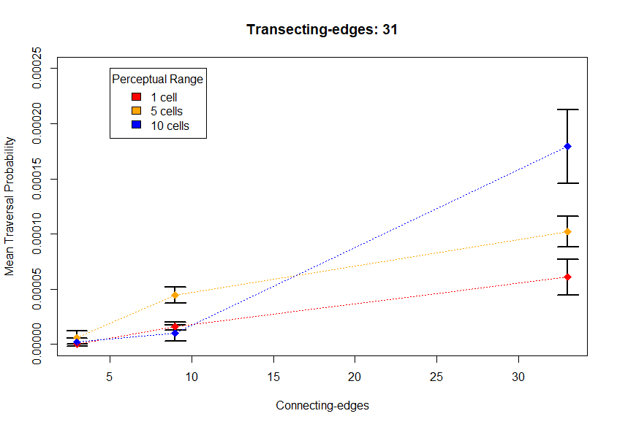
Figure 10: mean Traversal Probability of fifteen TartanGraphs at Directional Persistence of 7.5. Each point indicates mean of three TartanGraphs and error bars indicate standard deviation. Traversal probability correlates positively with perceptual range and connecting-edge number.

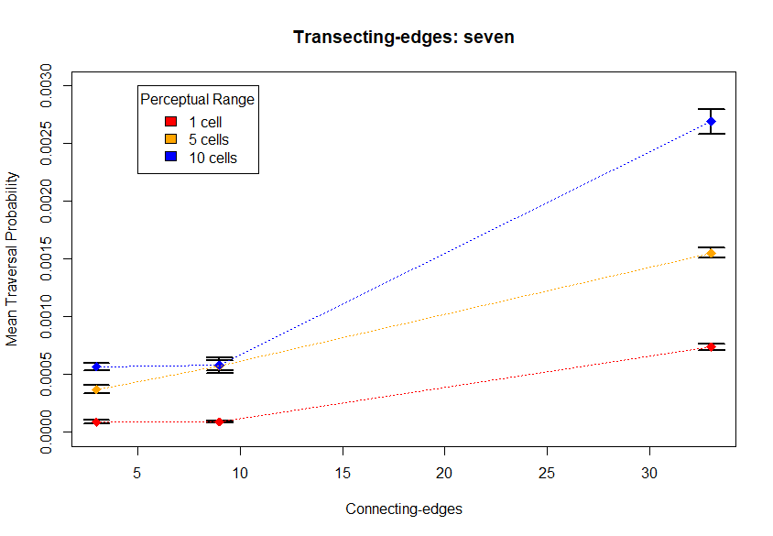
Figure 11: mean Traversal Probability of fifteen TartanGraphs at Directional Persistence of 7.5. Each point indicates mean of three TartanGraphs and error bars indicate standard deviation. Traversal probability correlates positively with perceptual range and connecting-edge number.
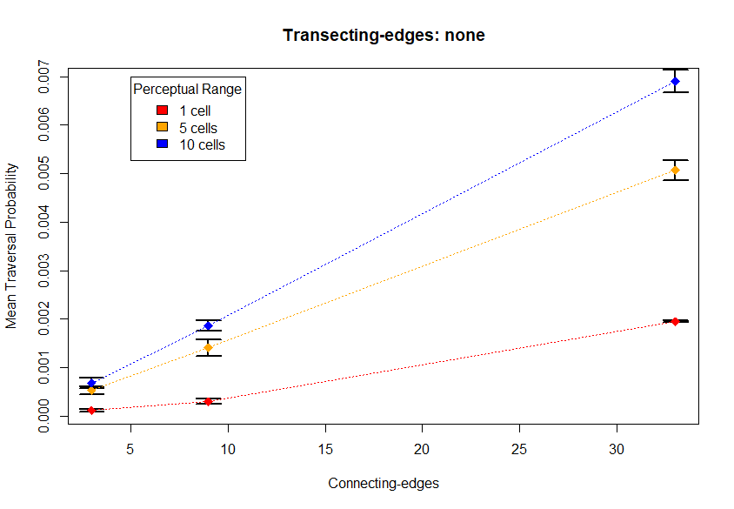
Figure 12: mean Traversal Probability of fifteen TartanGraphs at Directional Persistence of 7.5. Each point indicates mean of three TartanGraphs and error bars indicate standard deviation. Traversal probability correlates positively with perceptual range and connecting-edge number.

