Supplementary Information 3 – Data on fruit availability per season and its relationship with tree height for 14 forest patches of the 26 in which bats were sampled with mist nets.

The relative importance of forest cover and patch-level drivers for phyllostomid bat communities in the Amazonian savannas

William Douglas Carvalho^{1,2,3,4,5}*, Luís Miguel Rosalino⁶, Bruna da Silva Xavier⁷, Isaí Jorge de Castro⁸, Renato Hilário^{3,5}, Tiago Miranda Marques^{3,5}, José Júlio de Toledo^{3,5}, Marcus Vinícius Vieira⁷, Jorge M. Palmeirim⁶, Karen Mustin³

1 - Terrestrial Ecology Group (TEG-UAM), Department of Ecology, Faculty of Sciences, Autonomous University of Madrid, Madrid, Spain.
2 - Centro de Investigación en Biodiversidad y Cambio Global (CIBC-UAM), Universidad Autónoma de Madrid, Madrid, Spain.
3 - Programa de Pós-Graduação em Biodiversidade Tropical, Universidade Federal do Amapá (UNIFAP), Macapá, Brazil.
4 – Programa de Pós-Graduação em Biodiversidade e Meio Ambiente, Universidade Federal da Grande Dourados (UFGD), Dourados, Brazil.
5 - Laboratório de Ecologia, Departamento de Meio Ambiente e Desenvolvimento, Universidade Federal do Amapá (UNIFAP), Macapá, Brazil.
6 - Centre for Ecology, Evolution and Environmental Changes and Departamento de
Biologia Animal, Faculdade de Ciências, Universidade de Lisboa, Lisboa, Portugal.
7 - Programa de Pós-Graduação em Ecologia, Universidade Federal do Rio de Janeiro (UFRJ), Rio de Janeiro, Brazil.
8 - Laboratório de Mamíferos, Instituto de Pesquisas Científicas e Tecnológicas do Estado do Amapá (IEPA), Macapá, Brazil.

*Correspondent author:
E-mail: wilruoca@hotmail.com

Between 2019 and 2021, we estimated fruit availability in 14 of the 26 forest patches sampled with mist nets, considering two meters on each side of the mist net. As such, we estimated the availability of fruits for all plants, except palm trees, within an area of approximately 440 m² around each mist net in each transect. Fruit availability estimates were performed on the same day that bats were captured, twice in the rainy season and twice in the dry season. All mentioned analyses were carried out in Program R (R Core Team 2021).
To compare the estimated average number of fruits between the rainy and dry seasons, we used a Mann-Whitney test. We found that there is higher availability of fruits in the wet season (mean ± SD = 2658.7 ± 4355.46) than in the dry season (mean ± SD = 357.07 ± 330.74; W = 52, p = 0.03 – Figure S1).

Table S1 – Tree height and number of estimated fruits per transect in 14 different forest patches sampled in the Savannas of Amapá, in the northeast of the Brazilian Amazon.

 | Tree height (m) |  | Number of fruits
 | Tree height (m) |  | Wet season | Dry season
Forest patch 1 | 5.42 |  | 1038 | 98
Forest patch 2 | 6.91 |  | 257 | 10
Forest patch 3 | 6.42 |  | 411 | 47
Forest patch 4 | 8.64 |  | 31 | 130
Forest patch 5 | 13.22 |  | 6059 | 275
Forest patch 6 | 4.87 |  | 513 | 503
Forest patch 7 | 10.50 |  | 15892 | 1150
Forest patch 8 | 15.38 |  | 6540 | 701
Forest patch 9 | 6.41 |  | 610 | 272
Forest patch 10 | 14.19 |  | 2216 | 351
Forest patch 11 | 6.25 |  | 880 | 370
Forest patch 12 | 11.24 |  | 262 | 300
Forest patch 13 | 19.51 |  | 2413 | 782
Forest patch 14 | 6.50 |  | 100 | 10

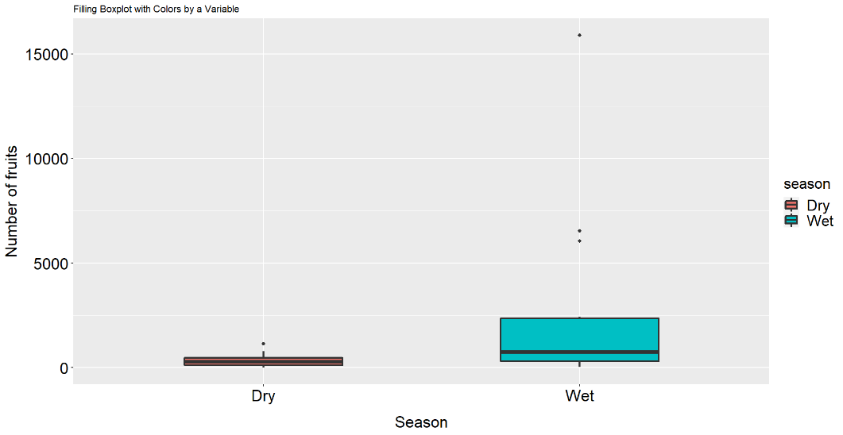

Figure S1 – Estimated number of fruits per season in transects that were sampled with mist nets to capture bats in the Savannas of Amapá between 2019 and 2021.
Subsequently, we related the total estimated number of fruits in each season with the tree height by transect through a linear regression. Tree height was only correlated with number of fruits per transect in the dry season (Table S2 and Figure S2).

Table S2 – Result of linear regression between the number of fruits estimated per season (wet and dry) and tree height of 14 different forest patches that were sampled in the Savannas of Amapá, in the northeast of the Brazilian Amazon.

Wet season
 | Estimate | Std. Error | t value | P value
(Intercept) | -777.8 | 2782.7 | -0.28 | 0.78
Tree height | 355 | 262.8 | 1.35 | 0.20
Dry season
(Intercept) | -29.92 | 191.07 | -0.16 | 0.87
Tree height | 39.98 | 18.04 | 2.21 | 0.04

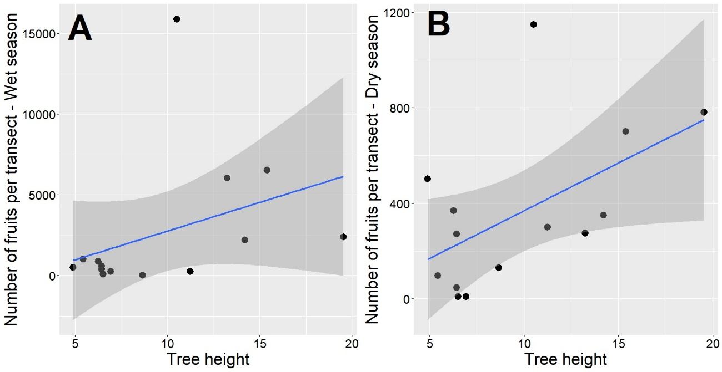

Figure S2 - Univariate relationship between tree height and number of fruits estimated in wet (A) and dry (B) seasons in the sampled forest patches in the Savannas of Amapá, in the northeast of the Brazilian Amazon. Each data point represents one of the 14 transects sampled. The shaded areas represent the 95% confidence intervals.

References
R Core Team (2021) R: A language and environment for statistical computing. R Foundation for Statistical Computing, Vienna, Austria. https://www.R-project.org/.

