Supplementary Information - Assessing large landscape patterns of potential fire connectivity using circuit methods

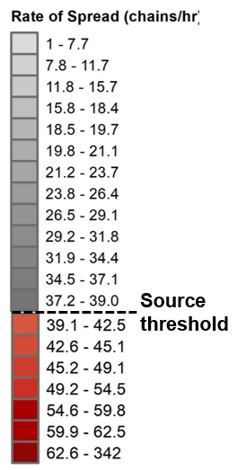
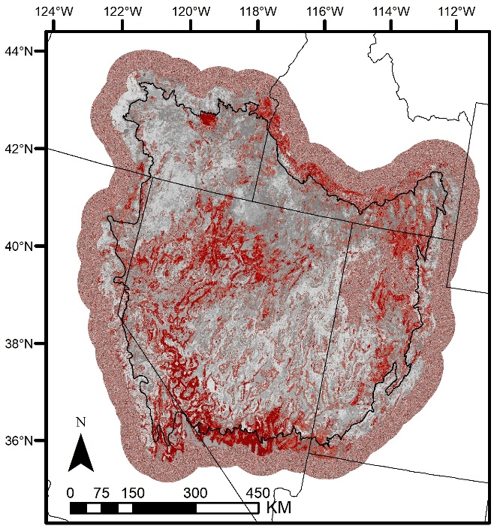
Buffer

SI Fig. 1 Conductance surface for the Great Basin based on the rate-of-spread (ROS) values calculated with FlamMap. Additional buffer zone was included to reduce potential edge effects. The buffer and non-target landcover areas were filled with a truncated normal distribution of values based on the distribution of values within the existing ROS surface. Pixels greater than the ROS source threshold were used as source and target locations during the analysis and are illustrated in red.

resistance_file = omni_fs/fs_ros_270x78_cnd_t01.tif
resistance_is_conductance = true
radius = 289
project_name = omni_fs/OUT_fs
source_from_resistance = false
source_threshold = 39
calc_normalized_current = true
block_size = 11
parallelize = true
parallel_batch_size = 12
write_raw_currmap = true
mask_nodata = true
write_as_tif = true
solver = cholmod

SI Fig. 2 Initialization (.ini) file for running Omniscape v0.5.6 in Julia 1.5.2.

SI Table 1 Summary calculations for fire connectivity and relative flow classes for Bureau of Land Management (BLM) Field Offices within the Great Basin. Connective class values ranged from low (2) to high (20) potential fire connectivity.
State | Field Office | Mean connectivity class | Dominant relative flow class
CA | Applegate | 5 | Impeded
CA | Bishop | 15 | Diffuse
CA | Eagle Lake | 13 | Diffuse-Channelized
CA | Mother Lode | 12 | Channelized
CA | Ridgecrest | 19 | Channelized
ID | Bruneau | 5 | Diffuse
ID | Burley | 15 | Diffuse
ID | Jarbidge | 11 | Diffuse
ID | Owyhee | 8 | Diffuse
ID | Pocatello | 15 | Channelized
ID | Upper Snake | 13 | Channelized
NV | Basin and Range | 13 | Channelized
NV | Black Rock | 12 | Diffuse
NV | Bristlecone | 6 | Diffuse
NV | Caliente | 15 | Diffuse-Channelized
NV | Humboldt River | 17 | Channelized
NV | Las Vegas | 20 | Diffuse-Channelized
NV | Mount Lewis | 10 | Diffuse-Impeded
NV | Pahrump | 17 | Diffuse-Channelized
NV | Sierra Front | 15 | Diffuse
NV | Stillwater | 17 | Channelized
NV | Tonopah | 15 | Diffuse
NV | Tuscarora | 14 | Diffuse-Channelized
NV | Wells | 7 | Diffuse
OR | Burns Andrews | 5 | Diffuse-Impeded
OR | Burns Three Rivers | 11 | Diffuse-Channelized
OR | Lakeview | 2 | Diffuse
OR | Prineville Central Oregon | 2 | Diffuse
OR | Prineville Deschutes | 3 | Diffuse-Impeded
OR | Vale Malheur | 8 | Diffuse
UT | Cedar City | 9 | Channelized
UT | Fillmore | 11 | Channelized
UT | Richfield | 12 | Channelized
UT | Salt Lake | 15 | Diffuse
UT | St. George | 16 | Channelized

Any use of trade, firm, or product names is for descriptive purposes only and does not imply endorsement by the U.S. Government. This work was partly funded by the US Department of Interior, Bureau of Land Management, in support of fuel break research.

