Landscape characteristics and predation risk influence spatial variation in auditory courtship of an upland game bird
Online Resource 2: Supporting Tables and Figures
P.H. Wightman*, J.A. Martin¹, M.T. Kohl¹, E. Rushton², B.A. Collier³, and M.J. Chamberlain¹
¹Warnell School of Forestry and Natural Resources, University of Georgia, Athens, GA 30602, USA
²Georgia Department of Natural Resources – Wildlife Resources Division, Social Circle, GA 30025.
³School of Renewable Natural Resources, Louisiana State University Agricultural Center, Baton Rouge, LA 70803, USA
*Corresponding author; email:pw78598@uga.edu

Table 1 Parameter estimates of full model for third-order resource selection functions for 36 coyotes in Georgia, USA, calculated from day time locations before turkey season (Pre Hunt), during turkey season (Hunt), and after turkey season (Post Hunt) during 2018 and 2019. Shown are regression coefficients (β), standard error (SE), and 95% confidence intervals (CI).
Model Variables | β | SE | CI
Intercept | -1.63 | 0.10 | -1.82 – -1.44
Distance to primary road:Pre Hunt | -0.03 | 0.01 | -0.05 – -0.00
Distance to primary road:Hunt | 0.20 | 0.01 | 0.18 – 0.22
Distance to primary road:Post Hunt | 0.18 | 0.01 | 0.16 – 0.20
Distance to secondary road:Pre Hunt | 0.04 | 0.01 | 0.02 – 0.06
Distance to secondary road:Hunt | 0.02 | 0.01 | -0.00 – 0.05
Distance to secondary road:Post Hunt | 0.06 | 0.01 | 0.04 – 0.09
Distance to hardwoods:Pre Hunt | -0.05 | 0.01 | 0.07 – 0.02
Distance to hardwoods:Hunt | -0.19 | 0.01 | -0.21 – -0.16
Distance to hardwoods:Post Hunt | -0.08 | 0.01 | -0.10 – -0.05
Distance to open:Pre Hunt | 0.03 | 0.02 | 0.00 – 0.07
Distance to open:Hunt | -0.13 | 0.02 | -0.16 – -0.10
Distance to open:Post Hunt | -0.12 | 0.02 | -0.16 – -0.08
Distance to water:Pre Hunt | -0.10 | 0.01 | -0.13 – -0.07
Distance to water:Hunt | 0.26 | 0.01 | 0.23 – 0.29
Distance to water:Post Hunt | -0.04 | 0.02 | -0.07 – -0.01
Distance to pine:Pre Hunt | -0.17 | 0.01 | -0.20 – -0.14
Distance to pine:Hunt | -0.17 | 0.02 | -0.20 – -0.14
Distance to pine:Post Hunt | -0.04 | 0.01 | -0.07 – -0.02
Distance to mix:Pre Hunt | 0.03 | 0.01 | 0.00 – 0.06
Distance to mix:Hunt | 0.08 | 0.02 | 0.05 – 0.11
Distance to mix:Post Hunt | -0.09 | 0.02 | -0.12 – -0.06
Distance to shrub:Pre Hunt | -0.21 | 0.01 | -0.24 – -0.18
Distance to shrub:Hunt | -0.19 | 0.01 | -0.21 – -0.16
Distance to shrub:Post Hunt | -0.05 | 0.02 | -0.08 – -0.02
Distance to forest edge:Pre Hunt | -0.06 | 0.01 | -0.09 – -0.04
Distance to forest edge:Hunt | -0.04 | 0.01 | -0.06 – -0.01
Distance to forest edge:Post Hunt | -0.21 | 0.02 | -0.25 – -0.18
Distance to access:Pre Hunt | 0.16 | 0.01 | 0.14 – 0.19
Distance to access:Hunt | -0.15 | 0.01 | -0.18 – -0.12
Distance to access:Post Hunt | -0.30 | 0.02 | -0.34 – -0.27
Distance to private:Pre Hunt | 0.11 | 0.01 | 0.08 – 0.13
Distance to private:Hunt | 0.06 | 0.01 | 0.03 – 0.08
Distance to private:Post Hunt | -0.06 | 0.01 | -0.10 – -0.02

Table 2. Parameter estimates of full model for third-order resource selection functions for 111 wild turkeys (81 F, 30 M) in Georgia, USA, calculated from day time locations before turkey season (Pre Hunt), during turkey season (Hunt), and after turkey season (Post Hunt) during 2018 and 2019. Shown are regression coefficients (β), standard error (SE), 95% confidence intervals (CI).
 | Female |  |  | Male
Model Variables | β | SE | CI | β | SE | CI
Intercept | -1.04 | 0.04 | -1.12 – -0.96 | -1.27 | 0.08 | -1.43 – -1.11
Distance to primary road: Pre Hunt | 0.07 | 0.01 | 0.05 – 0.08 | 0.12 | 0.01 | 0.10 – 0.14
Distance to primary road: Hunt | 0.10 | 0.01 | 0.09 – 0.12 | 0.36 | 0.01 | 0.34 – 0.38
Distance to primary road: Post Hunt | 0.09 | 0.01 | 0.08 – 0.10 | 0.16 | 0.01 | 0.14 – 0.18
Distance to secondary road: Pre Hunt | -0.10 | 0.01 | -0.11 – -0.08 | 0.07 | 0.01 | 0.05 – 0.09
Distance to secondary road: Hunt | -0.21 | 0.01 | -0.23 – -0.20 | -0.02 | 0.01 | -0.05 – 0.00
Distance to secondary road: Post Hunt | -0.15 | 0.01 | -0.16 – -0.13 | -0.26 | 0.02 | -0.29 – -0.23
Distance to hardwoods: Pre Hunt | -0.25 | 0.01 | -0.27 – -0.24 | -0.27 | 0.02 | -0.30 – -0.24
Distance to hardwoods: Hunt | -0.09 | 0.01 | -0.10 – -0.07 | -0.39 | 0.01 | -0.41 – -0.36
Distance to hardwoods: Post Hunt | -0.18 | 0.01 | -0.20 – -0.17 | -0.09 | 0.01 | -0.11 – -0.07
Distance to open: Pre Hunt | -0.03 | 0.01 | -0.05 – -0.02 | -0.09 | 0.01 | -0.11 – -0.07
Distance to open: Hunt | -0.20 | 0.01 | -0.22 – -0.19 | -0.20 | 0.01 | -0.23 – -0.17
Distance to open: Post Hunt | -0.12 | 0.01 | -0.14 – -0.10 | -0.19 | 0.02 | -0.22 – -0.16
Distance to water: Pre Hunt | 0.02 | 0.01 | 0.01 – 0.04 | -0.07 | 0.01 | -0.09 – -0.05
Distance to water: Hunt | 0.04 | 0.01 | 0.02 – 0.05 | -0.13 | 0.01 | -0.16 – -0.11
Distance to water: Post Hunt | -0.07 | 0.01 | -0.08 – -0.05 | -0.10 | 0.01 | -0.13 – -0.08
Distance to pine: Pre Hunt | 0.07 | 0.01 | 0.05 – 0.08 | -0.03 | 0.01 | -0.05 – 0.00
Distance to pine: Hunt | 0.03 | 0.01 | 0.02 – 0.04 | 0.16 | 0.01 | 0.14 – 0.18
Distance to pine: Post Hunt | 0.00 | 0.01 | -0.01 – 0.02 | -0.05 | 0.02 | -0.08 – -0.02
Distance to mix: Pre Hunt | -0.06 | 0.01 | -0.07 – -0.04 | 0.01 | 0.01 | -0.01 – 0.03
Distance to mix: Hunt | 0.00 | 0.01 | -0.01 – 0.02 | 0.02 | 0.01 | -0.01 – 0.04
Distance to mix: Post Hunt | 0.02 | 0.01 | 0.01 – 0.04 | -0.02 | 0.01 | -0.04 – 0.01
Distance to shrub: Pre Hunt | -0.06 | 0.01 | -0.07 – -0.05 | 0.07 | 0.01 | 0.05 – 0.10
Distance to shrub: Hunt | 0.05 | 0.01 | 0.04 – 0.07 | 0.18 | 0.01 | 0.15 – 0.20
Distance to shrub: Post Hunt | 0.13 | 0.01 | 0.12 – 0.15 | 0.20 | 0.02 | 0.17 – 0.23
Distance to forest edge: Pre Hunt | -0.05 | 0.01 | -0.07 – -0.03 | 0.32 | 0.02 | 0.29 – 0.36
Distance to forest edge: Hunt | 0.01 | 0.01 | -0.01 – 0.02 | -0.15 | 0.01 | -0.18 – -0.12
Distance to forest edge: Post Hunt | -0.03 | 0.01 | -0.05 – -0.02 | -0.07 | 0.01 | -0.10 – -0.05
Distance to access:Pre Hunt | 0.20 | 0.01 | 0.18 – 0.22 | 0.02 | 0.02 | -0.01 – 0.06
Distance to access:Hunt | -0.08 | 0.01 | -0.09 – -0.07 | 0.08 | 0.02 | 0.05 – 0.12
Distance to access:Post Hunt | -0.15 | 0.01 | -0.17 – -0.14 | 0.17 | 0.02 | 0.13 – 0.20
Distance to private:Pre Hunt | -0.15 | 0.01 | -0.17 – -0.14 | -0.08 | 0.01 | -0.10 – -0.05
Distance to private:Hunt | 0.21 | 0.01 | 0.19 – 0.22 | 0.04 | 0.01 | 0.01 – 0.06
Distance to private:Post Hunt | -0.08 | 0.01 | -0.10 – -0.06 | 0.05 | 0.02 | 0.02 – 0.08

Table 3. Average (x̄), standard error (SE), minimum (Min), and maximum (Max) probability of use for 3rd order resource selection by male and female wild turkeys, and coyotes, within a 250‐m buffer around autonomous recording units, along with distance (m) to land cover variables. Probability of use was determined before, during, and after turkey hunting season on Cedar Creek Wildlife Management Area and B. F. Grant Wildlife Management Area, Georgia, USA, 2018–2019.
Variable | x̄ | SE | Min | Max
3rd order coyote probability of use prior to hunting | 0.25 | 0.01 | 0.11 | 0.48
3rd order coyote probability of use during hunting | 0.14 | 0.01 | 0.05 | 0.32
3rd order coyote probability of use after hunting | 0.25 | 0.01 | 0.09 | 0.59
3rd order female turkey probability of use prior to hunting | 0.42 | 0.01 | 0.02 | 0.71
3rd order female turkey probability of use during hunting | 0.42 | 0.01 | 0.26 | 0.72
3rd order female turkey probability of use after hunting | 0.34 | 0.01 | 0.13 | 0.55
3rd order male turkey probability of use prior to hunting | 0.30 | 0.01 | 0.13 | 0.63
3rd order male turkey probability of use during hunting | 0.10 | 0.01 | 0.02 | 0.30
3rd order male turkey probability of use after hunting | 0.22 | 0.01 | 0.09 | 0.38
Distance to private | 646.23 | 26.24 | 0 | 1972
Distance to access | 979.55 | 40.32 | 0 | 3200
Distance to primary road | 598.76 | 18.04 | 0.5 | 1243.65
Distance to secondary road | 136.56 | 9.73 | 0.05 | 605.13
Distance to open | 321.82 | 14.80 | 0 | 1194.74
Distance to hardwoods | 33.20 | 2.07 | 0 | 180
Distance to pine | 36.80 | 2.61 | 0 | 254.56
Distance to mix | 110.81 | 6.51 | 0 | 630.71
Distance to shrub | 255.42 | 10.73 | 30.00 | 989.54
Distance to edge | 219.45 | 13.43 | 0 | 892.25

Table 4. Estimated effects of third-order resource selection probability of use by 36 coyotes on average daily gobbling activity of male eastern wild turkeys in Georgia, USA, calculated from day time locations before turkey season (Pre Hunt), during turkey season (Hunt), and after turkey season (Post Hunt) during 2018 and 2019. Also included are effects of distance to access, distance to secondary road, distance to primary road, and distance to private property on average daily gobbling activity of male eastern wild turkeys. Shown are coefficient estimates (β), standard deviation (SD), 95% credible intervals (CI), R hat values, percent in region of practical equivalence (ROPE), and probability of direction (pd).
Parameter | β | SD | CI (95%) | R-hat | ROPE | pd
Pre hunt | 1.75 | 0.27 | 1.22 – 2.27 | 1.00 | 0% | 1.00
Hunt | 0.72 | 0.24 | 0.24 – 1.19 | 1.00 | 0% | 0.99
Post hunt | -1.51 | 0.34 | -2.22 – -0.87 | 1.00 | 0% | 1.00
Third order coyote use: Pre hunt | -0.21 | 0.21 | -0.64 – 0.16 | 1.00 | 26% | 0.58
Third order coyote use: Hunt | -0.08 | 0.17 | -0.45 – 0.26 | 1.00 | 46% | 0.74
Third order coyote use: Post hunt | 0.29 | 0.27 | -0.15 – 0.91 | 1.00 | 20% | 0.54
Distance to access: Pre hunt | 0.03 | 0.15 | -0.29 – 0.39 | 1.00 | 54% | 0.64
Distance to access: Hunt | 0.58 | 0.24 | 0.12 – 1.08 | 1.00 | 0% | 0.99
Distance to access: Post hunt | -0.08 | 0.18 | -0.49 – 0.29 | 1.00 | 44% | 0.72
Distance to secondary road: Pre hunt | -0.15 | 0.16 | -0.47 – 0.14 | 1.00 | 37% | 0.85
Distance to secondary road: Hunt | -0.02 | 0.15 | -0.35 – 0.30 | 1.00 | 56% | 0.54
Distance to secondary road: Post hunt | 0.12 | 0.20 | -0.25 – 0.57 | 1.00 | 40% | 0.74
Distance to primary road: Pre hunt | -0.11 | 0.18 | -0.52 – 0.21 | 1.00 | 42% | 0.76
Distance to primary road: Hunt | -0.12 | 0.21 | -0.61 – 0.27 | 1.00 | 38% | 0.73
Distance to primary road: Post hunt | -0.15 | 0.23 | -0.69 – 0.28 | 1.00 | 34% | 0.76
Distance to private: Pre hunt | -0.03 | 0.14 | -0.33 – 0.26 | 1.00 | 59% | 0.58
Distance to private: Hunt | -0.32 | 0.20 | -0.74 – 0.05 | 1.00 | 8% | 0.95
Distance to private: Post hunt | -0.11 | 0.19 | -0.57 – 0.24 | 1.00 | 41% | 0.74

Table 5. Estimated effects of third-order resource selection probability of use for 111 wild turkeys (81 F, 30 M) on average daily gobbling activity of male eastern wild turkeys in Georgia, USA, calculated from day time locations before turkey season (Pre Hunt), during turkey season (Hunt), and after turkey season (Post Hunt) during 2018 and 2019. Shown are coefficient estimates (β), standard deviation (SD), 95% credible intervals (CI), R hat values, percent in region of practical equivalence (ROPE), and probability of direction (pd).
Parameter | β | SD | CI (95%) | R-hat | ROPE | pd
Pre Hunt | 1.98 | 0.39 | 1.23 – 2.75 | 1.00 | 0% | 0.99
Hunt | 0.90 | 0.36 | 0.22 – 1.67 | 1.00 | 0% | 0.99
Post Hunt | -1.19 | 0.41 | -2.01 – 0.40 | 1.00 | 0% | 1.00
Third order female use: Pre hunt | 0.31 | 0.28 | -0.18 – 0.91 | 1.00 | 21% | 0.86
Third order female use :Hunt | -0.22 | 0.16 | -0.55 – 0.08 | 1.00 | 20% | 0.92
Third order female use: Post hunt | 0.45 | 0.30 | -0.09 – 1.07 | 1.00 | 8% | 0.94
Third order male use: Pre hunt | -0.34 | 0.32 | -1.17 – 0.04 | 1.00 | 28% | 0.74
Third order male use: Hunt | 0.44 | 0.24 | -0.01 – 0.94 | 1.00 | 2% | 0.97
Third order male use: Post hunt | -0.14 | 0.35 | -0.89 – 0.53 | 1.00 | 28% | 0.65

Table 6. Estimated effects of the distance to hardwoods, pine, open, water, shrub, and mix on B.F. Grant and Cedar Creek Wildlife Management Area in Georgia, USA, before turkey season (Pre Hunt), during turkey season (Hunt), and after turkey season (Post Hunt) during 2018 and 2019. Shown are coefficient estimates (β), standard deviation (SD), 95% credible intervals (CI), R hat values, percent in region of practical equivalence (ROPE), and probability of direction (pd).
Parameter | β | SD | CI (95%) | R-hat | ROPE | pd
Pre hunt | 1.53 | 0.23 | 1.07 – 1.98 | 1.00 | 0% | 1.00
Hunt | 0.67 | 0.24 | 0.19 – 1.13 | 1.00 | 0% | 0.99
Post hunt | -1.46 | 0.29 | -2.05 – -0.90 | 1.00 | 0% | 1.00
Distance to hardwoods: Pre hunt | -0.01 | 0.12 | -0.27 – 0.26 | 1.00 | 66% | 0.52
Distance to hardwoods: Hunt | -0.08 | 0.14 | -0.41 – 0.19 | 1.00 | 52% | 0.73
Distance to hardwoods: Post hunt | 0.07 | 0.17 | -0.26 – 0.47 | 1.00 | 49% | 0.67
Distance to pine: Pre hunt | 0.07 | 0.13 | -0.20 – 0.38 | 1.00 | 57% | 0.70
Distance to pine: Hunt | 0.05 | 0.12 | -0.20 – 0.34 | 1.00 | 62% | 0.66
Distance to pine: Post hunt | 0.10 | 0.18 | -0.24 – 0.56 | 1.00 | 45% | 0.72
Distance to open: Pre hunt | 0.01 | 0.13 | -0.28 – 0.31 | 1.00 | 62% | 0.52
Distance to open: Hunt | -0.01 | 0.12 | -0.28 – 0.24 | 1.00 | 66% | 0.55
Distance to open: Post hunt | -0.01 | 0.17 | -0.41 – 0.37 | 1.00 | 52% | 0.53
Distance to water: Pre hunt | -0.02 | 0.13 | -0.31 – 0.26 | 1.00 | 63% | 0.56
Distance to water: Hunt | -0.05 | 0.13 | -0.36 – 0.22 | 1.00 | 59% | 0.65
Distance to water: Post hunt | -0.02 | 0.16 | -0.43 – 0.34 | 1.00 | 51% | 0.56
Distance to shrub: Pre hunt | 0.12 | 0.15 | -0.15 – 0.46 | 1.00 | 45% | 0.80
Distance to shrub: Hunt | -0.06 | 0.13 | -0.35 – 0.19 | 1.00 | 60% | 0.69
Distance to shrub: Post hunt | -0.04 | 0.18 | -0.49 – 0.33 | 1.00 | 48% | 0.61
Distance to mix: Pre hunt | -0.02 | 0.13 | -0.33 – 0.27 | 1.00 | 61% | 0.55
Distance to mix: Hunt | -0.01 | 0.11 | -0.25 – 0.25 | 1.00 | 69% | 0.51
Distance to mix: Post hunt | -0.32 | 0.28 | -0.96 – 0.10 | 1.00 | 22% | 0.89

Table 7. Estimated effects of third-order resource selection probability of use for 111 eastern wild turkeys (81 F, 30 M), Georgia, USA, calculated from day time locations before turkey season (Pre Hunt), during turkey season (Hunt), and after turkey season (Post Hunt) during 2018 and 2019, distance to access, and distance to private. Shown are coefficient estimates (β), standard deviation (SD), 95% credible intervals (CI), R hat values, percent in region of practical equivalence (ROPE), and probability of direction (pd).
Parameter | β | SD | CI (95%) | R-hat | ROPE | pd
Pre hunt | 1.56 | 0.30 | 0.96 – 2.16 | 1.00 | 0% | 1.00
Hunt | 0.83 | 0.31 | 0.26 – 1.53 | 1.00 | 0% | 0.99
Post hunt | -1.06 | 0.33 | -1.71 – -0.41 | 1.00 | 0% | 0.99
Distance to access: Pre hunt | 0.06 | 0.14 | -0.23 – 0.39 | 1.00 | 55% | 0.71
Distance to access: Hunt | 0.42 | 0.19 | 0.05 – 0.79 | 1.00 | 0% | 0.98
Distance to access: Post hunt | -0.02 | 0.16 | -0.37 – 0.33 | 1.00 | 52% | 0.70
Third order male use: Pre hunt | -0.06 | 0.25 | -0.60 – 0.41 | 1.00 | 35% | 0.57
Third order male use: Hunt | 0.29 | 0.22 | -0.11 – 0.75 | 1.00 | 17% | 0.91
Third order male use: Post hunt | -0.05 | 0.32 | -0.73 – 0.58 | 1.00 | 35% | 0.55
Third order female use: Pre hunt | 0.08 | 0.25 | -0.38 – 0.62 | 1.00 | 44% | 0.62
Third order female use: Hunt | -0.21 | 0.15 | -0.52 – 0.17 | 1.00 | 19% | 0.92
Third order female use: Post hunt | 0.39 | 0.30 | -0.09 – 1.05 | 1.00 | 17% | 0.91
Distance to private: Pre hunt | -0.05 | 0.14 | -0.36 – 0.24 | 1.00 | 57% | 0.64
Distance to private: Hunt | -0.24 | 0.18 | -0.61 – 0.08 | 1.00 | 12% | 0.94
Distance to private: Post hunt | -0.01 | 0.17 | -0.39 – 0.36 | 1.00 | 50% | 0.51

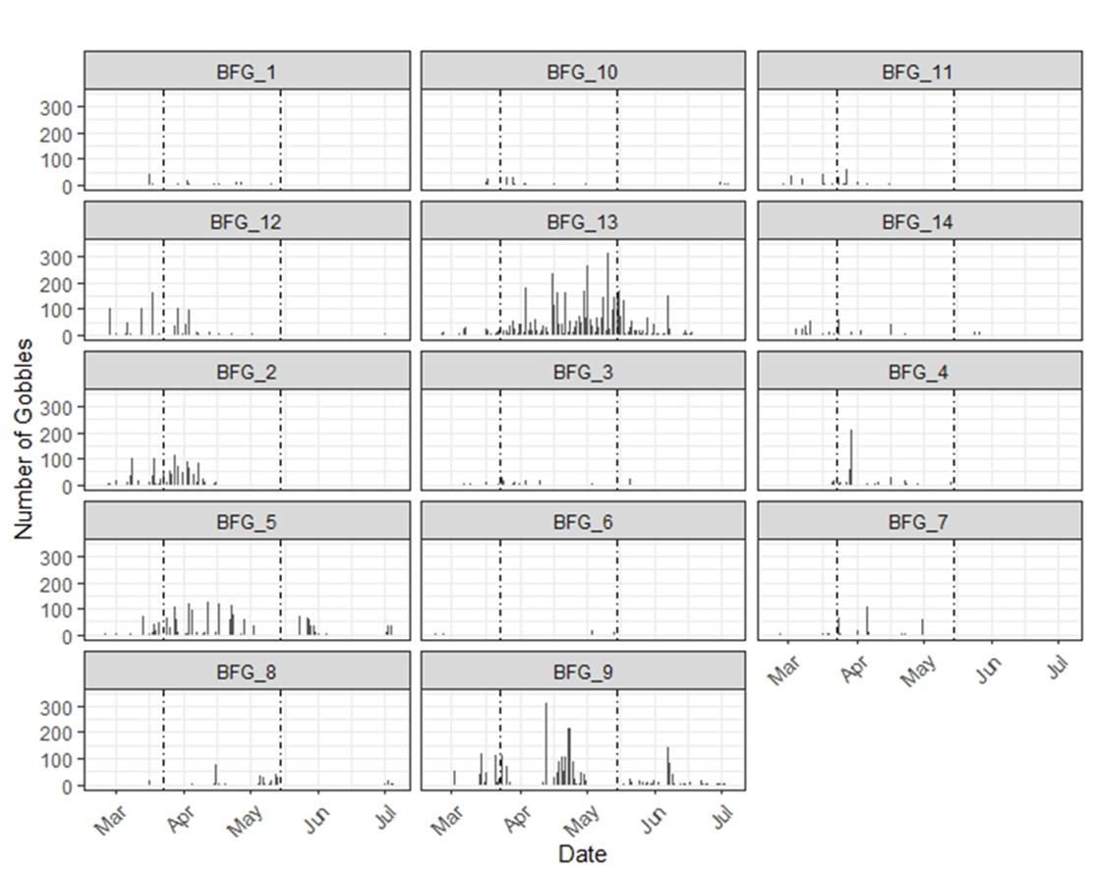
Figure 1. Daily eastern wild turkey gobbling activity for autonomous recording units on B.F. Grant Wildlife Management Area in Georgia, USA, 2019. The first dotted line represents the start date for the spring turkey season, whereas the second denotes the date the season ended.

Email: pw78598@uga.edu

