Supporting Information for: Prerequisites for coexistence: human pressure and refuge habitat availability shape continental-scale habitat use patterns of a large carnivore

Authors: Julian Oeser^{1*}, Marco Heurich^{2, 3, 4}, Stephanie Kramer-Schadt^{4, 5, 6}, Henrik Andrén⁷, Guna Bagrade ⁸, Elisa Belotti^{9,10}, Luděk Bufka¹⁰, Christine Breitenmoser-Würsten¹¹, Rok Černe¹², Martin Duľa¹³, Christian Fuxjäger¹⁴, Tomislav Gomerčić¹⁵, Włodzimierz Jędrzejewski^{16,17}, Raido Kont¹⁸, Petr Koubek¹⁹, Rafał Kowalczyk¹⁶, Miha Krofel²⁰, Jarmila Krojerová-Prokešová^{19,21}, Jakub Kubala^{22, 23}, Josip Kusak¹⁵, Miroslav Kutal¹³, John D.C. Linnell^{4, 24}, Jenny Mattisson²⁴, Anja Molinari-Jobin²⁵, Peep Männil²⁶, John Odden²⁷, Henryk Okarma²⁸, Teresa Oliveira²⁰, Nives Pagon¹², Jens Persson⁷, Jaanus Remm^{18, 29}, Krzysztof Schmidt¹⁶, Sven Signer^{11,} Branislav Tám³⁰, Kristina Vogt¹¹, , Fridolin Zimmermann¹¹, and Tobias Kuemmerle ^{1, 31}
*Corresponding author: julian.oeser@gmail.com

Affiliations:
¹ Geography Department, Humboldt-Universität zu Berlin, Unter den Linden 6, 10099 Berlin, Germany
² Bavarian Forest National Park, Department of Visitor Management and National Park Monitoring, Freyungerstr. 2, 94481 Grafenau, Germany
³ Chair of Wildlife Ecology and Management, Faculty of Environment and Natural Resources, University of Freiburg, Tennenbacher Straße 4, 79106 Freiburg, Germany
⁴ Department of Forestry and Wildlife Management, Inland Norway University of Applied Science, Campus Evenstad, NO-2480 Koppang, Norway
⁵ Department of Ecological Dynamics, Leibniz Institute for Zoo and Wildlife Research, Alfred-Kowalke-Str. 17, D-10315 Berlin, Germany
⁶ Institute of Ecology, Technische Universität Berlin, Rothenburgstr. 12, D-12165 Berlin
⁷ Grimsö Wildlife Research Station, Department of Ecology, Swedish University of Agricultural Sciences, SE-739 93 Sweden
⁸ Latvian State Forest Research Institute ‘Silava’, Rigas str.111, Salaspils, LV-2169, Latvia
⁹ Faculty of Forestry and Wood Sciences, Czech University of Life Sciences Prague, Kamýcká 1176, CZ-16521 Prague, Czech Republic
¹⁰ Department of Research and Nature Protection, Šumava National Park Administration, Sušická 399, CZ-34192 Kašperské Hory, Czech Republic
¹¹ Foundation KORA, Thunstrasse 31, 3074 Muri bei Bern, Switzerland
¹² Slovenia Forest Service, Večna pot 2, SI-1000 Ljubljana, Slovenia
¹³ Department of Forest Ecology, Faculty of Forestry and Wood Technology, Mendel University in Brno, Zemědělská 1, 613 00, Brno, Czech Republic
¹⁴ Nationalpark Zentrum Molln, Nationalpark Kalkalpen, Nationalpark Allee 1, 4591 Molln, Austria
¹⁵ Department of Veterinary Biology, University of Zagreb, Heinzelova 55, 10000 Zagreb, Croatia
¹⁶ Mammal Research Institute, Polish Academy of Sciences, Stoczek 1, 17-230 Białowieża, Poland
¹⁷ Centro de Ecología, Instituto Venezolano de Investigaciones Científicas (IVIC), 1020-A Caracas, Venezuela
¹⁸ Department of Zoology, Institute of Ecology and Earth Sciences, University of Tartu, Liivi 2, 50409 Tartu, Estonia
¹⁹ Institute of Vertebrate Biology of the Czech Academy of Sciences, Květná 8, 603 65 Brno, Czech Republic
²⁰ University of Ljubljana, Biotechnical Faculty, Department of Forestry and Renewable Forest
Resources, Jamnikarjeva 101, SI-1000 Ljubljana, Slovenia
²¹ Department of Zoology, Fisheries, Hydrobiology and Apiculture, Faculty of AgriSciences, Mendel University in Brno, Zemědělská 1, 613 00 Brno, Czech Republic
²² Technical University Zvolen, Faculty of Forestry, Department of Applied Zoology and Wildlife Management, T. G. Masaryka 24, 960 01 Zvolen, Slovakia
²³ DIANA – Carpathian Wildlife Research, Mládežnícka 47, 97404 Banská Bystrica, Slovakia
²⁴ Norwegian Institute for Nature Research, PO Box 5685 Torgarden, 7485 Trondheim, Norway
²⁵ Progetto Lince Italia, Via Roma 43, 33018 Tarvisio, Italy
²⁶ Estonian Environment Agency, Mustamäe tee 33, 10616 Tallinn, Estonia
²⁷ Norwegian Institute for Nature Research, Sognsveien 68, NO-0855 Oslo, Norway
²⁸ Institute of Nature Conservation, Polish Academy of Sciences, Mickiewicza 33, 31-120 Krakow, Poland
²⁹ OÜ Rewild, Jaama 1a, 11615 Tallinn, Estonia
³⁰ National Zoological Garden Bojnice, Zámok a okolie 939/6, 972 01 Bojnice, Slovakia
³¹ Integrative Research Institute on Transformation in Human Environment Systems, Humboldt-Universität zu Berlin, Unter den Linden 6, 10099 Berlin, Germany

Table S1: Overview of tracking datasets from different lynx populations.
Population | Number of individuals  (GPS / VHF) | Share of male / female locations | Monitoring period | Number of locations
Alpine | 58 (28/31) | 0.52/0.48 | 1997 - 2021 | 56,620
Baltic | 44 (17/28) | 0.67/0.33 | 1991 - 2016 | 28,287
Bohemian-Bavarian-Austrian | 19 (10/12) | 0.53/0.47 | 1997 - 2013 | 17,472
Carpathian | 17 (17/0) | 0.9/0.1 | 2011 - 2021 | 26,537
Dinaric | 21 (21/0) | 0.63/0.37 | 2006 - 2021 | 15,864
Jura | 23 (0/23) | 0.36/0.64 | 1988 - 1998 | 9,595
Scandinavian | 252 (137/137) | 0.38/0.62 | 1993 - 2017 | 250,159
TOTAL | 434 (230/231) | 0.47/0.53 | 1988 - 2021 | 417,648

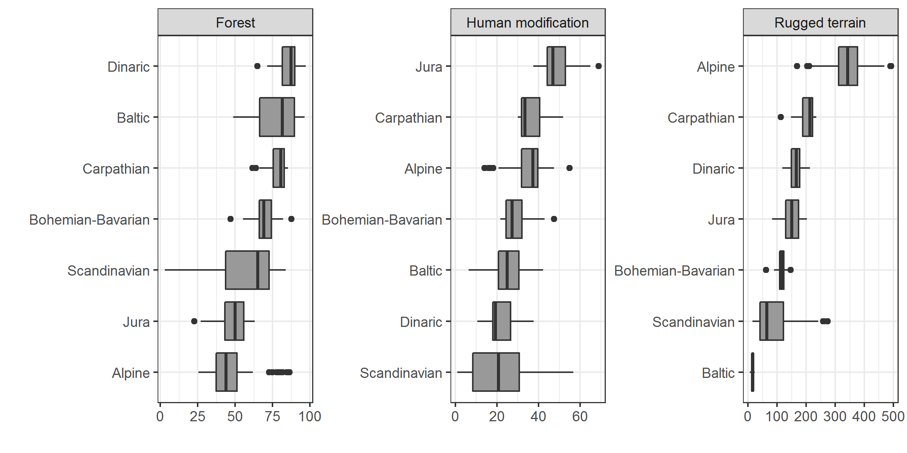
Fig. S1 Overview of variable distributions across the seven lynx populations we studied. Values shown represent habitat availability at the home range scale (i.e., randomly sampled points within home ranges of lynx individuals).

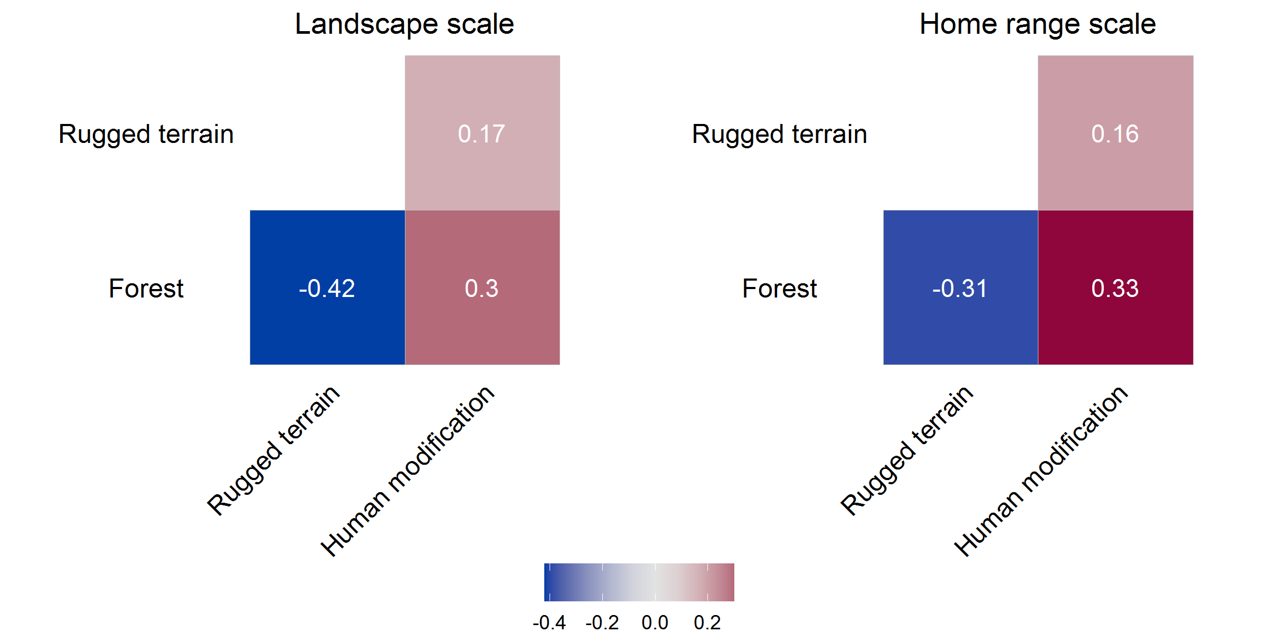
Fig. S2 Correlation matrix of model variables used at the landscape and home range scale

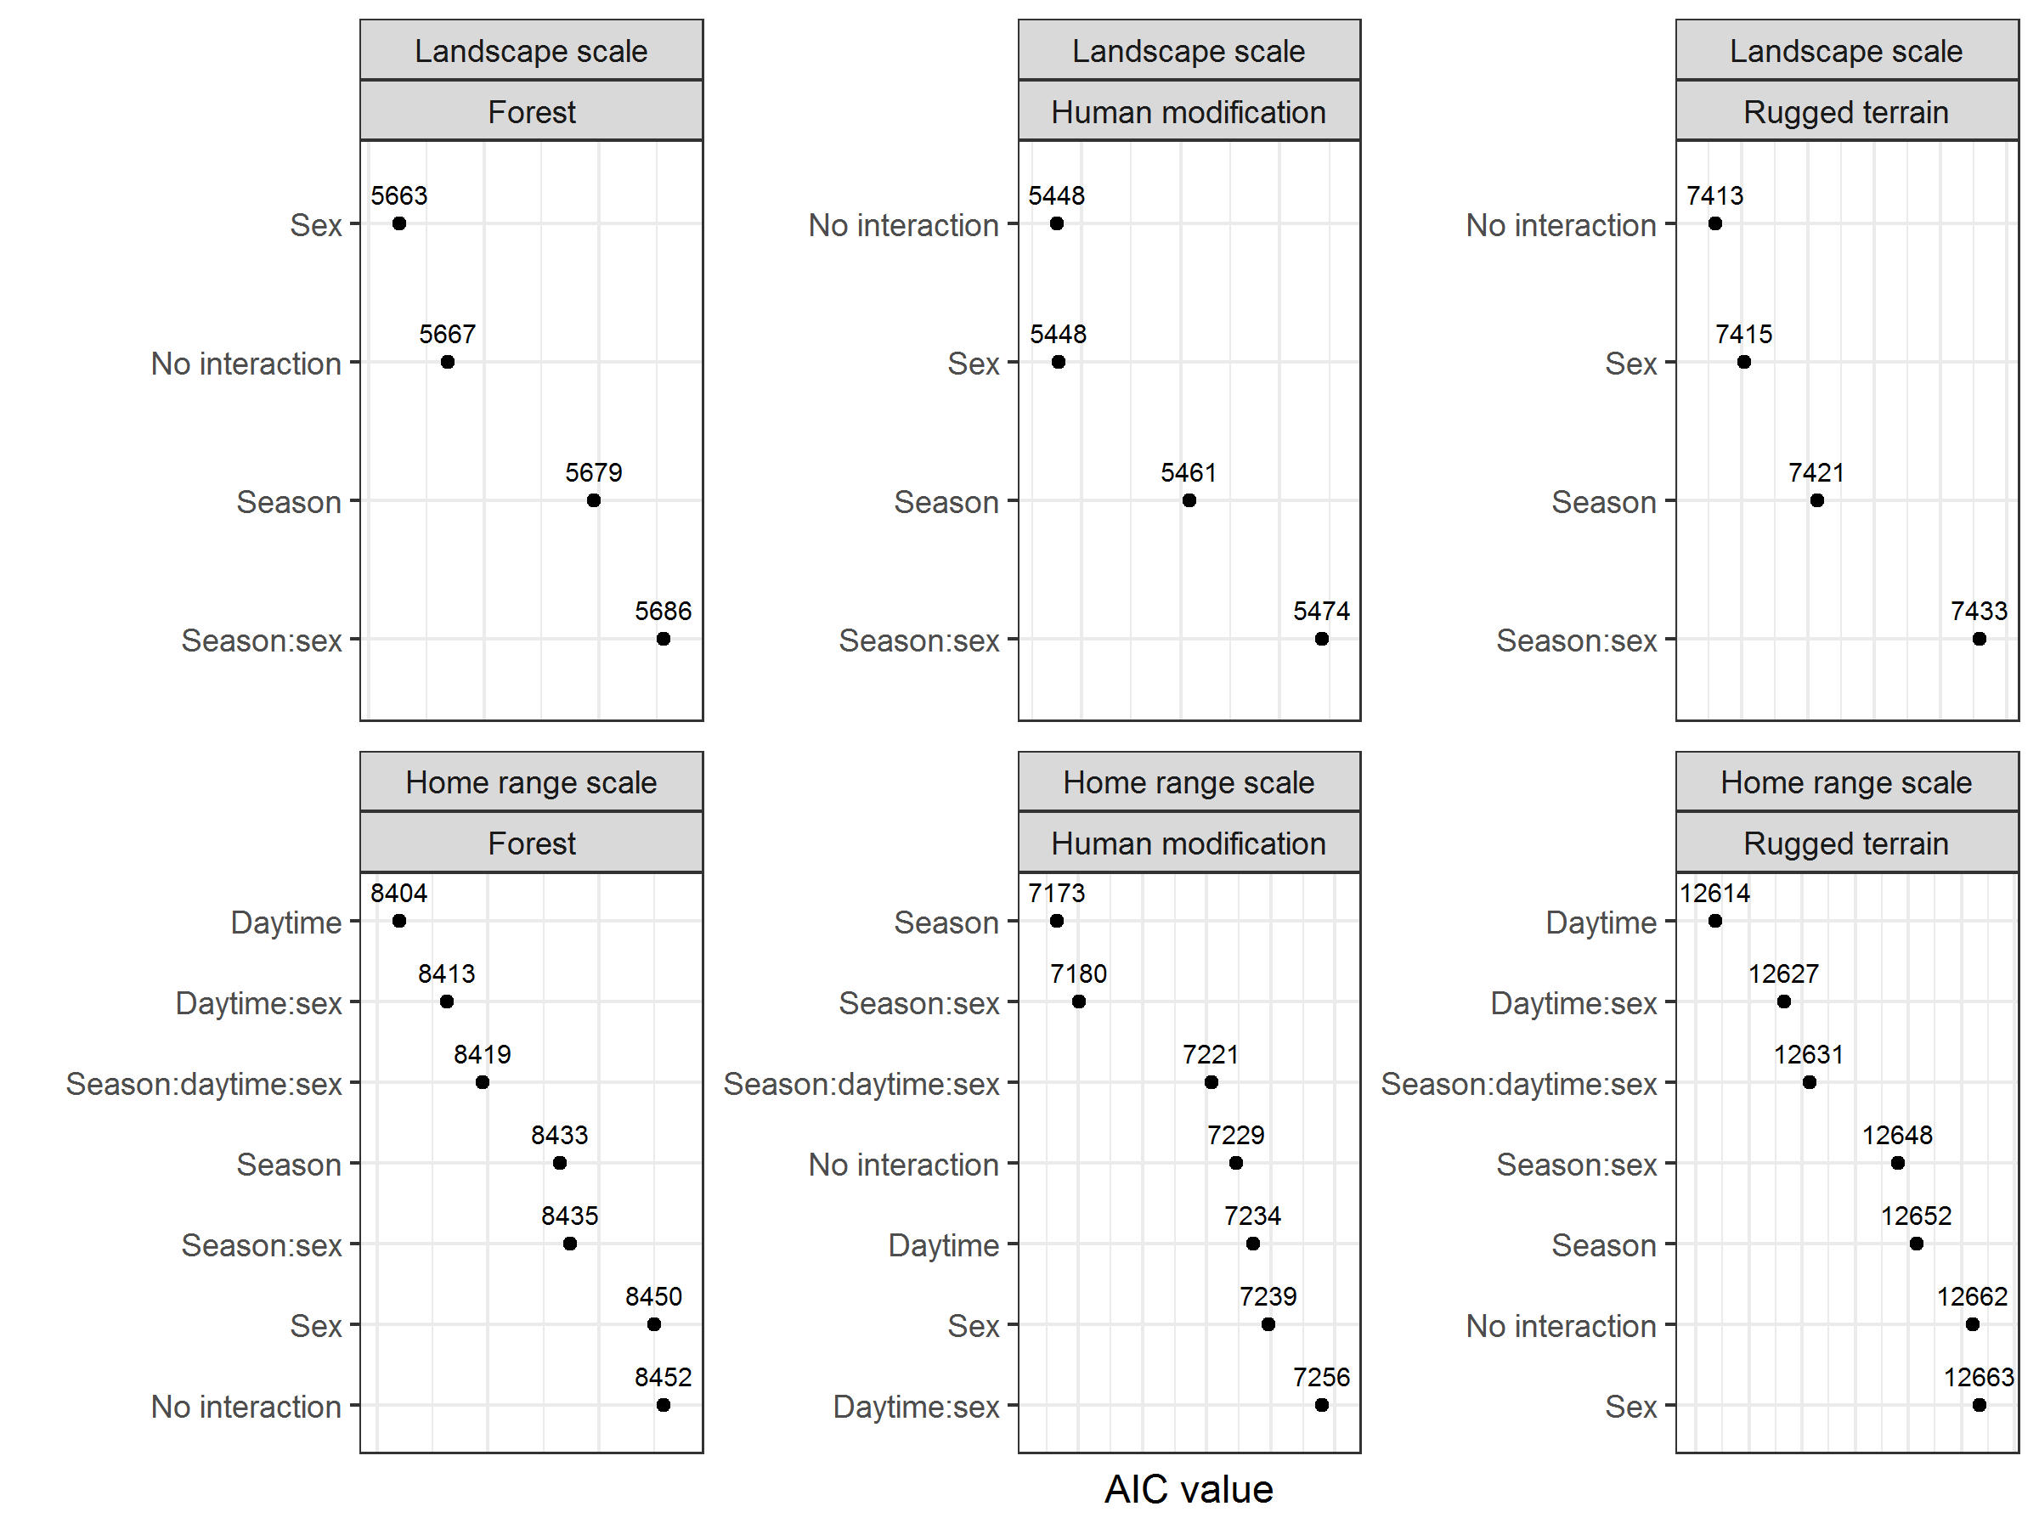
Fig. S3 Comparison of model support (AIC values) for different model setups of functional response models at the landscape scale (top panels) and home range scale (bottom panels). Model setups differ in terms of interacting variables (daytime, season, sex) used to account for temporal and sex-specific variation in lynx habitat use

Table S2: Overview of model coefficients for model setups selected based on AIC.
Forest: Landscape scale
Term | Estimate | SE |  | T-statistic |  | p value
Intercept | -9.69 | 5.79 |  | -1.67 |  | 0.0944
forest | 1.01 | 0.0825 |  | 12.3 |  | 1.04E-31
rugged_terrain | -0.0321 | 0.0426 |  | -0.754 |  | 0.451
human_modification | 1.97 | 0.167 |  | 11.8 |  | 1.64E-29
male | 20.1 | 9.14 |  | 2.2 |  | 0.0285
forest:rugged_terrain | 0.0053 | 5.11E-04 |  | 10.4 |  | 1.28E-23
forest:human_modification | -0.0262 | 0.00273 |  | -9.58 |  | 1.31E-20
rugged_terrain:human_modification | -0.00574 | 8.78E-04 |  | -6.54 |  | 1.12E-10
forest:male | -0.249 | 0.123 |  | -2.02 |  | 0.0433
rugged_terrain:male | -0.131 | 0.0735 |  | -1.79 |  | 0.0744
human_modification:male | -0.589 | 0.225 |  | -2.61 |  | 0.00914
forest:rugged_terrain:male | -8.14E-04 | 7.84E-04 |  | -1.04 |  | 0.299
forest:human_modification:male | 0.00964 | 0.0039 |  | 2.47 |  | 0.0136
rugged_terrain:human_modification:male | 0.00344 | 0.00133 |  | 2.58 |  | 0.0102
Forest: Home range scale
Term | Estimate | SE |  | T-statistic |  | p value
Intercept | 18.1 | 2.14 |  | 8.47 |  | 6.78E-17
forest | 0.922 | 0.029 |  | 31.8 |  | 4.65E-163
rugged_terrain | -0.0404 | 0.0136 |  | -2.96 |  | 0.00312
human_modification | 0.646 | 0.0731 |  | 8.83 |  | 3.44E-18
night | -0.906 | 3.23 |  | -0.281 |  | 0.779
forest:rugged_terrain | 1.28E-04 | 1.54E-04 |  | 0.83 |  | 0.407
forest:human_modification | -0.0107 | 0.00105 |  | -10.2 |  | 1.57E-23
rugged_terrain:human_modification | 8.42E-04 | 2.61E-04 |  | 3.23 |  | 0.00127
forest:night | -0.0331 | 0.0431 |  | -0.768 |  | 0.442
rugged_terrain:night | 0.0046 | 0.021 |  | 0.219 |  | 0.827
human_modification:night | -0.194 | 0.122 |  | -1.59 |  | 0.112
forest:rugged_terrain:night | 1.22E-04 | 2.37E-04 |  | 0.514 |  | 0.607
forest:human_modification:night | 0.00288 | 0.00171 |  | 1.68 |  | 0.0928
rugged_terrain:human_modification:night | -3.35E-04 | 4.11E-04 |  | -0.815 |  | 0.415
Human modification: Landscape scale
Term | Estimate | SE |  | T-statistic |  | p value
Intercept | -9 | 3.81 |  | -2.36 |  | 0.0184
forest | 0.266 | 0.0532 |  | 5 |  | 6.95E-07
rugged_terrain | 0.112 | 0.0294 |  | 3.8 |  | 1.56E-04
human_modification | 0.415 | 0.0962 |  | 4.32 |  | 1.79E-05
forest:rugged_terrain | -0.00279 | 3.23E-04 |  | -8.62 |  | 3.74E-17
forest:human_modification | 0.00413 | 0.00163 |  | 2.53 |  | 0.0116
rugged_terrain:human_modification | 6.85E-04 | 5.47E-04 |  | 1.25 |  | 0.211
Human modification: Home range scale
Term | Estimate | SE |  | T-statistic |  | p value
Intercept | -1.8 | 1.46 |  | -1.23 |  | 0.217
forest | 0.017 | 0.0195 |  | 0.869 |  | 0.385
rugged_terrain | 0.0215 | 0.00938 |  | 2.29 |  | 0.0221
human_modification | 1.11 | 0.0522 |  | 21.2 |  | 3.99E-85
rest_of_year | 0.401 | 1.97 |  | 0.204 |  | 0.838
forest:rugged_terrain | -6.14E-05 | 1.06E-04 |  | -0.579 |  | 0.563
forest:human_modification | -0.00195 | 7.37E-04 |  | -2.64 |  | 0.00834
rugged_terrain:human_modification | -5.05E-04 | 1.81E-04 |  | -2.79 |  | 0.00537
forest:rest_of_year | 0.0258 | 0.0264 |  | 0.979 |  | 0.328
rugged_terrain:rest_of_year | 0.00168 | 0.0127 |  | 0.132 |  | 0.895
human_modification:rest_of_year | 0.0329 | 0.0712 |  | 0.462 |  | 0.644
forest:rugged_terrain:rest_of_year | -2.84E-05 | 1.43E-04 |  | -0.199 |  | 0.842
forest:human_modification:rest_of_year | -4.43E-04 | 0.001 |  | -0.441 |  | 0.66
rugged_terrain:human_modification:rest_of_year | -2.70E-05 | 2.46E-04 |  | -0.11 |  | 0.912
Rugged terrain: Landscape scale
Term | Estimate | SE |  | T-statistic |  | p value
Intercept | 31.4 | 13.7 |  | 2.29 |  | 0.0222
forest | -0.856 | 0.191 |  | -4.48 |  | 8.72E-06
rugged_terrain | 1.07 | 0.106 |  | 10.1 |  | 1.10E-22
human_modification | -0.297 | 0.346 |  | -0.857 |  | 0.391
forest:rugged_terrain | -7.60E-05 | 0.00116 |  | -0.0655 |  | 0.948
forest:human_modification | 0.0134 | 0.00587 |  | 2.28 |  | 0.0231
rugged_terrain:human_modification | 0.00386 | 0.00197 |  | 1.96 |  | 0.05
Rugged terrain: Home range scale
Term | Estimate | SE |  | T-statistic |  | p value
Intercept | 161 | 11.5 |  | 14 |  | 1.47E-41
forest | -1.67 | 0.156 |  | -10.7 |  | 1.04E-25
rugged_terrain | 0.478 | 0.0733 |  | 6.52 |  | 1.03E-10
human_modification | 0.929 | 0.393 |  | 2.36 |  | 0.0183
night | -27.3 | 17.3 |  | -1.57 |  | 0.116
forest:rugged_terrain | 0.00583 | 8.27E-04 |  | 7.05 |  | 2.94E-12
forest:human_modification | -0.0254 | 0.00561 |  | -4.52 |  | 6.73E-06
rugged_terrain:human_modification | 0.00827 | 0.0014 |  | 5.9 |  | 4.63E-09
forest:night | 0.39 | 0.231 |  | 1.69 |  | 0.092
rugged_terrain:night | -0.0185 | 0.113 |  | -0.164 |  | 0.87
human_modification:night | -0.473 | 0.654 |  | -0.723 |  | 0.47
forest:rugged_terrain:night | -0.00101 | 0.00127 |  | -0.794 |  | 0.427
forest:human_modification:night | 0.00457 | 0.00919 |  | 0.498 |  | 0.619
rugged_terrain:human_modification:night | 0.00112 | 0.00221 |  | 0.506 |  | 0.613
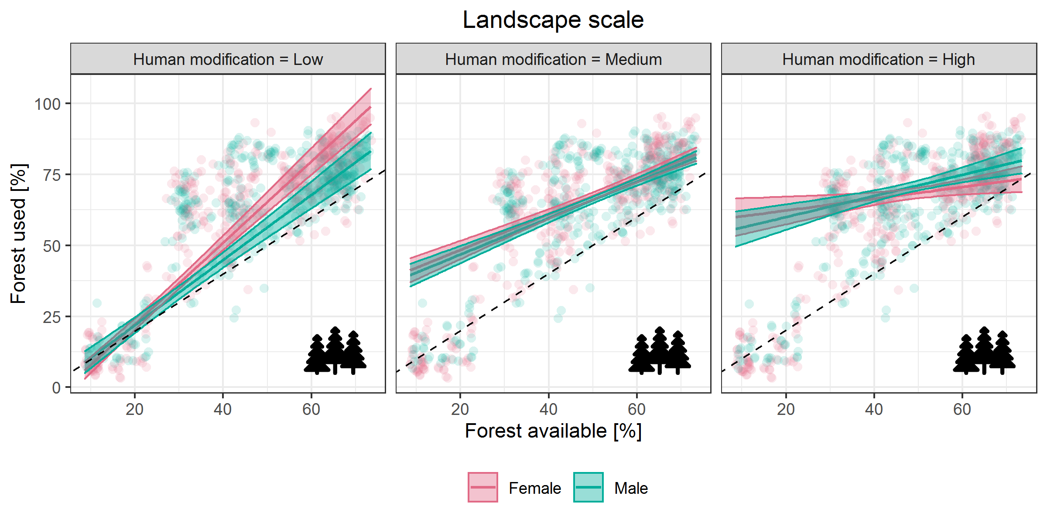
Fig. S4 Functional responses of forest use at the landscape scale (i.e., home range placement) depending on human modification and sex. Dashed diagonal lines indicate use proportional to availability. Low, medium, and high levels of human modification correspond to 10th, 50th and 90th percentile values in our dataset. Marginal model effects with 95% confidence intervals and partial residuals are colored by sex. Other variables are kept at their mean values for computing marginal effects

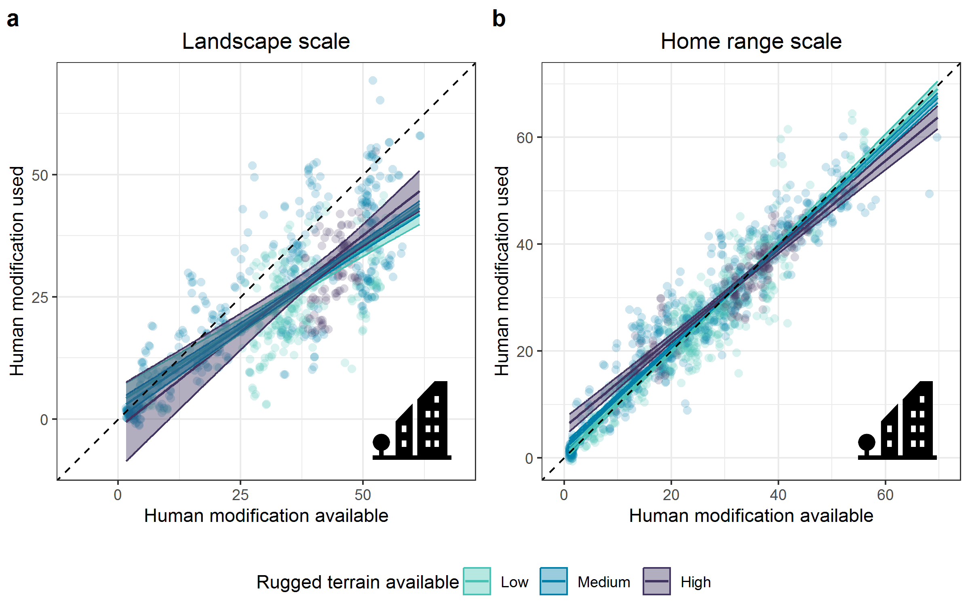
Fig. S5 Association of lynx with different levels of the human modification index (Kennedy et al., 2019) with varying availability of rugged terrain. Plots show functional responses in habitat use (i.e., use in dependence on availability), with dashed diagonal lines indicating proportional use. Marginal model effects with 95% confidence intervals and partial residuals for low, medium, and high levels of rugged terrain (10th, 50th and 90th percentile in our dataset) are highlighted in different colors. Other variables are kept at their mean values for computing marginal effects. In contrast to the effect of forest on human modification use (see Fig. 4), no clear effect of rugged terrain was detected

