Supplementary Information for “The Effects of Climate Change on the Timing of Peak Fall Foliage in Acadia National Park” submitted to Landscape Ecology.
Stephanie A. Spera^{1,2,}*, Keith R. Spangler³ , M. Olivia Hubert¹, Marc G. Gorman¹
- Department of Geography, Environment, and Sustainability, University of Richmond
- The Schoodic Institute, Acadia National Park, Maine
- Department of Environmental Health, Boston University School of Public Health
*corresponding author, sspera@richmond.edu

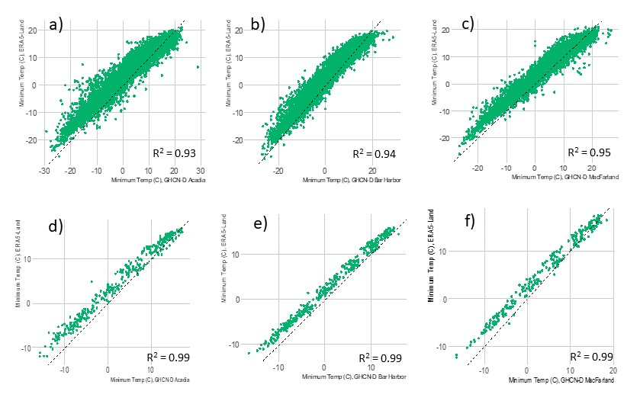
SFigure 1. Comparison of daily (a-c) and monthly (d-f) ERA5-Land and GHCNd Acadia National Park (a and d, 1983-2013), Bar Harbor (b and e, 1950-1982) and MacFarland (c and f, 2002-2022) minimum temperature data. Dashed black line represents the 1:1 line.
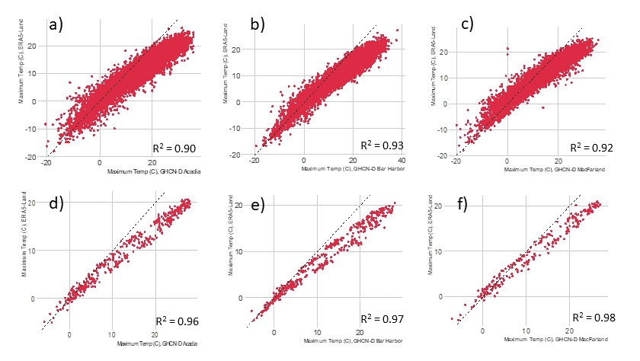
SFigure 2. Comparison of daily (a-c) and monthly (d-f) ERA5-Land and GHCNd Acadia National Park (a and d, 1983-2013), Bar Harbor (b and e, 1950-1982) and MacFarland (c and f, 2002-2022) maximum temperature data. Dashed black line represents the 1:1 line.
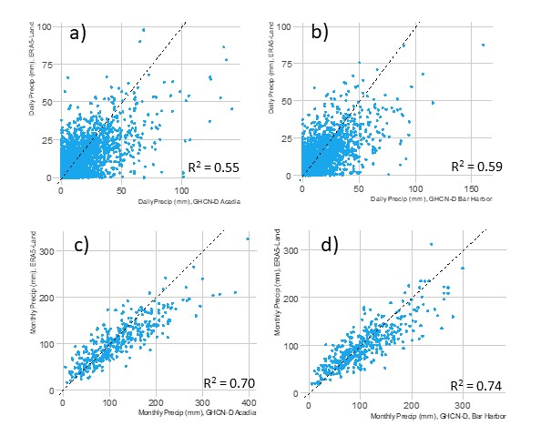
SFigure 3. Comparison of total daily (a-c) and total monthly (d-f) ERA5-Land and GHCNd Acadia National Park (a and c, 1983-2013), Bar Harbor (b and d, 1950-1982) precipitation data. Dashed black line represents the 1:1 line.
STable 1. Derived ERA5-Land variables used in climate trends analysis. DJF = December, January February; MAM = March, April, May; JJA = June, July, August; SON = September, October, November.
Climate Variable | Time Period | Definition
Average Minimum Temperature | DJF, MAM, JJA, SON | Average minimum temperature
Average Maximum Temperature | DJF, MAM, JJA, SON | Average maximum temperature
Total Precipitation | DJF, MAM, JJA, SON | Total precipitation
Number of warm nights | DJF, MAM, JJA, SON | Number of nights within each time period with temperatures above the 95% threshold across the entire study period
Number of hot nights | DJF, MAM, JJA, SON | Number of nights within each time period with temperatures above the 99% threshold across the entire study period
Number of cool nights | DJF, MAM, JJA, SON | Number of nights within each time period with temperatures between the 54% and 73% percentile (~4.5°C - 10°C)
Number of warm days | DJF, MAM, JJA, SON | Number of days within each time period with temperatures above the 95% threshold across the entire study period
Number of hot days | DJF, MAM, JJA, SON | Number of nights within each time period with temperatures above the 95% threshold across the entire study period
Number of wet days | DJF, MAM, JJA, SON | Number of days within each time period with rainfall above 1 mm
Number of rain days | DJF, MAM, JJA, SON | Number of days within each time period with temperatures above the 50% threshold across the entire study period
Number of pour days | DJF, MAM, JJA, SON | Number of days within each time period with temperatures above the 95% threshold across the entire study period
Number of downpour days | DJF, MAM, JJA, SON | Number of days within each time period with temperatures above the 99% threshold across the entire study period

STable 2. R², Adjusted R², and p value associated with each independent variable when the day of year of peak fall foliage was used as the dependent variable. Only variables with p values ≤ 0.10 (above the bolded line) were used as variables in our model-selection analysis. Warm days, hot days, warm nights, cool nights, hot nights, wet days, rain days, pour days, and downpour days are defined in STable 1 above. Tmn = minimum temperature, tmx = maximum temperature, tav = average temperature, pcp = total precipitation, pcp7d = number of 7-day periods with 0 mm of rainfall within the time period, lSummer = JulyAugust, Oct_w1 = Oct 1-Oct 7, Oct_w2 = Oct 8-Oct 14, Oct_w3 = Oct 15-Oct21.
Variable | R² | Adjusted R² | p Value
Sep_tmn | 0.37 | 0.36 | 2.70E-06
Sep_tav | 0.36 | 0.35 | 3.81E-06
Sep_coolnights | 0.35 | 0.33 | 7.10E-06
Sep_tmx | 0.34 | 0.32 | 1.06E-05
year | 0.32 | 0.30 | 1.96E-05
Sep_warmnights | 0.18 | 0.17 | 1.93E-03
Aug_tmn | 0.14 | 0.12 | 0.01
lSummer_tmn | 0.13 | 0.11 | 0.01
lSummer_tav | 0.12 | 0.10 | 0.01
May2_pcp | 0.12 | 0.10 | 0.01
lSummer_warmnights | 0.12 | 0.10 | 0.01
May_pcp | 0.12 | 0.10 | 0.01
Aug_tav | 0.12 | 0.10 | 0.01
lSummer_tmx | 0.12 | 0.10 | 0.02
Sep_hotdays | 0.11 | 0.10 | 0.02
lSummer_pcp7d | 0.11 | 0.09 | 0.02
lSummer_warmdays | 0.11 | 0.09 | 0.02
Aug_tmx | 0.10 | 0.09 | 0.02
Aug_warmnights | 0.10 | 0.08 | 0.02
Aug_warmdays | 0.10 | 0.08 | 0.03
July_warmnights | 0.09 | 0.07 | 0.04
Oct_w2_tmx | 0.08 | 0.07 | 0.04
June_pcp7d | 0.08 | 0.06 | 0.04
July_tav | 0.08 | 0.06 | 0.05
Oct_w2_pcp7d | 0.08 | 0.06 | 0.05
July_tmn | 0.08 | 0.06 | 0.05
July_tmx | 0.08 | 0.06 | 0.05
Sep2_pcp | 0.08 | 0.06 | 0.05
lSummer2_pcp7d | 0.07 | 0.05 | 0.06
Sep_pcp | 0.07 | 0.05 | 0.06
Oct_w2_pcp | 0.07 | 0.05 | 0.06
Sep_warmdays | 0.07 | 0.05 | 0.06
Sep_dpdays | 0.07 | 0.05 | 0.06
Oct_w2_tav | 0.07 | 0.05 | 0.07
May_pourdays | 0.06 | 0.04 | 0.08
MarApr_coolnights | 0.06 | 0.04 | 0.08
Oct_w1_coolnights | 0.06 | 0.04 | 0.08
Oct_w2_pourdays | 0.06 | 0.04 | 0.09
July_warmdays | 0.06 | 0.04 | 0.09
Oct_w1_pcp | 0.06 | 0.04 | 0.09
May_tmn | 0.06 | 0.04 | 0.10
May_dpdays | 0.05 | 0.03 | 0.10
Oct_w1_pourdays | 0.05 | 0.03 | 0.11
Oct_w1_tmx | 0.05 | 0.03 | 0.11
Oct_w2_tmn | 0.05 | 0.03 | 0.13
Oct_w1_tav | 0.05 | 0.03 | 0.13
May_coolnights | 0.05 | 0.03 | 0.13
June2_pcp7d | 0.04 | 0.02 | 0.14
MarApr_wetdays | 0.04 | 0.02 | 0.14
July_hotdays | 0.04 | 0.02 | 0.15
Oct_w2_dpdays | 0.04 | 0.02 | 0.15
Oct_w2_warmdays | 0.04 | 0.02 | 0.16
June_tmn | 0.04 | 0.02 | 0.16
July_pourdays | 0.04 | 0.02 | 0.16
Oct_w1_tmn | 0.04 | 0.02 | 0.18
Aug2_pcp7d | 0.04 | 0.02 | 0.19
lSummer_hotdays | 0.04 | 0.02 | 0.19
Aug_coolnights | 0.04 | 0.02 | 0.19
lSummer_hotnights | 0.03 | 0.01 | 0.21
July_hotnights | 0.03 | 0.01 | 0.21
lSummer_coolnights | 0.03 | 0.01 | 0.21
Aug_pcp7d | 0.03 | 0.01 | 0.21
Sep_hotnights | 0.03 | 0.01 | 0.23
Oct_w2_warmnights | 0.03 | 0.01 | 0.23
June_coolnights | 0.03 | 0.01 | 0.26
Sep_pourdays | 0.03 | 0.01 | 0.26
MarApr_pcp | 0.03 | 0.01 | 0.27
May_wetdays | 0.02 | 0.00 | 0.32
Oct_w2_wetdays | 0.02 | 0.00 | 0.33
May_tav | 0.02 | 0.00 | 0.33
July_pcp7d | 0.02 | 0.00 | 0.35
MarApr2_pcp | 0.02 | 0.00 | 0.35
Sep_wetdays | 0.02 | 0.00 | 0.35
Aug_hotnights | 0.02 | 0.00 | 0.36
June_pourdays | 0.02 | 0.00 | 0.36
June_tav | 0.02 | -0.01 | 0.40
May_warmdays | 0.01 | -0.01 | 0.40
Oct_w2_coolnights | 0.01 | -0.01 | 0.41
Oct_w1_warmnights | 0.01 | -0.01 | 0.42
Oct_w1_hotnights | 0.01 | -0.01 | 0.42
Aug2_pcp | 0.01 | -0.01 | 0.44
MarApr2_pcp7d | 0.01 | -0.01 | 0.45
July2_pcp7d | 0.01 | -0.01 | 0.45
lSummer_pourdays | 0.01 | -0.01 | 0.45
June_warmnights | 0.01 | -0.01 | 0.47
July2_pcp | 0.01 | -0.01 | 0.47
MarApr_tmx | 0.01 | -0.01 | 0.48
June_pcp | 0.01 | -0.01 | 0.51
lSummer_dpdays | 0.01 | -0.01 | 0.53
Oct_w3_tmn | 0.01 | -0.01 | 0.54
Sep2_pcp7d | 0.01 | -0.01 | 0.54
July_coolnights | 0.01 | -0.01 | 0.55
MarApr_tav | 0.01 | -0.01 | 0.56
Aug_hotdays | 0.01 | -0.01 | 0.56
Aug_pcp | 0.01 | -0.01 | 0.57
Aug_dpdays | 0.01 | -0.01 | 0.57
May_warmnights | 0.01 | -0.01 | 0.57
MarApr_dpdays | 0.01 | -0.01 | 0.58
June_hotnights | 0.01 | -0.01 | 0.59
Aug_wetdays | 0.01 | -0.01 | 0.60
MarApr_pcp7d | 0.01 | -0.02 | 0.61
lSummer_wetdays | 0.01 | -0.02 | 0.63
June_hotdays | 0.00 | -0.02 | 0.63
MarApr_tmn | 0.00 | -0.02 | 0.64
Oct_w3_tav | 0.00 | -0.02 | 0.67
Oct_w3_pcp7d | 0.00 | -0.02 | 0.69
MarApr_pourdays | 0.00 | -0.02 | 0.69
Oct_w1_wetdays | 0.00 | -0.02 | 0.69
June2_pcp | 0.00 | -0.02 | 0.69
July_dpdays | 0.00 | -0.02 | 0.70
May_pcp7d | 0.00 | -0.02 | 0.71
May_tmx | 0.00 | -0.02 | 0.72
May2_pcp7d | 0.00 | -0.02 | 0.73
Oct_w1_pcp7d | 0.00 | -0.02 | 0.73
Oct_w3_pourdays | 0.00 | -0.02 | 0.74
July_pcp | 0.00 | -0.02 | 0.74
June_tmx | 0.00 | -0.02 | 0.75
Oct_w3_wetdays | 0.00 | -0.02 | 0.76
Oct_w3_pcp | 0.00 | -0.02 | 0.80
June_wetdays | 0.00 | -0.02 | 0.81
Oct_w3_tmx | 0.00 | -0.02 | 0.85
lSummer_pcp | 0.00 | -0.02 | 0.85
Oct_w3_coolnights | 0.00 | -0.02 | 0.88
June_warmdays | 0.00 | -0.02 | 0.90
June_dpdays | 0.00 | -0.02 | 0.90
Aug_pourdays | 0.00 | -0.02 | 0.91
Oct_w1_warmdays | 0.00 | -0.02 | 0.94
lSummer2_pcp | 0.00 | -0.02 | 0.95
Sep_pcp7d | 0.00 | -0.02 | 0.96
July_wetdays | 0.00 | -0.02 | 0.99

STable 3. Trends across all seasonal ERA5-Land climate-based variables.
Time Period | Variable | p value | Sen’s Slope | Tau
Annual | Peak Fall Foliage | 2.42E-05 | 0.21 | 0.42
SON | Tmin | 2.16E-04 | 0.02 | 0.30
SON | Tmax | 1.78E-04 | 0.02 | 0.30
SON | Warm nights | 4.28E-04 | 0.03 | 0.31
SON | Hot nights | 0.10 | 0.00 | 0.16
SON | Cool nights | 0.03 | -0.09 | -0.18
SON | Warm days | 0.01 | 0.00 | 0.22
SON | Hot days | 0.08 | 0.00 | 0.17
SON | Precipitation | 0.14 | 0.73 | 0.12
SON | Wet days | 1.00 | 0.00 | 0.00
SON | Rain days | 0.86 | 0.00 | 0.02
SON | Pour days | 0.08 | 0.00 | 0.15
SON | Downpour days | 0.28 | 0.00 | 0.10
DJF | Tmin | 0.04 | 0.02 | 0.16
DJF | Tmax | 0.06 | 0.02 | 0.15
DJF | Warm nights | - | - | -
DJF | Hot nights | - | - | -
DJF | Cool nights | 0.23 | 0.00 | 0.11
DJF | Warm days | - | - | -
DJF | Hot days | - | - | -
DJF | Precipitation | 0.41 | 0.32 | 0.07
DJF | Wet days | 0.72 | 0.00 | -0.03
DJF | Rain days | 0.78 | 0.00 | 0.02
DJF | Pour days | 0.33 | 0.00 | 0.09
DJF | Downpour days | 0.65 | 0.00 | 0.05
MAM | Tmin | 0.08 | 0.01 | 0.14
MAM | Tmax | 0.06 | 0.01 | 0.15
MAM | Warm nights | 0.81 | 0.00 | 0.03
MAM | Hot nights | - | - | -
MAM | Cool nights | 0.07 | 0.06 | 0.15
MAM | Warm days | 0.36 | 0.00 | 0.09
MAM | Hot days | 0.31 | 0.00 | 0.10
MAM | Precipitation | 0.31 | 0.46 | 0.08
MAM | Wet days | 0.93 | 0.00 | 0.01
MAM | Rain days | 0.31 | 0.02 | 0.09
MAM | Pour days | 0.03 | 0.00 | 0.19
MAM | Downpour days | 0.81 | 0.00 | -0.02
JJA | Tmin | 1.19E-07 | 0.02 | 0.43
JJA | Tmax | 2.19E-05 | 0.02 | 0.34
JJA | Warm nights | 1.19E-07 | 0.32 | 0.44
JJA | Hot nights | 3.93E-06 | 0.07 | 0.40
JJA | Cool nights | 3.92E-05 | -0.15 | -0.34
JJA | Warm days | 2.77E-05 | 0.23 | 0.34
JJA | Hot days | 5.31E-04 | 0.06 | 0.29
JJA | Precipitation | 0.68 | 0.20 | 0.03
JJA | Wet days | 0.50 | 0.00 | -0.06
JJA | Rain days | 0.32 | -0.02 | -0.08
JJA | Pour days | 0.02 | 0.00 | 0.21
JJA | Downpour days | 0.54 | 0.00 | 0.06

STable 4. Summary statistics for variables used in regression models.
Variable | Standard Deviation | Mean | Median | Coefficient of Variation | Min | Max | 75th Percentile | 25th Percentile
Aug_tav | 16.49 | 18.91 | 17.03 | 0.87 | 14.44 | 156.75 | 17.47 | 16.29
Aug_tmn | 32.76 | 18.97 | 15.16 | 1.73 | 12.64 | 293.00 | 15.60 | 14.50
Aug_tmx | 0.90 | 18.85 | 18.89 | 0.05 | 16.24 | 20.91 | 19.39 | 18.26
Aug_warmdays | 5.29 | 7.71 | 7 | 0.69 | 0 | 22 | 10 | 3
Aug_warmnights | 6.82 | 8.63 | 7 | 0.79 | 0 | 28 | 12.25 | 3
July_tav | 0.90 | 16.70 | 16.65 | 0.05 | 14.76 | 18.61 | 17.17 | 16.15
July_tmn | 0.89 | 14.78 | 14.62 | 0.06 | 12.98 | 16.77 | 15.30 | 14.23
July_tmx | 0.95 | 18.62 | 18.67 | 0.05 | 16.54 | 20.56 | 19.21 | 18.09
July_warmdays | 5.12 | 7.13 | 6 | 0.72 | 0 | 21 | 10 | 3
June_pcp7d | 1.84 | 1.22 | 0 | 1.51 | 0 | 8 | 2 | 0
lSummer_pcp7d | 3.06 | 3.51 | 3 | 0.87 | 0 | 13 | 6 | 1
lSummer_tav | 0.79 | 16.85 | 16.87 | 0.05 | 14.89 | 18.61 | 17.26 | 16.31
lSummer_tmn | 0.80 | 14.96 | 14.93 | 0.05 | 13.05 | 16.89 | 15.44 | 14.44
lSummer_tmx | 0.80 | 18.73 | 18.76 | 0.04 | 16.73 | 20.42 | 19.16 | 18.25
lSummer_warmdays | 8.68 | 14.83 | 14 | 0.59 | 0 | 41 | 20 | 8.75
lSummer_warmnights | 10.94 | 15.49 | 12 | 0.71 | 1 | 50 | 21 | 6.75
lSummer2_pcp | 17790.6 | 28124.7 | 24727.4 | 0.6 | 2145.5 | 80840.7 | 38607.8 | 14534.3
MarApr_coolnights | 1.73 | 1.39 | 1 | 1.25 | 0 | 10 | 2 | 0
May_dpdays | 0.26 | 0.07 | 0 | 3.69 | 0 | 1 | 0 | 0
May_pcp | 43.44 | 94.87 | 84.40 | 0.46 | 22.39 | 206.76 | 125.78 | 62.74
May_pourdays | 0.58 | 0.26 | 0 | 2.20 | 0 | 2 | 0 | 0
May_tmn | 0.87 | 7.25 | 7.29 | 0.12 | 4.73 | 9.03 | 7.73 | 6.75
May2_pcp | 9442.1 | 10860.7 | 7124.5 | 0.9 | 501.4 | 42747.6 | 15820.5 | 3936.6
Oct_w1_coolnights | 1.56 | 4.36 | 4.5 | 0.36 | 1 | 7 | 6 | 3
Oct_w1_pcp | 18.67 | 21.93 | 18.44 | 0.85 | 0.288 | 78.118 | 29.406 | 6.444
Oct_w2_pcp | 25.43 | 24.72 | 23.03 | 1.03 | 0.19 | 164.58 | 33.57 | 5.83
Oct_w2_pcp7d | 1.16 | 0.42 | 0 | 2.78 | 0 | 7 | 0 | 0
Oct_w2_pourdays | 0.40 | 0.15 | 0 | 2.61 | 0 | 2 | 0 | 0
Oct_w2_tav | 1.68 | 10.93 | 10.91 | 0.15 | 7.48 | 14.57 | 12.06 | 9.66
Oct_w2_tmx | 1.57 | 12.87 | 12.86 | 0.12 | 9.37 | 16.69 | 14.03 | 11.72
peak | 5.11 | 284.88 | 285.5 | NA | 273 | 296 | 288 | 282
Sep_coolnights | 4.38 | 9.39 | 9 | 0.47 | 1 | 21 | 12 | 6.75
Sep_dpdays | 0.56 | 0.22 | 0 | 2.53 | 0 | 3 | 0 | 0
Sep_hotdays | 0.49 | 0.19 | 0 | 2.54 | 0 | 2 | 0 | 0
Sep_pcp | 47.98 | 94.56 | 83.05 | 0.51 | 27.78 | 264.71 | 120.56 | 62.26
Sep_tav | 0.93 | 14.52 | 14.38 | 0.06 | 12.42 | 16.83 | 15.04 | 13.97
Sep_tmn | 0.98 | 12.67 | 12.58 | 0.08 | 10.24 | 15.19 | 13.22 | 12.18
Sep_tmx | 0.92 | 16.36 | 16.18 | 0.06 | 14.60 | 18.73 | 16.91 | 15.79
Sep_warmdays | 1.81 | 1.44 | 1 | 1.26 | 0 | 9 | 2 | 0
Sep_warmnights | 2.51 | 1.92 | 1 | 1.31 | 0 | 11 | 3 | 0
Sep2_pcp | 12417.59 | 11212.28 | 6898.93 | 1.11 | 771.51 | 70069.27 | 14536.89 | 3875.84
year | 1985.5 | 72 | 1985.5 | 0.01 | 1950 | 2021 | 2003.25 | 1967.75

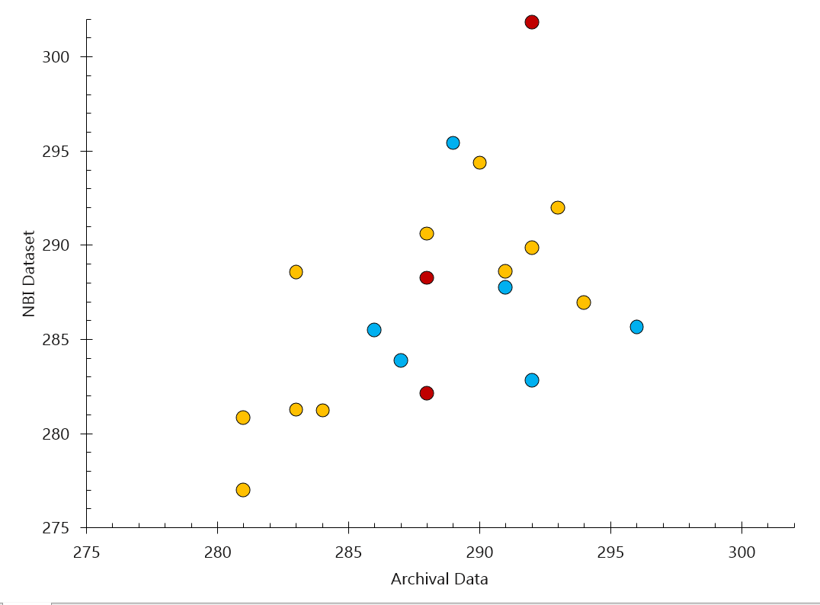
SFigure 4. Comparison of day of year of peak fall foliage between the archival dataset (x-axis) and the remotely-sensed NBI dataset (y-axis). R² = 0.29. Data points are color-coded by archival data source: red points were sourced from Downeast Magazine, blue points were sourced from the Foliage Network reports, and yellow points were sourced from the Maine DCAF fall foliage reports.
STable 5. Unstandardized coefficients of five variable selection models using maximum temperatures on the timing of peak fall foliage across Mount Desert Island. Note that the July-August drought term present in the Lasso model is squared.
Variables | Best Subsets A | Best Subsets B | Best Subsets + Validation Set | K-Folds Cross Validation | Lasso
Average Sept. Max Temp. | 2.856 | 2.800 | 3.000 | 2.591 | 2.876
May Precipitation | 0.023 | 0.027 |  | 0.027 | 0.025
September Precipitation | 0.022 | 0.024 | 0.024 | 0.023 | 0.022
June Drought |  |  |  | -0.373
Oct Week 1 Precip | -0.061 |  |  |  | -0.634
Average Oct Week 1 Max Temp |  |  | 0.206
Drought in Jul & Aug | 0.291 | 0.281 |  | 0.277
(Drought in Jul & Aug)² |  |  |  |  | 0.034
Intercept | 233.779 | 232.855 | 230.118 | 236.806 | 233.608
R² | 0.456 | 0.412 | 0.321 | 0.418 | 0.460
AIC | 284 | 288 | 294 | 288 | 283
BIC | 298 | 299 | 303 | 301 | 296
RMSE | 3.806 | 3.937 | 4.248 | 3.938 | 3.794

STable 6. Unstandardized coefficients of five variable selection models using minimum temperatures on the timing of peak fall foliage across Mount Desert Island.
Variables | Best Subsets A | Best Subsets B | Best Subsets + Validation Set | K-Folds Cross Validation | Lasso
Average Sept. Min Temp. | 2.908 | 3.285 | 3.303 | 2.878 | 2.611
May Precipitation | 0.029 |  | 0.039 | 0.029 | 0.026
September Precipitation | 0.018 |  |  | 0.017 | 0.019
Average June Min Temp. |  |  |  | 0.125 | 0.071
Average Oct Week 1 Min Temp | -0.225 | -0.155 | -0.346 | -0.239
Drought in Jul & Aug |  |  |  |  | 0.254
Intercept | 245.414 | 244.286 | 244.514 | 244.503 | 245.473
R² | 0.386 | 0.332 | 0.375 | 0.361 | 0.396
AIC | 289 | 293 | 290 | 291 | 290
BIC | 301 | 301 | 300 | 305 | 303
RMSE | 4.049 | 4.230 | 4.078 | 4.143 | 4.013

STable 7. Unstandardized coefficients of five variable selection models using percentile-based temperature and precipitation thresholds on the timing of peak fall foliage across Mount Desert Island.
Variables | Best Subsets A | Best Subsets B | Best Subsets + Validation Set | K-Folds Cross Validation | Lasso
September Cool Nights | -0.659 | -0.740 | -0.790 | -0.814 | -0.423
September Hot Days | 2.483 | 2.742
Oct Week 1 Pour Days | -6.514 | -5.997 |  | -4.789 | -0.150
September Warm Days |  | -0.262
May Downpour Days | -2.782
September Warm Nights |  |  |  |  | 0.016
September Downpour Days |  |  |  |  | 0.015
Intercept | 290.244 | 291.516 | 291.544 | 292.219 | 288.502
R² | 0.451 | 0.403 | 0.330 | 0.399 | 0.427
AIC | 286 | 288 | 294 | 294 | 289
BIC | 298 | 300 | 300 | 303 | 300
RMSE | 3.987 | 3.986 | 4.204 | 3.981 | 3.891

STable 8. Global Historical Climatology Network – Daily (GHCNd) data availability across Mount Desert Island.
Station | Location | Data Available | Years
Bar Harbor (USC00170371) | 44.41667, -68.25 | Temperature, precipitation | 1893 - 1982
Acadia National Park  (USC00170100) | 44.3769, -68.2608 | Temperature, precipitation | 1983 - 2013
McFarland Hill (USR0000MMCF) | 44.3769, -68.2608 | Temperature | 2002 - present
East Surry (US1MEHN0002) | 44.493673, -68.45775 | Precipitation | 2009 - present
Southwest Harbor 2.6 SE (US1MEHN0003) | 44.2517, -68.2945 | Precipitation | 2009 - present
Southwest Harbor 0.9 NW (US1MEHN0064) | 44.28867, -68.3377 | Precipitation | 2020 - present

ARCHIVAL AND PHOTO EVIDENCE

MNR = Monthly Narrative Report, Acadia National Park, National Park Service, Department of the Interior

MNR for Oct 1966 (1966-11-09 G.G. Bruce)
MNR for Oct1924 (no recorded date of publication, G.B. Dorr)
MNR Sep 1936 (1936-10-08 G.B. Dorr)

MNR Oct 1936 (1936-11-04 G.B. Dorr)
MNR Sep 1962 (1962-10-18 H. A. Hubler)
MNR Oct 1964 (1964-11-17 H.A. Hubler)
MNR Oct 1952 (1952-11-06 C.R. Scarborough)
Observations
The autumn foliage display -reached its peak of color around the 12th and remained evident for about two weeks. Rain and windy days near the end of the month defoliated most" trees in the area…

MNR Sep 1952 (1952-10-08 C.R. Scarborough)
Research and Observation
Fall foliage coloration became evident the last week of the
month, the peak of color is expected to occur about the 10th of
October…

MNR Oct 1955 (1955-11-14 F.R. Givens)
Research and Observation
The fall coloration reached it’s peak on the weekend of October 9.

MNR Oct 1951 (1951-11-08 B/L. Hadley)
Weather
This month presented us with delightful weather for the most part. Several storms occurred, one with a skiff' of snow which was gone by next morning. Many visitors were in the area to enjoy the fall colors which reached their peak the week of the 15th.

MNR Sep 1951 (1951-10-04 B.L. Hadley)
Observations
Autumn foliage is beginning to turn color. The display of fall colors should be at their height by the middle of October.

MNR Oct 1959 (1959-11-12 G.G. Bruce)
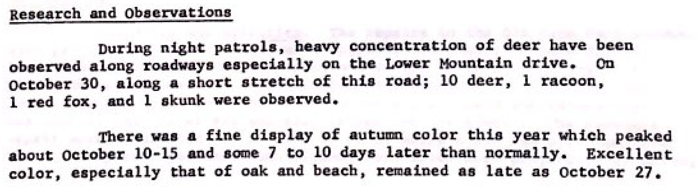

Newspaper Archives

1971-10-07
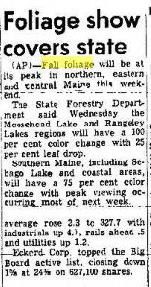

1971-10-14
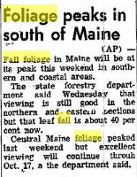

1972-10-12
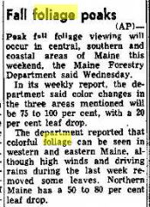

Downeast Magazine 1996
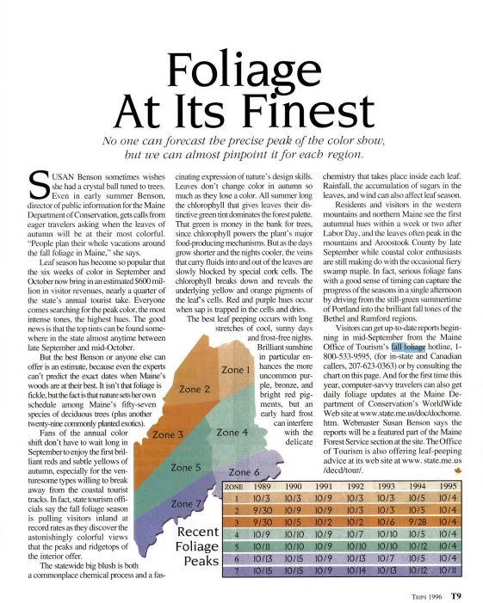

Downeast Magazine 1998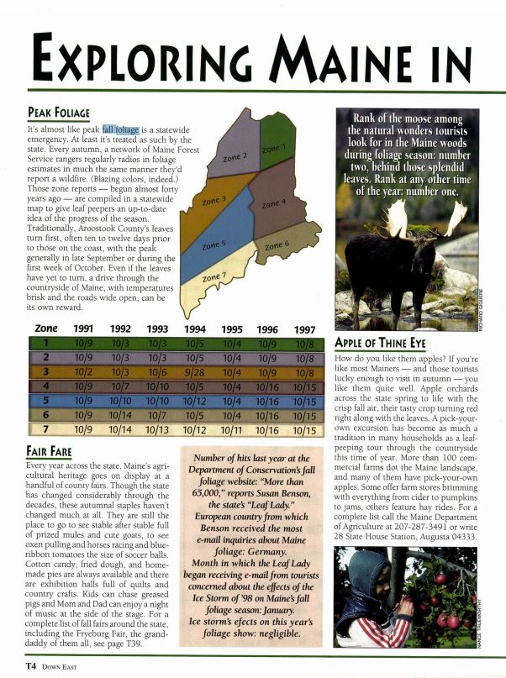
Downeast Magazine 2000
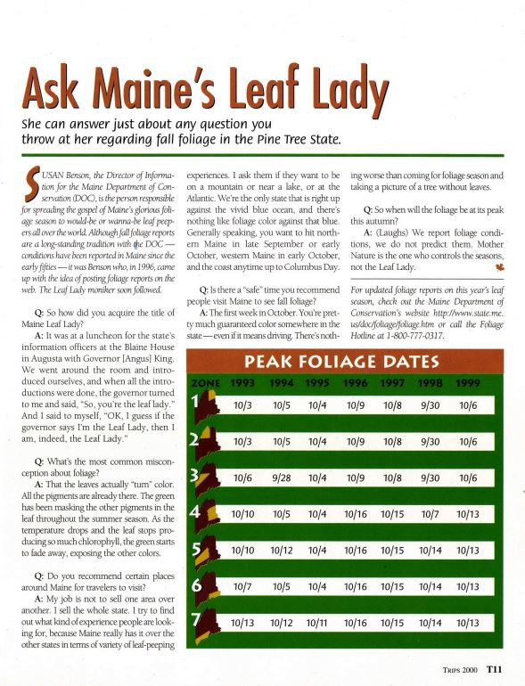

Downeast Magazine 2004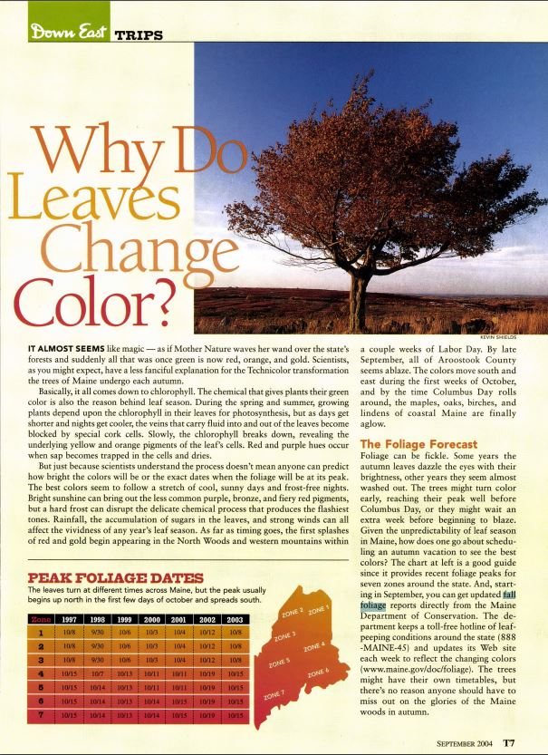
Community Science Submitted Photos
1981-10-04

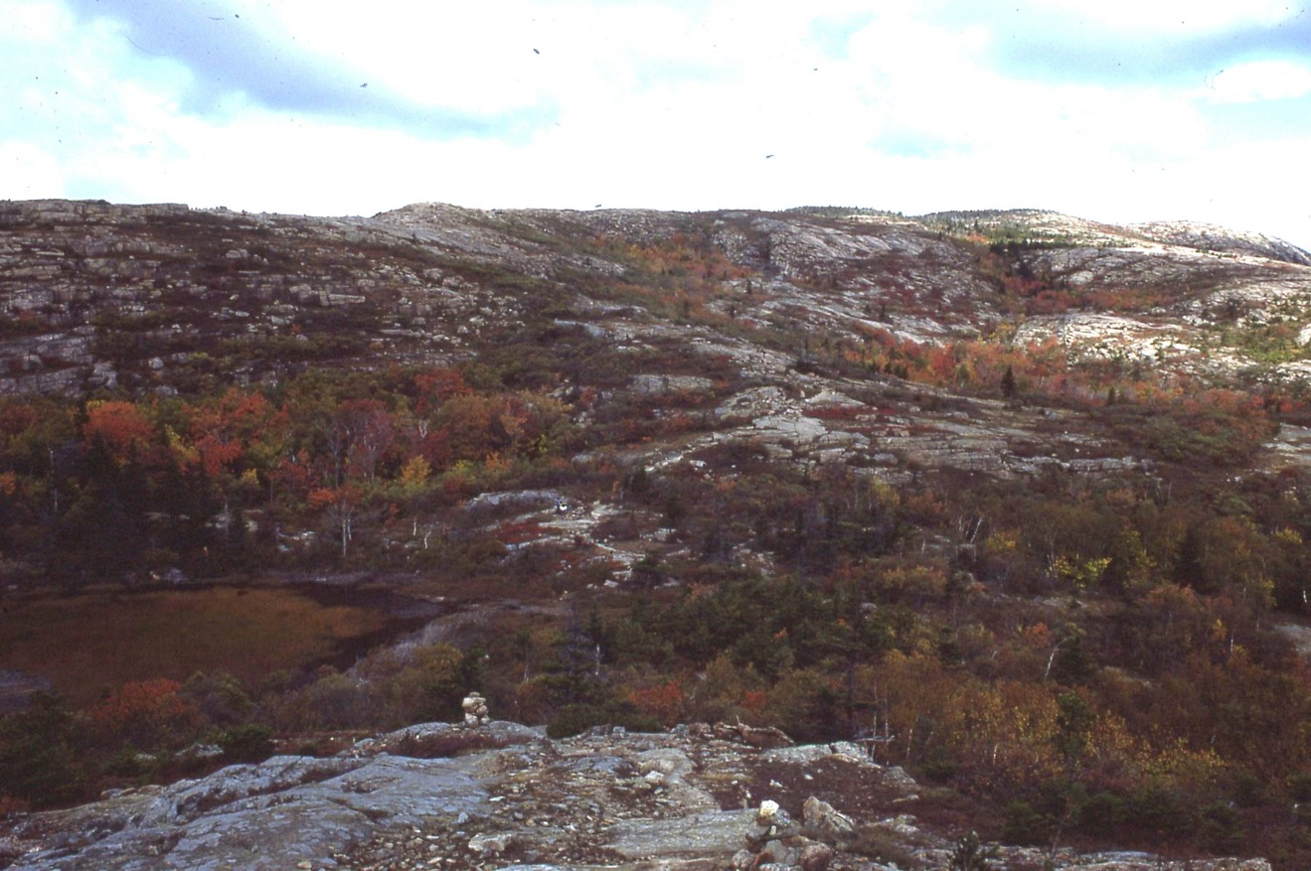

1987-10-13
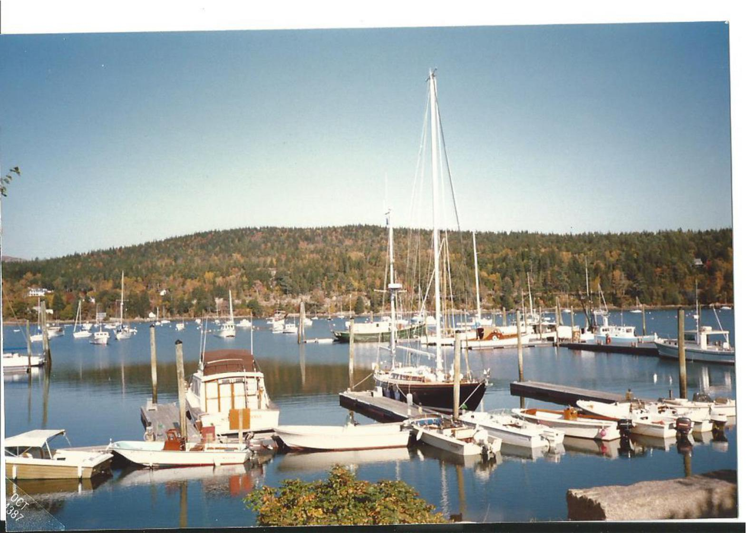

1990-10-05
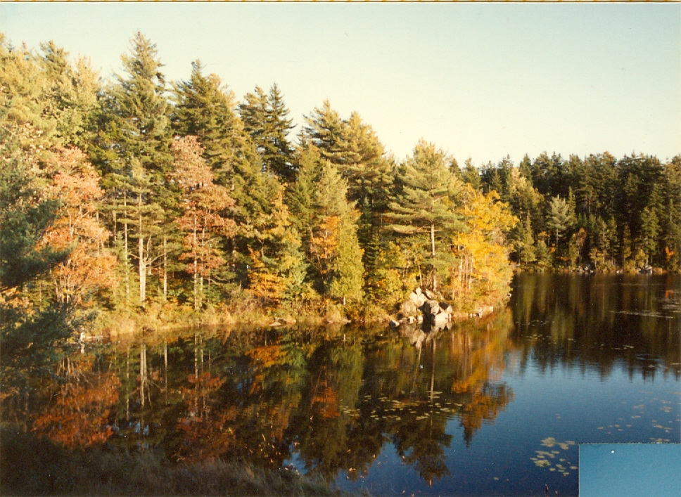

1993-10-10

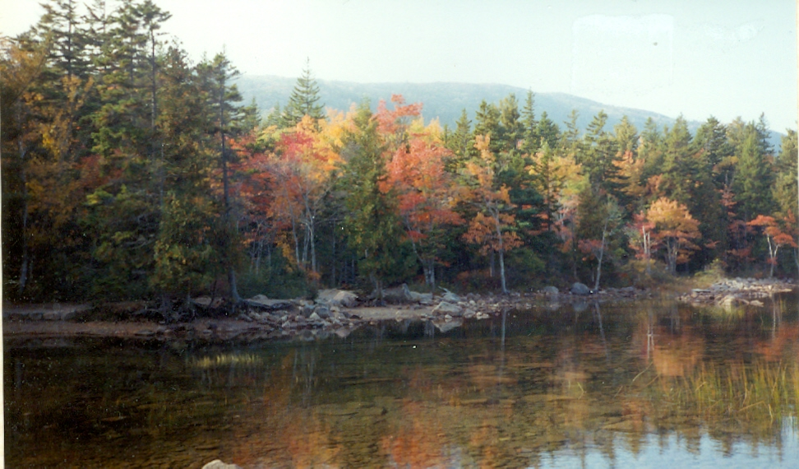

1993-10-10
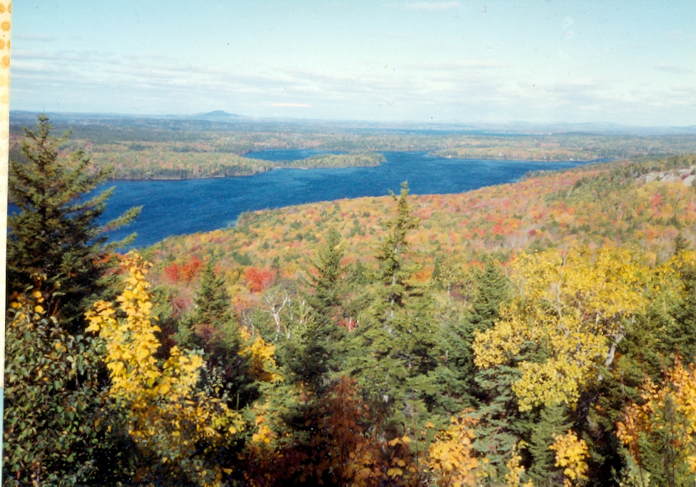

1997-10-12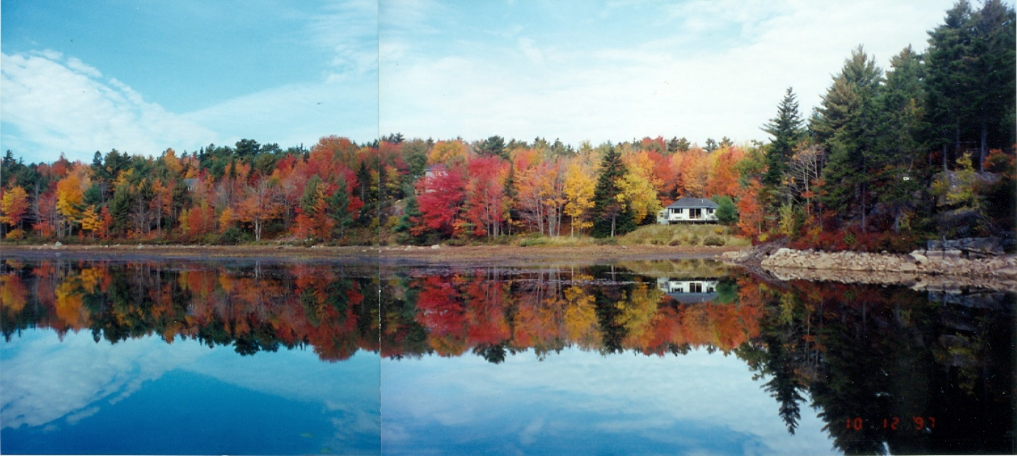

More photos can be found on Instagram at @anpfallfoliage.
Maine Fall Foliage Reports: https://www.maine.gov/dacf/mfs/projects/fall_foliage/report/past.shtml

Photos from Mount Desert Island Oct 12-13, 2022.
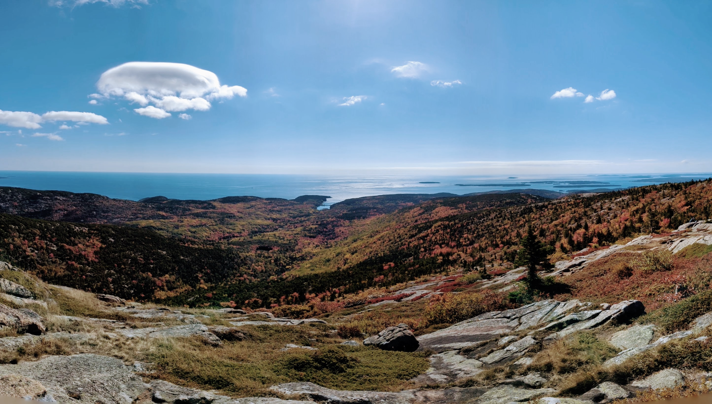
Oct 12, 2022, view from Cadillac Mountain


Oct 13, 2022, Asticou Azalea Gardens

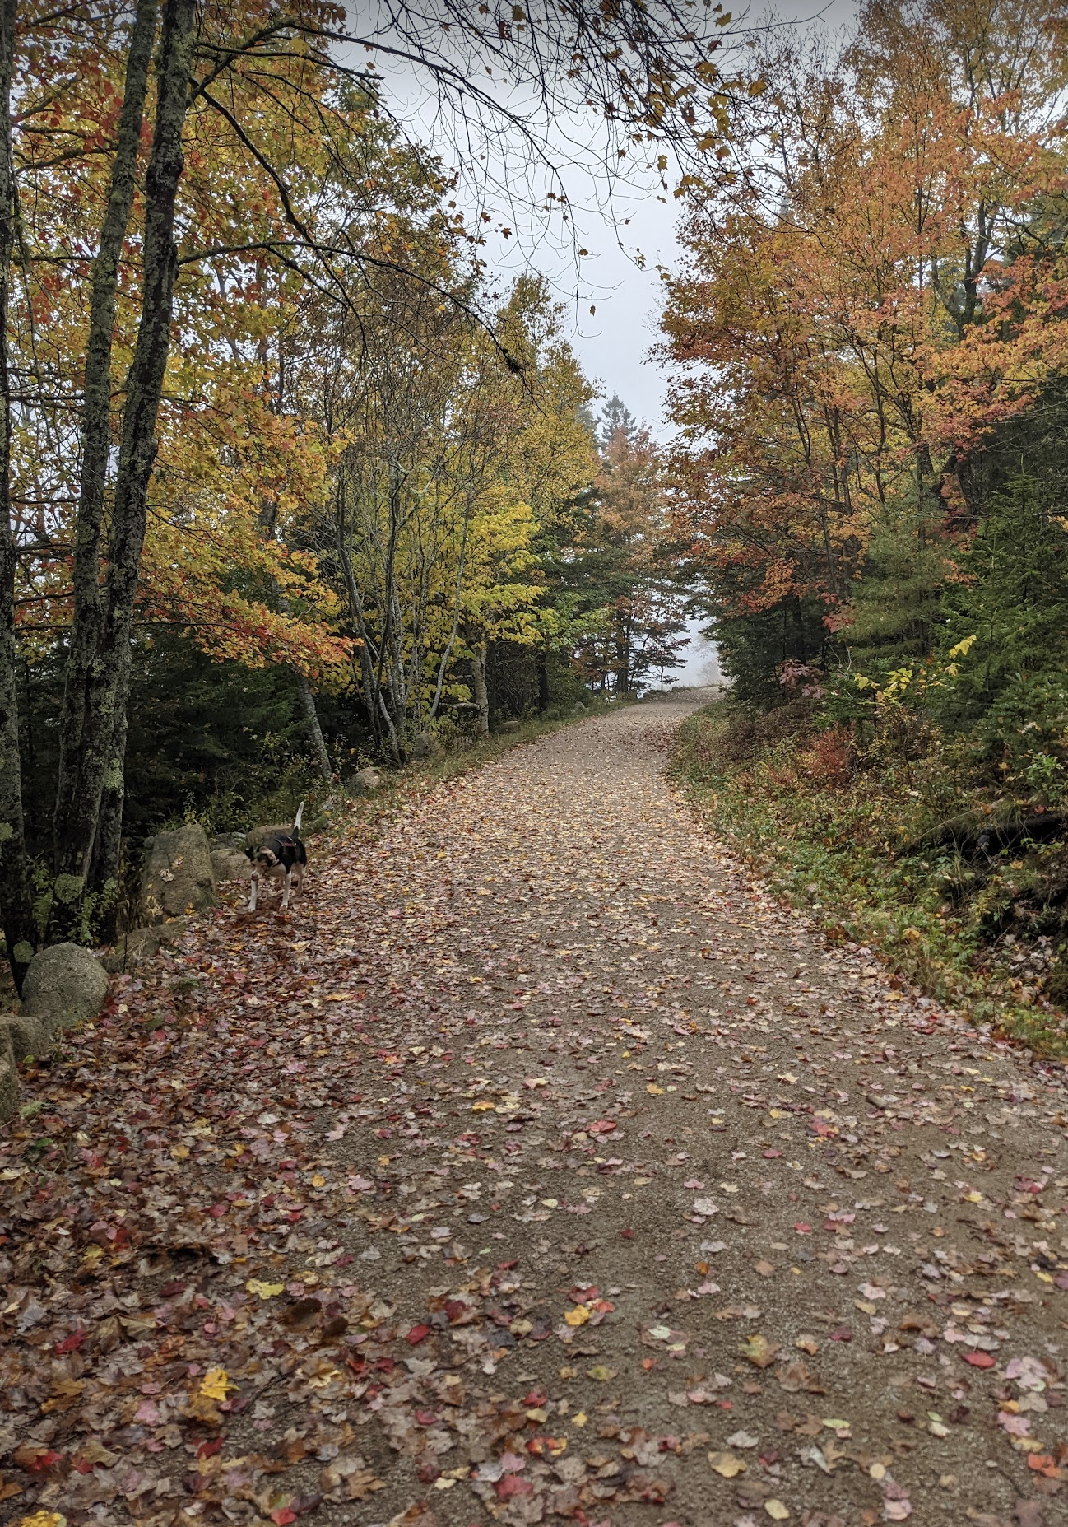
Oct 15, 2022, Little Long Pond

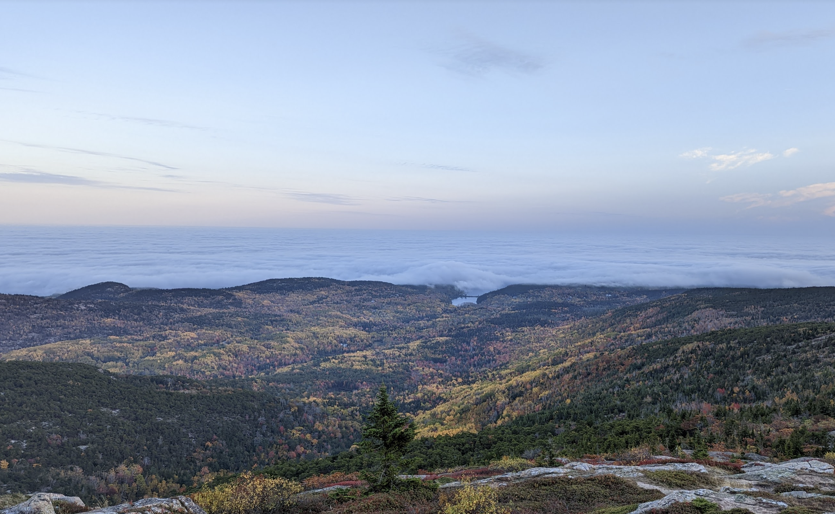
Oct 16, 2022 view from Cadillac Mountain

