Supplementary material
Article title: Understanding residents’ perspectives on cultural ecosystem service supply, demand, and subjective well-being in rapidly urbanizing landscapes: A case study of peri-urban Shanghai
Journal name: Landscape Ecology

Understanding residents’ perspectives on cultural ecosystem service supply, demand and subjective well-being in rapidly urbanizing landscapes: A case study of peri-urban Shanghai

Zheyi Xia ª, Yi Wang ^{b}, Qingling Lu ª, Zhen Shen ª, Kui Liu ^{c}, Xue Wei ^{d}, Chengcheng Yuan ª, Yang Gao ª, Liming Liu ^{a,} *

ª College of Land Science and Technology, China Agricultural University, Beijing 100193, China
^{b} Department of Landscape Architecture, China Agricultural University, Beijing 100193, China
^{c} School of Public Policy and Administration, Xi’an Jiaotong University, Xi’an 710049, China
^{d} Center for Public Policy and Social Management Innovation Research, Henan Normal University, Xinxiang 453000, China

* Corresponding author: Liming Liu
Address: China Agricultural University, No. 2 Yuanmingyuan West Road, Beijing, 100193, China
E-mail: liulm@cau.edu.cn

Appendix A. Questionnaire for residents’ perceived CES supply, demand, and SWB. Translated from Chinese to English
Hello! We are graduate students from China Agricultural University, and we sincerely invite you to participate in our survey. We would like to use this questionnaire to understand your perceptions of the environment and landscapes in Qingpu District. Please answer the following questions according to your own opinion. Your answers are not right or wrong, good or bad. This survey is anonymous, and we guarantee that all your answers will be used for scientific research only. Thank you very much for your participation and support!

First, could you identify the location of your home in this satellite image shown on the A3 sheet? You could also identify your neighboring villages, communities, or towns as well as some iconic landmarks.
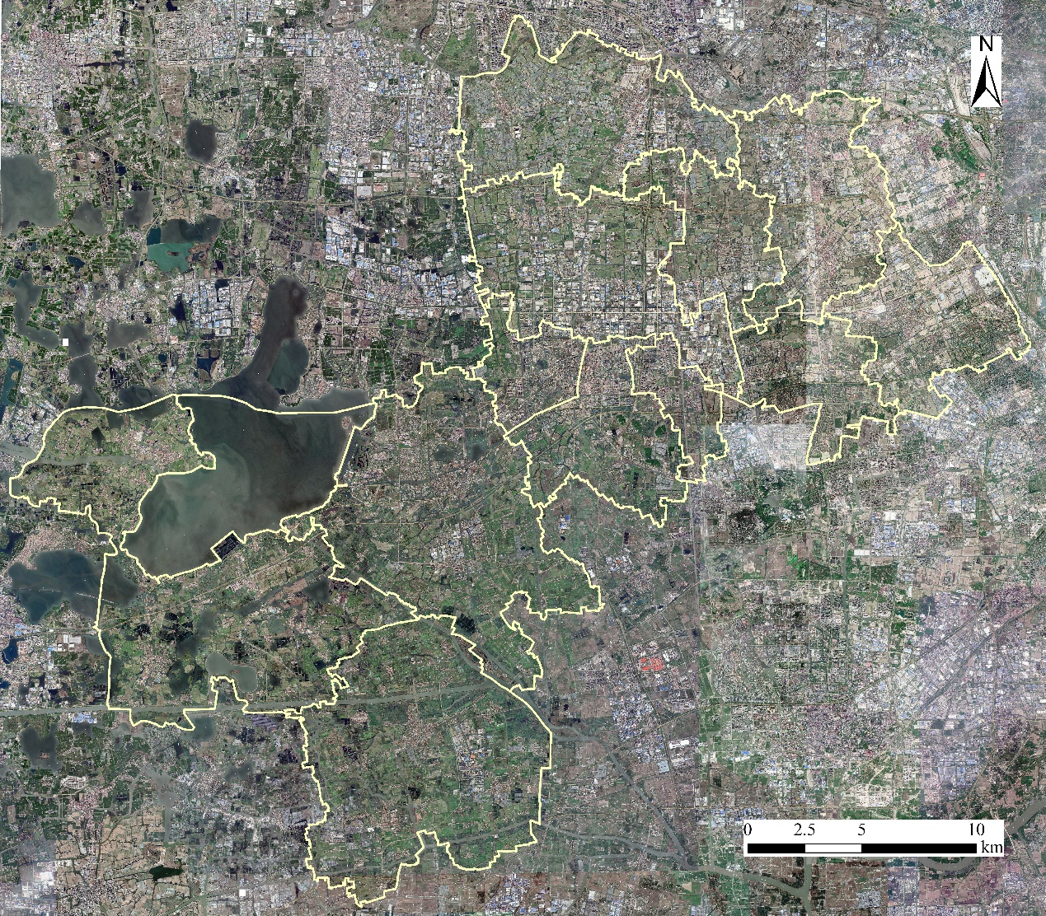

1. Mapping the locations in Qingpu District:
Please answer which places do you personally think provide you with the benefits or values? You could use the marker to draw the corresponding location on the map, or you could tell us the name of the place and we draw the location for you. You may mark up to five locations per question. If you think there is no appropriate location available for a question, you can leave the question unmarked.
(1) Which places provide outdoor recreation and leisure activities, such as walking, running, and fishing?
(2) Which places have beautiful and attractive scenery?
(3) Which places embody local historical and cultural traditions, wisdom, and ways of life?
(4) Which places enable to learn about the environment through observation and study?
(5) Which places have special spiritual meanings, such as reverence and respect for nature?
(6) Which places enable to spend time together with other people to maintain social connections?

2. Importance of the following demands:
Please rate each of the following questions on a scale of 1-5, with 1 = not important at all, 2 = not very important, 3 = medium, 4 = quite important, and 5 = very important.
(1) Outdoor recreation and leisure activities such as walking, running, and fishing
(2) Beautiful and attractive scenery
(3) Local historical and cultural traditions, wisdom, and ways of life
(4) Learn about the environment through observation and study
(5) Special spiritual meanings such as reverence and respect for nature
(6) Spend time together with other people to maintain social connections

3. Your level of satisfaction with living in Qingpu:
Please rate each of the following questions on a scale of 1-5, with 1 = not satisfied at all, 2 = not very satisfied, 3 = medium, 4 = quite satisfied, and 5 = very satisfied.
(1) Basic materials for a good life, such as food, clothing, housing, and goods
(2) Health, such as good physical and mental health, and a healthy physical environment
(3) Security, such as secure access to resources, safety of person and possessions, and response to disasters
(4) Good social relations, such as family relations and social cohesion
(5) Freedom of choice and action, such as being able to achieve what is value doing
(6) Leisure time

4. Your basic information: (Single choice, please note answers for any additional information.)
(1) The town or sub-district of your residence in Qingpu District:
Jinze Town
Zhujiajiao Town
Zhaoxiang Town
Xujing Town
Huaxin Town
Chonggu Town
Baihe Town
Liantang Town
Xiayang Street
Yingpu Street
Xianghuaqiao Street
Other, please specify:
(2) The village or community of your residence in Qingpu District, please write down.
(3) Your gender:
(4) Your age:
16–35
36–55
Above 55
(5) Your education level:
Primary school and below
Middle school
High school
College degree and above
(6) Your household disposable income per capital:
<￥10000
￥10001-￥50000
￥50001-￥100000
>￥100000
(7) What do you think can be improved in environmental and landscape management of Qingpu District? Do you have any other comments and suggestions?

Appendix B. Calculation process of the entropy weight method
Standardization of the indicators using Z-values:
$$A_{ij}=\frac{X_{ij}-X_{min}}{X_{max}-X_{min}}$$ |  | (1)
where $A_{ij}$ and $X_{ij}$ represent the standardized value and the original value of the $j$th indicator for the $i$th village and community, respectively. $X_{max}$ and $X_{min}$ represent the maximum and minimum values of the $j$th indicator for all villages and communities, respectively.
Determination of indicator weights:
$$Y_{ij}=\frac{A_{ij}}{\sum_{i=1}^{m}{A_{ij}}}$$ |  | (2)
$$e_{j}=-\frac{1}{\ln{m}}\sum_{i=1}^{m}{Y_{ij}\ln{Y_{ij}}}$$ |  | (3)
$$f_{j}=1-e_{j}$$ |  | (4)
$$w_{j}=\frac{f_{j}}{\sum_{j=1}^{n}{f_{j}}}$$ |  | (5)
$$R_{a}=\sum_{j=1}^{n}{w_{j}A_{ij}}$$ |  | (6)
where $Y_{ij}$ represents the information entropy of the $j$th indicator of the $i$th village and community, $m$ is the number of villages and communities, $e_{j}$ is the information entropy of $j$th indicator, $f_{j}$ is the redundancy of the information entropy, $w_{j}$ is the weight of indicator $j$, $n$ is the number of indicators, and $R_{s}$ represent the evaluation score of the system $a$.

Appendix C. Calculation of SWB weights through principal component analysis
Equations for principal component analysis:
$$\left\{\begin{aligned}F_{1}=a_{11}X_{1}+a_{21}X_{2}+⋯+a_{p1}X_{p} \\ F_{2}=a_{12}X_{1}+a_{22}X_{2}+⋯+a_{p2}X_{p} \\ ⋮ \\ F_{k}=a_{1k}X_{1}+a_{2k}X_{2}+⋯+a_{pk}X_{p}\end{aligned}\right.$$ |  | (7)
$$a_{ij}=\frac{f_{ij}}{\sqrt{λ_{j}}}$$ |  | (8)
where $F_{1}$, $F_{2}$, $⋯$, $F_{k}$ represent principal components, $X_{1}$, $X_{2}$, $⋯$, $X_{p}$ represent original data, $a_{ij}$ is the factor score of the factor $i$ in $j$th principal component, $f_{ij}$ is the original factor loadings, and $λ_{j}$ is the eigenvalue of $j$th principal component.
Determination of weights:
$$w_{i}=\frac{\sum_{j=1}^{m}{a_{ij}θ_{j}}}{\sum_{j=1}^{m}{θ_{j}}}$$ |  | (9)
where $w_{i}$ represents the weight of $i$th factor, and $θ_{j}$is the corresponding variance contribution of the $j$th principal component.
Normalization of weights:
$$w_{i}^{0}=\frac{w_{i}}{\sum_{i=1}^{p}{w_{i}}}$$ |  | (10)
where $w_{i}^{0}$ represents normalized indicator weights.

Appendix D. Spatial pattern of urbanization level for different dimensions
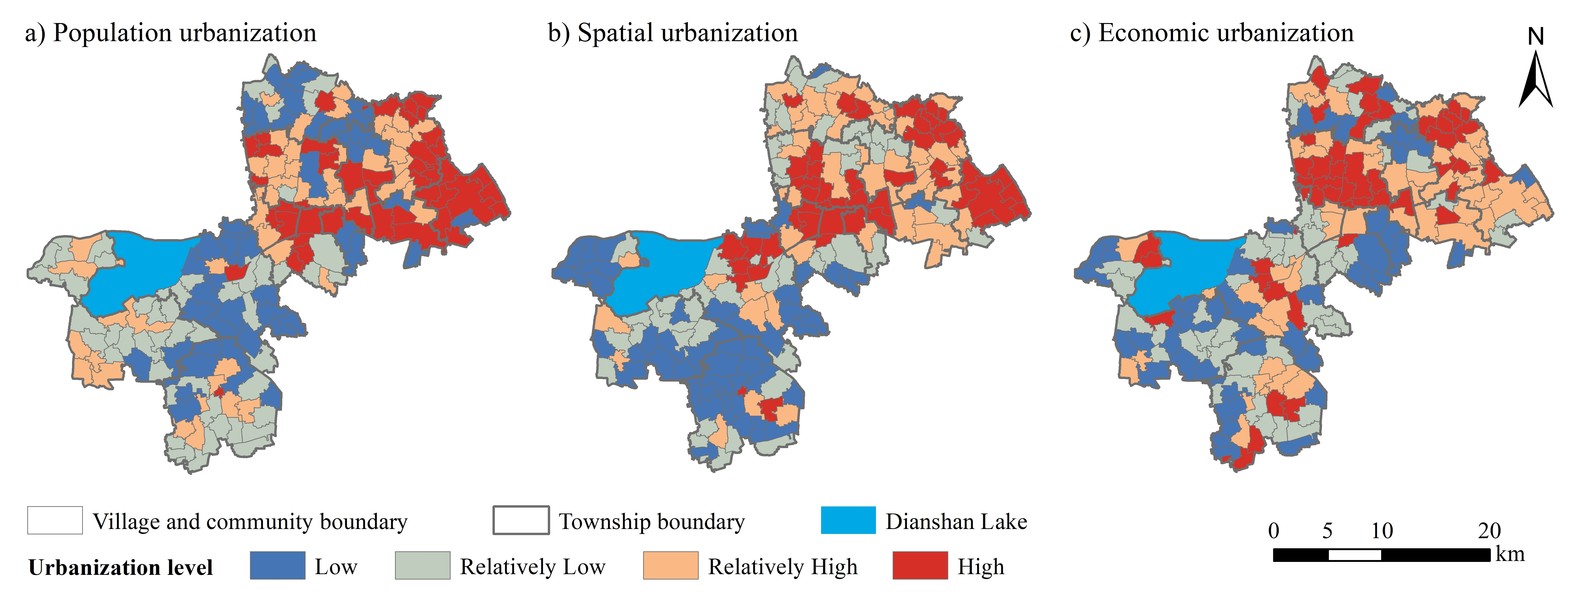

Appendix E. Loadings and eigenvalue from the principal component analysis
 | Principal component 1
Basic materials for a good life | 0.740
Health | 0.799
Security | 0.753
Good social relations | 0.765
Freedom of choice and action | 0.852
Leisure time | 0.595
Eigenvalue | 3.419
Kaiser-Meyer-Olkin (KMO) | 0.836
Cronbach’s α | 0.840

Appendix F. Spatial relationships between urbanization dimensions and CES supply
Note: * and ** indicate significant differences at p < 0.05 and p < 0.01, respectively.

