Data management of environmental variables
Elevation at 20 m resolution was retrieved from the Digital Elevation Model (DEM) by Natural Resources Canada (NRC; Natural Resource Canada 2016). Because eagles may select a location relative to its surrounding environmental characteristics, we calculated the relative elevation by subtracting the mean of elevation over a 10 km radius from the elevation at each pixel. Terrain ruggedness and slope aspect were calculated from the NRC DEM at 20 m resolution (Natural Resource Canada 2016). Terrain ruggedness index (m) is the mean difference in elevation between neighboring cells (Shawn Riley et al. 1999). A high index is characteristic of steep cliffs. Slope aspect indicates the cardinal direction the slope is facing (Amatulli, Giuseppe et al. 2018). We calculated the northness and the eastness of the slope with the cosine (northness) and sin (eastness) of the slope aspect so that -1 would indicate south- or west-facing slopes and 1 would indicate north- or east-facing slopes. Northness and eastness were only used for the nest model because south-facing slopes appear to be preferred by raptors nesting in arctic regions (Morneau et al. 1994; Galipeau et al. 2020). We used mean annual wind speed (m/s) at 10 m above ground as a proxy of air currents used by eagles to subsidize flight (Duerr et al. 2019; Katzner et al. 2020); these data were retrieved at 250 m resolution from Global Wind Atlas (Technical University of Denmark 2021). Although mean wind speed during the breeding seasons would have been ideal for our study, mean annual wind is correlated with summer winds (Technical University of Denmark 2021).
Our land cover features included forest cover and distance to waterbodies. Forest cover and water body data were retrieved from the 2010 North American Land Cover 30-meter (Commission de la coopération environnementale 2017). We modified the value in the vegetation cover raster in a binary manner to allow us to focus on forest versus open cover in general (Miller et al. 2017; McCabe et al. 2021). To do this, we classified evergreen, temperate, and mixed forests as 1, and shrubland, tundra, barren land, wetland, waterbodies, and cropland as 0. Finally, we created a raster from the 2010 North American Land Cover 30-meter (Commission de la coopération environnementale 2017), where we reclassified water bodies (including coastal and ocean waters) and wetlands as 1, and all other categories of land to 0. We then calculated distance in meters to closest water feature.
Supplementary Material Table S1. Source of raster files of environmental predictors used in our models by categories (aerial and topographical and landcover features).
Features | Predictor | Name | Source | Year
Aerial and topographical | Elevation | High Resolution Digital Elevation Model (HRDEM) - CanElevation Series | Natural Resources Canada | 2016
Aerial and topographical | Terrain ruggedness index | Calculated from Elevation | Natural Resources Canada | 2016
Aerial and topographical | Northness | Calculated from Elevation | Natural Resources Canada | 2016
Aerial and topographical | Eastness | Calculated from Elevation | Natural Resources Canada | 2016
Aerial and topographical | Mean annual wind speed | Average wind speed at 10 m from ground | Global Wind Atlas | 2021
Land cover | Forest cover | 2010 North American Land Cover 30-meter | Commision de la coopération environmentale | 2010
Land cover | Distance to water | 2010 North American Land Cover 30-meter | Commision de la coopération environmentale | 2010

Amatulli, Giuseppe, Domisch, Sami, Tuanmu, Mao-Ning, et al (2018) A suite of global, cross-scale topographic variables for environmental and biodiversity modeling, links to files in GeoTIFF format, supplement to: Amatulli, Giuseppe; Domisch, Sami; Tuanmu, Mao-Ning; Parmentier, Benoit; Ranipeta, Ajay; Malczyk, Jeremy; Jetz, Walter (2018): A suite of global, cross-scale topographic variables for environmental and biodiversity modeling. Scientific Data, 5, 180040. 2 datasets. https://doi.org/10.1594/PANGAEA.867115
Commission de la coopération environnementale (2017) 2010 Land Cover of North America at 30 meters
Duerr AE, Miller TA, Dunn L, et al (2019) Topographic drivers of flight altitude over large spatial and temporal scales. The Auk 136:ukz002. https://doi.org/10.1093/auk/ukz002
Galipeau P, Franke A, Leblond M, Bêty J (2020) Multi-scale selection models predict breeding habitat for two arctic-breeding raptor species. Arctic Science 6:24–40. https://doi.org/10.1139/as-2018-0026
Katzner TE, Kochert MN, Steenhof K, et al (2020) Golden Eagle (Aquila chrysaetos). In: Rodewald PG, Keeney BK (eds) Birds of the World. Cornell Lab of Ornithology, Ithaca, NY
McCabe JD, Clare JD, Miller TA, et al (2021) Resource selection functions based on hierarchical generalized additive models provide new insights into individual animal variation and species distributions. Ecography 44:1756–1768. https://doi.org/10.1111/ecog.06058
Miller TA, Brooks RP, Lanzone MJ, et al (2017) Summer and winter space use and home range characteristics of Golden Eagles (Aquila chrysaetos) in eastern North America. The Condor 119:697–719. https://doi.org/10.1650/condor-16-154.1
Morneau F, Brodeur S, Decarie R, et al (1994) Abundance and Distribution of Nesting Golden Eagles in Hudson-Bay, Quebec. Journal of Raptor Research 28:220–225
Natural Resource Canada (2016) High Resolution Digital Elevation Model (HRDEM) - CanElevation Series
Shawn Riley, Stephen D. DeGloria, Robert Elliot (1999) A terrain ruggedness index that quantifies topographic heterogeneity. Intermountain Journal of Sciences 5:23–27
Technical University of Denmark (2021) Global Wind Atlas 3.1, a free, web-based application developed, owned and operated by the Technical University of Denmark (DTU). https://globalwindatlas.info

Random effect for the mixed model (foraging level)
Likelihood ratio test for foraging level (mixed vs fixed model)
Model 1: as.integer(case_) ~ ztri + zralt + zwindsp + zdwater + zforest + ZdNest + (1 + ztri | id) + (1 + zralt | id) + (1 + zwindsp | id) + (1 + zdwater | id) + (1 + zforest | id)
Model 2: as.integer(case_) ~ ztri + zralt + zwindsp + zdwater + zforest + ZdNest
Model 1: as.integer(case_) ~ ztri + zralt + zwindsp + zdwater + zforest +
ZdNest + (1 + ztri | id) + (1 + zralt | id) + (1 + zwindsp |
id) + (1 + zdwater | id) + (1 + zforest | id)
Model 2: as.integer(case_) ~ ztri + zralt + zwindsp + zdwater + zforest +
ZdNest + (1 | id)
#Df LogLik Df Chisq Pr(>Chisq)
1 22 -5925177
2 8 -6152263 -14 454173 < 2.2e-16 ***
---
Signif. codes: 0 ‘***’ 0.001 ‘**’ 0.01 ‘*’ 0.05 ‘.’ 0.1 ‘ ’ 1

# | DF | LogLik | Chisq | Pr(>Chisq)
1 | 22 | -1202564
2 | 7 | -1296879 | 188631 | < 2.2e-16 ***

Models are significantly different from each other.
Mixed model has a higher log likelihood and thus was chosen.
Supplementary Material Table S2. Variation explained by random effects in the foraging mixed model of habitat selection with individual eagle as random effect (intercept and slope)
Groups | Name | Variance |  | Std.Dev. | Corr
TRI | Intercept | 0.098 |  | 0.312
TRI | Slope | 0.150 |  | 0.388 | -0.62
Rel Elevation | Intercept | 0.483 |  | 0.695
Rel Elevation | Slope | 0.089 |  | 0.299 | -0.16
Wind speed | Intercept | 0.367 |  | 0.606
Wind speed | Slope | 0.077 |  | 0.277 | 0.19
Dist to water | Intercept | 0.122 |  | 0.350
Dist to water | Slope | 0.183 |  | 0.428 | 0.63
Forest cover | Intercept | 0.296 |  | 0.544
Forest cover | Slope | 0.277 |  | 0.526 | -0.86

Supplementary Material Table S3. Summary of individual tracking duration of breeding golden eagles and sample size by bioclimatic zones in Eastern North America.
Bioclimatic zone | Eagle ID | Sex | Year of tracking |  | No. summers | Total summers | Total individual
Bioclimatic zone | Eagle ID | Sex | Start | End | No. summers | Total summers | Total individual
Boreal | 27 | Female | 2011 | 2012 | 2 | 48 | 13
Boreal | GOEA01 | Female | 2013 | 2013 | 1 | 48 | 13
Boreal | GOEA03 | Male | 2007 | 2010 | 4 | 48 | 13
Boreal | GOEA04_Manu | Male | 2014 | 2021 | 8 | 48 | 13
Boreal | GOEA05 | Male | 2008 | 2013 | 6 | 48 | 13
Boreal | GOEA08 | Male | 2009 | 2018 | 9 | 48 | 13
Boreal | GOEA11_Lucky | Male | 2018 | 2018 | 1 | 48 | 13
Boreal | GOEA12 | Male | 2013 | 2020 | 8 | 48 | 13
Boreal | GOEA14_Ti_Louis | Male | 2019 | 2020 | 2 | 48 | 13
Boreal | GOEA15_Charlie | Female | 2016 | 2017 | 2 | 48 | 13
Boreal | GOEA17_Celia | Female | 2017 | 2018 | 2 | 48 | 13
Boreal | GOEA26_Fulton | Male | 2020 | 2021 | 2 | 48 | 13
Boreal | Martin_Gap | Male | 2014 | 2014 | 1 | 48 | 13
Polar | 252 | Female | 2016 | 2016 | 1 | 33 | 17
Polar | 30 | Female | 2014 | 2014 | 1 | 33 | 17
Polar | 319 | Male | 2008 | 2008 | 1 | 33 | 17
Polar | 35 | Male | 2014 | 2016 | 2 | 33 | 17
Polar | 36 | Male | 2013 | 2013 | 1 | 33 | 17
Polar | 572 | Male | 2018 | 2018 | 1 | 33 | 17
Polar | 70 | Female | 2015 | 2015 | 1 | 33 | 17
Polar | 73 | Female | 2017 | 2018 | 2 | 33 | 17
Polar | 74 | Unknown | 2015 | 2017 | 3 | 33 | 17
Polar | GOEA10_Jue | Female | 2015 | 2015 | 1 | 33 | 17
Polar | GOEA18_Nakturalik | Female | 2018 | 2021 | 4 | 33 | 17
Polar | GOEA19_Alfred | Male | 2018 | 2021 | 4 | 33 | 17
Polar | GOEA22_Michel | Male | 2019 | 2021 | 3 | 33 | 17
Polar | GOEA23_Arnaud | Male | 2019 | 2021 | 3 | 33 | 17
Polar | GOEA24_Charlot | Male | 2019 | 2021 | 3 | 33 | 17
Polar | GOEA28_Athena | Female | 2021 | 2021 | 1 | 33 | 17
Polar | GOEA29_Joly | Female | 2021 | 2021 | 1 | 33 | 17

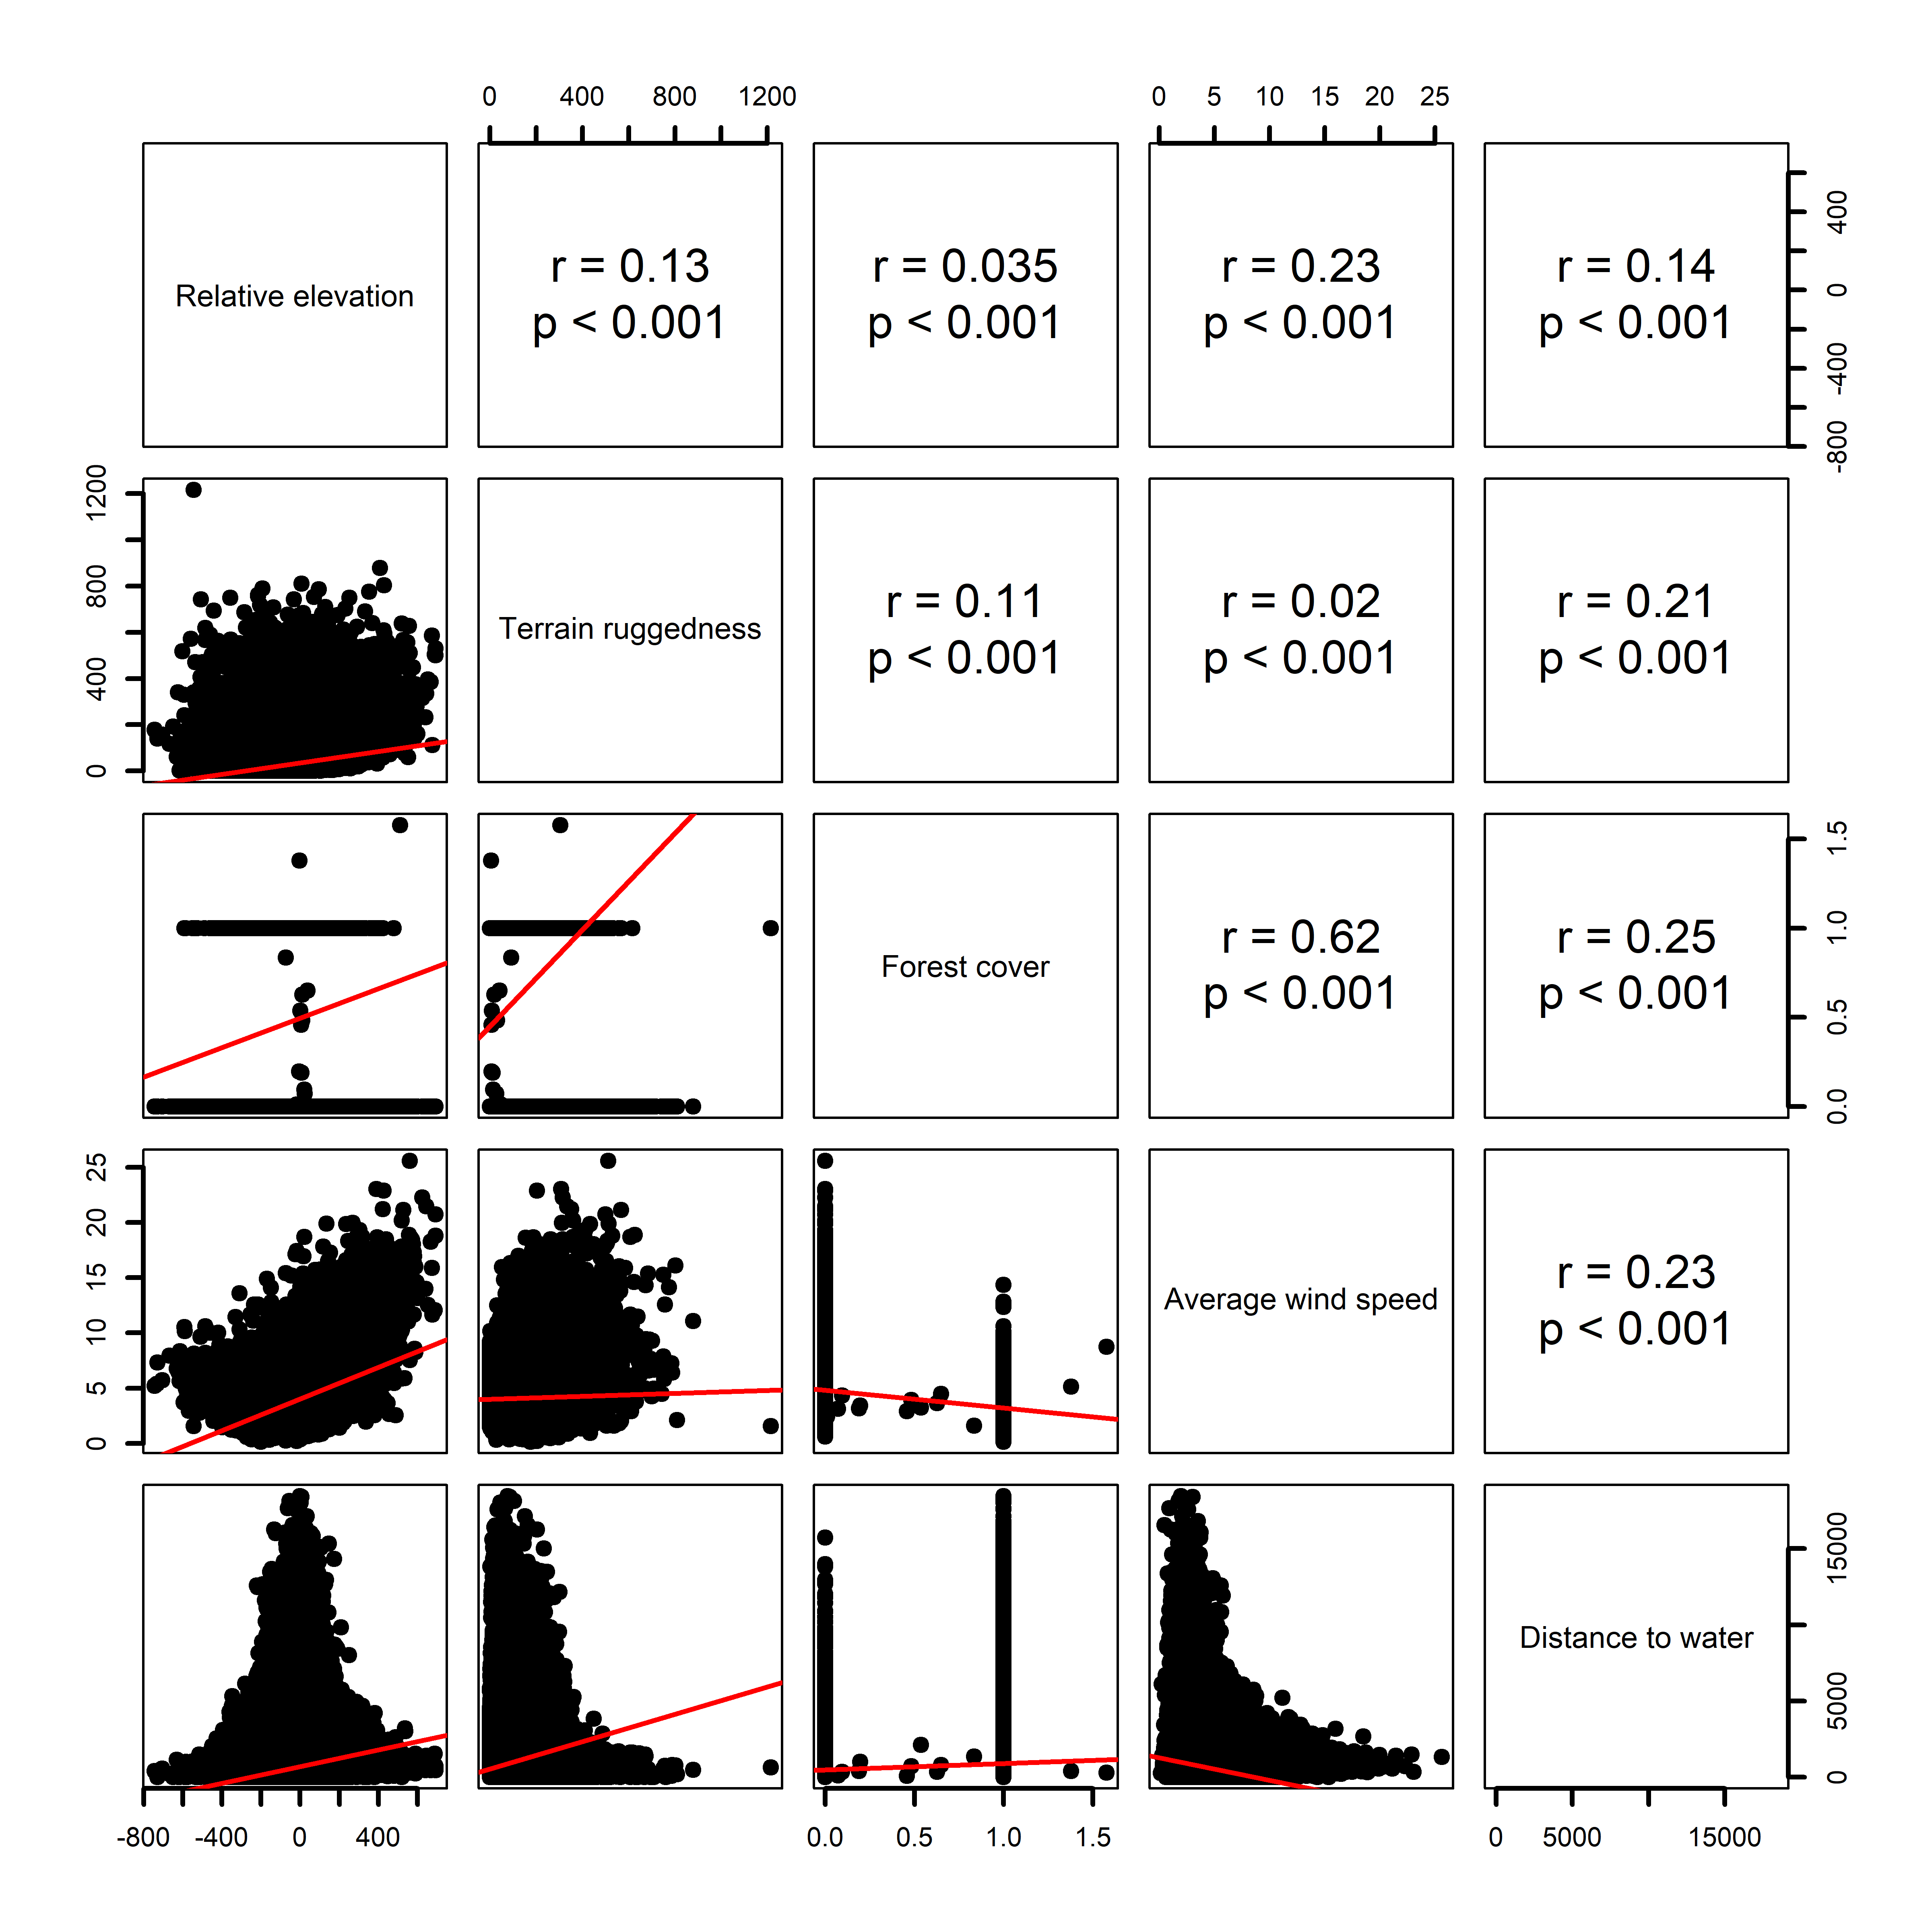
Supplementary Material Figure S1. Correlation matrix between environmental variables with Pearson’s correlation coefficient (r).

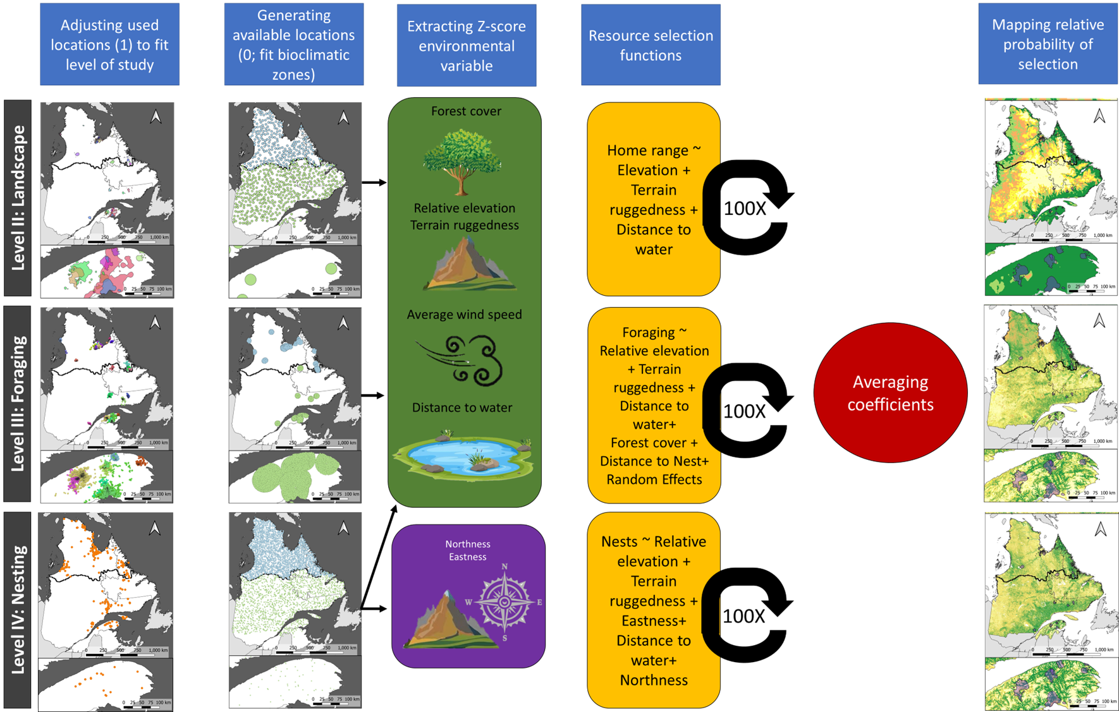
Supplementary Material Figure S2. Used and available data for all three levels and steps for building habitat selection models.
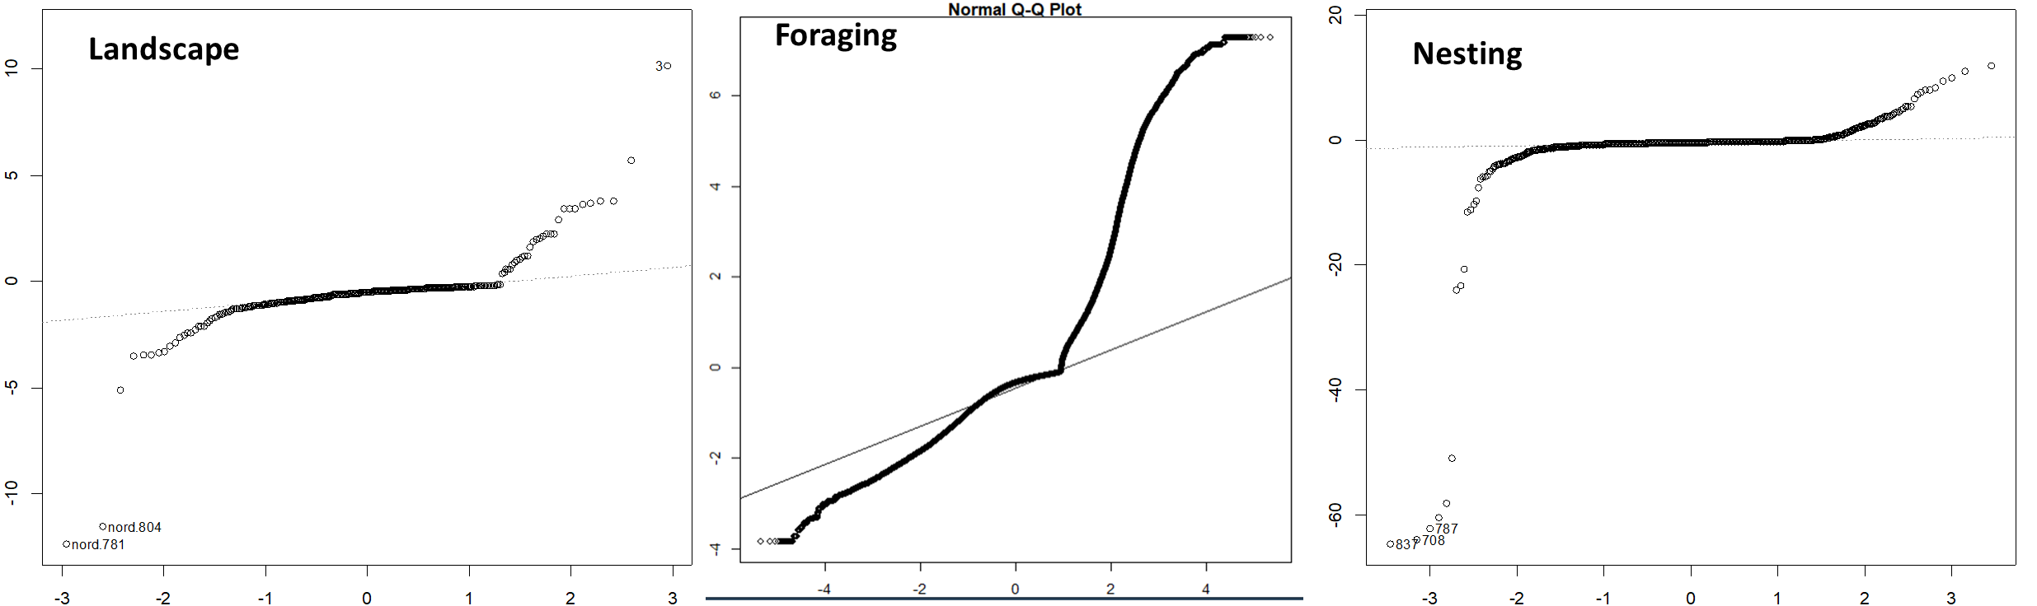
Supplementary Material Figure S3. Normal Q-Q plot for normality diagnostics.

