APPENDIX
Table A.1 Locations of the study sites, grouped by region. In addition to site name, the exact locations (latitude and longitude, WGS84), farm management type of arable fields (organic and conventional) and crop species are given. *Stützkow was converted to organic management just one year before sampling. As our data of that site resembled those of conventional transects according to pre-analyses, it was also treated as conventional for this study.
Region  Site name | Lat | Lon | Farm management | crop species
Brandenburg
Rummelsberg | 52.9089 | 13.9830 | organic | lupine
Breitenteichener Mühle | 53.0869 | 14.0269 | organic | wheat
Mühlenberg | 52.9106 | 13.9678 | organic | wheat
Schiefer Berg | 52.9068 | 13.9704 | organic | rye
Krogberg | 52.8994 | 13.9577 | organic | barley
Müllerberge | 53.1275 | 14.2570 | conventional | flax
Jamikow | 53.1568 | 14.1795 | conventional | rapeseed
Seeberge | 53.2444 | 14.4174 | conventional | wheat
Stützkow | 52.9992 | 14.1718 | conventional* | maize
Zanderberge | 53.1874 | 13.7654 | conventional | rapeseed
Eifel
Prachtacker | 50.3926 | 6.7203 | organic | wheat
Tiesberg | 50.5849 | 6.7626 | conventional | rapeseed
Baumberg | 50.3439 | 6.6479 | conventional | barley
Eierberg | 50.3675 | 6.6308 | conventional | barley
Kalvarienberg | 50.3689 | 6.6412 | conventional | barley
Lambertsberg | 50.5604 | 6.7162 | conventional | barley
Halsberg | 50.5510 | 6.7014 | conventional | wheat
Kneip-Berg | 50.5434 | 6.7050 | conventional | wheat
Auf Lind | 50.3674 | 6.6214 | conventional | barley
Pinnert | 50.3317 | 6.6108 | conventional | rapeseed

Table A.2 Phytosociological grouping leading to assignment as grassland or arable specialists.
specialist group | phytosociological unit
grassland | 5.1 Nardo-Callunetea
 | 5.2 Sedo-Scleranthetea
 | 5.3 Festuco-Brometea
 | 5.4 Molineo-Arrhenateretea (only with OEK_N < 4)
 | 6.1 Trifolio-Geranietea
 | 4.7.1 Seslerietae albicantis
 | joint character species of 5.1, 5.2 and 5.3
arable field | 3.3 Chenopodieta
 | 3.4 Secalietea

Table A.3 List of all found species with habitat preference (S – grassland specialist, A – arable specialist, G – generalist, NA – in case of uncertain taxa, unless all possible taxa of a group had the same preference), habitat type in which they were found and farm type, under which they occurred (org – organic, con – conventional).
taxon | group | habitat | farm type
Acer platanoides | G | crop field | con
Acer pseudoplatanus | G | both | org
Achillea millefolium | G | both | both
Achillea millefolium agg. | NA |  | con
cf. Achillea millefolium | NA |  | org
Acinos arvensis | S | grassland | both
Aethusa cynapium subsp. cynapium | A | both | both
cf. Aethusa cynapium | NA |  | org
Agrimonia eupatoria | S | grassland | both
Agrostis capillaris | S | both | both
Agrostis stolonifera | G | both | both
Ajuga | NA |  | org
Ajuga chamaepitys | A | crop field | org
Ajuga genevensis | S | grassland | org
Allium oleraceum | S | grassland | both
Allium vineale s. l. | A | both | both
Alopecurus myosuroides | A | crop field | con
Alopecurus pratensis | G | crop field | con
Alyssum alyssoides | S | grassland | both
Amaranthus retroflexus | A | crop field | con
cf. Amaranthus retroflexus | NA |  | org
Anagallis | A |  | con
Anagallis arvensis subsp. arvensis | A | both | both
Anagallis foemina | A | crop field | org
Anchusa | NA |  | con
Anchusa arvensis s. l. | A | crop field | both
Anchusa officinalis | G | both | con
Antennaria dioica | S | grassland | org
Anthemis arvensis | A | crop field | org
Anthemis ruthenica | A | grassland | org
Anthemis tinctoria | G | both | both
Anthoxanthum odoratum s. str. | G | grassland | con
Anthriscus caucalis | A | both | con
Anthriscus sylvestris | G | both | con
Anthyllis vulneraria s. l. | S | grassland | both
Apera spica-venti | A | both | both
Aphanes arvensis | A | both | both
Apiaceae | NA |  | con
Arabidopsis thaliana | S | both | both
Arctium | G | crop field | con
Arenaria serpyllifolia s. l. | G | both | both
Armeria maritima s. l. | G | grassland | con
Arrhenatherum elatius | G | both | both
Artemisia campestris | S | both | both
Artemisia vulgaris | G | both | both
Asparagus officinalis | S | grassland | con
Asperula cynanchica | S | grassland | both
Astragalus glycyphyllos | S | grassland | con
Atriplex patula | A | crop field | con
Avena fatua | A | both | both
Ballota nigra s. l. | G | grassland | con
Berteroa incana | G | both | both
Betula pendula | G | grassland | both
Boraginaceae | NA |  | both
Brachypodium pinnatum | S | both | both
Brachypodium sylvaticum | G | grassland | con
Brassica napus | NA | both | con
Brassicaceae | NA |  | con
Briza media | G | grassland | both
Bromus erectus | S | both | both
Bromus hordeaceus | G | grassland | both
Bromus inermis | G | grassland | org
Bromus squarrosus | G | grassland | org
Bromus sterilis | A | both | both
Bromus tectorum | A | grassland | org
Bryonia dioica | G | NPM | con
Calamagrostis epigejos | G | grassland | both
Camelina microcarpa | A | both | org
Campanula bononiensis | S | grassland | con
Campanula glomerata | S | grassland | con
Campanula persicifolia | G | grassland | con
Campanula rotundifolia s. str. | G | grassland | both
Campanula sibirica | S | grassland | org
Capsella bursa-pastoris | A | both | both
Cardamine hirsuta | G | grassland | org
Cardamine pratensis s. l. | G | grassland | con
Carduus crispus | G | both | con
Carduus nutans | G | grassland | org
Carex caryophyllea | S | grassland | both
Carex flacca | S | grassland | both
Carex hirta | G | both | both
Carex humilis | S | grassland | con
Carex montana | S | grassland | both
Carex muricata agg. | NA | grassland | con
Carlina vulgaris s. str. | S | grassland | both
Caryophyllaceae | NA |  | con
Centaurea cyanus | A | both | both
Centaurea jacea agg. | NA | grassland | both
Centaurea nigrescens | G | grassland | org
Centaurea scabiosa | S | both | both
Centaurea stoebe s. l. | S | grassland | both
Cerastium arvense | G | grassland | both
Cerastium holosteoides | G | both | both
Cerastium semidecandrum | S | both | both
Chaenorhinum minus | G | crop field | con
Chaerophyllum temulum | G | NPM | con
Chenopodium album | A | both | both
Chondrilla juncea | G | grassland | both
Cichorium intybus | G | both | both
Cirsium acaulon | S | grassland | both
Cirsium arvense | G | both | both
Cirsium vulgare | G | grassland | con
cf. Cirsium vulgare | NA |  | con
Clinopodium vulgare | S | both | con
Consolida regalis | A | both | both
Convolvulus arvensis | G | both | both
Cornus sanguinea | G | grassland | con
Corylus avellana | G | grassland | con
Crataegus | G | grassland | both
Crepis biennis | G | both | both
Crepis capillaris | G | both | both
Cruciata laevipes | G | NPM | con
Cynoglossum officinale | G | grassland | con
Cynosurus cristatus | G | grassland | con
Dactylis glomerata s. str. | G | both | both
Danthonia decumbens | S | grassland | con
Daucus | NA |  | con
Daucus carota | G | both | both
cf. Daucus carota | NA |  | org
Descurainia sophia | A | both | con
Dianthus carthusianorum | S | grassland | both
Draba praecox | S | grassland | org
Draba verna agg. | S |  | con
Dryopteris filix-mas s. str. | G | grassland | con
Echinochloa crus-galli | G | crop field | both
Echium vulgare | G | grassland | both
Elymus repens s. str. | G | both | both
Epilobium tetragonum s. l. | G | NPM | con
Equisetum arvense | G | both | both
Erigeron acris s. l. | S | grassland | org
Erigeron canadensis | A | both | both
Erodium cicutarium s. str. | S | both | both
Eryngium campestre | S | grassland | con
Euonymus europaeus | G | both | both
Euphorbia cyparissias | S | grassland | org
Euphorbia esula s. str. | G | both | org
Euphorbia exigua | A | crop field | both
Euphorbia helioscopia | A | both | both
Euphrasia | NA |  | org
Euphrasia cf. officinalis | NA |  | org
Euphrasia officinalis s. l. | G | grassland | org
Euphrasia stricta | S | grassland | both
Fagopyrum esculentum | NA | crop field | both
Fagus sylvatica | G | grassland | con
Falcaria vulgaris | G | both | both
Fallopia convolvulus | A | both | both
Festuca | NA |  | con
Festuca arundinacea | G | both | con
Festuca ovina agg. | NA | both | both
Festuca pratensis s. l. | G | grassland | both
Festuca rubra agg. | NA | both | both
Fragaria vesca | G | both | both
Fragaria viridis | S | both | both
Fraxinus excelsior | G | grassland | con
Fumaria | A |  | both
Fumaria officinalis s. l. | A | crop field | both
Galeopsis tetrahit | G | NPM | con
Galium | NA |  | con
Galium album | G | both | both
Galium aparine | G | both | con
cf. Galium aparine | NA |  | org
Galium mollugo agg. | NA | grassland | con
Galium mollugo s. str. | G | grassland | con
Galium pomeranicum | S | grassland | both
Galium pumilum s. str. | S | grassland | con
Galium spurium | A | both | con
Galium verum s. str. | S | grassland | both
Genista pilosa | S | grassland | both
Genista tinctoria | S | grassland | con
Geranium columbinum | A | crop field | con
Geranium pusillum | A | both | both
Geum urbanum | G | both | both
Glechoma hederacea | G | both | con
Globularia bisnagarica | S | grassland | both
Gymnadenia conopsea s. l. | S | grassland | con
Helianthemum nummularium s. l. | S | grassland | both
Helichrysum arenarium | S | grassland | both
Helictotrichon pratense | S | grassland | both
Helictotrichon pubescens | G | grassland | both
Heracleum sphondylium | G | both | con
Hieracium echioides | S | grassland | org
Hieracium pilosella | S | grassland | both
Hieracium umbellatum | S | grassland | both
Hippocrepis comosa | S | grassland | both
Holcus lanatus | G | grassland | both
Holosteum umbellatum | S | grassland | both
Hordeum vulgare | NA | crop field | both
Hypericum perforatum | S | both | both
Hypochaeris maculata | G | grassland | org
Juniperus communis s. l. | G | grassland | con
Knautia arvensis s. str. | G | both | both
Koeleria macrantha | S | grassland | both
Koeleria pyramidata | S | grassland | both
Lactuca serriola | G | both | both
Lamium album | G | both | con
Lamium amplexicaule | A | crop field | both
Lamium purpureum s. str. | G | both | both
Lapsana communis | G | crop field | con
Lathyrus pratensis | G | both | both
Legousia speculum-veneris | A | crop field | org
Leontodon | NA |  | org
Leontodon hispidus | G | both | con
Leontodon saxatilis | G | grassland | con
Leucanthemum ircutianum | S | both | con
Leucanthemum vulgare s. str. | S | grassland | both
Linaria vulgaris | G | grassland | org
Linum austriacum | S | grassland | org
Linum catharticum | S | grassland | both
Linum usitatissimum | NA | crop field | org
Listera ovata | S | grassland | both
Lolium perenne | G | both | both
Lotus corniculatus | G | both | both
Lupinus angustifolius | NA | crop field | org
Luzula campestris | S | grassland | con
Medicago | NA | crop field | both
Medicago cf. falcata | NA |  | con
Medicago falcata s. str. | S | both | both
Medicago lupulina | S | both | both
Medicago minima | S | grassland | org
Medicago varia | G | both | both
Melampyrum arvense | A | grassland | org
Melilotus officinalis | G | grassland | org
Alsinoideae | NA |  | org
Myosotis | NA |  | con
Myosotis arvensis | A | crop field | con
Myosotis ramosissima | S | both | both
Odontites vulgaris | G | grassland | con
Ononis repens | S | grassland | both
Origanum vulgare | S | both | both
Orobanche teucrii | S | grassland | con
Papaver | A |  | both
Papaver argemone | A | both | both
Papaver dubium s. l. | A | both | both
Papaver rhoeas | A | both | both
Pastinaca sativa | G | grassland | con
Persicaria lapathifolia s. l. | G | crop field | org
Petrorhagia prolifera | S | grassland | both
Peucedanum oreoselinum | S | grassland | org
Phacelia tanacetifolia | NA | crop field | org
Phleum phleoides | S | both | both
Phleum pratense s. str. | G | grassland | both
Phyteuma orbiculare s. l. | G | grassland | both
Picris hieracioides s. l. | G | grassland | both
cf. Picris hieracioides | NA |  | con
Pimpinella nigra s. str. | S | grassland | both
Pimpinella saxifraga | S | both | both
Pinus sylvestris | G | grassland | both
Plantago lanceolata | G | both | both
Plantago major s. str. | G | NPM | con
Plantago media | S | grassland | con
Poa angustifolia | S | both | both
Poa annua | G | both | both
Poa compressa | G | grassland | both
Poa pratensis s. str. | G | grassland | both
Poa trivialis s. l. | G | both | con
Poaceae | NA |  | con
Polygala amarella | S | grassland | both
Polygala comosa | S | grassland | org
Polygala vulgaris s. l. | S | grassland | con
Polygonum aviculare s. l. | G | both | both
Populus tremula | G | grassland | con
Potentilla argentea s. l. | S | grassland | both
cf. Potentilla argentea | NA |  | org
Potentilla heptaphylla | S | grassland | both
Potentilla incana | S | grassland | con
Potentilla reptans | G | both | both
Potentilla verna | S | grassland | both
Primula veris | S | grassland | con
Prunella grandiflora | S | grassland | both
Prunella vulgaris | G | grassland | org
Prunus | G |  | org
Prunus cerasus | G | grassland | org
Prunus cf. spinosa | NA |  | con
Prunus domestica s. l. | NA | grassland | org
Prunus spinosa s. str. | G | both | both
Pulsatilla vulgaris subsp. vulgaris | S | grassland | both
Pyrus pyraster | G | grassland | both
Quercus robur | G | grassland | both
Ranunculus bulbosus | S | grassland | both
Ranunculus polyanthemos s. l. | G | grassland | con
Ranunculus repens | G | crop field | con
Reseda lutea | G | grassland | con
Rhamnus cathartica | G | grassland | both
Rhinanthus minor | S | grassland | con
Ribes uva-crispa | G | grassland | con
Robinia pseudoacacia | G | grassland | org
Rosa | NA | grassland | both
Rosaceae | NA |  | con
Rubus | NA | both | both
Rumex acetosa | G | grassland | con
Rumex acetosa agg. | NA | both | both
Rumex acetosella s. l. | G | crop field | org
Rumex cf. obtusifolius | NA |  | con
Rumex crispus | G | grassland | con
Rumex obtusifolius | G | crop field | con
Rumex thyrsiflorus | G | grassland | both
Salvia pratensis | S | grassland | both
Sambucus nigra | G | both | con
Sanguisorba minor s. l. | G | both | both
Saxifraga tridactylites | S | grassland | both
Scabiosa columbaria | S | grassland | both
Scleranthus annuus s. str. | A | crop field | org
Scorzoneroides autumnalis | G | grassland | con
Secale cereale | NA | crop field | both
Securigera varia | S | grassland | org
Sedum acre | S | grassland | both
Sedum sexangulare | S | grassland | org
Senecio jacobaea | G | both | both
Senecio vernalis | A | grassland | org
cf. Senecio vernalis | NA |  | con
Senecio vulgaris | A | crop field | con
Sesleria caerulea | S | grassland | both
Setaria pumila | A | crop field | org
Setaria viridis | A | both | both
Sherardia arvensis | A | crop field | con
Silene latifolia subsp. alba | G | both | both
Silene otites | S | grassland | org
Silene vulgaris subsp. vulgaris | G | grassland | both
Sinapis arvensis | A | crop field | both
Sinapis cf. arvensis | NA |  | con
Sisymbrium officinale | A | crop field | con
Solanum nigrum s. str. | A | crop field | org
Solidago canadensis | G | grassland | org
Solidago virgaurea | G | grassland | both
Sonchus | A | both | con
Sonchus arvensis | A |  | con
Sonchus asper subsp. asper | A | grassland | con
Sonchus cf. oleraceus | NA | crop field | con
Sorbus aria agg. | NA | grassland | con
Spergula arvensis | A | crop field | org
Stachys recta | S | grassland | both
Stellaria media s. str. | A | both | both
Stipa capillata | S | grassland | both
Succisa pratensis | S | grassland | con
Tanacetum vulgare | G | both | con
Taraxacum | NA |  | org
Taraxacum sect. Ruderalia | G | both | both
Teucrium chamaedrys | S | grassland | both
Thlaspi arvense | A | crop field | both
Thymus pulegioides subsp. pulegioides | S | grassland | both
Torilis japonica | G | grassland | con
Tragopogon cf. pratensis | NA |  | both
Tragopogon dubius | A | grassland | both
Tragopogon pratensis s. str. | G | grassland | both
Trifolium | NA |  | org
Trifolium arvense | S | both | both
Trifolium campestre | S | both | both
Trifolium hybridum | G | grassland | con
Trifolium montanum | S | grassland | con
Trifolium pratense | G | both | both
Trifolium repens | G | both | both
Tripleurospermum | NA |  | con
Tripleurospermum perforatum | A | crop field | org
cf. Tripleurospermum perforatum | NA |  | con
Trisetum flavescens | G | both | con
Triticum aestivum | NA | both | both
cf. Tussilago farfara | NA |  | con
Ulmus minor | G | grassland | con
Urtica dioica s. l. | G | both | both
Valerianella dentata | S | both | both
Valerianella locusta | A | both | both
Valerianella rimosa | A | crop field | org
Verbascum lychnitis | S | grassland | org
Veronica agrestis | A | crop field | con
Veronica agrestis agg. | A |  | both
Veronica arvensis | S | both | both
Veronica chamaedrys s. str. | G | both | both
Veronica hederifolia s. str. | G | both | both
Veronica persica | A | both | both
Veronica polita | A | both | both
Veronica praecox | S | both | org
Veronica spicata | S | grassland | org
Veronica triphyllos | A | crop field | org
Viburnum lantana | G | grassland | con
Viburnum opulus | G | grassland | con
Vicia | NA |  | both
Vicia angustifolia s. l. | G | both | con
Vicia angustifolia s. str. | G |  | con
Vicia cf. cracca | NA |  | both
Vicia cracca | G | grassland | con
Vicia hirsuta | A | both | both
Vicia sativa | G | crop field | org
Vicia sativa agg. | NA |  | con
Vicia segetalis | G | both | both
Vicia sepium | G | both | con
Vicia tenuifolia | S | grassland | con
Vicia tetrasperma | A | grassland | con
Vicia villosa s. l. | A | both | org
Viola arvensis | A | both | both
Viola hirta | S | grassland | both
Zea mays | G | crop field | con
lactuliflore composite | NA |  | con
rosette small | NA |  | con
seedling (Galium? Pinus?) | NA |  | org
vascular plant | NA |  | con

Table A.4 AIC values for the models for all sites. Best models in bold.
model | all species | generalists | grassland specialists | arable specialists
null | 1803.1 | 1477.6 | 1613.1 | 1345.5
linear | 1662.3 | 1354.8 | 1414.9 | 1302.1
unimodal | 1660.0 | 1349.0 | 1411.6 | 1285.9
cubic | 1641.6 | 1322.5 | 1377.6 | 1273.2
sigmoid | 1652.4 | 1328.5 | 1344.4 | 1271.8
power | 1678.2 | 1376.6 | 1438.0 | 1313.0
bell | NA | 1323.5 | NA | 1260.1

Table A.5 AIC values for the models for organic sites only. Best models in bold.
model | all species | generalists | grassland specialists | arable specialists
null | 537.7 | 455.1 | 523.4 | 453.3
linear | 474.2 | 412.5 | 439.1 | 414.4
unimodal | 473.4 | 412.0 | 439.2 | 411.3
cubic | 464.3 | 403.1 | 421.1 | 402.3
sigmoid | 471.4 | 407.6 | 412.3 | 398.7
power | 479.9 | 418.9 | 450.4 | 423.0
bell | NA | 402.9 | NA | 395.9

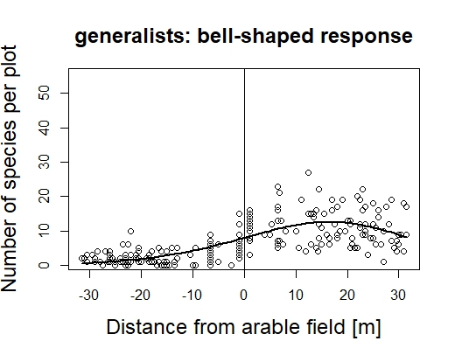
Figure A.1 Number of generalist species per plot over distance to the border between arable field (left) and semi-natural grassland (right) with 2nd best fitting model (delta AIC to cubic model: 1.08).
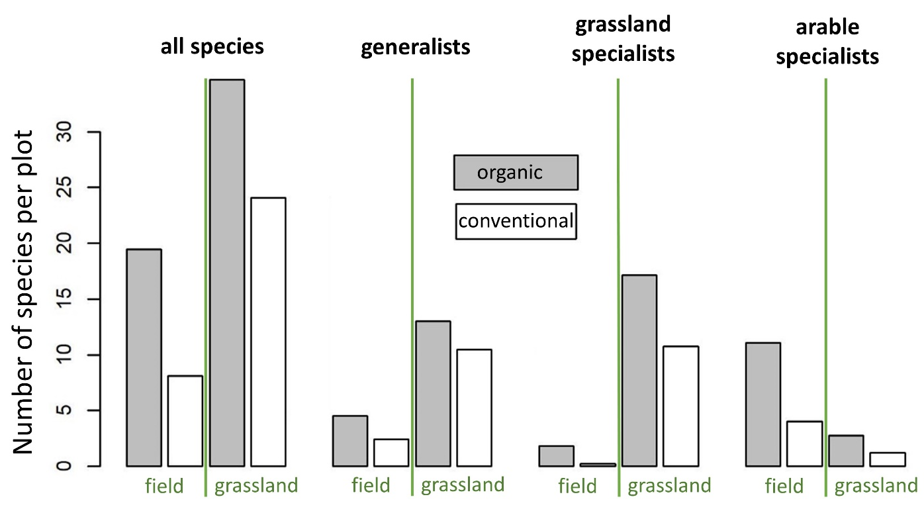
Figure A.2 Mean number of species per plot for the four species groups, separated by farm type. We only show barplots without statistics, because the data is unbalanced with only one of ten sites in the Eifel region being organic (in the Uckermark region it was five to five). It is therefore not possible to disentangle effects of region and farm type.
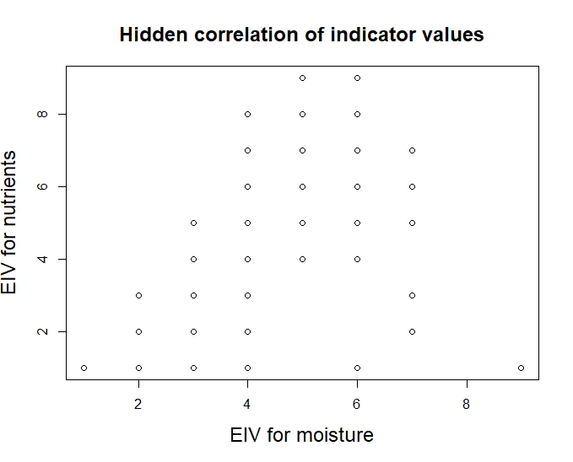
Figure A.3 Correlation of Ellenberg indicator values for moisture and nutrients for all species.

