SUPPLEMENTARY MATERIAL

What can be learned from using participatory landscape scenarios in Rio Doce State Park, Brazil?

Authors: Sónia Carvalho Ribeiro¹, Erika Ferreira¹, Luiz Paula¹, Ramon Rodrigues², Maria Auxiliadora Drummond ² , Henrique Purcino², Brayan Oliveira², Vinicius Moreira¹, Adriana Monteiro¹, Braulio Fonseca¹, Natalia Almeida¹, Tim O´Riordan³, Úrsula Azevedo¹, Alfio Conti¹, Paulina Maia Brabosa²

¹ Programa Pós Graduação em Análise e Modelagem Sistemas Ambientais (PPG AMSA), Instituto Geociencias; ² Programa Pós Graduação em Ecologia e Manejo da Vida Silvestre, Instituto Ciências Biológicas, Universidade Federal Minas Gerais, Belo Horizonte, Brasil; ³ School of Environmental Sciences University of East Anglia, Norwich UK
Content
SM1: DEVELOPING SPATIALLY EXPLICIT LANDSCAPE SCENARIOS IN THE BUFFER AREA OF PERD 1
SM1.1 Participatory scenarios and land suitability analysis in Bom Jesus do Galho 2
SM 1.2 Participatory scenarios and land suitability analysis in Córrrego Novo and Dionísio 6
SM 1.3 Participatory scenarios and land use suitability analysis Pingo de Água 13
SM2: INSTITUTIONAL ANALYSIS & GOVERNANCE 19

SM1: DEVELOPING SPATIALLY EXPLICIT LANDSCAPE SCENARIOS IN THE BUFFER AREA OF PERD

Table SM1. Total population, urban and rural and degree of population urbanization of the 11 municipalities in Rio Doce State Park buffer area.
Municipality | Total  Population | Urban population | Rural  population | Degree of population urbanization
Bom Jesus do Galho¹ | 15.364 | 10.024 | 5.340 | 65,24
Caratinga¹ | 85.239 | 70.474 | 14.765 | 82,68
Córrego Novo¹ | 3.127 | 2.038 | 1.089 | 65,17
Dionísio¹ | 8.739 | 7.165 | 1.574 | 81,99
Jaguaraçu¹ | 2.990 | 2.138 | 852 | 71,50
Marliéria¹ | 4.012 | 2.844 | 1.168 | 70,89
Pingo d'água¹ | 4.420 | 4.035 | 385 | 91,29
Raul Soares¹ | 23.818 | 15.484 | 8.334 | 65,01
Timóteo¹ | 81.243 | 81.124 | 119 | 99,85
Coronel Fabriciano² | 103.694 | 102.395 | 1.299 | 98,75
Ipatinga² | 239.468 | 236.968 | 2.500 | 98,96
Source: IBGE, 2010.
¹ Includes the park's buffer zone. ² Doesn't not include the park's buffer zone.

This work focused on the development of a spatially explicit model to identify the potential for agroforestry, agri husbandry, tourism and conservation across the area. The scenario development process was implemented in only four municipalities: Bom Jesus do Galho, Pingo dágua, Córrego Novo e Dionísio (bold in Table SM1).

SM1.1 Participatory scenarios and land suitability analysis in Bom Jesus do Galho

This work was developed in a Master thesis on environmental modelling, referenced as: Silva, E. F. 2019. Como implementar paisagens multifuncionais? Futuros possíveis (cenários) para o entorno do Parque Estadual do Rio Doce - MG. Dissertação de Mestrado. Programa de Pós-Graduação em Análise e Modelagem de Sistemas Ambientais. Departamento de Cartografia. Universidade Federal de Minas Gerais, Belo Horizonte, Minas Gerais, Brasil.

This work focused on the development of a spatially explicit model to identify the potential for agricultural use in the Municipality of Bom Jesus do Galho, located around the Park. The Socioeconomic Transformation Potential and the Need for Environmental Conservation were estimated. Weighting criteria were determined for each class of variables in relation to the physical capacity of the studied environment to meet the potential (COSTA et al., 2017a and COSTA et al., 2017b). The variables used in the model met the specificities of the methodology according to tables 2, 3 and 4.

Table SM2. Weights attributed to each slope class present in the study area.
% | Relief Type | Weights
0 to 3 | Flat | 5
3 to 8 | Smooth indulating | 4
8 to 20 | Moderately indulated to indulated | 3
20 to 45 | Strong indulated | 2
>45 | Mountainous to rugged | 1
Source: Costa et al (2017b) and research data.

Table SM3. Weights attributed to each soil class present in the study area.
Class | Weights
Red Argisol | 4,1
Yellow Latosol | 4,7
Red-Yellow Latosol | 4,7
Source: Costa et al (2017b) and research data.

Table SM4. Weights attributed to each lithology class present in the study area.
Class | Weights
Amphibolite, Hornblende-biotite gneiss | 2,7
Sand deposits, Gravel deposits | 1,1
Metatonalite | 1,9
Tonalito | 1,9
Source: Costa et al (2017b) and research data.

Potential areas of conflict due to agricultural use, comprising water PPA, Integral Protection Units and urban areas, were also included in the model due to restrictions related to Brazilian legislation. The areas considered urban were extracted from the census sectors by IBGE (2010).

The result presented information containing the classes of impact assessment and potential for agricultural use. The land use and land cover map of Bom Jesus do Galho included (Fig. SM1) to indicate the reality in the field because this can be related to the aspirations of a community that are in question.

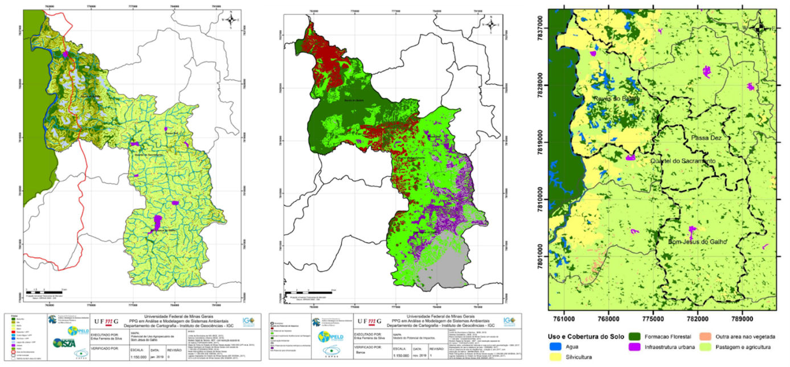
Figure SM1. Elaborated models (from left to right): Agricultural potential; Impact Assessment and Land Use and land cover. Source: Silva (2019).

Some highlights of this result can be seen in the table SM5 below.

Table SM5. Highlights of the joint assessment of cartographic models.
Impact Assessment | Land Use and Coverage | Agricultural Potential | area km²
High potential for urbanization | Pasture and Agriculture | Average | 36,621
High potential for urbanization | Pasture and Agriculture | High | 5,4901
High potential for urbanization | Pasture and Agriculture | Very high | 0,2388
High potential for urbanization | Another non-vegetated area | Average | 0,0005
High potential for urbanization | Another non-vegetated area | High | 0,0006
High potential for urbanization | Another non-vegetated area | Very high | 0,0006
High potential for urbanization | Forestry | Average | 0,1157
High potential for urbanization | Forestry | High | 0,3191
High potential for urbanization | Forestry | Very high | 0,0031
Low Conflict  Anthropic and Environmental use | Pasture and Agriculture | Average | 52,168
Low Conflict  Anthropic and Environmental use | Pasture and Agriculture | High | 3,4415
Low Conflict  Anthropic and Environmental use | Pasture and Agriculture | Very high | 1,1076
Low Conflict  Anthropic and Environmental use | Another non-vegetated area | Average | 0,0083
Low Conflict  Anthropic and Environmental use | Another non-vegetated area | High | 0,0032
Low Conflict  Anthropic and Environmental use | Another non-vegetated area | Very high | 0,0024
Low Conflict  Anthropic and Environmental use | Forestry | Average | 0,0017
Low Conflict  Anthropic and Environmental use | Forestry | High | 0,0001
Potential Investment  Multifunctional Landscape | Forest Formation | Low | 7,9999
Potential Investment  Multifunctional Landscape | Forest Formation | Average | 33,354
Potential Investment  Multifunctional Landscape | Forest Formation | High | 3,8554
Potential Investment  Multifunctional Landscape | Forest Formation | Very high | 0,3171
Potential Investment  Multifunctional Landscape | Forest Formation | Watercourse + PPA | 2,6930
Potential Investment  Multifunctional Landscape | Forest Formation | Source + PPA | 0,2188
Potential Investment  Multifunctional Landscape | Forest Formation | Doce River + PPA | 0,0213
Potential Investment  Multifunctional Landscape | Forest Formation | Non-urban pond + PPA | 1,0762
Potential Investment  Multifunctional Landscape | Forest Formation | Urban | 0,4846
Potential Investment  Multifunctional Landscape | Pasture and Agriculture | Average | 123,39
Potential Investment  Multifunctional Landscape | Pasture and Agriculture | High | 20,615
Potential Investment  Multifunctional Landscape | Pasture and Agriculture | Very high | 7,0772
Potential Investment  Multifunctional Landscape | Another non-vegetated area | Average | 0,0179
Potential Investment  Multifunctional Landscape | Another non-vegetated area | High | 0,0104
Potential Investment  Multifunctional Landscape | Another non-vegetated area | Very high | 0,0020
Potential Investment  Multifunctional Landscape | Forestry | Average | 4,6075
Potential Investment  Multifunctional Landscape | Forestry | High | 8,3973
Potential Investment  Multifunctional Landscape | Forestry | Very high | 2,3625
Need for Environmental Conservation | Forest Formation | Average | 20,006
Need for Environmental Conservation | Forest Formation | High | 10,242
Need for Environmental Conservation | Forest Formation | Very high | 1,5332
Need for Environmental Conservation | Forest Formation | Watercourse + PPA | 1,9957
Need for Environmental Conservation | Forest Formation | Source + PPA | 0,2675
Need for Environmental Conservation | Forest Formation | Doce River + PPA | 0,8395
Need for Environmental Conservation | Forest Formation | Non-urban pond + PPA | 3,3087
Need for Environmental Conservation | Pasture and Agriculture | Average | 18,740
Need for Environmental Conservation | Pasture and Agriculture | High | 14,369
Need for Environmental Conservation | Pasture and Agriculture | Very high | 10,954
Need for Environmental Conservation | Another non-vegetated area | Average | 0,0195
Need for Environmental Conservation | Another non-vegetated area | High | 0,0020
Need for Environmental Conservation | Another non-vegetated area | Very high | 0,0023
Need for Environmental Conservation | Forestry | Average | 5,4065
Need for Environmental Conservation | Forestry | High | 10,774
Need for Environmental Conservation | Forestry | Very high | 8,0450
TOTAL |  |  | 422,52
Source: MapBiomas, Collection 3 - year 2017 and research data.

References
CAMARGO, B.V.; JUSTO, A.M. Tutorial para uso do software IRAMUTEQ. Interface de R pourles Analyses Multidimensionnelles de Textes et de Questionnaires [Florianópolis]: Universidade Federal de Santa Catarina, 2018. 74p.
COSTA, A. M. C.; SALIS, H. C.; VIANA, J. H. M.; AQUINO, J. N.; PEREIRA, M. P. R. Zoneamento Ambiental e Produtivo: uso da modelagem para identificação de potencialidades e limitações no uso do solo. Informe Agropecuário, v 38, 2017a. p. 81-91.
COSTA, A. M. C.; VIANA, J. H. M.; EVANGELISTA, L. P.; CARVALHO, D. C.; PEDRAS, K. C.; HORTA, I. M. F.; SALIS, H. C.; PEREIRA, M. P. R.; SAMPAIO, J.D.L. Ponderação de variáveis ambientais para a determinação do Potencial de Uso Conservacionista para o estado de Minas Gerais. Geografias, v 14. n.1, 2017b. p. 118-134.
IBGE. Instituto Brasileiro de Geografia e Estatística. Censo Demográfico 2010. Disponível em: <https://cidades.ibge.gov.br/brasil/mg/bom-jesus-do-galho/panorama> Acesso em: 25 jun. 2017.
IEF. Instituto Estadual de Florestas. Plano de Manejo do Parque Estadual do Rio Doce. 2008.. Disponível em: <http://www.ief.mg.gov.br/component/content/article/306> Acesso em: 09 maio 2017.
MAPBIOMAS. Projeto MapBiomas - Coleção [3]. Ano 2017. Da Série Anual de Mapas de Cobertura e Uso de Solo do Brasil. Disponível em: <https://code.earthengine.google.com/?accept_repo=users/mapbiomas/user-toolkit> Acesso em: 30 nov. 2018.
MOURA, A.C.M. Reflexões metodológicas como subsídio para estudos ambientais baseados em Análise de Multicritérios. In.: Anais do XIII Yespósio de Sensoriamento Remoto (SBSR), 13, 2007, Florianópolis, Anais... São José dos Campos: INPE, 2007. Artigos, p. 2899-2906.
MOURA, A C M; MAGALHÃES, D. M.; PARIZZI, M. G. Vocações e Conflitos de Interesse na Ocupação do Território da Região Metropolitana de Belo Horizonte – Apoio ao Plano Diretor de Desenvolvimento Integrado - PDDI. In. XV Yespósio Brasileiro de Sensoriamento Remoto - SBSR. Anais... Curitiba: INPE, 2011. p.690–687.
SALVIATI, M. E. Manual do Aplicativo Iramuteq. Compilação, organização e notas. Versão 0.7 Alpha 2 e R Versão 3.2.3. Planaltina, março 2017.

SM 1.2 Participatory scenarios and land suitability analysis in Córrrego Novo and Dionísio

This work was developed in a Master thesis on Biological sciences, referenced as: RODRIGUES, N. R.2019.Áreas prioritárias para conservação e restauração florestal no entorno do Parque Estadual do Rio Doce. Dissertação de Mestrado. Programa de Pós-Graduação em Ecologia, Conservação e Manejo da Vida Silvestre. Departamento de Biologia Geral. Universidade Federal de Minas Gerais, Belo Horizonte, Minas Gerais, Brasil.

To define the priority areas for conservation and restoration, an analytical technique based on the spatial overlap of multiple criteria with different weights of importance was chosen. Nine criteria were used to compose the models to define priority areas for conservation and restoration around the Rio Doce State Park, which were then multiplied by weights in two different scenarios (Figure SM2). The notes referring to the information in the maps of the criteria were the same in both scenarios.

Table SM6: Criteria selected for the composition of the models for the definition of priority areas for conservation and restoration in the vicinity of the Rio Doce State Park, Minas Gerais, Brazil.
Criteria selected for each model
Priority conservation areas | Priority areas for restoration
Areas fragments | Proximity to forest fragments
Natural Erosive Potential | Natural Erosive Potential
Importance for connectivity | Likely areas to ecological corridors
Proximity to springs | Proximity to springs
Proximity to streams and rivers | Proximity to streams and rivers
Proximity to headwaters | Proximity to headwaters
Hilltop areas | Hilltop areas
Distance from urban centers | Distance from urban centers
Distance from the road network | Distance from the road network

In the first scenario, the weights used to select priority areas for conservation and restoration were based on a systematic literature review. In the second scenario, the wishes of the local population were considered based on participatory multi-layer techniques. In this case, we opted for the application of semi-structured interviews and participatory workshops. In total, 102 interviews were carried out in the municipalities of Bom Jesus do Galho, Córrego Novo, Dionísio and Pingo D'água. The semi-structured scripts applied contained open, closed questions and a randomly applied photo-questionnaire. In order to complement the interviews, seven participatory workshops were held, six within the municipalities where the interviews were organised and one in the Rio Doce State Park. In total, 148 people participated in the workshops.

After completing the application of the interviews and workshops, the qualitative and quantitative data obtained were digitized, tabulated and pre-processed to correct spelling errors and standardize the semantic words. For the interviews, we performed a Yesplified analysis to outline the interviewees' profiles and a content analysis to classify the answers in thematic axes (BARDIN, 1977). For the workshops, due to the large volume of information, we performed a textual statistical analysis with the aid of the Iramuteq 4.1 software, which uses the statistical environment of the R software (RATINAUD; MARCHAND, 2012).
Finally, to compose the paired comparison matrix, the volume of discussions on the different topics was compared, aiming to classify the criteria established for the definition of priority areas for conservation and recovery in order of importance. The weights considered in each scenario can be seen in Figure SM2.

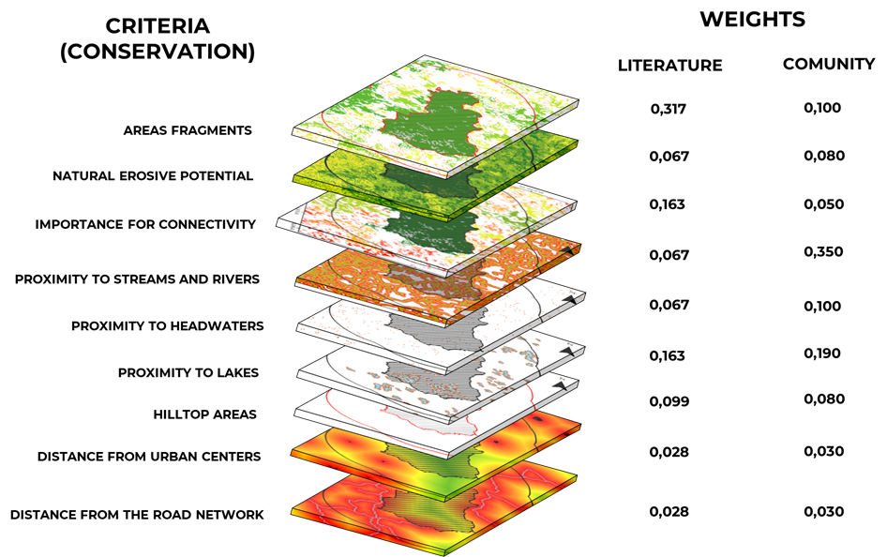
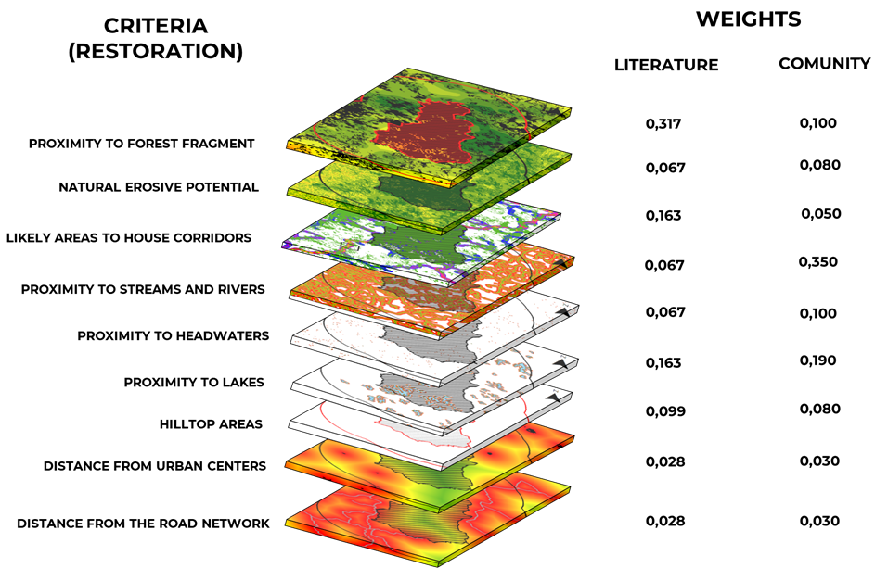
Figure SM2: Weights used to define priority areas for conservation and restoration for each of the criteria used in the two proposed scenarios.

In the model based on the weights defined by the literature, there was a trend towards the selection of big forest fragments , due to the higher concentration of weights in factors with these characteristics, such as the area of the fragment and the importance of functional connectivity (Figure SM3). The selection of priority areas based on integral areas, usually ranking entire fragments of the landscape, is more common in studies that rely heavily on habitat quality (GENELETTI, 2004; PRESSEY; TAFFS, 2001; MERGULES; PRESSEY, 2000; MYERS, et al., 2000) and, therefore, more focused on the preservation of biodiversity. As there is a ranking of fragments, the area defined as high and very high priority was higher in the scenario built according to the wishes of the community, 18.17% against 3.2% in the second scenario (Figure SM3).

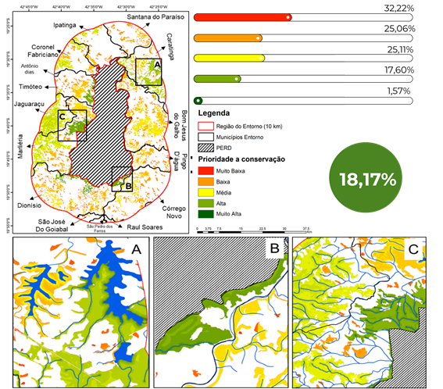
Figure SM3: Map of priority conservation areas around the Rio Doce State Park, Minas Gerais, Brazil, according to weights taken from the literature.

In the model based on the wishes and needs of the local community for conservation, there was a trend in the selection of specific areas within the fragment, such as areas close to water courses and areas with high erosive potential. In this type of approach, it is considered that parts of the same fragment have different roles for conservation and, therefore, should be prioritized in different ways (DUARTE et al., 2016). In this way, areas of a fragment at the bottom of valleys, which house springs and streams, will have a higher priority in conservation in relation to the other areas of the fragment. This type of approach is becoming more and more common due to the difficulty of conservationists in obtaining human and financial resources for the protection of integral areas that do not demonstrate their benefits to society (SEPPELT et al., 2011).

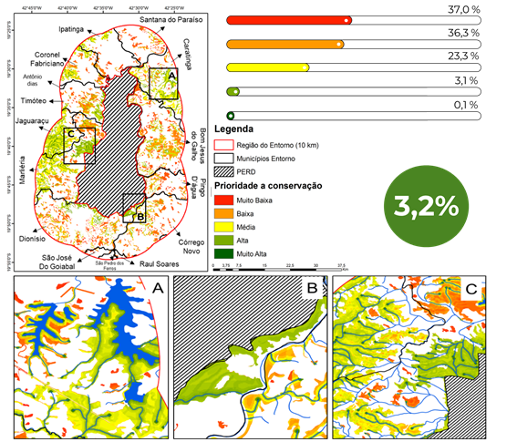
Figure SM4 : Map of priority areas for conservation around the Rio Doce State Park, Minas Gerais, Brazil, as desired by local communities.

As for the model for defining priority areas for restoration, the pattern was repeated for the model for defining priority areas for conservation. The model built based on the weights in the literature classified a larger area as being of high priority precisely because it concentrated the weights on integral factors of the landscape, such as the proximity to fragments of a larger area, which was strongly influenced by the presence of PERD in the center of the region. In this model, it was also possible to observe that there was a predominance of very high classes in regions with a high probability of housing corridors and close to the largest forest fragments, proving to be very effective in the selection of areas of permanent preservation that had to be increased in width.

Zimbres et al. (2018), studying the use of riparian areas preserved in a degraded matrix in the Amazon biome by large mammals, found that these areas have high potential for landscape connectivity and that their effectiveness of use is directly linked to their structure, such as width and quality of resources. Therefore, its effectiveness as an ecological corridor depends directly on restoration actions, mainly by implementing areas of legal reserves linked to them as a way of increasing its width (Figure SM5).

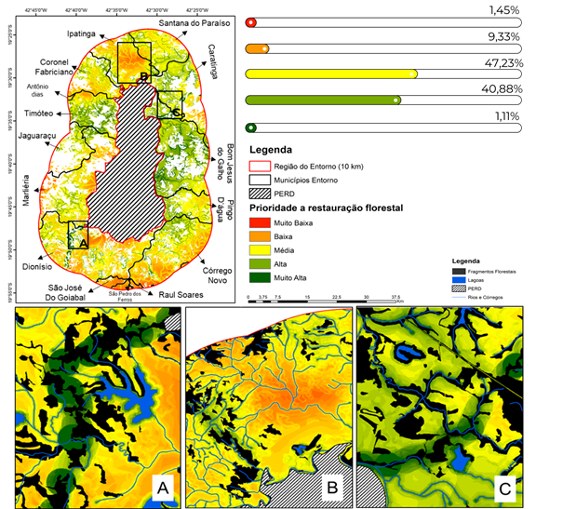
Figure SM5 : Map of priority areas for forest restoration around the Rio Doce State Park, Minas Gerais, Brazil, according to weights taken from the literature.

On the other hand, in the restoration model based on the wishes of the local community, there was a strong concentration of areas with very high priority within the areas of permanent preservation of water bodies, justified by the concentration of the population's wishes for the maintenance of water resources. Despite this strong concentration, it was also possible to identify areas of permanent preservation that can also be used as ecological corridors. As in the model defined from the weights in the literature, this model clearly indicated the areas in need of increased width by restorative techniques, by rural owners or private companies and areas for the application of artificial techniques for restoring connectivity, such as bridges, tunnels and airline tickets over highways (Figure SM6).

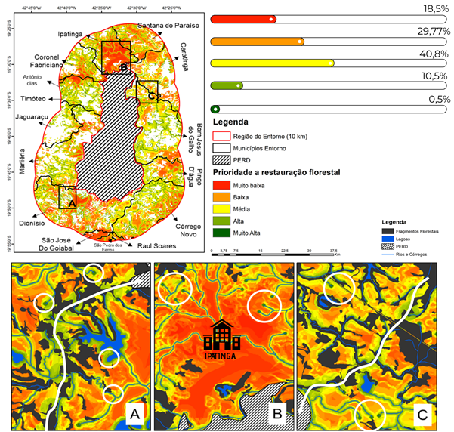
Figure SM6 : Map of priority areas for forest restoration for the surroundings of the Rio Doce State Park, Minas Gerais, Brazil, according to weights relative to the desire of the local community.

Within the local scale, the establishment of priority areas for conservation and restoration, at this level of detail, can support several aspects of decision-making, both in the public and private spheres.

In the public sphere, this type of model could help the creation of new conservation units at the municipal level, guaranteeing the conservation of areas of high importance for the maintenance of ecosystem services and biodiversity, directly and indirectly. Considering the existing units, this approach could assist managers in the more assertive definition of areas for the implementation of preventive actions, such as the construction of firebreaks, the inspection and awareness of local communities, and remedial actions, such as planting seedlings and fire fighting. More specifically, with regard to the Environmental Protection Areas - APAs in the surrounding municipalities (20 in total; PINTO, 2018), this type of approach, in addition to subsidizing the actions mentioned above, could facilitate the process of zoning and definition of management actions, ensuring greater efficiency in the definition of more restrictive zones, which does not happen for the vast majority of Brazilian APAs (ESTEVES; SOUZA, 2014).
Within the private sphere, this level of detail may allow more assertive decision-making in the definition of the Legal Reserve areas, provided for in the Brazilian Forest Code (Federal Law No. 12651/2012). In this way, legal reserves can become important conservation instruments, especially if used in conjunction with Permanent Preservation Areas - APP's, which is not currently happening (SOARES-FILHOS, 2014). In addition, prioritization models of this type can be important decision-making tools within public policies aimed at Payment for Environmental Services - PSA (WUNDER, 2008). Hence happens most of the PES Programs, instituted in Brazil, do not take into account the quality of the habitat or the needs of the population for valuation and subsequent payment for the service provided (SANTOS, et al. 2012). Within the State of Minas Gerais, more specifically in the “Bolsa Verde”, although there is a gradation of the amount paid according to compliance with the limits established by the Forest Code, the financial aid paid is calculated proportionally to the dimensions of the area (BRASIL, 2009 ) and not in proportion to the quality of the habitat or the potential in the provision of ecosystem services, decreasing its effectiveness.

Within the reality of the Rio Doce State Park, the implementation of PES and other public policies mentioned above, together with the proposed prioritization models, could be an effective solution to the problems faced by the population, mainly related to the region's water scarcity and the decrease water quality of the Doce River, after the rupture of the tailings dam in Mariana - MG. Carvalho (2016), for example, studying the perception of the residents of Dionísio, regarding the importance of ecosystem services for their lives, concludes that fostering spring recovery activities in the region, although they are growing, will depend at some point on resources external to the project.

References

BARDIN. L. Análise de conteúdo. Lisboa: Editora Edições 70, 1977.
CARVALHO, A.A. Percepção ambiental de produtores rurais do entorno do Parque Estadual do Rio Doce (MG): subsídios para a educação ambiental. Dissertação de Mestrado. Universidade Federal de Minas Gerais. 2016.
DUARTE, G. T.; RIBEIRO, M. C.; PAGLIA, A. P. 2016. Ecosystem Services Modeling as a Tool for Defining Priority Areas for Conservation. PLOS ONE, v. 11, n. 5, p. 1 - 19.
GASTON, K.J.; JACKSON, S.F.; CANTU-SALAZAR, L.; CRUZ, G., 2008. The ecological performance of protected areas. Annual Review of Ecology, Evolution, and Systematics. v. 39. p. 93–113.
GENELETTI, D. 2004. A GIS-based decision support system to identify nature conservation priorities in an alpine valley. Land Use Policy, v.21, p. 149–160.
GOLDMAN, R.L.; TALLIS, H.; KAREIVA, P.; DAILY, G.C. 2008. Field evidence that ecosystem service projects support biodiversity and diversify options. PNAS – USA, v. 5, n. 27, p. 9445 – 9448.
INSTITUTO ESTADUAL DE FLORESTAS – IEF. 2008. Plano de Manejo do Parque Estadual do Rio Doce. Marliéria, Minas Gerais. Disponível em: http://www.ief.mg.gov.br/compone nt/content/article/306. Acesso em: 10/12/2018.
MARGULES, C. R.; PRESSEY, R. L. 2000. Systematic conservation planning. Nature, v. 405, p. 243 - 253.
OLIVEIRA, B. R.; CARVALHO-RIBEIRO, S. M.; MAIA-BARBOSA, P, M. 2019. A multiscale analysis of land use dynamics in the buffer zone of Rio Doce State Park. Journal of Environmental Planning and Management, Accepted, in prep.
ORSI, F.; GENELETTI, D. 2010. Identifying priority areas for Forest Landscape Restoration in Chiapas (Mexico): An operational approach combining ecological and socioeconomic criteria. Landscape and Urban Planning, v. 94, p. 20 – 30.
PALUMBI, S. R. 2001. Humans as the world’s greatest evolutionary force. Science, v. 293, p. 1786-1790.
PEIXOTO, E. L. 2012. Caracterização e perspectivas do Parque Estadual do Rio Doce – MG: Uma abordagem a partir de imagens de sensoriamento remoto e fotografias hemisféricas do dossel. Dissertação de Mestrado. Instituto de Geociências da Universidade Federal de Minas Gerais.
PRESSEY, R.; TAFFS, K. 2001. Scheduling conservation action in production landscapes: priority areas in western New South Wales defined by irreplaceability and vulnerability to vegetation loss. BIOLOGICAL CONSERVATION, v. 100, n. 3, p. 355 – 376.
RATINAUD, P. ; MARCHAND, P. 2012. Application de la méthode ALCESTE à de “gros” corpus et stabilité des “mondes lexicaux” : analyse du “CableGate” avec IraMuTeQ. Journées internationales d’Analyse statistique des Données Textuelles. JADT. 36p.
SOARES-FILHO, B.; RAJÃO, R.; MACEDO, M.; CARNEIRO, A.; COSTA, W.; COE, M.; RODRIGUES, H.; ALENCAR, A. 2014. Cracking Brasil’s Forest Code. Science, v. 344, p. 363 – 364.
ZIMBRES, B.; PERES, C. A.; PENIDO, G.; MACHADO, R. B. 2018. Thresholds of riparian forest use by terrestrial mammals in a fragmented Amazonian deforestation frontier . Biodiversity and Conservation, V.27, p. 2815 – 2836.

SM 1.3 Participatory scenarios and land use suitability analysis Pingo de Água

This work developed in a master thesis on environmental modelling, referenced as: PAULA, L. G. S. 2019 Cenários Participativos e Governança no Entorno do Parque Estadual do Rio Doce: o papel dos Sistemas Agroflorestais como estratégia de desenvolvimento . Dissertação de Mestrado. Programa de Pós-Graduação em Análise e Modelagem de Sistemas Ambientais. Departamento de Cartografia. Universidade Federal de Minas Gerais, Belo Horizonte, Minas Gerais, Belo Horizonte, Brasil.

During the workshops, the stakeholders were local resididents in the municipality, whether from the public, business or non-governmental sectors.

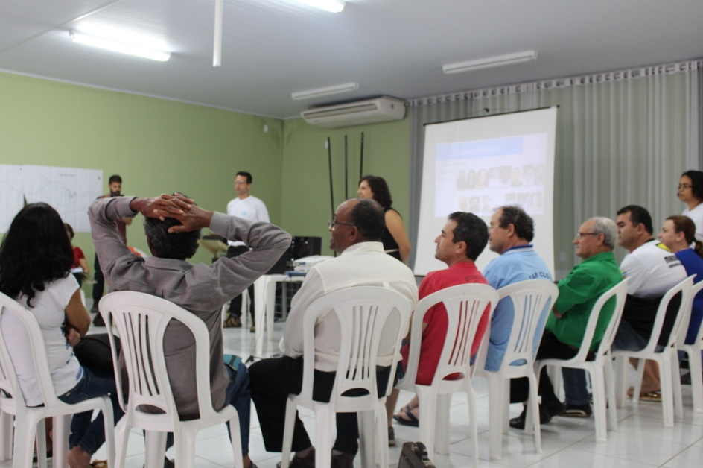
Figure SM7: Workshop in Pingo d’Água. Source: project collection – PELD

Among the products built, a spatially explicit model was developed that shows the suitability of the areas in the surroundings of the park for implementing agroforestry systems (SAF). The model was built based on the multicriteria analysis method AHP (Analytic Hierarchy Process) and the use of geographic information system tools. The result shows the locations and sizes of the areas, given their tendency to receive agroforestry planting programs.
The AHP method is a process of decision making based on a procedure of successive comparisons of variables, pair by pair. These comparisons result in a hierarchical order of priority, formed among the several variables that make up the set of significant criteria for the decision-making process in question. This hierarchical order of importance is represented through specific assigned values (weights) for each variable. These variables play the role of the various criteria that make up the model, and in this case, they are constructed in the form of layers of georeferenced spatial representation. This is so that the result is also a spatially explicit model, obtained by map algebra, weighted by the weights identified in the Hierarchical Analytical Process.
The variables applied in the analysis were: (a) Normalized Difference Vegetation Index (NDVI), (b) occurrence of Permanent Preservation Areas (APP), (c) Classification of Land Use and Coverage, (d) proximity to access roads.

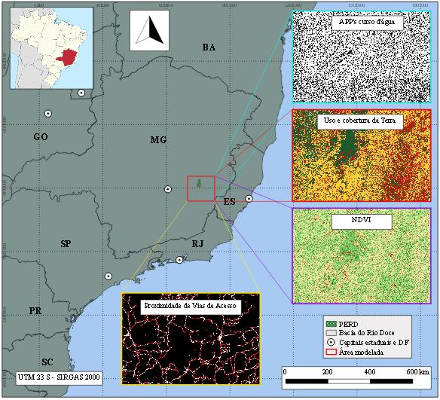
FIGURE SM8: Location and Coverage of the Area and Layers of the Model. Source: Paula (2019).

The AHP method requires the different variables to be compared pairwise. The level of difference in importance or priority between them is given according to a numerical scale ranging from 1 to 9, according to the table below.

TABLE SM7: Fundamental Scale of Comparative Judgments
Intensity of importance on an absolute scale | Definition | Description
1 | Equally important | Two variables contribute equally to the objective
3 | Moderate importance of one over the other | Experiences and / or judgments favor one variable over another
5 | Essential or of strong importance | Experiences and / or judgments strongly favor one variable over the other
7 | Very strong importance | A variable is strongly preferred and its dominance is demonstrated in practice
9 | Extremely important | The evidence favors one variable over the other with the highest degree of certainty
2,4,6,8 | Intermediate values between two adjacent judgments | When adjustments are needed
Source: Adapted from de Saaty (1987)

Thus, for this work, the various attributes of the four variables applied (land use and cover, APPs, proximity to access roads and NDVI) received scores from 1 to 3 (see Table 2), 1 being the representation of the ‘very low’ level of aptitude for implementing SAF, 2 the moderate level and grade 3 being the ‘very high’ level.

Table SM8: Attributes of Variables Score
Variables | Attributes | Grades | APTUDE
Proximity to access roads | Distance > 200 m | 1 | Very low
Proximity to access roads | Distance between 200 m e 100 m | 2 | Moderate
Proximity to access roads | Distance < 100 m | 3 | Very high
Land use / coverage | Water | 1 | Very low
Land use / coverage | Urbanized areas | 1 | Very low
Land use / coverage | Forests and woods | 1 | Very low
Land use / coverage | Silviculture | 2 | Moderate
Land use / coverage | Áreas rurais desmatadas | 3 | Very high
NDVI | High | 1 | Very low
NDVI | Average | 2 | Moderate
NDVI | Low | 3 | Very high
APP’s corpos d’água | Inside | 3 | Very high
APP’s corpos d’água | Outside | 1 | Very low

The importance matrix of the AHP method, with each criterion used for the model, presents the values shown below, according to the stipulated scale and presented in Chart 2. As can be seen, the value of λ (eigenvalue) resulted in 4, 08, that of the consistency index (CI) at 0.027 and that of the consistency ratio (CR) at 0.03. Considering that, according to the requirements of the method presented by Saaty (1987), the CR needs to demonstrate a result lower than 0.1. In this way, it is possible to affirm the existence of consistency in the choice of importance of the criteria according to the proposal of the work.

TABLE SM9: Matrix of Pairwise Comparisons of The Criteria and Importance
Criteria | Land use and coverage | PPA of bodies of water | NDVI | Proximity to access roads | Weights
Land use and coverage | 1 | 4,5 | 5,5 | 5 | 0,605
PPA of bodies of water | 2/9 | 1 | 3 | 1,5 | 0,185
NDVI | 2/11 | 1/3 | 1 | 0,5 | 0,079
Proximity to access roads | 1/5 | 2/3 | 2 | 1 | 0,132
λ = 4,08 CI = 0,027 CR = 0,03

Of the entire modeled area (1,677,033 ha), 5.580 ha obtained top marks, which were identfied in anthropized rural areas, low NDVI, within riparian APPs and close to highways. Among these areas considered to be 'very high' for the implementation of SAFs, the largest of them have areas of more than 30 hectares located on the banks of the Piracicaba River, relatively closer to its mouth on the Doce River.

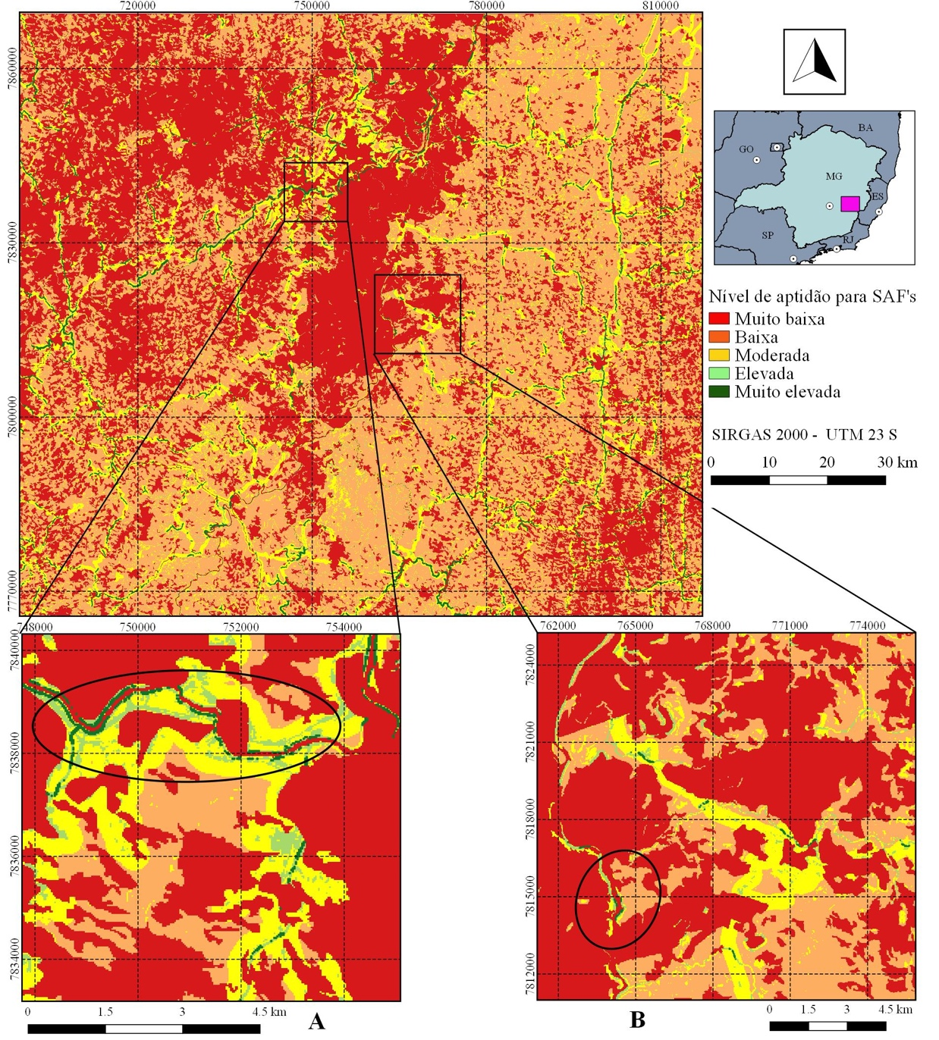
FIGURE SM9: Result of the Model Analysis.

The final result showed that there are more than five and a half thousand hectares of man-made rural areas, close to highways, within APPs and with a low vegetation index in the region surrounding the Rio Doce State Park. It is a significant extension of land, when it comes to implementing agroforestry systems. The most frequent presence of larger areas, considered to have very high suitability for implementing SAFs, occurs along APPs of the most voluminous rivers. Smaller rivers, which consequently have smaller APPs, also have a lot of potential, albeit on a smaller scale. For this type of information to be useful in the decision making of a supposed program for revegetation of degraded areas, other filters may possibly be needed, using different variables.

References
BRASIL. Lei n. 9.985, de 18 de julho de 2000. Regulamenta o artigo 225, parágrafo 1, incisos I, II, III e VII da Constituição Federal; institui o Sistema Nacional de Unidades de Conservação da Natureza e dá outras providências. Diário Oficial da União, Atos do Poder Legislativo, Brasília, DF, 19 jul. 2000. Seção 1, p. 1. Disponível em: <http://www.planalto.gov.br/ccivil_03/LEIS/L9985.htm>. Acesso em: 09 abr. 2019.
BRASIL. Ministério do Meio Ambiente. Dispõe sobre procedimentos técnicos para a utilização da vegetação da Reserva Legal sob regime de manejo florestal sustentável, e dá outras providências. Instrução Normativa n. 04, de 08 de setembro de 2009. Sistema Nacional de Informações Florestais, Brasília, set. 2009. Disponível em: <http://snif.florestal.gov.br/images/pdf/legislacao/normativas/in_mma_04_2009.pdf>. Acesso em: 09 abr. 2019.
CORSEUIL, C. W. Técnicas de Geoprocessamento e de Análise de Multicritérios na Adequação de Uso das Terras. 2006. 101 f. Tese (Doutorado em Agronomia) – Universidade Estadual Paulista, Botucatu, 2006.
FÁVERO, C. Uso e degradação de solos na microrregião de Governador Valadares, MG. 2001. 80 f. Tese (Doutorado em Solos e Nutrição de Plantas) – Universidade Federal de Viçosa. Viçosa, 2001.
Fávero, C.; Lovo, I. C.; Mendonça, E. S. Recuperação de Área Degradada com Sistema Agroflorestal no Vale do Rio Doce, Minas Gerais. Revista Árvore, Viçosa, v.32, n.5, p.861-868, Out. 2008.
Fonseca, E. L.; Locatelli M.; Silva Filho, E. P. NDVI Aplicado na Detecção de Degradação de Pastagens Cultivadas. Revista Franco Brasileira de Geografia Confins, [S. l.], n. 35, abr. 2018. Disponível em: <https://journals.openedition.org/confins/13180#quotation>. Acesso em: 15 mai. 2019.
GONÇALVES, J. L. G.; FRANCISCO, P. R. M.; MORAES NETO, J. M. Análise da Degradação Ambiental do Município de Soledade Utilizando Índice de Vegetação. In: Congresso Técnico Científico da Engenharia e da Agronomia, 2., 2015, Fortaleza. Anais… Fortaleza: Confea/Crea-CE, 2015. v. 2.
LANFREDI, M. Early Identification of Land Degradation Hotspots in Complex Bio-Geographic Regions. Remote Sensing. v. 7, p. 8154-8179, 2015.
LEITE, T. V. P. Sistemas Agroflorestais na Recuperação de Espaços Protegidos por Lei (app e reserva legal): estudo de caso do Sítio Geranium, DF. 2014. 117 f. Tese (Doutorado em Ciências Florestais) - Universidade de Brasília, Brasília, 2014.
LITTLE, P. E. Territórios sociais e povos tradicionais no Brasil: por uma antropologia da territorialidade. In:
MARTINS, T. P.; RANIERI, V. E. L. Sistemas Agroflorestais como Alternativa para as Reservas Legais. Ambiente & Sociedade, São Paulo, v. 17, n. 3, p. 79-96, set. 2014.
MELO, E. T.; SALES, M. C. L.; OLIVEIRA, J. G. B. Aplicação do Índice de Vegetação por Diferença Normalizada (NDVI) para Análise da Degradação Ambiental da Microbacia Hidrográfica do Riacho dos Cavalos, Crateús-CE. Raega - O Espaço Geográfico em Análise, v. 23, p. 520-533, nov. 2011.
Montebelo, L. A. et al. Relação entre uso e cobertura do solo e risco de erosão nas áreas de preservação permanente na bacia do ribeirão dos Marins, Piracicaba-SP. In: Yespósio Brasileiro de Sensoriamento Remoto, 12., 2005, Goiânia. Anais... Goiânia: INPE, 2005. p. 3829-3836. v. 12.
Nepomuceno, M. Q.; Lobão, J. S. B.; Vale, R. M. C. Uso e cobertura da terra como indicativo do processo de desertificação na região de Irecê – BA. In: Yespósio Brasileiro de Sensoriamento Remoto, 15., 2011, Curitiba. Anais… Curitiba: INPE. 2011. p.6794-6802. v. 15.
Pinese Jr., J. F.; Rodrigues, S. C. O Método de Análise Hierárquica – AHP – como Auxílio na Determinação da Vulnerabilidade Ambiental da Bacia Hidrográfica do Rio Piedade (MG). Revista do Departamento de Geografia – USP, São Paulo, v. 23, p. 4-26, jul. 2012.
Saaty, R. W. The Analytic Hierarchy Process: what it is and how it is used. Mathematical Modeling, v. 9, n. 3-5, p. 161-176, 1987.

SM2: INSTITUTIONAL ANALYSIS & GOVERNANCE

Table SM10: Instituions that work in the area for implemeting activiteis associated to preferred scenarios
Institutions | Sector | Income generation | Industry employ-ment | Agro forestry eystems | Conser-vation | Ecoturism | Urban develop-ment & Infrastruc-ture | Family farming | Micro-enterprises investments | Trainning andeEducation (younger) | Fire fighting brigades | Forest restoration | Environ-mental education
Usiminas | Private | Yes | Yes | No | Yes | Possível | Yes | No | Yes | Yes | Yes | Yes | Yes
Cenibra | Private | Yes | Yes | Possível | Yes | Yes | Yes | Yes | Yes | Yes | Yes | Yes | Yes
Aperam | Private | Yes | Yes | No | Yes | No | Yes | No | Yes | Yes | Yes | Yes | Yes
Sindicatos Rurais Municipais | NGO | Yes | No | Yes | Yes | Yes | No | Yes | No | Yes | Yes | Yes | Yes
Serviço Nacional de Aprendizagem Rural - Senar | Public | Yes | No | Yes | Yes | Yes | No | Yes | No | Yes | Yes | Yes | Yes
Instituto Federal Minas Gerais - Campus Ipatinga | Public | No | No | No | No | No | No | No | No | Yes | No | No | Yes
Centro Federal de Educação Tecnológica de Minas Gerais - Campus Timóteo | Public | No | No | No | No | No | No | No | No | Yes | No | No | Yes
Prefeituras Municipais | Public | No | No | Yes | Yes | Yes | Yes | Yes | No | Yes | Yes | Yes | Yes
Serviço Brasileiro de Apoio as Micro e Pequenas Empresas - SEBRAE | Private | Yes | No | Yes | No | Yes | No | Yes | Yes | Yes | No | No | No
Serviço Nacional de Aprendizagem Industrial - SENAI | Private | No | Yes | No | No | No | No | No | No | Yes | No | No | Yes
Federação das Indústrias do Estado de Minas Gerais - FIEMG | Private | Yes | Yes | No | No | Yes | Yes | No | Yes | Yes | No | No | Yes
Câmara de Dirigentes Lojistas - CDL | NGO | Yes | No | No | No | No | No | No | No | Yes | No | No | No
Agência de Desenvolvimento da Região Metropolitana do Vale do Aço - ARMVA | Public | No | No | No | Yes | Yes | Yes | No | Yes | No | No | No | No
Corpo de Bombeiros Militares de Minas Gerais - CBMMG | Public | No | No | No | Yes | No | No | No | No | No | Yes | No | Yes
Defesa Civil Municipais | Public | No | No | No | Yes | No | Yes | No | No | No | Yes | No | No
Previncêndio Sistema Contra Incêndio - SEMAD | Public | No | No | No | Yes | No | No | No | No | Yes | Yes | No | Yes
Associação Amigos do PERD | NGO | No | No | No | Yes | Yes | No | No | No | No | Yes | No | Yes
Parque Estadual Rio Doce - PERD | Public | Yes | No | No | Yes | Yes | No | No | No | No | Yes | No | Yes
Instituto Estadual de Florestas - IEF | Public | No | No | Yes | Yes | Yes | No | No | No | No | Yes | Yes | Yes
Superintendência Regional de Meio Ambiente do Leste Mineiro - SUPRAMLM | Public | No | No | No | Yes | No | No | No | No | No | Yes | No | Yes
Companhia Energética de Minas Gerais - CEMIG | Public company | No | No | No | Yes | Yes | Yes | No | No | Yes | Yes | No | Yes
Polícia Militar de Minas Gerais - PMMG | Public | No | No | No | Yes | No | No | No | No | No | Yes | No | Yes
Companhia de Saneamento de Minas Gerais - COPASA | Public company | No | No | No | No | No | Yes | No | No | No | Yes | Yes | Yes
Emalto | Private | Yes | Yes | No | Yes | No | No | No | No | Yes | No | No | Yes
Council Municipais de Meio Ambiente - CODEMA's | Council | No | No | Yes | Yes | Yes | No | No | No | No | Yes | Yes | Yes
Conselho Consultivo PERD | Council | No | No | No | Yes | Yes | No | No | No | No | No | No | Yes
Council Municipais de Turismo | Council | No | No | No | Yes | Yes | No | No | No | No | No | No | Yes
Projeto Turismo no Vale | NGO | No | No | No | Yes | Yes | No | No | No | No | No | No | Yes
Circuito Turístico Mata Atlântica de Minas | NGO | No | No | No | Yes | Yes | No | No | No | No | Yes | Yes | Yes
Fundação Renova | Private | Yes | No | Yes | Yes | Yes | Yes | Yes | Yes | Yes | Yes | Yes | Yes
Ministério Public | Public | No | No | No | Yes | No | No | No | No | No | Yes | Yes | Yes
Departamento de Edificações e Estradas de Rodagem de Minas Gerais | Public | No | No | No | No | No | Yes | No | No | No | No | No | No
Programa de Concessões de Parques Estaduais IEF | Public | Yes | No | No | Yes | Yes | Yes | No | No | No | No | No | Yes
Secretarias Municipais de Meio Ambiente | Public | No | No | Yes | Yes | Yes | No | No | No | No | Yes | Yes | Yes
Secretarias Municipais de Desenvolvimento Econômico | Public | Yes | No | Yes | No | Yes | Yes | Yes | Yes | Yes | No | No | No
Secretarias Municipais de Obras | Public | No | No | No | No | No | Yes | No | No | No | No | No | No
Secretarias Municipais de Agricultura | PublicPublic | No | No | Yes | Yes | Yes | No | Yes | No | No | No | Yes | Yes
Banco de Desenvolvimento de Minas Gerais - BDMG | Public companyPublic company | Yes | Yes | No | No | No | Yes | No | Yes | No | No | No | No
WWF | NGONGO | Yes | No | Yes | Yes | Yes | No | Yes | Yes | Yes | Yes | Yes | Yes
ICRAFT | NGONGO | Yes | No | Yes | Yes | Yes | No | Yes | Yes | Yes | Yes | Yes | Yes

