Appendix
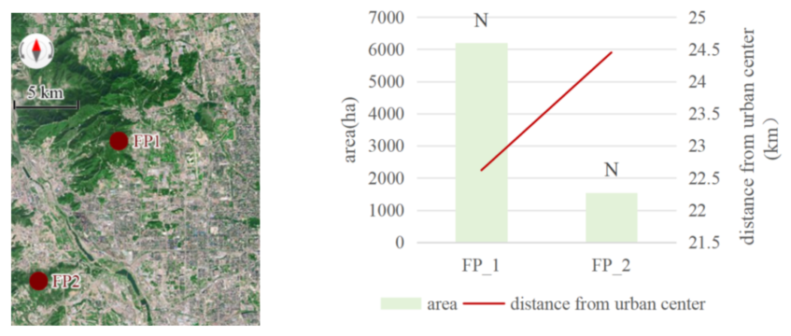

- spatial position  This satellite image from Baidu Map, retrieved October 28, 2023 at https://map.baidu.com/ | (b) The fundamental characteristics of PAs in zone1  the bar chart represents area of PAs, the line chart represents PAs distance from urban center; the color of the bar chart represents strong sustainability (green) and weak sustainability(red); from left to right, the sustainability intensity increases; “N” means national, “M” means municipal, D means district
Fig. 1 Protected areas of Zone 1

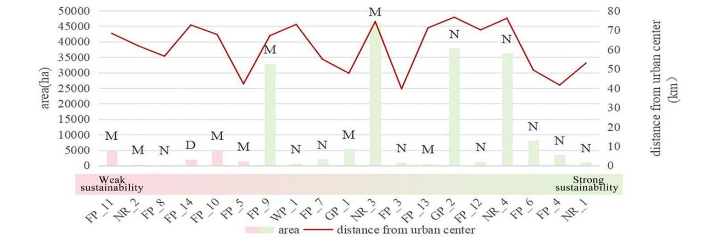

the bar chart represents area of PAs, the line chart represents PAs distance from urban center; the color of the bar chart represents strong sustainability (green) and weak sustainability(red); from left to right, the sustainability intensity increases;
“N” means national, “M” means municipal, D means district
Fig . 2 The fundamental characteristics of PAs in zone2

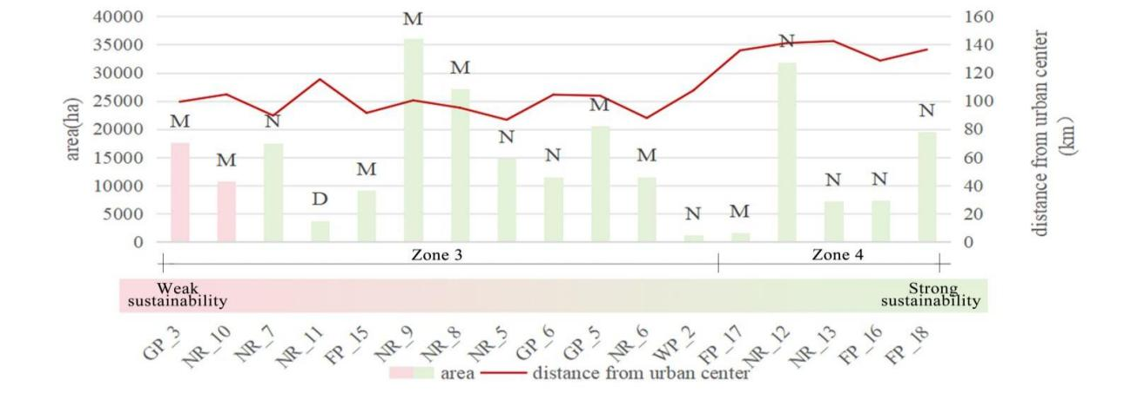
the bar chart represents area of PAs, the line chart represents PAs distance from urban center; the color of the bar chart represents strong sustainability (green) and weak sustainability(red); from left to right, the sustainability intensity increases; “N” means national, “M” means municipal, D means district
Fig. 3 The fundamental characteristics of PAs in Zone 3 and Zone4

Schedule 1 The calculation methods for ecological functions indicators
Indicator |  | calculation methods
1 | Water yield | $$Y_{xj}=\left(1-\frac{{AET}_{xj}}{P_{x}}\right)P_{x}$$  where,  $Y_{xj}$ is the water capacity of raster x in land cover type j;$P_{x}$ is precipitation of raster x; ${AET}_{xj}$ is the actual evapotranspiration of raster x in land cover type j;  $$\frac{{AET}_{xj}}{P_{x}}=\frac{1+w_{x}R_{xj}}{1+w_{x}R_{x}+\frac{1}{R_{xj}}}$$  where,  $R_{xj}$ is the dryness factor of raster x in land cover type j; $w_{x}$is the ratio of modified water availability of vegetation to precipitation;  $$w_{x}=Z\frac{{AWC}_{x}}{P_{x}}$$  where,  ${AWC}_{x}$ is the content of vegetation effective use water in raster x; Z is the seasonal constant;  $$R_{xj}=\frac{k_{j}×{{ET}_{0}}_{xj}}{P_{x}}$$  where,  $k_{j}$ is evapotranspiration coefficient of vegetation of land cover type j, is decided by leaf area index (LAI) of vegetation; ${{ET}_{0}}_{xj}$is the potential evapotranspiration of raster x in land cover type j;
2 | Habitat quality | $$Q_{xj=H_{j}}\left(1-\left(\frac{D_{xj}^{z}}{D_{xj}^{z}+k^{z}}\right)\right)$$  where,  $Q_{xj}$ is the habitat quality of raster $x$ in land cover type $j$; $H_{j}$ is the habitat suitability of land cover type $j$; $k$ and $z$ are scale factors.
2 | Habitat quality | $$D_{xj}=\sum_{r=1}^{R}{\sum_{y=1}^{Y_{r}}{\left(\frac{w_{r}}{\sum_{r=1}^{R}{w_{r}}}\right)}}r_{y}×i_{rxy}{{×β}_{x}×S}_{jr}$$  where,  $D_{xj}$ is the total threat level of raster x in land cover type j; $R$ is the number of threat source; $w_{r}$ is the weight of threat source; $Y_{r}$ is the number of grid cells on r raster map; $r_{y}$ is the threat intensity of raster r; $i_{rxy}$ is the threat level of $r_{y}$ to raster x; $β_{x}$ is the accessibility of the threat source to raster x; $S_{jr}$ is the sensitivity for threat sources of land cover type j;
3 | Carbon sequestration | $$C=C_{above}+C_{belowe}+C_{dead}+C_{soil}$$  where,  $C$is the total carbon density of soil and biomass; $C_{above}$is the above ground biomass carbon density; $C_{belowe}$is the underground biomass carbon density; $C_{dead}$is the organic carbon density of dead leaves; $C_{soil}$ is the carbon density in the soil.
4 | Soil conservation | $$SD=RKLS-USLE$$  where,  $SD$ is soil conservation, $RKLS$ is the amount of potential soil erosion and $USLE$ is the amount of actual soil loss.  $$USLE=R×K×L×S×C×P$$  $$RKLS=R×K×L×S$$  where,  $R$ is the rainfall erosion factor; $K$ is soil erodibility factor; L is slope length factor; S is slope gradient factor; C is vegetable coverage and management factor; P is measure of soil conservation factor .

The formulas are compiled from the following literature:

[1] Natural Capital Project, 2024. InVEST 3.14.1. Stanford University, University of Minnesota, Chinese Academy of Sciences, The Nature Conservancy, World Wildlife Fund, Stockholm Resilience Centre and the Royal Swedish Academy of Sciences. https://naturalcapitalproject.stanford.edu/software/investWang DD.JiaYW, NiuCW. Sui Y B, Yan X,Evaluation method for main functions of water retention based on WEP-L model: a case of water retention
area in Wei River.Acta Ecologica Sinica,2024.44(10).
[2]Fan, F., Liu, Y., Chen, J., & Dong, J. (2021). Scenario-based ecological security patterns to indicate landscape sustainability: a case study on the Qinghai-Tibet Plateau. Landscape Ecology, 36, 2175-2188.
[3] LIU Jiayi,XU Dawei, XU Jia.Analysis of landscape patterns and spatio-temporale volution of habitat quality in the PU River basin based on the INVEST Model [J]. Journal of Soiland Water Conservation, 2024,38(2).
[4] SHI Ying, BIE Qiang, SU Xiaojie, LI Xinzhang, Spatiotemporal variation of water conservation function evaluation based on InVEST model: A case of Lanzhou City [J/OL]. Arid Land Geography :1-14 [2024-03-16]. http://kns.cnki.net/kcms/detail/65.1103.X.20240305.0855.001.html.
[5] Bao Yubin, Li Ting, Liu Hui, et al. Spatial and temporal changes of water conservation of Loess Plateau in northern Shaanxi Province by InVEST model[J]. Geographical Research, 2016, 35(4): 664-676.
[6] Yang Jie, Xie Baopeng, Zhang Degang. Spatio-temporal variation of water yield and its response to precipitation and land use change in the Yellow River Basin based on InVEST model[J].Chinese Journal of Applied Ecology, 2020, 31(8): 2731-2739.
[7] YAN Y,QIN Y W,PING Y R,et al.Quantitative analysis of the impact of human activities on habitat quality and their spatial relationship: Shijiazhuang as an example[J].Journal of Environmental Engineering Technology,2024,14(2):1-9
[8]GONG Shengxuan, ZHANG Yuhu, LI Yuhang. Spatio－ temporal variation and prediction of carbon storage in Beijing Tianjin－ Hebei region－A PLUS－InVEST model approach[J].Journal of Arid Land Resources and Environment, 2023,37(06):20-28.DOI:10.13448/j.cnki.jalre.2023.133.

Schedule 2 Result of ecological functions change of 2000-2019

ID | 2000-2005 | 2005-2010 | 2010-2015 | 2015-2019 | 2000-2019
NR_1 | 0.001194315 | 0.003656692 | 0.00099627 | 0.019389855 | 0.025237132
NR_2 | -0.029888529 | -0.032771492 | 0.048616602 | -0.017143201 | -0.031186621
NR_3 | 0.002177579 | 0.017839674 | -0.0039218 | 0.007074877 | 0.02317033
NR_4 | 0.010733948 | 0.023352458 | -0.002638682 | 0.008952024 | 0.040399748
NR_5 | 0.006085448 | 0.014350985 | 0.00252347 | 0.005563298 | 0.028523201
NR_6 | 0.00177255 | 0.005786196 | -0.003245606 | 0.001730297 | 0.006043437
NR_7 | 0.002702365 | 0.01178256 | 0.006400327 | 0.011697842 | 0.032583093
NR_8 | 0.010673105 | 0.013740202 | 0.006075838 | 0.007407968 | 0.037897113
NR_9 | 0.006369038 | 0.021396128 | -0.004714516 | 0.009491246 | 0.032541896
NR_10 | -0.009786038 | 0.032801836 | -0.042269553 | 0.000905099 | -0.018348656
NR_11 | 0.004357462 | 0.012358503 | 0.003423026 | 0.005605566 | 0.025744556
NR_12 | 0.005791218 | 0.014157697 | -0.002403571 | 0.011994951 | 0.029540295
NR_13 | 0.015303059 | 0.042990452 | -0.005265863 | 0.01720776 | 0.070235407
FP_1 | 0.004165484 | 0.016898628 | -0.01815492 | 0.013769846 | 0.016679039
FP_2 | 0.021145583 | 0.014188314 | -0.028263905 | -0.000376916 | 0.006693077
FP_3 | 0.005479842 | 0.003718663 | 0.001839652 | 0.001505897 | 0.012544053
FP_4 | 0.002187304 | 0.021319506 | -0.002030789 | 0.005225413 | 0.026701433
FP_5 | 0.001976534 | -0.011241066 | -0.028589619 | 0.019180546 | -0.018673606
FP_6 | 0.007789362 | -0.008371966 | 0.029820972 | -0.024145509 | 0.005092859
FP_7 | 0.005539556 | -0.006228449 | -0.015653208 | 0.021851403 | 0.005509303
FP_8 | 0.003914967 | 0.031420633 | 0.006378539 | -0.011640177 | 0.030073961
FP_9 | 0.002709921 | 0.009528006 | 0.008116614 | 0.004858348 | 0.025212888
FP_10 | 0.008349001 | 0.019900859 | -0.039441655 | 0.005782358 | -0.005409436
FP_11 | 0.000729008 | -0.001055412 | -0.002963743 | -0.00299469 | -0.006284837
FP_12 | 0.008211643 | -0.001092263 | 0.002760206 | 0.007853298 | 0.017732884
FP_13 | 0.006705594 | 0.01561122 | 0.003318703 | 0.02029755 | 0.045933067
FP_14 | 0.002814482 | 0.003833883 | -0.011076921 | -0.004089519 | -0.008518076
FP_15 | 0.004465963 | 0.009745005 | 0.002987623 | 0.007503391 | 0.024701983
FP_16 | 0.009041559 | 0.012927399 | 0.015759947 | -0.003943255 | 0.03378565
FP_17 | 0.013912386 | 0.034236268 | 0.018549373 | 0.006288975 | 0.072987002
FP_18 | 0.001055745 | 0.00816577 | 0.00408962 | 0.004585605 | 0.01789674
GP_1 | 0.004099448 | 0.008946494 | -0.005739024 | 0.008447507 | 0.015754424
GP_2 | 0.006171274 | 0.008500125 | 0.012256429 | 0.0147063 | 0.041634128
GP_3 | 0.008727397 | -0.018853411 | 0.003886235 | 0.001372889 | -0.00486689
GP_4 | 0.013351268 | 0.021766025 | 0.00307374 | 0.01713032 | 0.055321353
GP_5 | 0.011475714 | 0.004396434 | 0.00359341 | -0.001069859 | 0.0183957
WP_1 | 0.003584937 | 0.000280594 | 0.003202334 | 0.000653802 | 0.007721667
WP_2 | 0.002427181 | -0.231464471 | 0.327809279 | 0.038288817 | 0.137060805

Schedule 3 Result of Socioeconomic functions change of 2000-2019

ID | 2000-2005 | 2005-2010 | 2010-2015 | 2015-2019 | 2000-2019
NR_1 | 0.032446789 | 0.101523117 | 0.074311957 | 0.053891179 | 0.262173042
NR_2 | 0.035886713 | 0.026218418 | 0.040642829 | -0.038387188 | 0.064360773
NR_3 | 0.026580052 | -0.000247813 | -0.020911007 | 0.004523155 | 0.009944386
NR_4 | 0.005777912 | 0.035552908 | 0.029146614 | -0.005000141 | 0.065477293
NR_5 | 0.017592247 | 0.012721043 | 0.025941418 | -0.010891823 | 0.045362884
NR_6 | -0.020503319 | 0.075988399 | 0.074296943 | 0.002881013 | 0.132663035
NR_7 | 0.014985677 | 0.01596595 | -0.010952664 | -0.000343664 | 0.019655299
NR_8 | -0.006828717 | 0.017895677 | 0.028187257 | -0.004727544 | 0.034526673
NR_9 | -0.004785934 | 0.016877991 | 0.027570892 | -0.004952677 | 0.034710271
NR_10 | -0.001853652 | 0.020145547 | 0.032413331 | 0.024862234 | 0.07556746
NR_11 | 0.011263 | 0.008679091 | 0.021013656 | -0.008337767 | 0.03261798
NR_12 | 0.011119204 | 0.005290283 | 0.017841241 | -0.004870638 | 0.02938009
NR_13 | 0.010999944 | 0.009032715 | 0.018001172 | -0.007481004 | 0.030552827
FP_1 | 0.086356314 | 0.098106374 | 0.42294141 | 0.203361342 | 0.810765439
FP_2 | 0.13572642 | 0.145605431 | 0.18680292 | 0.07707219 | 0.545206961
FP_3 | 0.049987563 | 0.101026696 | 0.477213457 | -0.056446132 | 0.571781585
FP_4 | 0.040103098 | 0.005770292 | -0.018352086 | -0.003518799 | 0.024002504
FP_5 | 0.052329709 | 0.128135971 | 0.01980301 | -0.048991575 | 0.151277115
FP_6 | 0.057224333 | 0.077920821 | -0.055609254 | 0.013125077 | 0.092660977
FP_7 | 0.020647686 | 0.040395553 | -0.006640909 | 0.048756652 | 0.103158983
FP_8 | 0.012311129 | 0.005669924 | 0.017895009 | -0.00889321 | -0.006285055
FP_9 | 0.016712067 | 0.019163099 | -0.014590621 | 0.00589737 | 0.027181916
FP_10 | 0.025220544 | 0.000603024 | -0.022342958 | 0.006115768 | 0.000112352
FP_11 | -0.005765328 | 0.046823844 | 0.071553977 | -0.017922159 | 0.094690334
FP_12 | 0.029095936 | -0.00447442 | -0.018156221 | 0.00788725 | 0.014352545
FP_13 | 0.021063843 | 0.028940589 | -0.017442808 | -7.66E-05 | 0.032485038
FP_14 | -0.008364815 | 0.022007029 | 0.034707973 | 0.019627847 | 0.067978034
FP_15 | 0.011202586 | 0.009602027 | 0.018372697 | -0.006972329 | 0.032204981
FP_16 | 0.009912658 | 0.003839759 | 0.014208456 | -0.001366076 | 0.026594797
FP_17 | 0.015796136 | 0.014193737 | 0.027513377 | -0.019344431 | 0.038158819
FP_18 | 0.016771773 | 0.008510877 | 0.022364824 | -0.011989293 | 0.03565818
GP_1 | 0.010119249 | 0.039403326 | -0.034551123 | -0.006380898 | 0.008590554
GP_2 | 0.011480264 | 0.028725494 | -0.02185106 | 0.001633912 | 0.01998861
GP_3 | 0.015298986 | 0.014022092 | 0.025914377 | -0.014989643 | 0.040245811
GP_4 | -0.013497401 | 0.035456181 | 0.043486773 | -0.013593939 | 0.051851614
GP_5 | 0.005098759 | 0.033845761 | 0.027557936 | -0.001995403 | 0.064507053
WP_1 | 0.011075034 | 0.112145724 | -0.071422205 | -0.036778297 | 0.015020256
WP_2 | 0.03162828 | 0.01112445 | 0.041142193 | -0.014934214 | 0.068960708

ID | 2000-2005 | 2005-2010 | 2010-2015 | 2015-2019 | 2000-2019
NR_1 | 0.033641104 | 0.105179809 | 0.075308227 | 0.073281034 | 0.287410174
NR_2 | 0.005998184 | -0.006553074 | 0.089259431 | -0.055530389 | 0.033174152
NR_3 | 0.028757631 | 0.017591861 | -0.024832807 | 0.011598032 | 0.033114716
NR_4 | 0.01651186 | 0.058905366 | 0.026507932 | 0.003951883 | 0.105877041
NR_5 | 0.023677695 | 0.027072028 | 0.028464888 | -0.005328525 | 0.073886085
NR_6 | -0.018730769 | 0.081774595 | 0.071051337 | 0.00461131 | 0.138706472
NR_7 | 0.017688042 | 0.02774851 | -0.004552337 | 0.011354178 | 0.052238392
NR_8 | 0.003844388 | 0.031635879 | 0.034263095 | 0.002680424 | 0.072423786
NR_9 | 0.001583104 | 0.038274119 | 0.022856376 | 0.004538569 | 0.067252167
NR_10 | -0.01163969 | 0.052947383 | -0.009856222 | 0.025767333 | 0.057218804
NR_11 | 0.015620462 | 0.021037594 | 0.024436682 | -0.002732201 | 0.058362536
NR_12 | 0.016910422 | 0.01944798 | 0.01543767 | 0.007124313 | 0.058920385
NR_13 | 0.026303003 | 0.052023167 | 0.012735309 | 0.009726756 | 0.100788234
FP_1 | 0.090521798 | 0.115005002 | 0.40478649 | 0.217131188 | 0.827444478
FP_2 | 0.156872003 | 0.159793745 | 0.158539015 | 0.076695274 | 0.551900038
FP_3 | 0.055467405 | 0.104745359 | 0.479053109 | -0.054940235 | 0.584325638
FP_4 | 0.042290402 | 0.027089798 | -0.020382875 | 0.001706614 | 0.050703937
FP_5 | 0.054306243 | 0.116894905 | -0.008786609 | -0.029811029 | 0.132603509
FP_6 | 0.065013695 | 0.069548855 | -0.025788282 | -0.011020432 | 0.097753836
FP_7 | 0.026187242 | 0.034167104 | -0.022294117 | 0.070608055 | 0.108668286
FP_8 | 0.016226096 | 0.037090557 | 0.024273548 | -0.020533387 | 0.023788906
FP_9 | 0.019421988 | 0.028691105 | -0.006474007 | 0.010755718 | 0.052394804
FP_10 | 0.033569545 | 0.020503883 | -0.061784613 | 0.011898126 | -0.005297084
FP_11 | -0.00503632 | 0.045768432 | 0.068590234 | -0.020916849 | 0.088405497
FP_12 | 0.037307579 | -0.005566683 | -0.015396015 | 0.015740548 | 0.032085429
FP_13 | 0.027769437 | 0.044551809 | -0.014124105 | 0.020220950 | 0.078418105
FP_14 | -0.005550333 | 0.025840912 | 0.023631052 | 0.015538328 | 0.059459958
FP_15 | 0.015668549 | 0.019347032 | 0.02136032 | 0.000531062 | 0.056906964
FP_16 | 0.018954217 | 0.016767158 | 0.029968403 | -0.005309331 | 0.060380447
FP_17 | 0.029708522 | 0.048430005 | 0.04606275 | -0.013055456 | 0.111145821
FP_18 | 0.017827518 | 0.016676647 | 0.026454444 | -0.007403688 | 0.05355492
GP_1 | 0.014218697 | 0.04834982 | -0.040290147 | 0.002066609 | 0.024344978
GP_2 | 0.017651538 | 0.037225619 | -0.009594631 | 0.016340212 | 0.061622738
GP_3 | 0.024026383 | -0.004831319 | 0.029800612 | -0.013616754 | 0.035378921
GP_5 | -0.000146133 | 0.057222206 | 0.046560513 | 0.003536381 | 0.107172967
GP_6 | 0.016574473 | 0.038242195 | 0.031151346 | -0.003065262 | 0.082902753
WP_1 | 0.014659971 | 0.112426318 | -0.068219871 | -0.036124495 | 0.022741923
WP_2 | 0.034055461 | -0.220340021 | 0.368951472 | 0.023354603 | 0.206021513

Schedule 4 Result of landscape services change of 2000-2019

Schedule 5 Result of PA-LS

ID | PA-LS | 2000-2019 change of ecological functions | 2000-2019 change of socio-economic functions | 2000-2019 change of landscape services
NR_1 | strong sustainability | 0.025237132 | 0.262173042 | 0.287410174
NR_2 | weak sustainability | -0.031186621 | 0.064360773 | 0.033174152
NR_3 | strong sustainability | 0.02317033 | 0.009944386 | 0.033114716
NR_4 | strong sustainability | 0.040399748 | 0.065477293 | 0.105877041
NR_5 | strong sustainability | 0.028523201 | 0.045362884 | 0.073886085
NR_6 | strong sustainability | 0.006043437 | 0.132663035 | 0.138706472
NR_7 | strong sustainability | 0.032583093 | 0.019655299 | 0.052238392
NR_8 | strong sustainability | 0.037897113 | 0.034526673 | 0.072423786
NR_9 | strong sustainability | 0.032541896 | 0.034710271 | 0.067252167
NR_10 | weak sustainability | -0.018348656 | 0.07556746 | 0.057218804
NR_11 | strong sustainability | 0.025744556 | 0.03261798 | 0.058362536
NR_12 | strong sustainability | 0.029540295 | 0.02938009 | 0.058920385
NR_13 | strong sustainability | 0.070235407 | 0.030552827 | 0.100788234
FP_1 | strong sustainability | 0.016679039 | 0.810765439 | 0.827444478
FP_2 | strong sustainability | 0.006693077 | 0.545206961 | 0.551900038
FP_3 | strong sustainability | 0.012544053 | 0.571781585 | 0.584325638
FP_4 | strong sustainability | 0.026701433 | 0.024002504 | 0.050703937
FP_5 | weak sustainability | -0.018673606 | 0.151277115 | 0.132603509
FP_6 | strong sustainability | 0.005092859 | 0.092660977 | 0.097753836
FP_7 | strong sustainability | 0.005509303 | 0.103158983 | 0.108668286
FP_8 | weak sustainability | 0.030073961 | -0.006285055 | 0.023788906
FP_9 | strong sustainability | 0.025212888 | 0.027181916 | 0.052394804
FP_10 | weak sustainability | -0.005409436 | 0.000112352 | -0.005297084
FP_11 | weak sustainability | -0.006284837 | 0.094690334 | 0.088405497
FP_12 | strong sustainability | 0.017732884 | 0.014352545 | 0.032085429
FP_13 | strong sustainability | 0.045933067 | 0.032485038 | 0.078418105
FP_14 | weak sustainability | -0.008518076 | 0.067978034 | 0.059459958
FP_15 | strong sustainability | 0.024701983 | 0.032204981 | 0.056906964
FP_16 | strong sustainability | 0.03378565 | 0.026594797 | 0.060380447
FP_17 | strong sustainability | 0.072987002 | 0.038158819 | 0.111145821
FP_18 | strong sustainability | 0.01789674 | 0.03565818 | 0.05355492
GP_1 | strong sustainability | 0.015754424 | 0.008590554 | 0.024344978
GP_2 | strong sustainability | 0.041634128 | 0.01998861 | 0.061622738
GP_3 | weak sustainability | -0.00486689 | 0.040245811 | 0.035378921
GP_4 | strong sustainability | 0.055321353 | 0.051851614 | 0.107172967
GP_5 | strong sustainability | 0.0183957 | 0.064507053 | 0.082902753
NR_11 | strong sustainability | 0.007721667 | 0.015020256 | 0.022741923
NR_12 | strong sustainability | 0.137060805 | 0.068960708 | 0.206021513

