Supporting Information

Decreased river runoff on the Mongolian Plateau since around 2000

This file includes:

Supporting Tables S1–S5 and References
Supporting Figures S1–S3

Table S1. Short descriptions on the 13 Ramsar sites located on the Mongolian Plateau
Site number | Site name | Location | Coordinates | Altitude (m) | Total Area (ha) | Biodiversity situation
924 | Mongol Daguur | Dornod Province, Mongolia | 49°42'00''N, 115°06'00''E | 596-821 | 210000 | High species diversity; Among the 260 bird species and two threatened crane species
953 | Terhiyn Tsagaan Nuur | Central Khangai Mountains, Mongolia | 48°10'00''N, 99°43'00''E | 2060 | 6110 | Important breeding and staging area for migratory waterfowl
954 | Valley of Lakes | Bayan-Khongor Province, Mongolia | 45°18'00''N, 100°07'00''E | 1100-1235 | 45600 | Important staging area for migratory waterfowl
955 | Ogii Nuur | Orkhon River Valley, Mongolia | 47°46'00''N, 102°46'00''E | 1280 | 2510 | Important breeding and staging area for waterfowl, particularly Anatidae (ducks, geese, swans, etc.)
976 | Har Us Nuur National Park | Western Mongolia | 47°58'00''N, 92°50'00''E | 1106-1160 | 321360 | Habitat for globally threatened Swan Goose, Ferruginous Duck, White-headed Duck and Relict Gull
977 | Ayrag Nuur | Western Mongolia | 48°53'00''N, 93°25'00''E | 1030 | 45000 | Breeding site for Dalmatian Pelican; Habitat for globally threatened Swan Goose and Relict Gull
1146 | Dalai Lake National Nature Reserve | Inner Mongolia, China | 48°33'00''N, 117°30'00''E | 545-784 | 740000 | Important for some 284 bird species, particularly Anatidae and shorebird species
1148 | Eerduosi National Nature Reserve | Inner Mongolia, China | 39°48'00''N, 109°35'00''E | 1360-1520 | 7680 | 60% of world's Relict gull population (Larus relictus)
1376 | Lake Achit and its surrounding wetlands | Western Mongolia | 49°40'00''N, 90°35'00''E | 1435 | 73730 | Exceptionally important for Great Crested Grebe (Podiceps cristatus), Black Stork (Ciconia Nigra) and Ruddy Shelduck (Tadorna ferruginea)
1377 | Lake Buir and its surrounding wetlands | Eastern Mongolia & China | 47°48'00''N, 117°40'00''E | 581 | 104000 | Largest freshwater lake in eastern Mongolia; Grazing land for Mongolian gazelle (Procapra gutturosa)
1378 | Lake Ganga and its surrounding wetlands | Sukhbaatar Province, Mongolia | 45°15'00''N, 114°00'00''E | 1294 | 3280 | Important breeding site for waterbirds, especially vulnerable or endangered species including White-naped Crane (Grus vipio), Swan Goose (Anser cygnoides), and Great Bustard (Otis tarda)
1379 | Lake Uvs and its surrounding wetlands | Western Mongolia | 50°20'00''N, 92°45'00''E | 759 | 585000 | Largest saline lake in Mongolia; Important resting areas for endangered species like White-headed Duck (Oxyura leucocephala) and Swan Goose (Anser cygnoides)
1380 | Lakes in the Khurkh-Khuiten river valley | Khentii Province, Mongolia | 48°18'00''N, 110°34'00''E | 1000-1100 | 42940 | Exceptionally important for threatened and endangered species like White-naped Crane (Grus vipio), Eurasian Crane (Grus Grus), Demoiselle Crane (Anthropoides virgo) and Black Stork (Ciconia nigra)
(Information provided by the Ramsar Sites Database at http://ramsar.wetlands.org/Database/AbouttheRamsarSitesDatabase/tabid/812/Default.aspx)

Table S2. Detailed information on the 30 hydrological stations and river runoff time series.
ID | Hydrological station | Longitude | Latitude | River | Drainage area (km²) | Temporal span of runoff | Reference
1 | Guchengzi | 124°15'36" | 48°31'48" | Nuomin River | 25277.92 | 1951-2019 | Wang X. 2014
2 | Suolun | 121°19'12" | 46°34'48" | Taoer River | 5737.57 | 1958-2019 | Yin X et al., 2012
3 | Bahou | 119°43'48" | 49°15'36" | Hailaer River | 43208.65 | 1961-2018 | Dong et al., 2022
4 | Alatanmo | 116°49'12" | 48°39'00" | Kherlen River | 81808.34 | 1963-2013 | Wang J et al.,2017
5 | Baiyinwula | 117°37'12" | 44°36'00" | Balager River | 2813.73 | 1959-2015 | Bai Y. 2018
6 | Xilinhaote | 116°10'12" | 43°49'12" | Xilin River | 3826.55 | 1963-2019 | Zhang A et al., 2019
7 | Baichengzi | 116°28'48" | 42°19'12" | Luan River | 1547.74 | 1957-2019 | Li F et al., 2008
8 | Jingpeng | 117°31'12" | 43°13'48" | Xar Moron River | 957.98 | 1983-2019 | Li Y et al., 2021
9 | Wanheyong | 118°00'00" | 43°07'48" | Xar Moron River | 1439.58 | 1973-2019 | Li Y et al., 2021
10 | Balinqiao | 118°37'12" | 43°15'00" | Xar Moron River | 11131.33 | 1994-2019 | Li Y et al., 2021
11 | Daban | 118°40'48" | 43°31'12" | Xar Moron River | 8222.21 | 1958-2019 | Li Y et al., 2021
12 | Wudan | 119°01'48" | 42°55'48" | Xar Moron River | 1441.38 | 1958-2019 | Li Y et al., 2021
13 | Xiawa | 120°32'24" | 42°35'24" | Liaohe River | 2584.61 | 1949-2019 | Ma L et al., 2015
14 | Xichanghanying | 111°34'48" | 41°34'48" | Tabu River | 2962.97 | 1955-2019 | Li F et al., 2021
15 | Zhuanlongwan | 110°00'36" | 39°31'12" | WulanMulun River | 1958.55 | 1997-2018 | Bai Y. 2018
16 | Erniuwan | 109°07'48" | 41°30'00" | Yellow River | 675.26 | 1956-2019 | Ma L et al., 2014
17 | Tugerige | 108°52'12" | 40°18'00" | Yellow River | 1061.79 | 1956-2019 | Ma L et al., 2014
18 | Longtouguai | 109°46'48" | 40°18'00" | Yellow River | 1268.11 | 1956-2019 | Ma L et al., 2014
19 | Chenliao | 112°00'00" | 40°31'48" | Yellow River | 172.40 | 1956-2019 | Ma L et al., 2014
20 | Qixiaying | 112°07'12" | 40°58'12" | Yellow River | 2852.34 | 1956-2019 | Ma L et al., 2014
21 | Sanling | 111°22'12" | 40°36'00" | Yellow River | 5915.67 | 1956-2019 | Ma L et al., 2014
22 | Taerwan | 109°49'12" | 40°49'12" | Yellow River | 2354.10 | 1956-2019 | Ma L et al., 2014
23 | Qiannaobao | 110°43'12" | 40°37'12" | Yellow River | 939.26 | 1956-2019 | Ma L et al., 2014
24 | Langxinshan | 100°19'48" | 41°01'48" | Heihe River | 59174.84 | 1988-2019 | Li P et al., 2018
25 | Ulaanbaatar | 106°43'48" | 47°52'48" | Selenga River | 7272.09 | 1979-2016 | Dorjsuren B, et al. 2018
26 | Erdenet | 103°37'48" | 49°23'24" | Selenga River | 42312.39 | 1979-2016 | Dorjsuren B, et al. 2018
27 | Tsetserleg | 101°24'36" | 47°43'12" | Selenga River | 3427.13 | 1979-2016 | Dorjsuren B, et al. 2018
28 | Murun | 99°52'48" | 49°37'48" | Selenga River | 18497.32 | 1979-2016 | Dorjsuren B, et al. 2018
29 | Shukhbaatar | 106°12'00" | 50°15'00" | Selenga River | 291635.32 | 1979-2016 | Dorjsuren B, et al. 2018
30 | Tarialan | 91°47'24" | 49°46'12" | Kharkhiraa River | 839.35 | 1977-2015 | Shinebayar O, et al.2018

Table S3. Runoff database of 30 basins.
ID1 |  | ID2 |  | ID3 |  | ID4 |  | ID5 |  | ID6 |  | ID7 |  | ID8 |  | ID9 |  | ID10
Year | mm | Year | mm | Year | mm | Year | mm | Year | mm | Year | mm | Year | mm | Year | mm | Year | mm | Year | mm
1951 | 122.0 | 1958 | 180.9 | 1980 | 90.7 | 1963 | 1.8 | 1959 | 41.4 | 1963 | 8.6 | 1957 | 31.5 | 1983 | 10.9 | 1973 | 26.5 | 1994 | 38.4
1952 | 308.0 | 1959 | 116.3 | 1981 | 80.2 | 1964 | 2.4 | 1960 | 19.6 | 1964 | 3.6 | 1958 | 34.3 | 1984 | 15.0 | 1974 | 27.4 | 1995 | 37.4
1953 | 254.5 | 1960 | 357.5 | 1982 | 89.0 | 1965 | 1.6 | 1961 | 14.4 | 1965 | 3.4 | 1959 | 54.3 | 1985 | 8.2 | 1975 | 18.6 | 1996 | 42.2
1954 | 107.1 | 1961 | 149.3 | 1983 | 118.9 | 1966 | 1.8 | 1962 | 9.3 | 1966 | 3.7 | 1960 | 38.1 | 1986 | 38.2 | 1976 | 10.8 | 1997 | 41.5
1955 | 200.9 | 1962 | 91.9 | 1984 | 161.1 | 1967 | 3.1 | 1963 | 17.8 | 1967 | 3.9 | 1961 | 36.8 | 1987 | 19.1 | 1977 | 13.4 | 1998 | 51.8
1956 | 297.6 | 1963 | 48.8 | 1985 | 92.4 | 1968 | 2.0 | 1964 | 6.5 | 1968 | 2.6 | 1962 | 34.8 | 1988 | 76.4 | 1978 | 19.1 | 1999 | 34.2
1957 | 276.8 | 1964 | 84.7 | 1986 | 59.1 | 1969 | 2.1 | 1965 | 10.1 | 1969 | 7.7 | 1963 | 35.1 | 1989 | 2.7 | 1979 | 37.5 | 2000 | 34.7
1958 | 194.9 | 1965 | 116.3 | 1987 | 30.6 | 1970 | 2.7 | 1966 | 9.0 | 1970 | 4.0 | 1964 | 43.9 | 1990 | 54.6 | 1980 | 13.4 | 2001 | 32.1
1959 | 171.1 | 1966 | 60.3 | 1988 | 108.4 | 1971 | 2.5 | 1967 | 9.8 | 1971 | 4.5 | 1965 | 29.1 | 1991 | 27.3 | 1981 | 10.5 | 2002 | 31.6
1960 | 337.8 | 1967 | 76.1 | 1989 | 142.3 | 1972 | 0.5 | 1968 | 4.2 | 1972 | 4.0 | 1966 | 30.2 | 1992 | 31.4 | 1982 | 16.2 | 2003 | 29.0
1961 | 122.0 | 1968 | 51.7 | 1990 | 136.4 | 1973 | 3.2 | 1969 | 14.5 | 1973 | 2.8 | 1967 | 32.4 | 1993 | 21.8 | 1983 | 21.9 | 2004 | 31.1
1962 | 196.4 | 1969 | 213.9 | 1991 | 111.8 | 1974 | 2.3 | 1970 | 7.6 | 1974 | 7.5 | 1968 | 31.6 | 1994 | 10.9 | 1984 | 13.4 | 2005 | 24.1
1963 | 239.6 | 1970 | 126.3 | 1992 | 68.6 | 1975 | 2.3 | 1971 | 8.8 | 1975 | 4.0 | 1969 | 26.7 | 1995 | 12.3 | 1985 | 16.0 | 2006 | 24.1
1964 | 107.1 | 1971 | 193.8 | 1993 | 97.3 | 1976 | 1.4 | 1972 | 4.3 | 1976 | 3.8 | 1970 | 31.1 | 1996 | 23.2 | 1986 | 30.9 | 2007 | 22.5
1965 | 159.2 | 1972 | 45.9 | 1994 | 84.2 | 1977 | 1.7 | 1973 | 5.9 | 1977 | 5.3 | 1971 | 33.0 | 1997 | 13.6 | 1987 | 23.7 | 2008 | 23.6
1966 | 205.4 | 1973 | 123.5 | 1995 | 66.4 | 1978 | 0.7 | 1974 | 8.5 | 1978 | 4.8 | 1972 | 24.2 | 1998 | 39.6 | 1988 | 18.9 | 2009 | 17.1
1967 | 104.2 | 1974 | 122.0 | 1996 | 81.8 | 1979 | 1.1 | 1975 | 5.9 | 1979 | 7.2 | 1973 | 33.0 | 1999 | 8.2 | 1989 | 3.3 | 2010 | 9.9
1968 | 110.1 | 1975 | 70.3 | 1997 | 78.9 | 1980 | 0.6 | 1976 | 6.9 | 1980 | 2.5 | 1974 | 33.3 | 2000 | 7.5 | 1990 | 18.7 | 2011 | 26.4
1969 | 293.2 | 1976 | 87.6 | 1998 | 149.9 | 1981 | 1.1 | 1977 | 5.5 | 1981 | 4.2 | 1975 | 28.3 | 2001 | 6.8 | 1991 | 28.9 | 2012 | 19.7
1970 | 144.4 | 1977 | 137.8 | 1999 | 69.2 | 1982 | 1.5 | 1978 | 9.1 | 1982 | 3.4 | 1976 | 28.9 | 2002 | 13.6 | 1992 | 32.7 | 2013 | 24.8
1971 | 141.4 | 1978 | 38.8 | 2000 | 57.3 | 1983 | 1.6 | 1979 | 10.4 | 1983 | 2.8 | 1977 | 29.2 | 2003 | 8.2 | 1993 | 30.3 | 2014 | 17.3
1972 | 166.7 | 1979 | 38.8 | 2001 | 39.6 | 1984 | 3.1 | 1980 | 7.1 | 1984 | 2.8 | 1978 | 33.3 | 2004 | 8.2 | 1994 | 27.9 | 2015 | 23.8
1973 | 181.6 | 1980 | 119.2 | 2002 | 28.7 | 1985 | 3.9 | 1981 | 12.9 | 1985 | 3.1 | 1979 | 30.8 | 2005 | 237.4 | 1995 | 15.8 | 2016 | 31.8
1974 | 55.1 | 1981 | 127.8 | 2003 | 49.5 | 1986 | 1.5 | 1982 | 5.4 | 1986 | 9.8 | 1980 | 18.8 | 2006 | 2.7 | 1996 | 23.7 | 2017 | 26.8
1975 | 120.5 | 1982 | 50.2 | 2004 | 62.8 | 1987 | 1.2 | 1983 | 10.5 | 1987 | 3.6 | 1981 | 25.9 | 2007 | 4.1 | 1997 | 18.7 | 2018 | 24.5
1976 | 125.0 | 1983 | 126.3 | 2005 | 63.6 | 1988 | 3.2 | 1984 | 8.9 | 1988 | 2.9 | 1982 | 30.0 | 2008 | 5.5 | 1998 | 19.8 | 2019 | 21.4
1977 | 141.4 | 1984 | 127.8 | 2006 | 50.9 | 1989 | 1.4 | 1985 | 13.6 | 1989 | 2.9 | 1983 | 31.7 | 2009 | 5.5 | 1999 | 16.2
1978 | 81.8 | 1985 | 170.8 | 2007 | 23.7 | 1990 | 3.9 | 1986 | 20.1 | 1990 | 6.2 | 1984 | 26.2 | 2010 | 5.5 | 2000 | 14.8
1979 | 52.1 | 1986 | 213.9 | 2008 | 32.2 | 1991 | 2.8 | 1987 | 14.1 | 1991 | 6.0 | 1985 | 30.3 | 2011 | 10.9 | 2001 | 13.4
1980 | 215.8 | 1987 | 77.5 | 2009 | 89.8 | 1992 | 1.8 | 1988 | 6.9 | 1992 | 9.2 | 1986 | 27.8 | 2012 | 0.1 | 2002 | 11.9
1981 | 183.0 | 1988 | 225.4 | 2010 | 65.6 | 1993 | 3.2 | 1989 | 6.5 | 1993 | 7.8 | 1987 | 25.1 | 2013 | 16.4 | 2003 | 10.5
1982 | 150.3 | 1989 | 109.1 | 2011 | 52.3 | 1994 | 3.2 | 1990 | 11.5 | 1994 | 3.8 | 1988 | 27.8 | 2014 | 8.2 | 2004 | 7.7
1983 | 276.8 | 1990 | 209.6 | 2012 | 62.9 | 1995 | 2.7 | 1991 | 12.2 | 1995 | 4.5 | 1989 | 24.3 | 2015 | 13.6 | 2005 | 11.0
1984 | 320.0 | 1991 | 119.2 | 2013 | 203.6 | 1996 | 1.0 | 1992 | 16.0 | 1996 | 7.9 | 1990 | 26.8 | 2016 | 4.1 | 2006 | 7.7
1985 | 153.3 | 1992 | 53.1 | 2014 | 103.4 | 1997 | 0.9 | 1993 | 23.6 | 1997 | 4.1 | 1991 | 30.1 | 2017 | 1.4 | 2007 | 4.4
1986 | 229.2 | 1993 | 183.8 | 2015 | 97.7 | 1998 | 2.8 | 1994 | 6.0 | 1998 | 8.7 | 1992 | 37.5 | 2018 | 1.4 | 2008 | 6.4
1987 | 92.3 | 1994 | 150.7 | 2016 | 48.4 | 1999 | 2.2 | 1995 | 5.6 | 1999 | 4.5 | 1993 | 28.4 | 2019 | 1.4 | 2009 | 2.2
1988 | 291.7 | 1995 | 86.1 | 2017 | 23.8 | 2000 | 0.8 | 1996 | 6.6 | 2000 | 4.2 | 1994 | 31.7 |  |  | 2010 | 6.4
1989 | 321.4 | 1996 | 91.9 | 2018 | 50.1 | 2001 | 0.6 | 1997 | 5.3 | 2001 | 2.1 | 1995 | 31.2 |  |  | 2011 | 11.2
1990 | 202.4 | 1997 | 23.0 | 2019 | 41.8 | 2002 | 0.5 | 1998 | 20.6 | 2002 | 2.5 | 1996 | 30.9 |  |  | 2012 | 8.6
1991 | 320.0 | 1998 | 414.9 |  |  | 2003 | 0.7 | 1999 | 7.4 | 2003 | 2.9 | 1997 | 35.0 |  |  | 2013 | 15.8
1992 | 111.6 | 1999 | 44.5 |  |  | 2004 | 0.4 | 2000 | 4.2 | 2004 | 4.8 | 1998 | 35.0 |  |  | 2014 | 4.6
1993 | 251.5 | 2000 | 23.0 |  |  | 2005 | 0.6 | 2001 | 3.6 | 2005 | 1.7 | 1999 | 28.4 |  |  | 2015 | 6.8
1994 | 209.8 | 2001 | 20.1 |  |  | 2006 | 0.4 | 2002 | 3.0 | 2006 | 2.9 | 2000 | 27.9 |  |  | 2016 | 14.2
1995 | 105.7 | 2002 | 14.4 |  |  | 2007 | 0.1 | 2003 | 3.4 | 2007 | 1.6 | 2001 | 25.2 |  |  | 2017 | 3.1
1996 | 209.8 | 2003 | 45.9 |  |  | 2008 | 0.3 | 2004 | 3.6 | 2008 | 3.1 | 2002 | 27.1 |  |  | 2018 | 4.9
1997 | 148.8 | 2004 | 20.1 |  |  | 2009 | 0.5 | 2005 | 2.4 | 2009 | 2.2 | 2003 | 29.3 |  |  | 2019 | 6.6
1998 | 532.8 | 2005 | 84.7 |  |  | 2010 | 0.7 | 2006 | 3.4 | 2010 | 1.4 | 2004 | 33.4
1999 | 98.2 | 2006 | 43.1 |  |  | 2011 | 0.7 | 2007 | 1.0 | 2011 | 1.7 | 2005 | 29.3
2000 | 120.5 | 2007 | 12.8 |  |  | 2012 | 1.3 | 2008 | 2.6 | 2012 | 9.9 | 2006 | 16.7
2001 | 83.3 | 2008 | 25.7 |  |  | 2013 | 2.5 | 2009 | 2.3 | 2013 | 2.0 | 2007 | 4.0
2002 | 87.8 | 2009 | 29.4 |  |  |  |  | 2010 | 2.0 | 2014 | 3.2 | 2008 | 7.7
2003 | 206.9 | 2010 | 43.9 |  |  |  |  | 2011 | 9.1 | 2015 | 3.2 | 2009 | 27.1
2004 | 126.5 | 2011 | 81.3 |  |  |  |  | 2012 | 23.7 | 2016 | 3.1 | 2010 | 26.4
2005 | 141.4 | 2012 | 146.2 |  |  |  |  | 2013 | 10.6 | 2017 | 1.7 | 2011 | 25.7
2006 | 138.4 | 2013 | 236.3 |  |  |  |  | 2014 | 8.7 | 2018 | 1.4 | 2012 | 29.9
2007 | 52.1 | 2014 | 105.0 |  |  |  |  | 2015 | 4.5 | 2019 | 1.2 | 2013 | 39.1
2008 | 56.6 | 2015 | 136.3 |  |  |  |  | 2016 | 7.5 |  |  | 2014 | 27.0
2009 | 190.5 | 2016 | 34.0 |  |  |  |  | 2017 | 5.8 |  |  | 2015 | 29.6
2010 | 138.4 | 2017 | 25.7 |  |  |  |  | 2018 | 4.6 |  |  | 2016 | 35.7
2011 | 172.6 | 2018 | 34.7 |  |  |  |  | 2019 | 2.5 |  |  | 2017 | 31.9
2012 | 105.7 | 2019 | 42.0 |  |  |  |  |  |  |  |  | 2018 | 35.8
2013 | 309.1 |  |  |  |  |  |  |  |  |  |  | 2019 | 29.9
2014 | 198.8
2015 | 220.5
2016 | 114.9
2017 | 76.5
2018 | 214.5
2019 | 221.1

ID11 |  | ID12 |  | ID13 |  | ID14 |  | ID15 |  | ID16 |  | ID17 |  | ID18 |  | ID19 |  | ID20
Year | mm | Year | mm | Year | mm | Year | mm | Year | mm | Year | mm | Year | mm | Year | mm | Year | mm | Year | mm
1958 | 26.4 | 1958 | 34.5 | 1957 | 56.7 | 1959 | 12.2 | 1997 | 17.9 | 1956 | 4.7 | 1956 | 11.9 | 1956 | 18.1 | 1956 | 31.8 | 1956 | 33.0
1959 | 99.1 | 1959 | 41.4 | 1958 | 28.3 | 1960 | 1.6 | 1998 | 26.0 | 1957 | 3.9 | 1957 | 9.1 | 1957 | 15.9 | 1957 | 25.4 | 1957 | 27.3
1960 | 37.3 | 1960 | 53.3 | 1959 | 51.9 | 1961 | 7.1 | 1999 | 6.3 | 1958 | 7.2 | 1958 | 45.3 | 1958 | 52.3 | 1958 | 89.0 | 1958 | 60.7
1961 | 31.6 | 1961 | 30.6 | 1960 | 39.4 | 1962 | 8.8 | 2000 | 4.2 | 1959 | 5.9 | 1959 | 21.2 | 1959 | 28.2 | 1959 | 152.6 | 1959 | 140.6
1962 | 38.4 | 1962 | 31.1 | 1961 | 31.2 | 1963 | 1.8 | 2001 | 2.8 | 1960 | 5.2 | 1960 | 12.1 | 1960 | 18.9 | 1960 | 38.1 | 1960 | 58.0
1963 | 45.3 | 1963 | 46.9 | 1962 | 79.7 | 1964 | 8.4 | 2002 | 2.3 | 1961 | 7.0 | 1961 | 72.6 | 1961 | 79.4 | 1961 | 127.1 | 1961 | 66.9
1964 | 23.6 | 1964 | 41.3 | 1963 | 128.2 | 1965 | 2.4 | 2003 | 11.4 | 1962 | 5.8 | 1962 | 12.7 | 1962 | 18.8 | 1962 | 69.9 | 1962 | 56.1
1965 | 28.2 | 1965 | 35.8 | 1964 | 65.8 | 1966 | 3.5 | 2004 | 6.8 | 1963 | 4.1 | 1963 | 10.6 | 1963 | 16.6 | 1963 | 69.9 | 1963 | 38.4
1966 | 32.7 | 1966 | 33.1 | 1965 | 60.5 | 1967 | 8.3 | 2005 | 3.9 | 1964 | 6.6 | 1964 | 9.5 | 1964 | 15.4 | 1964 | 89.0 | 1964 | 59.9
1967 | 24.2 | 1967 | 27.9 | 1966 | 79.7 | 1968 | 5.7 | 2006 | 3.3 | 1965 | 3.6 | 1965 | 5.1 | 1965 | 11.0 | 1965 | 31.8 | 1965 | 20.7
1968 | 30.5 | 1968 | 22.7 | 1967 | 55.2 | 1969 | 8.7 | 2007 | 1.3 | 1966 | 6.0 | 1966 | 26.9 | 1966 | 33.1 | 1966 | 76.3 | 1966 | 31.5
1969 | 8.7 | 1969 | 42.9 | 1968 | 42.3 | 1970 | 4.1 | 2008 | 1.5 | 1967 | 5.7 | 1967 | 33.9 | 1967 | 39.7 | 1967 | 158.9 | 1967 | 42.3
1970 | 47.1 | 1970 | 27.4 | 1969 | 23.5 | 1971 | 4.4 | 2009 | 1.7 | 1968 | 5.2 | 1968 | 27.5 | 1968 | 33.6 | 1968 | 44.5 | 1968 | 31.5
1971 | 32.2 | 1971 | 27.1 | 1970 | 69.1 | 1972 | 5.3 | 2010 | 0.5 | 1969 | 5.6 | 1969 | 14.4 | 1969 | 20.7 | 1969 | 114.4 | 1969 | 26.9
1972 | 13.3 | 1972 | 15.8 | 1971 | 38.9 | 1973 | 6.1 | 2011 | 0.3 | 1970 | 6.2 | 1970 | 9.5 | 1970 | 15.0 | 1970 | 69.9 | 1970 | 33.0
1973 | 24.2 | 1973 | 17.5 | 1972 | 32.7 | 1974 | 4.9 | 2012 | 3.4 | 1971 | 4.3 | 1971 | 10.8 | 1971 | 16.8 | 1971 | 63.6 | 1971 | 26.1
1974 | 46.6 | 1974 | 29.1 | 1973 | 28.3 | 1975 | 4.8 | 2013 | 2.7 | 1972 | 4.5 | 1972 | 7.0 | 1972 | 13.6 | 1972 | 44.5 | 1972 | 24.6
1975 | 16.2 | 1975 | 23.9 | 1974 | 32.7 | 1976 | 7.2 | 2014 | 1.9 | 1973 | 6.9 | 1973 | 30.1 | 1973 | 35.6 | 1973 | 69.9 | 1973 | 25.4
1976 | 15.7 | 1976 | 21.2 | 1975 | 26.9 | 1977 | 3.9 | 2015 | 1.4 | 1974 | 5.1 | 1974 | 13.1 | 1974 | 20.0 | 1974 | 63.6 | 1974 | 25.4
1977 | 13.4 | 1977 | 14.1 | 1976 | 64.3 | 1978 | 7.4 | 2016 | 4.0 | 1975 | 5.6 | 1975 | 22.9 | 1975 | 29.3 | 1975 | 38.1 | 1975 | 26.5
1978 | 18.0 | 1978 | 21.5 | 1977 | 25.0 | 1979 | 11.9 | 2017 | 7.8 | 1976 | 5.1 | 1976 | 57.1 | 1976 | 63.0 | 1976 | 82.6 | 1976 | 46.9
1979 | 32.9 | 1979 | 10.4 | 1978 | 37.9 | 1980 | 4.4 | 2018 | 9.8 | 1977 | 6.5 | 1977 | 15.7 | 1977 | 21.9 | 1977 | 44.5 | 1977 | 25.4
1980 | 12.8 | 1980 | 7.6 | 1979 | 29.8 | 1981 | 6.8 |  |  | 1978 | 5.7 | 1978 | 32.4 | 1978 | 38.4 | 1978 | 216.1 | 1978 | 30.7
1981 | 11.1 | 1981 | 19.2 | 1980 | 51.9 | 1982 | 2.7 |  |  | 1979 | 8.2 | 1979 | 26.7 | 1979 | 32.9 | 1979 | 69.9 | 1979 | 83.4
1982 | 16.9 | 1982 | 19.2 | 1981 | 24.0 | 1983 | 4.0 |  |  | 1980 | 7.7 | 1980 | 13.3 | 1980 | 19.0 | 1980 | 63.6 | 1980 | 48.4
1983 | 37.5 | 1983 | 22.2 | 1982 | 23.5 | 1984 | 4.0 |  |  | 1981 | 17.2 | 1981 | 15.0 | 1981 | 21.5 | 1981 | 76.3 | 1981 | 37.3
1984 | 28.9 | 1984 | 16.8 | 1983 | 17.3 | 1985 | 6.7 |  |  | 1982 | 2.0 | 1982 | 3.4 | 1982 | 16.9 | 1982 | 31.8 | 1982 | 27.7
1985 | 48.6 | 1985 | 61.4 | 1984 | 21.1 | 1986 | 3.2 |  |  | 1983 | 0.9 | 1983 | 1.9 | 1983 | 13.5 | 1983 | 38.1 | 1983 | 32.7
1986 | 68.4 | 1986 | 39.1 | 1985 | 25.0 | 1987 | 3.7 |  |  | 1984 | 8.0 | 1984 | 8.3 | 1984 | 20.1 | 1984 | 38.1 | 1984 | 25.4
1987 | 41.5 | 1987 | 16.8 | 1986 | 54.7 | 1988 | 7.5 |  |  | 1985 | 2.9 | 1985 | 33.0 | 1985 | 16.9 | 1985 | 50.9 | 1985 | 30.4
1988 | 24.9 | 1988 | 11.8 | 1987 | 38.9 | 1989 | 4.2 |  |  | 1986 | 2.5 | 1986 | 4.2 | 1986 | 10.0 | 1986 | 6.4 | 1986 | 18.8
1989 | 11.8 | 1989 | 6.9 | 1988 | 48.5 | 1990 | 5.4 |  |  | 1987 | 3.7 | 1987 | 3.4 | 1987 | 7.7 | 1987 | 19.1 | 1987 | 16.9
1990 | 49.0 | 1990 | 34.5 | 1989 | 36.0 | 1991 | 8.3 |  |  | 1988 | 1.6 | 1988 | 23.7 | 1988 | 15.3 | 1988 | 89.0 | 1988 | 32.3
1991 | 51.6 | 1991 | 24.4 | 1990 | 23.5 | 1992 | 8.3 |  |  | 1989 | 0.0 | 1989 | 82.8 | 1989 | 67.6 | 1989 | 12.7 | 1989 | 15.4
1992 | 54.1 | 1992 | 29.8 | 1991 | 18.7 | 1993 | 5.1 |  |  | 1990 | 6.7 | 1990 | 14.4 | 1990 | 14.2 | 1990 | 76.3 | 1990 | 36.1
1993 | 88.5 | 1993 | 42.2 | 1992 | 31.2 | 1994 | 6.7 |  |  | 1991 | 0.5 | 1991 | 7.2 | 1991 | 10.7 | 1991 | 50.9 | 1991 | 25.7
1994 | 31.8 | 1994 | 29.7 | 1993 | 26.4 | 1995 | 4.4 |  |  | 1992 | 1.8 | 1992 | 18.8 | 1992 | 33.0 | 1992 | 76.3 | 1992 | 64.9
1995 | 34.4 | 1995 | 17.3 | 1994 | 23.0 | 1996 | 7.2 |  |  | 1993 | 5.6 | 1993 | 8.7 | 1993 | 14.8 | 1993 | 38.1 | 1993 | 34.6
1996 | 37.0 | 1996 | 17.3 | 1995 | 54.7 | 1997 | 5.7 |  |  | 1994 | 8.4 | 1994 | 38.1 | 1994 | 53.2 | 1994 | 57.2 | 1994 | 15.4
1997 | 23.3 | 1997 | 13.6 | 1996 | 103.2 | 1998 | 4.5 |  |  | 1995 | 3.2 | 1995 | 14.2 | 1995 | 16.0 | 1995 | 158.9 | 1995 | 43.4
1998 | 79.9 | 1998 | 42.2 | 1997 | 25.5 | 1999 | 2.6 |  |  | 1996 | 1.5 | 1996 | 24.3 | 1996 | 34.4 | 1996 | 89.0 | 1996 | 46.9
1999 | 27.9 | 1999 | 7.4 | 1998 | 36.0 | 2000 | 5.8 |  |  | 1997 | 9.2 | 1997 | 37.0 | 1997 | 31.4 | 1997 | 63.6 | 1997 | 36.9
2000 | 21.6 | 2000 | 24.4 | 1999 | 12.5 | 2001 | 2.5 |  |  | 1998 | 3.2 | 1998 | 11.0 | 1998 | 37.6 | 1998 | 63.6 | 1998 | 37.3
2001 | 27.9 | 2001 | 9.4 | 2000 | 18.7 | 2002 | 3.0 |  |  | 1999 | 1.9 | 1999 | 9.5 | 1999 | 14.6 | 1999 | 38.1 | 1999 | 28.0
2002 | 14.2 | 2002 | 6.9 | 2001 | 9.6 | 2003 | 10.8 |  |  | 2000 | 3.7 | 2000 | 11.6 | 2000 | 14.2 | 2000 | 31.8 | 2000 | 11.5
2003 | 14.7 | 2003 | 8.1 | 2002 | 5.3 | 2004 | 3.5 |  |  | 2001 | 7.0 | 2001 | 11.2 | 2001 | 12.8 | 2001 | 31.8 | 2001 | 9.2
2004 | 25.6 | 2004 | 6.8 | 2003 | 9.1 | 2005 | 3.3 |  |  | 2002 | 28.8 | 2002 | 2.3 | 2002 | 12.6 | 2002 | 38.1 | 2002 | 13.4
2005 | 14.2 | 2005 | 5.6 | 2004 | 6.2 | 2006 | 2.8 |  |  | 2003 | 8.9 | 2003 | 29.0 | 2003 | 40.4 | 2003 | 50.9 | 2003 | 29.6
2006 | 10.8 | 2006 | 4.2 | 2005 | 6.2 | 2007 | 3.1 |  |  | 2004 | 4.4 | 2004 | 5.7 | 2004 | 14.7 | 2004 | 31.8 | 2004 | 32.3
2007 | 7.3 | 2007 | 3.0 | 2006 | 6.2 | 2008 | 6.0 |  |  | 2005 | 4.4 | 2005 | 5.3 | 2005 | 9.0 | 2005 | 19.1 | 2005 | 21.1
2008 | 17.1 | 2008 | 6.9 | 2007 | 11.0 | 2009 | 2.8 |  |  | 2006 | 1.0 | 2006 | 8.0 | 2006 | 22.3 | 2006 | 57.2 | 2006 | 11.9
2009 | 5.6 | 2009 | 1.0 | 2008 | 10.1 | 2010 | 1.9 |  |  | 2007 | 0.0 | 2007 | 2.1 | 2007 | 9.9 | 2007 | 19.1 | 2007 | 6.1
2010 | 5.6 | 2010 | 16.0 | 2009 | 6.7 | 2011 | 1.4 |  |  | 2008 | 0.2 | 2008 | 3.6 | 2008 | 23.6 | 2008 | 12.7 | 2008 | 10.4
2011 | 35.4 | 2011 | 10.4 | 2010 | 3.4 | 2012 | 3.2 |  |  | 2009 | 0.0 | 2009 | 1.9 | 2009 | 8.8 | 2009 | 12.7 | 2009 | 4.6
2012 | 20.0 | 2012 | 4.7 | 2011 | 3.4 | 2013 | 3.1 |  |  | 2010 | 0.1 | 2010 | 0.8 | 2010 | 7.6 | 2010 | 6.4 | 2010 | 6.9
2013 | 24.6 | 2013 | 3.8 | 2012 | 1.4 | 2014 | 1.3 |  |  | 2011 | 0.0 | 2011 | 0.5 | 2011 | 5.8 | 2011 | 1.0 | 2011 | 5.8
2014 | 9.7 | 2014 | 3.0 | 2013 | 0.0 | 2015 | 1.0 |  |  | 2012 | 5.7 | 2012 | 8.5 | 2012 | 7.3 | 2012 | 36.4 | 2012 | 35.2
2015 | 13.1 | 2015 | 7.2 | 2014 | 0.9 | 2016 | 2.3 |  |  | 2013 | 0.0 | 2013 | 2.4 | 2013 | 6.1 | 2013 | 24.2 | 2013 | 22.2
2016 | 8.6 | 2016 | 3.5 | 2015 | 1.8 | 2017 | 0.9 |  |  | 2014 | 1.0 | 2014 | 3.2 | 2014 | 7.4 | 2014 | 4.6 | 2014 | 12.4
2017 | 17.7 | 2017 | 3.9 | 2016 | 2.8 | 2018 | 1.4 |  |  | 2015 | 0.0 | 2015 | 1.4 | 2015 | 4.5 | 2015 | 11.6 | 2015 | 1.8
2018 | 4.6 | 2018 | 9.4 | 2017 | 6.9 | 2019 | 0.4 |  |  | 2016 | 0.1 | 2016 | 5.2 | 2016 | 56.6 | 2016 | 13.5 | 2016 | 18.1
2019 | 8.0 | 2019 | 0.5 | 2018 | 0.5 |  |  |  |  | 2017 | 0.3 | 2017 | 1.0 | 2017 | 6.7 | 2017 | 9.7 | 2017 | 9.1
 |  |  |  | 2019 | 1.4 |  |  |  |  | 2018 | 54.8 | 2018 | 3.9 | 2018 | 9.7 | 2018 | 21.5 | 2018 | 15.6
 |  |  |  |  |  |  |  |  |  | 2019 | 0.0 | 2019 | 2.6 | 2019 | 6.1 | 2019 | 6.1 | 2019 | 8.4

ID21 |  | ID22 |  | ID23 |  | ID24 |  | ID25 |  | ID26 |  | ID27 |  | ID28 |  | ID29 |  | ID30
Year | mm | Year | mm | Year | mm | Year | mm | Year | mm | Year | mm | Year | mm | Year | mm | Year | mm | Year | mm
1956 | 6.1 | 1956 | 11.7 | 1956 | 3.5 | 1988 | 3.6 | 1979 | 26804.6 | 1979 | 17252.8 | 1979 | 26885.6 | 1979 | 18131.7 | 1979 | 7801.6 | 1975 | 120.4
1957 | 8.3 | 1957 | 8.6 | 1957 | 0.9 | 1989 | 17.0 | 1980 | 12287.4 | 1980 | 21325.4 | 1980 | 13401.0 | 1980 | 11887.2 | 1980 | 5024.8 | 1976 | 140.2
1958 | 28.5 | 1958 | 78.1 | 1958 | 7.0 | 1990 | 24.8 | 1981 | 25841.0 | 1981 | 13849.3 | 1981 | 41927.1 | 1981 | 15578.7 | 1981 | 7008.2 | 1977 | 118.4
1959 | 121.2 | 1959 | 16.0 | 1959 | 3.5 | 1991 | 21.8 | 1982 | 53272.4 | 1982 | 19823.6 | 1982 | 36632.7 | 1982 | 21924.5 | 1982 | 8683.1 | 1978 | 102.6
1960 | 24.8 | 1960 | 12.3 | 1960 | 0.0 | 1992 | 18.4 | 1983 | 54523.2 | 1983 | 25391.1 | 1983 | 33265.7 | 1983 | 26655.1 | 1983 | 7977.9 | 1979 | 146.1
1961 | 73.9 | 1961 | 34.3 | 1961 | 4.8 | 1993 | 22.7 | 1984 | 53570.4 | 1984 | 20767.7 | 1984 | 27392.6 | 1984 | 49172.1 | 1984 | 16705.1 | 1980 | 144.1
1962 | 41.8 | 1962 | 15.1 | 1962 | 3.2 | 1994 | 20.6 | 1985 | 62392.5 | 1985 | 16959.9 | 1985 | 22579.0 | 1985 | 21674.9 | 1985 | 14765.7 | 1981 | 130.3
1963 | 9.6 | 1963 | 13.4 | 1963 | 3.2 | 1995 | 20.5 | 1986 | 41252.8 | 1986 | 35025.9 | 1986 | 32510.0 | 1986 | 42345.5 | 1986 | 12473.7 | 1982 | 144.1
1964 | 30.0 | 1964 | 15.5 | 1964 | 6.0 | 1996 | 23.4 | 1987 | 31468.5 | 1987 | 22794.7 | 1987 | 18254.6 | 1987 | 19353.2 | 1987 | 10446.2 | 1983 | 132.3
1965 | 11.3 | 1965 | 10.8 | 1965 | 0.3 | 1997 | 18.1 | 1988 | 74038.4 | 1988 | 29584.4 | 1988 | 34446.2 | 1988 | 16806.8 | 1988 | 10137.7 | 1984 | 100.7
1966 | 8.2 | 1966 | 11.5 | 1966 | 3.8 | 1998 | 17.6 | 1989 | 21043.9 | 1989 | 29988.2 | 1989 | 19806.3 | 1989 | 17492.7 | 1989 | 9256.1 | 1985 | 126.3
1967 | 20.4 | 1967 | 10.5 | 1967 | 5.7 | 1999 | 12.9 | 1990 | 86320.5 | 1990 | 38272.6 | 1990 | 35708.6 | 1990 | 18063.6 | 1990 | 12914.5 | 1986 | 1158.7
1968 | 12.6 | 1968 | 13.0 | 1968 | 4.7 | 2000 | 8.6 | 1991 | 77481.6 | 1991 | 29438.0 | 1991 | 20200.8 | 1991 | 20022.0 | 1991 | 10842.9 | 1987 | 189.5
1969 | 12.2 | 1969 | 14.5 | 1969 | 0.9 | 2001 | 2.7 | 1992 | 71482.5 | 1992 | 24814.4 | 1992 | 22132.5 | 1992 | 21402.5 | 1992 | 11680.3 | 1988 | 108.6
1970 | 13.7 | 1970 | 12.2 | 1970 | 1.8 | 2002 | 1.5 | 1993 | 103956.7 | 1993 | 43696.5 | 1993 | 28015.9 | 1993 | 37567.2 | 1993 | 22875.9 | 1989 | 159.9
1971 | 11.3 | 1971 | 8.5 | 1971 | 3.8 | 2003 | 4.7 | 1994 | 100480.8 | 1994 | 51573.3 | 1994 | 24168.1 | 1994 | 31437.9 | 1994 | 14457.2 | 1990 | 144.1
1972 | 6.5 | 1972 | 7.4 | 1972 | 0.2 | 2004 | 1.5 | 1995 | 68301.2 | 1995 | 34314.6 | 1995 | 16657.5 | 1995 | 29353.5 | 1995 | 9829.1 | 1991 | 191.5
1973 | 19.3 | 1973 | 25.7 | 1973 | 2.8 | 2005 | 0.7 | 1996 | 11839.4 | 1996 | 17600.1 | 1996 | 8953.0 | 1996 | 16871.2 | 1996 | 6876.0 | 1992 | 130.3
1974 | 14.6 | 1974 | 11.2 | 1974 | 0.2 | 2006 | 2.0 | 1997 | 16878.3 | 1997 | 23982.2 | 1997 | 8284.6 | 1997 | 24375.1 | 1997 | 6347.1 | 1993 | 410.6
1975 | 10.0 | 1975 | 12.5 | 1975 | 4.4 | 2007 | 3.4 | 1998 | 23807.4 | 1998 | 28190.7 | 1998 | 9638.1 | 1998 | 36035.1 | 1998 | 11636.3 | 1994 | 665.2
1976 | 19.6 | 1976 | 20.4 | 1976 | 1.8 | 2008 | 6.2 | 1999 | 31368.0 | 1999 | 23023.5 | 1999 | 14461.7 | 1999 | 18817.7 | 1999 | 7889.7 | 1995 | 146.1
1977 | 9.3 | 1977 | 11.7 | 1977 | 1.8 | 2009 | 8.2 | 2000 | 18429.1 | 2000 | 23155.8 | 2000 | 5409.1 | 2000 | 12574.3 | 2000 | 7404.9 | 1996 | 197.4
1978 | 12.0 | 1978 | 13.9 | 1978 | 1.1 | 2010 | 6.8 | 2001 | 25046.9 | 2001 | 34565.6 | 2001 | 1944.0 | 2001 | 36016.1 | 2001 | 10137.7 | 1997 | 252.7
1979 | 39.5 | 1979 | 21.9 | 1979 | 3.7 | 2011 | 8.0 | 2002 | 17467.5 | 2002 | 22333.3 | 2002 | 6092.7 | 2002 | 12100.8 | 2002 | 5068.8 | 1998 | 181.6
1980 | 18.9 | 1980 | 12.1 | 1980 | 1.8 | 2012 | 8.2 | 2003 | 20296.6 | 2003 | 31433.5 | 2003 | 19781.2 | 2003 | 37736.4 | 2003 | 12121.1 | 1999 | 159.9
1981 | 17.0 | 1981 | 13.8 | 1981 | 6.6 | 2013 | 10.2 | 2004 | 22497.0 | 2004 | 31156.9 | 2004 | 4946.8 | 2004 | 21443.8 | 2004 | 7625.3 | 2000 | 185.6
1982 | 8.7 | 1982 | 11.8 | 1982 | 0.8 | 2014 | 8.7 | 2005 | 21540.8 | 2005 | 21100.0 | 2005 | 4662.2 | 2005 | 13122.1 | 2005 | 7449.0 | 2001 | 152.0
1983 | 7.0 | 1983 | 13.3 | 1983 | 10.4 | 2015 | 5.9 | 2006 | 20587.9 | 2006 | 23678.1 | 2006 | 3223.3 | 2006 | 53657.9 | 2006 | 10490.3 | 2002 | 134.2
1984 | 12.2 | 1984 | 13.1 | 1984 | 6.6 | 2016 | 11.7 | 2007 | 14270.1 | 2007 | 16202.4 | 2007 | 6118.5 | 2007 | 12185.0 | 2007 | 7272.7 | 2003 | 213.2
1985 | 15.6 | 1985 | 15.6 | 1985 | 1.1 | 2017 | 11.9 | 2008 | 26563.5 | 2008 | 30599.8 | 2008 | 8243.5 | 2008 | 9753.7 | 2008 | 9079.8 | 2004 | 181.6
1986 | 6.5 | 1986 | 11.8 | 1986 | 1.1 | 2018 | 8.1 | 2009 | 19932.4 | 2009 | 20950.0 | 2009 | 4972.5 | 2009 | 16909.6 | 2009 | 6787.8 | 2005 | 211.2
1987 | 5.0 | 1987 | 9.1 | 1987 | 0.1 | 2019 | 10.7 | 2010 | 10776.8 | 2010 | 21082.1 | 2010 | 22513.2 | 2010 | 20367.4 | 2010 | 8066.1 | 2006 | 240.8
1988 | 20.7 | 1988 | 21.3 | 1988 | 3.3 |  |  | 2011 | 18022.6 | 2011 | 23251.9 | 2011 | 17508.8 | 2011 | 13893.7 | 2011 | 7889.7 | 2007 | 229.0
1989 | 7.4 | 1989 | 14.5 | 1989 | 3.3 |  |  | 2012 | 34100.0 | 2012 | 19173.3 | 2012 | 25222.4 | 2012 | 12038.9 | 2012 | 6567.4 | 2008 | 221.1
1990 | 16.9 | 1990 | 18.3 | 1990 | 4.0 |  |  | 2013 | 32513.7 | 2013 | 30854.5 | 2013 | 14531.8 | 2013 | 24391.9 | 2013 | 11327.7 | 2009 | 84.9
1991 | 9.1 | 1991 | 10.2 | 1991 | 0.4 |  |  | 2014 | 31873.6 | 2014 | 20524.1 | 2014 | 20799.4 | 2014 | 16300.0 | 2014 | 6567.4 | 2010 | 187.5
1992 | 24.8 | 1992 | 9.0 | 1992 | 0.7 |  |  | 2015 | 11050.0 | 2015 | 14271.0 | 2015 | 26684.4 | 2015 | 15600.3 | 2015 | 6787.8 | 2011 | 169.8
1993 | 10.9 | 1993 | 10.6 | 1993 | 0.4 |  |  | 2016 | 23658.1 | 2016 | 30843.4 | 2016 | 34590.1 | 2016 | 31072.0 | 2016 | 14765.7 | 2012 | 280.3
1994 | 28.9 | 1994 | 12.3 | 1994 | 0.7 |  |  |  |  |  |  |  |  |  |  |  |  | 2013 | 140.2
1995 | 24.8 | 1995 | 10.6 | 1995 | 0.4 |  |  |  |  |  |  |  |  |  |  |  |  | 2014 | 136.2
1996 | 21.9 | 1996 | 12.9 | 1996 | 2.0 |  |  |  |  |  |  |  |  |  |  |  |  | 2015 | 140.2
1997 | 11.7 | 1997 | 15.0 | 1997 | 3.0
1998 | 25.8 | 1998 | 11.7 | 1998 | 0.1
1999 | 5.7 | 1999 | 15.9 | 1999 | 4.6
2000 | 4.4 | 2000 | 13.3 | 2000 | 0.4
2001 | 5.2 | 2001 | 6.3 | 2001 | 0.1
2002 | 7.2 | 2002 | 7.3 | 2002 | 0.4
2003 | 12.2 | 2003 | 12.7 | 2003 | 6.5
2004 | 4.4 | 2004 | 6.3 | 2004 | 0.0
2005 | 3.3 | 2005 | 5.2 | 2005 | 0.3
2006 | 1.7 | 2006 | 7.3 | 2006 | 4.2
2007 | 2.0 | 2007 | 5.1 | 2007 | 0.0
2008 | 5.4 | 2008 | 6.3 | 2008 | 0.7
2009 | 3.0 | 2009 | 6.3 | 2009 | 0.3
2010 | 5.4 | 2010 | 8.1 | 2010 | 2.2
2011 | 4.0 | 2011 | 4.3 | 2011 | 4.4
2012 | 16.7 | 2012 | 3.9 | 2012 | 1.7
2013 | 17.4 | 2013 | 2.7 | 2013 | 0.0
2014 | 16.5 | 2014 | 2.1 | 2014 | 0.3
2015 | 7.5 | 2015 | 2.2 | 2015 | 0.0
2016 | 5.2 | 2016 | 1.9 | 2016 | 0.1
2017 | 6.7 | 2017 | 1.4 | 2017 | 0.2
2018 | 8.2 | 2018 | 13.1 | 2018 | 35.0
2019 | 8.9 | 2019 | 1.3 | 2019 | 0.2
The units of runoff data have been unified into depth in millimeters (mm).

Table S4. List of the 26 CMIP6 models used in this study.
ID | Model name | Atmos model | Land model | No. of grids  (Lat×Lon) | Institution
1 | ACCESS-CM2 | MetUM-HadGEM3-GA7.1 | CABLE2.3.5 | 192×144 | Australian National University, Australia
2 | ACCESS-ESM1-5 | HadGAM2 | CABLE2.2.3 | 192×145 | Commonwealth Scientific and Industrial Research Organisation, Australia
3 | AWI-ESM-1-1-LR | ECHAM6.3.04p1 | JSBACH 3.20 | 192×96 | Alfred Wegener Institute, Helmholtz Centre for Polar and Marine Research, Germany
4 | BCC-CSM2-MR | BCC AGCM3 MR | BCC_AVIM2 | 320×160 | Beijing Climate Center, China
5 | BCC-ESM1 | BCC AGCM3 LR | BCC_AVIM2 | 128×64 | Beijing Climate Center, China
6 | CAS-ESM2-0 | IAP AGCM4.1 | CoLM | 256×128 | Chinese Academy of Sciences, China
7 | CESM2 | CAM6 | CLM5 | 288×192 | National Center for Atmospheric Research, United States
8 | CESM2-FV2 | CAM6 | CLM5 | 144×96 | National Center for Atmospheric Research, United States
9 | CESM2-WACCM | WACCM6 | CLM5 | 288×192 | National Center for Atmospheric Research, United States
10 | CMCC-CM2-HR4 | CAM4 | CLM4.5 | 288×192 | Euro-Mediterranean Center on Climate Change, Italy
11 | CMCC-CM2-SR5 | CAM5.3 | CLM4.5 | 288×192 | Euro-Mediterranean Center on Climate Change, Italy
12 | CMCC-ESM2 | CAM5.3 | CLM4.5 | 288×192 | Euro-Mediterranean Center on Climate Change, Italy
13 | FGOALS-F3-L | FAMIL2.2 | CLM4.0 | 360×180 | Chinese Academy of Sciences, China
14 | FIO-ESM-2-0 | CAM4 | CLM4.0 | 192×288 | First Institute of Oceanography, China
15 | GISS-E2-1-G | GISS-E2.1 | GISS LSM | 144×90 | NASA Goddard Institute for Space Studies, United States
16 | GISS-E2-1-H | GISS-E2.1 | GISS LSM | 144×90 | NASA Goddard Institute for Space Studies, United States
17 | GISS-E2-2-G | GISS-E2.1 | GISS LSM | 144×90 | NASA Goddard Institute for Space Studies, United States
18 | GISS-E2-2-H | GISS-E2.1 | GISS LSM | 144×90 | NASA Goddard Institute for Space Studies, United States
19 | MCM-UA-1-0 | R30L14 | UALSM | 96×80 | University of Arizona, United States
20 | MIROC6 | CCSR AGCM | MATSIRO6.0 | 256×128 | Atmosphere and Ocean Research Institute, University of Tokyo
21 | MPI-ESM-1-2-HAM | ECHAM6.3 | JSBACH 3.20 | 192×96 | Max Planck Institute for Meteorology Germany
22 | MPI-ESM1-2-HR | ECHAM6.3 | JSBACH 3.20 | 384×192 | Max Planck Institute for Meteorology, Germany
23 | MPI-ESM1-2-LR | ECHAM6.3 | JSBACH 3.20 | 384×192 | Max Planck Institute for Meteorology, Germany
24 | MRI-ESM2-0 | MRI-AGCM3.5 | HAL 1.0 | 320×160 | Meteorological Research Institute, Japan
25 | NORESM2-LM | CAM-OSLO | CLM | 144×96 | Max Planck Institute for Meteorology, Germany
26 | NORESM2-MM | CAM-OSLO | CLM | 144×96 | NorESM Climate modeling Consortium, Norway

Table S5. CMIP6 models with simulated runoff significantly correlated with measured runoff from the corresponding basin.
Model | Basin ID | Correlation | P value
ACCESS-CM2 | 20 | -0.29 | 0.028
ACCESS-CM2 | 24 | 0.50 | 0.008
ACCESS-CM2 | 28 | 0.40 | 0.015
ACCESS-ESM1-5 | 22 | 0.26 | 0.043
ACCESS-ESM1-5 | 27 | -0.36 | 0.048
BCC-CSM2-MR | 2 | -0.26 | 0.047
BCC-CSM2-MR | 5 | -0.29 | 0.028
BCC-CSM2-MR | 15 | -0.48 | 0.045
BCC-CSM2-MR | 22 | 0.33 | 0.010
BCC-ESM 1 | 10 | -0.48 | 0.028
BCC-ESM 1 | 12 | -0.31 | 0.021
BCC-ESM 1 | 27 | -0.39 | 0.032
CAS-ESM2-0 | 6 | -0.29 | 0.040
CAS-ESM2-0 | 29 | -0.34 | 0.040
CESM2 | 5 | -0.27 | 0.048
CESM2 | 9 | -0.36 | 0.018
CESM2 | 12 | -0.27 | 0.043
CESM2 | 22 | -0.28 | 0.033
CESM2 | 23 | -0.26 | 0.049
CESM2-WACCM | 5 | -0.34 | 0.012
CESM2-WACCM | 23 | -0.31 | 0.017
CMCC-CM2-HR4 | 4 | 0.31 | 0.029
CMCC-CM2-HR4 | 29 | 0.48 | 0.003
CMCC-CM2-SR5 | 24 | -0.49 | 0.009
CMCC-CM2-SR5 | 25 | -0.45 | 0.005
CMCC-CM2-SR5 | 27 | -0.47 | 0.009
CMCC-CM2-SR5 | 29 | -0.34 | 0.045
CMCC-ESM2 | 8 | 0.55 | 0.001
CMCC-ESM2 | 11 | -0.27 | 0.045
CMCC-ESM2 | 12 | -0.52 | 0.000
CMCC-ESM2 | 13 | -0.51 | 0.000
CMCC-ESM2 | 19 | 0.36 | 0.005
FGOALS-F3-L | 5 | 0.30 | 0.026
FGOALS-F3-L | 7 | -0.39 | 0.003
FGOALS-F3-L | 13 | -0.27 | 0.040
FGOALS-F3-L | 24 | 0.41 | 0.035
FIO-ESM-2-0 | 12 | 0.42 | 0.001
FIO-ESM-2-0 | 20 | 0.29 | 0.026
FIO-ESM-2-0 | 24 | -0.53 | 0.004
GISS-E2-1-H | 13 | -0.30 | 0.024
GISS-E2-1-H | 17 | 0.26 | 0.048
GISS-E2-1-H | 18 | 0.26 | 0.047
GISS-E2-2-G | 12 | -0.28 | 0.034
GISS-E2-2-G | 29 | -0.37 | 0.027
MCM-UA-1-0 | 14 | 0.39 | 0.003
MIROC6 | 9 | -0.31 | 0.042
MPI-ESM-1-2-HAM | 7 | -0.40 | 0.002
MPI-ESM-1-2-HAM | 11 | -0.28 | 0.036
MPI-ESM-1-2-HAM | 12 | -0.31 | 0.018
MPI-ESM1-2-HR | 24 | 0.53 | 0.005
MPI-ESM1-2-LR | 4 | -0.40 | 0.004
MPI-ESM1-2-LR | 25 | -0.45 | 0.006
MRI-ESM2-0 | 12 | -0.26 | 0.047
NORESM2-MM | 13 | -0.28 | 0.038
NORESM2-MM | 22 | 0.33 | 0.011

References:
Wang, X. (2014). Study on the Runoff Change Characteristic and Forecast Method of Nuomin River Basin. Northeast Agricultural University, 22-24.
Yin, X., Wang, X., Hou, L., & Wang, Y. (2012). Trend analysis of hydrological and meteorological factor change for Taoer River basin. Water Resources and Hydropower of Northeast, 30(01), 45-47+72.
Dong, X., Chen, Z., Hu, C., & Liu, P. (2022). Coupling relationship between climate, runoff and inundation state of river floodplain wetlands in the lower section of the Hailar River. Acta Ecologica Sinica, 42(22), 9297-9308.
Wang, J., Li, C., Sun, B., Fan, C., Liang, L., & Han, Z. (2017). Impacts of Precipitation on Runoff Yield of Hulun Lake Basin During 1963-2014. Bulletin of Soil and Water Conservation, 37(02), 115-119+125.
Bai, Y., Gao, R., Wang, X., Liu, L., & Wang, W. (2018). Driving Factors Causing the Change of Runoff Volume of the Balager River in Inner Mongolia. Arid Zone Research, 35(02), 296-305.
Zhang, A., Gao, R., Liu, T., & Qin, Z. (2019). Study on Precipitation and Runoff at Different Time Scales in Semi-Arid Grassland Basin over the Past 50 Years. Research of Soil and Water Conservation, 26(04), 80-86+95.
Li, F. (2008). Research on the simulation and prediction of the runoff changes and water resources of the Luanhe Basin in Inner Mongolia. Inner Mongolia Agricultural University, 14-23.
Li, Y. (2021). Analysis of measured rainfall runoff variation in Xilamulun River Basin, Chifeng City. Inner Mongolia Water Resources, (09), 22-23.
Ma, L., Liu, T., Ma, L., Sun, M., & Ding, T. (2015). The effect of climate change and human activities on the runoff in the upper and middle reaches of the Liaohe River, Inner Mongolia. Journal of Glaciology and Geocryology, 37(02), 470-479.
Li, F., Liang, W., Yin, H., Dong, T., & Han, Y. (2021). Effects of climate change and human activities on runoff change in the Tabu River Basin. Inner Mongolia Water Resources, (05), 12-15.
Bai Y. (2021). Analysis on the Evolution Characteristics and Driving Factors of Semi-arid Watershed in the Changing Environment. Inner Mongolia University, 37-41.
Ma, L., & Liu, Y. (2014). Runoff Response to Climate Change of Typical Tributary in the Inner Mongolia Reach of Yellow River Basin. Journal of Irrigation and Drainage, 33(06), 122-126.
Li, P., Si, J., Feng, Q., Yu, T., & Zhao, C. (2018). Variation regularity of periodic characteristics of runoff in Heihe River in the last 70 years. Journal of Lanzhou University: Natural Sciences, 54(01), 32-38.
Dorjsuren, B., Yan, D., Wang, H., Chonokhuu, S., Enkhbold, A., Davaasuren, D., ... & Gedefaw, M. (2018). Observed trends of climate and land cover changes in Lake Baikal basin. Environmental Earth Sciences, 77, 1-12.
Shinebayar, O., Lanhai, L., Muhammad, S., & Valentine, M. (2018). Characterization of long-term seasonal climate and its impact on runoff of Kharkhiraa River in western Mongolia. East European Scientific Journal,12(40):7-17.

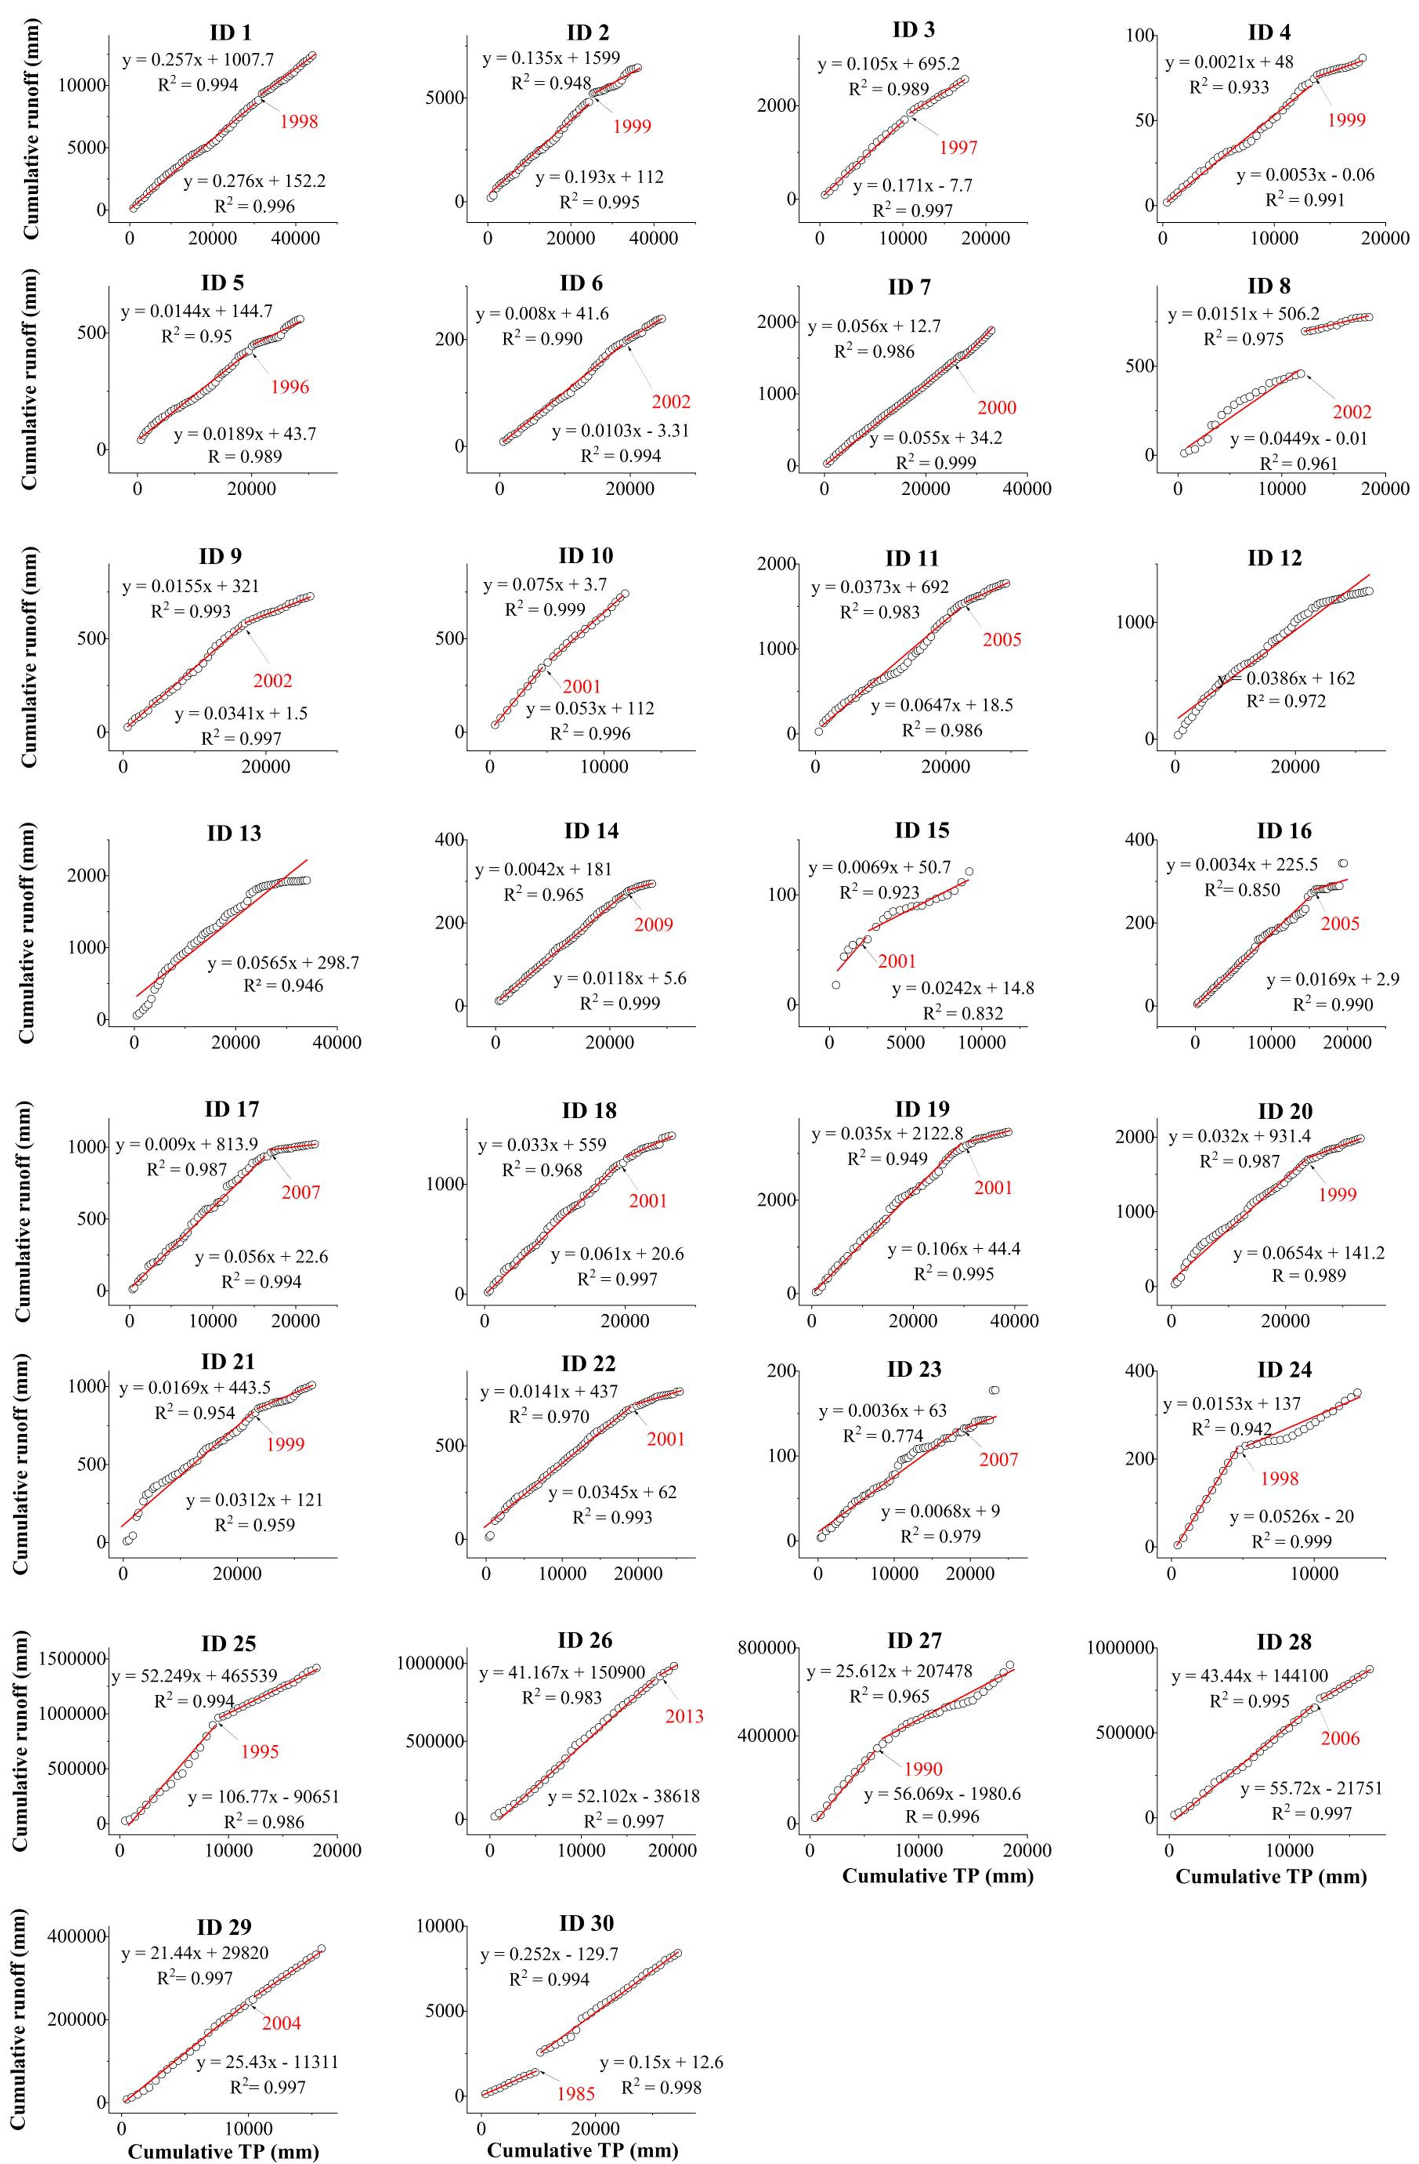
Fig. S1. Double-mass curves of TP and runoff for the 30 Mongolian rivers.
In each subset, the year of abrupt change is marked and colored in red. The red line represents the fitted curve. The equation of the fit curve, the correlation coefficient (R²) before and after the year of abrupt change are also given.
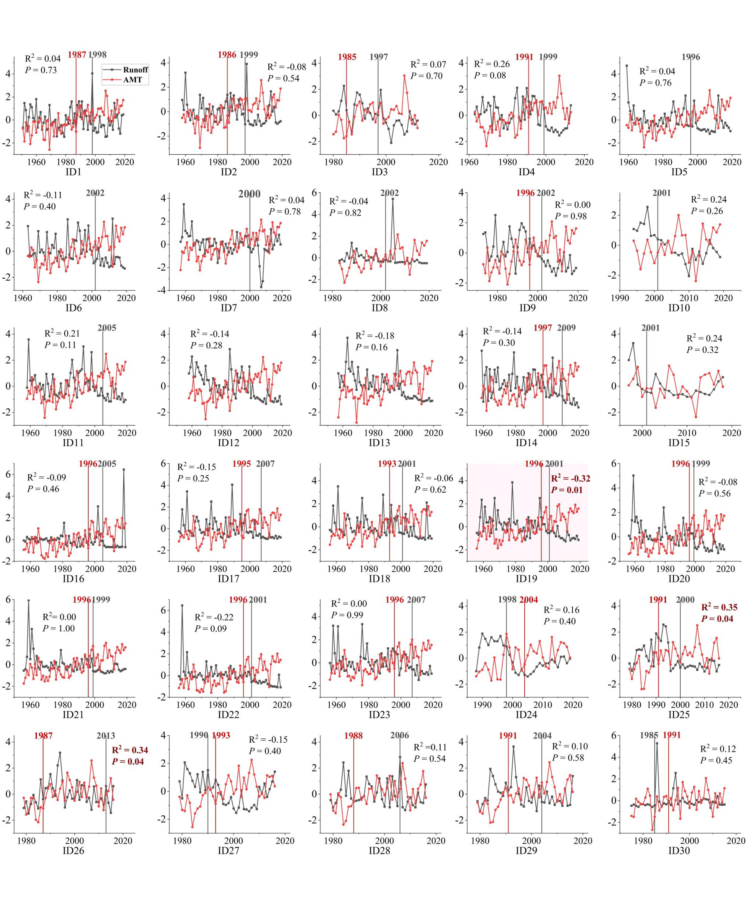
Fig. S2. Time series of river runoff (colored in gray) and AMT (colored in red) for the 30 Mongolian rivers.
The Y axis in each subset represents the standardized values of river runoff and AMT, employing max-min normalization. The vertical gray and red lines indicate the years of sudden change in runoff and AMT, respectively. The strength (R²) and significance (P) of the correlation between river runoff and AMT were labeled within each subset. R² and P were colored into red if P < 0.05. Subset #19 was highlighted with a red background in which AMT correlated significantly with runoff and AMT displayed abrupt changes five years before the sudden runoff shift (P＜0.05).

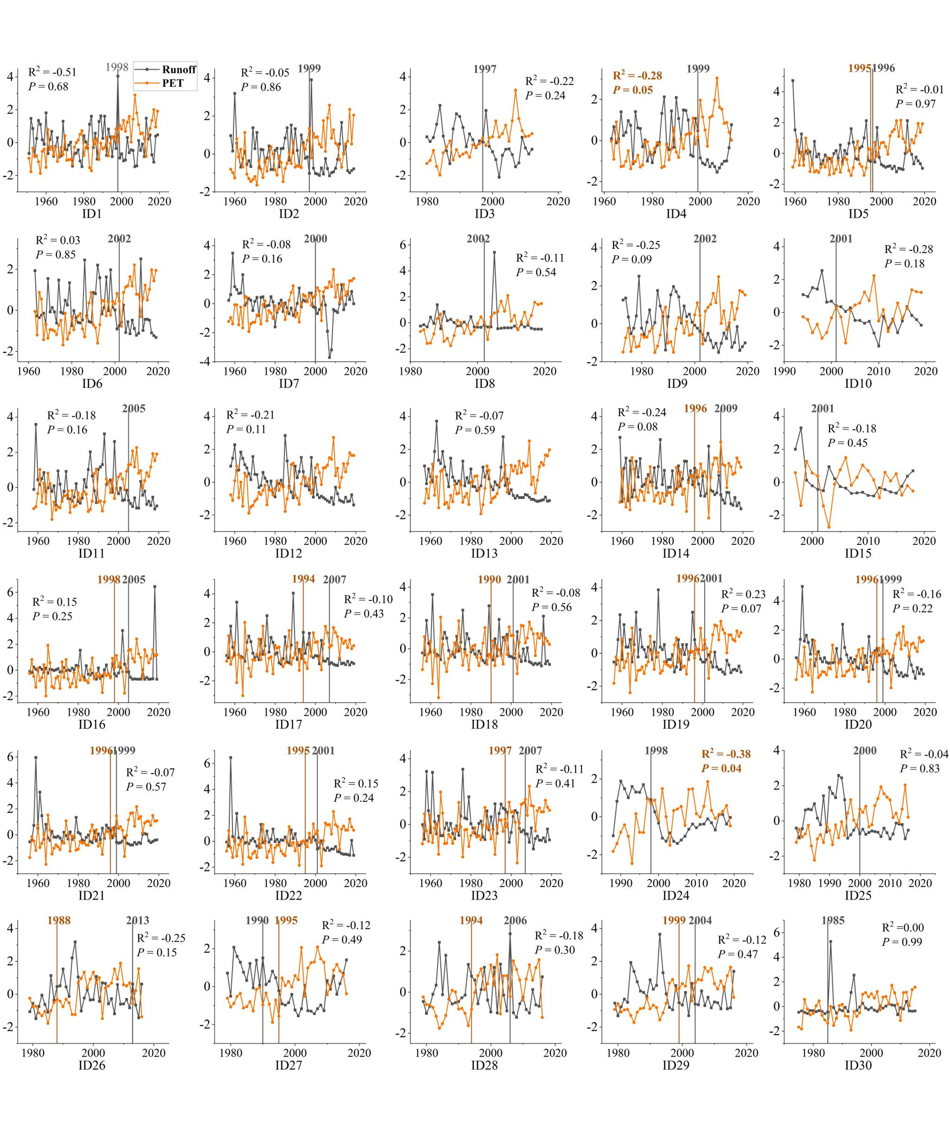
Fig. S3. Time series of river runoff (colored in gray) and PET (colored in orange) for the 30 Mongolian rivers.
The Y axis in each subset represents the standardized values of river runoff and PET, employing max-min normalization. The vertical gray and orange lines indicate the years of sudden change in runoff and PET, respectively. The strength (R²) and significance (P) of the correlation between river runoff and PET were labeled within each subset.

