Title: Land-Use Change Alters Specialist Bee Diet and Drives Body Size Declines
Authors: Sarah E. Anderson^{*1}, Philip Hahn², Gabriela Gonzalez³, Rachel E. Mallinger⁴
Journal: Landscape Ecology
*Corresponding author, ¹sea004@uark.edu; Department of Entomology and Nematology, University of Florida, 1881 Natural Area Dr., Gainesville, FL 32608; Current Address: University of Arkansas, 465 N Campus Walk, Fayetteville, AR 72701; ORCID:0000-0003-3543-0732
²hahnp@ufl.edu; Department of Entomology and Nematology, University of Florida, 1881 Natural Area Dr., Gainesville, FL 32608; ORCID:0000-0001-9717-9489
³gabriela.gonzalez@fdacs.gov; Department of Plant Industry, Florida Department of Agriculture and Consumer Services, 1911 SW 34th St., Gainesville, FL 32608
⁴rachel.mallinger@ufl.edu; Department of Entomology and Nematology, University of Florida, 1881 Natural Area Dr., Gainesville, FL 32608; ORCID: 0000-0003-3782-1710
S3: Relationship between host pollen collection and body size
Previous work has shown that larger bees are more competitive during pollen foraging than smaller conspecifics. Because Habropoda laboriosa is a purported specialist bee, we would expect that larger bees collect more pollen from host plants than smaller bees. To test whether larger bees were more competitive in pollen collection, we assessed the relationship between the proportion of Ericaceae pollen collected and the intertegular distance (ITD) of the same bees. We used a generalized mixed effects model with a beta distribution that included the proportion of Ericaceae pollen collected as the response variable, ITD as a fixed effect, and site and collection week nested within year as random effects. We found a significant, positive relationship between the proportion of Ericaceae pollen collected and body size (χ2 = 8.111, p = 0.004) (Fig. S3.1), indicating that larger bees do collect a greater proportion of host plant pollen than smaller conspecifics.

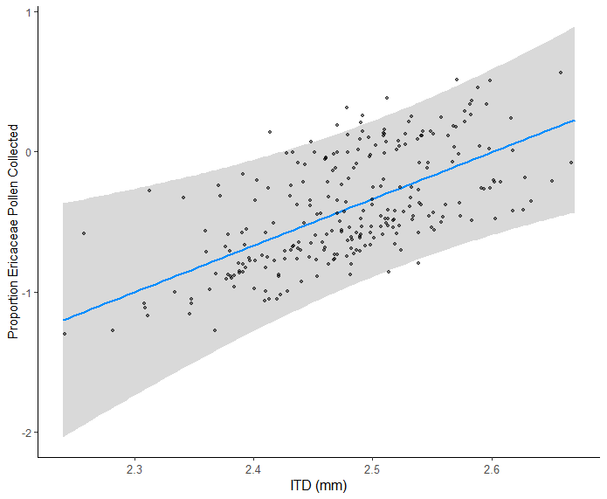
Fig S3.1 Response of proportion of host plant pollen (i.e., Ericaceae pollen) collected to ITD (i.e., body size). Displayed are estimates and model residuals for the response of proportion Ericaceae pollen collection to ITD. Site and collection week nested with year were included as random effects in the model. Points are slightly transparent such that darker points indicate overlapping values.

