Appendix

Appendix I. Detailed Method Description

Crossing Activity from GPS collared roe deer
Between 2010 and 2013, 46 roe deer (17 males and 29 females) were marked with GPS collars, in five study sites in Baden-Wuerttemberg, Germany. The roe deer were initially collared to understand the interaction of roe deer with a few selected roads sharing the same characteristics (see Brieger et al. (2019) for detailed methods and aim). Marking was carried out at four study sites within the Upper Rhine Valley (Oberbruch, Gamshurst, Zierolshofen and Sand) and one study site in the Hegau region. At each study site roe deer were caught using baited wooden box traps with triggered release or drive nets. Deer that weighed more than 15 kg and showed good health were equipped with GPS tracking collars (e-obs GmbH, Germany). Each collared roe deer sent GPS locations at a 15-minute fix interval when deer were active, and at a 180-minute fix interval once no movement was detected after five consecutive locations. Inaccurate GPS-fixes with an accuracy measure < 1000 were removed to reduce the probability of including false crossing events.
To get an estimate of how often each roe deer individual crossed a specific part of the road network, we divided the road network within the aggregated home range (99 % Minimum Convex Polygon) of roe deer into 50 m sampling buffers (centroids 100 m apart). Then we counted the number of times each individual crossed the road through the given sampling unit per biological season influencing roe deer behaviour (i.e., straight-line trajectory between two successive GPS-fixes that intersected a road; Kämmerle et al. 2017; Lewis et al. 2011; Meisingset et al. 2013; Kramer et al. 2016). While the 15-minute interval between fixes may be sufficient time for roe deer to walk along the road before crossing (thus contacting the road in multiple locations), we assumed the discrepancies between our estimated crossing locations and the true crossing locations were minimal, since we aggregated crossings into buffers encompassing a maximum of 100 m of road length.

Predicting the risk of a WVC occurring
To estimate the risk of WVC occurrence, we generated SDMs using known WVC locations from police reports as presence points, according to environmental predictors. To account for changes in movement behaviour of roe deer throughout the year, we built four models according to the biological seasons.
Data on the location of WVCs in Baden-Wuerttemberg were only available for one year, thus, to build the SDMs we used data from neighbouring state Hesse, where data is available for five years (2013 – 2017, n = 56 076; Brieger et al. 2021), and then validated the models using the data from Baden-Wuerttemberg (2021 – 2022, n = 12 617). Hesse and Baden-Wuerttemberg are both in southwestern Germany, and are similar in size, landcover type, human – and roe deer population density (Table 2).The advantage of using a SDM is the possibility of predicting relative collision risks in areas without WVC observations and identifying the variables that best explain their presence using nonlinear and discontinuous functions, which are to be expected when modelling the risk of WVC. Since known WVC locations are 'presence-only' data, we used Maximum Entropy Modelling (MaxEnt) to create spatially explicit predictions of WVC occurrence (Chyn et al. 2021; Merow et al. 2013). We chose SDM modelling, in particular MaxEnt, over other methods because of the predictive quality of comparable accuracy to ensemble methods, the ease of use, reduced computational time (Kaky et al. 2020) and because analyses are not as dependent on the quality and completeness of the data through the whole study area. Since each collision was recorded independently of one another, issues of spatial autocorrelation were negligible. In order to only include areas where the species are physically present and could potentially cross the roads, we created a bias grid using a two-dimensional kernel density estimate based on the coordinates of the WVC presence points and masked it to the road network (Syfert et al. 2013). We then generated 10 000 background points, with the probability of being sampled according to the bias grid, thus, biased towards areas with a higher density of presence points (Dudík et al. 2005; Elith et al. 2011; Phillips et al. 2009; Background collision positions generated using the ‘MASS’ package, Venables and Ripley 2002).
Table 2: Comparison of the two federal states Hesse and Baden-Wuerttemberg.
 | Hesse | Baden-Wuerttemberg
Size | 21 115 km² | 35 751 km²
Predominate landcover types | arable areas, meadows and broad-leafed forests | arable areas, meadows and coniferous forests
Proportion of landcover as traffic area or settlement | 15.9 % | 14.6 %
Length of road | 19 689 km | 36 643 km
Human population density | 298 inhabitants/km² | 310.6 inhabitants/km²
Roe deer density (in average hunting bag/ha) | 0.036 | 0.043

All MaxEnt models were trained using 5-fold cross validation (split into 80 % training and 20 % testing data). With many environmental predictors in the model, Vignali et al. (2020) recommend reducing collinearity in order to reduce model complexity and increase the interpretability of the predictors, without excluding certain predictors from the start. Therefore, the initial models were trained with all variables and only then variables were removed with a Spearman’s rho correlation value higher than 0.7, while using the Area Under the Receiver-Operating-Characteristics curve (AUC) to compare between the simplified models (Vignali et al. 2020). The three hyperparameters, thus, the fixed values that must be defined before model training, that can be optimized for MaxEnt modelling are the amount of regularization, the number of iterations and the feature class combinations (Merow et al. 2013). We used a Generic Algorithm implementation to optimize the hyperparameter configuration. Finally, we reduced the simplified optimized models to only include variables with a permutation importance higher than 2 %, while keeping the model performance constant. The resulting estimated risk of a WVC occurrence on the “cloglog” scale ranged between 0 and 1, which could be interpreted as the probability of a WVC to occur. We projected the estimated risk of WVC, as predicted from the model using data from Hesse, into Baden-Wuerttemberg. This served two purposes: to evaluate the spatial consistency of WVC and to validate the risk models using independent WVC data (i.e., the WVC data from 2021 – 2022 in Baden-Wuerttemberg).

Appendix II. SDM model results and evaluation
The most parsimonious model for each season included between 12 and 14 predictors to explain the risk of a WVC to occur (Fig. 6).
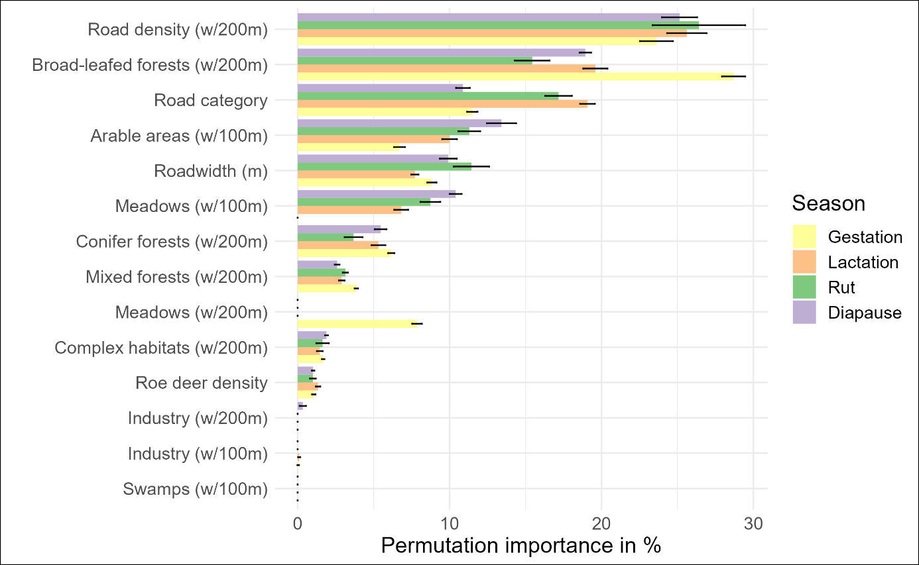Fig. 6: Mean permutation importance and standard error of the covariates remaining in the best model per ecological season. Landcover variables are described either for a 100x100 m (w/100m) or a 200x200 m (w/200m) moving window.
For evaluating model performance, we focused on the predictive performance between the training and testing data in Hesse describing the discrimination ability of the model. Discrimination is “the ability to distinguish between occupied and unoccupied sites” (Araújo et al. 2019). We used the evaluation statistics Area Under the Receiver-Operating-Characteristics curve (AUC) and the Correlation value (COR) (Syfert et al. 2013). The AUC metric evaluates the ability to discriminate between presence and absence sites, with an AUC value of 1.0 being considered a perfect prediction and a value of 0.5 or less a prediction no better than random. This measure can provide an indication of the usefulness of the models for prioritizing high risk areas. The COR, also known as the point biserial correlation, is calculated as the Pearson correlation coefficient between the prediction of WVC risk using the final risk models and the presence and background points. This value can inform about the degree of correlation between the model-predicted probability of occurrence.
In addition to the discriminate evaluation statistics AUC and COR and the statistical comparison of predicted WVC risk at actual WVC presence and background locations, the model calibration was, furthermore, evaluated for the independent data. Calibration can be defined as the concurrence between predicted probabilities of occurrence and observed proportions of sites occupied (e.g., an occurrence probability of 0.2 should mean that 20 % of such sites contain presence observations; Phillips and Elith 2010). The Presence only calibration (POC) plot treats the background locations used in MaxEnt modelling similarly to absence locations. It could, therefore, be used to indicate the extent to which the predicted probability of presence was related to the actual prevalence of presence points in the background data (Phillips and Elith 2010).
Using MaxEnt as a tool for distribution modelling of WVC proved to be useful for testing this complicated human-wildlife conflict. We could confirm that spatial modelling of WVC occurrences on a landscape-scale performed well in predicting collision hotspots for roe deer (Chyn et al. 2021). The strength of SDM modelling is that predictions can be made easily into areas where no data is available using true observational data (Merow et al. 2013), as opposed to more traditional methods for determining WVC hotspots such as kernel density estimations. This was proven by the validation of the model in a spatially different but regarding landscape features similar area. Predicted WVC risk in Baden-Wuerttemberg (the independent data) was significantly higher at all presence locations (0.6 ±0.18) than all background locations (0.26 ±0.26; Welch two-sampled t-test, t (17 256) = -72.531, p < 0.001, d = 0.99). However, it needs to be considered that projection into another area is only possible if the area is comparable in its characteristics and the data used for the modelling represents all the possible spatial characteristics. In order to project into more variable areas, the study area used for modelling has to be adapted. Similarly, this is also true when modelling WVC occurrence for another species than the species the model was built for. While roe deer are relatively easy to study, this is not the case for example with many carnivores (Grilo et al. 2009). Possible solutions for the future could be to model the risk for species guilds or higher-order groupings to allow sharing of information between similar species (Chyn et al. 2021). Thus, SDM modelling of WVC could be of great value for study species or areas where data is limited and detect potentially dangerous road sections before and plan mitigation measures accordingly (Gunson et al. 2011). The AUC for all models were in a moderate range, which was to be expected when using a large sampling size (Table 3 and Fig. 7). Models that have an AUC value higher than 0.75 can be considered useful in predicting the occurrence of a species or in the case of the present study, occurrence of WVCs (Lobo et al. 2008; Phillips and Dudík 2008). The COR values, furthermore, supported that the final models correctly predicted high risk for WVC ompare with known occurrence points within Hesse as well as Baden-Wuerttemberg.
Table 3: Mean model performance measures calculated on the internal withheld testing data in each cross-validation fold for the final model per season. Secondly, the mean model performance measures on the independent data from Baden-Wuerttemberg are shown. SD is lower than 0.00 for all measures.
 | Internal data |  | Independent data
 | AUC | COR | AUC | COR
Gestation (fc = “lqph”, reg = 0.4, iter = 500) | 0.75 | 0.46 | 0.74 | 0.40
Lactation (fc = “lqph”, reg = 0.4, iter = 500) | 0.74 | 0.44 | 0.73 | 0.33
Rut (fc = “lqph”, reg = 0.2, iter = 500) | 0.74 | 0.40 | 0.74 | 0.26
Diapause (fc = “lqph”, reg = 0.2, iter = 500) | 0.75 | 0.46 | 0.75 | 0.41
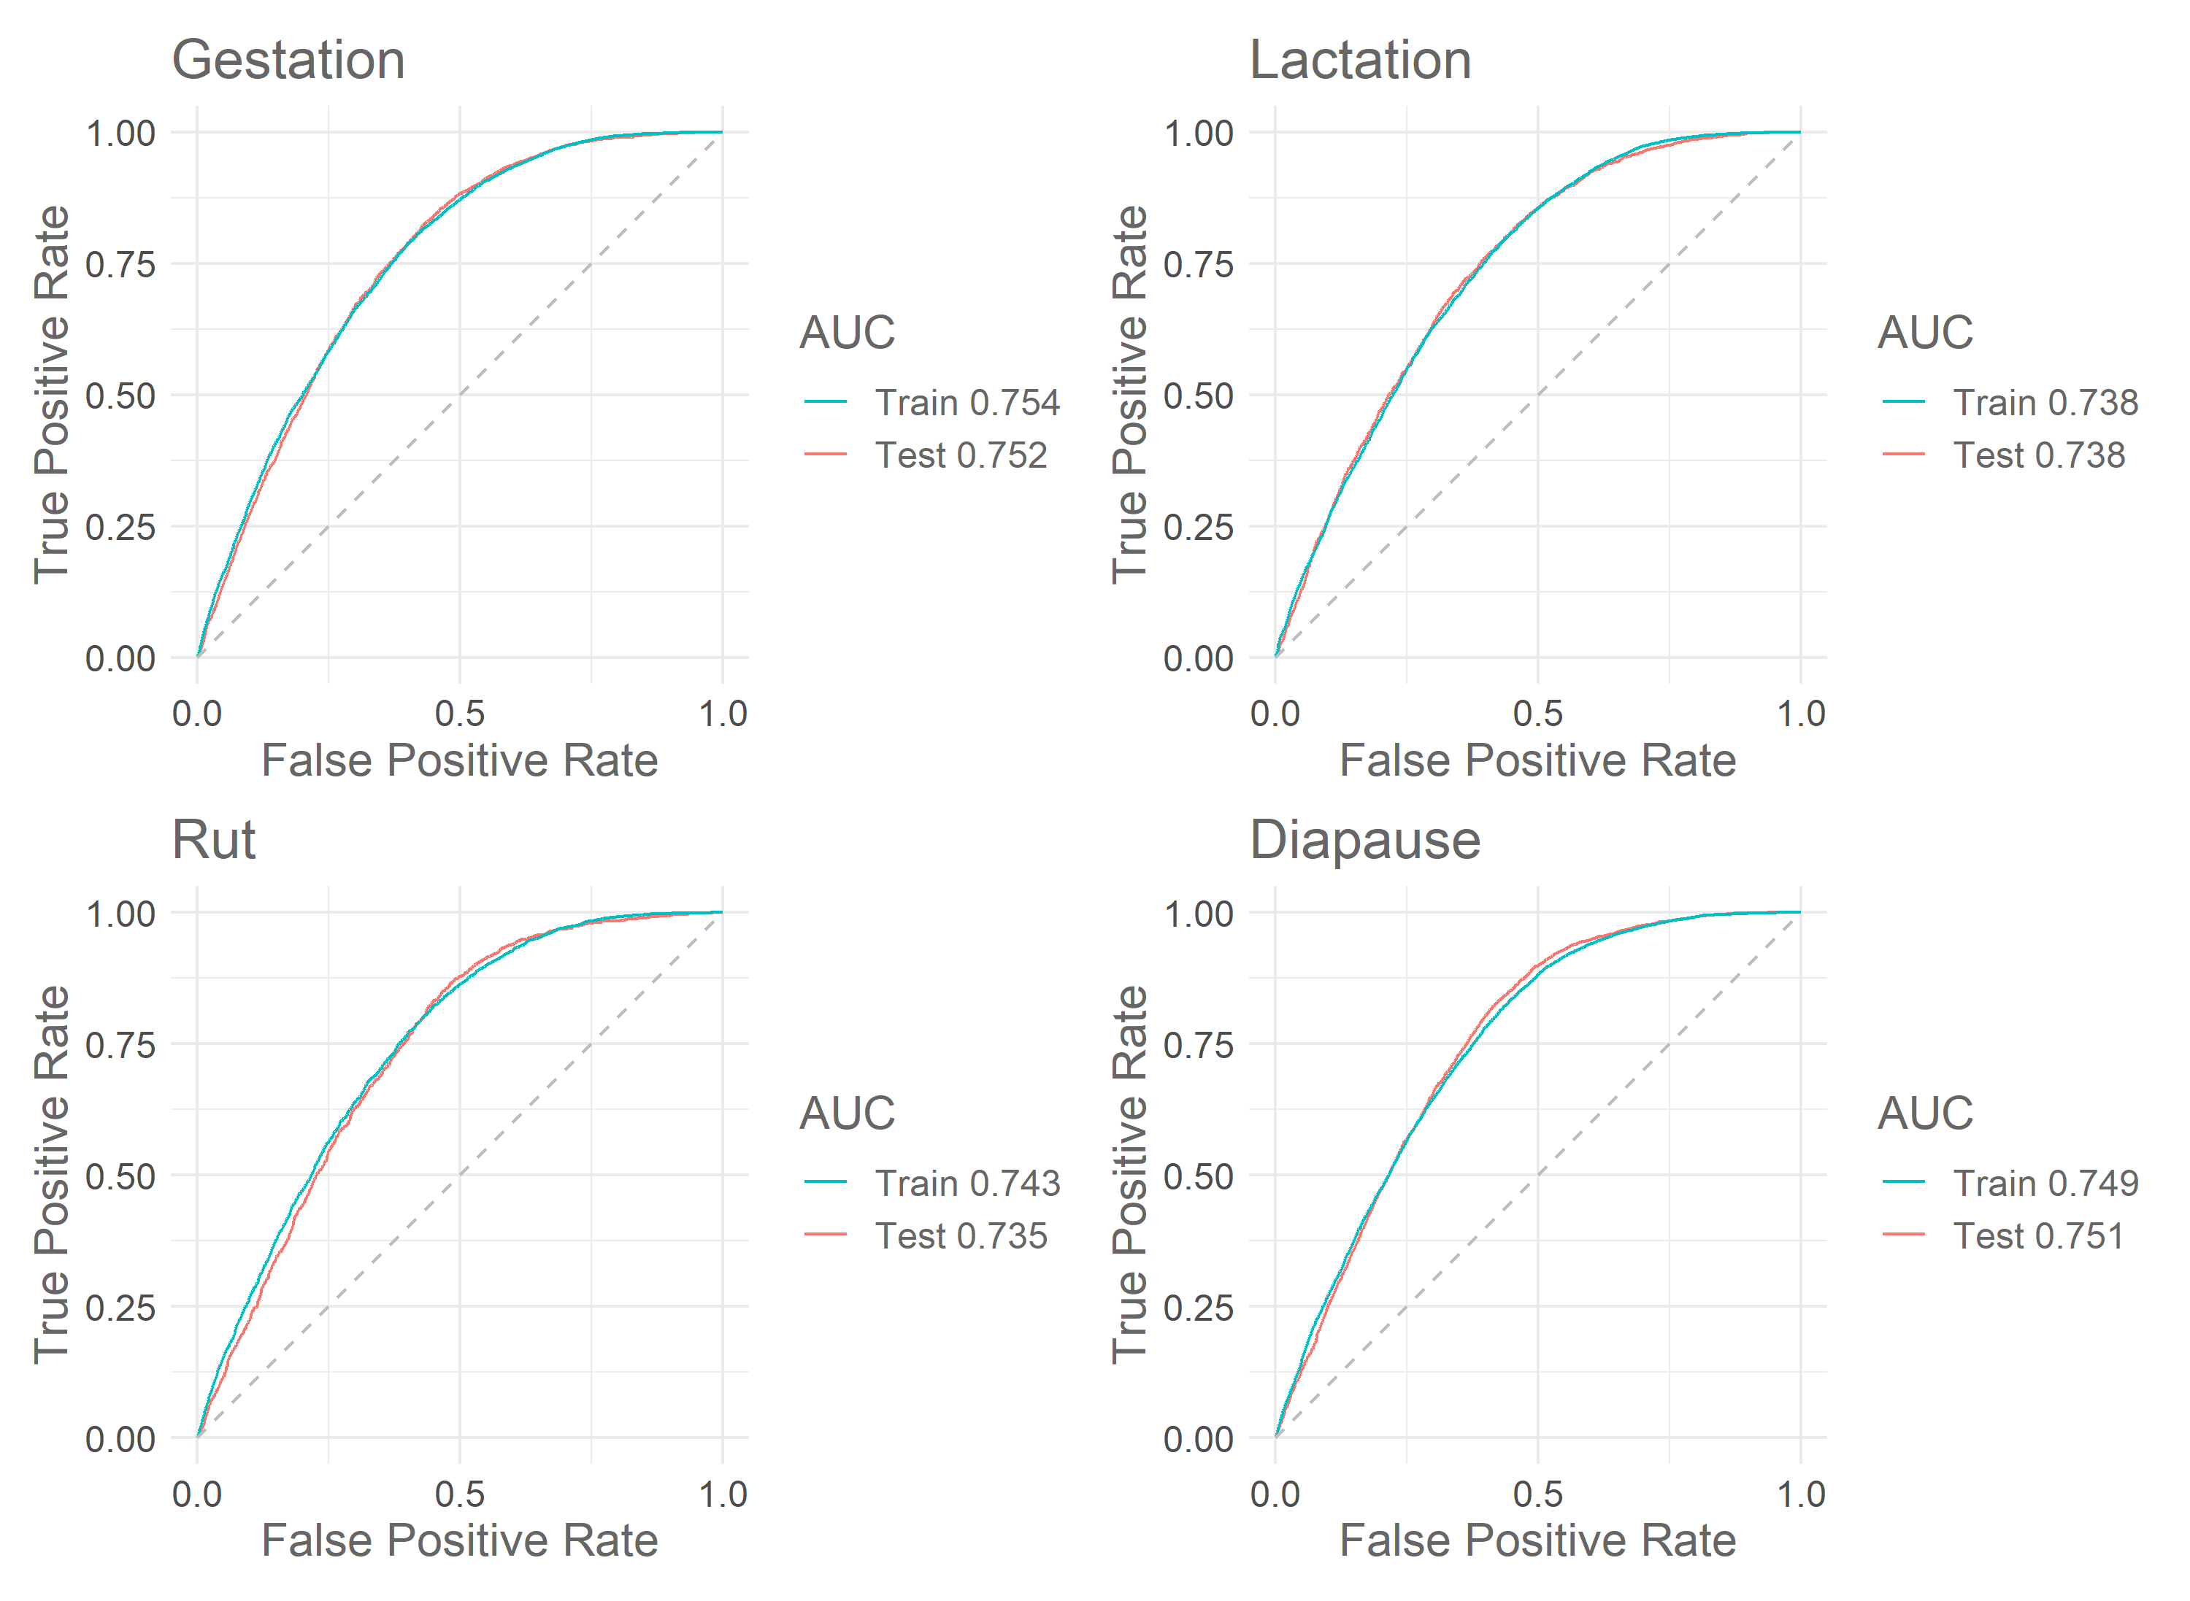Fig. 7: Receiver-Operating Characteristics curve showing the trade-off between the true positive rate (sensitivity) against the false positive rate (specificity) for each model per season comparing the training data from WVC in Hesse against the testing data from WVC in Baden-Wuerttemberg.
As the COR value might be sensitive to miscalibration (Phillips and Elith 2010), the POC plot evaluated the linearity of the predicted probabilities of a WVC to occur (Fig. 8). POC plots for all models indicated a slight underestimation of the relative probability of a WVC in low predicted probabilities. This underestimation could be attributed to the sampling bias that was inherent in the data. As the data came from mostly accidents with car and/or human damage, especially those WVC that might have been innocuous for the driver but nevertheless resulted in injury or death of the animals, remained unregistered. Likewise, probably due to the same sampling bias, the relative probability of a WVC to occur is overestimated in the range of high predicted probability. This bias was partly corrected for, as the background points were sampled according to the sampling effort but needs to be considered. Taking the uncertainties into account, it can be concluded that the model proves to identify hotspots of WVC with human or car damage with a slight overestimation. When using the model to predict high WVC risk zones, this overestimation can be adjusted for, by setting the threshold when to talk of a WVC risk zone, accordingly.
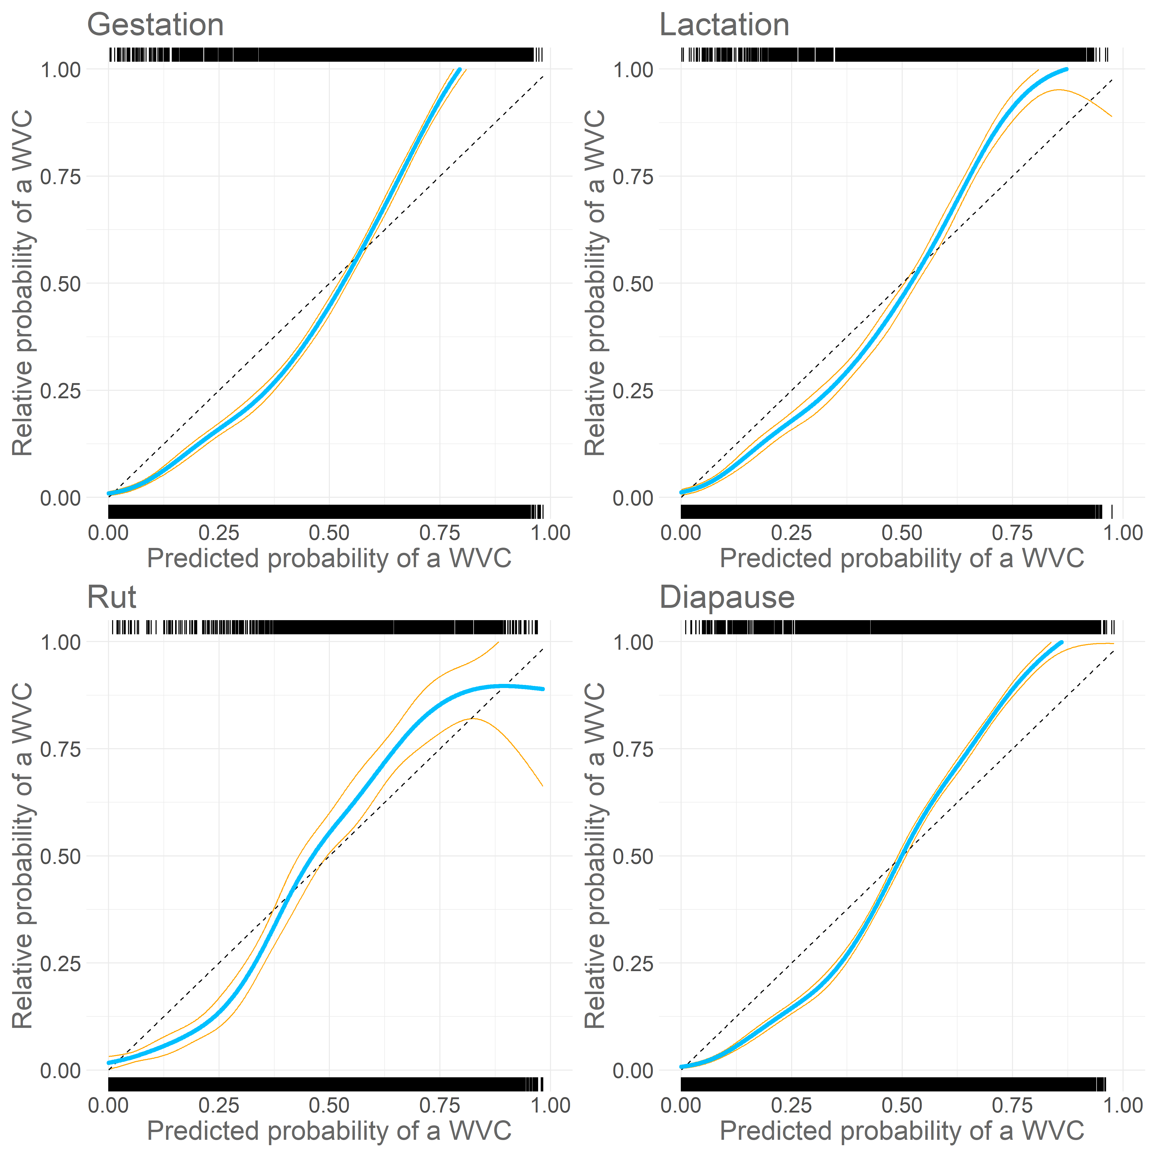
Fig. 8: Calibration plots on independent WVC locations in Baden-Wuerttemberg per season. The rug depicts the distribution of presence locations (top) and the background locations (bottom). Shown it the calibration curve (cyan) ± 2 SD (orange).

Appendix III. Crossing analysis results and evaluation
Table 4: Model output of the negative-binomial zero-inflated GLMM of number of crossings, as a response to WVC risk, sex, and season. The count model coefficients are from a negative binomial distribution with log link which estimated the number of crossing, while the zero-inflation model coefficients are from a binomial distribution with logit link, which evaluated the probability of zeros occurring in the data.
 | E (SE)
Count model: (Intercept) | -2.87 (0.27)***
Count model: DVC risk | 0.42 (0.17)*
Count model: Sex - males | 0.22 (0.10)*
Count model: Season - Lactation | 0.28 (0.14)*
Count model: Season - Rut | 0.29 (0.21)*
Count model: Season – Diapause | -0.06 (0.12)
Zero model: (Intercept) | -1.17 (0.24)***
Zero model: Season – Lactation | 1.38 (0.28)***
Zero model: Season – Rut | 0.42 (0.58)
Zero model: Season – Diapause | 0.17 (0.33)
Zero model: Sex – males | -0.66 (0.26)*
AIC | 12 096.2
Log Likelihood | -6 035.1
Num. Obs. | 3 069
Num. Groups: area | 5
Var (count model): area (Intercept) | 0.27
***p < 0.001; **p < 0.01; *p < 0.05

Table 5: AIC comparison of all models with number of crossings as response variable. Furthermore, included in all models is the log of days sampled and study area as random effect. "Count" described the count model, while "zi" described the part dealing with zero inflation in the same model.
 | df | AIC | Δ AIC to the next-best model
count: Risk + Season + Sex, zi: Season + Sex | 13 | 12 096.2 | 0
count: Risk + Season + Sex, zi: Season + Risk + Sex | 14 | 12 097.99 | 1.79
count: Sex*Season + Risk, zi: Season + Sex | 16 | 12 098.38 | 0.39
count: Risk + Sex, zi: Season + Risk + Sex | 11 | 12 098.76 | 0.38
count: Risk*Sex + Season, zi: Season + Risk + Sex | 15 | 12 099.18 | 0.42
count: Sex + Season, zi: Season + Risk + Sex | 13 | 12 100.00 | 0.82
count: Risk*Sex, zi: Season + Risk + Sex | 12 | 12 100.15 | 0.15
count: Sex*Season + Risk, zi: Season + Risk + Sex | 17 | 12 100.31 | 0.16
count: Sex*Season, zi: Season + Risk + Sex | 16 | 12 101.49 | 1.18
count: Risk + Season + Sex, zi: Season + Risk | 13 | 12 102.47 | 0.98
count: Sex*Season + Risk, zi: Season + Risk | 16 | 12 103.51 | 1.04
count: Risk + Season + Sex, zi: Risk + Sex | 11 | 12 114.29 | 10.78
count: Sex*Season + Risk, zi: Risk + Sex | 14 | 12 115.09 | 0.8

Extra References
Grilo, C., Bissonette, J.A. & Santos-Reis, M. (2009). Spatial-temporal patterns in Mediterranean carnivore road casualties: Consequences for mitigation. Biol Conserv 142(2):301–313. https://doi.org/10.1016/j.biocon.2008.10.026
Gunson, K.E., Mountrakis, G. & Quackenbush, L.J. (2011). Spatial wildlife-vehicle collision models: A review of current work and its application to transportation mitigation projects. J Environ Manage 92(4):1074–1082. https://doi.org/10.1016/j.jenvman.2010.11.027
Lobo, J.M., Jiménez-Valverde, A. & Real, R. (2008). AUC: A misleading measure of the performance of predictive distribution models. Glob Ecol Biogeogr 17(2):145–151. https://doi.org/10.1111/j.1466-8238.2007.00358.x
Phillips, S.J. and Dudík, M. (2008). Modelling of species distributions with MaxEnt: New extensions and a comprehensive evaluation. Ecography 31(2):161–175. https://doi.org/10.1111/j.0906-7590.2008.5203.x
Phillips, S.J. and Elith, J. (2010). POC plots: Calibrating species distribution models with presence-only data. J Ecol 91(8):2476–2484. https://doi.org/10.1890/09-0760.1

