Appendix S1

Expected relationships of farmland and landscape variables on bird densities
Table S1. Key farmland and landscape compositional variables with their expected relationships on bird densities based on the literature with exemplary key references (superscripts). References are in bold if the paper was conducted at a landscape scale (i.e., here: anything larger than field-scale or a 500 m radius).
Variable | Expected relationship
Arable land & grassland
Fodder & hay fields | positive ¹
Leys & pastures | positive (TD, OF) ²
Spring crops direct sown | positive (TD, OF) ³
Spring-sown crops | positive (TD, OF) ⁴
Autumn sown crops | positive ⁵ / negative ³
Subsidized grasslands | positive ^{6, 7}
Set asides | positive ⁸
Farmland structures
Farmyards | positive (FY/E) ⁹
Farmyards with animals | positive (FY/E) ^{2, 10}
Barns & Sheds | positive (FY/E) ¹¹
Non-crop habitats
Non-crop open | positive (OF) ¹²
Non-crop closed | positive (E) ²
Ditches | positive (E) ¹³
Landscape mosaic
Clearcuts (area) | positive/negative (ss) ¹⁴
Forests (area) | negative (OF) ¹⁵
Farmland (area) | positive (TD) ¹⁶
¹ Hancock & Wilson (2010), ² Hiron et al. (2013a), ³ Eggers et al. (2011), ⁴ Siriwardena et al. (2000), ⁵ Piha et al. (2003), ⁶ Toivonen et al. (2015), ⁷ Staggenborg & Anthes (2022), ⁸ Bracken & Bolger (2006), ⁹ Virkkala et al. (2004), ¹⁰ Šálek et al. (2018), ¹¹ Rosin et al. (2016), ¹² Marja et al. (2013), ¹³ Marja & Herzon (2012), ¹⁴ Ram et al. (2020), ¹⁵ Reino et al. (2009), ¹⁶ Stoate et al. (2001). Abbreviations: OF = open field species; E = edge species; FY = farmyard species; TD = total density; ss = species-specific responses
- Species guilds
Table S2. Species lists for the three guilds open field, edge, and farmyard species. The 14 Finnish Farmland Bird Index (FBI) species are marked with an asterisk and listed in Table 1 in the main text. Mean and SD of abundances across the 36 landscapes are given.
Scientific Name | Common Name | Mean abundance | SD abundance
Open field species
*Saxicola rubetra | Whinchat | 9.31 | 7.57
Perdix perdix | Grey partridge | 0.444 | 1.03
Coturnix coturnix | Quail | 0.0833 | 0.368
*Crex crex | Corncrake | 0.806 | 1.21
*Vanellus vanellus | Lapwing | 12.1 | 10.9
Gallinago gallinago | Common snipe | 2.61 | 3.1
Numenius phaeopus | Whimbrel | 0.111 | 0.398
*Numenius arquata | Curlew | 4.08 | 4.85
Tringa totanus | Redshank | 0.278 | 1.06
Asio flammeus | Short-eared owl | 0.139 | 0.424
*Alauda arvensis | Skylark | 55.4 | 58.4
*Anthus pratensis | Meadow pipit | 10.4 | 12.1
Motacilla flava | Yellow wagtail | 0.111 | 0.523
*Emberiza hortulana | Ortolan bunting | 3.03 | 5.56
Locustella naevia | Grasshopper warbler | 0.389 | 0.599
Limosa limosa | Black-tailed godwit | 0.111 | 0.667
Edge species
Emberiza citrinella | Yellowhammer | 51.1 | 20.1
Pica pica | Magpie | 4.67 | 2.77
Phasianus colchicus | Pheasant | 1.25 | 2.09
Locustella fluviatilis | Sedge warbler | 0.0278 | 0.167
Acrrocephalus dumetorum | Blyth’s reed warbler | 0.889 | 1.12
*Sylvia communis | Whitethroat | 16.1 | 11
Lanius collurio | Red-backed shrike | 2.14 | 2.38
Carpodacus erythrinus | Scarlet rosefinch | 3.25 | 3.48
Emberiza schoeniclus | Reed bunting | 5.08 | 8.12
Acrocephalus palustris | Marsh warbler | 0.806 | 1.45
Acrocephalus schoenobaenus | Sedge warbler | 5.78 | 10
Iduna caligata | Booted warbler | 0.0278 | 0.167
Luscinia luscinia | Thrush nightingale | 0.667 | 1.434
Tringa glareola | Wood sandpiper | 0.167 | 0.737
Carduelis cannabina | Linnet | 1.61 | 2.03

Farmyard species
*Hirundo rustica | Barn swallow | 8.556 | 7.077
*Delichon urbicum | House martin | 5.194 | 7.841
*Sturnus vulgaris | Starling | 6.111 | 7.210
*Passer montanus | Tree sparrow | 7.028 | 6.700
Passer domesticus | House sparrow | 6.917 | 9.324
Apus apus | Swift | 3.972 | 5.040
Oenanthe oenanthe | Wheatear | 0.472 | 0.774
Columba livia | Feral pigeon | 0.167 | 1.000
Streptopelia decaocto | Collared dove | 0.028 | 0.167
Motacilla alba | Pied wagtail | 12.000 | 6.986
*Corvus monedula | Jackdaw | 3.500 | 4.280

Correlation plots of predictors
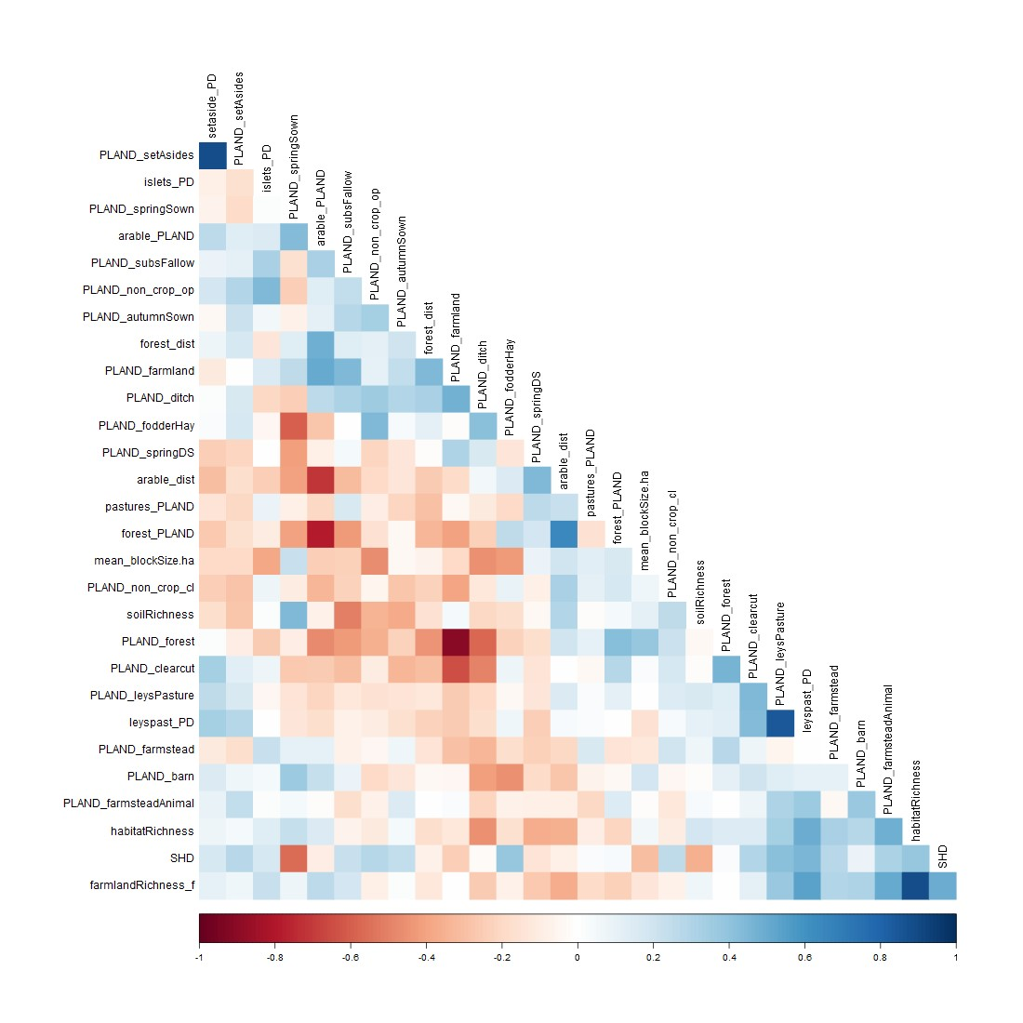
Fig. S1. Correlation matrix between all continuous predictors used for the modeling. PLAND_ refers to habitat classes mapped in the field (i.e., within the landscape area) while _PLAND and _dist refer to the CORINE landcover based variables measured within the extended 5 km buffer.
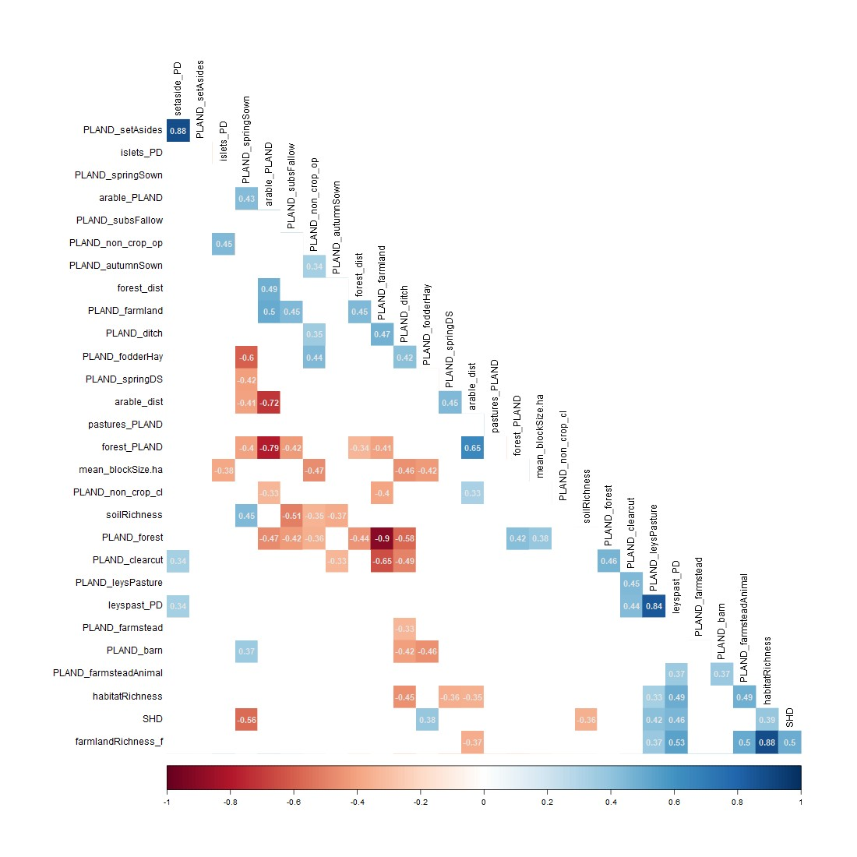
Fig. S2. Correlation matrix between all continuous predictors used for the modeling, shown for the significant correlations (p<0.05) with Pearson correlation values indicated in the squares. PLAND_ refers to habitat classes mapped in the field (i.e., within the landscape area) while _PLAND and _dist refer to the CORINE landcover based variables measured within the extended 5km buffer.

Additional results
Table S3. Model estimates of the best model for the total species density, densities of open field species, edge species, farmyard species, and FBI species. Given are model estimates, standard errors (SE), p-values, and confidence intervals (CI). Significant variables are shown in bold.
Term | Estimate | SE | p.value | CI 2.50% | CI 97.50%
Total Density (AICc = 26.193; R² = 0.550; R² adj = 0.492)
Intercept | 5.379 | 1.678 | 0.003 | 1.955 | 8.802
forest_dist.std | -0.170 | 0.057 | 0.006 | -0.286 | -0.053
shd.std | 0.222 | 0.063 | 0.001 | 0.094 | 0.351
PLAND_springSown.std | 0.173 | 0.063 | 0.010 | 0.044 | 0.302
PLAND_farmland.log | -1.983 | 0.913 | 0.038 | -3.844 | -0.121
Field Density (AICc = -30.554; R² = 0. 553; R² adj = 0. 511)
Intercept | 0.506 | 0.024 | 0.000 | 0.458 | 0.554
pastures_PLAND.std | 0.095 | 0.025 | 0.000 | 0.045 | 0.145
PLAND_farmland.std | 0.102 | 0.024 | 0.000 | 0.053 | 0.151
PLAND_fodderHay.std | -0.047 | 0.025 | 0.065 | -0.097 | 0.003
Farmyard Density (AICc = -69.213; R² = 0.628; R² adj = 0.590)
Intercept | 0.106 | 0.029 | 0.001 | 0.047 | 0.166
PLAND_farmstead.log | 0.234 | 0.078 | 0.005 | 0.075 | 0.392
PLAND_farmsteadAnimal.log | 0.396 | 0.110 | 0.001 | 0.171 | 0.622
PLAND_leysPasture.log | 0.124 | 0.049 | 0.017 | 0.024 | 0.224
Edge Density (AICc = -41.031; R² = 0.630; R² adj = 0.575)
Intercept | 2.891 | 1.429 | 0.053 | -0.040 | 5.823
pastures_dist.log | 0.139 | 0.039 | 0.002 | 0.058 | 0.220
setaside_PD.log | 0.279 | 0.121 | 0.028 | 0.032 | 0.526
forest_dist.log | -1.579 | 0.811 | 0.062 | -3.243 | 0.085
PLAND_farmland.std | -0.096 | 0.023 | 0.000 | -0.143 | -0.048
FBI density (AICc = -6.126; R² = 0.589; R² adj = 0.536)
Intercept | -2.213 | 1.127 | 0.059 | -4.511 | 0.086
habitatRichness.log | 2.299 | 0.937 | 0.020 | 0.388 | 4.210
PLAND_ditch.std | -0.100 | 0.038 | 0.014 | -0.178 | -0.022
PLAND_leysPasture.log | 0.245 | 0.113 | 0.039 | 0.014 | 0.476
PLAND_subsFallow.log | 0.352 | 0.109 | 0.003 | 0.129 | 0.574

4.1 Total density
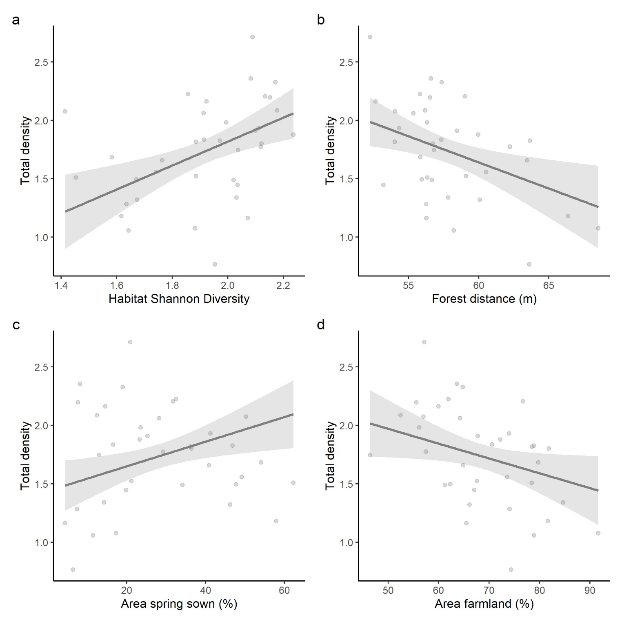
Fig. S3. Significant variables based on the full model for the total density of all farmland species observed in relation to a) habitat Shannon diversity, b) the mean distance between forest patches in the 5km buffer (m), c) the relative area of spring sown crops (%), and d) the relative farmland area (%). Points show the raw data, lines depict the mean and shaded area the CI.
4.2 Field species density
One outlier in the variable “Area pastures (5 km)” was removed (=truncated to values below 1%) and model estimates presented in the Figures here and in all tables are based on the subset data. (N = 35).
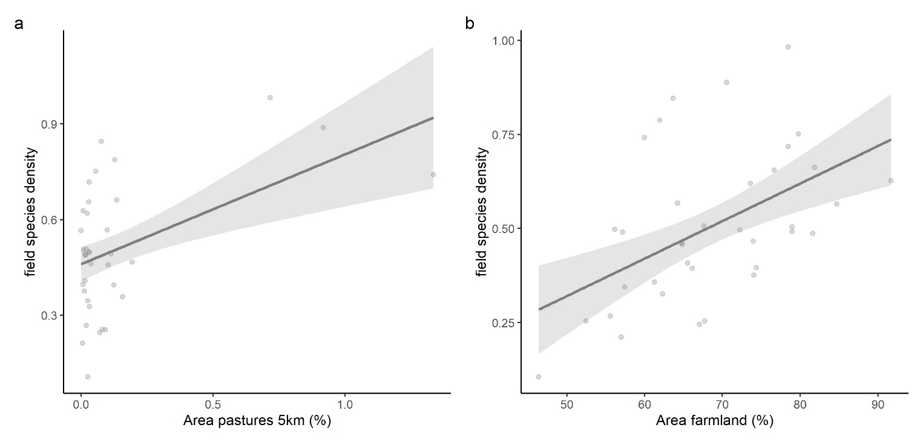
Fig. S4. Significant variables based on the full model for the density of field species observed in relation to a) the relative area of pastures in the 5km buffer, and b) the relative farmland area (%). Points show the raw data, lines depict the mean and shaded area the CI.
Outlier test:
check_outliers(fullm3.field, method = c("zscore_robust", "cook"))
OK: No outliers detected.
- Based on the following methods and thresholds: zscore_robust (3.09), cook (0.86)

Farmyard species density
Two outliers in the variable “Area farmyards with animals” were removed (=truncated to values below 2%) and model estimates presented in the Figures here and in all tables are based on the subset data (N = 34).
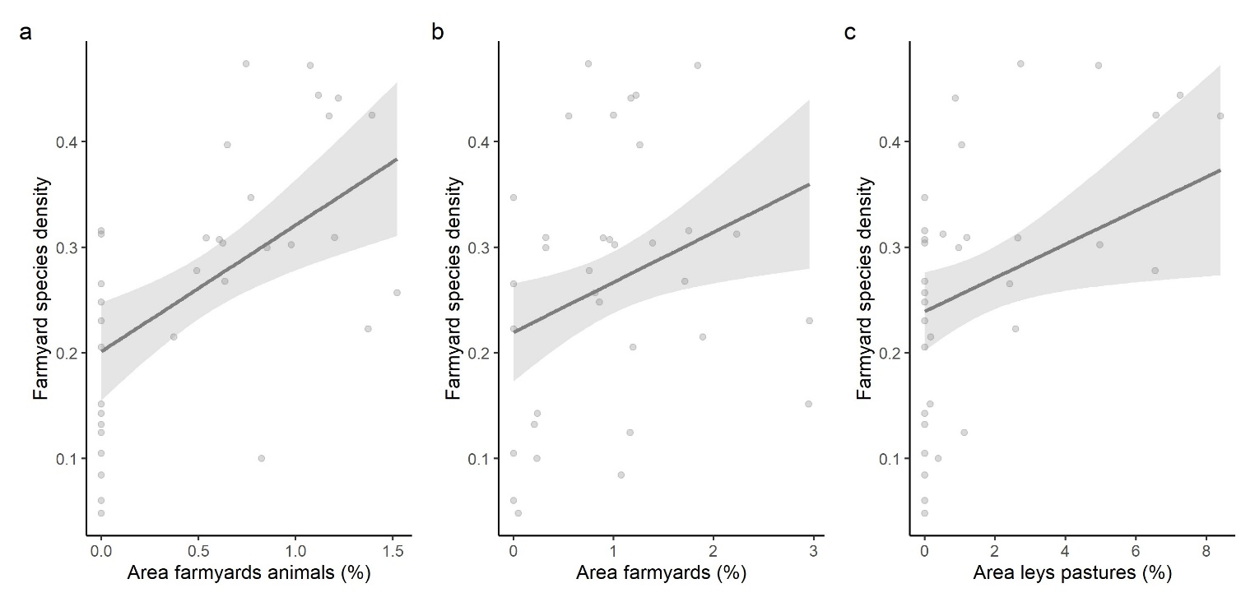
Fig. S5. Significant variables based on the full model for the density of farmyard species observed in relation to a) the relative area of farmyards with animals (%), b) the relative area of farmyards (%), and c) the relative area of leys and pastures (%). Points show the raw data, lines depict the mean and shaded area the CI.
Outlier test (after removing the outlier in area farmyards animals):
check_outliers(fullm5.farmyard, method = c("zscore_robust", "cook"))
OK: No outliers detected.
- Based on the following methods and thresholds: zscore_robust (3.09), cook (0.86)

Edge species density
One outlier in the variable “Set-aside density” was removed (=truncated to values below 6) and model estimates presented in the Figures here and in all tables are based on the subset data. In addition, there are 3 missing values in the variable “Mean distance pastures”. (N = 32).
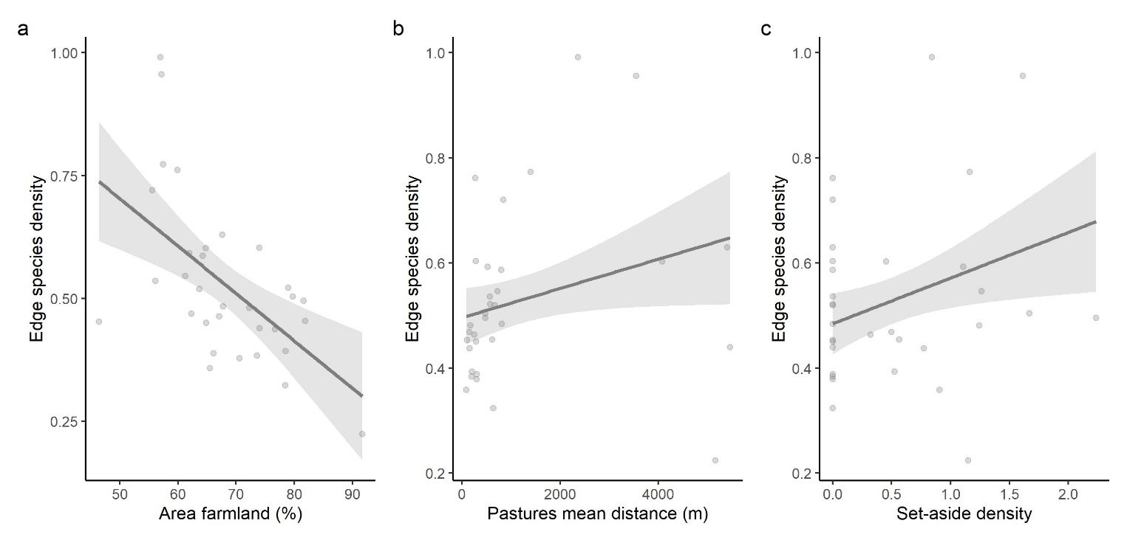
Fig. S6. Significant variables based on the full model for the density of edge species observed in relation to a) the relative area farmland (%), b) the mean distance between pastures in the 5km buffer, and c) the patch density of set-asides (patches/ha). Points show the raw data, lines depict the mean and shaded area the CI. Note that one observation was deleted due to an outlier in the set-aside density (value>6 was removed).
Outlier test (after removing the outlier in set-aside density):
check_outliers(fullm3, method = c("zscore_robust", "cook"))
OK: No outliers detected.
- Based on the following methods and thresholds: zscore_robust (3.09), cook (0.89)

4.5 FBI species density
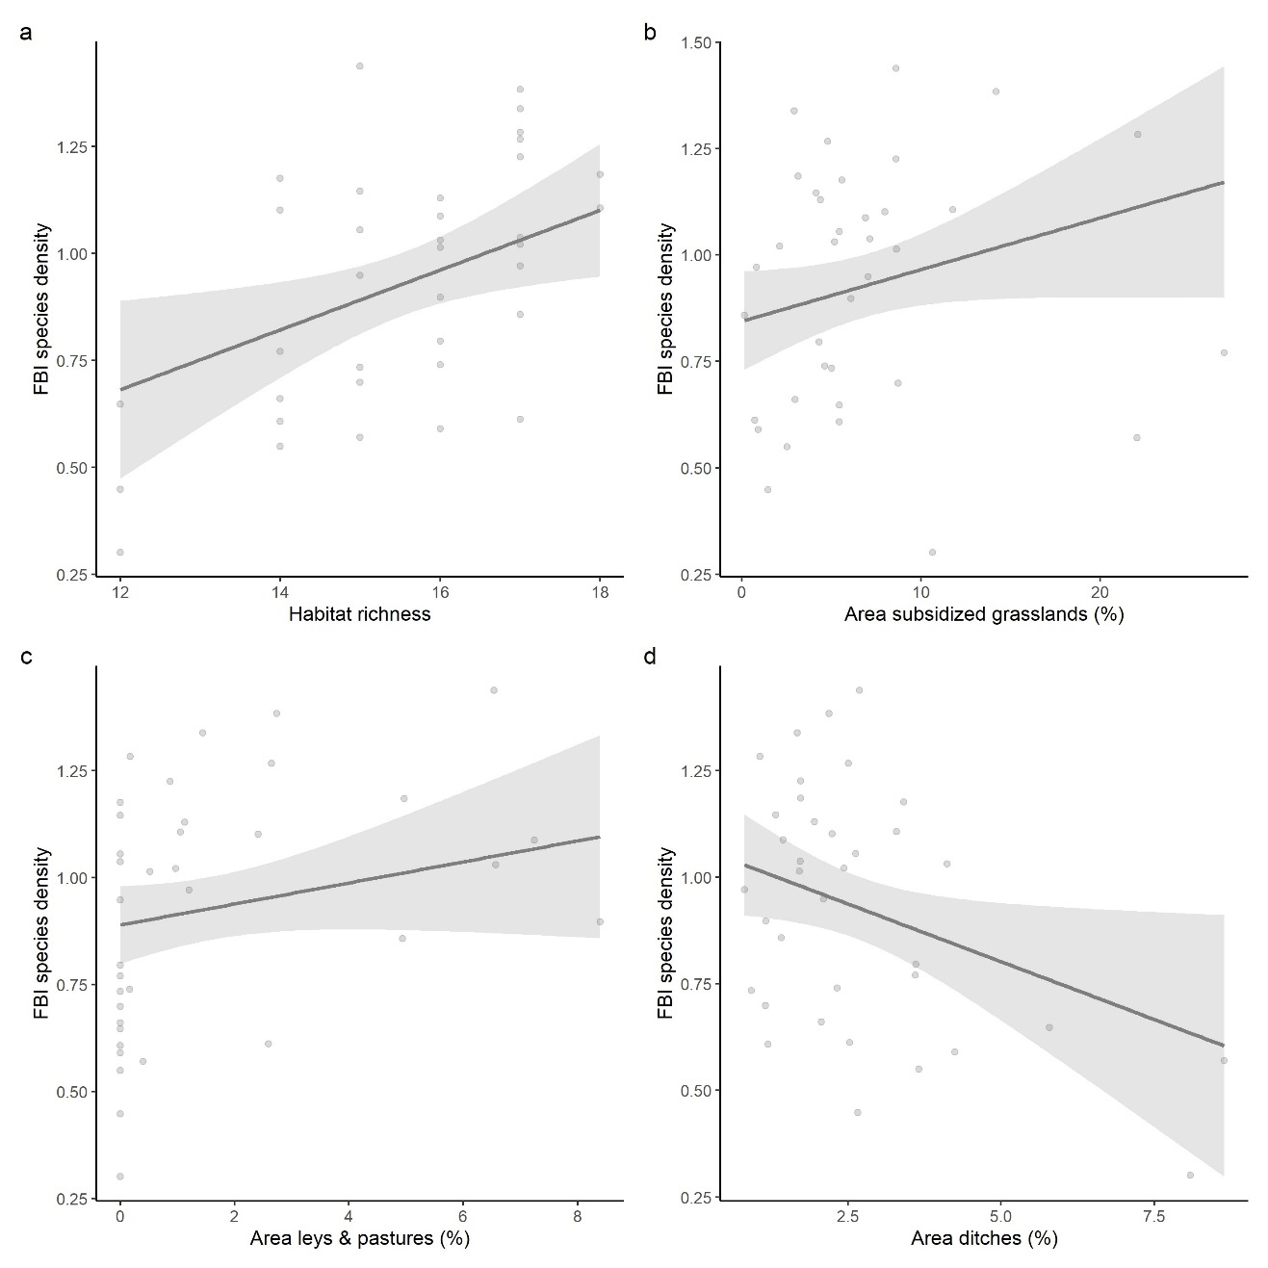
Fig. S7. Variables present in the full model for the density of FBI species observed in relation to a) habitat richness, b) the relative area of subsidized grasslands (%), c) the relative area of leys and pastures (%), and d) the relative area of ditches (%). Points show the raw data, lines depict the mean and shaded area the CI.
Outlier test:
performance::check_outliers(fullm.fbi, method = c("zscore_robust", "cook"))
OK: No outliers detected.
- Based on the following methods and thresholds: zscore_robust (3.09), cook (0.89)

Linear regression of single species top models
One outlier in the response variable (skylark abundances) was removed (=truncated to values below 300) and model estimates presented in the Figures here and in all tables are based on the subset data. (N = 35).

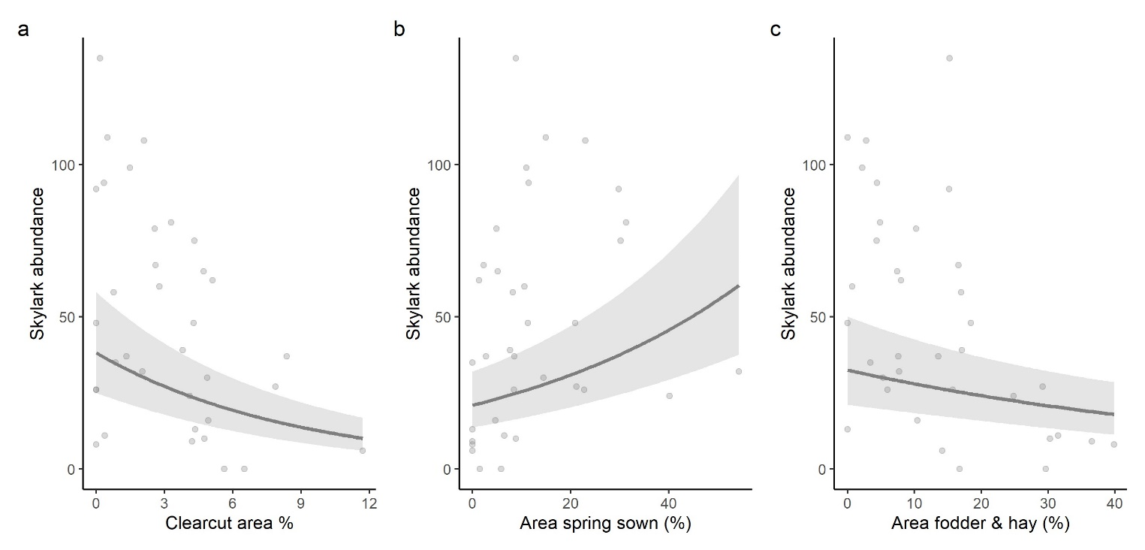
Fig. S8. Significant variables based on the full model for the abundance of skylarks observed in relation to a) the relative clearcut area (%), b) the relative area of spring direct-sown crops (%), and c) the relative area of fodder and hay (%). Points show the raw data, lines depict the mean and shaded area the CI.

N = 36
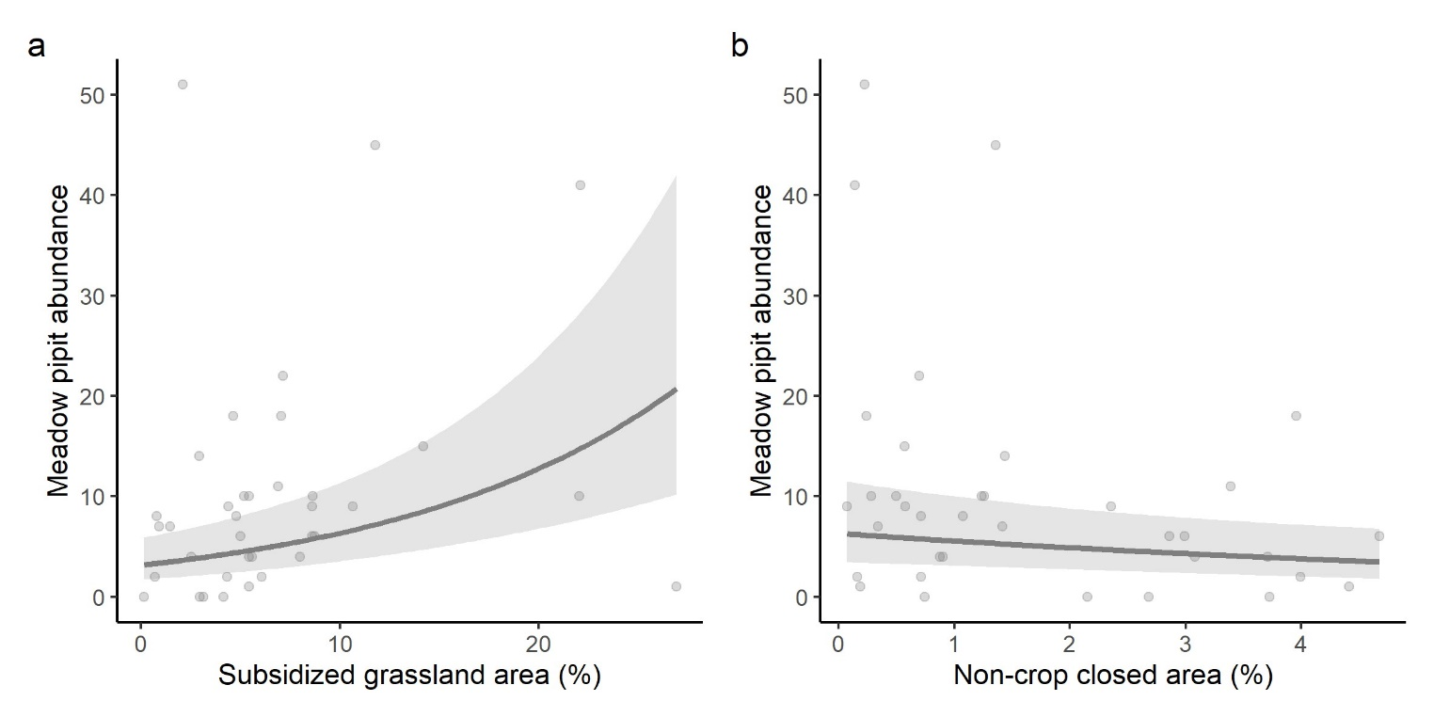
Fig. S9. Significant variables based on the full model for the abundance of meadow pipits observed in relation to a) the relative area of subsidized grasslands (%), and b) the relative area of non-crop closed elements (%). Points show the raw data, lines depict the mean and shaded area the CI.

One outlier in the response variable (house martin abundances) was removed (=truncated to values below 30) and model estimates presented in the Figures here and in all tables are based on the subset data. (N = 35).
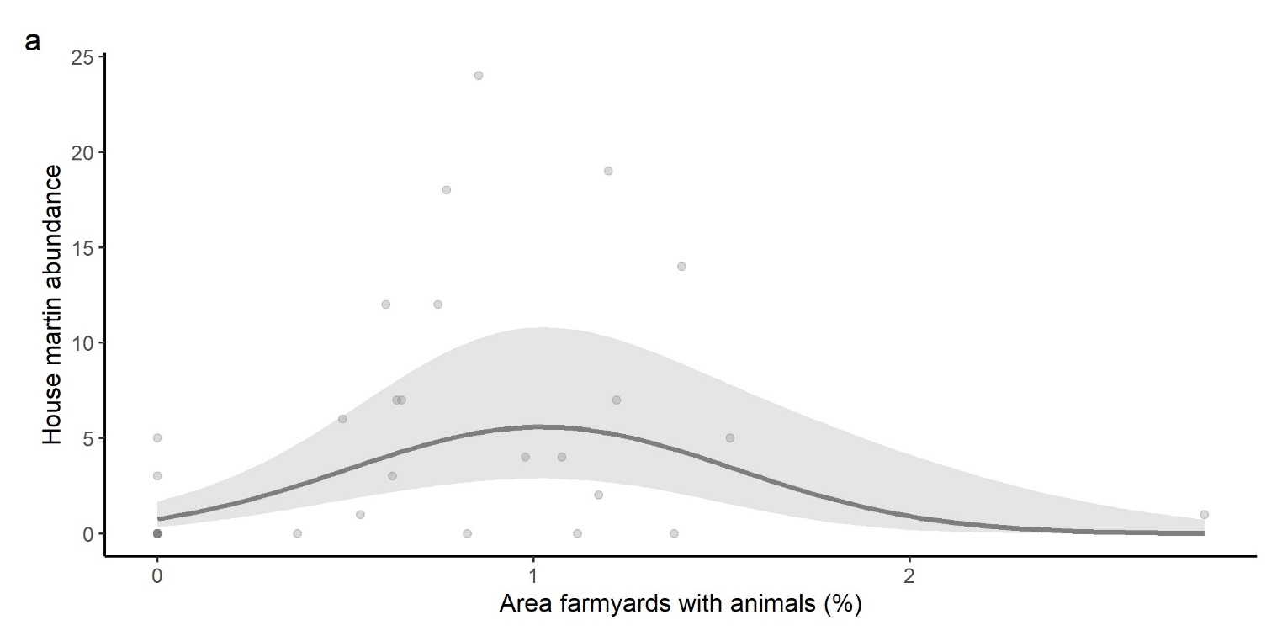
Fig. S10. Significant variable based on the full model for the abundance of house martins observed in relation to the relative area of farmyards with animals (%). Points show the raw data, lines depict the mean and shaded area the CI.

Two outliers in the response variable (ortolan bunting abundances) were removed (=truncated to values below 20) and model estimates presented in the Figures here and in all tables are based on the subset data. (N = 34).
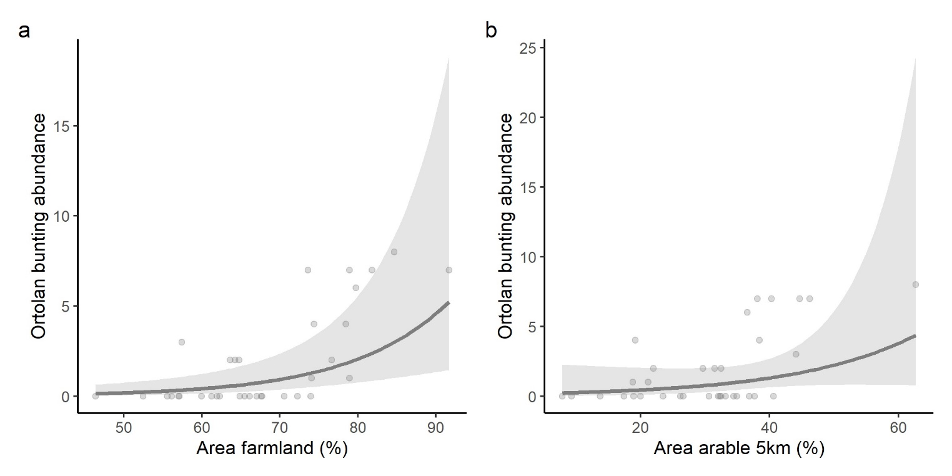
Fig. S11. Significant variables based on the full model for the abundance of ortolan buntings observed in relation to a) the relative farmland area (%), and b) the relative area of arable land in the 5km buffer (%) (ns). Points show the raw data, lines depict the mean and shaded area the CI.

N = 36
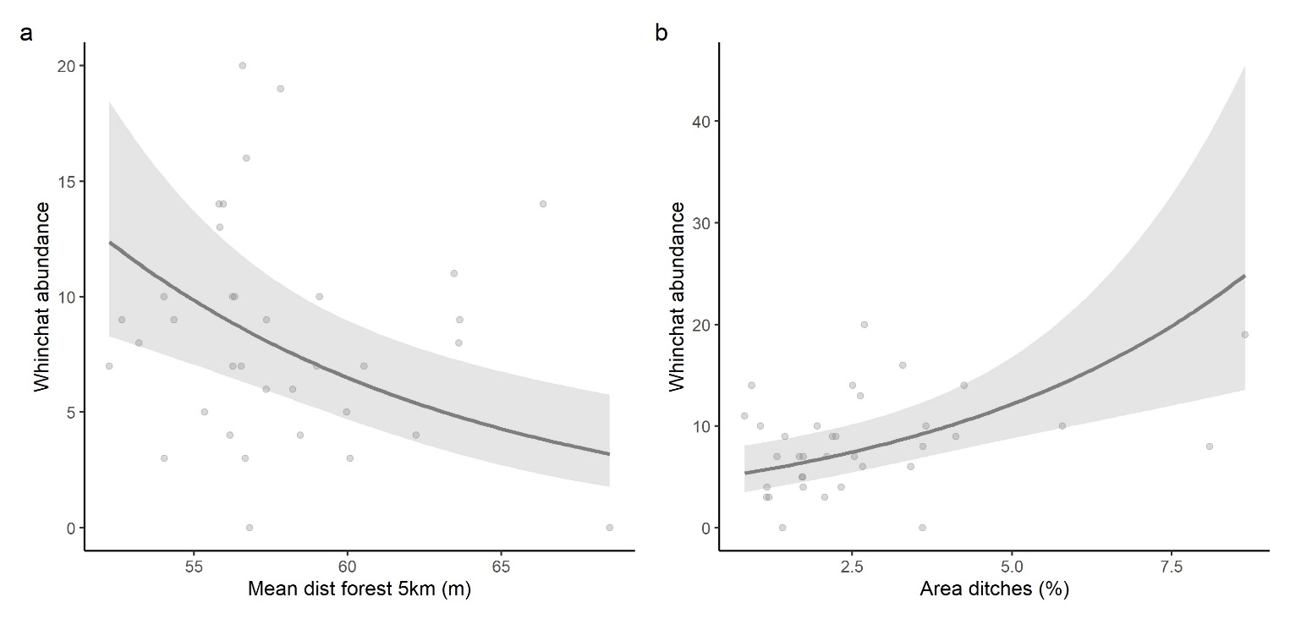
Fig. S12. Significant variables based on the full model for the abundance of whinchats observed in relation to a) the mean distance between forest patches in the 5km buffer, and b) the relative area of ditches (%). Points show the raw data, lines depict the mean and shaded area the CI.

N = 36
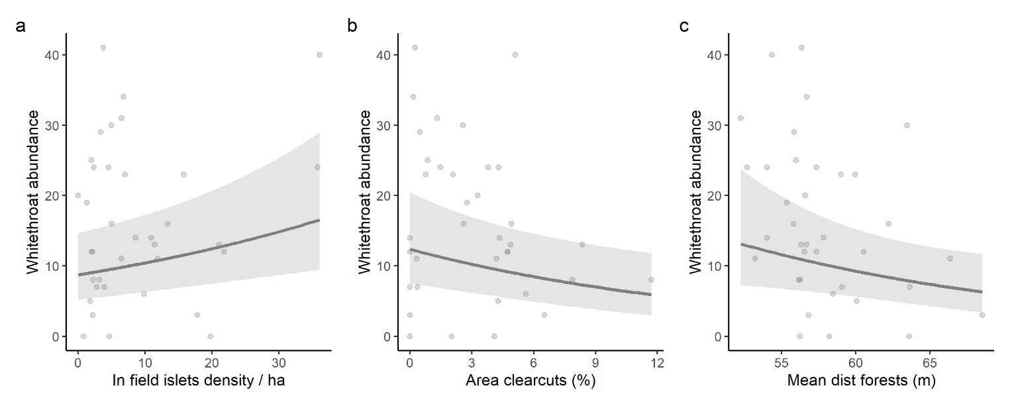
Fig. S13. Significant variables based on the full model for the abundance of whitethroat observed in relation to a) the patch density of in-field islets (patches/100 h), b) the relative area of clearcuts (%), and c) the mean distance between forest patches in the wider 5km buffer. Points show the raw data, lines depict the mean and shaded area the CI.

One outlier in the response variable (barn swallow abundances) was removed (=truncated to values below 30) and model estimates presented in the Figures here and in all tables are based on the subset data. (N = 35).
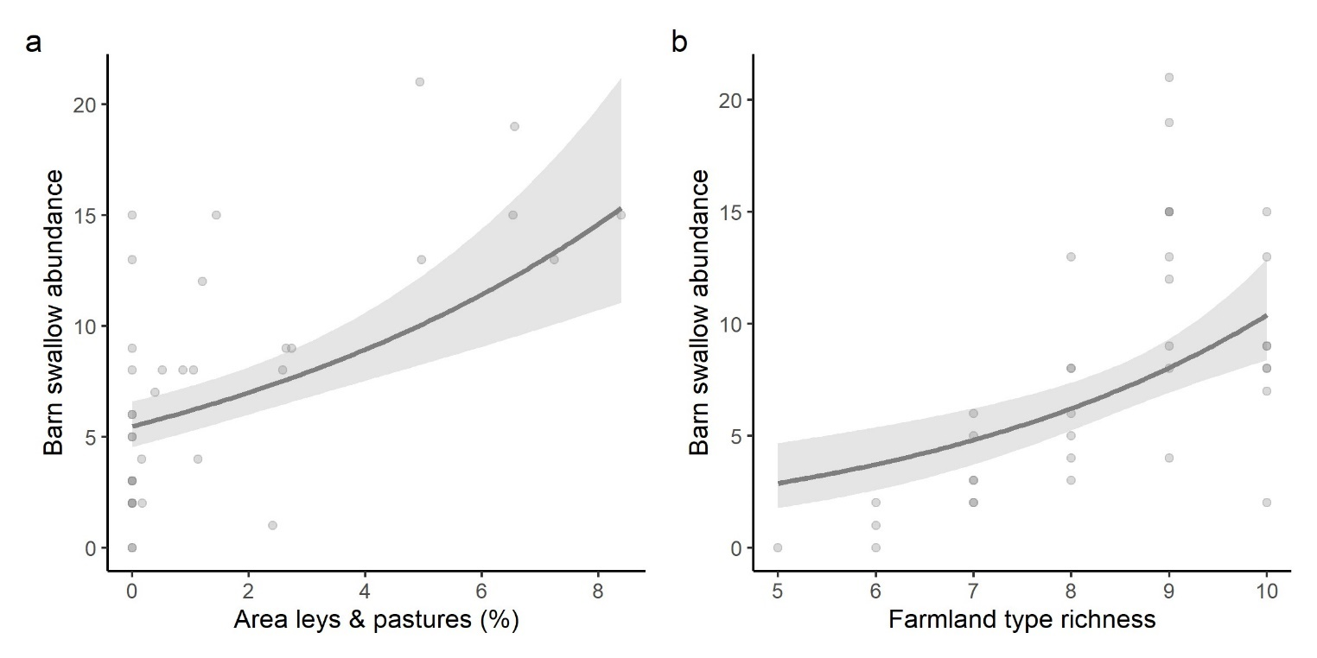
Fig. S14. Significant variables based on the full model for the abundance of barn swallows observed in relation to a) the relative area of leys and pastures (%), and b) the farmland type richness. Points show the raw data, lines depict the mean and shaded area the CI.

Three missing values present in the variable “Mean dist pastures”. (N = 33).
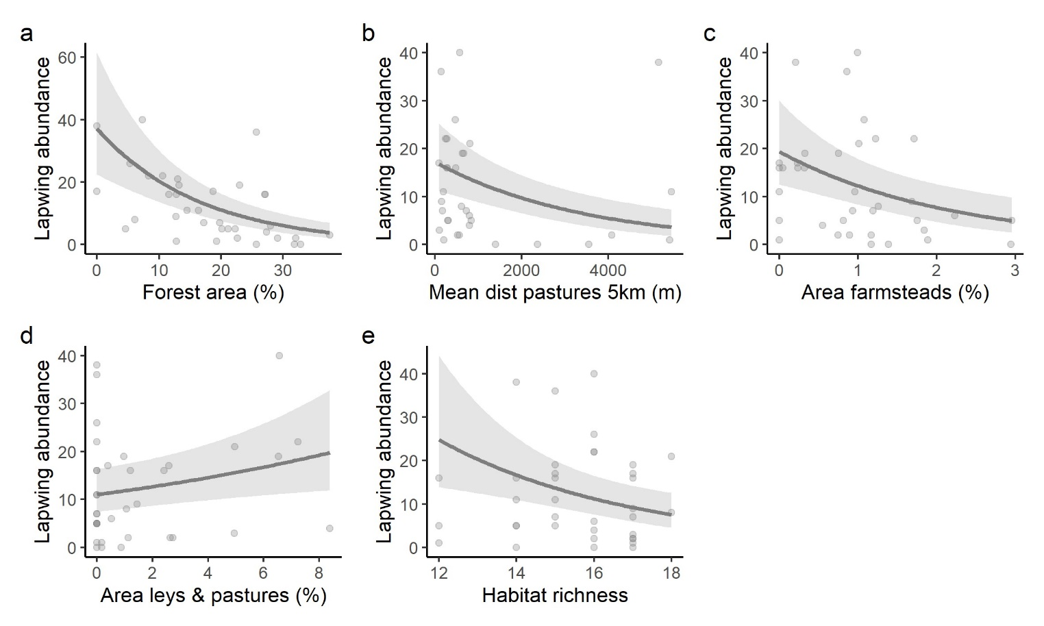
Fig. S15. Significant variables based on the full model for the abundance of lapwings observed in relation to a) the relative area of forest patches (%), b) the mean distance between pastures in the 5km buffer (m), c) the relative area of farmyards (%), d) the relative area of leys and pastures (%), and e) the habitat richness. Points show the raw data, lines depict the mean and shaded area the CI.

N = 36
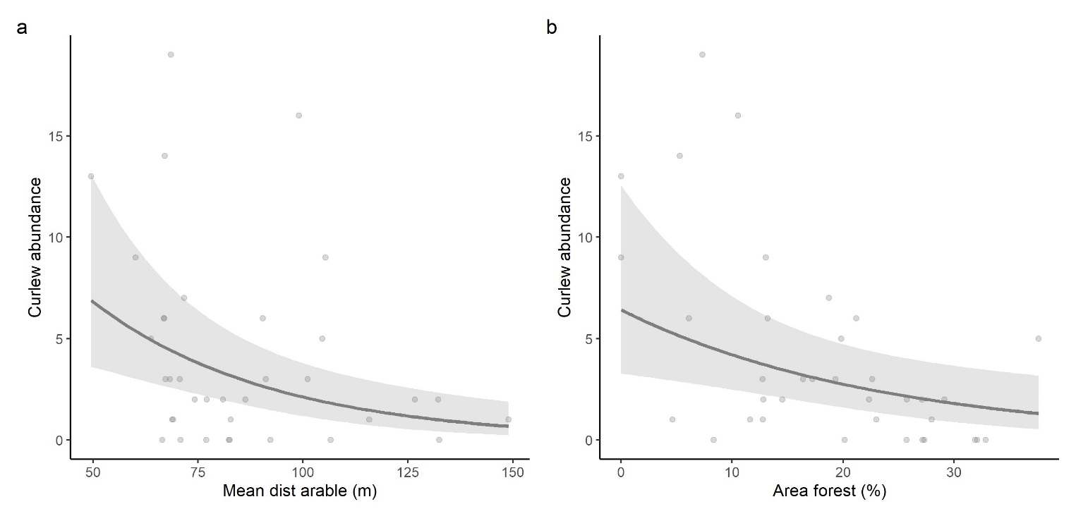
Fig. S16. Significant variables based on the full model for the abundance of curlews observed in relation to a) the mean distance between arable land (m), and b) the relative area of forests (%). Points show the raw data, lines depict the mean and shaded area the CI.

N = 36
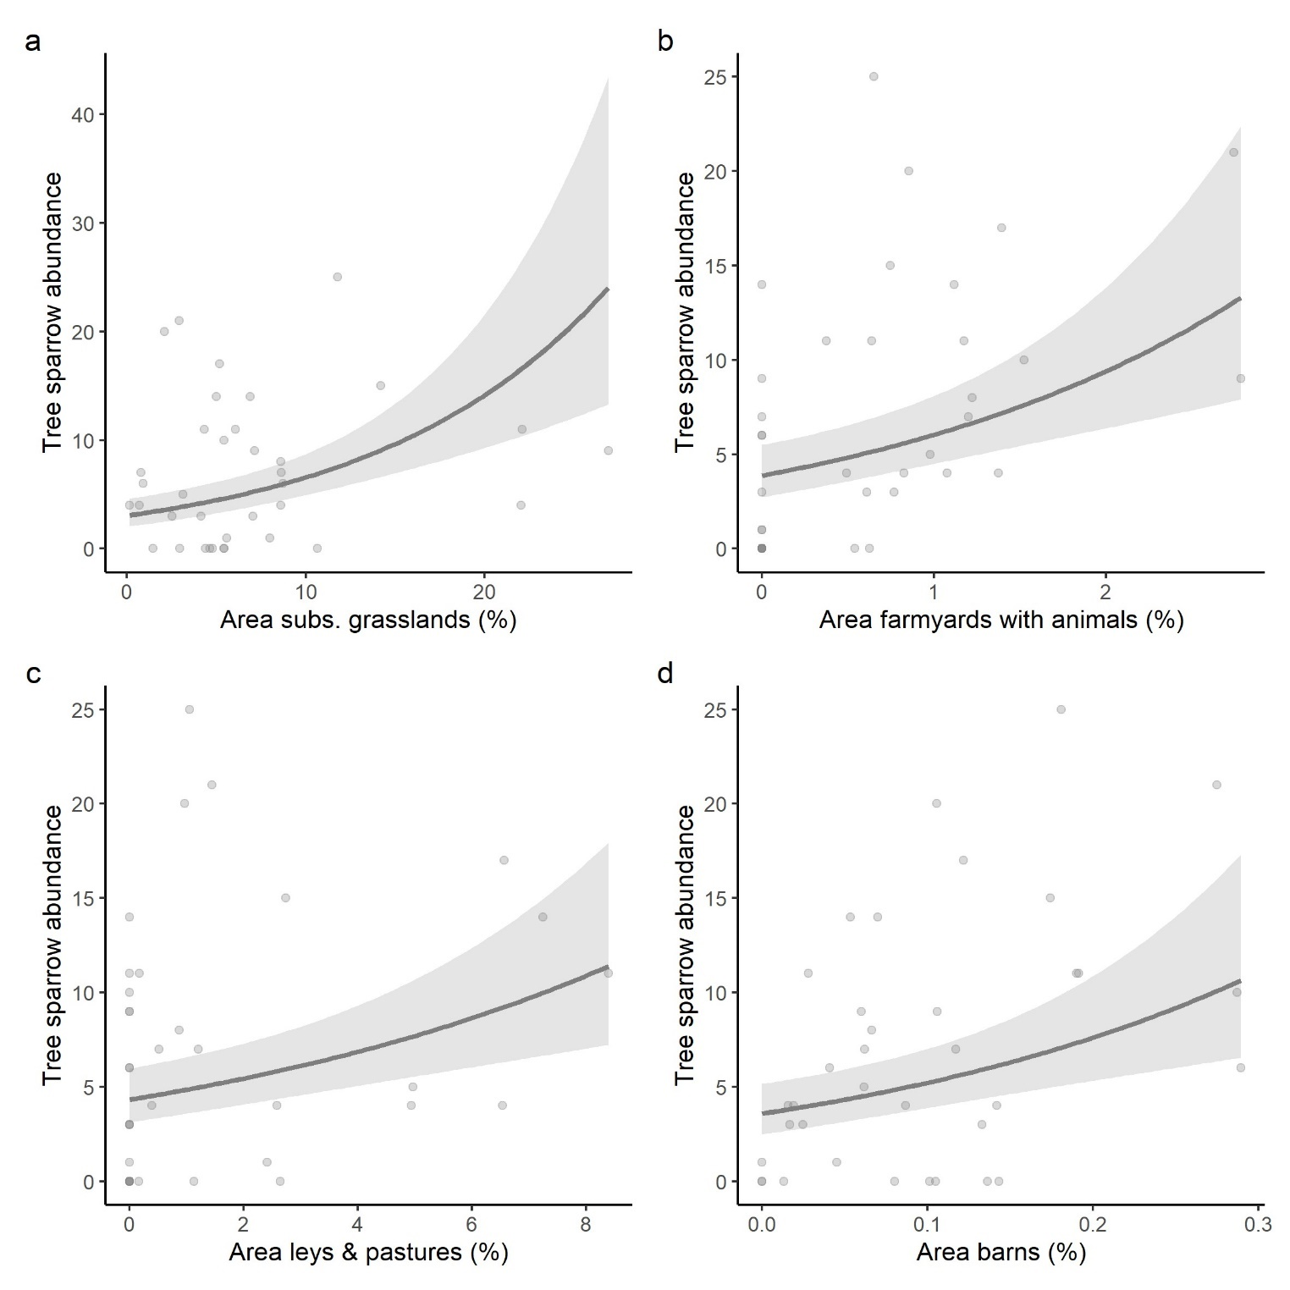
Fig. S17. Significant variables based on the full model for the abundance of tree sparrows observed in relation to a) the relative area of subsidized grasslands (%), b) the relative area of farmyards with animals (%), c) the relative area of leys and pastures (%), and d) the relative area of barns (%). Points show the raw data, lines depict the mean and shaded area the CI.
N = 36
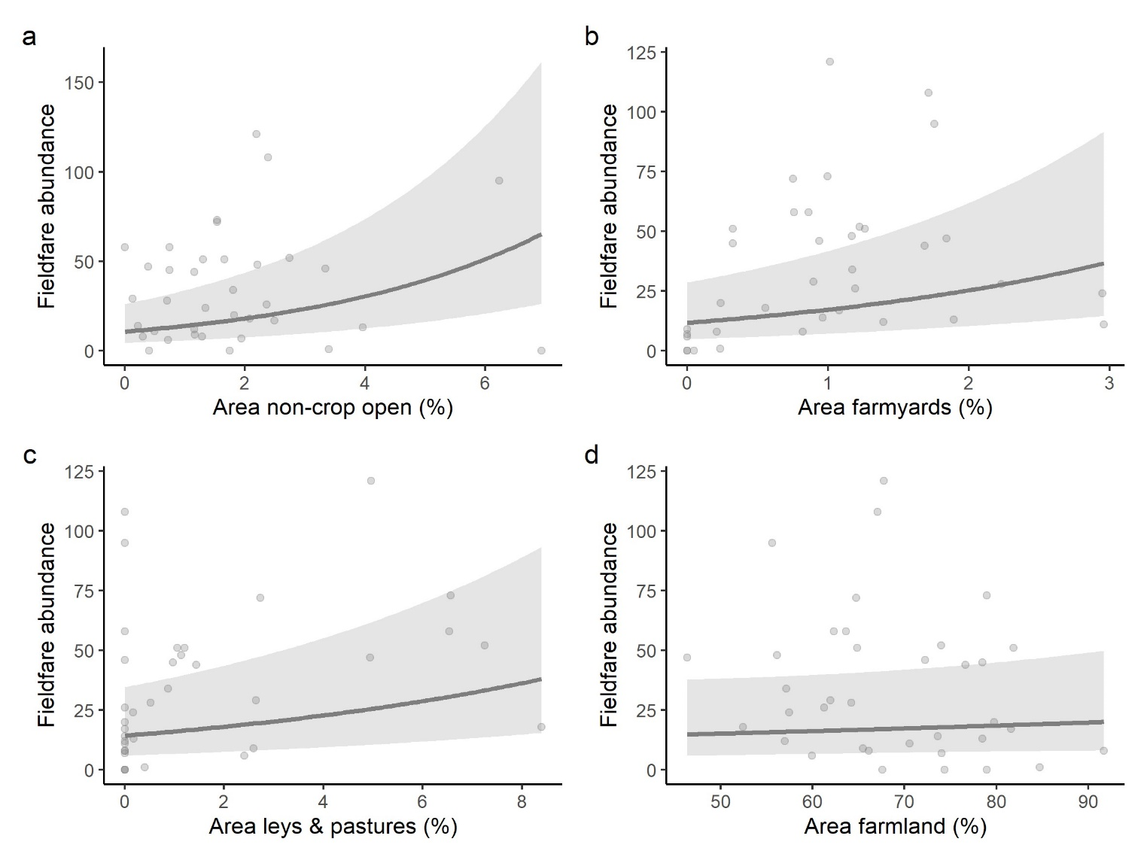
Fig. S18. Significant variables based on the full model for the abundance of fieldfares observed in relation to a) the relative area of non-crop open habitats (%), b) the relative area of farmyards (%), c) the relative area of leys and pastures (%), and d) the relative area of farmland (%). Points show the raw data, lines depict the mean and shaded area the CI.

N = 36
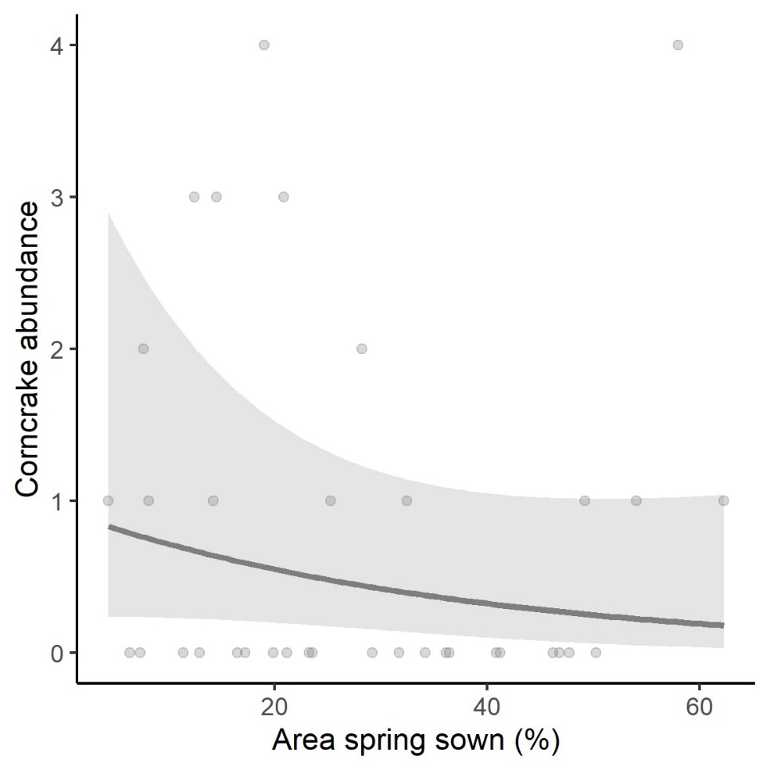
Fig. S19. Significant variables based on the full model for the abundance of corncrakes observed in relation to the relative area of spring sown crops (%). Points show the raw data, lines depict the mean and shaded area the CI.

One outlier in the response variable (starling abundances) was removed (=truncated to values below 30) and model estimates presented in the Figures here and in all tables are based on the subset data. (N = 35).
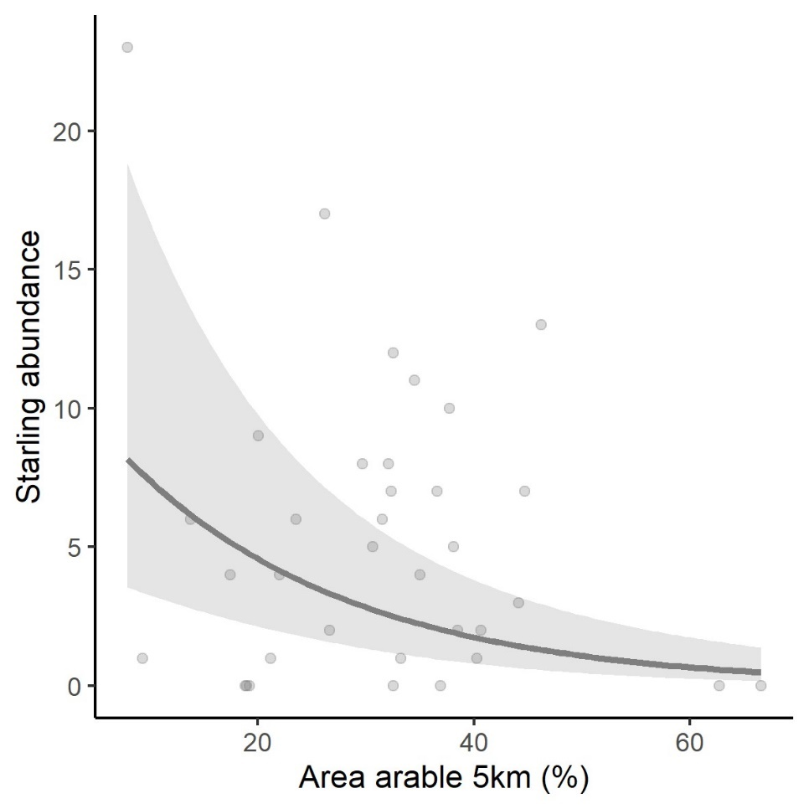
Fig. S20. Significant variables based on the full model for the abundance of starlings observed in relation to the relative area of arable land in the 5km buffer (%). Points show the raw data, lines depict the mean and shaded area the CI.

N = 36
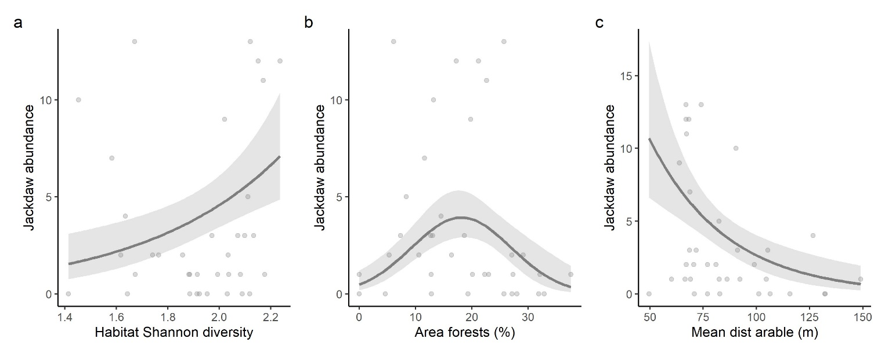
Fig. S21. Significant variables based on the full model for the abundance of jackdaws observed in relation to a) habitat Shannon diversity, b) the relative area of forests (%), and c) the mean distance between arable land (m). Points show the raw data, lines depict the mean and shaded area the CI.

4.7 Relationship between farmland bird density and latitude
Linear model total density ~ latitude:
lm: estimate ± SE = -0.178 ± 0.041, t=-4.337, p<0.001
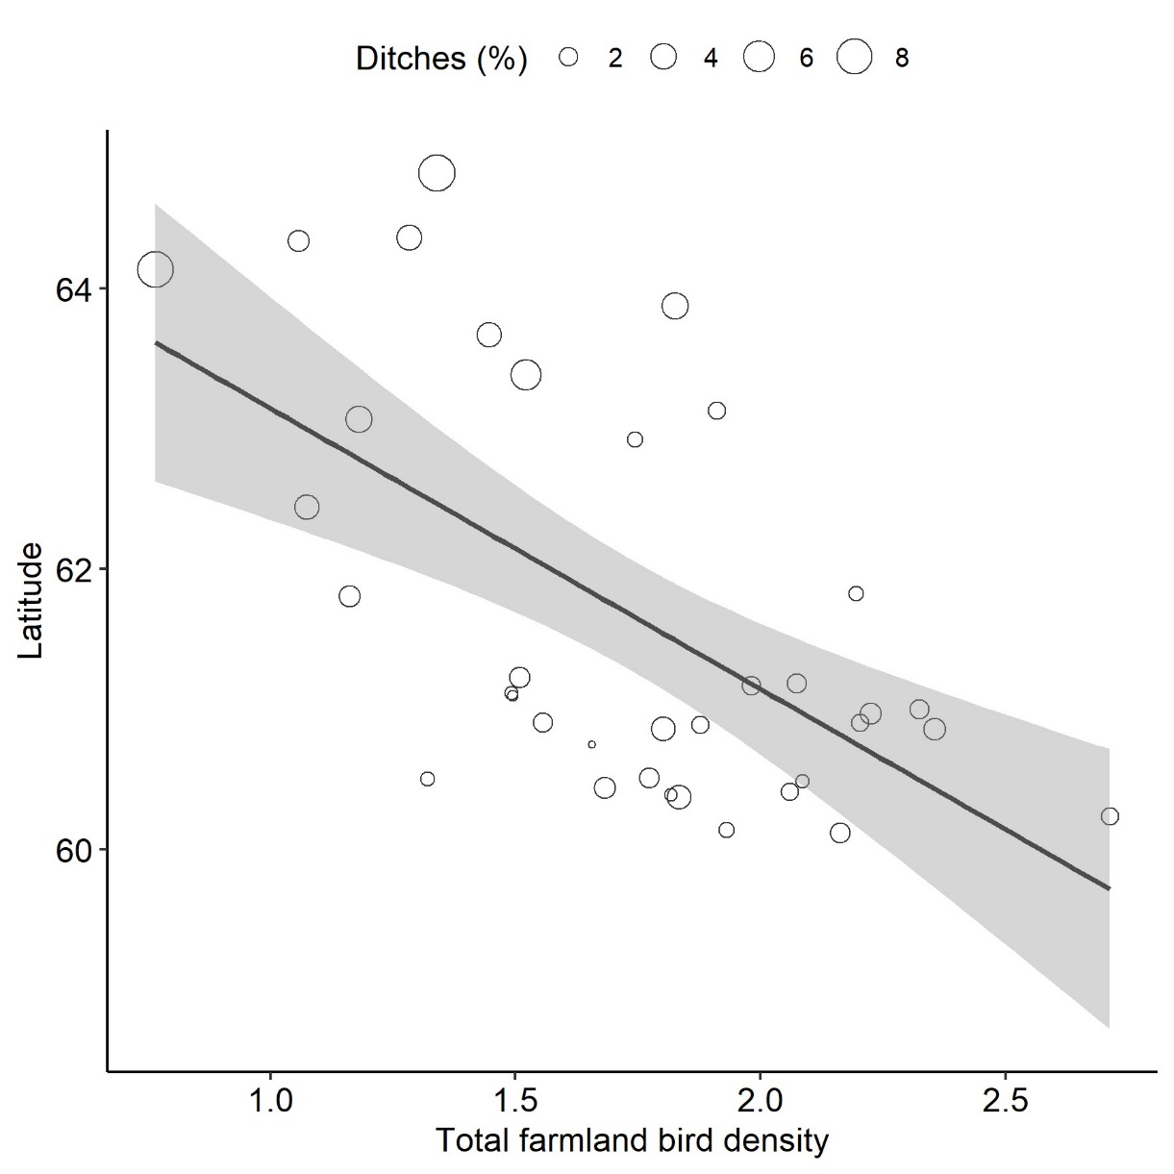
Fig. S22. Negative linear relationship between the total farmland bird density and the latitude. Points show the raw data distribution where larger points indicate a higher area of ditches and smaller ones a smaller ditch area per study landscape.

Additional References
Bracken, F., & Bolger, T. (2006). Effects of set-aside management on birds breeding in lowland Ireland. Agric Ecosys Environ, 117(2-3), 178–184.
Eggers, S., Unell, M. & Pärt, T. (2011). Autumn-sowing of cereals reduces breeding bird numbers in a heterogeneous agricultural landscape. Biol Conserv, 144, 1137–1144.
Hancock, M. H. & Wilson, J. D. (2003). Winter habitat associations of seed-eating passerines on Scottish farmland, Bird Study, 50:2, 116–130, DOI: 10.1080/00063650309461303
Hiron, M., Berg, Å., Eggers, S., Josefsson, J. & Pärt, T. (2013a). Bird diversity relates to agri-environment schemes at local and landscape level in intensive farmland. Agric Ecosys Environ, 176, 9–16.
Marja, R. & Herzon, I. (2012). The importance of drainage ditches for farmland birds in agricultural landscapes in the Baltic countries: does field type matter? Ornis Fenn, 89, 170 –181.
Marja, R., Herzon, I., Rintala, J., Tiainen, J., & Seimola, T. (2013). Type of agricultural drainage modifies the value of fields for farmland birds. Agric Ecosys Environ, 165, 184–189.
Piha, M., Pakkala, T. & Tiainen, J. (2003). Habitat preferences of the Skylark Alauda arvensis in southern Finland. Ornis Fenn, 80, 97–110.
Ram, D., Lindström, Å., Pettersson, L.B. & Caplat, P. (2020). Forest clear-cuts as habitat for farmland birds and butterflies. For Ecol Manage, 473. https://doi.org/10.1016/j.foreco.2020.118239
Reino, L., Beja, P., Osborne, P. E., Morgado, R., Fabião, A., & Rotenberry, J. T. (2009). Distance to edges, edge contrast and landscape fragmentation: interactions affecting farmland birds around forest plantations. Biol Conserv, 142(4), 824–838.
Rosin, Z.M., Skorka, P., Part, T., Zmihorski, M., Ekner-Grzyb, A., Kwiecinski, Z., et al. (2016). Villages and their old farmsteads are hot spots of bird diversity in agricultural landscapes. J Appl Ecol, 53, 1363–1372.
Šálek, M., Bazant, M. & Zmihorski, M. (2018). Active farmsteads are year-round strongholds for farmland birds. J Appl Ecol, 55, 1908–1918.
Siriwardena, G.M., Crick, H.Q.P., Baillic, S.R. & Wilson, J.D. (2000), Agricultural land-use and the spatial distribution of granivorous lowland farmland birds. Ecography, 23: 702-719. https://doi.org/10.1111/j.1600-0587.2000.tb00314.x
Staggenborg, J. & Anthes, N. (2022). Long‐term fallows rate best among agri‐environment scheme effects on farmland birds – A meta‐analysis. Conserv Lett, 15.
Stoate, C., Boatman, N. D., Borralho, R. J., Carvalho, C. R., De Snoo, G. R., & Eden, P. (2001). Ecological impacts of arable intensification in Europe. J Environ Manage, 63(4), 337-365.
Toivonen, M., Herzon, I., & Kuussaari, M. (2015). Differing effects of fallow type and landscape structure on the occurrence of plants, pollinators and birds on environmental fallows in Finland. Biol Conserv, 181, 36–43.
Virkkala, R., Luoto, M. & Rainio, K. (2004). Effects of landscape composition on farmland and red-listed birds in boreal agricultural-forest mosaics. Ecography, 27, 273–284. https://doi.org/10.1111/j.0906-7590.2004.03810.x

