Supplementary Information
Table S1: Model summaries for modelling of vegetation metrics across vegetation types: LSM = Lowan Sands Mallee, SRS = Sandstone Ridge Shrubland, YGW = Yellow Gum Woodland.
Vegetation measure | Predictor | Estimate | CIs (95%)
Vegetation structure – low
LSM | (Intercept) | 1.83 | 1.55 – 2.10
 | Patch type [Fragment] | -0.33 | -0.72 – 0.05
SRS | (Intercept) | -0.03 | -0.52 – 0.45
 | Patch type [Fragment] | -0.38 | -1.07 – 0.31
YGW | (Intercept) | 0.11 | -0.57 – 0.80
 | Patch type [Fragment] | 1.68 | 0.69 – 2.67
All veg types | (Intercept) | 1.68 | 1.24 – 2.11
 | Patch type [Fragment] | 0.08 | -0.42 – 0.58
Vegetation structure – mid
LSM | (Intercept) | -0.33 | -0.71 – 0.05
 | Patch type [Fragment] | -0.07 | -0.60 – 0.47
SRS | (Intercept) | -0.94 | -1.25 – -0.62
 | Patch type [Fragment] | -0.14 | -0.58 – 0.30
YGW | (Intercept) | -1.70 | -2.36 – -1.05
 | Patch type [Fragment] | -0.16 | -1.09 – 0.78
All veg types | (Intercept) | -0.3 | -0.60 – 0.00
 | Patch type [Fragment] | -0.1 | -0.45 – 0.25
Vegetation structure – high
LSM | (Intercept) | -1.75 | -2.17 – -1.33
 | Patch type [Fragment] | 0.64 | 0.10 – 1.19
SRS | (Intercept) | -0.70 | -1.15 – -0.25
 | Patch type [Fragment] | 0.82 | 0.19 – 1.45
YGW | (Intercept) | -2.02 | -2.70 – -1.34
 | Patch type [Fragment] | -0.09 | -1.08 – 0.89
All veg types | (Intercept) | -1.73 | -2.09 – -1.36
 | Patch type [Fragment] | 0.57 | 0.17 – 0.97
Vegetation structure – canopy
LSM | (Intercept) | -1.66 | -1.94 – -1.38
 | Patch type [Fragment] | 0.54 | 0.16 – 0.92
SRS | (Intercept) | -0.83 | -1.19 – -0.47
 | Patch type [Fragment] | 0.68 | 0.18 – 1.17
YGW | (Intercept) | -0.50 | -0.83 – -0.17
 | Patch type [Fragment] | -0.26 | -0.74 – 0.21
All veg types | (Intercept) | -1.6 | -1.89 – -1.32
 | Patch type [Fragment] | 0.42 | 0.10 – 0.73
CWD volume log (cm³)
LSM | (Intercept) | 9.94 | 8.67 – 11.21
 | Patch type [Fragment] | 0.57 | -1.23 – 2.36
SRS | (Intercept) | 9.13 | 7.30 – 10.97
 | Patch type [Fragment] | 1.41 | -1.18 – 4.00
YGW | (Intercept) | 12.01 | 11.06 – 12.97
 | Patch type [Fragment] | -0.04 | -1.39 – 1.31
All veg types | (Intercept) | 9.88 | 8.86 – 10.89
 | Patch type [Fragment] | 0.69 | -0.43 – 1.82
Leaf litter rating
LSM | (Intercept) | 1.61 | 1.35 – 1.88
 | Patch type [Fragment] | 0.24 | -0.14 – 0.61
SRS | (Intercept) | 1.01 | 0.65 – 1.37
 | Patch type [Fragment] | 0.36 | -0.15 – 0.87
YGW | (Intercept) | 0.96 | 0.81 – 1.12
 | Patch type [Fragment] | 0.02 | -0.20 – 0.24
All veg types | (Intercept) | 1.61 | 1.40 – 1.82
 | Patch type [Fragment] | 0.26 | 0.02 – 0.50
Log(largest tree - cm dbh)  LSM - E. arenacea | (Intercept) | 4.34 | 4.11 – 4.57
 | Patch type [Fragment] | 0.07 | -0.25 – 0.40
SRS - E. costata | (Intercept) | 3.03 | 2.77 – 3.30
 | Patch type [Fragment] | 0.15 | -0.22 – 0.51
SRS - E. leptophylla | (Intercept) | 3.09 | 2.60 – 3.59
 | Patch type [Fragment] | 0.34 | -0.36 – 1.04
YGW - E. leucoxylon | (Intercept) | 3.85 | 3.57 – 4.13
 | Patch type [Fragment] | 0.08 | -0.32 – 0.48
Log(mean tree size - cm dbh)  LSM - E. arenacea | (Intercept) | 3.79 | 3.63 – 3.95
 | Patch type [Fragment] | -0.01 | -0.24 – 0.22
SRS - E. costata | (Intercept) | 2.53 | 2.32 –2.74
 | Patch type [Fragment] | 0.07 | -0.22 – 0.36
SRS - E. leptophylla | (Intercept) | 2.36 | 2.14 – 2.58
 | Patch type [Fragment] | 0.40 | 0.08 – 0.72
YGW - E. leucoxylon | (Intercept) | 3.31 | 3.07 – 3.55
 | Patch type [Fragment] | 0.00 | -0.34 – 0.34

Table S2: Top performing models (delta AICc < 2) to describe species richness and diversity
Response variable | Model | df | AICc | Delta AICc | R^2
Richness (raw) | Size | 3 | 126.3 | 0 | 0.127
 | Null | 2 | 126.6 | 0.28 | 0
Diversity (raw) | Null | 2 | 23.30 | 0 | 0
 | Size | 3 | 23.77 | 0.47 | 0.097

Table S3: A summary of models that received substantial support (delta AICc < 2) showing the influence of predictor variables on species richness and diversity
Response variable | Coefficients | Estimate | CI (85%)
Richness (raw) | Intercept | 11.6364 | 10.47 – 12.80
 | Size | 1.409 | 0.22 – 2.60
 | Intercept | 11.636 | 10.42 – 12.85
Diversity (raw) | Intercept | 1.970 | 1.85 – 2.09
 | Intercept | 1.970 | 1.85 – 2.08
 | Size | 0.118 | 0.00 – 0.23

Table S4: Model selection for generalised linear models exploring how patch type and patch size influence individual species occupancy per patch (only models with delta AICc < 2 are shown)
Species | Model Terms | df | AICc | Delta AICc | R^2
Lerista bougainvillii | Patch type | 2 | 58.9 | 0 | 0.456
 | Patch type + size | 3 | 59.2 | 0.27 | 0.513
 | Patch type + size + Patch type:size | 4 | 60.7 | 1.76 | 0.546
Lampropholis delicata | Null | 1 | 87.3 | 0 | 0
 | Size | 2 | 89.1 | 1.74 | 0.032
Ctenotus robustus | Patch type | 2 | 80.5 | 0 | 0.768
 | Patch type + size + Patch type:size | 4 | 80.9 | 0.41 | 0.818
 | Patch type + size | 3 | 81.8 | 1.27 | 0.783
Ctenotus orientalis | Patch type + size | 3 | 61.0 | 0 | 0.481
 | Size | 2 | 62.4 | 1.43 | 0.374
Menetia greyii | Null | 1 | 67.6 | 0 | 0
Christinus marmoratus | Patch type | 2 | 88.8 | 0 | 0.237
 | Patch type + size | 3 | 90.4 | 1.62 | 0.274
Amphibolurus norrisi | Patch type | 2 | 44.1 | 0 | 0.491
 | Patch type + size | 3 | 45.2 | 1.14 | 0.526
Morethia obscura | Null | 1 | 60.5 | 0 | 0
 | Patch type | 2 | 62.3 | 1.84 | 0.026
 | Size | 2 | 62.4 | 1.97 | 0.021
Ctenophorus pictus | Size | 2 | 74.8 | 0 | 0.258
Cercartetus lepidus | Patch type + size + Patch type:size | 4 | 65.7 | 0 | 0.636
Cercartetus concinnus | Size | 2 | 82.0 | 0 | 0.210
Pseudomys apodemoides | Patch type + size + Patch type:size | 4 | 92.4 | 0 | 0.589
 | Patch type | 2 | 93.5 | 1.06 | 0.441
Limnodynastes dumerilii | Patch type | 2 | 84.2 | 0 | 0.359
 | Patch type + size + Patch type:size | 4 | 85.5 | 1.33 | 0.475
Tiliqua rugosa | Patch type | 2 | 37.5 | 0 | 0.350
 | Patch type + size | 3 | 38.8 | 1.26 | 0.391
Aprasia striolata | Patch type | 2 | 37.5 | 0 | 0.113
 | Null | 1 | 37.7 | 0.21 | 0
Neobatrachus sp. | Null | 1 | 60.7 | 0 | 0
 | Patch type | 2 | 62.0 | 1.34 | 0.049
Mus musculus | Patch type | 2 | 48.2 | 0 | 0.455
Pygopus lepidopodus | Patch type | 2 | 36.1 | 0 | 0.176
 | Null | 1 | 37.9 | 1.83 | 0
 | Patch type + size | 3 | 37.9 | 1.84 | 0.208

Table S5: Estimated model coefficients from models with substantial support (delta AICc < 2), occupancy per patch as the response variable.
Species | Predictors | Estimate | CI (85%)
Lerista bougainvillii | (Intercept) | -1.97 | -2.78 – -1.16
 | Patch type [Fragment] | 1.76 | 0.80 – 2.73
 | (Intercept) | -1.73 | -2.52 – -0.95
 | Patch type [Fragment] | 1.82 | 0.90 – 2.73
 | Size | -0.49 | -1.03 – 0.05
 | (Intercept) | -1.60 | -2.40 – -0.80
 | Patch type [Fragment] | 1.51 | 0.49 – 2.53
 | Size | -0.99 | -1.89 – -0.10
 | Patch type [Fragment] × Size | 0.80 | -0.32 – 1.91
Lampropholis delicata | (Intercept) | 0.16 | -0.30 – 0.63
 | (Intercept) | 0.30 | -0.57 – 1.17
 | Size | -0.23 | -0.88 – 0.43
Ctenotus robustus | (Intercept) | -1.63 | -2.67 – -0.60
 | Patch type [Fragment] | 2.55 | 1.21 – 3.89
 | (Intercept) | -3.19 | -6.11 – -0.28
 | Patch type [Fragment] | 4.12 | 1.02 – 7.21
 | Size | 1.84 | -0.83 – 4.51
 | Patch type [Fragment] × Size | -1.86 | -4.74 – 1.03
 | (Intercept) | -1.90 | -3.12 – -0.67
 | Patch type [Fragment] | 2.60 | 1.24 – 3.95
 | Size | 0.40 | -0.50 – 1.29
Ctenotus orientalis | (Intercept) | 1.07 | 0.27 – 1.86
 | Patch type [Fragment] | 0.93 | 0.08 – 1.78
 | Size | -1.17 | -1.92 – -0.42
 | (Intercept) | 1.47 | 0.72 – 2.22
 | Size | -1.12 | -1.89 – -0.36
Menetia greyii | (Intercept) | -0.97 | -1.41 – -0.53
Christinus marmoratus | (Intercept) | 0.63 | -0.10 – 1.36
 | Patch type [Fragment] | -1.00 | -2.02 – 0.01
 | (Intercept) | 0.81 | -0.07 – 1.70
 | Patch type [Fragment] | -1.02 | -2.06 – 0.03
 | Size | -0.29 | -1.01 – 0.42
Amphibolurus norrisi | (Intercept) | -0.72 | -1.16 – -0.29
 | Patch type [Fragment] | -2.43 | -3.56 – -1.31
 | (Intercept) | -0.47 | -0.99 – 0.05
 | Patch type [Fragment] | -2.47 | -3.61 – -1.34
 | Size | -0.45 | -0.97 – 0.07
Morethia obscura | (Intercept) | 1.43 | 0.92 – 1.93
 | (Intercept) | 1.63 | 0.85 – 2.42
 | Patch type [Fragment] | -0.39 | -1.44 – 0.65
 | (Intercept) | 1.58 | 0.85 – 2.30
 | Size | -0.24 | -0.99 – 0.51
Ctenophorus pictus | (Intercept) | -0.92 | -1.64 – -0.21
 | Size | -0.79 | -1.59 – 0.00
Cercartetus lepidus | (Intercept) | 0.84 | 0.06 – 1.62
 | Patch type [Fragment] | -3.12 | -4.82 – -1.42
 | Size | -0.33 | -1.14 – 0.48
 | Patch type [Fragment] × Size | 2.20 | 0.51 – 3.88
Cercartetus concinnus | (Intercept) | -0.37 | -1.00 – 0.25
 | Size | -0.65 | -1.32 – 0.03
Pseudomys apodemoides | (Intercept) | 0.18 | -0.89 – 1.24
 | Patch type [Fragment] | -3.69 | -7.45 – 0.07
 | Size | -0.50 | -1.64 – 0.63
 | Patch type [Fragment] × Size | 2.49 | -0.96 – 5.93
 | (Intercept) | -0.12 | -0.96 – 0.72
 | Patch type [Fragment] | -1.67 | -3.13 – -0.21
Limnodynastes dumerilii | (Intercept) | -1.13 | -1.92 – -0.33
 | Patch type [Fragment] | 1.33 | 0.27 – 2.39
 | (Intercept) | -1.43 | -2.66 – -0.19
 | Patch type [Fragment] | 2.13 | 0.50 – 3.75
 | Size | 0.46 | -0.80 – 1.72
 | Patch type [Fragment] × Size | -1.24 | -2.93 – 0.45
Tiliqua rugosa | (Intercept) | -3.87 | -5.33 – -2.42
 | Patch type [Fragment] | 2.51 | 0.97 – 4.05
 | (Intercept) | -3.65 | -5.12 – -2.19
 | Patch type [Fragment] | 2.55 | 1.00 – 4.10
 | Size | -0.50 | -1.09 – 0.09
Aprasia striolata | (Intercept) | -2.73 | -3.59 – -1.87
 | Patch type [Fragment] | 1.10 | 0.07 – 2.12
 | (Intercept) | -2.07 | -2.53 – -1.61
Neobatrachus sp. | (Intercept) | -1.49 | -2.05 – -0.93
 | (Intercept) | -1.24 | -1.98 – -0.50
 | Patch type [Fragment] | -0.55 | -1.71 – 0.61
Mus musculus | (Intercept) | -3.16 | -4.38 – -1.93
 | Patch type [Fragment] | 2.34 | 1.01 – 3.67
Pygopus lepidopodus | (Intercept) | -1.63 | -2.19 – -1.08
 | Patch type [Fragment] | -1.52 | -2.70 – -0.34
 | (Intercept) | -2.17 | -2.66 – -1.69
 | (Intercept) | -1.95 | -2.76 – -1.14
 | Patch type [Fragment] | -1.53 | -2.72 – -0.35
 | Size | 0.47 | -0.31 – 1.25

When using proportion of sites occupied per patch as the response variable rather than total abundance per patch, results were very similar with top models reporting an effect of patch type for 11 species, comprising the same nine species identified previously plus two new effects (Ctenotus orientalis positive association with fragments and P. apodemoides negative association with fragments). Only two species showed a significant effect of patch size compared to 11 species when using abundance as the response variable. This is intuitive in the context of our proportional sampling design as total abundance per patch is biased toward larger patches with more trapping sites. The interaction term showed an effect in only one supported model.
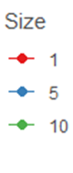
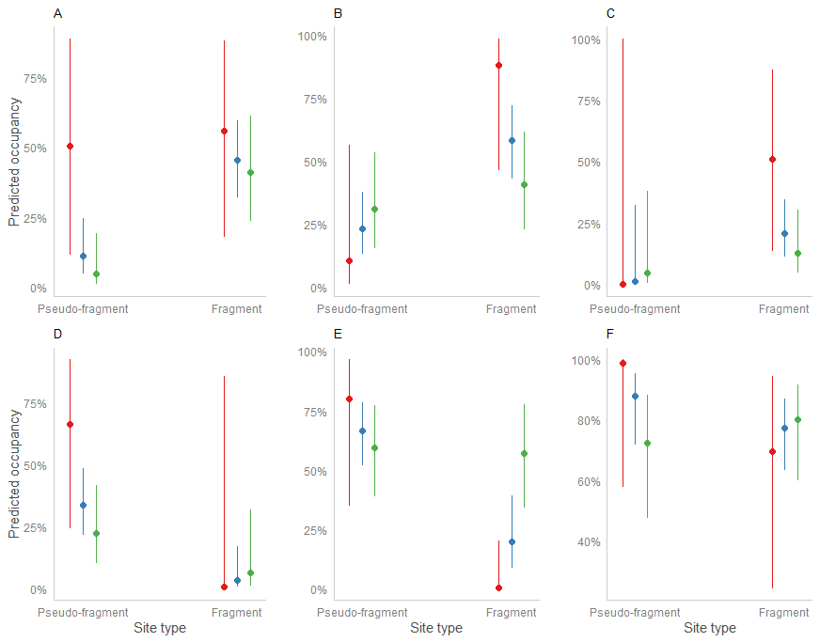

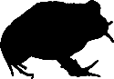
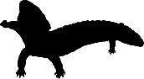

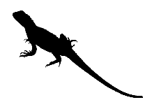
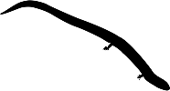

Figure S1: Predicted proportion of sites occupied per patch for: (A) Lerista bougainvilli, (B) Limnodynastes dumerilii, (C) Tiliqua rugosa, (D) Amphibolurus norrisi, (E) Cercartetus lepidus, (F) Morethia obscura at agricultural fragments and reserve pseudo-fragments of sizes 1, 5 and 10 hectares.

Response variable | Coefficients | Estimate | CI (85%)
Fox activity | Intercept | -4.89 | -5.39 – -4.39
 | Fragment type [Fragment] | 1.16 | 0.45 – 1.87
Table S6: Model summary showing the influence of fragment type on fox activity

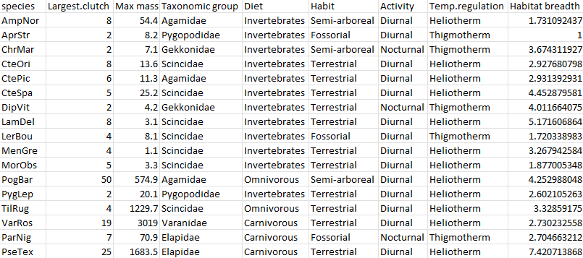
Table S7: Trait data used for analysis

