Electronic supplementary material

Detrimental effects of urbanisation on animal assemblages and a key ecological function persist across ecosystems

Jesse D. Mosman¹*, Hayden P. Borland¹, Ben L. Gilby², Ashley J. Rummell¹, Andrew D. Olds¹, Christopher J. Henderson¹

- School of Science, Technology and Engineering, University of the Sunshine Coast, Queensland 4558, Australia
- School of Science, Technology and Engineering, University of the Sunshine Coast, Petrie, Queensland 4502, Australia

*Corresponding author- jesse.mosman@research.usc.edu.au

Target Journal: Landscape Ecology

Table S1. Environmental variables, their definitions and dimensions.
Environmental variable | Definition | Dimensions
Distance to the estuary mouth | The least cost path distance between a deployment and the nearest estuary mouth (km). For sites that were within estuaries, these values are negatives. | mean: 3.14 km  range: -1.99 – 16.29 km
Distance to urban land | Euclidean distance between the deployment to the nearest urban land (i.e. the nearest human infrastructure) (km). | mean: 0.35 km  range: 0.001 – 1.60 km
Urban area 500 m | The area of urbanisation (i.e. the area of human infrastructure) within a 500m buffer of each deployment (km²). | mean: 0.134 km²  range: 0 – 0.489 km²
Natural habitat area  500 m | The area of natural habitats within a 500m buffer of each deployment (km²). These included reefs, headlands, saltmarsh, mangroves, seagrass, and rocky outcrops. | mean: 0.142 km²  range: 0 – 0.512 km²
Natural habitat diversity 500 m | The number of different natural habitats within a 500m buffer of each deployment. These included reefs, headlands, saltmarsh, mangroves, seagrass, and rocky outcrops | mean: 1.5  range: 0 – 3
Urban area 4 km | The area of urbanisation (i.e. the area of human infrastructure) within a 4km buffer of each deployment (km²). | mean: 12.967 km²  range: 4.359 – 22.220 km²
Natural habitat area  4 km | The area of natural habitats within a 4km buffer of each deployment (km²). These included reefs, headlands, saltmarsh, mangroves, seagrass, and rocky outcrops. | mean: 2.786 km²  range: 0.357 – 5.431 km²
Natural habitat diversity 4 km | The number of different natural habitats within a 4 km buffer of each deployment. These included reefs, headlands, saltmarsh, mangroves, seagrass, and rocky outcrops | mean: 4.4  range: 1 – 6

 | Deep water | Headland | Sand | Shallow water | Reef | Class accuracy (%)
Deep water | 28 | 0 | 0 | 2 | 0 | 93.33
Headland | 0 | 29 | 0 | 0 | 1 | 96.66
Sand | 0 | 4 | 26 | 0 | 0 | 86.66
Shallow water | 8 | 0 | 0 | 22 | 0 | 73.33
Reef | 0 | 0 | 0 | 0 | 30 | 100
Table S2: Confusion matrix showing the accuracy of each class from the total 150 reference samples used to create reef and headland habitat maps.
Model type | Model formula
manyGLM | Site + Habitat*Distance to estuary mouth + Habitat*Distance to urban land + Habitat*Urban area 500 m + Habitat*Natural Habitat area 500 m + Habitat*Urban area 4 km + Habitat*Natural Habitat area 4 km + Habitat*Habitat diversity 500 m + Habitat*Habitat diversity 4 km, family = "negative.binomial"
Table S3. Formula of manyGLM model used in the analysis.

Table S4. Species found in the study, if they are harvested in the region, their abundance in each ecosystem and their total abundance across all three ecosystems.
Scientific name | Common name | Harvested | Estuary | Headland | Surf zone | Total
Acanthopagrus australis | Yellowfin bream | Yes | 164 | 47 | 13 | 224
Acanthurus grammoptilus | Inshore surgeonfish | Yes | 0 | 3 | 2 | 5
Aetobatus ocellatus | Whitespotted eagle ray | No | 0 | 1 | 0 | 1
Anampses geographicus | Scribbled wrasse | Yes | 0 | 1 | 0 | 1
Apogon doederleini | Four-line cardinalfish | No | 0 | 2 | 0 | 2
Aptychotrema rostrata | Eastern shovelnose ray | Yes | 3 | 2 | 17 | 22
Arothron manilensis | Narrow lined puffer | No | 1 | 0 | 0 | 1
Atule mate | Yellowtail scad | Yes | 0 | 8 | 8 | 16
Atypichthys latus | Australian mado | No | 0 | 1 | 3 | 4
Aurigequula fasciata | Threadfin pony fish | Yes | 1 | 0 | 0 | 1
Brachaelurus waddi | Blind shark | No | 0 | 2 | 1 | 3
Caranx ignoblis | Giant trevally | Yes | 3 | 0 | 2 | 5
Caranx sexfasciatus | Big eye trevally | Yes | 0 | 1 | 0 | 1
Chiloscyllium punctatum | Grey carpet shark | Yes | 0 | 11 | 2 | 13
Chrysophrys auratus | Snapper | Yes | 0 | 11 | 7 | 18
Coris aurilineata | Goldlined wrasse | No | 0 | 1 | 0 | 1
Coris pictoides | Pixie wrasse | No | 0 | 1 | 0 | 1
Cybiosarda elegans | Leaping bonito | Yes | 0 | 0 | 33 | 33
Epinephelus lanceolatus | Queensland grouper | No | 1 | 0 | 0 | 1
Favonigobius exquisitus | Sand goby | No | 7 | 0 | 0 | 7
Feroxodon multistriatus | Ferocious pufferfish | No | 0 | 1 | 0 | 1
Gerres subfasciatus | Common silver biddy | Yes | 2 | 0 | 0 | 2
Glaucostegus typus | Giant shovelnose ray | Yes | 0 | 0 | 1 | 1
Gnathanodon speciosus | Golden trevally | Yes | 1 | 0 | 0 | 1
Gymnothorax cribroris | Sieve moray | No | 0 | 5 | 1 | 6
Gymnothorax favagineus | Tessellate moray | No | 0 | 2 | 0 | 2
Gymnothorax monochrous | Monotone moray | No | 0 | 2 | 0 | 2
Grammatorcynus bicarinatus | Shark mackerel | Yes | 0 | 10 | 0 | 10
Halichoeres nebulosus | Cloud wrasse | No | 0 | 2 | 0 | 2
Halichoeres nigrescens | Bubblefin wrasse | No | 0 | 4 | 0 | 4
Hemitrygon fluviorum | Estuary ray | Yes | 7 | 0 | 0 | 7
Herklotsichthys castelnaui | Southern herring | Yes | 4 | 0 | 0 | 4
Hermit Crab spp. | Hermit crab | No | 0 | 1 | 2 | 3
Himantura australis | Australian whipray | No | 1 | 0 | 0 | 1
Kyphosus bigibbus | Grey drummer | Yes | 0 | 1 | 1 | 2
Labroides dimidiatus | Common cleaner fish | No | 0 | 1 | 0 | 1
Lagocephalus inermis | Smooth golden toadfish | No | 0 | 0 | 3 | 3
Lagocephalus scleratus | Silver toadfish | No | 1 | 0 | 2 | 2
Leiognathus equulus | Common ponyfish | Yes | 1 | 0 | 0 | 1
Lethrinus genivittatus | Threadfin emperor | Yes | 0 | 1 | 0 | 1
Lethrinus laticaudis | Grass emperor | Yes | 0 | 10 | 3 | 13
Lobotes surinamensis | Tripletail | Yes | 1 | 0 | 0 | 1
Lutjanus argentimaculatus | Mangrove jack | Yes | 0 | 3 | 0 | 3
Lutjanus fulviflamma | Blackspot snapper | Yes | 0 | 1 | 0 | 1
Lutjanus russellii | Moses perch | Yes | 3 | 4 | 1 | 8
Megalops cyprinoides | Tarpon | Yes | 1 | 0 | 0 | 1
Microcanthus joyceae | East-Australian stripey | No | 0 | 6 | 0 | 6
Monacanthus chinensis | Fanbelly leatherjacket | Yes | 1 | 0 | 0 | 1
Monodactylus argenteus | Diamondfish | Yes | 11 | 4 | 6 | 21
Mugil cephalus | Sea mullet | Yes | 4 | 0 | 0 | 4
Mututa victor | Common moon crab | No | 5 | 7 | 52 | 64
Neotrygon kuhlii | Bluespotted maskray | Yes | 2 | 3 | 3 | 8
Orectolobus maculatus | Spotted wobbegong | No | 0 | 1 | 1 | 2
Orectolobus ornatus | Ornatte wobbegong | No | 0 | 5 | 2 | 7
Ostorhinchus limenus | Sydney cardinalfish | No | 0 | 12 | 5 | 17
Pantolabus radiatus | Fringefin trevally | Yes | 1 | 0 | 0 | 1
Parapercis australis | Southern grubfish | No | 0 | 1 | 0 | 1
Parma oligolepis | Bigscale fin | No | 0 | 5 | 0 | 5
Pastinachus ater | Cowtail ray | No | 0 | 1 | 0 | 1
Pelates sexlineatus | Eastern striped trumpeter | Yes | 0 | 3 | 0 | 3
Pentapodus paradiseus | Paradise threadfin bream | No | 0 | 1 | 0 | 1
Platycephalus endrachtensis | Northern sand flathead | Yes | 0 | 3 | 17 | 20
Platycephalus fuscus | Dusky flathead | Yes | 4 | 0 | 0 | 4
Plectorhinchus flavomaculatus | Gold spotted sweetlip | Yes | 0 | 1 | 0 | 1
Plectorhinchus gibbosus | Brown sweetlip | Yes | 0 | 1 | 0 | 1
Pomacentrus wardi | Wards damsel | No | 0 | 13 | 0 | 13
Pomatomus saltatrix | Tailor | Yes | 1 | 0 | 0 | 1
Portunus pelagicus | Blue swimmer crab | Yes | 3 | 0 | 5 | 8
Portunus sanguinolentus | Threespot swimmer crab | Yes | 0 | 1 | 3 | 4
Pseudocaranx georgianus | Silver trevally | Yes | 0 | 9 | 0 | 9
Pseudolabrus guentheri | Gunthers wrasse | No | 0 | 53 | 10 | 63
Pseudorhombus arsius | Largetoothed flounder | Yes | 1 | 1 | 9 | 11
Ranina ranina | Spanner crab | Yes | 0 | 0 | 1 | 1
Remora remora | Remora | Yes | 0 | 1 | 0 | 1
Rhabdosargus sarba | Tarwhine | Yes | 2 | 11 | 5 | 18
Rhynchobatus australiae | White spotted guitarfish | Yes | 0 | 6 | 11 | 17
Schuettea scalaripinnis | Eastern pomfret | No | 0 | 2 | 2 | 4
Scomberoides commersonnianus | Giant queenfish | Yes | 0 | 0 | 1 | 1
Scomberomorus queenslandicus | School mackerel | Yes | 0 | 17 | 1 | 18
Scorpaena jacksoniensis | Eastern red scorpionfish | No | 0 | 1 | 0 | 1
Scorpis lineolata | Silver sweep | No | 1 | 20 | 7 | 28
Scylla serrata | Mud crab | Yes | 1 | 0 | 0 | 1
Siganus fuscescens | Black rabbitfish | Yes | 54 | 35 | 9 | 98
Silago analis | Golden lined whiting | Yes | 0 | 21 | 127 | 148
Silago ciliata | Sand whiting | Yes | 0 | 0 | 10 | 10
Sphyraena barracuda | Great barracuda | Yes | 1 | 0 | 0 | 1
Sphyraena obtusata | Obtuse barracuda | Yes | 0 | 2 | 0 | 2
Synodus sageneus | Fishnet lizardfish | No | 0 | 0 | 5 | 5
Thalassoma lunare | Moon wrasse | No | 0 | 3 | 0 | 3
Torquigener pleurogramma | Weeping toadfish | No | 1 | 54 | 183 | 238
Torquigener squamicauda | Scalytail toadfish | No | 2 | 0 | 6 | 6
Trachinotus blochii | Snubnose dart | Yes | 0 | 17 | 0 | 17
Tripodichthys angustifrons | Yellowfin tripodfish | No | 1 | 0 | 0 | 1
Tylosurus crocodilus | Crocodile longtom | Yes | 3 | 0 | 0 | 3
Ulua mentalis | Longraker trevally | Yes | 4 | 7 | 0 | 11

Table S5. The amount of carrion consumed by each species (grams) in each ecosystem and across all three ecosystems. Species are ordered by the amount of carrion they consumed in the study.
Scientific name | Common name | Estuary | Headland | Surf zone | Total
Acanthopagrus australis | Yellowfin bream | 1188.0 | 27.1 | 6.7 | 1221.8
Torquigener pleurogramma | Weeping toadfish | 0 | 105.5 | 536.0 | 641.6
Siganus fuscescens | Black rabbitfish | 232.0 | 31.7 | 58.8 | 322.5
Portunus armatus | Blue swimmer crab | 122.9 | 0 | 177.7 | 300.5
Pagrus auratus | Snapper | 0 | 242.1 | 33.1 | 275.2
Chiliocyllium punctatum | Grey carpet shark | 0 | 237.4 | 24.7 | 262.1
Orectolobus ornatus | Ornate wobbegong | 0 | 193.0 | 60.0 | 253.0
Pseudolabrus guentheri | Gunther’s wrasse | 0 | 214.9 | 13.6 | 228.5
Brachaelurus waddi | Blind shark | 0 | 125.0 | 70.0 | 195.0
Gymnothorax cribroris | Sieve moray | 0 | 157.0 | 0 | 157.0
Rhynchobatus australiae | White spotted guitarfish | 0 | 0 | 139.9 | 139.9
Aptychotrema rostrata | Eastern shovel nose ray | 11.8 | 34.0 | 84.9 | 130.7
Platycephalus endrachtensis | Northern sand flathead | 0 | 0 | 123.6 | 123.6
Hemitrygon fluviorum | Estuary stingray | 108.8 | 0 | 0 | 108.8
Lagocephalus sclerartus | Silver toadfish | 0 | 0 | 105.2 | 105.2
Mututa victor | Commo moon crab | 0.4 | 0.9 | 98.9 | 101.2
Feroxodon multistriatus | Ferocious pufferfish | 0 | 81.9 | 0 | 81.9
Lagocephalus inermis | Smooth golden toadfish | 0 | 0 | 57.0 | 57.0
Gymnothorax monochrous | Monotone moray | 0 | 40.0 | 0 | 40.0
Lutjanus russellii | Moses perch | 0 | 40.0 | 0 | 40.0
Portunus sanguinolentus | Threespot swimmer crab | 0 | 9.9 | 29.9 | 39.8
Scylla serrata | Giant mud crab | 33.0 | 0 | 0 | 33.0
Neotrygon kuhlii | Blue spotted maskray | 7.4 | 24.3 | 0 | 31.7
Silago analis | Golden lined whiting | 0 | 4.7 | 22.1 | 26.8
Pseudocaranx georgianus | Silver trevally | 0 | 24.0 | 0 | 24.0
Scorpis lineolate | Silver sweep | 0 | 2.3 | 18.1 | 20.4
Orectolobus maculatus | Spotted wobbegong | 0 | 0 | 19.3 | 19.3
Atule mate | Yellowtail scad | 0 | 17.3 | 0 | 17.3
Gymnothorax favagineus | Tesselate moray | 0 | 16.6 | 0 | 16.6
Tylosurus crocodilus | Crocodile longtom | 12.9 | 0 | 0 | 12.9
Rhabdosargus sarba | Tarwhine | 0 | 4.8 | 6.5 | 11.3
Atypichthys latus | Australian mado | 0 | 0 | 9.5 | 9.5
Glaucostegus typus | Giant shovelnose ray | 0 | 0 | 6.2 | 6.2
Ranina ranina | Spanner crab | 0 | 0 | 5.9 | 5.9
Torquigener squamicauda | Scaly tail toadfish | 0 | 0 | 5.8 | 5.8
Lethrinus laticaudis | Grass emperor | 0 | 5.0 | 0 | 5.0
Lutjanus argentimaculatus | Mangrove jack | 0 | 5.0 | 0 | 5.0
Monacanthus chinensis | Fanbelly leatherjacket | 4.9 | 0 | 0 | 4.9
Pelates sexlineatus | Eastern striped trumpeter | 0 | 4.8 | 0 | 4.8
Ostorhinchus limenus | Sydney cardinalfish | 0 | 1.0 | 3.3 | 4.3
Pseudorhombus arsius | Largetoothed flounder | 0.7 | 0 | 0.5 | 1.2
Halichoeres nebulosus | Cloud wrasse | 0 | 1.0 | 0 | 1.0
Monodactylus argenteus | Diamondfish | 0.9 | 0 | 0 | 0.9
Silago ciliata | Sand whiting | 0 | 0 | 0.8 | 0.8
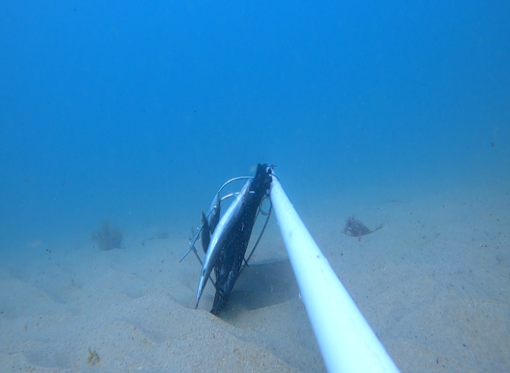
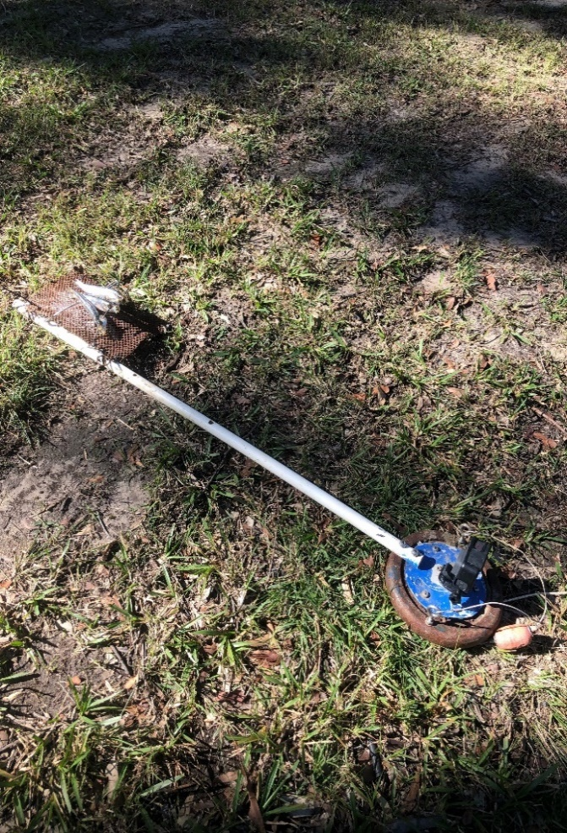

Figure S1. A photo of the BRUVS and scavenging assay design used in the study (left) and the field of view of the BRUVS and scavenging assay (right).

