List of Appendices
Appendix A: Data collection, screening and summary
Figure A.1. The flow of selecting neighbourhoods and recycling stations.
Table A.1. Summary of recording hours from March 7 to April 8 and from December 9 to 24 in 2019.
Table A.2. Summary statistics for independent variables of neighbourhoods
Table A.3. Demographic characteristics of questionnaire samples in Guangzhou
Table A.4. Scale variables of questionnaire survey in Guangzhou and the results of reliability and validity
Eq. (A.1). The calculation of Clumpiness Index
Eq. (A.2). The calculation of Landscape Shape Index
Appendix B: Recycling behaviour pattern
Figure B.1. Box plots comparing recycling behaviour between weekdays and weekends/official holidays with the Wilcoxon Test.
Figure B.2. Box plots comparing recycling behaviour between March and December using the Wilcoxon Test.
Appendix C. The results of models
Table C.1. Model selection table for Recycling Index adjusted for district-level per capita waste (N=235).
Table C.2. Model selection table for Recycling Index adjusted for subdistrict-level per capita waste (N=124).
Table C.3. Summary of model-conditional averaged coefficients for the subset models (ΔAICc <2.0) from model selection, with green space characteristics within 500 m, 1000 m, and 1500 m buffers zone around neighbourhoods used separately as independent variables in each global model.
Table C.4. The summary of SEM results for model examining all hypothesized pathways and direct effect from incidental exposure to neighbourhood green spaces influencing recycling behaviour, with the moderator of Clumpiness Index of green spaces
Table C.5. The summary of SEM results for model examining all hypothesized pathways and direct effect from incidental exposure to neighbourhood green spaces influencing recycling behaviour, with the moderator of Landscape Shape Index of green spaces.
Figure C.1. DHARMa residual plot of the residuals of all best models.
Figure C.2. Comparison of the density of recycling facilities between sample Group S and the completed sample.

Appendix. Supplementary materials
Appendix A. Data collection, screening and summary

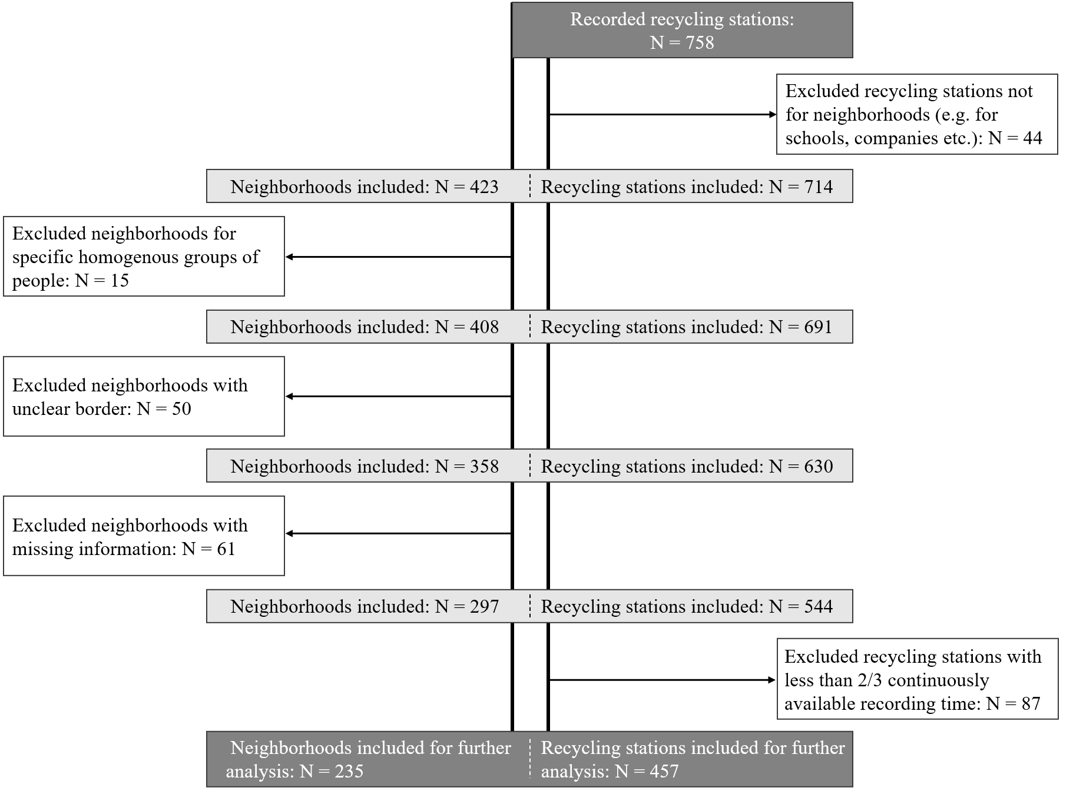
Figure A.1. The flow of selecting neighbourhoods and recycling stations.

Table A.1. Summary of recording hours from March 7 to April 8 and from December 9 to 24 in 2019.
 | Mon. | Tues. | Wed. | Thur. | Fri. | Sat. | Sun.
March,  2019 |  |  |  |  | 1 | 2 | 3
March,  2019 |  |  |  |  | Pre-collect | Pre-collect | Pre-collect
March,  2019 | 4 | 5 | 6 | 7 | 8 | 9 | 10
March,  2019 | Pre-collect | Pre-collect | Pre-collect | 13h | 13 h | 10 h | 12 h
March,  2019 | 11 | 12 | 13 | 14 | 15 | 16 | 17
March,  2019 | 12 h | 13 h | 13 h | 13 h | 12 h | 12 h | 12 h
March,  2019 | 18 | 19 | 20 | 21 | 22 | 23 | 24
March,  2019 | 13 h | 13 h | 13 h | 13 h | 11 h | 12 h | 12 h
March,  2019 | 25 | 26 | 27 | 28 | 29 | 30 | 31
March,  2019 | 10 h | 13 h | 11 h | 12 h | 13 h | 4 h | 12 h
April,  2019 | 1 | 2 | 3 | 4 | 5 | 6 | 7
April,  2019 | 12 h | 13 h | 13 h | 13 h | 13 h | 13 h | 13 h
April,  2019 | 8
April,  2019 | 11 h
December,  2019 |  |  |  |  |  |  | 1
December,  2019 | 2 | 3 | 4 | 5 | 6 | 7 | 8
December,  2019 |  |  |  |  | Pre-collect | Pre-collect | Pre-collect
December,  2019 | 9 | 10 | 11 | 12 | 13 | 14 | 15
December,  2019 | 13 h | 14 h | 13 h | 14 h | 11 h | 13 h | 14 h
December,  2019 | 16 | 17 | 18 | 19 | 20 | 21 | 22
December,  2019 | 13 h | 14 h | 14 h | 14 h | 14 h | 14 h | 14 h
December,  2019 | 23 | 24 | 25 | 26 | 27 | 28 | 29
December,  2019 | 14 h | 14 h
December,  2019 | 30 | 31

Table A.2. Summary statistics for independent variables of neighbourhoods
Variables | Mean | SD | Max | Min | Range
Social-economic characteristics
Housing Price (Yuan/m²) | 31407.69 | 13091.25 | 85514 | 10201 | 75313
Building Age (Year) | 14.23 | 6.54 | 39 | 1 | 38
Accessibility (N_{rs}/ha) | 0.78 | 0.37 | 2.74 | 0.14 | 2.60
Variables for green space within neighbourhoods
Green Space Area (ha) | 1.37 | 1.96 | 9.82 | 0 | 9.82
Green Area Ratio (%) | 20.67 | 13.09 | 67.56 | 0 | 67.56
Clumpiness Index | 0.73 | 0.18 | 0.98 | 0 | 0.98
Landscape Shape Index | 3.26 | 1.84 | 111.02 | 1 | 10.02
Variables for green space within buffer zones around neighbourhoods
Green Area Ratio - 500m (%) | 0.20 | 0.12 | 0.72 | 0.02 | 0.70
CIG_500m | 0.74 | 0.08 | 0.90 | 0.50 | 0.40
LSIG_500m | 10.93 | 2.26 | 17.83 | 5.55 | 12.28
Green Area Ratio - 1000m (%) | 0.22 | 0.13 | 0.76 | 0.05 | 0.71
CIG_1000m | 0.76 | 0.07 | 0.93 | 0.58 | 0.35
LSIG_1000m | 17.61 | 3.43 | 25.21 | 7.09 | 18.12
Green Area Ratio - 1500m (%) | 0.23 | 0.13 | 0.73 | 0.06 | 0.67
CIG_1500m | 0.78 | 0.06 | 0.93 | 0.61 | 0.31
LSIG_1500m | 23.85 | 4.93 | 34.00 | 8.31 | 25.68
Abbreviations: CIG_500m/1000m/1500m = Clumpiness index of green space within 500/1000/1500 m buffer zone around neighbourhoods; LSIG_500m/1000m/1500m = Landscape shape index of green space within 500/1000/1500 m buffer zone around neighbourhoods; N_{rs} = Number of recycling stations
Table A.3. Demographic characteristics of questionnaire samples in Guangzhou
Categorical variable | Category | Derivation for modelling | N
Gender | Male | 0 (Reference) | 124
Gender | Female | 1 | 176
Education | Associate degree or below | 0 (Reference) | 49
Education | Bachelor's degree or above | 1 | 251
Continuous Variable | Mean | SD
Income (Yuan/Year) | 139562.52 | 129982.46
Age | 32.35 | 7.90
Note: “The associate degree or below” includes education levels of primary education, secondary education, associate degree and no formal education. “Bachelor's degree or above” includes education levels of bachelor’s degree, master’s degree and doctorate.

Table A.4. Scale variables of questionnaire survey in Guangzhou and the results of reliability and validity
Measure | Item | Mean | SD | Factor Loadings | Composite reliability  (CR) | Average variance extracted (AVE) | Response and Coding
Nature visits |  |  |  |  |  |  | (1) Everyday = 6  (2) Several times a week = 5  (3) Once or twice a week = 4  (4) Once or twice a month = 3  (5) Several times a year = 2  (6) Never or once a year = 1
How often have you spent leisure time within neighbourhood? |  | 4.14 | 1.53 | 0.82 | 0.81 | 0.67
How often have you spent leisure time in green spaces around neighbourhood? |  | 3.94 | 1.45 | 0.82 | 0.81 | 0.67
Perception of neighbourhood green spaces |  |  |  |  |  |  | (1) Strongly agree = 7  (2) Agree = 6  (3) Somewhat agree = 5  (4) Neutral = 4  (5) Somewhat disagree = 3  (6) Disagree = 2  (7) Strongly disagree = 1
There is plenty of greenery within my neighbourhood. |  | 4.73 | 1.45 | 0.86 | 0.85 | 0.65
The natural landscape in my neighbourhood is very diverse and attractive. |  | 4.39 | 1.57 | 0.92 | 0.85 | 0.65
There is plenty of greenery around my neighbourhood. |  | 4.55 | 1.62 | 0.61 | 0.85 | 0.65
Subjective norm toward pro-environmental behaviour
Most people around me promote an environmentally friendly lifestyle. |  | 5.10 | 1.25 | 0.67 | 0.73 | 0.48
My friends encourage me to volunteer for environmental activities. |  | 4.70 | 1.51 | 0.78 | 0.73 | 0.48
My family thinks I should take action to protect the environment. |  | 5.33 | 1.28 | 0.61 | 0.73 | 0.48
Environmental protection Awareness
I think it is necessary to take action to protect the environment. |  | 6.08 | 0.92 | / | / | /
Recycling behaviours
Recycling on a recycling platform is what I'm used to. |  | 3.58 | 1.81 | / | / | /

The calculation of Clumpiness Index
Given $G_{i}= g_{ii}/ \sum_{k=1}^{m}{g_{ik}}$
CLUMPY = $\left[\begin{aligned}{(G}_{i}-P_{i})/(1-P_{i}) for G_{i}≥P_{i} \\ {(G}_{i}-P_{i})/(1-P_{i}) for G_{i}<P_{i}; P_{i}≥5 \\ {(G}_{i}-P_{i})/P_{i} for G_{i}<P_{i}; P_{i}<5 \end{aligned}\right]$ Eq. (A.1)

g_{ii} = number of like adjacencies (joins) between pixels of patch type (class) i based on the double-count method.
g_{ik} = number of adjacencies (joins) between pixels of patch types (classes) i and k based on the double-count method.
P_{i} = proportion of the landscape occupied by patch type (class) i.
The value of CI ranges from -1 (when the focal patch type is maximally disaggregated) to 1 (when the patch type is maximally aggregated), and when the corresponding patch type is randomly distributed, CI is equal to 0 (Mcgarigal et al., 2023).

The calculation of Landscape Shape Index
$LSI=\frac{0.25\sum_{k=1}^{m}{e_{ik}^{*}}}{\sqrt{A}}$ Eq. (A.2)
e*_{ik} = total length (m) of edge in landscape between patch types (classes) i and k.
A = total landscape area (m²).
LSI increases from 1 without limit as landscape shape becomes more irregular and/or as the length of edge within the landscape of the corresponding patch type increases (Mcgarigal et al., 2023).

Appendix B. Recycling behaviour pattern

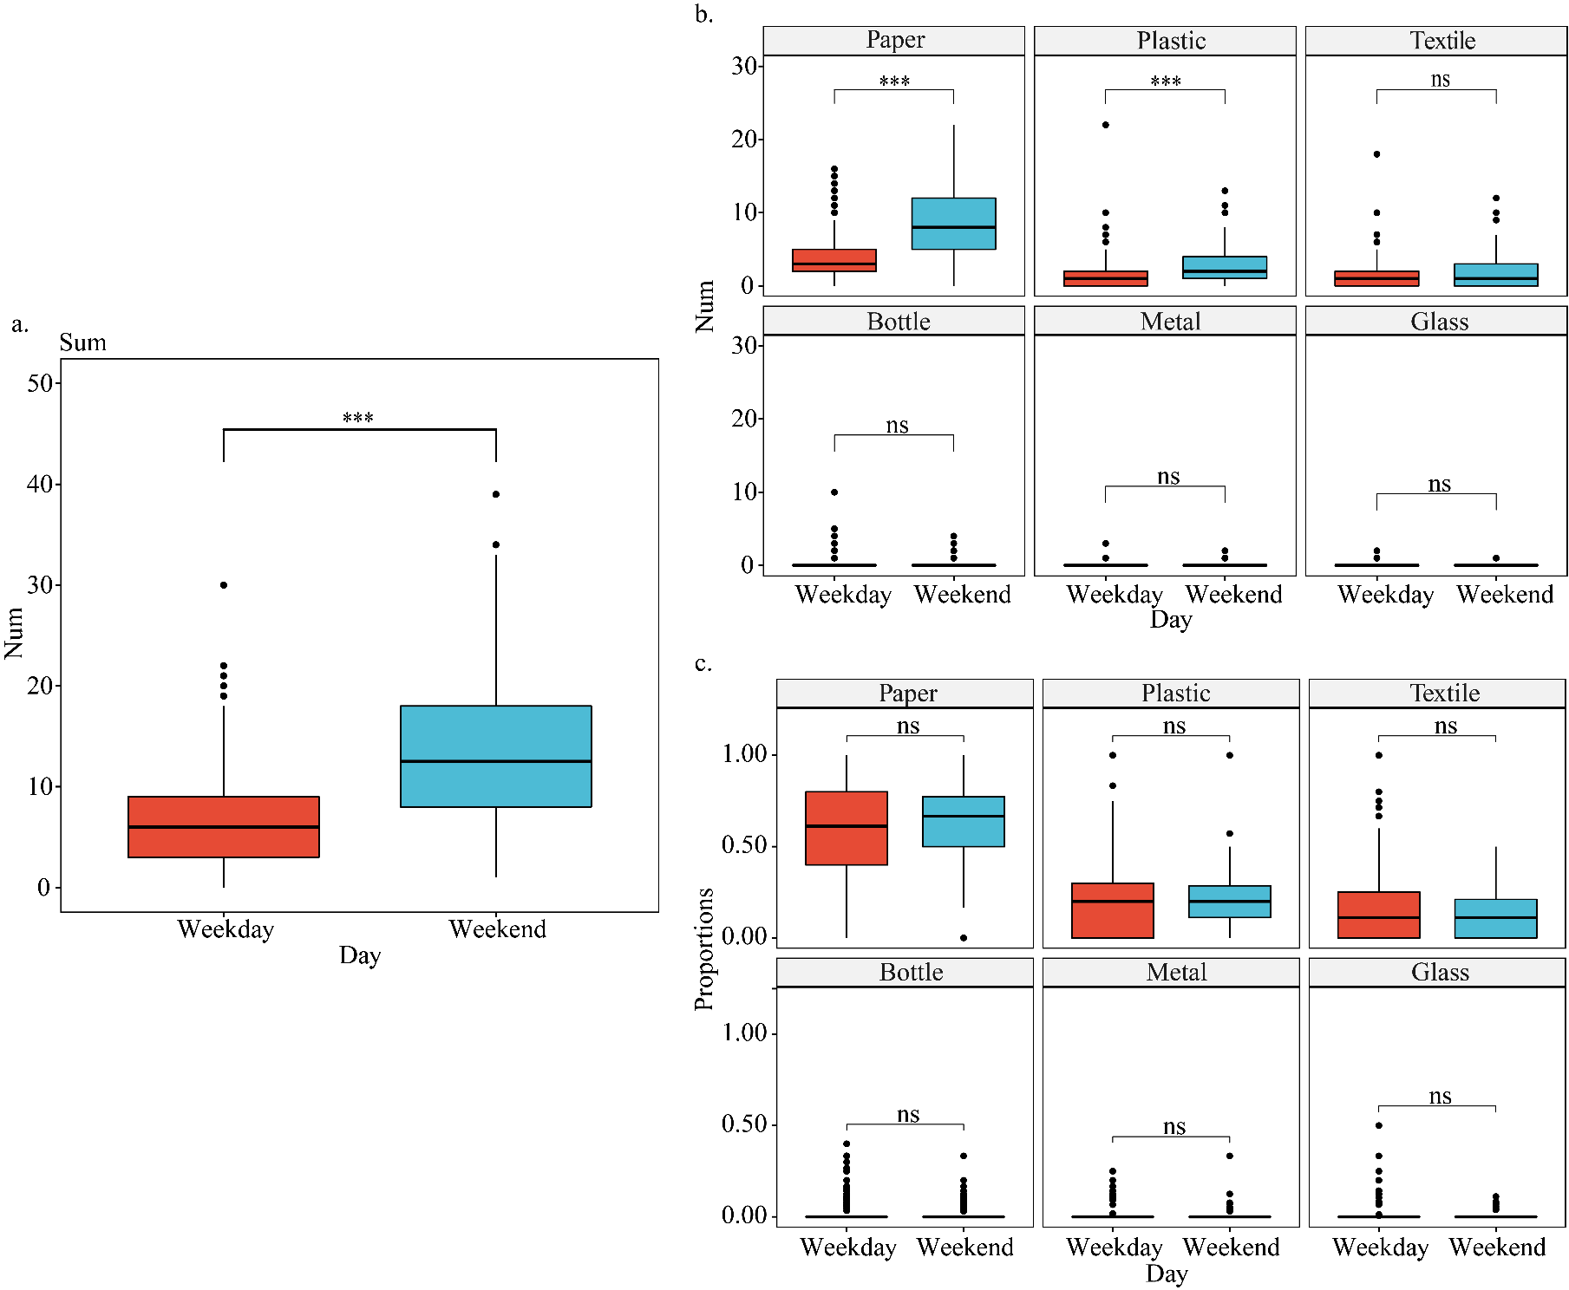
Figure B.1. Box plots comparing recycling behaviour between weekdays and weekends/official holidays with the Wilcoxon Test. The middle line in each box represents the median, while the bottom and top edges indicate the 25th and 75th percentiles, respectively. (Asterix indicates: p<0.001***, p<0.01**, p<0.05*)
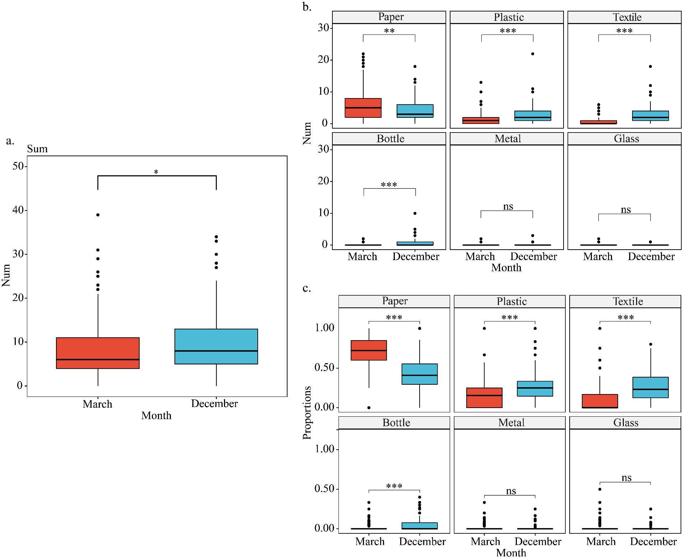
Figure B.2. Box plots comparing recycling behaviour between March and December using the Wilcoxon Test. The middle line in each box represents the median, while the bottom and top edges indicate the 25th and 75th percentiles, respectively. (Asterix indicates: p<0.001***, p<0.01**, p<0.05*)

Appendix C. The results of models
Table C.1. Model selection table for Recycling Index adjusted for district-level per capita waste (N=235).
Result for all recyclables
No. | (Intr) | Month | Dens. | GAR_N | Dens.: GAR_N | R^2 | df | logLik | AICc | delta | weight
1 | -0.13 | + | 0.38 | 0.27 | 0.15 | 0.18 | 7.00 | -630.88 | 1276.00 | 0.00 | 0.38
Result for paper recyclables
No. | (Intr) | Month | Dens. | GAR_N | Dens.: GAR_N | R^2 | df | logLik | AICc | delta | weight
1 | 0.14 | + | 0.26 | 0.23 | 0.12 | 0.09 | 7.00 | -654.23 | 1322.70 | 0.00 | 0.14
2 | 0.04 |  | 0.26 | 0.23 | 0.12 | 0.08 | 6.00 | -655.33 | 1322.80 | 0.13 | 0.13
3 | 0.10 | + | 0.20 | 0.22 |  | 0.08 | 6.00 | -655.49 | 1323.20 | 0.46 | 0.11
44 | 0.00 |  | 0.20 | 0.22 |  | 0.07 | 5.00 | -656.59 | 1323.30 | 0.61 | 0.11
Models ranked by AICc (with ΔAICc ≤ 2.0)
Abbreviations: GAR_N = Green area ratio within neighbourhoods; Dens. = Density of recycling stations; AICc = Akaike Information Criterion corrected
Table C.2. Model selection table for Recycling Index adjusted for subdistrict-level per capita waste (N=124).
Result for all recyclables
No. | (Intr) | Month | Dens. | GAR_N | R^2 | df | logLik | AICc | delta | weight
1 | -0.31 | + |  | 0.20 | 0.15 | 5.00 | -336.51 | 683.30 | 0.00 | 0.30
2 | -0.31 | + | 0.16 | 0.26 | 0.17 | 6.00 | -335.69 | 683.70 | 0.46 | 0.23
Result for paper recyclables
No. | (Intr) | Month | Dens. | GAR_N | R^2 | df | logLik | AICc | delta | weight
1 | 0.00 |  |  | 0.22 | 0.06 | 4.00 | -347.70 | 703.60 | 0.00 | 0.32
Models ranked by AICc (with ΔAICc ≤ 2.0)
Abbreviations: GAR_N = Green area ratio within neighbourhoods; Dens. = Density of recycling stations; AICc = Akaike Information Criterion corrected

Table C.3. Summary of model-conditional averaged coefficients for the subset models (ΔAICc <2.0) from model selection, with green space characteristics within 500 m, 1000 m, and 1500 m buffer zones around neighbourhoods used separately as independent variables in each global model.
Dependent variables | Recycling Index _{district} |  |  |  |  |  | Recycling Index _{subdistrict}
Dependent variables | All recyclables |  |  | Paper recyclables |  |  | All recyclables |  |  | Paper recyclables
 | Est. | S.E. | P | Est. | S.E. | P | Est. | S.E. | P | Est. | S.E. | P
Global models with green space characteristics within 500 m buffer zone around neighbourhoods
(Intercept) | -0.18 | 0.06 | 0.00 | 0.05 | 0.08 | 0.51 | -0.31 | 0.09 | 0.00 | 0.00 | 0.07 | 1.00
Month (ref. March) | 0.36 | 0.08 | 0.00 | -0.19 | 0.08 | 0.02 | 0.62 | 0.11 | 0.00 | - | - | -
GAR_500m | - | - | - | 0.11 | 0.05 | 0.04 | 0.14 | 0.07 | 0.04 | 0.18 | 0.07 | 0.01
Density of recycling stations | 0.21 | 0.05 | 0.00 | 0.14 | 0.05 | 0.01 | - | - | - | - | - | -
Year | -0.12 | 0.05 | 0.02 | - | - | - | - | - | - | - | - | -
Price | 0.11 | 0.05 | 0.03 | 0.11 | 0.05 | 0.03 | - | - | - | - | - | -
Global models with green space characteristics within 1000 m buffer zone around neighbourhoods
(Intercept) | -0.18 | 0.06 | 0.06 | 0.05 | 0.08 | 0.08 | *-0.31 | 0.09 | 0.00 | 0.00 | 0.07 | 1.00
Month (ref. March) | 0.36 | 0.08 | 0.08 | -0.19 | 0.08 | 0.08 | *0.62 | 0.11 | 0.00 | - | - | -
GAR_1000m | - | - | - | - | - | - | - | - | - | 0.16 | 0.07 | 0.02
CIG_1000m | - | - | - | - | - | - | - | - | - | 0.16 | 0.07 | 0.02
Density of recycling stations | 0.21 | 0.05 | 0.05 | 0.13 | 0.05 | 0.05 | - | - | - | - | - | -
Year | -0.12 | 0.05 | 0.05 |  |  |  | - | - | - | - | - | -
Price | 0.11 | 0.05 | 0.05 | 0.11 | 0.05 | 0.05 | - | - | - | - | - | -
Global models with green space characteristics within 1500 m buffer zone around neighbourhoods
(Intercept) | -0.18 | 0.06 | 0.06 | 0.05 | 0.08 | 0.08 | *-0.31 | 0.09 | 0.00 | *-0.31 | 0.09 | 0.00
Month (ref. March) | 0.36 | 0.08 | 0.08 | -0.19 | 0.08 | 0.08 | *0.62 | 0.11 | 0.00 | *0.62 | 0.11 | 0.00
Density of recycling stations | 0.21 | 0.05 | 0.05 | 0.13 | 0.05 | 0.05
Year | -0.12 | 0.05 | 0.05
Price | 0.11 | 0.05 | 0.05 | 0.11 | 0.05 | 0.05
Abbreviations: Recycling Index _{district} = Recycling Index adjusted for district-level per capita waste; Recycling Index _{Subdistrict} = Recycling Index adjusted for subdistrict-level per capita waste; GAR_500 m / 1000 m / 1500 m = green area ratio within 500 m / 1000 m / 1500 m buffer zone around neighbourhoods
Table C.4. The summary of SEM results for model examining all hypothesized pathways and direct effect from incidental exposure to neighbourhood green spaces influencing recycling behaviour, with the moderator of Clumpiness Index of green spaces.
Pathways | Estimate | S.E. | Est./S.E. | P-Value
GAR → NPG | 0.41 | 0.09 | 4.84 | 0.00
GAR →VFG | -0.16 | 0.09 | -1.87 | 0.06
NPG → VFG | 0.37 | 0.06 | 6.30 | 0.00
VFG → SN | 0.27 | 0.06 | 4.56 | 0.00
GAR→ Recycling | -0.03 | 0.06 | -0.55 | 0.58
SN → Recycling | 0.29 | 0.08 | 3.60 | 0.00
VFG → Recycling | 0.17 | 0.06 | 2.80 | 0.01
Moderation effect
CIG → NPG | -0.07 | 0.07 | -0.88 | 0.38
GAR*CIG → NPG | -0.21 | 0.07 | -2.89 | 0.00
CIG→VFG | 0.12 | 0.07 | 1.79 | 0.07
GAR*CIG →VFG | 0.14 | 0.07 | 1.98 | 0.05
Covariates
Gender → NPG | 0.04 | 0.06 | 0.75 | 0.45
Age → NPG | -0.04 | 0.06 | -0.70 | 0.48
Education → NPG | -0.01 | 0.06 | -0.10 | 0.92
EPA → NPG | 0.15 | 0.06 | 2.53 | 0.01
Income → NPG | 0.19 | 0.06 | 3.23 | 0.00
Gender → VFG | -0.02 | 0.06 | -0.33 | 0.74
Age → VFG | -0.03 | 0.06 | -0.53 | 0.60
Education → VFG | 0.03 | 0.06 | 0.59 | 0.56
EPA → VFG | 0.05 | 0.06 | 0.84 | 0.40
Income → VFG | 0.02 | 0.06 | 0.36 | 0.72
Gender → SN | 0.05 | 0.06 | 0.75 | 0.45
Age → SN | 0.12 | 0.06 | 1.93 | 0.05
Education → SN | 0.03 | 0.06 | 0.53 | 0.60
EPA → SN | 0.45 | 0.06 | 7.38 | 0.00
Income → SN | 0.00 | 0.06 | 0.02 | 0.98
Gender → Recycling | 0.02 | 0.06 | 0.36 | 0.72
Age → Recycling | 0.02 | 0.06 | 0.42 | 0.67
Education → Recycling | 0.12 | 0.06 | 2.20 | 0.03
EPA → Recycling | -0.08 | 0.07 | -1.22 | 0.22
Income → Recycling | -0.03 | 0.06 | -0.59 | 0.55
X²/df = 1.91; CFI = 0.94; TLI = 0.90; RMSEA = 0.06; SRMR = 0.04
Abbreviations: GAR = Green area ratio within 500 m buffer zone around respondent’s residual; CIG = Clumpiness index of green space within 500 m buffer zone around respondent’s residual; NPG = Perception of neighbourhood green spaces; VFG = Neighbourhood green space visit frequency; SN = Subjective norm; EPA = Environmental protection awareness.
Table C.5. The summary of SEM results for model examining all hypothesized pathways and direct effect from incidental exposure to neighbourhood green spaces influencing recycling behaviour, with the moderator of Landscape Shape Index of green spaces.
Pathways | Estimate | S.E. | Est./S.E. | P-Value
GAR → NPG | 0.35 | 0.07 | 4.93 | 0.00
GAR →VFG | -0.02 | 0.07 | -0.31 | 0.76
NPG → VFG | 0.36 | 0.06 | 6.21 | 0.00
VFG → SN | 0.27 | 0.06 | 4.56 | 0.00
GAR→ Recycling | -0.03 | 0.06 | -0.55 | 0.58
SN → Recycling | 0.29 | 0.08 | 3.60 | 0.00
VFG → Recycling | 0.17 | 0.06 | 2.80 | 0.01
Moderation effect
LSIG → NPG | 0.06 | 0.06 | 1.04 | 0.30
GAR* LSIG→ NPG | 0.14 | 0.07 | 1.88 | 0.06
LSIG→VFG | -0.14 | 0.06 | -2.56 | 0.01
GAR* LSIG→VFG | -0.01 | 0.07 | -0.07 | 0.94
Covariates
Gender → NPG | 0.05 | 0.06 | 0.79 | 0.43
Age → NPG | -0.04 | 0.06 | -0.64 | 0.52
Education → NPG | 0.00 | 0.06 | 0.02 | 0.99
EPA → NPG | 0.15 | 0.06 | 2.57 | 0.01
Income → NPG | 0.20 | 0.06 | 3.45 | 0.00
Gender → VFG | -0.02 | 0.06 | -0.28 | 0.78
Age → VFG | -0.02 | 0.06 | -0.39 | 0.70
Education → VFG | 0.03 | 0.06 | 0.61 | 0.54
EPA → VFG | 0.04 | 0.06 | 0.72 | 0.47
Income → VFG | 0.02 | 0.06 | 0.34 | 0.73
Gender → SN | 0.05 | 0.06 | 0.75 | 0.45
Age → SN | 0.12 | 0.06 | 1.93 | 0.05
Education → SN | 0.03 | 0.06 | 0.53 | 0.60
EPA → SN | 0.45 | 0.06 | 7.38 | 0.00
Income → SN | 0.00 | 0.06 | 0.02 | 0.98
Gender → Recycling | 0.02 | 0.06 | 0.36 | 0.72
Age → Recycling | 0.02 | 0.06 | 0.42 | 0.67
Education → Recycling | 0.12 | 0.06 | 2.20 | 0.03
EPA → Recycling | -0.08 | 0.07 | -1.22 | 0.22
Income → Recycling | -0.03 | 0.06 | -0.59 | 0.55
X²/df = 1.83; CFI = 0.94; TLI = 0.91; RMSEA = 0.05; SRMR = 0.04
Abbreviations: GAR = Green area ratio within 500 m buffer zone around respondent’s residual; LSIG = Landscape shape index of green space within 500 m buffer zone around respondent’s residual; NPG = Perception of neighbourhood green spaces; VFG = Neighbourhood green space visit frequency; SN = Subjective norm; EPA = Environmental protection awareness.
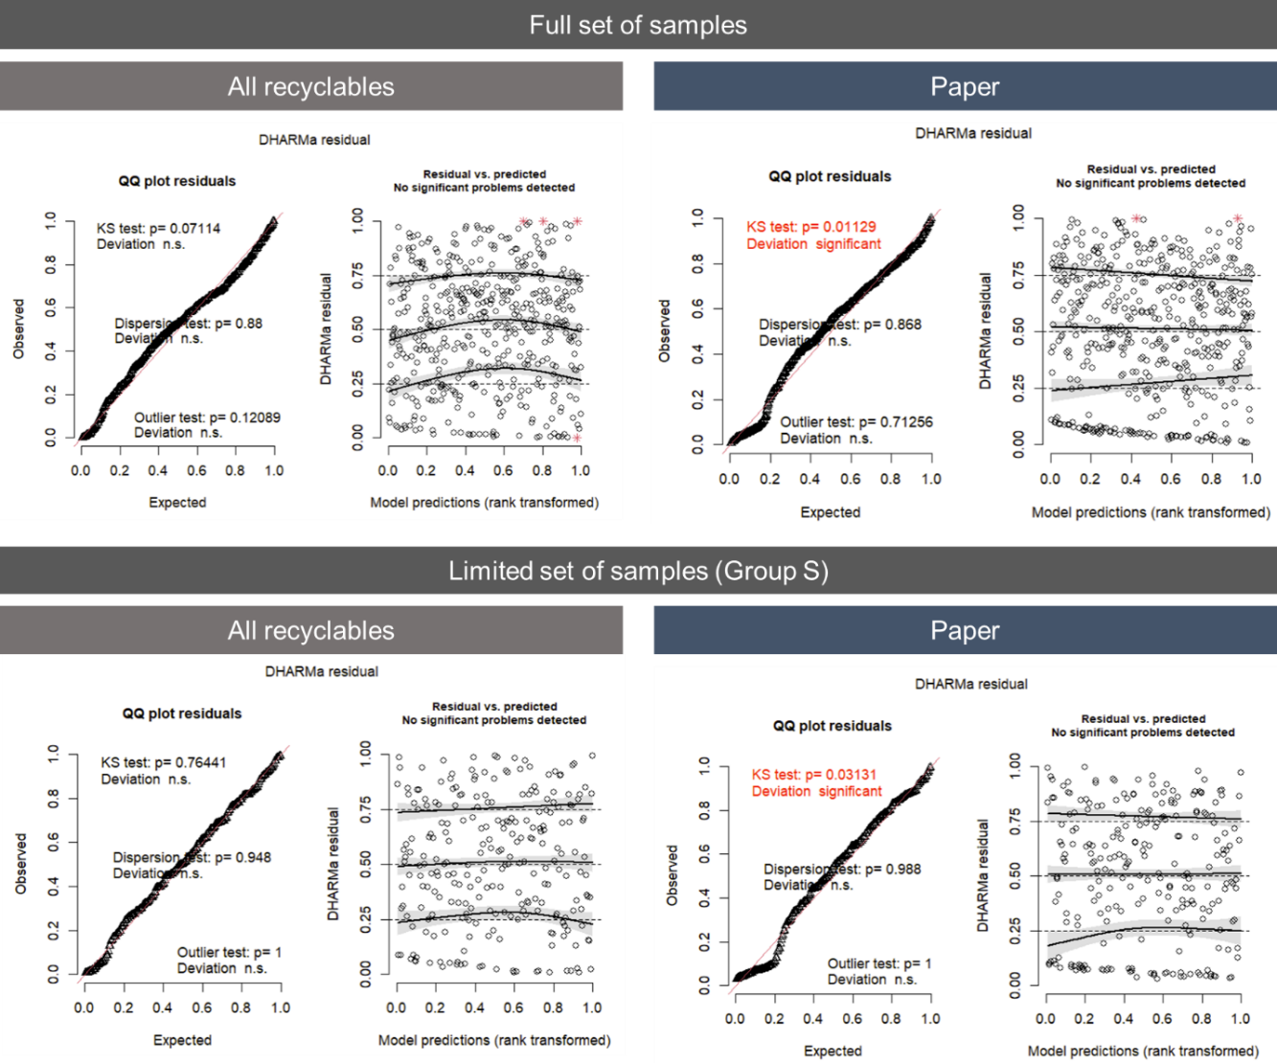
Figure C.1. DHARMa residual plot of the residuals of all best models.
Figure C.2. Comparison of the density of recycling facilities between sample Group S and the completed sample.

