Supplementary Materials to Sarmati et al. - A complex interplay between natural and anthropogenic factors shapes plant diversity patterns in Mediterranean coastal dunes -. Landscape Ecology.

Appendix 1

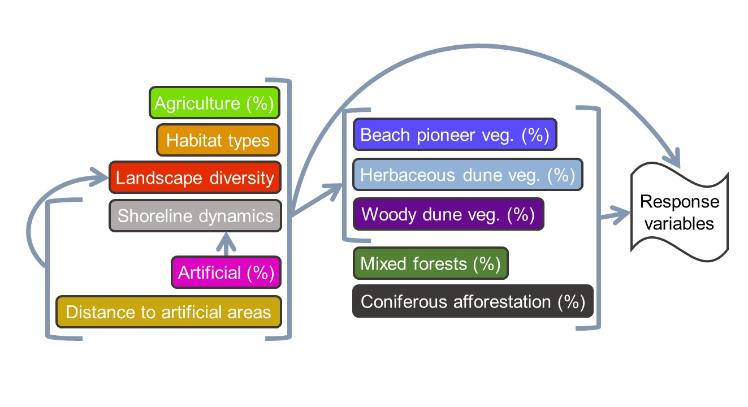
Fig. S1 Hypothesized meta-model used to analyse the complex interplay between landscape configuration and shoreline dynamism, and their effect on coastal dune plant diversity. Response variables included: species richness, proportion of typical species, and proportion of ruderal species. Veg. = vegetation.

Table S1. List of EUNIS habitat types
List of EUNIS codes along with the corresponding habitat type(s) included in the Annex I of the Habitats Directive (92/43/EEC) and their related typical species (nomenclature follows Bartolucci et al. 2018). N = number of vegetation plots assigned to each EUNIS habitat types.

3-level EUNIS | Description | EU Habitats Directive  (Annex I 92/43/EEC) | Typical species
N12 - Sand beach driftlines  (N = 23) | Annual pioneer herbaceous formations typically found near the shoreline | 1210 - Annual vegetation of drift lines (upper beach) | Atriplex prostrata, Cakile maritima subsp. maritima, Euphorbia peplis, Convolvulus soldanella, Matthiola sinuata, Polygonum maritimum, Salsola kali
N14 - Shifting coastal dunes  (N = 185) | Mobile and semi-permanent dune systems including embryonic and shifting dunes | 2110 - Embryonic shifting dunes (embryo dune) characterized by Thinopyrum junceum (= Elymus farctus)  2120 - Shifting dunes along the shoreline with Ammophila arenaria (white dune) | Achillea maritima subsp. maritima, Anthemis maritima subsp. maritima, Calamagrostis arenaria subsp. arundinacea, Centaurea aplolepa, Cyperus capitatus, Echinophora spinosa, Thinopyrum junceum, Eryngium maritimum, Euphorbia paralias, Medicago marina, Ononis variegata, Solidago virgaurea subsp. litoralis, Sporobolus virginicus, Stachys maritima
N16 - Coastal stable dune grasslands  (N = 130) | Perennial grasslands of the fixed and semifixed dunes and annual species-rich communities that colonize grasslands clearings | 2210 - Crucianellion maritimae fixed and semifixed dunes dominated by Crucianella maritima  2230 - Malcolmietalia dune grasslands  2240 - Brachypodietalia dune grasslands with annuals | Crucianella maritima, Cutandia maritima, Daucus pumilus, Festuca fasciculata (= Vulpia fasciculata), Helichrysum stoechas, Lagurus ovatus, Lomelosia rutifolia, Marcus-kochia ramosissima, Medicago littoralis, Pancratium maritimum, Phleum arenarium subsp. caesium, Seseli tortuosum, Silene canescens, Sonchus bulbosus subsp. bulbosus, Tuberaria guttata
N1B - Coastal dune shrubs  (N = 136) | Stable dunes with Juniperus spp. communities or sclerophyllous shrubs | 2250 - Coastal dunes with Juniperus spp.  2260 - Cisto-Lavanduletalia dune sclerophyllous shrubs | Arbutus unedo, Asparagus acutifolius, Cistus creticus eriocephalus, Clematis flammula, Daphne gnidium, Erica multiflora, Juniperus oxycedrus, J. phoenicea, Lonicera implexa subsp. implexa, Myrtus communis, Osyris alba, Phillyrea angustifolia, Pistacia lentiscus, Rhamnus alaternus subsp. alaternus, Rubia peregrina, Ruscus aculeatus, Salvia rosmarinus, Smilax aspera, Stachys major

Table S2. List of all sampled plant species
List of all sampled species. Species are classified in typical (T), ruderal (R), alien (A). All species not included in these three categories were classified as other species (O). Species nomenclature and families follows Portal of Flora of Italy (2024). Species are sorted alphabetically by type, family and specie’s name.
Family | Species | Type
AIZOACEAE | Carpobrotus acinaciformis | A
ASPARAGACEAE | Yucca gloriosa | A
ASPHODELACEAE | Aloë maculata | A
ASTERACEAE | Ambrosia psilostachya | A
ASTERACEAE | Erigeron canadensis | A
ASTERACEAE | Erigeron sumatrensis | A
ASTERACEAE | Symphyotrichum squamatum | A
ASTERACEAE | Xanthium italicum | A
FABACEAE | Amorpha fruticosa | A
FABACEAE | Robinia pseudacacia | A
PITTOSPORACEAE | Pittosporum tobira | A
POACEAE | Arundo donax | A
POACEAE | Avena sterilis | A
POACEAE | Paspalum vaginatum | A
POACEAE | Phalaris canariensis | A
POACEAE | Sporobolus pumilus | A
ROSACEAE | Prunus armeniaca | A
AMARYLLIDACEAE | Pancratium maritimum | T
ANACARDIACEAE | Pistacia lentiscus | T
APIACEAE | Daucus pumilus | T
APIACEAE | Echinophora spinosa | T
APIACEAE | Eryngium maritimum | T
APIACEAE | Seseli tortuosum subsp. tortuosum | T
ASPARAGACEAE | Asparagus acutifolius | T
ASPARAGACEAE | Ruscus aculeatus | T
ASTERACEAE | Achillea maritima subsp. maritima | T
ASTERACEAE | Anthemis maritima subsp. maritima | T
ASTERACEAE | Centaurea aplolepa subsp. subciliata | T
ASTERACEAE | Helichrysum stoechas subsp. stoechas | T
ASTERACEAE | Solidago litoralis | T
ASTERACEAE | Sonchus bulbosus subsp. bulbosus | T
BRASSICACEAE | Cakile maritima subsp. maritima | T
BRASSICACEAE | Marcus-kochia ramosissima | T
BRASSICACEAE | Matthiola sinuata | T
CAPRIFOLIACEAE | Lomelosia rutifolia | T
CAPRIFOLIACEAE | Lonicera implexa subsp. implexa | T
CARYOPHYLLACEAE | Silene canescens | T
CHENOPODIACEAE | Atriplex prostrata | T
CHENOPODIACEAE | Salsola kali | T
CISTACEAE | Cistus creticus subsp. eriocephalus | T
CISTACEAE | Tuberaria guttata | T
CONVOLVULACEAE | Convolvulus soldanella | T
CUPRESSACEAE | Juniperus oxycedrus | T
CUPRESSACEAE | Juniperus phoenicea | T
CYPERACEAE | Cyperus capitatus | T
ERICACEAE | Arbutus unedo | T
ERICACEAE | Erica multiflora subsp. multiflora | T
EUPHORBIACEA | Euphorbia paralias | T
EUPHORBIACEA | Euphorbia peplis | T
FABACEAE | Medicago littoralis | T
FABACEAE | Medicago marina | T
FABACEAE | Ononis variegata | T
LAMIACEAE | Salvia rosmarinus | T
LAMIACEAE | Stachys major | T
LAMIACEAE | Stachys maritima | T
MYRTACEAE | Myrtus communis | T
OLEACEAE | Phillyrea angustifolia | T
POACEAE | Calamagrostis arenaria subsp. arundinacea | T
POACEAE | Cutandia maritima | T
POACEAE | Elymus farctus | T
POACEAE | Festuca fasciculata | T
POACEAE | Lagurus ovatus | T
POACEAE | Phleum arenarium subsp. caesium | T
POACEAE | Sporobolus virginicus | T
POLYGONACEAE | Polygonum maritimum | T
RANUNCULACEAE | Clematis flammula | T
RHAMNACEAE | Rhamnus alaternus subsp. alaternus | T
RUBIACEAE | Crucianella maritima | T
RUBIACEAE | Rubia peregrina | T
SANTALACEAE | Osyris alba | T
SMILACACEAE | Smilax aspera | T
THYMELAEACEAE | Daphne gnidium | T
APIACEAE | Crithmum maritimum | O
ARALIACEAE | Hedera helix subsp. helix | O
ARECACEAE | Chamaerops humilis | O
ASTERACEAE | Chondrilla juncea | O
ASTERACEAE | Cichorium intybus | O
ASTERACEAE | Cota tinctoria | O
ASTERACEAE | Hedypnois rhagadioloides | O
ASTERACEAE | Hypochaeris achyrophorus | O
ASTERACEAE | Hypochaeris glabra | O
ASTERACEAE | Hypochaeris radicata | O
ASTERACEAE | Jacobaea maritima subsp. maritima | O
ASTERACEAE | Limbarda crithmoides subsp. longifolia | O
ASTERACEAE | Reichardia picroides | O
ASTERACEAE | Urospermum dalechampii | O
BRASSICACEAE | Maresia nana | O
BRASSICACEAE | Raphanus raphanistrum subsp. landra | O
CAMPANULACEAE | Campanula rapunculus | O
CAPRIFOLIACEAE | Sixalix atropurpurea | O
CARYOPHYLLACEAE | Arenaria leptoclados subsp. leptoclados | O
CARYOPHYLLACEAE | Arenaria serpyllifolia subsp. serpyllifolia | O
CARYOPHYLLACEAE | Cerastium diffusum subsp. diffusum | O
CARYOPHYLLACEAE | Petrorhagia prolifera | O
CARYOPHYLLACEAE | Silene otites | O
CHENOPODIACEAE | Atriplex halimus | O
CHENOPODIACEAE | Halimione portulacoides | O
CISTACEAE | Cistus creticus subsp. creticus | O
CONVOLVULACEAE | Convolvulus sp. | O
CONVOLVULACEAE | Cuscuta sp. | O
CYPERACEAE | Carex flacca s.l. | O
CYPERACEAE | Cyperus rotundus | O
CYPERACEAE | Schoenus nigricans | O
EQUISETACEAE | Equisetum ramosissimum | O
EUPHORBIACEA | Euphorbia barrelieri | O
EUPHORBIACEA | Euphorbia peplus | O
FABACEAE | Lotus hirsutus | O
FABACEAE | Medicago lupulina | O
FABACEAE | Medicago rigidula | O
FABACEAE | Onobrychis caput-galli | O
FABACEAE | Ononis reclinata | O
FABACEAE | Trifolium angustifolium subsp. angustifolium | O
FABACEAE | Trifolium dubium | O
FABACEAE | Trifolium squamosum | O
FABACEAE | Trifolium striatum subsp. striatum | O
FAGACEAE | Quercus ilex subsp. ilex | O
GENTIANACEAE | Blackstonia perfoliata | O
GENTIANACEAE | Centaurium erythraea | O
GERANIACEAE | Geranium pusillum | O
JUNCACEA | Juncus acutus subsp. acutus | O
JUNCACEA | Juncus inflexus subsp. inflexus | O
LAMIACEAE | Clinopodium nepeta | O
LAMIACEAE | Mentha suaveolens subsp. suaveolens | O
LAMIACEAE | Stachys arvensis | O
LAMIACEAE | Teucrium capitatum subsp. capitatum | O
LAMIACEAE | Teucrium flavum subsp. flavum | O
LAMIACEAE | Teucrium polium subsp. polium | O
LINACEAE | Linum corymbulosum | O
LINACEAE | Linum maritimum | O
LINACEAE | Linum strictum | O
LINACEAE | Linum tenuifolium | O
OLEACEAE | Phillyrea latifolia | O
ONAGRACEAE | Oenothera sp. | O
OROBANCHACEAE | Odontites luteus subsp. luteus | O
OROBANCHACEAE | Orobanche minor | O
PAPAVERACEAE | Fumaria bicolor | O
PAPAVERACEAE | Glaucium flavum | O
PINACEAE | Pinus pinaster subsp. pinaster | O
PINACEAE | Pinus pinea | O
PLANTAGINACEAE | Plantago coronopus | O
PLUMBAGINACEAE | Limonium multiforme | O
POACEAE | Alopecurus myosuroides subsp. myosuroides | O
POACEAE | Ampelodesmos mauritanicus | O
POACEAE | Anisantha rubens | O
POACEAE | Avena barbata | O
POACEAE | Avena fatua | O
POACEAE | Brachypodium rupestre | O
POACEAE | Brachypodium sp. | O
POACEAE | Brachypodium sylvaticum | O
POACEAE | Imperata cylindrica | O
POACEAE | Parapholis incurva | O
POACEAE | Phleum hirsutum subsp. ambiguum | O
POACEAE | Phragmites australis | O
POACEAE | Rostraria pubescens | O
POACEAE | Tripidium ravennae subsp. ravennae | O
POLYGONACEAE | Rumex bucephalophorus | O
RESEDACEAE | Reseda alba | O
ROSACEAE | Rubus hirtus | O
RUBIACEAE | Asperula cynanchica subsp. cynanchica | O
RUBIACEAE | Galium murale | O
RUBIACEAE | Sherardia arvensis | O
SOLANACEAE | Solanum sp. | O
TAMARICACEAE | Tamarix africana | O
TAMARICACEAE | Tamarix gallica | O
THYMELAEACEAE | Daphne sericea | O
ULMACEAE | Ulmus minor | O
APIACEAE | Daucus carota | R
APIACEAE | Torilis arvensis subsp. arvensis | R
ASTERACEAE | Centaurea sphaerocephala subsp. sphaerocephala | R
ASTERACEAE | Crepis foetida subsp. foetida | R
ASTERACEAE | Dittrichia viscosa subsp. viscosa | R
ASTERACEAE | Scolymus hispanicus | R
ASTERACEAE | Sonchus asper | R
ASTERACEAE | Sonchus oleraceus | R
BORAGINACEAE | Myosotis arvensis | R
BRASSICACEAE | Raphanus raphanistrum | R
CARYOPHYLLACEAE | Cerastium glomeratum | R
CHENOPODIACEAE | Chenopodium album subsp. album | R
CONVOLVULACEAE | Convolvulus arvensis | R
FABACEAE | Medicago minima | R
FABACEAE | Trifolium campestre | R
FABACEAE | Vicia bithynica | R
GERANIACEAE | Geranium purpureum | R
OROBANCHACEAE | Orobanche artemisiae-campestris | R
PAPAVERACEAE | Papaver rhoeas subsp. rhoeas | R
POACEAE | Anisantha madritensis subsp. madritensis | R
POACEAE | Anisantha rigida | R
POACEAE | Anisantha sterilis | R
POACEAE | Anisantha tectorum | R
POACEAE | Catapodium balearicum | R
POACEAE | Catapodium hemipoa | R
POACEAE | Cynodon dactylon | R
POACEAE | Dactylis glomerata | R
POACEAE | Elymus repens subsp. repens | R
POACEAE | Poa bulbosa | R
POLYGONACEAE | Polygonum aviculare subsp. aviculare | R
PRIMULACEAE | Lysimachia arvensis | R
RANUNCULACEAE | Clematis vitalba | R
ROSACEAE | Rubus ulmifolius | R
SCROPHULARIACEAE | Verbascum sinuatum | R
Table S3. List of mapped land cover classes
List of mapped land cover classes expanded up to the fourth level of detail of the CORINE code (and description). A detailed description of each class is also reported. In bold was indicated the reference to each specific coverage class in this paper.

CORINE Code | CORINE Description | Detailed description
1.1.1.2. | Artificial areas | Artificial facilities, including urban fabrics, and industrial and commercial units
1.4 | Artificial, non-agricultural vegetated areas | Tourism facilities, including bathing houses and camping
2 | Agricultural areas | Agricultural areas, including arable land, permanent crops, pastures, and heterogeneous agricultural areas.
3.1.2.1 | Afforestation | Coniferous afforestation on coastal dunes with Pinus spp.
3.1.3.1 | Mixed forests | Mixed forests: vegetation formation composed principally of trees, including shrub and bush understorey, where neither broad-leaved nor coniferous species predominate
3.2.3.1. | Mediterranean maquis | Woody dune vegetation growing on fixed dune. Includes shrub and sclerophyll communities dominated by Juniperus spp. and Cistus-Lavenduletalia typical of the EUNIS habitat: N1B
3.2.4.1. | Semi-natural Woody Vegetation | Bushy vegetation with scattered trees represented by foredune woodland degradation or forest regeneration/recolonization
3.2.4.2. | Semi-natural Herbaceous Vegetation | Abandoned meadows and pastures with different degree of degradation or recolonization
3.3.1.1. | Open sand | Beach pioneer vegetation: upper beach characterised by open sand colonised by pioneer annual vegetation. Includes the EUNIS habitat N12
3.3.1.2. | Herbaceous Dune Vegetation | Herbaceous Dune Vegetation: foredunes colonised by herbaceous vegetation intermingled to open sectors. Includes the EUNIS habitat N14 and N16
4 | Wetlands | Inland and coastal wetlands and marshes

Table S4. List of predictors used in the linear and generalized linear models, and in structural equation models.
All variables below were calculated within each linear buffer. Exceptions are: distance to artificial areas, distance to tourism facilities, and shoreline dynamism, which were measured in terms of minimum distance from each vegetation plot. Variables in bold did not score high values of the variance inflation factor (VIF; vif function, car R package, Fox and Weisberg 2019), and therefore were included in the statistical analyses.

Name | Description
Beach pioneer vegetation (%) | Proportion (%) of areas covered by beach pioneer vegetation land cover class
Herbaceous dune vegetation (%) | Proportion (%) of areas covered by herbaceous dune vegetation land cover class
Woody Dune Vegetation (%) | Proportion (%) of areas covered by woody dune vegetation land cover class
Mixed forests (%) | Proportion (%) of areas covered by mixed forests land cover class
Coniferous afforestation (%) | Proportion (%) of areas covered by coniferous afforestation with Pinus spp. land cover class
Agricultural (%) | Proportion (%) of areas covered by agricultural land cover class
Artificial areas (%) | Proportion (%) of areas covered by artificial land cover class
Tourism facilities (%) | Proportion (%) of areas covered by tourism facilities land cover class
Landscape diversity (Shannon’s index) | Shannon’s diversity Index of land cover class
Landscape diversity (Simpson’s index) | Simpson’s diversity index of land cover class
Number of classes | Number of land cover classes
Distance to artificial areas | Minimum distance from each vegetation plot to the centroid of artificial patches
Distance to tourism facilities | Minimum distance from each vegetation plot to the centroid of touristic patches
Shoreline dynamism | Shoreline erosion (negative values) and accretion (positive values) between 2010 - 2019
Latitude | Latitude (Y coordinate) of each vegetation plot

Table S5. Summary of the model for species richness. Statistically significant relationships are highlighted in bold. Adjusted R²: 35%

Predictors | Estimate | Std. Error | z value | p-value
(Intercept) | 1.49 | 0.16 | 9.12 | <0.001
EUNIS N16 | 0.06 | 0.07 | 0.90 | 0.370
EUNIS N1B | 0.27 | 0.05 | 5.08 | <0.001
Agriculture (%) | 0.46 | 0.21 | 2.16 | <0.05
Artificial areas (%) | 0.44 | 0.17 | 2.58 | <0.01
Beach Pioneer Veg.(%) | 1.15 | 0.23 | 4.92 | <0.001
Coniferous afforestation (%) | -0.10 | 0.13 | -0.76 | 0.448
Distance to artificial areas (m) | -0.00 | 0.00 | -2.07 | <0.05
Herbaceous Dune Vegetation (%) | 0.49 | 0.15 | 3.17 | 0.01
Landscape diversity (Shannon's index) | 0.11 | 0.07 | 1.63 | 0.103
Mixed forests (%) | -0.37 | 0.20 | -1.88 | 0.060
Shoreline dynamism | -0.00 | 0.00 | -1.64 | 0.102
Woody Dune Vegetation (%) | -0.05 | 0.18 | -0.28 | 0.782
EUNIS N16:Agriculture (%) | 1.19 | 0.33 | 3.57 | <0.001
EUNIS N1B:Agriculture (%) | -1.47 | 0.66 | -2.22 | <0.05
EUNIS N16:Artificial areas (%) | 0.77 | 0.23 | 3.33 | <0.001
EUNIS N1B:Artificial areas (%) | 0.10 | 0.22 | 0.43 | 0.666
EUNIS N16:Shoreline dynamism | 0.01 | 0.00 | 2.70 | <0.01
EUNIS N1B:Shoreline dynamism | 0.00 | 0.00 | 1.53 | 0.126

Table S6 Summary of the model for proportion of typical and ruderal species. Statistically significant relationships are highlighted in bold. Adjusted R²: 31% (proportion of typical species); 19% (proportion of ruderal species).

 | Proportion of typical species |  |  |  | Proportion of ruderal species
Predictors | Estimate | Std. Error | z value | p-value | Estimate | Std. Error | z value | p-value
(Intercept) | 1.49 | 0.43 | 3.45 | <0.001 | -4.82 | 0.77 | -6.26 | <0.001
EUNIS N16 | -2.65 | 0.59 | -4.51 | <0.001 | 1.30 | 0.29 | 4.42 | <0.001
EUNIS N1B | -0.77 | 0.46 | -1.67 | 0.095 | 1.59 | 0.29 | 5.54 | <0.001
Agriculture (%) | -1.20 | 0.45 | -2.65 | <0.01 | 3.15 | 0.92 | 3.42 | <0.001
Artificial areas (%) | -2.11 | 0.36 | -5.88 | <0.001 | 3.20 | 0.73 | 4.35 | <0.001
Beach pioneer vegetation (%) | -1.34 | 0.72 | -1.85 | 0.064 | 0.41 | 1.06 | 0.39 | 0.699
Coniferous afforestation (%) | -0.26 | 0.28 | -0.92 | 0.355 | -0.03 | 0.66 | -0.05 | 0.963
Distance to artificial areas (m) | -0.00 | 0.00 | -1.69 | 0.092 | -0.00 | 0.00 | -1.83 | 0.067
Herbaceous dune vegetation (%) | -0.86 | 0.46 | -1.88 | 0.059 | 1.52 | 0.69 | 2.20 | <0.05
Landscape diversity (Shannon's index) | -0.35 | 0.23 | -1.52 | 0.128 | 0.57 | 0.29 | 1.98 | <0.05
Mixed forests (%) | -1.23 | 0.50 | -2.43 | <0.05 | 1.51 | 1.14 | 1.32 | 0.186
Shoreline dynamism | 0.00 | 0.00 | 1.35 | 0.178 | -0.01 | 0.01 | -2.35 | <0.05
Woody dune vegetation (%) | 0.88 | 0.38 | 2.32 | <0.05 | -0.43 | 0.83 | -0.52 | 0.600
EUNIS N16:Agriculture (%) | -0.84 | 0.84 | -1.00 | 0.319 | -0.15 | 1.07 | -0.14 | 0.887
EUNIS N1B:Agriculture (%) | 5.81 | 1.69 | 3.43 | <0.001 | -10.79 | 8.57 | -1.26 | 0.208
EUNIS N16:Artificial areas (%) | 2.17 | 0.55 | 3.95 | <0.001 | -2.25 | 0.84 | -2.68 | <0.01
EUNIS N1B:Artificial areas (%) | 1.86 | 0.47 | 3.92 | <0.001 | -3.36 | 0.92 | -3.67 | <0.001
EUNIS N16:Beach pioneer vegetation (%) | 2.15 | 0.90 | 2.40 | <0.05 | - | - | - | -
EUNIS N1B:Beach pioneer vegetation (%) | 0.14 | 0.92 | 0.16 | 0.876 | - | - | - | -
EUNIS N16:Herbaceous dune vegetation (%) | 1.99 | 0.55 | 3.64 | <0.001 | - | - | - | -
EUNIS N1B:Herbaceous dune vegetation (%) | -0.78 | 0.51 | -1.53 | 0.125 | - | - | - | -
EUNIS N16:Landscape diversity (Shannon's index) | 0.74 | 0.38 | 1.91 | 0.056 | - | - | - | -
EUNIS N1B:Landscape diversity (Shannon's index) | -0.42 | 0.34 | -1.24 | 0.215 | - | - | - | -
EUNIS N16:Mixed forests (%) | 0.92 | 0.80 | 1.16 | 0.247 | -1.69 | 1.45 | -1.16 | 0.246
EUNIS N1B:Mixed forests (%) | 3.81 | 1.15 | 3.32 | <0.001 | -5.36 | 3.53 | -1.52 | 0.129

References
Portal to the Flora of Italy (2024) Version 2024.2. https://dryades.units.it/floritaly Accessed 6 Feb 2024
Fox J, Weisberg S (2019). An {R} Companion to Applied Regression, Third Edition. Thousand Oaks CA: Sage. URL: https://socialsciences.mcmaster.ca/jfox/Books/Companion/
Appendix 2

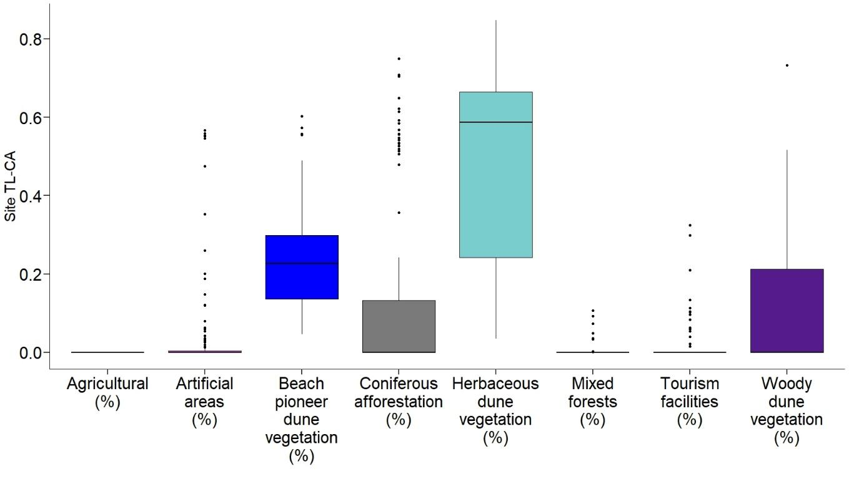

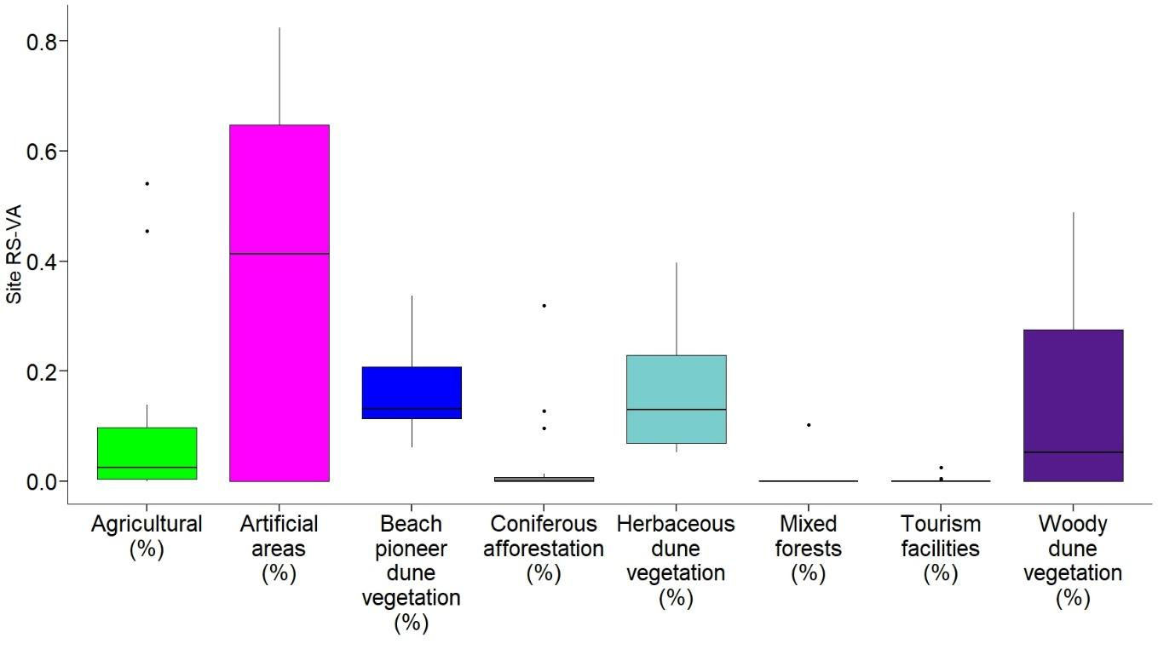

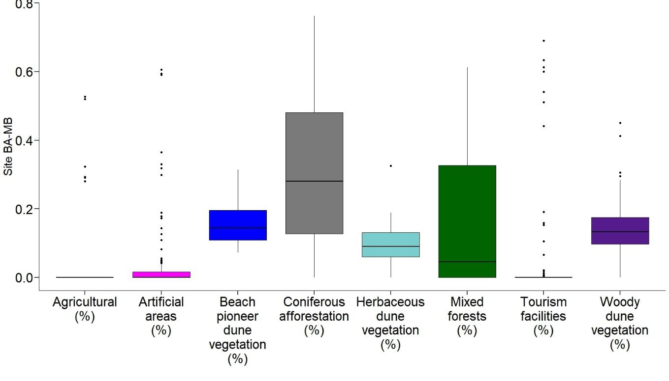

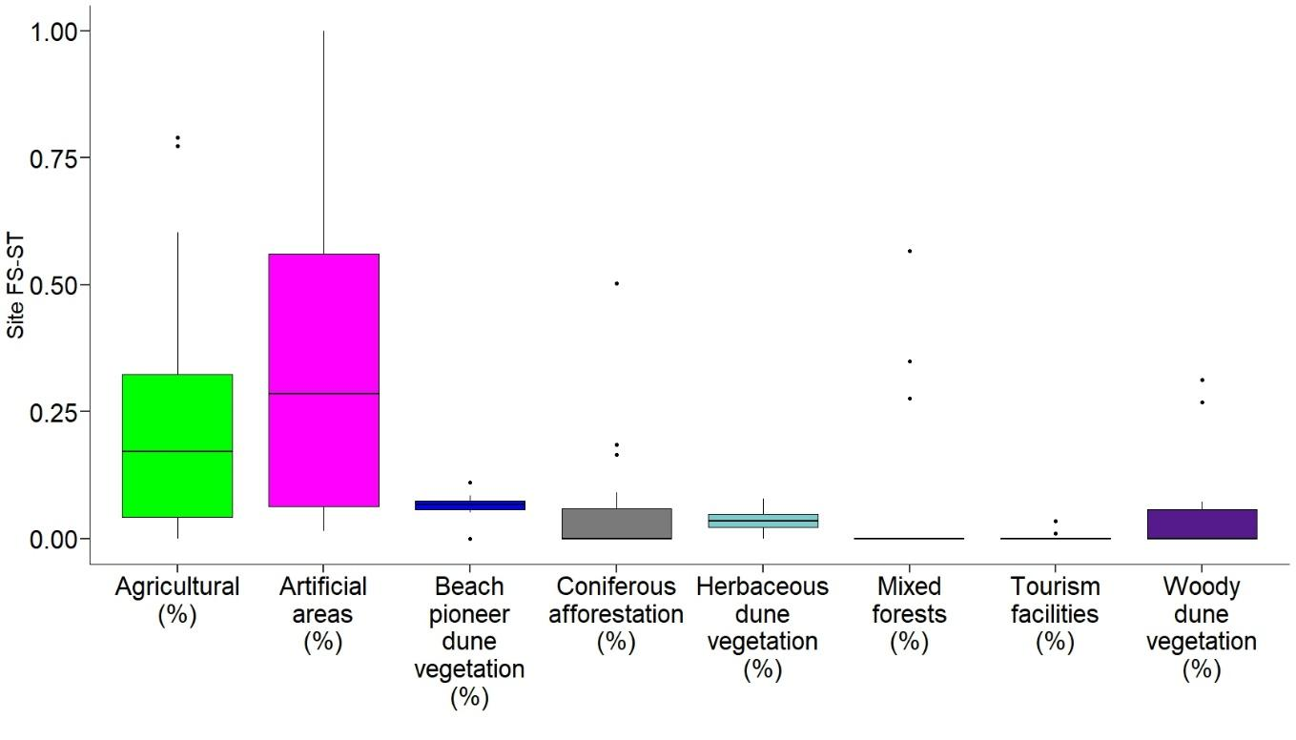
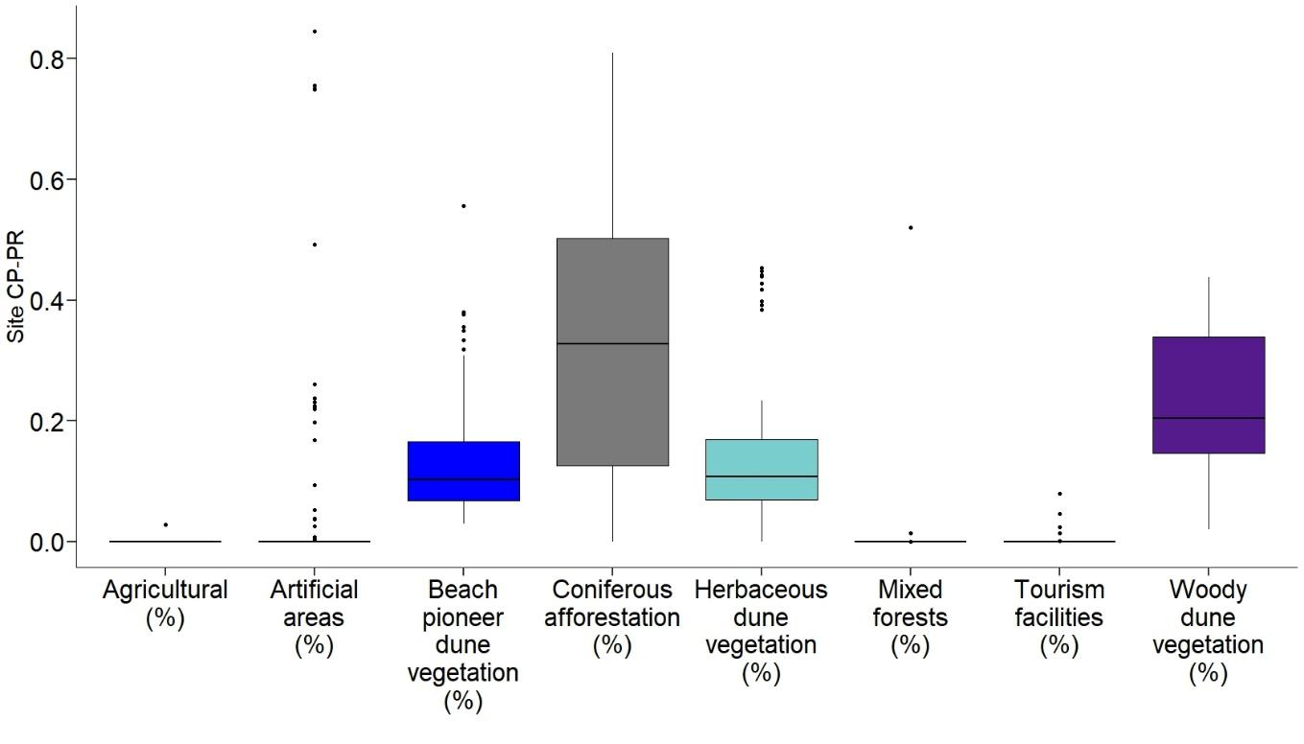
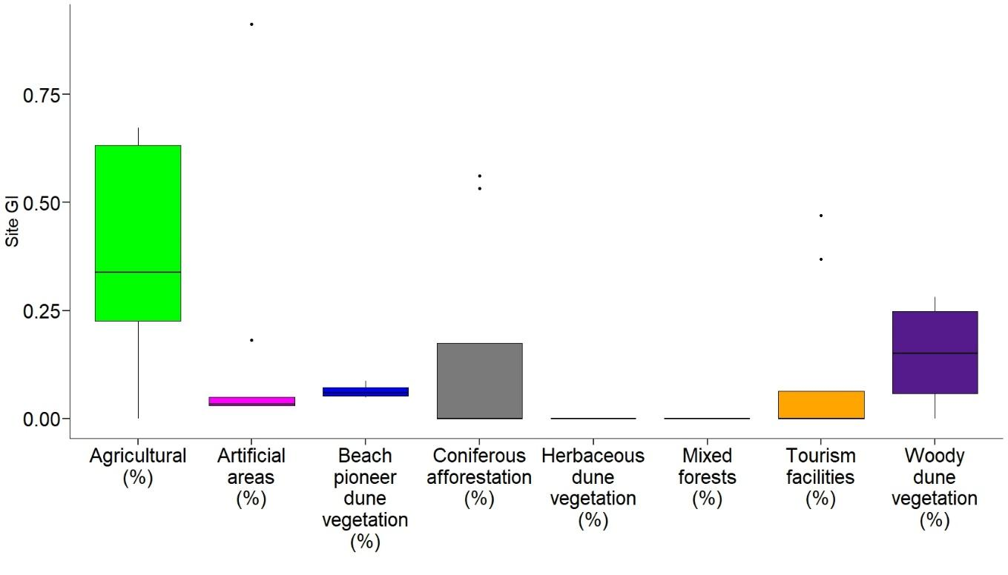

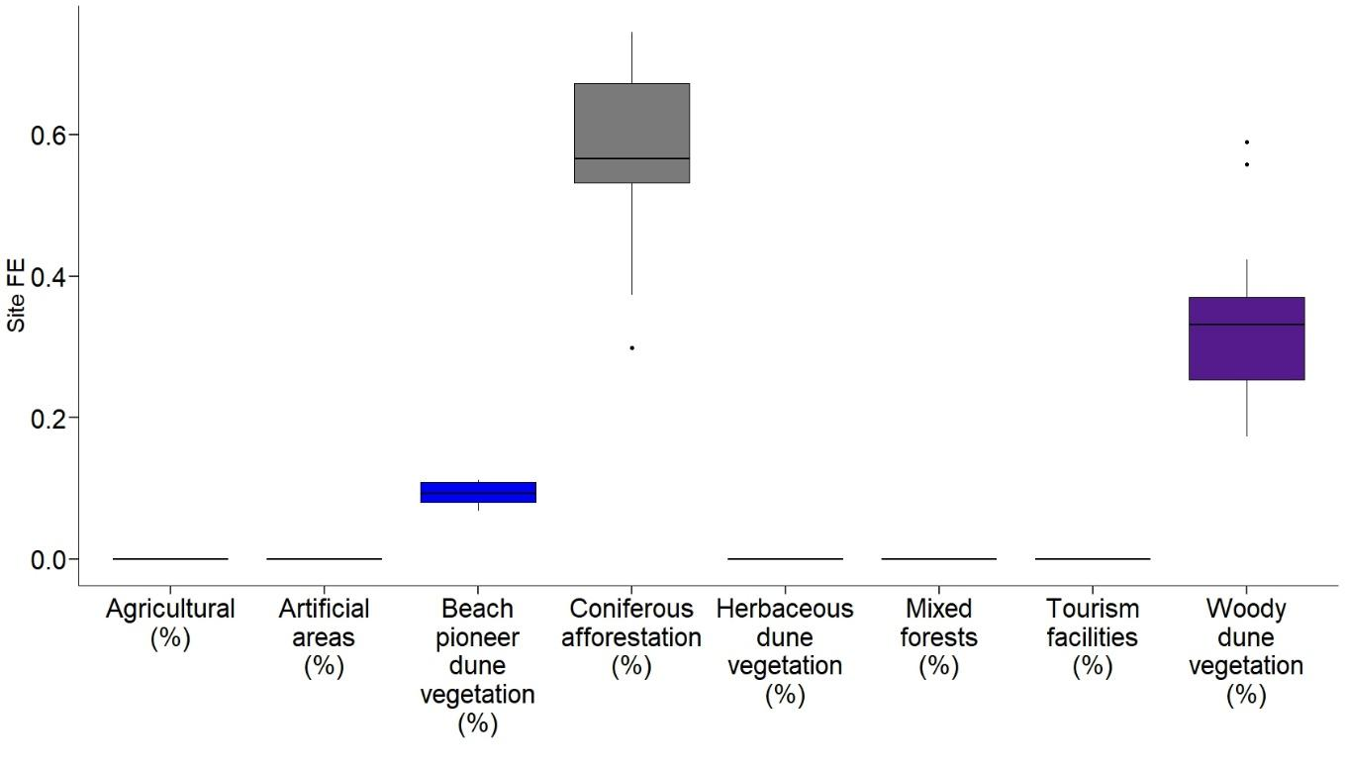
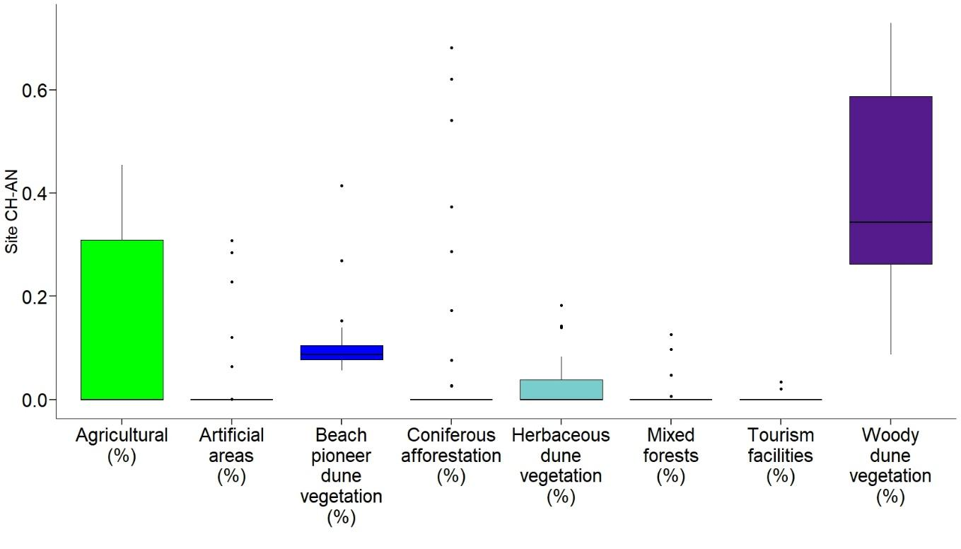
Fig. S1 Boxplots showing median (black line), quartiles, outliers of proportional area (%) covered by each landcover class in all the study sites (from north to south). TL-CA: from Dune Litoranee di Torre del Lago to Calambrone; RS-VA: Rosignano Solvay and Vada; BA-MB: from Marina di Bibbona to Baratti; FS-ST: from Parco Costiero di Sterpaia to Tomboli di Follonica e Scarlino; CP-PR: from Dune di Castiglione della Pescaia to Principina a mare; GI: Giannella; FE: Feniglia; CH-AN: from Ansedonia to Chiarone Scalo.

Table S1 Summary statistics of the lower (Q1), medium (Q2), and upper quartiles (Q3) of the proportional area (%) covered by each landcover class within each study site. TL-CA (from Dune Litoranee di Torre del Lago to Calambrone); RS-VA (Rosignano Solvay and Vada); BA-MB (from Marina di Bibbona to Baratti); FS-ST (from Coastal Park of Sterpaia to Tomboli di Follonica e Scarlino); CP-PR (from Castiglion della Pescaia dunes to Principina a mare); GI (Giannella); FE (Feniglia); CH-AN (from Ansedonia to Chiarone Scalo).

Site | Landcover class | Q1 | Q2 | Q3
BA-MB | Agricultural (%) | 0 | 0 | 0
BA-MB | Artificial areas (%) | 0 | 0 | 0.016
BA-MB | Beach pioneer dune vegetation (%) | 0.108 | 0.143 | 0.196
BA-MB | Coniferous afforestation (%) | 0.127 | 0.281 | 0.480
BA-MB | Herbaceous dune vegetation (%) | 0.060 | 0.090 | 0.131
BA-MB | Mixed forests (%) | 0 | 0.045 | 0.327
BA-MB | Tourism facilities (%) | 0 | 0 | 0
BA-MB | Woody dune vegetation (%) | 0.097 | 0.133 | 0.174
CH-AN | Agricultural (%) | 0 | 0 | 0.309
CH-AN | Artificial areas (%) | 0 | 0 | 0
CH-AN | Beach pioneer dune vegetation (%) | 0.077 | 0.087 | 0.105
CH-AN | Coniferous afforestation (%) | 0 | 0 | 0
CH-AN | Herbaceous dune vegetation (%) | 0 | 0 | 0.039
CH-AN | Mixed forests (%) | 0 | 0 | 0
CH-AN | Tourism facilities (%) | 0 | 0 | 0
CH-AN | Woody dune vegetation (%) | 0.262 | 0.343 | 0.587
CP-PR | Agricultural (%) | 0 | 0 | 0
CP-PR | Artificial areas (%) | 0 | 0 | 0
CP-PR | Beach pioneer dune vegetation (%) | 0.067 | 0.102 | 0.166
CP-PR | Coniferous afforestation (%) | 0.125 | 0.328 | 0.503
CP-PR | Herbaceous dune vegetation (%) | 0.069 | 0.108 | 0.169
CP-PR | Mixed forests (%) | 0 | 0 | 0
CP-PR | Tourism facilities (%) | 0 | 0 | 0
CP-PR | Woody dune vegetation (%) | 0.146 | 0.205 | 0.339
FE | Agricultural (%) | 0 | 0 | 0
FE | Artificial areas (%) | 0 | 0 | 0
FE | Beach pioneer dune vegetation (%) | 0.080 | 0.092 | 0.108
FE | Coniferous afforestation (%) | 0.532 | 0.566 | 0.672
FE | Herbaceous dune vegetation (%) | 0 | 0 | 0
FE | Mixed forests (%) | 0 | 0 | 0
FE | Tourism facilities (%) | 0 | 0 | 0
FE | Woody dune vegetation (%) | 0.254 | 0.331 | 0.370
FS-ST | Agricultural (%) | 0.042 | 0.171 | 0.324
FS-ST | Artificial areas (%) | 0.064 | 0.285 | 0.561
FS-ST | Beach pioneer dune vegetation (%) | 0.058 | 0.066 | 0.074
FS-ST | Coniferous afforestation (%) | 0 | 0 | 0.058
FS-ST | Herbaceous dune vegetation (%) | 0.023 | 0.034 | 0.048
FS-ST | Mixed forests (%) | 0 | 0 | 0
FS-ST | Tourism facilities (%) | 0 | 0 | 0
FS-ST | Woody dune vegetation (%) | 0 | 0 | 0.058
GI | Agricultural (%) | 0.226 | 0.339 | 0.632
GI | Artificial areas (%) | 0.030 | 0.033 | 0.049
GI | Beach pioneer dune vegetation (%) | 0.052 | 0.059 | 0.072
GI | Coniferous afforestation (%) | 0 | 0 | 0.174
GI | Herbaceous dune vegetation (%) | 0 | 0 | 0
GI | Mixed forests (%) | 0 | 0 | 0
GI | Tourism facilities (%) | 0 | 0 | 0.064
GI | Woody dune vegetation (%) | 0.058 | 0.151 | 0.248
RS-VA | Agricultural (%) | 0.003 | 0.024 | 0.098
RS-VA | Artificial areas (%) | 0 | 0.414 | 0.648
RS-VA | Beach pioneer dune vegetation (%) | 0.114 | 0.132 | 0.208
RS-VA | Coniferous afforestation (%) | 0 | 0 | 0.007
RS-VA | Herbaceous dune vegetation (%) | 0.069 | 0.130 | 0.230
RS-VA | Mixed forests (%) | 0 | 0 | 0
RS-VA | Tourism facilities (%) | 0 | 0 | 0
RS-VA | Woody dune vegetation (%) | 0 | 0.052 | 0.275
TL-CA | Agricultural (%) | 0 | 0 | 0
TL-CA | Artificial areas (%) | 0 | 0 | 0.004
TL-CA | Beach pioneer dune vegetation (%) | 0.136 | 0.227 | 0.299
TL-CA | Coniferous afforestation (%) | 0 | 0 | 0.133
TL-CA | Herbaceous dune vegetation (%) | 0.242 | 0.587 | 0.665
TL-CA | Mixed forests (%) | 0 | 0 | 0
TL-CA | Tourism facilities (%) | 0 | 0 | 0
TL-CA | Woody dune vegetation (%) | 0 | 0 | 0.213

