Appendix Table 1. Data layers used for Florida Ecological Greenways Network (FEGN).
Data Layer | Source | Criteria
Landscape Species Models  -Crested caracara (FNAI model)  -FL sandhill crane (FWC model)  -Short-tailed hawk (FWC model)  -Swallow-tailed kite (FWC model)  -Sherman's fox squirrel (FWC model)  -Big Cypress fox squirrel (FNAI model)  Species added in this update:  -Eastern indigo snake (FNAI model)  -Eastern diamondback rattlesnake (EDR) (FWC model)  -Wood stork (FNAI model)  -Snail kite (FNAI model)  -Gulf sturgeon (FNAI model)  -Manatee (FNAI model) | FNAI, FWC, UF. | All high and moderate priority FNAI habitat; All Florida Fish and Wildlife Conservation Commission (FWC) Maxent habitat in the top 2/3 of ranked potential habitat and 20 acres (8.09 hectares) or larger; all FWC short-tailed hawk habitat; all southern fox squirrel habitat in patches 250 acres (101.17 hectares) or larger; all  Florida sandhill crane in patches 1,250 acres (101.17 hectares) or greater; all  American swallow-tailed kite habitat in patches 5,000 acres (2,023.43 hectares) or greater.
Matrix-Landscape Natural Communities  -Sandhill  -Pine flatwoods  -Dry prairie  -Upland hardwood forest  -Upland pine  New natural communities now included as matrix natural communities or other landscape relevant natural communities:  -Slope forest  -Larger wetland systems and especially swale; slough marsh; basin marsh, strand swamp; marl prairie; basin swamp; hydric hammock; that are 500 acres (202.34 hectares) or larger  -All blocks of natural communities at least 1000 acres (404.69 hectares) or larger | CLC version 3.4, FNAI modified version | All such natural communities combined in patches 500 acres (202.34 hectares) or larger. In addition, All blocks of natural communities at least 1000 acres (404.69 hectares) or larger.
Florida Panther Conservation Zones | USFWS | Panther Habitat Conservation Zones: Primary, Dispersal, Secondary, and North Zones. Removed areas with Landscape Integrity scores less than 6 from the Secondary and North Zones.
Panther Habitat  Used the USFWS Random Forest Florida Panther Habitat Model | USFWS | Counties intersecting and south of I-4 used the 0.315 habitat score as the threshold; counties north of I-4 used the 0.55 threshold (stricter).
Florida Black Bear Habitat  Used the new University of Maryland Maxent habitat model combined with bear range data from FWC | University of Maryland and FWC | Used all Maxent model habitat inside or in patches overlapping bear range
Existing Conservation Lands | FNAI FLMA | All existing conservation lands
Strategic Habitat Conservation Areas (SHCAs) | FWC | P1-P3
Rare Species Habitat Conservation Priorities (FNAIHAB) | FNAI | P1-P3
FL Forever Under-Represented Natural Communities | FNAI | All rare natural communities
FL Forever Functional Wetlands | FNAI | P1-P3
FL Forever Natural Floodplains | FNAI | P1-P3
Potential Natural Areas (PNAs) | FNAI | P1-P4
Coastal Barrier Resources Act (CBRA) lands | DEP | All CBRA lands
Dark Sky Regions  We used The New World Atlas of Artificial Sky Brightness GIS data available from Heimholtz Centre in Potsdam, Germany; https://dataservices.gfz-potsdam.de/contact/showshort.php?id=escidoc:1541893&contactform. | Heimholtz Centre | We compared these data to the two official dark sky parks in Florida (Kissimmee Prairie State Preserve and Big Cypress National Preserve) to determine the mean and standard deviation of night sky brightness in these two parks and identified all areas in Florida below this mean or within 1 standard deviation of the mean as additional dark sky areas with nighttime ecological conditions related to protected large, intact landscapes with low human disturbance.
Air Force Conservation Partnership Priority Focal Species Habitat  We worked with the USFWS and the Air Force to identify habitat conservation priority areas adjacent or near Florida Air Force installations across the state. These habitat areas were prioritized based on proximity to installations or related conservation lands, patch size, and landscape integrity, and they represent significant landscape conservation opportunities that can also functionally buffer Air Force installations across the state. | US Air Force, USFWS, University of Florida, FNAI, FWC | All high priority focal species habitat (top third of ranked habitat priorities)
Landscape Integrity was first created for the Florida Critical Lands and Waters Identification Project in 2006 under the direction of another Technical Advisory Group to serve as an index of landscape-scale ecological integrity (Oetting et al. 2016); the most recent Landscape Integrity layer was created using a combination of Land Use Intensity (LUI) and landscape patch size from the Florida Cooperative Land Cover (CLC) 3.4, a natural community-focused land cover product created through interpretation of aerial imagery by FWC and FNAI (Peninsular Florida Landscape Conservation Cooperative, 2020). LUI was assessed by reclassifying all site-level categorizations of land cover into five general land cover/land use categories—natural, seminatural, improved pasture, agricultural/low-intensity development, and high-intensity development. The land-use intensity was ranked using this reclassified layer, and a moving window (neighborhood) analysis was conducted in ArcGIS Pro at three scales (4 ha, 40 ha, and 400 ha) in combination. Patch Size Index (PSI) identified contiguous patches not fragmented by large roads, waterbodies, or more intensive land uses and ranked them based on area. PSI was created using reclassified CLC data into two categories of natural and seminatural land cover patches, with areas fragmented by primary highways (identified based on lane number and average daily traffic) and then grouped into distinct patches in ArcGIS Pro. LUI and PSI were combined and averaged to create the Landscape Integrity layer. | FNAI, CLCP | Use existing methodology combining Land Use Intensity (LUI) and Patch Size Index (PSI) based on natural and seminatural land cover patches, eliminating fragmented patches.

Appendix Table 2. Ecological Connectivity Models include:
1) Riverine/Riparian Corridor Buffers and Connectivity
Major river riparian connectivity is based on the 50 Florida Major Rivers and intersecting Outstanding Florida Waters (FREAC 1990; FWC GIS librarian et al. 2020; FDEP 2024b). The goal was to identify areas around major rivers that could serve as buffers, protecting water sources and habitat and serving as corridors for critical species. These include St. Johns River, Peace River, Kissimmee River, Withlacoochee River, Suwannee River, Steinhatchee River, Aucilla River, St. Marks River, Ochlocknee River, Apalachicola River, Chipola River, Econfina Creek, Choctawhatchee River, Yellow River, Escambia River, and Perdido River. The original outline was derived from the Florida Geographic Data Library's Major Rivers line shape file. Only the sections of the shape file that were identified as rivers or streams were retained. We buffered all Major Rivers and their connected Special Outstanding Florida Waters by 800 meters and included all connected compatible land uses within those buffers (all natural and seminatural land uses).
Using FNAI Cooperative Land Cover Data, all natural communities, forest plantations, and unimproved pastures/rangelands were identified.
2) Sea Level Rise Coastal Gradient Connectivity
The sea level rise coastal gradient connectivity analysis is a comprehensive evaluation of the likelihood that larger areas with higher landscape integrity will be available for native species to retreat/migrate from current coastlines to locations beyond a predicted 3-meter sea level rise (SLR). All areas with a CLIP 4.0 Landscape Integrity index score of 5 or higher, which includes all natural and seminatural land uses in areas dominated by low intensity land uses, were included where they provided continuous paths from current coastal natural communities inland as far as 2 miles beyond a projected 3-meter SLR. See 2013's previous FEGN update for a detailed description of methods (Hoctor et al. 2013).
3) Xeric Natural Community Connectivity
The Xeric Natural Community Connectivity model identifies all xeric natural community patches (upland pine, scrub, sandhill, and scrubby flatwoods) of 4 ha or larger patches as sources. The patch size was selected based on discussion with the TAG to align with focal species needs and xeric natural community processes. The impedance surface includes suitable soils for gopher tortoise (Gopherus polyphemus) (USDA NRCS 2019) on natural or seminatural land uses with Landscape Integrity index scores of 6 or greater based on an integrity index scale of 1-10, where a six or higher represents areas dominated by natural and seminatural land uses. Connections narrower than 60 meters wide or further than 2.4 kilometers from source patches were removed based on home range and dispersal considerations for Florida scrub-jay (Aphelocoma coerulescens) and gopher tortoise (Breininger 1999; Eubanks et al. 2003; Coulon et al. 2010; Hoctor et al. 2013). Only source patches and connectivity areas linking at least two xeric natural community patches were retained. See 2013's previous FEGN update for a detailed description of methods (Hoctor et al. 2013).
4) Florida Black Bear Habitat Connectivity
Florida Black Bear Habitat and Connectivity were modeled using the inverse of the recent University of Maryland’s Florida black bear Maxent habitat model as the impedance surface (Poor et al. 2020). Sources were the larger existing conservation lands within occupied range. Hubs were the bigger protected areas of bear habitat. The best possible bear corridors between chosen bear hubs were found using ArcGIS's Cost Distance and Corridor tools. The optimum corridor path between each pair of hubs was determined by using the Slice tool to get the 0.25-0.5 percent slice with the highest appropriateness. See 2013's previous FEGN update for a detailed description of methods (Hoctor et al. 2013).
5) Florida Panther Habitat Connectivity
Florida Panther Habitat Connectivity was modeled using the Frakes et al. (2015) random forest habitat model and inverted using a negative exponential transformation (-8) as the impedance surface (Also see Frakes and Knight 2021). Sources were the larger existing conservation lands (200 km²) within areas identified as potential habitat by Frakes et al. (2015). This model has been previously validated by telemetry data (Leskova et al. 2022). Corridors were identified using ESRI’s Cost Distance, Corridor, and ArcGIS Slice tools. These were used to find the optimum 0.25-0.5 percent of the corridor result that represented a sufficiently wide corridor path between each selected source pair. We defined “sufficiently wide” as a minimum of 1.6 km wide, with wider corridors selected in areas exceeding 16 km in length (Kautz et al. 2006).
6) Integrated Habitat Network
The Integrated Habitat Network is a plan to protect and restore riparian-based connectivity in the phosphate mining region in southwest Florida (FDEP and Florida Bureau of Mine Reclamation 1992). This network has been used in every iteration of the FEGN since 1997. Based on input from the TAG, we expanded the IHN to include natural, seminatural, agricultural, and extractive land uses, which are expected to undergo restoration efforts according to in-place post-mining regulations. We identified all rivers, streams, and canals within the IHN and all-natural, seminatural, agricultural, and mining land uses connected to and within 200 m.
7) General Landscape Connectivity
Cost Surface was based on the CLIP 4.0 Landscape Integrity layer, and only a few locations not covered by other connectivity models were identified with additional corridors to close remaining gaps in the statewide ecological network.

Appendix Table 3. Hectares in 2021 FEGN (excluding open water) by Conservation Importance.
Key Areas | Total Priority Area Hectares in FLORIDA | Total Priority Area Hectares in 2021 FEGN | % Total Priority Area in FLORIDA in 2021 FEGN | FEGN Priority 1 Critical Linkages |  | FEGN Priority 2 |  | FEGN Priority 3 |  | FEGN Priority 4 |  | FEGN Priority 5
 |  |  |  | % of Priority Area in FL. | % of Priority Area in FEGN | % of Priority Area in FL. | % of Priority Area in FEGN | % of Priority Area in FL. | % of Priority Area in FEGN | % of Priority Area in FL. | % of  Priority Area in FEGN | % of Priority Area in FL. | % of Priority Area in FEGN
High/Mod Importance CLIP Biodiversity Resource Category Areas | 8,141,415 | 7,218,653 | 89% | 48% | 55% | 19% | 22% | 5% | 5% | 6% | 6% | 11% | 12%
High/Mod Importance IP Surface Water Resource Category Areas | 5,744,792 | 5,156,508 | 90% | 51% | 56% | 18% | 20% | 5% | 5% | 6% | 7% | 11% | 12%
High Value Bear Habitat Areas | 5,595,973 | 5,116,388 | 91% | 48% | 53% | 21% | 23% | 5% | 5% | 6% | 6% | 11% | 12%
High Value Panther Habitat Areas | 5,376,248 | 5,137,280 | 96% | 56% | 59% | 20% | 21% | 5% | 5% | 5% | 5% | 10% | 10%
High Value  Bear Connectivity Areas | 6,702,826 | 5,875,151 | 88% | 46% | 53% | 21% | 24% | 4% | 4% | 6% | 7% | 10% | 12%
High Value Panther Connectivity Areas | 6,829,819 | 6,169,197 | 90% | 47% | 52% | 22% | 24% | 6% | 6% | 6% | 6% | 10% | 12%
High Value Agricultural Connectivity | 7,587,431 | 6,435,573 | 85% | 44% | 52% | 19% | 22% | 5% | 6% | 6% | 7% | 11% | 13%
Low Intensity Agricultural | 2,374,493 | 1,425,016 | 60% | 21% | 35% | 17% | 28% | 6% | 10% | 6% | 10% | 10% | 16%
Diffuse High Florida Circuit Model | 3,112,632 | 2,995,799 | 96% | 67% | 70% | 15% | 16% | 3% | 3% | 3% | 3% | 8% | 9%

a)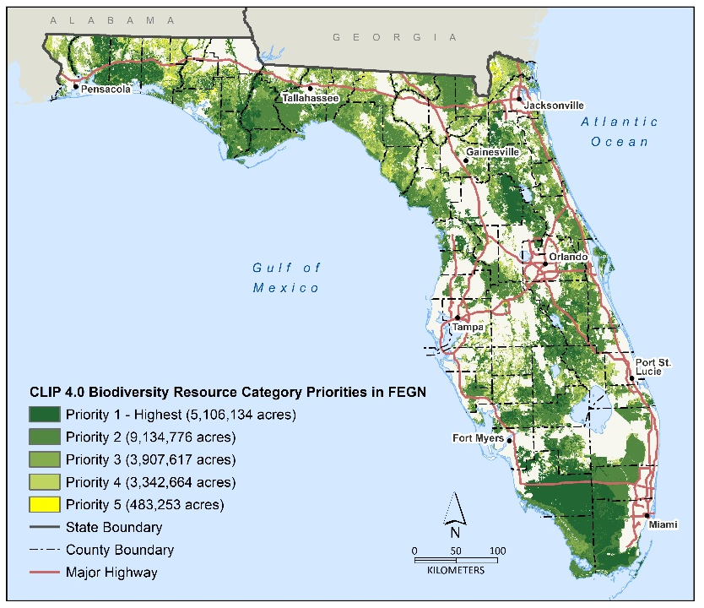b) 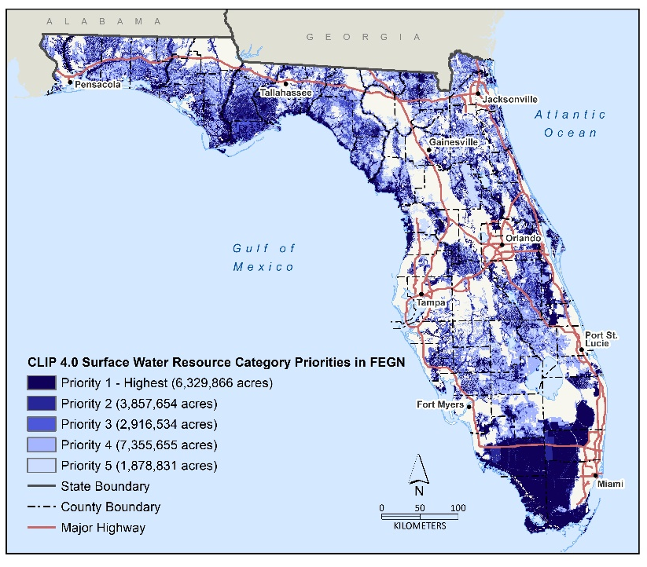
Appendix Figure 1. Clip 4.0 a) Biodiversity Resource Value in FEGN b) Surface Water Resource Value in FEGN.
a)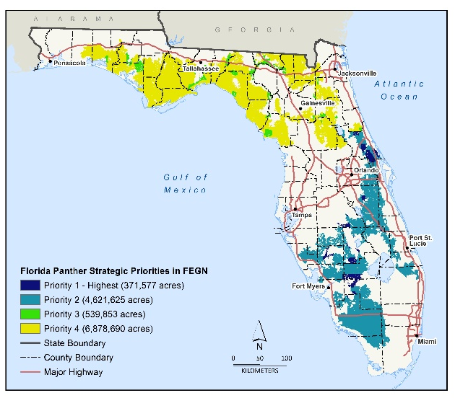b)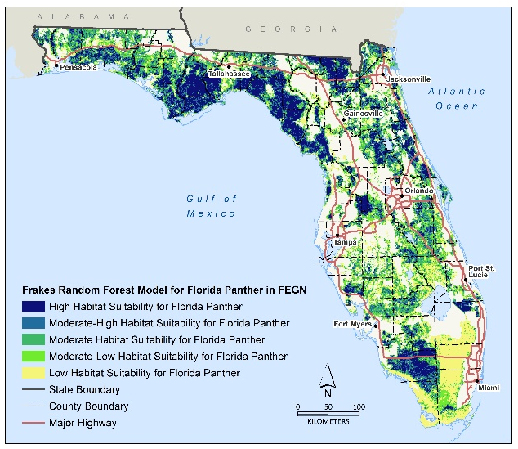c)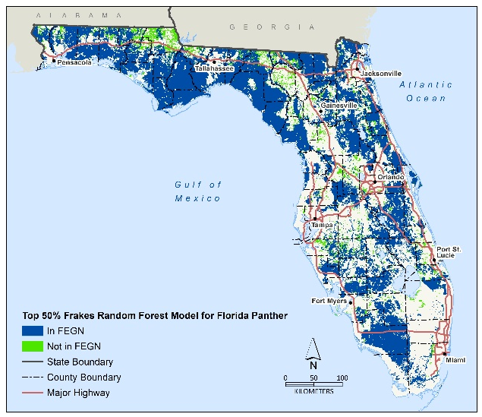
d)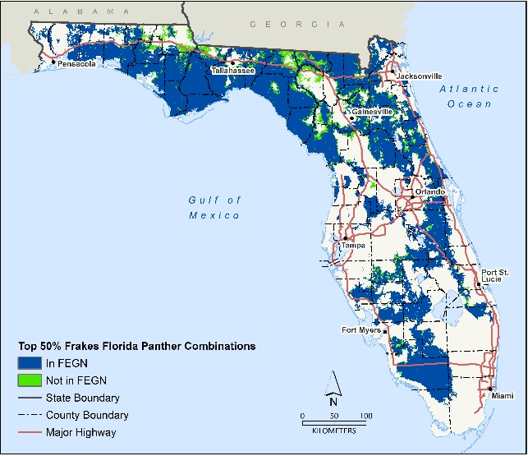
Appendix Figure 2. Florida Panther: a) Strategic Value in the FEGN; b) Habitat Suitability Results from the Random Forest Model (Frakes et al. 2015); c) Top 50% Suitable Areas for the Florida Panther and D) Top 50% Connectivity Results for Florida Panther (Bohnett et al. 2024), highlighting high-priority regions both within and outside the FEGN.

a)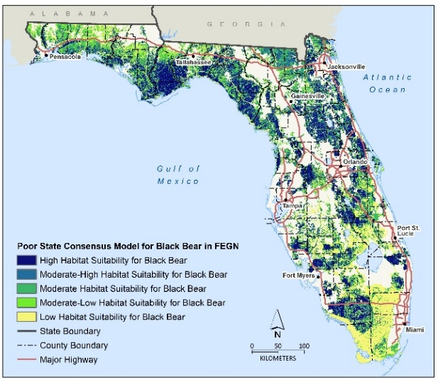b) 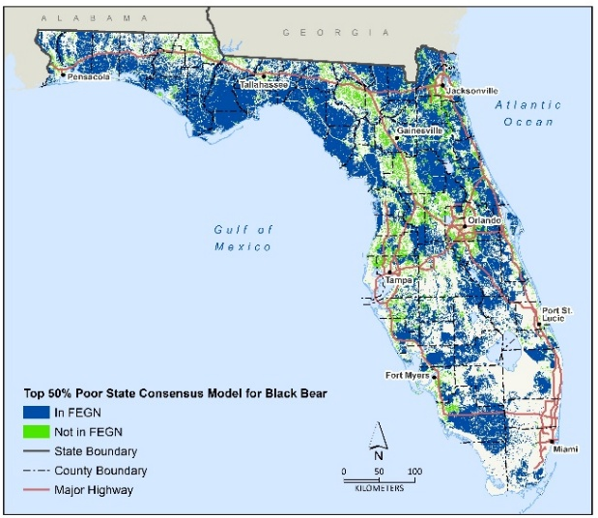 c) 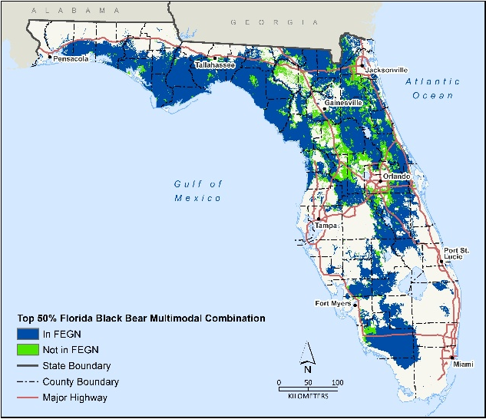
Appendix Figure 3. Florida Black Bear a) Habitat suitability results from the Consensus Maxent Mahalobis Distance Model (Poor et al. 2020), b) Top 50% Suitable Areas for the Florida Black Bear (Poor et al. 2020) c) Top 50% Connectivity results for Florida Black Bear (Bohnett et al. 2024), highlighting high-priority regions both within and outside the FEGN.

a)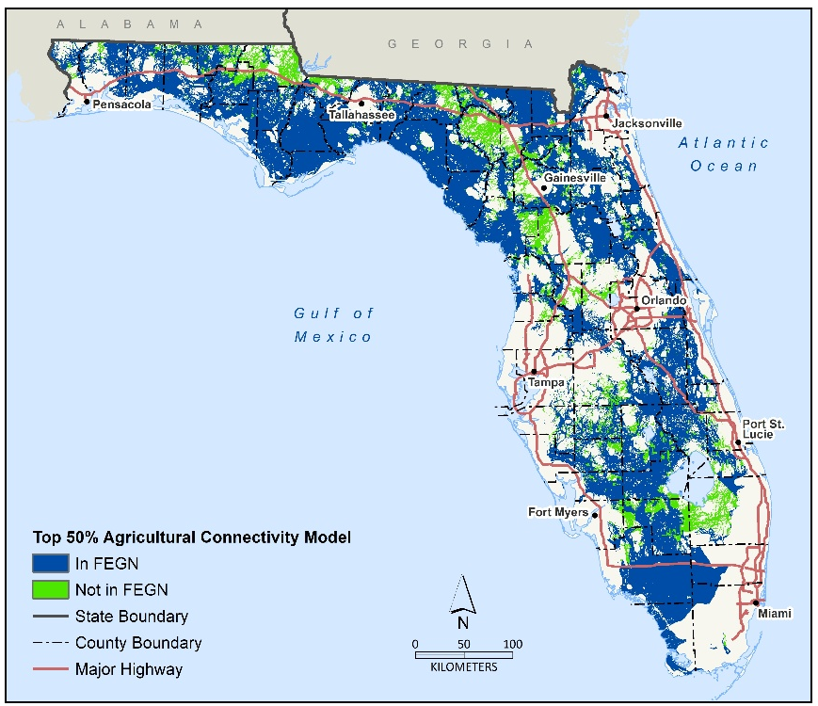b)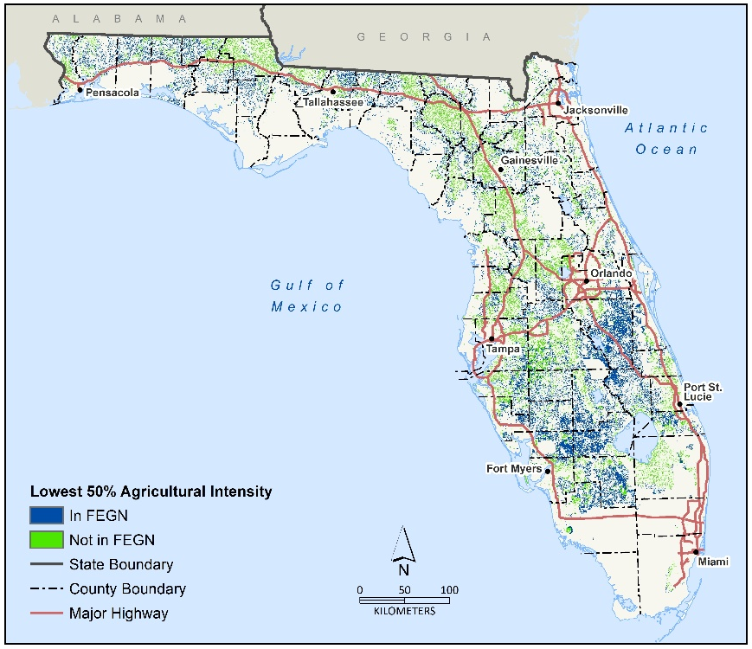
Appendix Figure 4. Agricultural Connectivity 1) omniscape results b) agricultural intensity

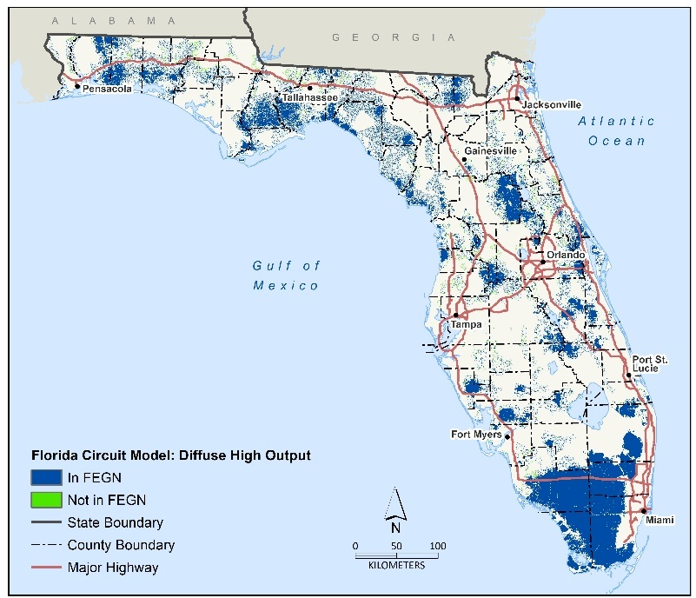

Appendix Figure 5. Florida Circuit Model “diffuse high” output overlap.

