Supplementary S1: Reclassified landscape categories
Title manuscript: Strong gene flow across an urbanised coastal landscape in a dune specialist digger wasp
Authors: Femke Batsleer*, Fabien Duez, Dirk Maes, Dries Bonte
*Corresponding author: F. Batsleer, Ghent University, Department of Biology, Terrestrial Ecology Unit. Karel Lodewijk Ledeganckstraat 35, 9000 Ghent, Belgium. E-mail: femke.batsleer@ugent.be. Telephone: +32 (0)9 264 52 58

We combined 2 types of landscape rasters, and a manually drawn polygon for the beach, resulting in a map of 7 landscape categories (Figure S1.3). For landscape categories within dune areas, we used detailed vegetation maps (Figure S1.1; resolution 0.4m) available for the region derived from remote sensing data with a classification machine learning technique (Bonte et al. 2021). For landscape categories outside dune areas, we used the ground cover map 2018 (Figure S1.2) provided by the Flemish government (BBK 1m resolution, source: www.geopunt.be). Table S1.1 gives an overview how the source maps were reclassified. Figure S1.1, S1.2 and S1.3 give maps representing the two original sources and the resulting reclassified map.
Table S1.1: Original source landscape categories and their reclassified landscape types (and map color from Figure 1 in main manuscript and Figure S1.3).
Source | Source landscape category | Reclassified landscape category | Map Color
Dune vegetation classification maps | Beachrose | Scrubs
Dune vegetation classification maps | Bucktorn | Scrubs
Dune vegetation classification maps | Nushgrass | Scrubs
Dune vegetation classification maps | Fixed | Trees
Dune vegetation classification maps | Grass | Open dune
Dune vegetation classification maps | Marram | Open dune
Dune vegetation classification maps | Marram/herb | Open dune
Dune vegetation classification maps | Moss | Open dune
Dune vegetation classification maps | Scrub/saltmarsh | Scrubs
Dune vegetation classification maps | Sand | Scrubs
Beach polygon | Beach | Beach
BBK | Buildings | Urbanised
BBK | Roads | Urbanised
BBK | Other asphalted | Urbanised
BBK | Railways | Urbanised
BBK | Water | Water
BBK | Other non-asphalted | Urbanised
BBK | Farmland | Agriculture
BBK | Grass, scrubs | Scrubs
BBK | Trees | Trees
BBK | Grass, scrubs (agricultural land) | Agriculture
BBK | Grass, scrubs (overlapping roads) | Urbanised
BBK | Trees (overlapping roads) | Urbanised
BBK | Grass, scrub (overlapping water) | Water
BBK | Trees (overlapping water) | Water

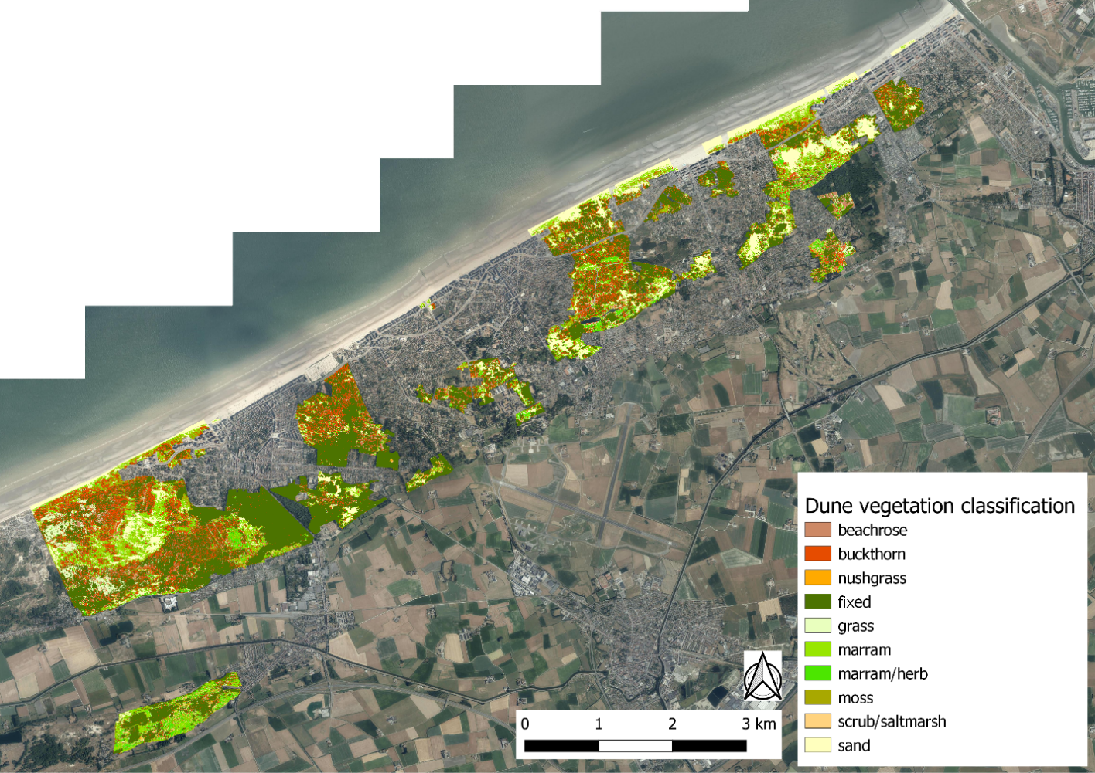Figure S1.1: Dune vegetation classification map (see Bonte et al. 2021).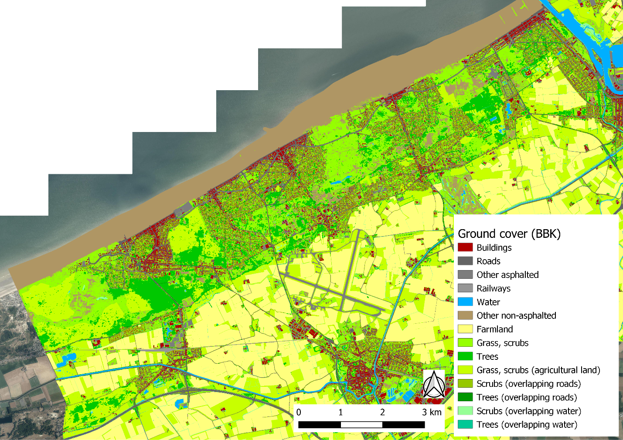Figure S1.2: Ground cover map (BBK, source: www.geopunt.be).
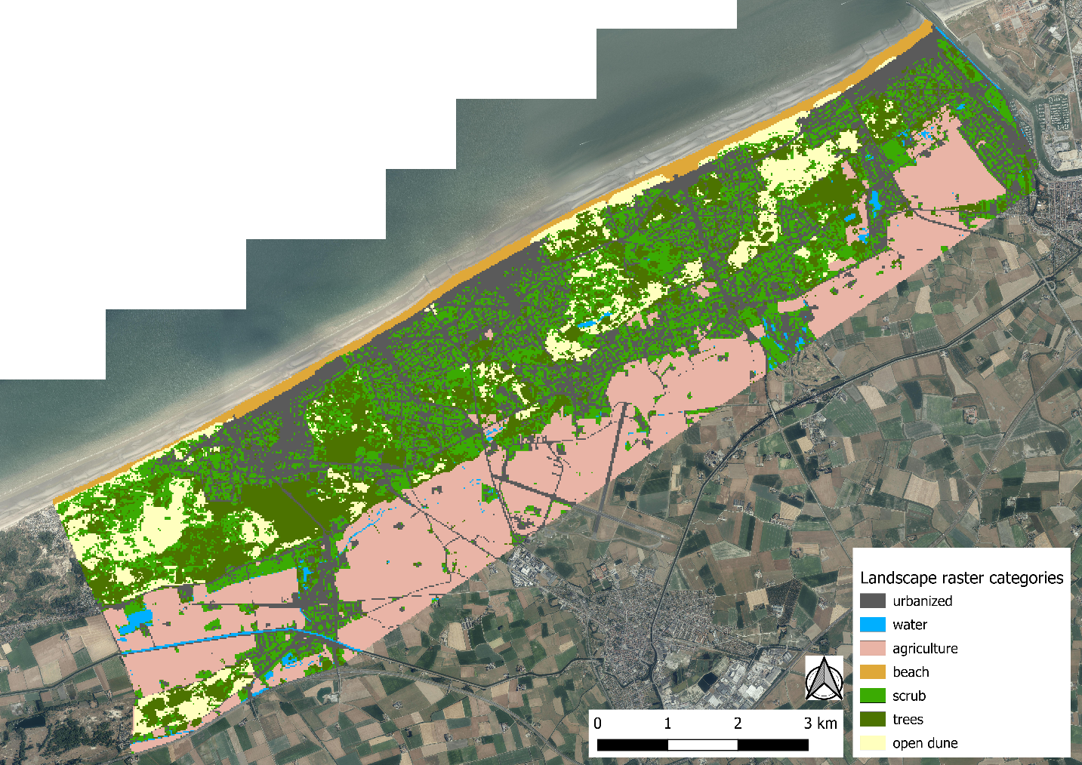Figure S1.3: Reclassified landscape map.

