Supplementary S4: dune area clusters
Title manuscript: Strong gene flow across an urbanised coastal landscape in a dune specialist digger wasp
Authors: Femke Batsleer*, Fabien Duez, Dirk Maes, Dries Bonte
*Corresponding author: F. Batsleer, Ghent University, Department of Biology, Terrestrial Ecology Unit. Karel Lodewijk Ledeganckstraat 35, 9000 Ghent, Belgium. E-mail: femke.batsleer@ugent.be. Telephone: +32 (0)9 264 52 58

For the four dune area clusters, results of the top 5 best supported models with optimisations of multi-categorical models (all possible combinations of landscape categories) after bootstrapping can be found in table S4.1 (full table in supplementary S5, including independent optimisation run 2). Figures similar to figure 2 are figures S4.2-S4.5 and table similar to table 2 is table S4.2 (full tables in supplementary S5).
Isolation-by-distance (IBD) is the overall best supported model for the dune area clusters, but there are a few exceptions and competing models (which have ΔAICc < 2). For Cabour, agriculture (impeding gene flow contrasting to the remaining landscape categories; table S4.1, Fig. S4.3) is the second best supported model, competing with IBD. For Westhoek, the combined model contrasting beach.scrub.opend to the remaining landscape categories is competing with IBD. These types of natural landscape (beach, scrub, open dune) are being barriers to gene flow (table S4.1, Fig. S4.2). For Doornpanne, the best supported model is trees contrasted to the remaining categories (facilitating gene flow; table S4.1, Fig. S4.4) with IBD a highly competing model. The four independent optimisation runs of single categories for the dune area clusters also confirm each other and the overall pattern of the multi-categorical optimisation runs (tables S4.3-S4.6). Several of the models with ΔAICc > 2 were not consistent in being either impeding or facilitating to gene flow across independent runs (table S4.3-S4.6). Thus, results regarding other categories then the best supported ones should be considered inconclusive on the scale of the four dune area clusters.
Table S4.1: Top 5 bootstrap results for the multi-categorical model optimisations for each dune area clusters.
Dune area | Model | k | avg.AICc | ΔAICc | avg.weight | avg.R²m | avg.LL | n.top | Res.value 1st | Res.value 2nd | Res.value 3rd | Res.value 4th | Res.value other
Westhoek | Distance | 2 | 29848.91 | 0.00 | 0.18 | 0.00024 | -14922.41 | 514 | - | - | - | - | -
Westhoek | beach.scrub.opend | 5 | 29850.55 | 1.64 | 0.09 | 0.00184 | -14920.05 | 152 | 1338 | 2500 | 659 | - | 1
Westhoek | scrub.opend | 4 | 29850.78 | 1.87 | 0.07 | 0.00140 | -14921.24 | 90 | 2500 | 451 | - | - | 1
Westhoek | beach | 3 | 29851.00 | 2.09 | 0.06 | 0.00024 | -14922.41 | 0 | 2500 | - | - | - | 1
Westhoek | urban.beach.scrub.opend | 6 | 29851.12 | 2.20 | 0.07 | 0.00163 | -14919.24 | 95 | 70 | 207 | 2500 | 526 | 1
Cabour | Distance | 2 | 1496.54 | 0.00 | 0.19 | 0.00050 | -746.05 | 634 | - | - | - | - | -
Cabour | agric | 3 | 1497.50 | 0.96 | 0.13 | 0.02864 | -745.29 | 289 | 2500 | - | - | - | 1
Cabour | opend | 3 | 1498.90 | 2.36 | 0.06 | 0.00184 | -745.99 | 19 | 2500 | - | - | - | 1
Cabour | trees | 3 | 1498.96 | 2.43 | 0.06 | 0.00086 | -746.02 | 14 | 2500 | - | - | - | 1
Cabour | water | 3 | 1499.02 | 2.48 | 0.05 | 0.00049 | -746.05 | 0 | 2500 | - | - | - | 1
Doornpanne | trees | 3 | 9930.95 | 0.00 | 0.10 | 0.00089 | -4962.31 | 474 | 1 | - | - | - | 2500
Doornpanne | Distance | 2 | 9931.05 | 0.09 | 0.09 | 0.00019 | -4963.44 | 399 | - | - | - | - | -
Doornpanne | opend | 3 | 9932.91 | 1.96 | 0.04 | 0.00119 | -4963.29 | 100 | 2500 | - | - | - | 1
Doornpanne | trees.opend | 4 | 9933.13 | 2.18 | 0.04 | 0.00098 | -4962.29 | 0 | 1 | 2500 | - | - | 1708
Doornpanne | beach.fixed | 4 | 9933.18 | 2.22 | 0.03 | 0.00089 | -4962.31 | 0 | 946 | 1 | - | - | 2500
Teryde | Distance | 2 | 16509.20 | 0.00 | 0.13 | 0.00010 | -8252.54 | 944 | - | - | - | - | -
Teryde | agric | 3 | 16511.32 | 2.12 | 0.04 | 0.00010 | -8252.54 | 0 | 2500 | - | - | - | 1
Teryde | beach | 3 | 16511.32 | 2.12 | 0.04 | 0.00010 | -8252.54 | 0 | 2500 | - | - | - | 1
Teryde | water | 3 | 16511.32 | 2.12 | 0.04 | 0.00010 | -8252.54 | 0 | 2500 | - | - | - | 1
Teryde | opend | 3 | 16511.68 | 2.47 | 0.04 | 0.00011 | -8252.72 | 1 | 1 | - | - | - | 1
Notes: 7 landscape categories compared in bootstrap analysis after optimisation of single category models. Urbanised (urban), beach, water, trees, agriculture (agric), scrub, open dune (opend). Distance is the isolation-by-distance null model: increasing genetic distance with increasing Euclidean geographic distance. Dune area, name of dune area cluster (Fig. 4.1); Predictor, landscape category or univariate model; k, number of parameters; avg.AICc, average AICc across all bootstrap iterations; ΔAICc, difference in avg.AICc compared to the lowest avg.AICc (the best supported model); avg.weight, average weight across iterations; avg.rank, average rank across iterations; avg.R²m, average marginal R² across iterations; avg.LL, average log-likelihood across iterations; n.top, number of times the model was the top model across iterations (does not sum op to 1000, as many more models were considered, see supplementary 5); Res.value 1st/2nd/3rd/4th, the optimised resistance value for the first/second/third/fourth mentioned landscape category (e.g. urban/beach.scrub/opend in the fifth row); Res.value other, optimised resistance value for all else (combined into one landscape variable).

Table S4.2: Summed Akaike weights per category for multivariate surfaces (multiple categories optimisations) for the dune area clusters.
Dune area | Category | Sum weights | Sum weights run 2
Westhoek | scrub | 0.551 | 0.537
Westhoek | opend | 0.465 | 0.460
Westhoek | beach | 0.434 | 0.408
Westhoek | trees | 0.283 | 0.264
Westhoek | urban | 0.280 | 0.266
Cabour | agric | 0.341 | 0.331
Cabour | water | 0.231 | 0.228
Cabour | scrub | 0.207 | 0.201
Cabour | opend | 0.188 | 0.191
Cabour | trees | 0.187 | 0.191
Cabour | urban | 0.187 | 0.187
Doornpanne | trees | 0.408 | 0.417
Doornpanne | opend | 0.307 | 0.311
Doornpanne | water | 0.271 | 0.264
Doornpanne | beach | 0.244 | 0.235
Doornpanne | scrub | 0.228 | 0.233
Doornpanne | agric | 0.226 | 0.237
Doornpanne | urban | 0.222 | 0.222
Ter Yde | scrub | 0.266 | 0.271
Ter Yde | agric | 0.264 | 0.261
Ter Yde | trees | 0.258 | 0.258
Ter Yde | water | 0.257 | 0.254
Ter Yde | beach | 0.257 | 0.255
Ter Yde | urban | 0.252 | 0.257
Ter Yde | opend | 0.249 | 0.248
Notes: the Akaike weight for a model (optimised surface) was added to the summation (Sum weights) if the focal category (Category) was in it.
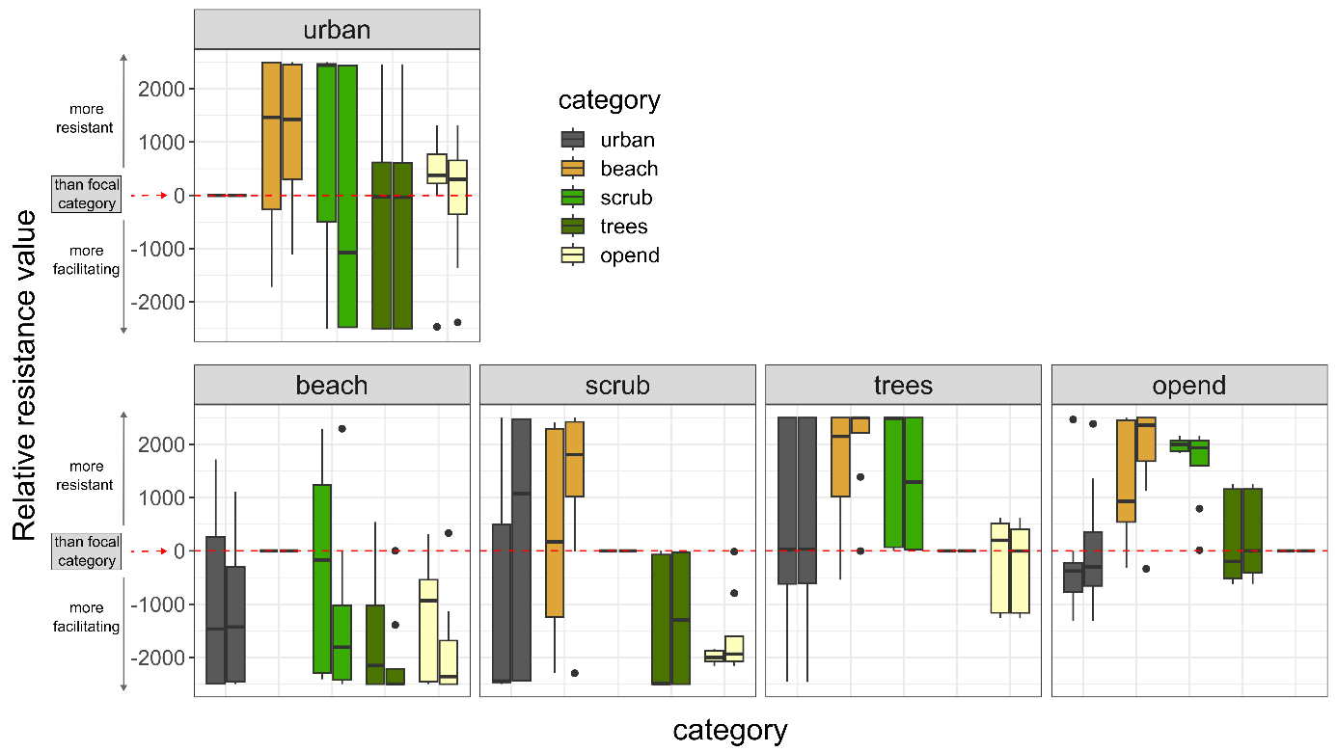
Figure S4.2: Relative resistance value from the optimisation of multivariate surfaces for dune area cluster Westhoek; similar to figure 2; The two independent runs are combined in as paired boxplots for each category in each panel (left run 1, right run 2).
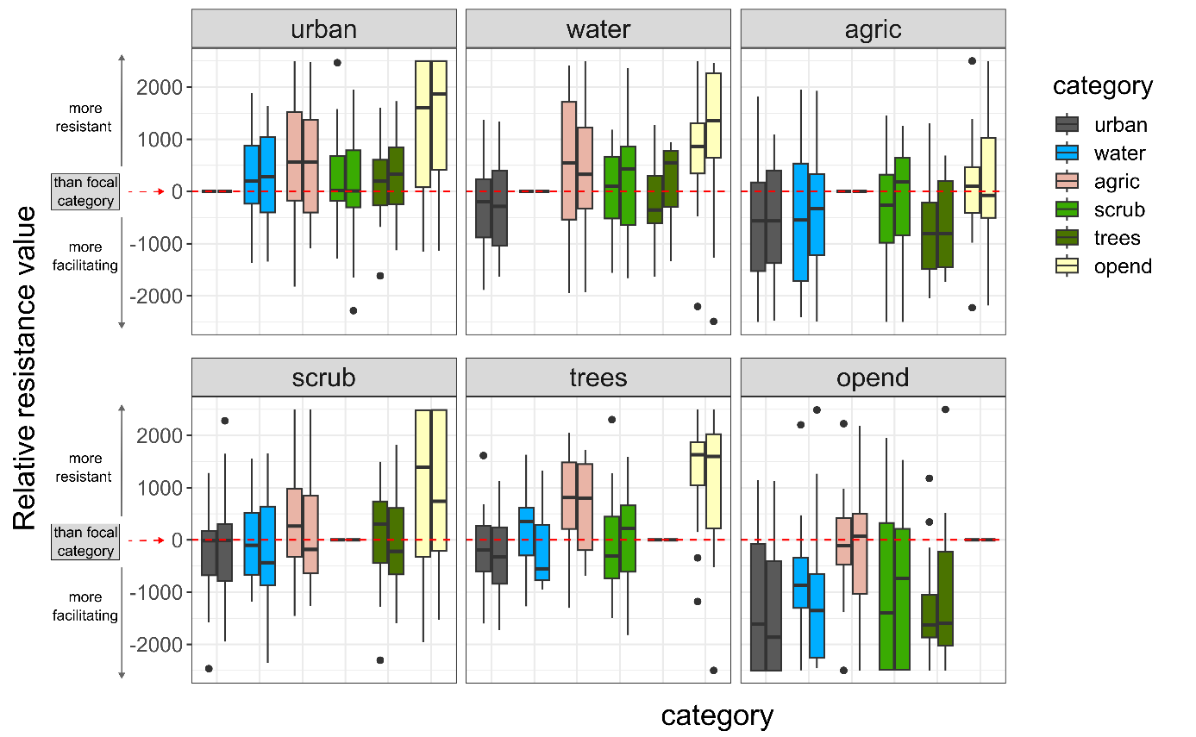
Figure S4.3: Relative resistance value from the optimisation of multivariate surfaces for dune area cluster Cabour; similar to figure 2; The two independent runs are combined in as paired boxplots for each category in each panel (left run 1, right run 2).

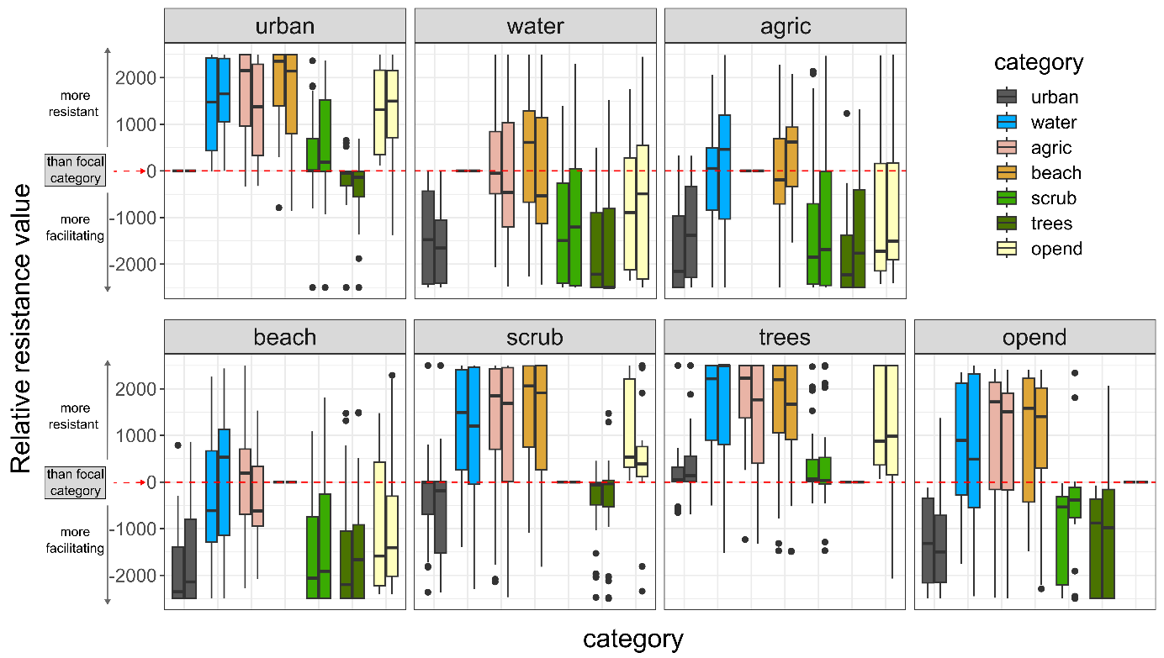
Figure S4.4: Relative resistance value from the optimisation of multivariate surfaces for dune area cluster Doornpanne; The two independent runs are combined in as paired boxplots for each category in each panel (left run 1, right run 2).

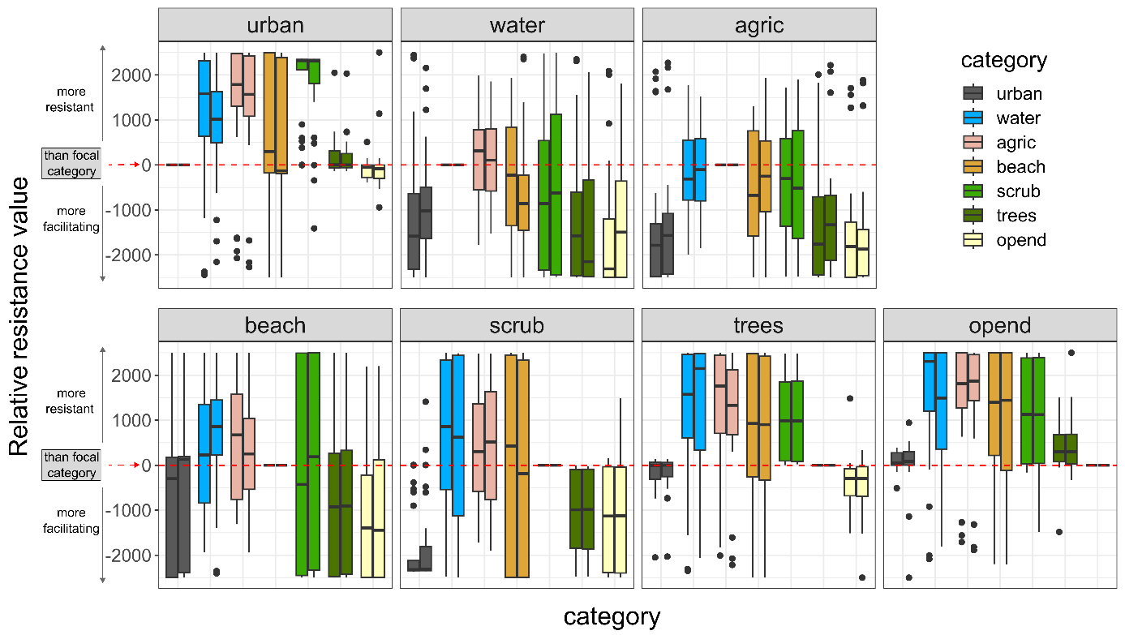Figure S4.5: Relative resistance value from the optimisation of multivariate surfaces for dune area cluster Ter Yde; The two independent runs are combined in as paired boxplots for each category in each panel (left run 1, right run 2).

Table S4.3: Bootstrap results for the single category model optimisations for the dune area clusters, run 1.
Dune area | Model | k | avg.AICc | ΔAICc | avg.weight | avg.R2m | avg.LL | n.top | Res.value. predictor | Res.value. other
Westhoek | Distance | 2 | 29842.52 | 0.00 | 0.50 | 0.00025 | -14919.21 | 901 | NA | NA
Westhoek | beach | 3 | 29844.61 | 2.09 | 0.17 | 0.00025 | -14919.21 | 0 | 2500 | 1
Westhoek | urban | 3 | 29845.76 | 3.25 | 0.11 | 0.00025 | -14919.79 | 15 | 1 | 2500
Westhoek | scrub | 3 | 29847.22 | 4.70 | 0.07 | 0.00596 | -14920.52 | 5 | 2500 | 1
Westhoek | trees | 3 | 29847.75 | 5.24 | 0.07 | 0.00074 | -14920.79 | 35 | 2500 | 1
Westhoek | opend | 3 | 29847.98 | 5.47 | 0.07 | 0.00014 | -14920.90 | 44 | 1 | 2500
Cabour | Distance | 2 | 1496.39 | 0.00 | 0.31 | 0.00049 | -745.97 | 661 | NA | NA
Cabour | agric | 3 | 1497.41 | 1.02 | 0.22 | 0.02727 | -745.24 | 312 | 2500 | 1
Cabour | opend | 3 | 1498.77 | 2.38 | 0.10 | 0.00175 | -745.92 | 15 | 2500 | 1
Cabour | trees | 3 | 1498.83 | 2.44 | 0.10 | 0.00085 | -745.95 | 12 | 2500 | 1
Cabour | water | 3 | 1498.87 | 2.48 | 0.09 | 0.00049 | -745.97 | 0 | 2500 | 1
Cabour | urban | 3 | 1498.87 | 2.48 | 0.09 | 0.00049 | -745.97 | 0 | 2500 | 1
Cabour | scrub | 3 | 1498.87 | 2.48 | 0.09 | 0.00049 | -745.97 | 0 | 2500 | 1
Doornpanne | trees | 3 | 9930.23 | 0.00 | 0.27 | 0.00089 | -4961.95 | 447 | 1 | 2500
Doornpanne | Distance | 2 | 9930.37 | 0.13 | 0.23 | 0.00018 | -4963.10 | 415 | NA | NA
Doornpanne | opend | 3 | 9931.99 | 1.76 | 0.13 | 0.00135 | -4962.83 | 126 | 2500 | 1
Doornpanne | agric | 3 | 9932.53 | 2.30 | 0.08 | 0.00018 | -4963.10 | 0 | 2500 | 1
Doornpanne | beach | 3 | 9932.53 | 2.30 | 0.08 | 0.00018 | -4963.10 | 0 | 2500 | 1
Doornpanne | water | 3 | 9932.54 | 2.31 | 0.08 | 0.00017 | -4963.11 | 0 | 2500 | 1
Doornpanne | urban | 3 | 9933.01 | 2.78 | 0.07 | 0.00015 | -4963.35 | 12 | 2500 | 1
Doornpanne | scrub | 3 | 9933.11 | 2.87 | 0.06 | 0.00013 | -4963.39 | 0 | 1 | 2500
Teryde | Distance | 2 | 16499.84 | 0.00 | 0.31 | 0.00010 | -8247.86 | 953 | NA | NA
Teryde | water | 3 | 16501.96 | 2.12 | 0.11 | 0.00010 | -8247.86 | 0 | 2500 | 1
Teryde | beach | 3 | 16501.96 | 2.12 | 0.11 | 0.00010 | -8247.86 | 0 | 2500 | 1
Teryde | agric | 3 | 16501.96 | 2.12 | 0.11 | 0.00010 | -8247.86 | 0 | 2500 | 1
Teryde | scrub | 3 | 16502.34 | 2.51 | 0.10 | 0.00056 | -8248.05 | 20 | 2500 | 1
Teryde | opend | 3 | 16502.35 | 2.51 | 0.09 | 0.00011 | -8248.05 | 3 | 1 | 2500
Teryde | trees | 3 | 16502.39 | 2.55 | 0.10 | 0.00050 | -8248.07 | 20 | 2500 | 1
Teryde | urban | 3 | 16502.50 | 2.67 | 0.09 | 0.00009 | -8248.13 | 4 | 1 | 2500
Notes: 7 landscape categories compared in bootstrap analysis after optimisation of single category models. Urbanised (urban), beach, water, trees, agriculture (agric), scrub, open dune (opend). Distance is the isolation-by-distance null model: increasing genetic distance with increasing Euclidean geographic distance. Dune area, name of dune area cluster (Fig. 1); Predictor, landscape category or univariate model; k, number of parameters; avg.AICc, average AICc across all bootstrap iterations; ΔAICc, difference in avg.AICc compared to the lowest avg.AICc (the best supported model); avg.weight, average weight across iterations; avg.R²m, average marginal R² across iterations; avg.LL, average log-likelihood across iterations; n.top, number of times the model was the top model across iterations; Res.value.predictor, the optimised resistance value for the focal landscape category; Res.value.other, optimised resistance value for all else (combined into one landscape variable). Models which have ΔAICc > 2 are coloured light grey.

Table S4.4: Bootstrap results for the single category model optimisations for the dune area clusters, run 2.
Dune area | Model | k | avg.AICc | ΔAICc | avg.weight | avg.R2m | avg.LL | n.top | Res.value. predictor | Res.value. other
Westhoek | Distance | 2 | 29846.00 | 0.00 | 0.48 | 0.00024 | -14920.96 | 894 | NA | NA
Westhoek | beach | 3 | 29848.09 | 2.09 | 0.17 | 0.00024 | -14920.96 | 0 | 1 | 2500
Westhoek | urban | 3 | 29849.22 | 3.22 | 0.11 | 0.00024 | -14921.52 | 10 | 2500 | 1
Westhoek | trees | 3 | 29850.00 | 3.99 | 0.10 | 0.00032 | -14921.91 | 37 | 2500 | 1
Westhoek | scrub | 3 | 29850.48 | 4.47 | 0.07 | 0.00634 | -14922.15 | 13 | 1 | 2500
Westhoek | opend | 3 | 29851.26 | 5.25 | 0.08 | 0.00014 | -14922.54 | 46 | 2500 | 1
Cabour | Distance | 2 | 1496.64 | 0.00 | 0.31 | 0.00051 | -746.10 | 647 | NA | NA
Cabour | agric | 3 | 1497.68 | 1.03 | 0.21 | 0.02757 | -745.38 | 311 | 1 | 2500
Cabour | opend | 3 | 1498.97 | 2.33 | 0.10 | 0.00196 | -746.02 | 28 | 1 | 2500
Cabour | trees | 3 | 1499.06 | 2.42 | 0.10 | 0.00091 | -746.07 | 14 | 1 | 2500
Cabour | water | 3 | 1499.12 | 2.48 | 0.09 | 0.00051 | -746.10 | 0 | 1 | 2500
Cabour | scrub | 3 | 1499.13 | 2.48 | 0.09 | 0.00051 | -746.10 | 0 | 1 | 2500
Cabour | urban | 3 | 1499.12 | 2.48 | 0.09 | 0.00051 | -746.10 | 0 | 1 | 2500
Doornpanne | trees | 3 | 9932.44 | 0.00 | 0.28 | 0.00090 | -4963.06 | 470 | 2500 | 1
Doornpanne | Distance | 2 | 9932.55 | 0.11 | 0.23 | 0.00018 | -4964.19 | 424 | NA | NA
Doornpanne | opend | 3 | 9934.44 | 2.00 | 0.12 | 0.00113 | -4964.06 | 94 | 1 | 2500
Doornpanne | agric | 3 | 9934.71 | 2.27 | 0.08 | 0.00018 | -4964.19 | 0 | 1 | 2500
Doornpanne | beach | 3 | 9934.71 | 2.27 | 0.08 | 0.00018 | -4964.19 | 0 | 1 | 2500
Doornpanne | water | 3 | 9934.72 | 2.29 | 0.08 | 0.00018 | -4964.20 | 0 | 1 | 2500
Doornpanne | urban | 3 | 9935.24 | 2.80 | 0.07 | 0.00014 | -4964.46 | 12 | 1 | 2500
Doornpanne | scrub | 3 | 9935.33 | 2.89 | 0.06 | 0.00013 | -4964.50 | 0 | 2500 | 1
Teryde | Distance | 2 | 16505.96 | 0.00 | 0.30 | 0.00011 | -8250.92 | 945 | NA | NA
Teryde | scrub | 3 | 16508.05 | 2.09 | 0.11 | 0.00009 | -8250.90 | 14 | 2500 | 1
Teryde | agric | 3 | 16508.08 | 2.12 | 0.10 | 0.00011 | -8250.92 | 0 | 1 | 2500
Teryde | beach | 3 | 16508.08 | 2.12 | 0.10 | 0.00011 | -8250.92 | 0 | 1 | 2500
Teryde | water | 3 | 16508.08 | 2.12 | 0.10 | 0.00011 | -8250.92 | 0 | 1 | 2500
Teryde | trees | 3 | 16508.50 | 2.54 | 0.10 | 0.00052 | -8251.13 | 27 | 1 | 2500
Teryde | opend | 3 | 16508.47 | 2.51 | 0.09 | 0.00012 | -8251.11 | 6 | 2500 | 1
Teryde | urban | 3 | 16508.60 | 2.64 | 0.09 | 0.00010 | -8251.18 | 8 | 2500 | 1
Notes: see table S4.3.

Table S4.5: Bootstrap results for the single category model optimisations for the dune area clusters, run 3.
Dune area | Model | k | avg.AICc | ΔAICc | avg.weight | avg.R2m | avg.LL | n.top | Res.value. predictor | Res.value. other
Westhoek | Distance | 2 | 29844.56 | 0.00 | 0.47 | 0.00024 | -14920.24 | 915 | NA | NA
Westhoek | beach | 3 | 29846.65 | 2.09 | 0.17 | 0.00024 | -14920.24 | 0 | 1 | 2500
Westhoek | urban | 3 | 29846.98 | 2.41 | 0.14 | 0.00023 | -14920.40 | 0 | 1 | 2500
Westhoek | scrub | 3 | 29849.17 | 4.60 | 0.07 | 0.00623 | -14921.49 | 13 | 1 | 2500
Westhoek | opend | 3 | 29850.05 | 5.48 | 0.07 | 0.00013 | -14921.93 | 37 | 2500 | 1
Westhoek | trees | 3 | 29849.76 | 5.20 | 0.07 | 0.00075 | -14921.79 | 35 | 1 | 2500
Cabour | Distance | 2 | 1496.92 | 0.00 | 0.31 | 0.00051 | -746.24 | 641 | NA | NA
Cabour | agric | 3 | 1497.90 | 0.98 | 0.22 | 0.02905 | -745.49 | 325 | 1 | 2500
Cabour | opend | 3 | 1499.33 | 2.41 | 0.10 | 0.00168 | -746.21 | 19 | 1 | 2500
Cabour | trees | 3 | 1499.36 | 2.44 | 0.10 | 0.00088 | -746.22 | 15 | 1 | 2500
Cabour | water | 3 | 1499.40 | 2.48 | 0.09 | 0.00051 | -746.24 | 0 | 1 | 2500
Cabour | scrub | 3 | 1499.40 | 2.48 | 0.09 | 0.00052 | -746.24 | 0 | 1 | 2500
Cabour | urban | 3 | 1499.40 | 2.48 | 0.09 | 0.00051 | -746.24 | 0 | 1 | 2500
Doornpanne | trees | 3 | 9929.87 | 0.00 | 0.28 | 0.00089 | -4961.77 | 470 | 2500 | 1
Doornpanne | Distance | 2 | 9929.95 | 0.08 | 0.23 | 0.00019 | -4962.90 | 410 | NA | NA
Doornpanne | opend | 3 | 9931.73 | 1.86 | 0.12 | 0.00123 | -4962.70 | 106 | 1 | 2500
Doornpanne | agric | 3 | 9932.12 | 2.25 | 0.08 | 0.00019 | -4962.90 | 0 | 1 | 2500
Doornpanne | beach | 3 | 9932.12 | 2.25 | 0.08 | 0.00019 | -4962.90 | 0 | 1 | 2500
Doornpanne | water | 3 | 9932.13 | 2.26 | 0.08 | 0.00018 | -4962.90 | 0 | 1 | 2500
Doornpanne | urban | 3 | 9932.64 | 2.77 | 0.07 | 0.00016 | -4963.16 | 14 | 1 | 2500
Doornpanne | scrub | 3 | 9933.06 | 3.19 | 0.06 | 0.00048 | -4963.37 | 0 | 1 | 2500
Teryde | Distance | 2 | 16501.49 | 0.00 | 0.30 | 0.00010 | -8248.69 | 935 | NA | NA
Teryde | agric | 3 | 16503.62 | 2.12 | 0.10 | 0.00010 | -8248.69 | 0 | 1 | 2500
Teryde | water | 3 | 16503.62 | 2.12 | 0.10 | 0.00010 | -8248.69 | 0 | 1 | 2500
Teryde | beach | 3 | 16503.62 | 2.12 | 0.10 | 0.00010 | -8248.69 | 0 | 1 | 2500
Teryde | trees | 3 | 16504.01 | 2.51 | 0.10 | 0.00052 | -8248.88 | 20 | 1 | 2500
Teryde | scrub | 3 | 16503.93 | 2.44 | 0.10 | 0.00064 | -8248.84 | 26 | 1 | 2500
Teryde | opend | 3 | 16503.97 | 2.47 | 0.09 | 0.00012 | -8248.86 | 9 | 2500 | 1
Teryde | urban | 3 | 16504.15 | 2.66 | 0.09 | 0.00009 | -8248.95 | 10 | 2500 | 1
Notes: see table S4.3.

Table S4.6: Bootstrap results for the single category model optimisations for the dune area clusters, run 4.
Dune area | Model | k | avg.AICc | ΔAICc | avg.weight | avg.R2m | avg.LL | n.top | Res.value. predictor | Res.value. other
Westhoek | Distance | 2 | 29850.13 | 0.00 | 0.46 | 0.00025 | -14923.02 | 914 | NA | NA
Westhoek | beach | 3 | 29852.22 | 2.09 | 0.16 | 0.00025 | -14923.02 | 0 | 1 | 2500
Westhoek | urban | 3 | 29852.57 | 2.44 | 0.14 | 0.00024 | -14923.19 | 1 | 1 | 2500
Westhoek | trees | 3 | 29854.25 | 4.12 | 0.09 | 0.00033 | -14924.03 | 34 | 2500 | 1
Westhoek | scrub | 3 | 29854.87 | 4.74 | 0.07 | 0.00604 | -14924.34 | 6 | 1 | 2500
Westhoek | opend | 3 | 29855.62 | 5.49 | 0.08 | 0.00014 | -14924.72 | 45 | 2500 | 1
Cabour | Distance | 2 | 1496.18 | 0.00 | 0.31 | 0.00055 | -745.87 | 628 | NA | NA
Cabour | agric | 3 | 1497.15 | 0.96 | 0.22 | 0.02881 | -745.11 | 328 | 1 | 2500
Cabour | opend | 3 | 1498.54 | 2.36 | 0.10 | 0.00199 | -745.81 | 27 | 1 | 2500
Cabour | trees | 3 | 1498.60 | 2.42 | 0.10 | 0.00095 | -745.84 | 17 | 1 | 2500
Cabour | water | 3 | 1498.66 | 2.48 | 0.09 | 0.00055 | -745.87 | 0 | 1 | 2500
Cabour | scrub | 3 | 1498.67 | 2.48 | 0.09 | 0.00055 | -745.87 | 0 | 1 | 2500
Cabour | urban | 3 | 1498.67 | 2.48 | 0.09 | 0.00054 | -745.87 | 0 | 1 | 2500
Doornpanne | trees | 3 | 9929.32 | 0.00 | 0.29 | 0.00092 | -4961.50 | 480 | 2500 | 1
Doornpanne | Distance | 2 | 9929.52 | 0.20 | 0.23 | 0.00018 | -4962.68 | 403 | NA | NA
Doornpanne | opend | 3 | 9931.30 | 1.99 | 0.12 | 0.00123 | -4962.49 | 107 | 1 | 2500
Doornpanne | agric | 3 | 9931.68 | 2.37 | 0.08 | 0.00018 | -4962.68 | 0 | 1 | 2500
Doornpanne | beach | 3 | 9931.68 | 2.37 | 0.08 | 0.00018 | -4962.68 | 0 | 1 | 2500
Doornpanne | water | 3 | 9931.70 | 2.38 | 0.08 | 0.00018 | -4962.69 | 0 | 1 | 2500
Doornpanne | urban | 3 | 9932.21 | 2.89 | 0.07 | 0.00015 | -4962.94 | 10 | 1 | 2500
Doornpanne | scrub | 3 | 9932.28 | 2.96 | 0.06 | 0.00013 | -4962.98 | 0 | 2500 | 1
Teryde | Distance | 2 | 16508.31 | 0.00 | 0.30 | 0.00010 | -8252.09 | 943 | NA | NA
Teryde | beach | 3 | 16510.43 | 2.12 | 0.11 | 0.00010 | -8252.09 | 0 | 1 | 2500
Teryde | water | 3 | 16510.43 | 2.12 | 0.11 | 0.00010 | -8252.09 | 0 | 1 | 2500
Teryde | agric | 3 | 16510.43 | 2.12 | 0.11 | 0.00010 | -8252.09 | 0 | 1 | 2500
Teryde | trees | 3 | 16510.85 | 2.55 | 0.10 | 0.00049 | -8252.30 | 16 | 1 | 2500
Teryde | scrub | 3 | 16510.81 | 2.51 | 0.10 | 0.00057 | -8252.28 | 27 | 1 | 2500
Teryde | opend | 3 | 16510.78 | 2.48 | 0.09 | 0.00012 | -8252.27 | 5 | 2500 | 1
Teryde | urban | 3 | 16510.95 | 2.65 | 0.09 | 0.00010 | -8252.35 | 9 | 2500 | 1
Notes: see table S4.3.

