Supplementary Information
Predictors of farmland bird species richness in intensively used agricultural landscapes: habitat heterogeneity, crop type, and food supply matter

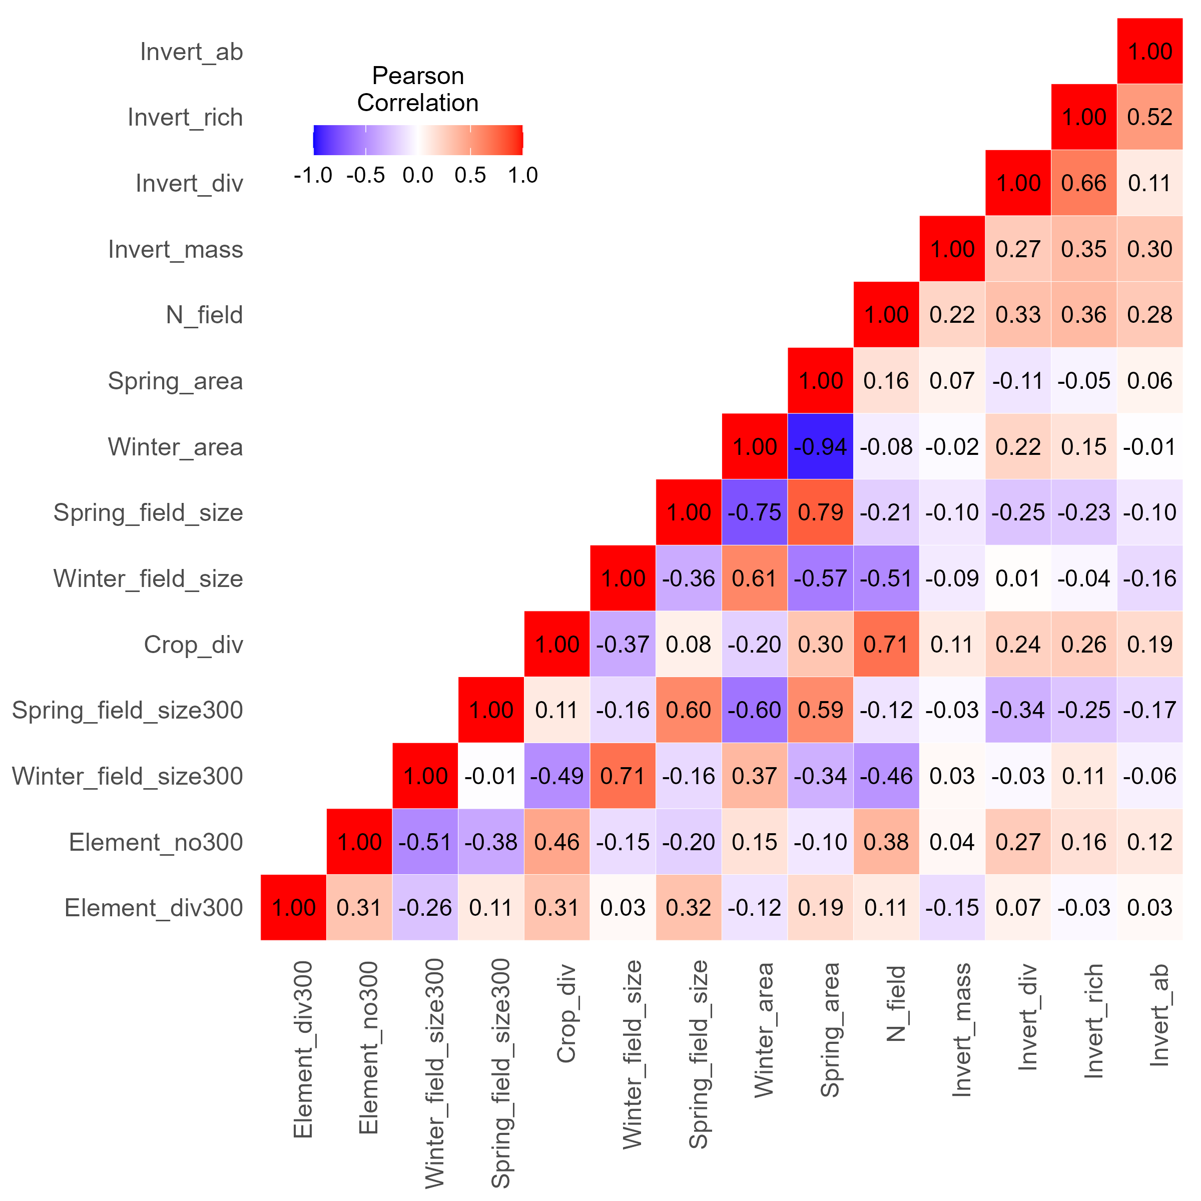
Fig. S1 Pearson’s correlation coefficients showing correlations between variables describing food supply and habitat heterogeneity. Refer to the chapters Food supply and Habitat heterogeneity in the main text for an explanation of the variables.
Table S1 List of invertebrate taxa sampled at the respective study sites. Formicidae of the order Hymenoptera were determined separately. Larvae of species with complete metamorphosis were included in the Insect larvae group. Other larvae were classified as adults of individual taxa.
Taxonomic group
Acari
Araneae
Auchenorrhyncha
Blatodea
Collembola
Coleoptera
Dermaptera
Diplopoda
Diptera
Formicidae
Heteroptera
Hymenoptera
Chilopoda
Insect larvae
Isopoda
Lepidoptera
Lumbricidae
Mecoptera
Nematoda
Neuroptera
Opilionidae
Orthoptera
Sternorrhyncha
Stylommatophora
Pseudoscorpionida
Thysanoptera

Table S2 Model selection tables showing the coefficient estimates in the best performing models (ΔAICc < 2) for (a) “spring” and (b) “winter” sets of models. Int = model intercept, k = number of model parameters, AICc = corrected Akaike Information Criterion, ΔAICc = difference in AICc from the top model, weight = Akaike weights. The plus sign (+) means that a given variable was included in the model. Refer to the main text for the description of model variables.
(a)
# | Int | Invert_ab | AEM | Spring_field_size | Spring_field_size300 | Winter_field_size300 | Element_no300 | Element_div300 | N_field | Month | k | AICc | ΔAICc | weight
1 | 0.1547 | 0.1207 | + | 0.1599 | NA | NA | 0.1255 | NA | 0.0934 | NA | 6 | 296.0 | 0.00 | 0.167
2 | 0.1870 | 0.1188 | NA | 0.1761 | −0.1194 | NA | NA | NA | 0.1109 | NA | 5 | 297.1 | 1.13 | 0.095
3 | 0.1637 | 0.1326 | + | 0.1375 | NA | NA | 0.1508 | NA | NA | NA | 5 | 297.2 | 1.22 | 0.091
4 | 0.0942 | 0.1116 | NA | 0.1807 | −0.1227 | NA | NA | NA | 0.1121 | + | 6 | 297.4 | 1.48 | 0.080
5 | 0.1905 | 0.1370 | NA | 0.1105 | NA | NA | 0.1208 | NA | NA | NA | 4 | 297.5 | 1.53 | 0.078
6 | 0.1886 | 0.1283 | NA | 0.1229 | NA | NA | 0.0951 | NA | 0.0731 | NA | 5 | 297.5 | 1.55 | 0.077
7 | 0.0673 | 0.1241 | + | 0.1409 | NA | NA | 0.1542 | NA | NA | + | 6 | 297.6 | 1.63 | 0.074
8 | 0.1458 | 0.1273 | + | 0.1280 | NA | −0.1046 | 0.1161 | NA | NA | NA | 6 | 297.6 | 1.64 | 0.073
9 | 0.1656 | 0.1136 | + | 0.1976 | −0.1188 | NA | NA | NA | 0.1316 | NA | 6 | 297.6 | 1.68 | 0.072
10 | 0.1870 | 0.1223 | NA | 0.1674 | −0.0885 | NA | 0.0674 | NA | 0.0849 | NA | 6 | 297.8 | 1.85 | 0.066
11 | 0.1411 | 0.1195 | + | NA | NA | −0.1762 | NA | 0.1243 | NA | NA | 5 | 297.8 | 1.88 | 0.065
12 | 0.1004 | 0.1306 | NA | 0.1128 | NA | NA | 0.1225 | NA | NA | + | 5 | 297.9 | 1.98 | 0.062

(b)
# | Int | Invert_ab | AEM | Winter_field_size | Spring_field_size300 | Element_no300 | Element_div300 | Month | k | AICc | delta | weight
1 | 0.1456 | 0.1110 | + | −0.1597 | NA | 0.07714 | 0.1370 | NA | 6 | 294.6 | 0.00 | 0.335
2 | 0.1509 | 0.1147 | + | −0.1655 | NA | NA | 0.1573 | NA | 5 | 295.1 | 0.41 | 0.273
3 | 0.0538 | 0.1070 | + | −0.1715 | NA | NA | 0.1587 | + | 6 | 295.3 | 0.66 | 0.241
4 | 0.1513 | 0.1094 | + | −0.1714 | −0.04838 | NA | 0.1611 | NA | 6 | 296.2 | 1.60 | 0.151

