Local-scale tree cover modulates pollination services and crop yield in tropical agroforestry landscapes
Jean Aimé Ruticumugambi^{a,b,c,d,h}, Pallieter De Smedtª, Hans Verbeeck^{b}, Beth Kaplin^{c,i}, Julienne Gatesi^{g,d}, Alain Ndoli^{d}, Valens Uwizeyimana^{e}, Jean Bosco Nkurikiye^{e}, Jules Rutebuka^{d}, Maurice Mugabowindekwe^{f}, Frieke Vancoillie^{b}, Kris Verheyenª, Maxime Eeraertsª
ªForest & Nature Lab, Department of Environment, Ghent University, Melle-Gontrode, Belgium
^{b} Q-ForestLab, Department of Environment, Ghent University, Belgium
^{c} CoEB – Center of Excellence in Biodiversity and Natural Resource Management, University of Rwanda
^{d}International Union for Conservation of Nature – Eastern and Southern Africa Region, Kigali, Rwanda
^{e} KU Leuven, Department of Earth and Environmental Sciences, Celestijnenlaan 200E, B-3001 Leuven, Belgium
^{f}Department of Geosciences and Natural Resource Management, University of Copenhagen, Denmark
^{g} SENSE Lab, Department Environment, Ghent University, Belgium
^{h}Department of Forestry, Kitabi College, Rwanda Polytechnic
^{i}School for the Environment, University of Massachusetts-Boston, USA

Corresponding author: Jean Aimé Ruticumugambi, Email: aimengambi1@gmail.com; jeanaime.ruticumugambi@ugent.be
Supplement Information (SI)
Table S1: Overview of the amount of tree cover (%) and the number of honeybee hives within a radius of 100 m, 250 m, 500 m, and 1000 m around the center of the study bean plots.
Plot ID | Tree cover  100 m | Tree cover  250 m | Tree cover  500 m | Bee hives  100 m | Bee hives  250m | Beehives 500m | Bee hives 1000m
41 | 6.3 | 2.7 | 1.6 | 0 | 0 | 18 | 21
43 | 24.5 | 2.7 | 2.9 | 0 | 0 | 21 | 29
47 | 1.6 | 3.7 | 6 | 0 | 0 | 0 | 12
412 | 0 | 0.2 | 0.9 | 0 | 0 | 8 | 8
420 | 0 | 0 | 0.2 | 0 | 0 | 0 | 3
423 | 1.8 | 2.7 | 3.3 | 0 | 0 | 8 | 59
424 | 0 | 0.1 | 2.9 | 0 | 0 | 0 | 77
427 | 0 | 0 | 0.6 | 0 | 0 | 0 | 3
431 | 5.8 | 6.2 | 5.1 | 0 | 0 | 0 | 19
435 | 3.8 | 4.2 | 3.9 | 0 | 0 | 0 | 31
437 | 4.7 | 4.5 | 2.6 | 0 | 3 | 11 | 29
438 | 5.3 | 5.9 | 5.8 | 0 | 0 | 30 | 33
439 | 1.7 | 3.2 | 5.4 | 0 | 0 | 0 | 36
443 | 0 | 0 | 0.6 | 0 | 0 | 0 | 18
445 | 0 | 0.4 | 1.7 | 0 | 0 | 0 | 17
450 | 4.8 | 4.4 | 3.8 | 0 | 0 | 0 | 50
451 | 4.3 | 4.3 | 2.8 | 0 | 2 | 2 | 2
456 | 3.5 | 6.4 | 2.8 | 13 | 13 | 26 | 41

Table S2: Flower visitor composition and their respective percentage abundance collected across 18 experimental plots installed in smallholder agroforestry farms with common bean (Phaseolus vulgaris L.) in Nyagatare District, Northeastern Rwanda. The most predominant flower visitors across the landscape were honey bees, followed by Other wild flower visitors and carpenter bees, respectively. Butterflies and wasps were the least represented pollinator visitor groups across the landscape.
Plot ID | Butterflies | Carpenter bee | Honey bee | Wasps | Others | Overall
41 | 0.0 | 1.3 | 3.9 | 0.0 | 0.0 | 5.3
43 | 0.0 | 1.3 | 6.6 | 1.3 | 1.3 | 10.5
47 | 0.0 | 0.0 | 3.9 | 0.0 | 3.9 | 7.9
412 | 0.0 | 0.0 | 5.3 | 0.0 | 0.0 | 5.3
420 | 0.0 | 0.0 | 1.3 | 0.0 | 2.6 | 3.9
423 | 0.0 | 2.6 | 1.3 | 0.0 | 0.0 | 3.9
424 | 0.0 | 0.0 | 0.0 | 0.0 | 1.3 | 1.3
427 | 0.0 | 0.0 | 3.9 | 0.0 | 1.3 | 5.3
431 | 0.0 | 0.0 | 2.6 | 0.0 | 1.3 | 3.9
435 | 0.0 | 0.0 | 2.6 | 0.0 | 2.6 | 5.3
437 | 0.0 | 0.0 | 7.9 | 0.0 | 0.0 | 7.9
438 | 0.0 | 1.3 | 5.3 | 0.0 | 1.3 | 7.9
439 | 0.0 | 0.0 | 5.3 | 0.0 | 2.6 | 7.9
443 | 0.0 | 1.3 | 0.0 | 0.0 | 2.6 | 3.9
445 | 0.0 | 0.0 | 5.3 | 0.0 | 0.0 | 5.3
450 | 0.0 | 0.0 | 1.3 | 0.0 | 0.0 | 1.3
451 | 2.6 | 1.3 | 6.6 | 0.0 | 0.0 | 10.5
456 | 0.0 | 0.0 | 1.3 | 1.3 | 0.0 | 2.6
Total abundance | 2.6 | 9.2 | 64.5 | 2.6 | 21.1 | 100.0

Table S3: Comparison of bean yield components, including the mean number of beans per pod, number of pods per branch, and dry matter yield, between bagged and open pollination treatments. For each comparison, the mean, standard error, and percentage increase are provided.
Response variable | Pollination treatment | Mean | SE | %increase of open vs bagged
Number of beans per pod | Bagged | 5.851235 | 0.159 | 10.81144
 | Open | 6.483838 | 0.131
Number of pods per branch | Bagged | 26.11111 | 2.97 | 120.6383
 | Open | 57.61111 | 3.1
Dry matter yield | Bagged | 25.15556 | 3.72 | 163.2288
 | Open | 66.21667 | 4

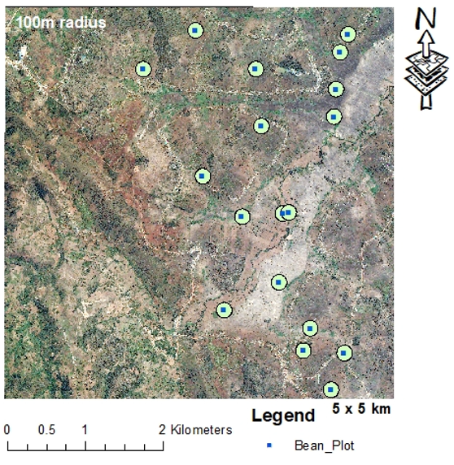
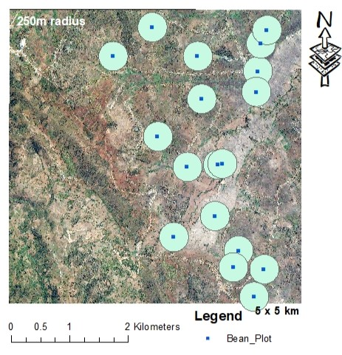
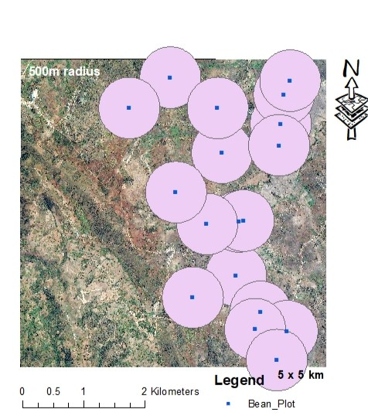
Fig. S1. A north-oriented map displays buffer zones of 100, 250, and 500 meters around 18 bean plots (5 m x 5 m). The analysis revealed that only two plots overlapped at the 100-meter landscape scale, the best-fit model scale, suggesting that the plots are independent.
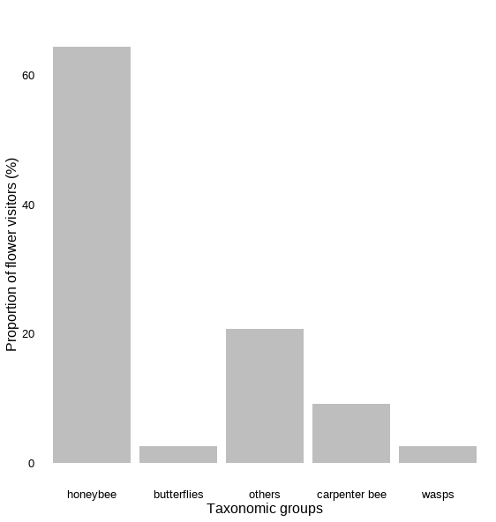
Fig. S2. The relative proportions of major pollinator groups of bean plants (Phaseolus vulgaris) in the Mukama (northeastern Rwanda) agroforestry farms.

Table S4: Model ranking of the full models at the different landscape scales for bean yield components (TD = Tree density at plot level, TC = Landscape-level tree cover (%) at 100m, 250m and 500m). Values in bold indicate models within the 2 ∆AICc unit range of the best fitting model.

Response variable | Model | AICc | delta AICc
Number of beans per pod | TD + TC500m | 156.06 | 0.00
 | TD + TC250m | 160.78 | 4.72
 | TD + TC100m | 161.88 | 5.82
Number of pods per branch | TD + TC500m | 79.06 | 3.76
 | TD + TC250m | 77.88 | 2.57
 | TD + TC100m | 75.31 | 0.00
Dry matter yield | TD + TC_500m | 271.99 | 3.68
 | TD + TC250m | 269.94 | 1.63
 | TD + TC100m | 268.31 | 0.00

Table S5: Model ranking of the full models at different landscape scales for honeybee visitation and other wild pollinators (TD = Tree Density at plot level, BF= Bean flowers, TC = Landscape-level tree cover (%) at 100m, 250m and 500m, HB = landscape-level honeybee hive density (Only for Honeybees)). Values in bold indicate models within the 2 ∆AICc unit range of the model with the best fitting landscape scale.

Response variable | Model | AICc | delta AICc
Honey bee visitation | TD + BF +TC100m + BH100m | 79.55 | 0.00
 | TD + BF +TC250m + BH250m | 81.68 | 2.14
 | TD + BF +TC500m + BH500m | 81.94 | 2.4
Wild pollinators | TD + BF +TC100m | 67.56 | 0.43
 | TD + BF +TC250m | 67.88 | 0.76
 | TD + BF +TC500m | 67.13 | 0.00
Table S6: Model ranking of the full models at the different landscape scales for wild pollinator visitation (flower beetles were not included here) (TD = Tree Density at plot level, TC = Landscape-level tree cover (%) at 100m, 250m and 500m).
Response variable | Model | delta AICc | Fixed variable | Estimate | SE | test stat (t - value) | p value
RQ4: Local tree density and landscape tree cover impact pollinator visitation
Wild pollinator visitation | TD + flowers +TC100m | 8,06 | TD | 0.00 | 0.01 | 0.59 | 0.57
 |  |  | flowers | -0.01 | 0.02 | -0.52 | 0.61
 |  |  | TC100m | 0.32 | 0.33 | 0.96 | 0.35
 | TD + flowers +TC250m | 8,41 | TD | 0.00 | 0.01 | 0.54 | 0.60
 |  |  | flowers | 0.00 | 0.02 | -0.25 | 0.81
 |  |  | TC250m | 0.23 | 0.41 | 0.55 | 0.59
 | TD + flowers +TC500m | 7,94 | TD | 0.01 | 0.01 | 0.59 | 0.56
 |  |  | flowers | 0.00 | 0.02 | -0.08 | 0.94
 |  |  | TC500m | 0.45 | 0.59 | 0.76 | 0.46

