Appendix S1: Supporting information for

Title: Hydrodynamics, elevation, and restoration history structure intertidal oyster recruitment

Journal: Landscape Ecology

Authors: Kinsey N. Tedford-Callahan^{1,*}, Rachel S. Smith², Bowdoin W. Lusk³, and Max C. N. Castorani¹

Author affiliations at the time the work was conducted:
¹Department of Environmental Sciences, University of Virginia, Charlottesville, VA 22904 USA
²Marine Science Institute, University of California, Santa Barbara, CA 93106 USA
³Virginia Coast Reserve, The Nature Conservancy, Nassawadox, VA 23413 USA

Present affiliations (if different): ¹Oyster Recovery Partnership, 1805 Virginia St., Annapolis, MD 21404 USA
The affiliations of Rachel S. Smith, Bowdoin W. Lusk, and Max C. N. Castorani remain the same as when the work was conducted.

*Corresponding author: Kinsey N. Tedford-Callahan
Email: ktedford@oysterrecovery.org
Tel: 405-313-6844.

This PDF file includes:
Figures S1 to S10 with captions
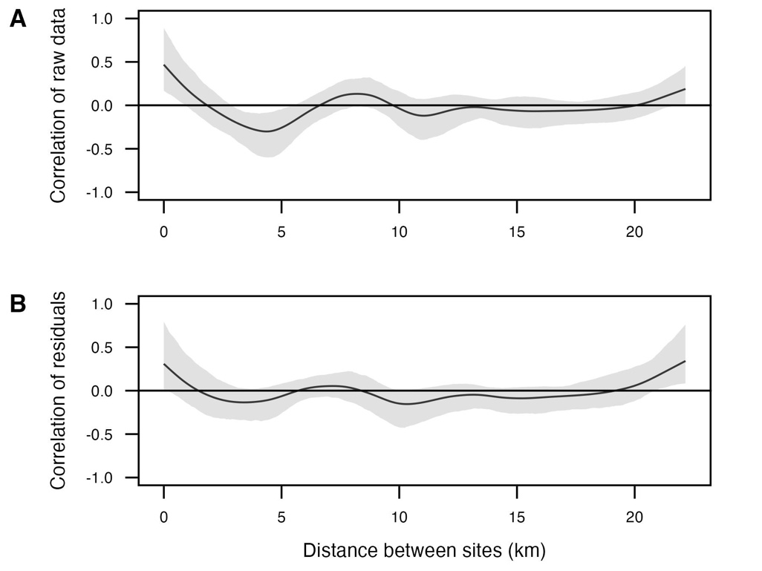
Fig. S1. Spatial correlograms displaying spatial autocorrelation of raw oyster recruitment to ceramic tiles (A) and of model residuals of oyster recruitment to tiles after controlling for wind fetch, water residence time, and elevation (B). Lines show the fitted spline correlogram and shading indicates the 95% confidence intervals.

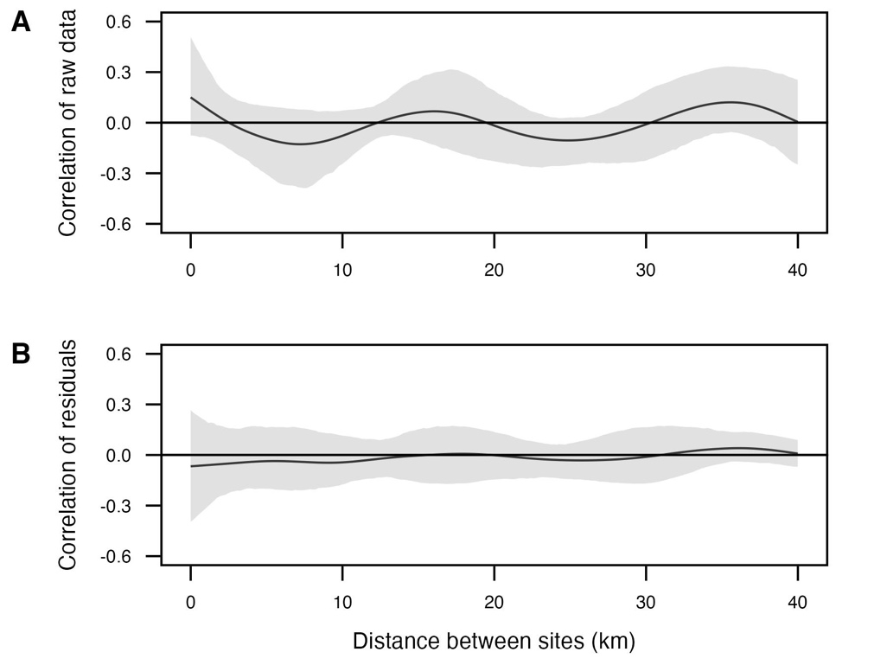
Fig. S2. Spatial correlograms displaying spatial autocorrelation of raw oyster recruitment to live oyster and shell hash (A) and of model residuals of oyster recruitment to live oyster and shell hash after controlling for wind fetch, water residence time, and elevation (B). Lines show the fitted spline correlogram and shading indicates the 95% confidence intervals.

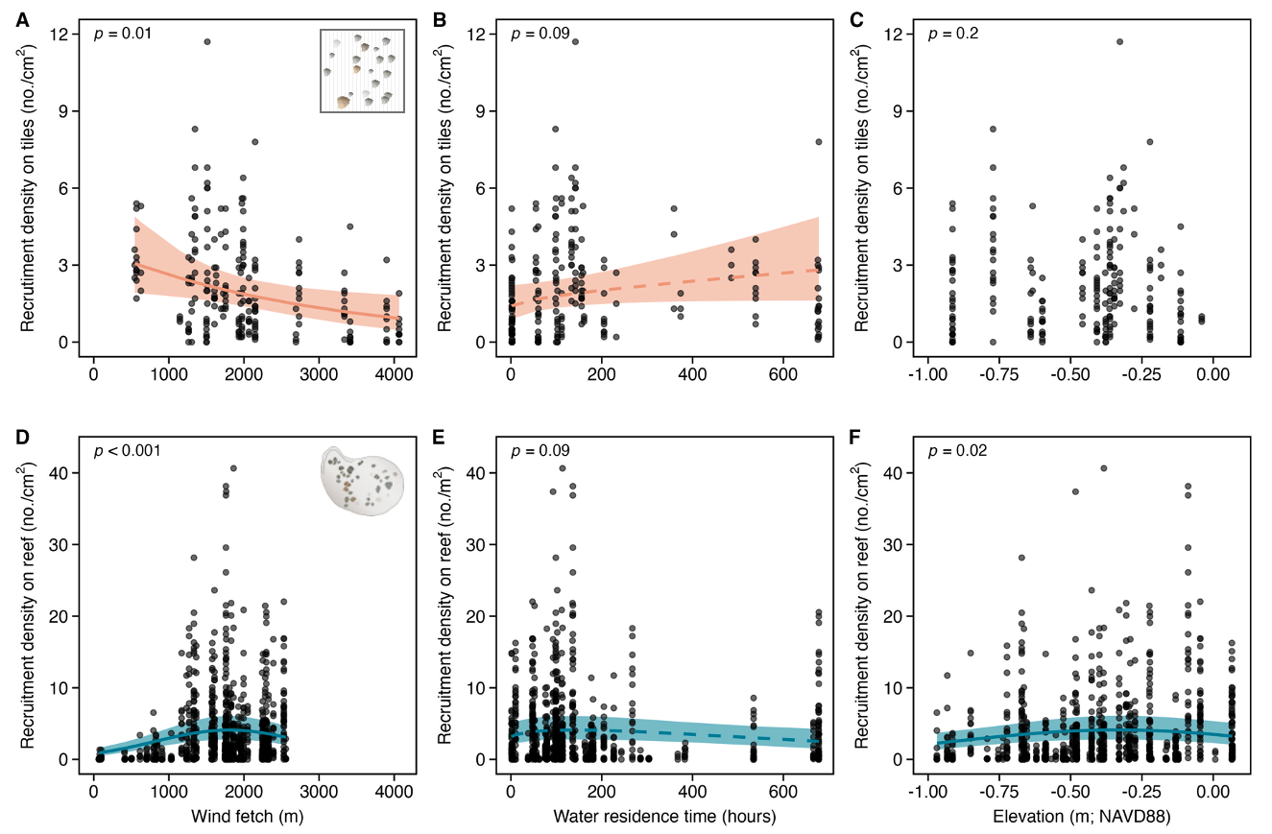
Fig. S3. Relationships between oyster recruitment and environmental conditions on ceramic tiles (A–C) and live oyster and shell hash (D–F). Points show raw data. P-values indicate the respective main effects displayed from the separate mixed-effects models based on the recruitment sampling method. Lines and shading show mean model predictions and 95% confidence intervals, respectively, after controlling for covariates. Solid lines indicate significant fits (p < 0.05), and dashed lines reflect moderately significant (0.05 < p < 0.1).

Fig. S4. Bubble plot of raw oyster recruitment measurements to ceramic tiles (A) and live oyster and shell hash (B) on each reef. The area of the bubble is proportional with the time-averaged recruitment for each reef location.

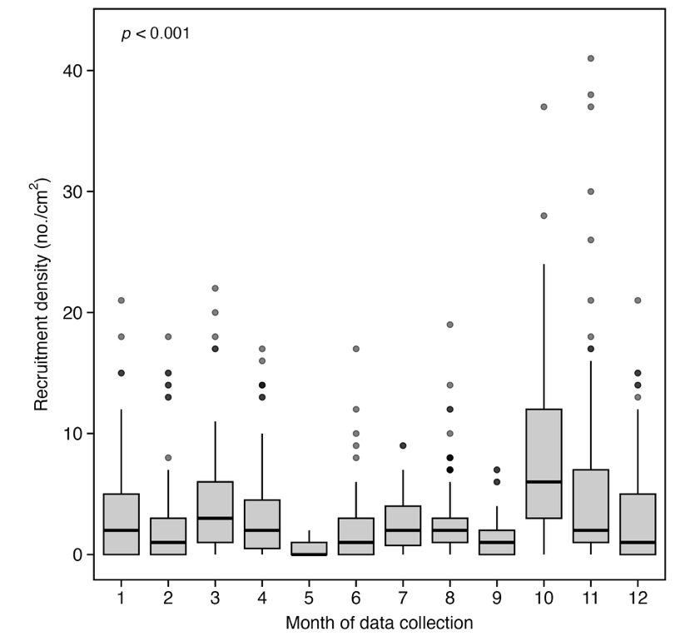
Fig. S5. Oyster recruitment varied based on month of data collection. Boxplots show raw data with the median (bold lines) and interquartile ranges (boxes) with outliers greater than 1.5 × IQR (whiskers). P-value indicates the respective main effect displayed from the mixed-effects model.

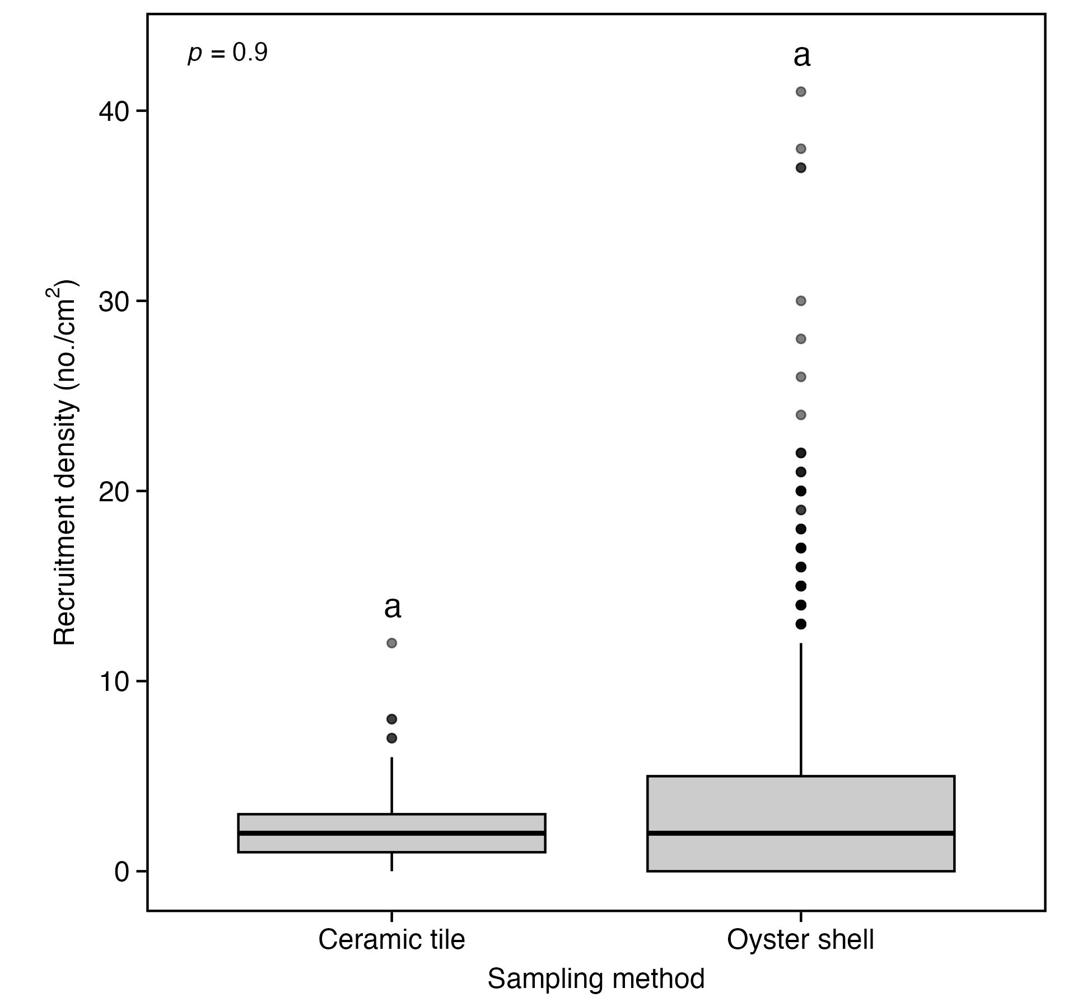
Fig. S6. Oyster recruitment did not vary based on sampling method. Boxplots show raw data with the median (bold lines) and interquartile ranges (boxes) with outliers greater than 1.5 × IQR (whiskers). P-value indicates the respective main effect displayed from the mixed-effects model. Lowercase letters represent results from post-hoc test and those that do not share a common letter are significantly different (p < 0.05).

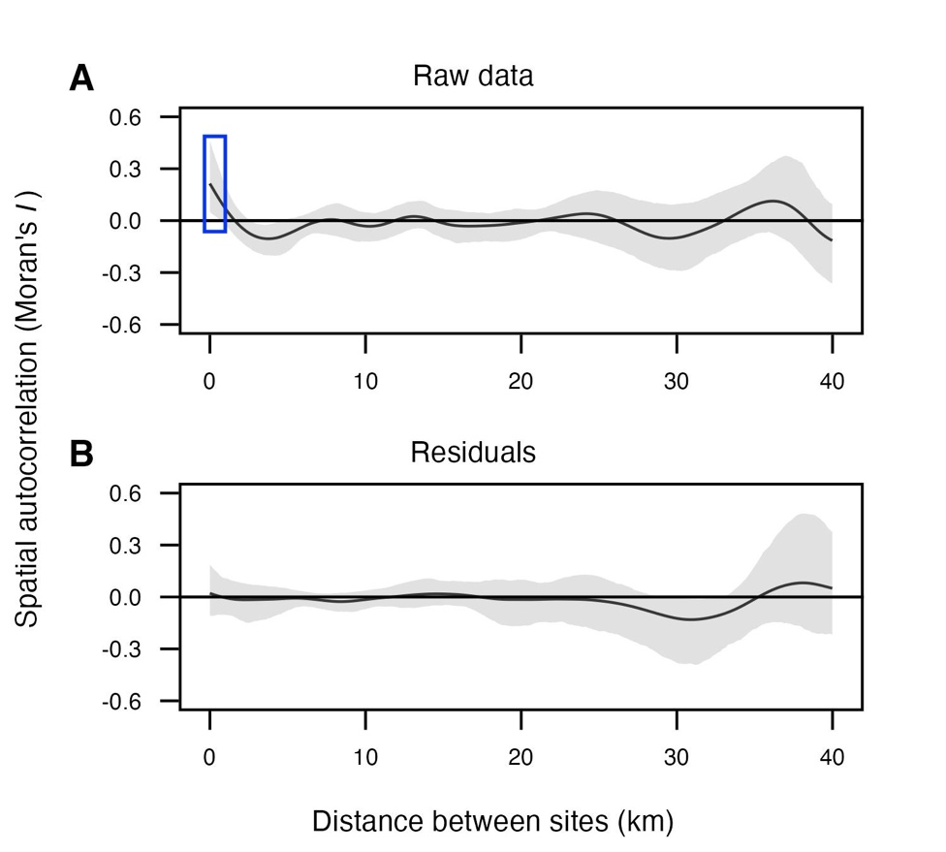
Fig. S7. Spatial correlograms display spatial autocorrelation of raw oyster recruitment (A) and model residuals of oyster recruitment after controlling for wind fetch, water residence time, and elevation (B) after removing five reefs at the southern margin of our study domain. Larger positive values of Moran’s I indicate greater spatial clustering of similar values, while larger negative values indicate stronger spatial dispersion of dissimilar values. The lines represent the fitted spline correlogram, with shading indicating the 95% confidence intervals. The blue rectangle highlights the area where the confidence intervals do not overlap zero, denoting positive spatial autocorrelation.

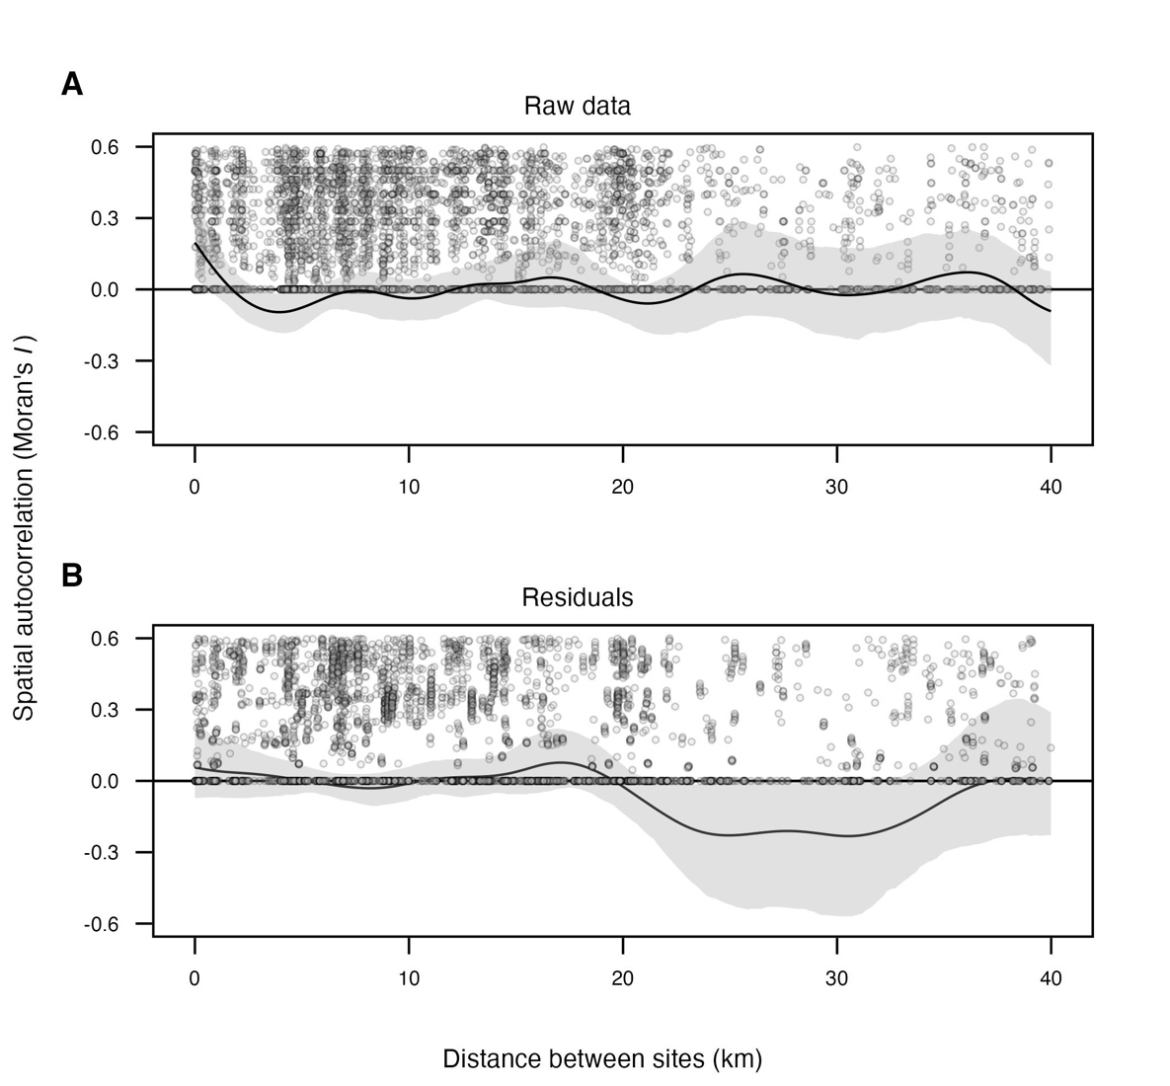
Fig. S8. Pairwise spatial autocorrelation of oyster recruitment based on raw data (A) and model residuals (B). Gray points represent all pairwise comparisons between sampling locations, with the x-axis showing distance between site pairs (km) and the y-axis showing a proxy for spatial correlation (Moran’s I). The black line is the fitted spline correlogram summarizing average autocorrelation at each distance bin, with gray shading indicating the 95% confidence interval. This figure complements Fig. 4 by showing the distribution and variability of spatial relationships that the spline correlogram summarizes.

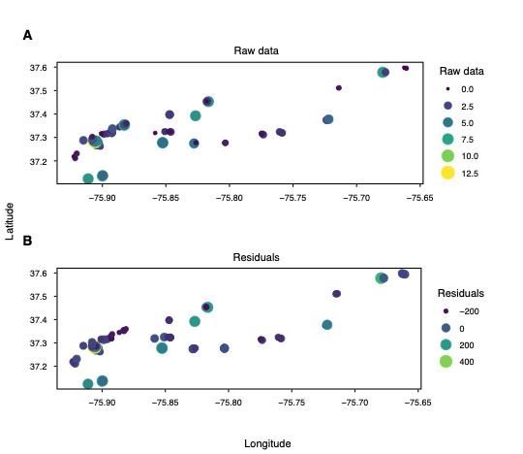
Fig. S9. Recruitment density plotted against latitude and longitude, with bubble size and color representing raw data or model residuals. These plots provide additional spatial context, complementing the spatial correlograms in Fig. 4, and illustrate the distribution of recruitment density across the study region.

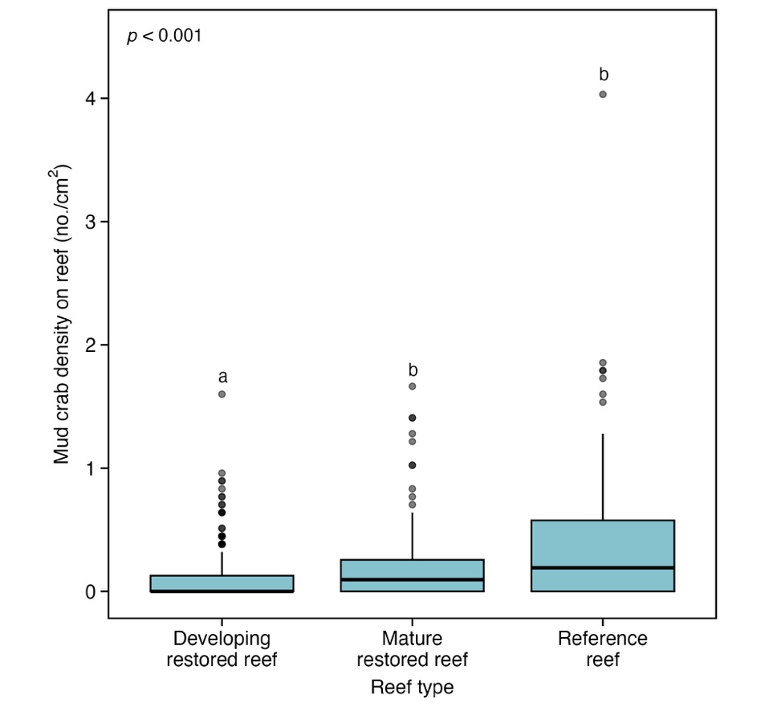
Fig. S10. Mud crab abundance, collected from excavations of live oyster and shell hash, was lower on developing restored reefs relative to mature restored or reference reefs (n = 925 total excavations from 2005 to 2022). Boxplots show raw data with the median (bold lines) and interquartile ranges (boxes) with outliers greater than 1.5 × IQR (whiskers). The p-value indicates the respective main effect displayed from the mixed-effects model. Lowercase letters represent results from post-hoc tests and those that do not share a common letter are significantly different (p < 0.05).

