Supplementary material S1. Description of the environmental variables included in this study and identification of the three sets (partitions) to which they belong. Variables produced using buffers of a given radius were used only in analyses associated with the spatial scale they encompassed (either small, medium or large) and the geographical linear or planar trend (XY data)

Variable

Description

Partition
*

Scale

Dtwt | Diameter at stump height (DHS) of the tree on which the trap was attached (cm) | P | All
Fire1 | Low fire severity (FireIndex < 2.5) in the plot (dummy variable) | P | All
Fire2 | Moderate fire severity (FireIndex (2.5-3.5) in the plot (dummy variable) | P | All
Dmean | Mean diameter of burned trees > 10cm of DSH (cm) | P | All
Bas_area | Total basal area in the plot (m².ha⁻¹) | P | All
Nd25 | Number of burned stems between 2 and 5 cm of DSH (n.ha⁻¹) | P | All

Nd510 | Number of burned stems between 5 and 10 cm of DSH (n.ha⁻¹) | P | All
Log12 | Volume of unburned downed woody debris (>5cm of maximum diameter) of decay classes 1 and 2 (m³.ha⁻¹) | SH | All
Snag12 | Basal area data of unburned snags (>5cm of diameter) of decay classes 1 and 2 (m².ha⁻¹) | SH | All
BurnResLiF | Total area of conifer-dominated forest lightly burned (FireIndex<2.5) in a 661m radius around the plot (%) | B | Small + XY data
BurnResMoF | Total area of conifer-dominated forest moderately burned (FireIndex  :2.5-3.5) in a 661m radius around the plot (%) | B | Small + XY data
BurnResSevF | Total area of conifer-dominated forest severely burned (FireIndex  >3.5) in a 661m radius around the plot (%) | B | Small + XY data
BurnResLiM | Total area of conifer-dominated forest lightly burned (FireIndex<2.5) in a 1322m radius around the plot (%) | B | Medium +  XY data
BurnResMoM | Total area of conifer-dominated forest moderately burned (FireIndex  :2.5-3.5) in a 1322m radius around the plot (%) | B | Medium +  XY data

BurnResSevM | Total area of conifer-dominated forest severely burned (FireIndex  >3.5) in a 1322m radius around the plot (%) | B | Medium +  XY data
BurnResLiL | Total area of conifer-dominated forest lightly burned (FireIndex<2.5) in a 2644m radius around the plot (%) | B | Large + XY data
BurnResMoL | Total area of conifer-dominated forest moderately burned (FireIndex  :2.5-3.5) in a 2644m radius around the plot (%) | B | Large + XY data
BurnResSevL | Total area of conifer-dominated forest severely burned (FireIndex  >3.5) in a 2644m radius around the plot (%) | B | Large + XY data
Log12 | Volume of unburned downed woody debris (>5cm of maximum diameter) of decay classes 1 and 2 (m³.ha⁻¹) | SH | All
Snag12 | Basal area of unburned snags (>5cm of diameter) of decay classes 1 and 2 (m².ha⁻¹) | SH | All
UnbF | Total area of unburned conifer-dominated forest in a 661m radius around the plot (%) | SH | Small + XY data
UnbM | Total area of unburned conifer-dominated forest in a 1322m radius | SH | Medium +
 | around the plot (%) |  | XY data
UnbL | Total area of unburned conifer-dominated forest in a 2644m radius around the plot (%) | SH | Large + XY data
Dist_edge | Minimum distance to the edge of the 2005 fire patch (m) | SH | All
Dist_2002 | Minimum distance to the 2002 fire patch (km) | SH | All
Dist_10ha | Minimum distance to unburned conifer-dominated forest of >10ha  (m) | SH | All

*P: plot-level attributes; B: landscape-scale burned habitat characteristics measured in buffers; SH: variables associated with dispersal from source habitats.

Supplementary material S2. Justifications for inclusion of environmental variables in each group.
Species distribution may be spatially structured because environment attributes measured in the plots and on which they rely on are themselves spatially structured (spatial dependency : Legendre 1993, Borcard et al. 2004). Several authors (Hÿvarinen et al. 2005, Hjälten et al. 2007, Boulanger et al. in press) have shown that local fire severity and other habitat quality components are known to affect the colonization of saproxylic species at the onset of the process. As these environmental characteristics are likely to be patchy at various spatial scales (Fortin and Payette 2002), one should expect that the abundance of saproxylic colonizer species should follow approximately the same spatial pattern.
Variables in the second group (ii) represented habitat characteristics displayed at a larger spatial scale than the mean distance between sampling points. If such habitat characteristics are selected by saproxylic species, it should produce measurable spatial patterns at this scale. Although one could assess such a relationship from spatially autocorrelated predictors in the first group, this may be best modelled by including habitat data measured in buffers around the sampling point. Relying solely on spatially structured plot-level attributes to assess this process may overlook the effect of habitat characteristics between sampling points on the local abundance of saproxylic species (see text, figure 1). Only burned severity of coniferous stands were included in this group since other computable variables from EOSD (Beaubien et al. 1999) and LandsatTM images (e.g. amount of bogs/fen, amount of shrubby area, index of total amount of burned wood), were highly correlated to either one or several of these variables. Moreover, in a recent analysis, Boulanger et al. (2009) stated that fire severity was the most important variable to predict early post-fire saproxylic assemblages in this area.
Most authors (Holliday 1991, Saint-Germain et al. 2004a, Hyvärinen et al. 2005, SaintGermain et al. 2008) stated that colonizing specimens converge to the newly burned habitat mainly from external sources as most insect species are temporarily excluded
(Wikars 1997, Gandhi et al. 2001, Wikars and Schimmel 2001) or killed (Paquin and Coderre 1997, McCullough et al. 1998) during the burning. Most species that colonize fresh burned wood are also able to breed in woody debris that were created in “green” forests (e.g. from windthrow, self-thinning). Hence, both unburned forests and other recently burned forest patches located in the vicinity of the 2005 fire were considered as potential source habitats. We considered two distance-based variables associated with unburned source-habitats (distance to fire edge, distance to the nearest >10ha unburned coniferous forest) and one with other recently burned patches (minimum distance to one of the 2002 fire patches) (Table S1.1). We considered 2002 fire patches (see text, figure 1) as a source habitat regarding the relative proximity (minimum distance = 4.8 km) of this burned patch to the study area. Several xylophagous species are known to complete their life cycle in 2-3 years (Haack and Slansky 1987); newly hatched specimens from this fire patch could therefore colonize the closely and newly burned habitat. Furthermore, we considered the amount of unburned coniferous forests in buffers of radius corresponding to each spatial scale investigated, i.e. 650, 1300 and 2650 m (Table 1).

Supplementary material S3. Total abundance of common taxa considered in the separate analyses. The functional group to which each taxa belongs is also indicated
Taxa | Functional group | Total number of individuals
Acmaeops proteus (Kirby) | Xylophage | 805
Arhopalus foveicollis Haldeman | Xylophage | 773
Hylobius congener Dalle Torre and Hustache | Xylophage | 190
Monochamus scutellatus (Say) | Xylophage | 188
Atomaria sp. | Mycophage | 175
Caenoscelis sp. | Mycophage | 284
Cartodere constritus (Gyllenhal) | Mycophage | 831
Clypastrea fusca Harold | Mycophage | 1030
Corticaria dentigera LeConte | Mycophage | 857
Corticaria sp.2 | Mycophage | 2851
Sericoda obsoleta (DeGeer) | Predator | 327
Sphariestes virescens (LeConte) | Predator | 741
Thanasimus undatulus nubilus Klug | Predator | 3562

Supplementary material S4. Production of PCNM variables and scale assessment
Production of PCNM variables. The PCNM analysis is a method belonging to the eigenfunction-based spatial analyses (Griffith and Peres-Neto 2006). It relies on a truncated matrix that retains geographic distances between neighbouring sites. In this matrix, the distances larger than the largest distance between two contiguous sites according to the minimum spanning tree method were replaced by a value equal to four times that threshold (Borcard and Legendre 2002). Threshold distances were 1158 and
831 m for PCNM produced in the northern and the southern areas respectively. Afterwards, we computed a principal coordinates analysis by using this truncated distance matrix and we kept only the coordinates of positive eigenvalues. These eigenvectors made up the PCNM variables. Final PCNM variables consist of orthogonal waves, whose wavelengths range across all spatial scales encompassed by the sampling design (Brind’Amour et al. 2005, Jones et al. 2008) (see figure 3.1 for an example). As PCNM variables are completely orthogonal, we can decompose every spatial scale at which an ecological process occurs without overlapping spatial components (Borcard and Legendre 2002).
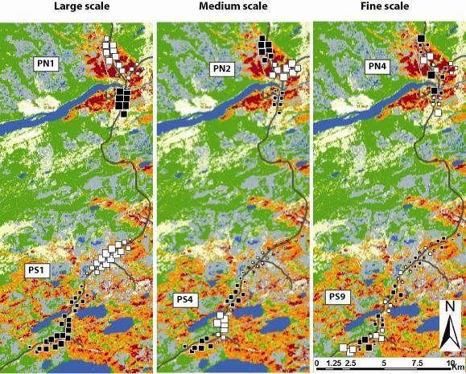
Figure S3.1. Mapped values of PCNM variable examples representing different spatial scales. Square size is proportional to the standardized (mean = 0; variance =1) value of the PCNM variable. Filled squares: positive values, open squares: negative values.

Assessing the scale of a PCNM variable. Borcard and Legendre (2002) noticed that it’s difficult to assess the corresponding spatial scale of a given PCNM variable when plots are not organized according to a regular sampling scheme. Highly irregular sampling design may produce PCNM variables that bear structures at several scales. However, a quick visual analysis of every PCNM variable showed that the great majority of them were still quite regular (figure 3.1) even though the distances to the nearest neighbour varied between 313 and 661 m (mean = 465 m) according to the minimum spanning tree technique. To know at which scale a PCNM variable is spatially autocorrelated, one can measure the approximate distance between each bump or through (D. Borcard, pers. comm.). Instead, we successively calculated Geary’s c at every lag-distance of 661 m (maximum distance between sampling plots) for each PCNM variable. We attributed their spatial scale according to the highest distance at which the Geary’s c was significant (P<0.05) before the first non-significant lag-distance (Legendre and Legendre 1998). Scale of PCNM variables corresponded respectively to 3 to 5-, 2- and 1-fold the maximum distance between nearest neighbours according to the minimum spanning tree technique. Statistical significance of Geary’s c was estimated after 999 Monte Carlo permutations using ROOKCASE (Sawada 1999).

Supplementary material S5. Variation partitioning in this study
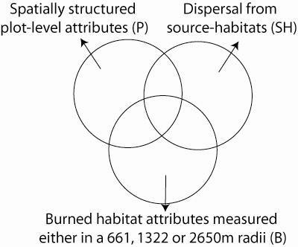
Figure S5.1. Venn diagram showing how the spatial variation at the large, medium and fine scales was partitioned among every saproxylic assemblages. Importance of each partition was obtained using variation partitioning on fitted sample scores on the first axis only from RDA computed on spatial variables. Analyses were repeated for every saproxylic assemblages and spatial scales encompassed by spatial variables.

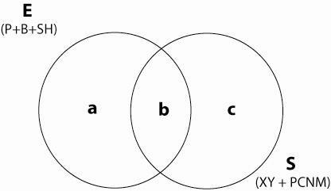

Figure S5.2. Venn diagram showing the partition of the variation between environmental
(E) variables (include plot-level, buffers and source-habitat variables) and spatial (PCNM + XY) variables (S). a: Independent effect of environmental variables; b: Unexplained spatial variation; c : variation shared by environmental and spatial variables. See Figure S5.1 for abbreviations.

References
Beaubien J, Hall FG, Huemmrich KF et al (1999) Land cover from multiple thematic mapper scenes using a new enhancement-classification methodology: BOREAS in 1999: Experiment and science overview. J Geophys Res 104:909–927
Borcard D, Legendre P (2002) All-scale spatial analysis of ecological data by means of principal coordinates of neighbour matrices. Ecol Model 153:51–68
Boulanger Y, Hébert C, Sirois L et al (in press) Distribution of saproxylic beetles in a recently burnt landscape of the northern boreal forest of Québec. For Ecol Manag
Brind’Amour A, Blanchet H, Dupuy C et al (2005) Multiscale spatial distribution of a littoral fish community in relation to environmental variables. Limnol Oceanogr 50:465–479
Fortin MJ, Payette S (2002) How to test the significance of the relation between spatially autocorrelated data at the landscape scale: a case study using fire and forest maps. Ecoscience 9:213–218
Gandhi KJK, Spence JR, Langor DW (2001) Fire residuals as habitat reserves for epigaeic beetles (Coleoptera: Carabidae and Staphylinidae). Biol Conserv 102:131–141
Griffith DA, Peres-Neto PR (2006) Spatial modeling in ecology: the flexibility of eigenfunction spatial analyses in exploiting relative location information. Ecology 87:2603–2613
Haack RA, Slansky F Jr (1987) Nutritional ecology of wood-feeding Coleoptera, Lepidoptera, and Hymenoptera. In: Slansky F, Rodriguez JG (eds) The nutritional ecology of insects, mites, and spiders. Wiley, New York, pp 449–489
Holliday NJ (1991) Species responses of carabid beetles (Coleoptera: Carabidae) during post-fire regeneration of boreal forest. Can Entomol 123:1369–1389
Hyvärinen E, Kouki J, Martikainen P (2005) Short-term effects of controlled burning and green-tree retention on beetle (Coleoptera) guilds in managed boreal forests. For Ecol Manag 212:315–332
Hjältén J, Stenbacka F, Johansson T (2007) The importance of substrate type, shading and scorching for the attractiveness of dead wood to saproxylic beetles. Basic Appl Ecol 8:364–376
Jones MM, Tuomisto H, Borcard D (2008) Explaining variation in tropical plant community composition: influence of environmental and spatial data quality. Oecologia 155:593–604
Legendre P (1993) Spatial autocorrelation: trouble or new paradigm? Ecology 74:1659–1673
Legendre P, Legendre L (1998) Numerical ecology, 2nd English ed. Elsevier Science BV, New York
McCullough DG, Werner RA, Neumann D (1998) Fire and insects in northern and boreal ecosystems of North America. Annu Rev Entomol 43:107–127
Paquin P, Coderre D (1997) Deforestation and fire impact on edaphic insect larvae and other macroarthropods. Environ Entomol 26:21–30
Saint-Germain M, Drapeau P, Hébert C (2004) Landscape-scale habitat selection patterns of Monochamus scutellatus (Say) (Coleoptera: Cerambycidae) in a recently burned black spruce forest. Environ Entomol 33:1703–1710
Saint-Germain M, Drapeau P, Hébert C (2008) Persistence of pyrophilous insects in fire-driven boreal forests: population dynamics in burned and unburned habitats. Divers Distrib 14:713–720
Sawada M (1999) ROOKCASE: An Excel 97/2000 Visual Basic (VB) Add-in for exploring global and local spatial autocorrelation. Bull Ecol Soc Am 80:231–234
Wikars LO (1997) Effects of forest fire and ecology of fire-adapted insects. PhD Dissertation, Department of Zoology, Uppsala University, Sweden
Wikars LO, Schimmel J (2001) Immediate effects of fire severity on soil invertebrates in cut and uncut pine forests. For Ecol Manag 141:189–200

