Landscape Ecology
SUPPORTING INFORMATION
A spatially independent seed dispersal design for forest landscape models
Hang Sun¹, Hong S. He^{2*}, Xianghua Zou¹,
Wen J. Wang³, Jacob S. Fraser⁴, Kai Liu1

1. Key Laboratory of Geographical Processes and Ecological Security of Changbai Mountains, Ministry of Education, School of Geographical Sciences
2. School of Natural Resources, University of Missouri, Columbia, MO 65211, USA
3. Northeast Institute of Geography and Agroecology, Chinese Academy of Sciences, Changchun, China
4. Northern Research Station, U.S. Forest Service, Columbia, 65211, MO, USA
Correspondence: heh@missouri.edu (H. S. He)

Appendix S1. Individual tree species biological traits used in the forest landscape model LANDIS PRO to project future tree species distributions in the Small Khingan Mountains of Northeast China. We grouped species based on their successional strategies as early-successional (E Spp.), mid-successional (M Spp.), or late-successional species (L Spp.) to help summarize general patterns in results. Table 1 Species biological traits used in the LANDIS PRO model
Common name | Species |  | Mature / Longevity | Shade  tolerance | Maximum dispersal  Distance  (m/year) | Vegetative probability | Maximum DBH  (cm) | Maximum SDI  (trees/ha) | Number of potential germination seeds per mature tree
Korean pine | Pinus koraiensis | L Spp. | 40 / 300 | 4 | 150 | 0 | 110 | 550 | 20
Korean spruce | Picea koraiensis and Picea jezoensis | L Spp. | 30 / 300 | 4 | 150 | 0 | 90 | 600 | 20
Khingan fir | Abies nephrolepis | L Spp. | 30 / 300 | 4 | 150 | 0 | 85 | 650 | 20
Larch | Larix gmelinii | M Spp. | 20 / 300 | 2 | 300 | 0 | 95 | 650 | 30
Manchurian ash | Fraxinus mandschurica | L Spp. | 30 / 250 | 3 | 300 | 0.9 | 100 | 600 | 25
Manchurian walnut | Juglans mandshurica | M Spp. | 20 / 250 | 2 | 200 | 0.9 | 90 | 650 | 25
Amur corktree | Phellodendron amurense | M Spp. | 20 / 250 | 3 | 300 | 0.8 | 95 | 650 | 25
Mongolian oak | Quercus mongolica | M Spp. | 20 / 300 | 2 | 200 | 1 | 95 | 600 | 20
Black elm | Ulmus davidiana | M Spp. | 20 / 250 | 3 | 800 | 0.5 | 90 | 600 | 25
Mono maple | Acer mono | L Spp. | 20 / 200 | 3 | 200 | 0.5 | 60 | 700 | 25
Ribbed birch | Betula costata | M Spp. | 20 / 250 | 3 | 800 | 0.9 | 90 | 650 | 25
Dahur birch | Betula dahurica | M Spp. | 15 / 150 | 2 | 800 | 0.9 | 50 | 750 | 25
Amur linden | Tilia amurensis | L Spp. | 30 / 300 | 3 | 200 | 0.8 | 85 | 650 | 20
White birch | Dahur birch | E Spp. | 15 / 150 | 1 | 2000 | 0.8 | 50 | 800 | 30
Poplar | Populus davidiana | E Spp. | 15 / 150 | 1 | 2000 | 0.9 | 60 | 800 | 30

Appendix S2. Results of repeated-measures analysis of variance (ANOVA) on percent cover for four tree species simulated using SID and CDD across multiple spatial resolutions in artificial landscape
 | SID |  |  | CDD
 | df | p-Values |  | df | p-Values
Korean pine | 2 | 0.642 |  | 2 | 0.000242 (< 0.01)
Mongolian oak | 2 | 1 |  | 2 | 0.00047 (< 0.01)
Ribbed birch | 2 | 0.906 |  | 2 | 0.891
Dahur birch | 2 | 0.944 |  | 2 | 0.935

Appendix S3. Results of repeated-measures analysis of variance (ANOVA) on percent cover for four tree species simulated using SID and CDD across multiple spatial resolutions in temperate forest landscape
 | SID |  |  | CDD
 | df | p-Values |  | df | p-Values
Korean pine | 2 | 0.991 |  | 2 | 0.00291 (< 0.01)
Mongolian oak | 2 | 0.83 |  | 2 | 0.898
Ribbed birch | 2 | 0.932 |  | 2 | 0.154
Dahur birch | 2 | 0.552 |  | 2 | 0.127
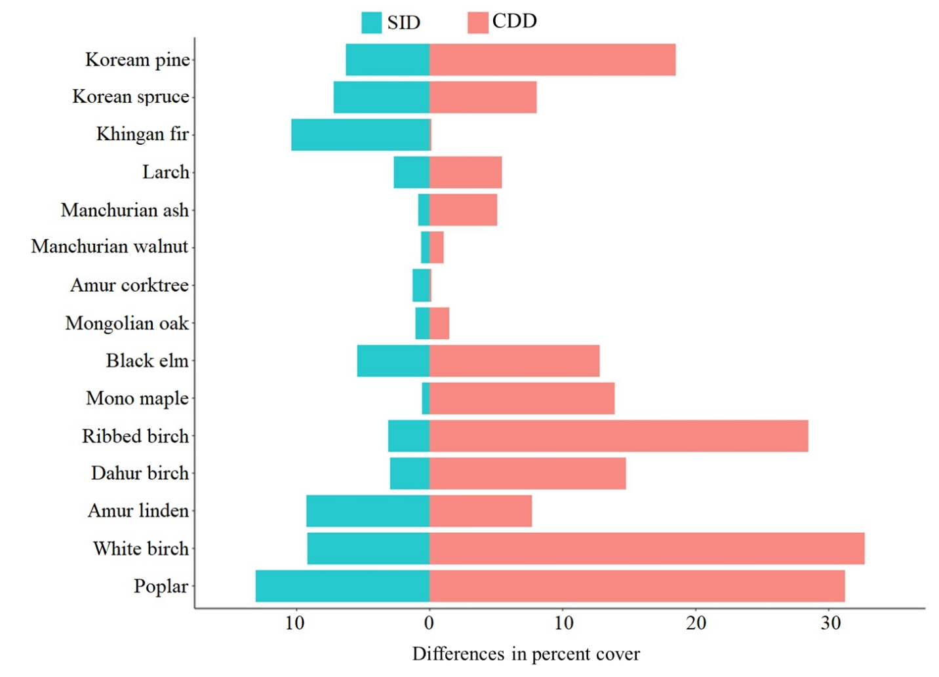
Appendix S4. The differences in percent cover of Korean pine, Mongolian oak, Ribbed birch, and Dahur birch based on CDD and SID algorithms after 200 years of simulation between 400 m resolution and 100 m resolution (resampled to 400 m resolution)

