National-scale multispecies connectivity models represent movements for majority of species tested

Supplemental Tables and Figures
Table S1 Land cover layers and their sources used to construct a resistance-to-movement (also called cost) layer for Canada. Resistance values were assigned to layers based on published data and in consultation with experts and our own knowledge (see Pither et al. 2023).
LAYER | COUNTRY | RESISTANCE | LAYER SOURCES
Built environments | Canada | 1000 | Agriculture and Agri-Food Canada; Science and Technology Branch 2016
Croplands | Canada | 100 | Agriculture and Agri-Food Canada; Science and Technology Branch 2016
Dams | Canada | 1000 | Global Forest Watch Canada 2010
Forestry (cut between 1985 & 2015) | Canada | 10 | White, J. C., Wulder, M. A., Hermosilla, T., Coops, N. C. & Hobart, G. W. A nationwide annual characterization of 25years of forest disturbance and recovery for Canada using Landsat time series. Remote Sensing of Environment 194, 303–321 (2017).
Mining | Canada | 1000 | Government of Canada; Natural Resources Canada 2017
Nighttime lights | Canada | 1000 | Annual composite from 2016 generated by NOAA to assess nighttime lights
Oil and gas | Canada | 1000 | Natural Resources Canada 2017
Pasturelands | Canada | 10 | Agriculture and Agri-Food Canada; Science and Technology Branch 2016
Lakes >= 10ha | Canada | 1000 | Lehner, B., and M. L. Messager. 2016. HydroLAKES Technical Documentation Version 1.0. https://www.hydrosheds.org/page/hydrolakes
Rails | Canada | 1000 | Natural Resources Canada’s National Railway Network (2012)
Roads - minor | Canada | 10 | Poley, L. G., Schuster, R., Smith, W., & Ray, J. C. (2022). Identifying differences in roadless areas in Canada based on global, national, and regional road datasets. Conservation Science and Practice, 4(4), e12656.
Roads - two-lane highway | Canada | 100
Roads - multi-lane highways | Canada | 1000
Elevation > 2300m | Canada & U.S. | 1000 | Global Multi-resolution Terrain Elevation Dataset, USGS 2010
Glaciers | Canada & U.S. | 1000 | CanVec Series, Hydrographic Features 2017
Ocean | Canada & U.S. | 1000 | NRCan Atlas of Canada Data (2017)
Rivers > 28m3/sec | Canada & U.S. | 1000 | HydroRIVERS : Lehner, B. & Grill, G. Global river hydrography and network routing: baseline data and new approaches to study the world’s large river systems. Hydrological Processes 27, 2171–2186 (2013).
Sea Ice | Canada & U.S. | 10 | USGS North America Glaciers and Sea Ice
Slopes > 30 degrees | Canada & U.S. | 1000 | Global Multi-resolution Terrain Elevation Dataset, USGS 2010
Built environments | U.S. | 1000 | Venter, O. et al. Sixteen years of change in the global terrestrial human footprint and implications for biodiversity conservation. Nat Commun 7, 12558 (2016).
Croplands | U.S. | 100
Nighttime lights | U.S. | 1000
Pasturelands | U.S. | 10
Rails | U.S. | 1000
Road buffer (500 - 1000m) | U.S. | 1
Road buffer (500m) | U.S. | 100
Roads | U.S. | 1000

Table S2 Summary of species, number of individuals, and data range for each of the 46 datasets examined. The last four columns on the right indicate the number of individuals from each dataset included in each analysis. Datasets currently available for the public are noted by α or β and corresponding footnotes.
Dataset Name | Scientific Name | N Individuals | N Locations | Fix Rate (minutes) | Minimum Fix Rate (minutes) | Maximum Fix Rate (minutes) | Date Range | Average Temporal Coverage (months) | N Individuals AKDE | N Individuals dBBMM and mv | N Individuals SSF | N Individuals Dispersal
Bighorn Sheep 1 | Ovis canadensis | 69 | 495153 | 120.02 | 14.02 | 2159.93 | 2019 to 2023 | 21.27 | 40 | 68 | 69 | 1
Black Bear 1 | Ursus americanus | 30 | 516325 | 30.13 | 5.07 | 2400.25 | 2006 to 2014 | 23.57 | 16 | 30 | 30 | 0
Black Bear 2 | Ursus americanus | 20 | 35667 | 120.00 | 3.05 | 2880.02 | 2017 to 2023 | 13.30 | 10 | 18 | 20 | 1
Bobcat 1 | Felis rufus | 6 | 1801 | 300.00 | 1.00 | 9900.00 | 2017 to 2018 | 4.50 | 3 | 3 | 6 | 0
Caribou – Barren Ground 1α | Rangifer tarandus | 465 | 1095733 | 478.90 | 1.00 | 38880.00 | 1996 to 2022 | 25.20 | 0 | 415 | 396 | 0
Caribou – Barren Ground 2α | Rangifer tarandus | 204 | 216875 | 480.00 | 1.00 | 100851.00 | 2005 to 2021 | 24.13 | 0 | 161 | 120 | 0
Caribou – Barren Ground 3α | Rangifer tarandus | 167 | 251430 | 480.00 | 1.00 | 132959.00 | 1995 to 2020 | 24.92 | 0 | 145 | 157 | 0
Caribou – Boreal 1 | Rangifer tarandus | 215 | 422129 | 480.00 | 1.00 | 46560.00 | 2005 to 2022 | 27.48 | 132 | 181 | 170 | 1
Caribou – Boreal 2 | Rangifer tarandus | 40 | 68762 | 478.22 | 472.47 | 12481.78 | 2002 to 2012 | 27.52 | 22 | 36 | 28 | 1
Caribou – Boreal 3 | Rangifer tarandus | 53 | 376736 | 239.00 | 57.00 | 6000.00 | 2017 to 2022 | 28.69 | 22 | 53 | 53 | 0
Caribou – Boreal 4 | Rangifer tarandus | 10 | 37985 | 120.00 | 117.48 | 361.90 | 2021 to 2022 | 9.80 | 1 | 10 | 10 | 1
Caribou – Boreal 5 | Rangifer tarandus | 300 | 869780 | 480.00 | 1.00 | 76320.00 | 2005 to 2022 | 28.08 | 178 | 281 | 283 | 3
Caribou – Boreal 6 | Rangifer tarandus | 231 | 425723 | 300.13 | 3.20 | 35999.72 | 2009 to 2014 | 25.52 | 85 | 227 | 227 | 1
Caribou – Coastal 1* | Rangifer tarandus | 43 | 77692 | 300.08 | 58.28 | 16500.00 | 2009 to 2013 | 26.40 | 0 | 2 | 43 | 0
Caribou – Mountain 1α | Rangifer tarandus | 185 | 245174 | 420.20 | 0.17 | 13919.00 | 2001 to 2016 | 17.71 | 79 | 165 | 184 | 0
Cougar 1 | Puma concolor | 10 | 7224 | 120.00 | 57.67 | 2640.47 | 2000 to 2003 | 6.80 | 5 | 9 | 10 | 0
Cougar 2β | Puma concolor | 7 | 26816 | 90.00 | 0.20 | 361.50 | 2017 to 2018 | 8.00 | 5 | 7 | 0 | 0
Cougar 3 | Puma concolor | 12 | 6855 | 360.58 | 357.17 | 4680.217 | 2010 to 2011 | 9.67 | 12 | 12 | 12 | 0
Cougar 4 | Puma concolor | 15 | 31739 | 180.00 | 174.93 | 1443.00 | 2008 to 2012 | 11.40 | 10 | 15 | 15 | 0
Coyote 1 | Canas latrans | 78 | 239200 | 89.13 | 0.12 | 1440.50 | 2010 to 2013 | 6.54 | 60 | 77 | 78 | 0
Coyote 2 | Canas latrans | 29 | 98221 | 177.93 | 0.12 | 2340.00 | 2012 to 2023 | 14.31 | 15 | 28 | 27 | 2
Coyote 3 | Canas latrans | 14 | 57908 | 89.97 | 0.12 | 1080.45 | 2012 to 2015 | 10.21 | 10 | 13 | 11 | 1
Elk 1α | Cervus canadensis | 170 | 874676 | 120.00 | 0.12 | 9838.93 | 2007 to 2013 | 16.60 | 74 | 169 | 170 | 5
Elk 2α | Cervus canadensis | 174 | 1510527 | 30.07 | 0.72 | 21060.00 | 2001 to 2020 | 24.41 | 130 | 159 | 173 | 0
Grizzly Bear 1 | Ursus arctos horribilis | 34 | 94961 | 120.00 | 0.28 | 17399.98 | 2000 to 2017 | 22.74 | 20 | 34 | 34 | 0
Grizzly Bear 2 | Ursus arctos horribilis | 60 | 116074 | 120.00 | 2.00 | 27361.00 | 2015 to 2022 | 17.81 | 47 | 52 | 58 | 0
Grizzly Bear 3 | Ursus arctos horribilis | 33 | 103943 | 60.15 | 54.17 | 4320.38 | 2005 to 2017 | 18.36 | 23 | 31 | 33 | 0
Lynx 1 | Lynx canadensis | 3 | 1983 | 300.00 | 298.00 | 991.00 | 2017 to 2018 | 9.00 | 3 | 3 | 3 | 0
Moose 1α | Alces alces | 19 | 55172 | 120.37 | 118.37 | 1680.00 | 2008 to 2010 | 11.32 | 11 | 19 | 19 | 0
Moose 2α | Alces alces | 25 | 133131 | 180.00 | 177.62 | 2519.87 | 2010 to 2012 | 23.88 | 22 | 25 | 25 | 0
Moose 3 | Alces alces | 39 | 314706 | 120.00 | 28.83 | 6600.53 | 2010 to 2016 | 24.18 | 30 | 38 | 39 | 0
Mountain Goat 1 | Oreamnos americanus | 12 | 114808 | 120.02 | 29.90 | 1320.27 | 2019 to 2023 | 28.58 | 11 | 12 | 12 | 0
Pine Marten 1 | Martes americana | 8 | 1806 | 360.37 | 359.48 | 2879.98 | 2020 to 2022 | 3.88 | 7 | 4 | 8 | 0
Pronghorn 1α | Antilocapra americana | 169 | 415185 | 121.12 | 0.77 | 2160.00 | 2003 to 2011 | 9.99 | 34 | 162 | 169 | 2
White-tailed Deer 1 | Odocoileus virginianus | 119 | 232214 | 120.00 | 0.95 | 1680.00 | 2021 to 2023 | 5.31 | 29 | 109 | 119 | 0
White-tailed Deer 2 | Odocoileus virginianus | 31 | 83064 | 90.18 | 0.13 | 2878.60 | 2011 to 2014 | 10.26 | 17 | 31 | 22 | 0
Wild Turkey 1 | Meleagris gallopavo | 51 | 139982 | 60.00 | 1.00 | 2550.00 | 2017 to 2020 | 8.43 | 45 | 47 | 51 | 1
Wolverine 1 | Gulo gulo | 4 | 1374 | 419.82 | 59.80 | 3359.67 | 2009 to 2012 | 5.00 | 4 | 3 | 4 | 0
Wolverine 2 | Gulo gulo | 47 | 65930 | 120.22 | 1.00 | 3120.00 | 2018 to 2022 | 10.47 | 28 | 52 | 47 | 4
Wolverine 3 | Gulo gulo | 34 | 45579 | 120.00 | 2.00 | 4560.00 | 2013 to 2016 | 9.71 | 25 | 30 | 34 | 0
Wolf 1α | Canis lupus | 67 | 174238 | 61.00 | 0.35 | 4800.00 | 2000 to 2011 | 7.46 | 54 | 62 | 67 | 2
Wolf 2 | Canis lupus | 37 | 124379 | 119.78 | 10.00 | 4141.08 | 2002 to 2022 | 9.43 | 32 | 35 | 37 | 0
Wolf 3 | Canis lupus | 43 | 233386 | 15.07 | 0.22 | 12960.52 | 2012 to 2014 | 8.44 | 27 | 41 | 43 | 1
Wolf 4 | Canis lupus | 59 | 108436 | 120.27 | 57.50 | 5760.63 | 2019 to 2022 | 11.42 | 0 | 56 | 59 | 4
Wolf 5 | Canis lupus | 21 | 49962 | 89.60 | 12.28 | 7918.93 | 2005 to 2008 | 7.67 | 19 | 21 | 7 | 0
Wolf 6 | Canis lupus | 63 | 155539 | 149.00 | 1.00 | 5700.00 | 2010 to 2013 | 8.73 | 48 | 63 | 63 | 0
AKDE = autocorrelated kernel density estimation used to estimate home range;
dBBMM = dynamic Brownian bridge movement model used to estimate probability of use during movement;
mv = motion variance used as an indicator of fast/irregular movements;
SSF = step selection function models used to estimate selection preferences for areas with higher current density.
* Coastal caribou refers to Eastern Migratory Caribou along the coast of Hudson Bay, which are listed as a distinct population by the Government of Ontario.
α Data available on https://www.movebank.org. Additional data from the Northwest Territory may be available by contacting wmisteam@gov.nt.ca.
β Data available on https://borealisdata.ca.

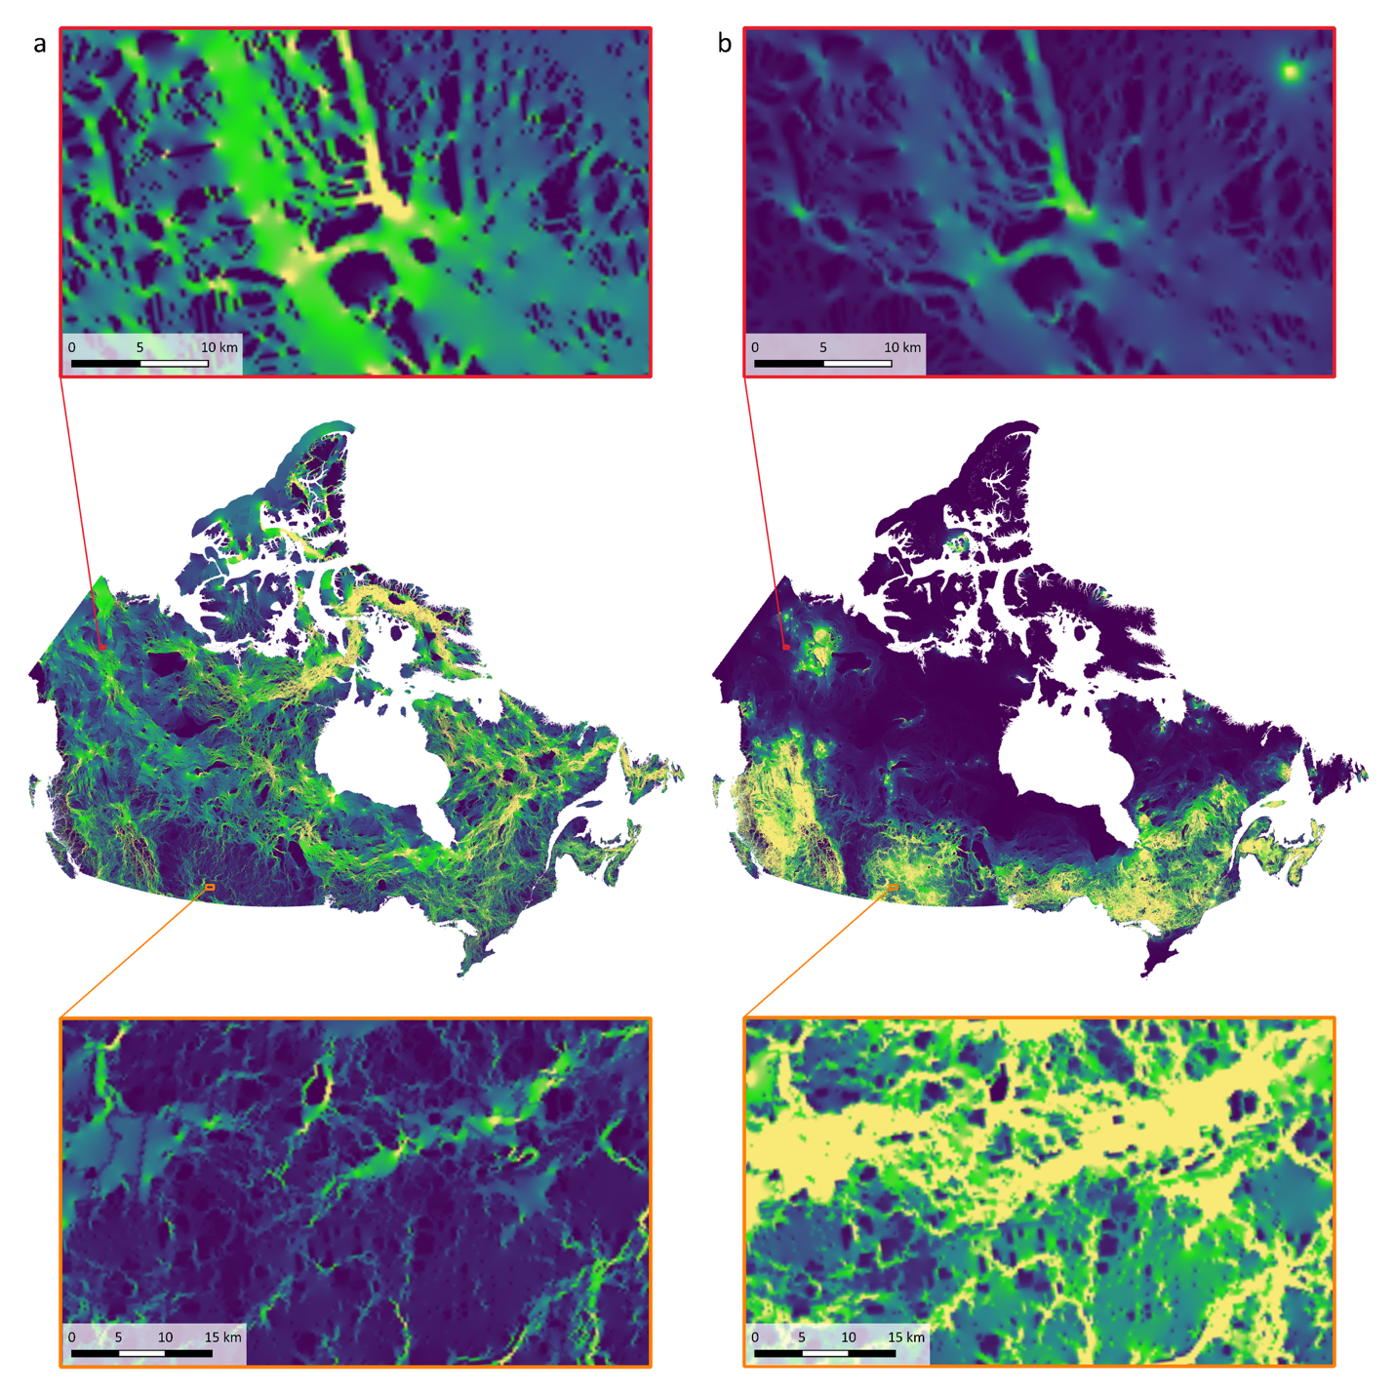
Fig. S1 Current density maps produced using omnidirectional wall-to-wall (Pither et al. 2023) and pairwise park-to-park (Brennan 2023, unpublished) GM connectivity models in panels a and b, respectively. Colours represent current density standardized at the national scale. Zooming in reveals local patterns that are not apparent at the national scale, as illustrated in the top and bottom panels.

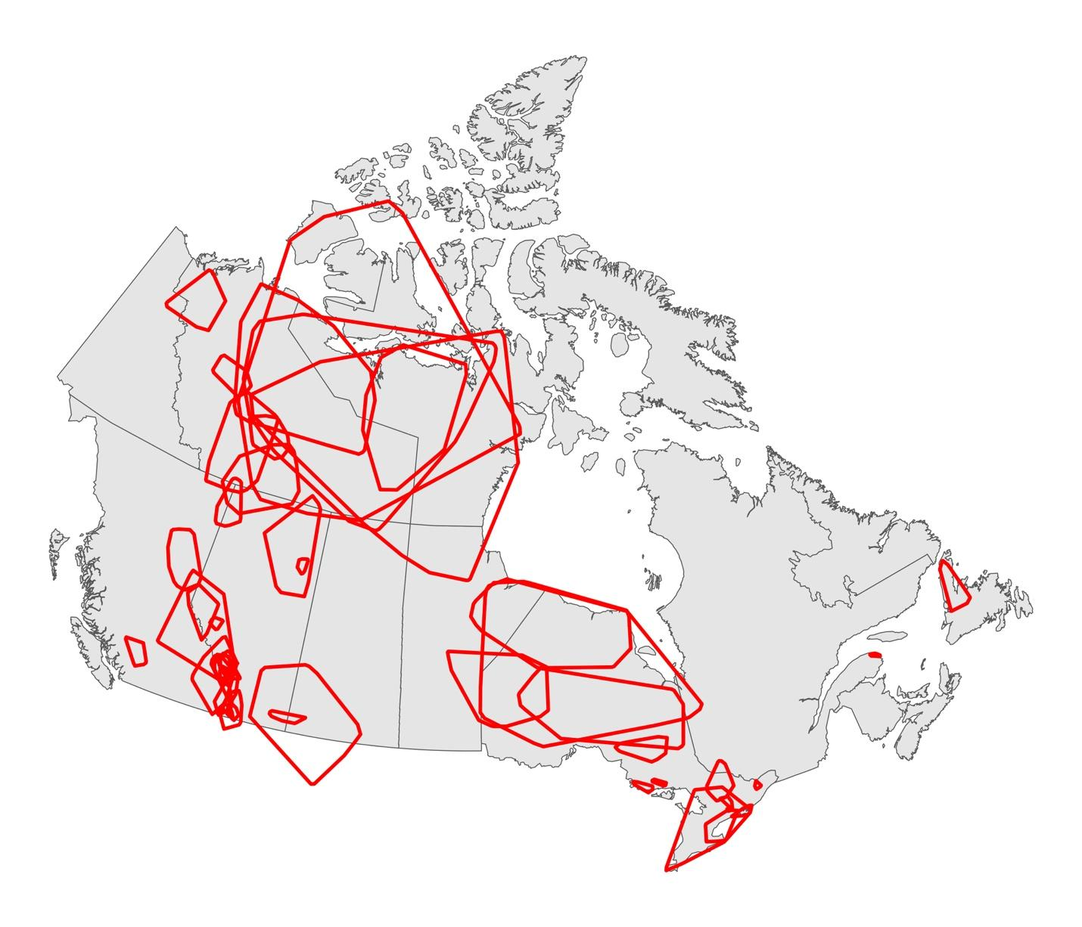
Fig. S2 Locations and spatial extents (minimum convex polygons) of the GPS telemetry data by species and study area.

Table S3 Model equations used in each of the validation analyses.
Validation movement process | Validation model equation | Parameter definitions
Home range defining movements | y_{ijk} =β₀ + β₁ x_{ijk} + b_{0j}⁽¹⁾ + b_{1j}⁽¹⁾ x_{ijk} + b_{0k}⁽²⁾ + b_{1k}⁽²⁾ x_{ijk} + ε_{ijk} | - y_{ijk} = log current density for observation i, in level j of grouping variable 1 (individual), and level k of grouping variable 2 (dataset)  - x_{ijk} = predictor for that observation (inside or outside the utilization distribution)  - β ₀, β₁ = fixed intercept and slope  - b _{0j,} b_{1j}⁽¹⁾ = random intercept and slope for group j in grouping variable 1  - b _{0k,} b_{1k}⁽²⁾ = random intercept and slope for group k in grouping variable 2  - ε_{ijk} = residual error
Patterns of occurrence | y_{ij} =β₀ + β₁ x_{ij} + b_{0j} + b_{1j} x_{ij} + ε_{ij} | - y_{ij} = log of the probability of occurrence for observation i, in level j of grouping variable 1 (dataset)  - x_{ij} = predictor value for that observation (log current density)  - β ₀, β₁ = fixed intercept and slope  - b _{0j,} b_{1j} = random intercept and slope for group j in the grouping variable 1  - ε_{ij} = residual error
Fast movements | y_{ij} =β₀ + β₁ x_{ij} + b_{0j} + ε_{ij} | - y_{ij} = log current density for observation i, in level j of grouping variable 1 (individual)  - x_{ij} = predictor value for that observation (fast or slower movements as defined by motion variance quintile)  - β ₀, β₁ = fixed intercept and slope  - b _{0j} = random intercept for group j in the grouping variable 1  - ε_{ij} = residual error
Step selection | y_{ijk} ~ Bernoulli(p_{ijk})  logit(p_{ijk}) = β₀ + β₁ x_{ijk} + u_{j}  u_{j} ~ 𝒩(0, $σ_{u}^{2}$) | - y_{ijk} = observed binary outcome (0 or 1 for random or observed step, respectively) for observation i, individual j, within matched stratum k  - p_{ijk} = probability that y_{ijk} = 1  - x_{ijk} = predictor value for that observation (log current density)  - β ₀, β₁ = fixed intercept and slope  - u_{j} = normally distributed random intercept for individual j with mean of zero and variance $σ_{}^{2}$  - (model is conditioned on stratum k, so stratum-level intercepts are not estimated)

Table S4 Number of individuals that had higher current densities along used dispersal paths than along half of the randomly generated pathways.

Species | # Individuals with Dispersal Events | # Individuals that had higher current densities along used dispersal paths than 50% of the random pathways
Species | # Individuals with Dispersal Events | Omnidirectional Model | Park-to-Park Model
Bighorn Sheep | 1 | 0 | 1
Black Bear | 1 | 1 | 1
Boreal Caribou | 7 | 4 | 5
Coyote | 3 | 0 | 1
Elk | 5 | 5 | 3
Pronghorn | 2 | 2 | 0
Wild Turkey | 1 | 0 | 0
Wolf | 7 | 5 | 4
Wolverine | 4 | 2 | 2

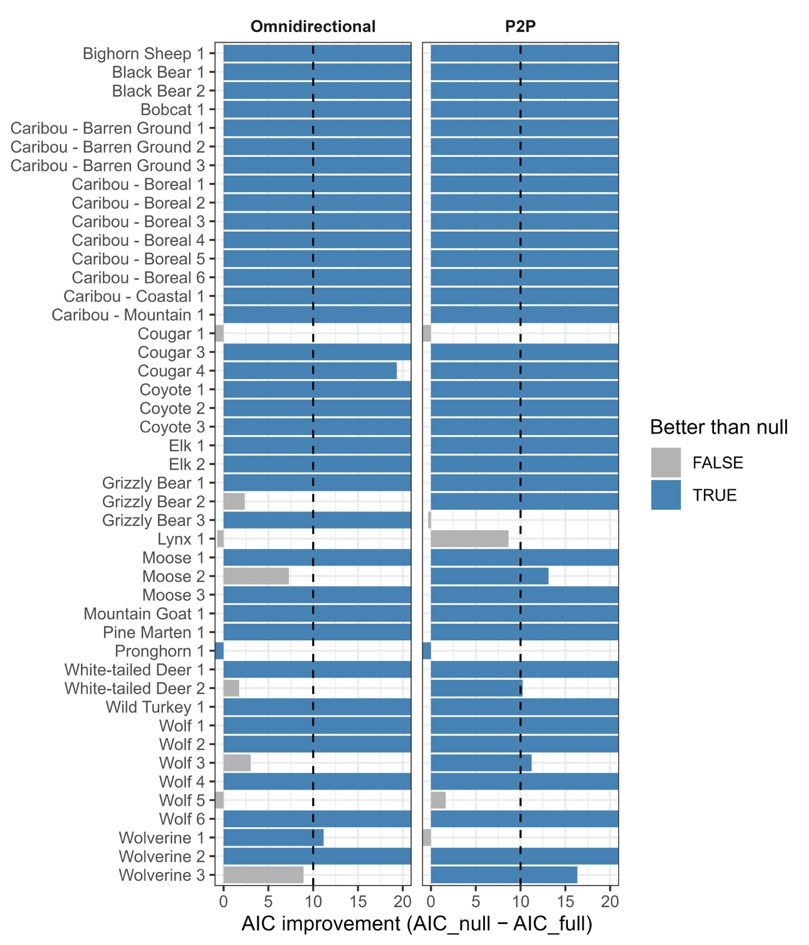
Figure S3. Comparison of AIC values between the full Cox proportional hazards models, used to evaluate omnidirectional and park-to-park (P2P) GM connectivity model prediction of step selection, and the corresponding null models with only the random effects structure and strata. Blue bars indicate the datasets (y axis) for which the full models were better than the null: when the null model was > 10 AIC from the full model. Vertical dashed lines indicate the 10 AIC threshold. The x axis was truncated at 20 to highlight values around the threshold.
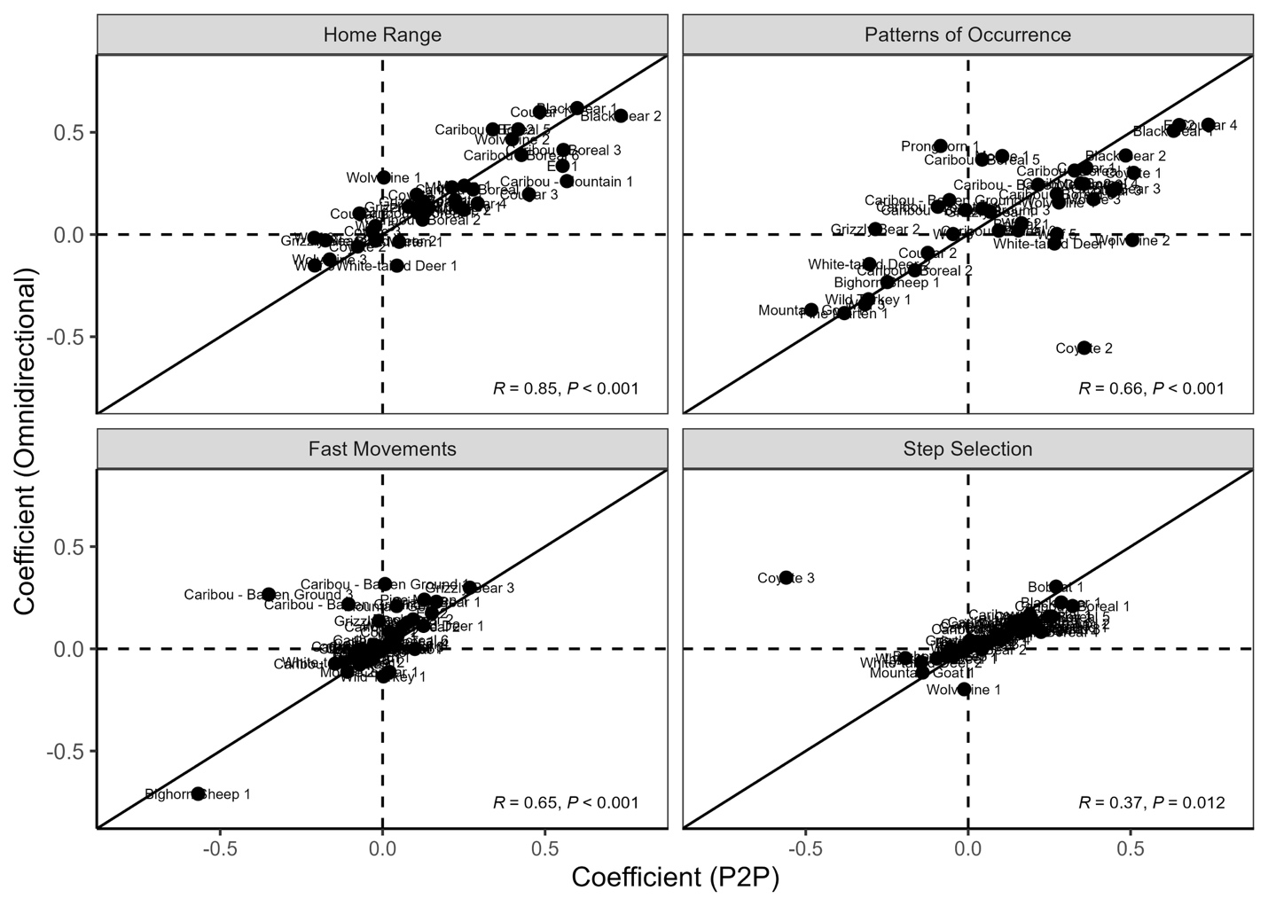Fig. S4 Comparing the prediction accuracy (coefficient values) of the omnidirectional and park-to-park (P2P) GM connectivity models, for each movement process analysis: home range-defining movements, patterns of occurrence along the entire movement path, fast movements, and step selection. Pearson’s correlation coefficients and P-values are printed in the lower right corner of each panel and lines depict the 1:1 relationship. Each data point represents the coefficient for a dataset, as labeled (labels match dataset rows in Table S2). Dotted lines isolate quadrants: the upper left quadrant is where the coefficients for a dataset were + and - for omnidirectional and park-to-park respectively; the upper right quadrant is where coefficients for a dataset were both +; the lower left quadrant is where coefficients for a dataset were both -; and the lower right quadrant is where coefficients for a dataset were - and +. The coefficients that fall in the upper left and lower right quadrants of each panel are those where there was a strong difference in model prediction accuracy.

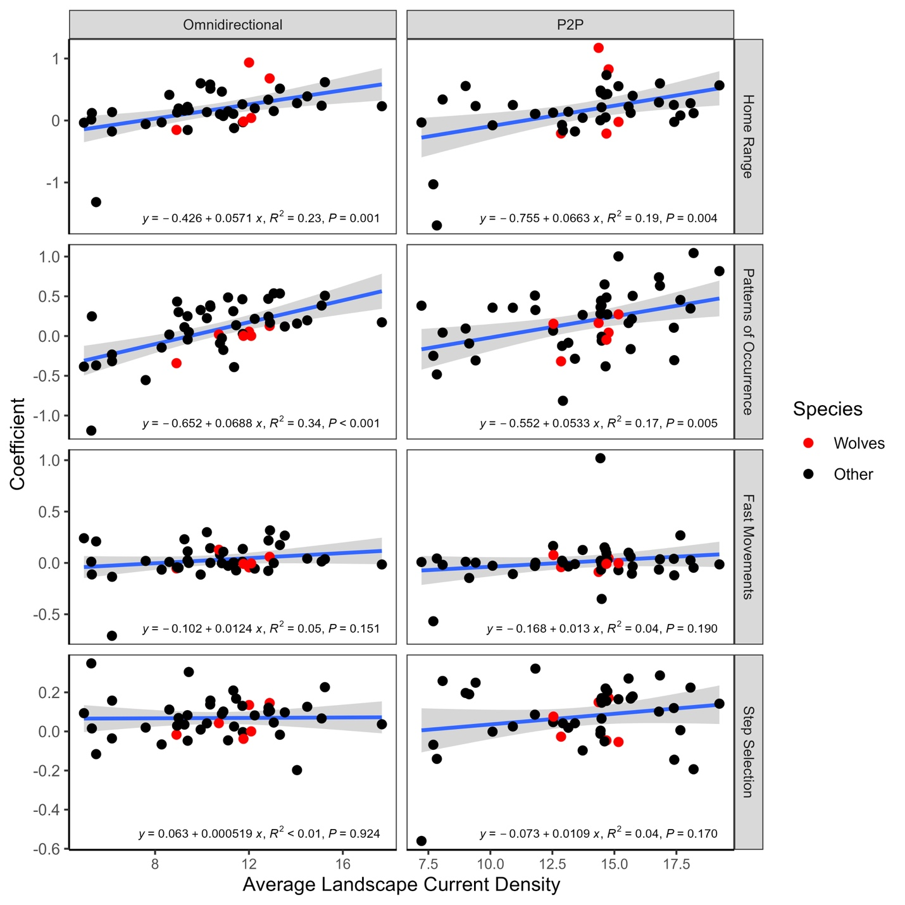Fig. S5 Examination of the effect of overall landscape flow on GM connectivity model prediction accuracy. Panels depict the linear relationships, R², and P-values estimated between average landscape current density and coefficient values for four of the five movement processes examined: home range-defining movements, patterns of occurrence along the entire movement path, fast movements, and step selection. Wolves are highlighted in red to show the degree to which within species variation in prediction accuracy can vary with average landscape current density (species interactions were not explicitly examined given there were few datasets per species). Omnidirectional = omnidirectional GM connectivity model; P2P = park-to-park GM connectivity model.

References

Pither R, O’Brien P, Brennan A, Hirsh-Pearson K, Bowman J (2023) Predicting areas important for ecological connectivity throughout Canada. PLOS ONE 18:e0281980. https://doi.org/10.1371/journal.pone.0281980

